ASSIGNMENT-2

[A] Implement XOR gate using NAND :-
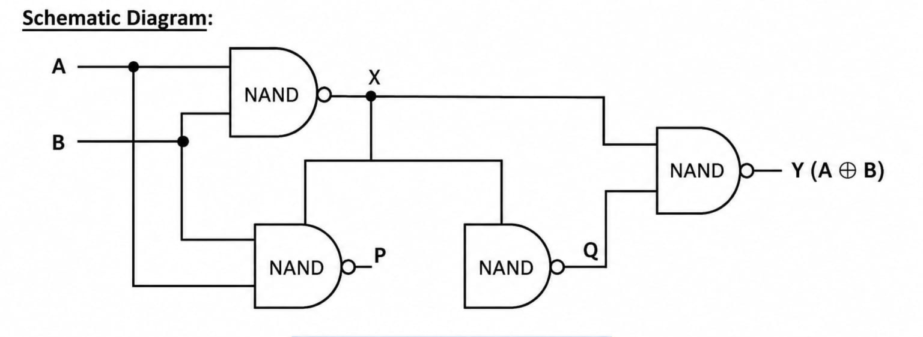
Boolean Expression :
Y’ = (AB’+A’B)’
Y = Y’’= ((AB’)’ .( A’B)’)’
Code :
CHIP Xor {
IN a, b;
OUT out;
PARTS:
Nand(a=a, b=a, out=x);
Nand(a=b, b=b, out=y);
Nand(a=a, b=y, out=z);
Nand(a=b, b=x, out=z1);
Nand(a=z, b=z1, out=out);
}

Truth Table :
a | b | Out
0 | 0 | 0
0 | 1 | 1
1 | 0 | 1
1 | 1 | 0

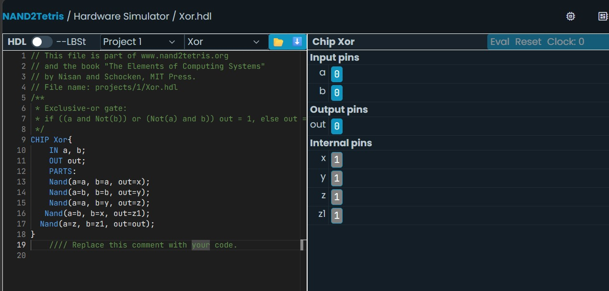
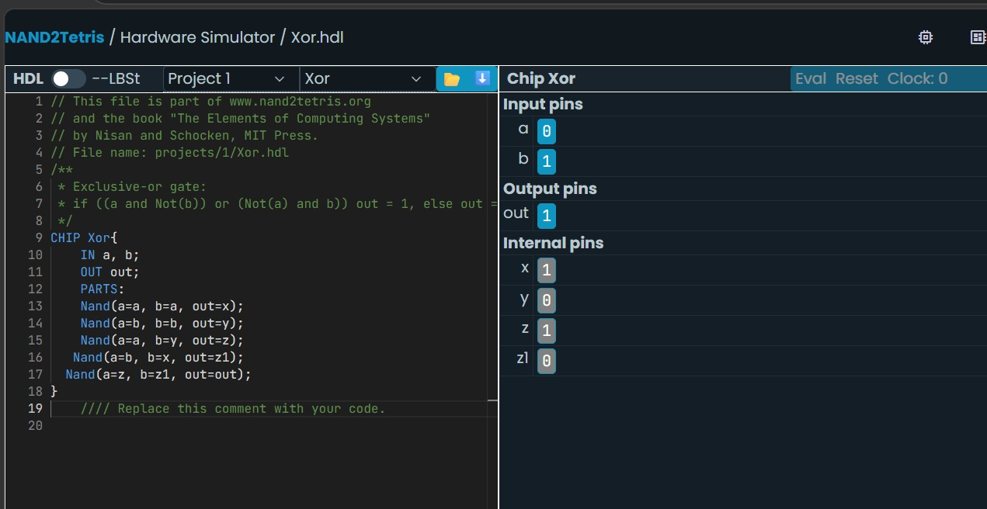
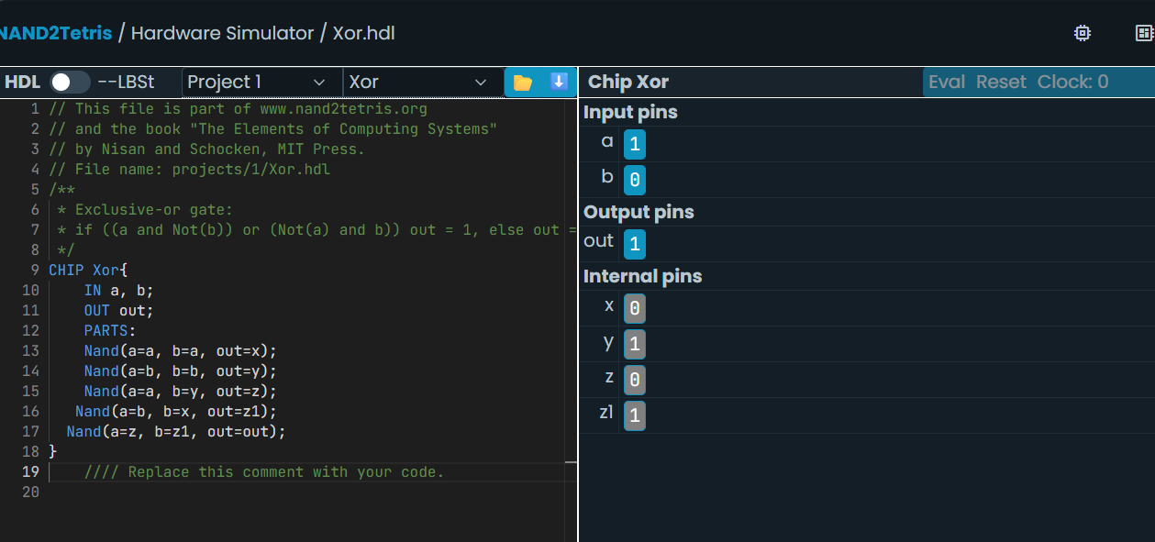
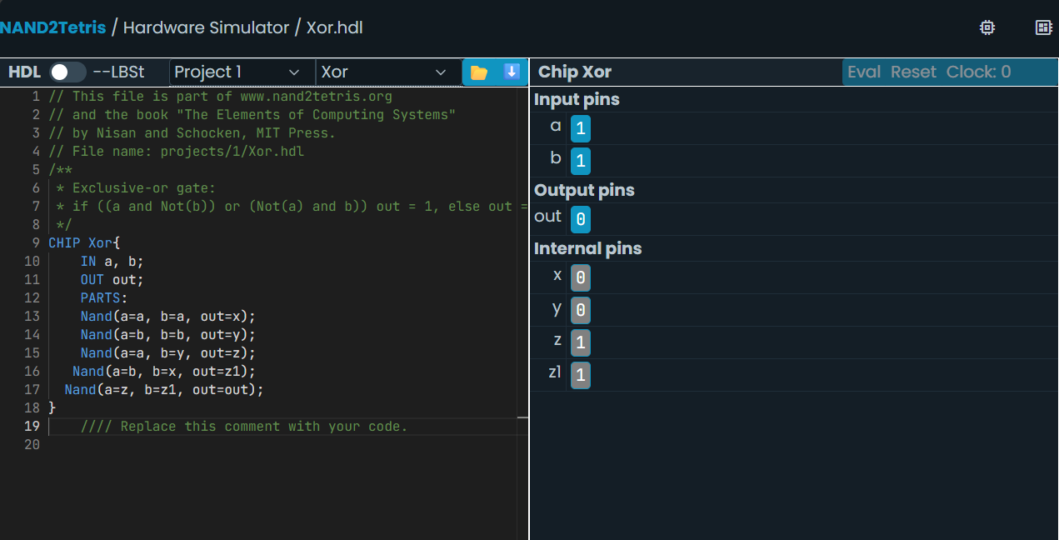
[B] Implement Multiplexer (2-Way MUX) using Nand :-
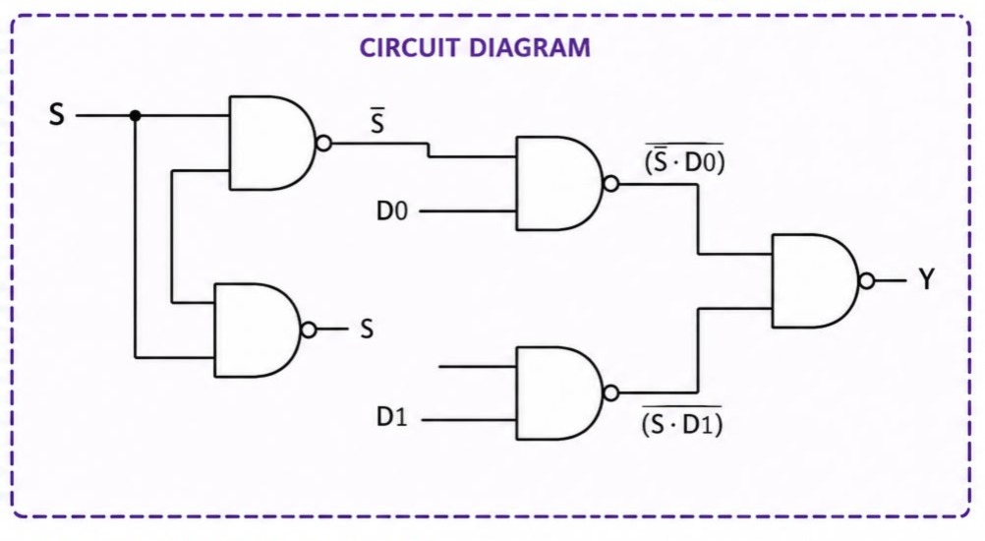
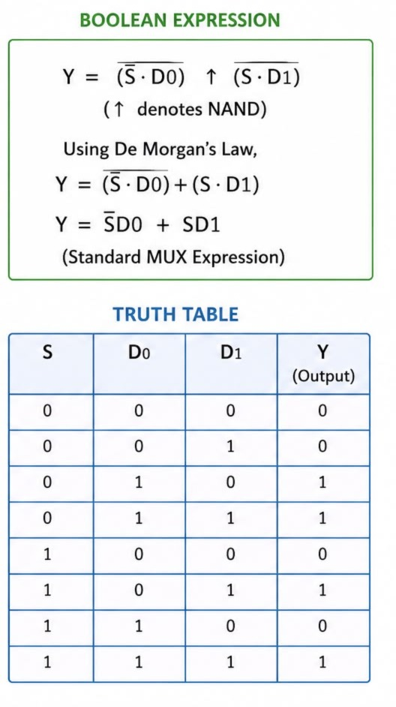

Code:
CHIP Mux16 {
IN a[2], b[2], sel;
OUT out[2];

PARTS:
Not(in=sel , out=nsel);
And(a=a[0], b=nsel, out=x);
And(a=a[1], b=nsel, out=x1);

And(a=b[0], b=sel, out=y);
And(a=b[1], b=sel , out=y1);

Or(a=x, b=y , out=out[0]);
Or(a=x1 , b=y1 , out=out[1]);
}
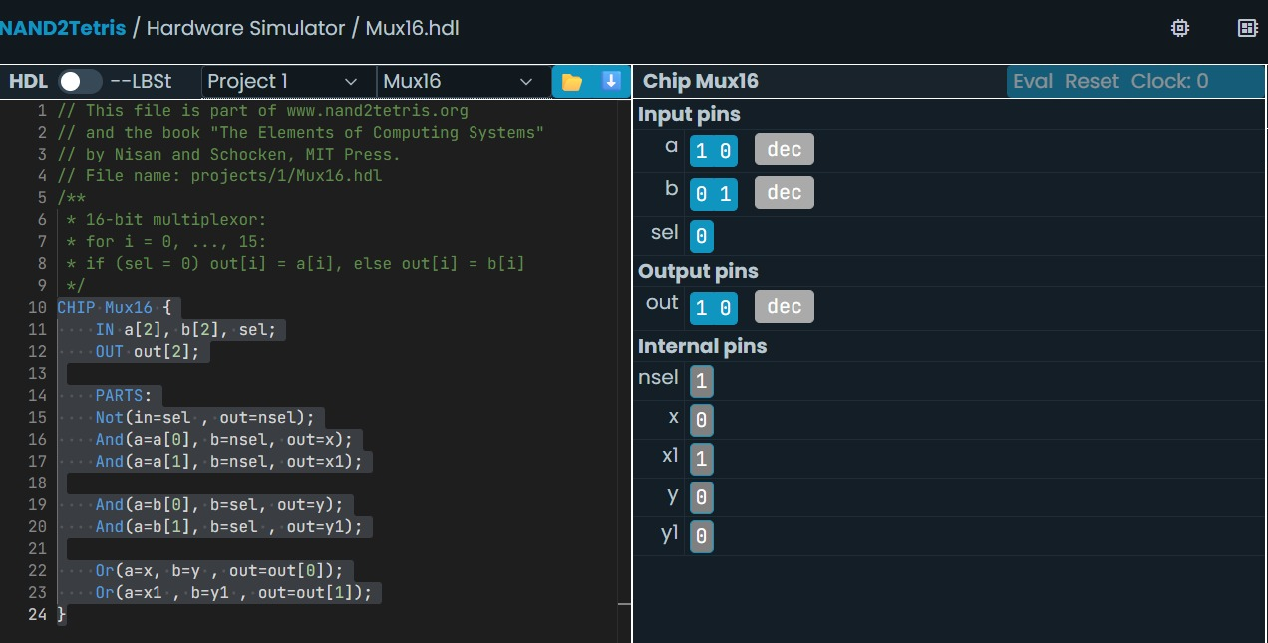
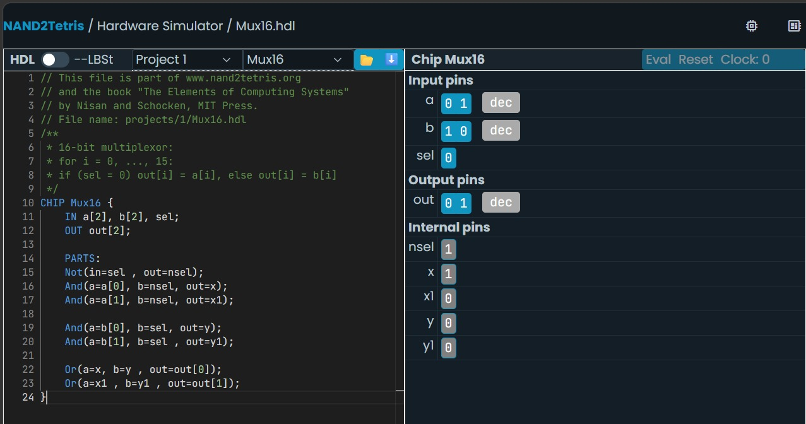
[C] Implement Multiplexer (4-Way MUX) using Nand :-
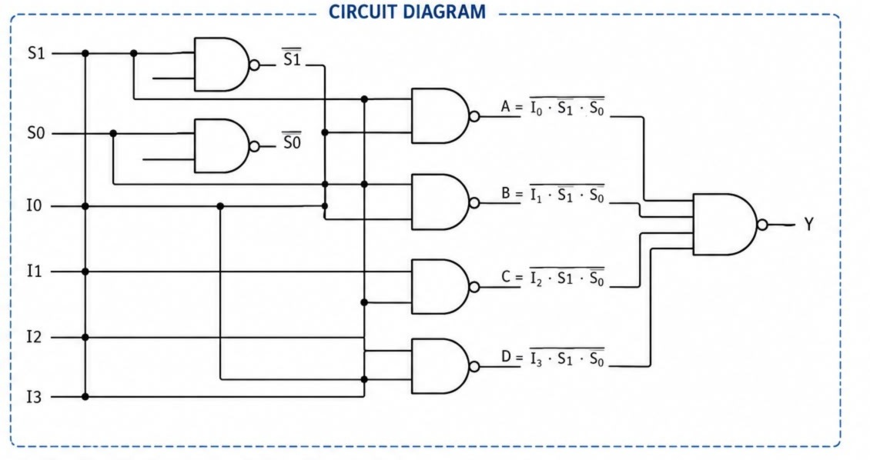
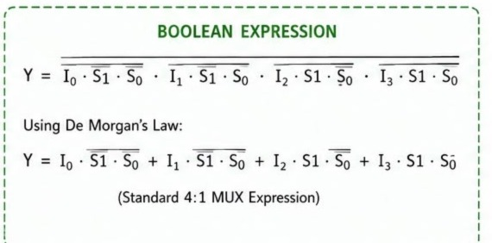
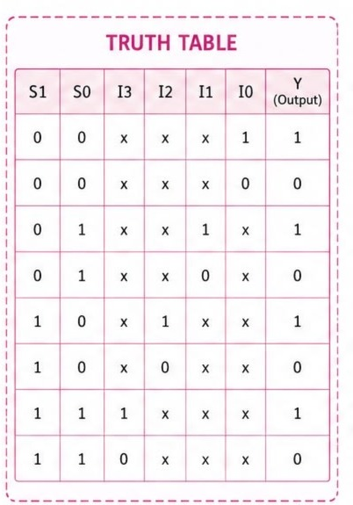
Code:
CHIP Mux16 {
IN a[4], b[4], sel;
OUT out[4];
PARTS:
Not(in=sel , out=nsel);
And(a=a[0], b=nsel, out=x);
And(a=a[1], b=nsel, out=x1);

And(a=b[0], b=sel, out=y);
And(a=b[1], b=sel , out=y1);

Or(a=x, b=y , out=out[0]);
Or(a=x1 , b=y1 , out=out[1]);
}

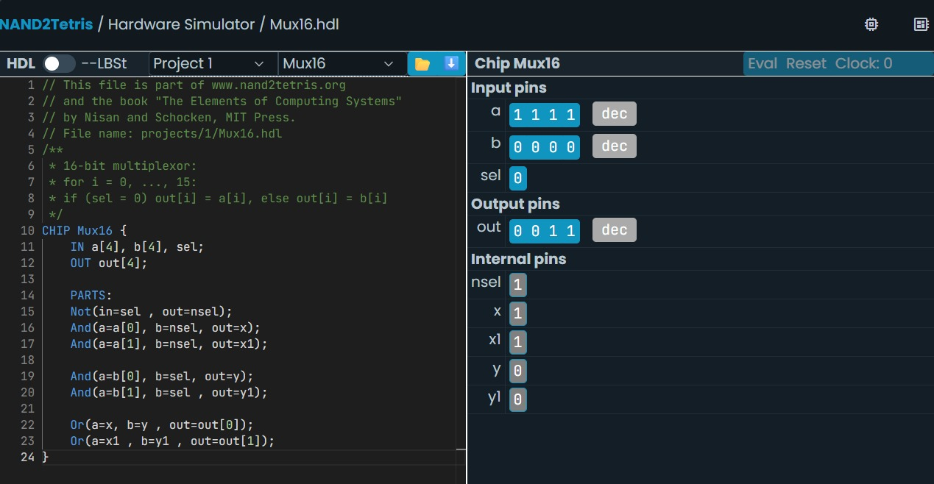
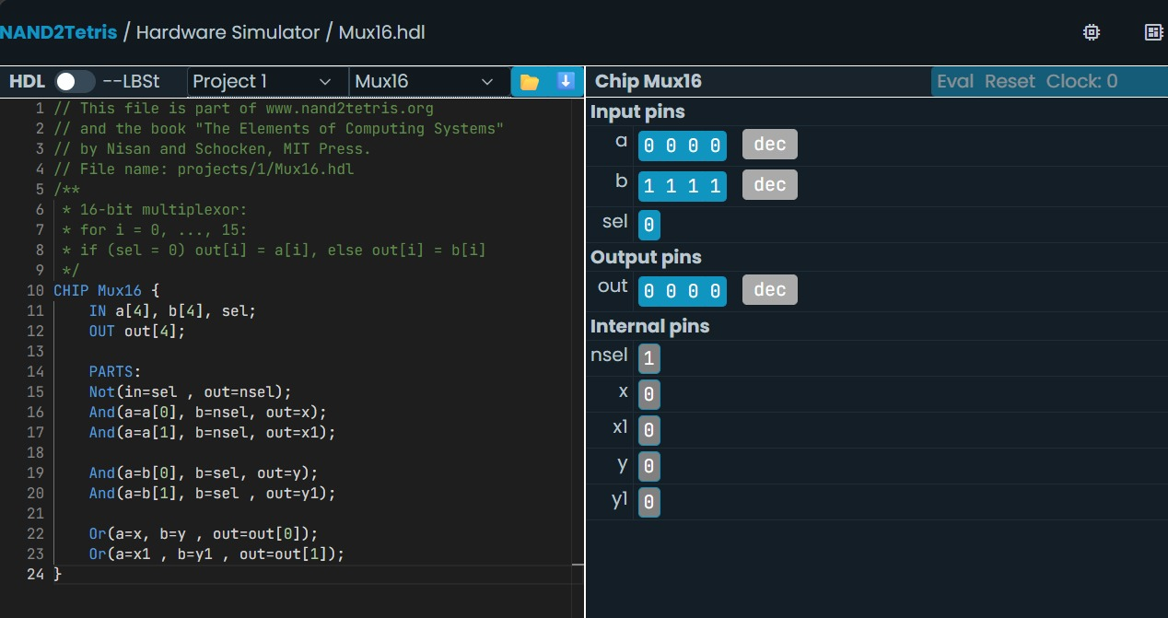
[D] Implement DMux using Nand :-
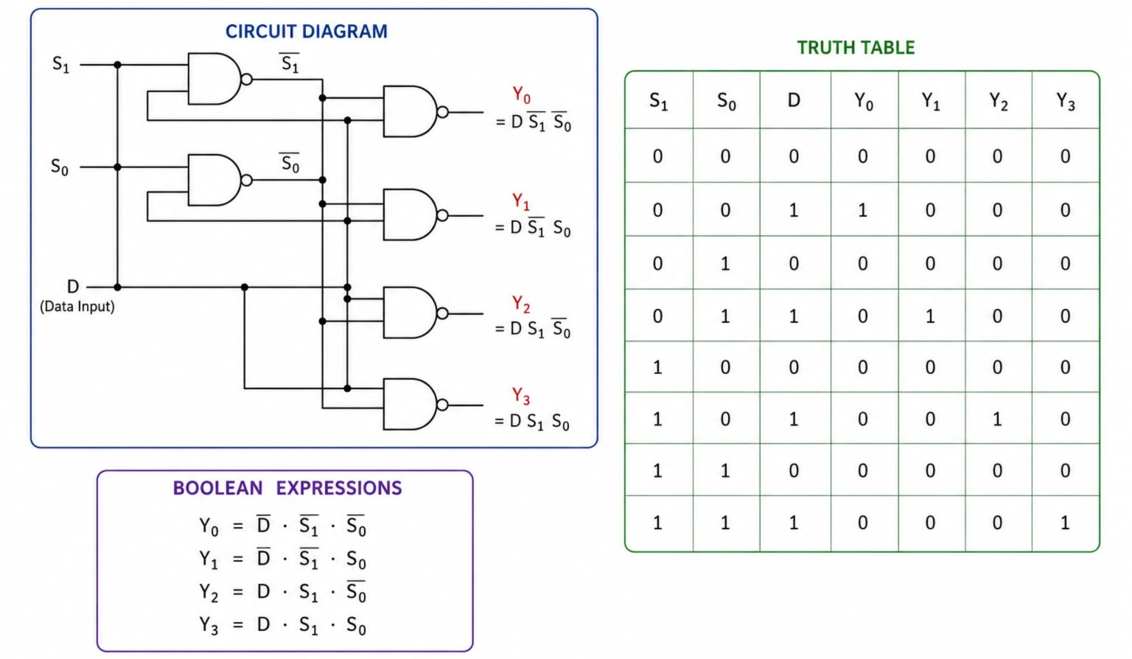

CODE:
CHIP DMux {
IN in, sel;
OUT a, b;
PARTS:
Nand(a=sel, b=sel, out=notSel)
Nand(a=in, b=notSel, out=x);
Nand(a=x, b=x, out=a);
Nand(a=in, b=sel, out=y);
Nand(a=y, b=y, out=b);
}
