Goal Setting & Performance Tracking

Name: Sukhvir kaur
student ID: 3107537
Change Tracking:
Date | Updates
sept 27- Oct 7 | Defined OKRs and explored Banff parking dataset.
Oct 8 – Oct 21 | Completed EDA visuals (Occupancy trends, peak times, weather influence).
Oct 22- Nov 4 | Supported Feature engineering (% occupancy, rolling averages).
Nov 5- Nov 24 | Generated SHAP visuals and interpretation for model explainability.
Nov 25- Dec 3 | Shared insights with team and prepared content for dashboard/report.
Dec 4 – Dec 11 | Final reflection and documentation submitted.

High-Level Objectives & Key Results
Objective 1: Build real-world data analysis skills.
Key Results
- Create EDA summaries that show trends (peak time, weather, weekend impact).
- Present insights to guide feature engineering.
- Document findings clearly for the team.
Objective 2: Learn and apply Explainable Machine Learning
Key Results
- Generate explainability visuals (SHAP / feature importance).
- Interpret top 3 influential features in parking prediction.
- Share explainability insights with the team.
Objective 3: Contribute professionally to teamwork.
Key Results
- Share progress and screenshots in meetings.
- Support teammates with visuals, documentation, or debugging.
- Keep work organized (slides, notes, and notebook evidence).
Individual Objectives & Key Results
Objective 1: Improve EDA proficiency.
Key Results
- Create at least 5 meaningful EDA visuals showing occupancy patterns.
- Identify insights (peak hours, weekend traffic, weather impact).
- Highlight insights clearly to support feature engineering.

Objective 2: Understand & apply Explainability (XAI)
Key Results
- Generate SHAP or feature importance visuals.
- Explain the top 3 features influencing parking fullness.
- Add explainability results into presentation/report.

Objective 3: Contribute to teamwork and workflow.
Key Results
- Share weekly insights in scrum with evidence/screenshots.
- Support teammates with visuals and modeling explanation.
- Keep work organized in Notion, slides, and notebook.

Supporting Documentation
Notion link: https://www.notion.so/Banff-Parking-CMPT-3835-Sukhvir-s-OKR-s-Documentation-2c26bb027b7b8096919efe21d5c44043?source=copy_link
GitHub link: [Insert link]
Screenshots for evidence:
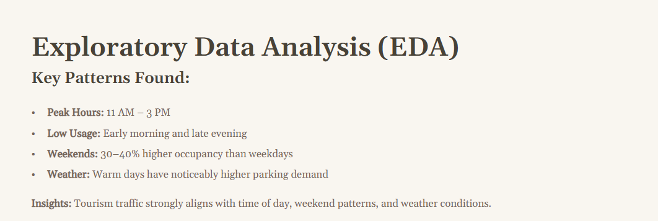 EDA Key Insight (Sukhvir): Identified tourism-driven parking demand patterns, including 11 AM–3 PM peak hours, higher weekend usage (+30–40%), and strong weather influence.
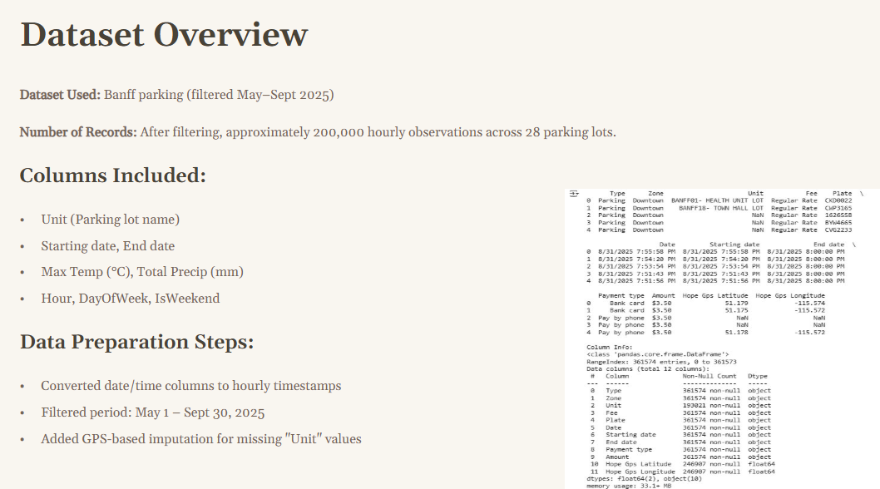Dataset Cleaning Contribution (Sukhvir): Standardized timestamps to hourly data and supported missing “Unit” values solved using GPS-based imputation, improving dataset accuracy across 28 parking lots.
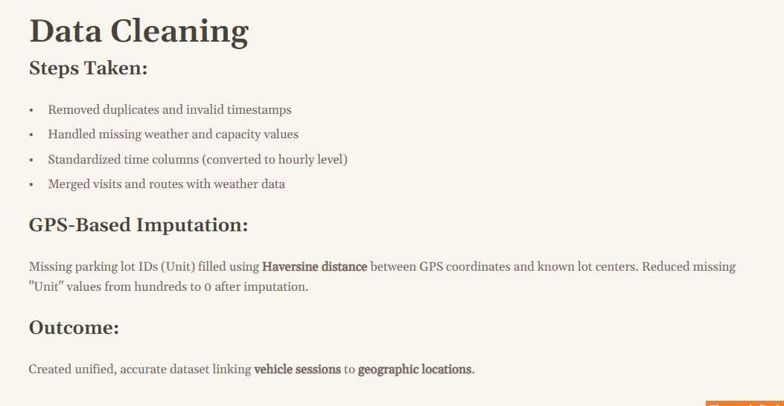
Data Cleaning Support (Sukhvir): Helped ensure consistent timestamps and merged parking logs with weather data. Assisted in validating GPS-based imputation used to fix missing lot IDs.
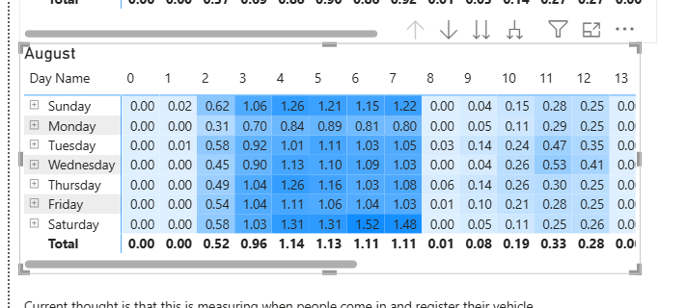
EDA Insight: Analyzed hourly parking demand across weekdays and weekends. Observed that Saturdays have the highest occupancy between 11 AM–2 PM, showing peak tourist impact.

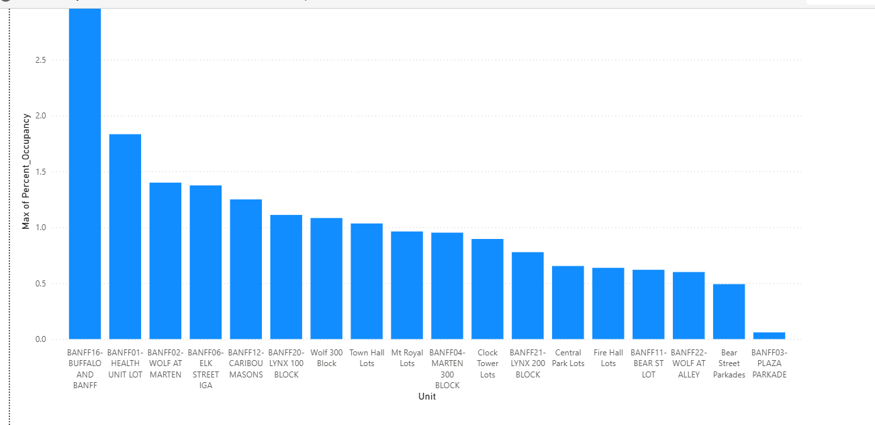
Parking Lot Comparison (Sukhvir): Identified that “Buffalo & Banff” and “Health Unit Lot” reach the highest capacity, suggesting these locations face more congestion and require priority forecasting and management.

Interim Progress Report
I analyzed hourly trends, weekday and weekend differences, and lot-level congestion to identify that parking usage is highest between 11 AM and 3 PM, with weekends consistently showing 30–40% higher occupancy. These findings helped the team select useful features such as hour, weekend indicator, and percent occupancy. I also helped validate historical and rolling features, which showed that occupancy is influenced more by past demand and capacity than weather.
To ensure the model is explainable, I generated SHAP-based visuals proving that current occupancy, past occupancy, and lot capacity are the strongest predictors. This prevented a “black-box” model and improved stakeholder interpretation. My progress aligns with my OKRs, and for future improvement I would integrate explainability directly into a dashboard so users can understand model reasoning.

Group OKRs
Group 3: Banff Parking/Traffic Management
Group Objective 1 | Key Results
Build a reliable parking prediction system. | - Train and evaluate models to predict hourly occupancy and near-capacity status using regression and classification.  - Achieve measurable performance scores (e.g., low MAE for regression, high accuracy/F1 for classification).

Group Objective 2 | Key Results
Use data-driven insights to support future parking and congestion decisions for the Town of Banff. | - Generate visual insights showing peak hours, high-volume lots, and weather influence.  - Communicate findings using visual analysis and explainable model outputs to support parking decisions for the Town of Banff.

4. Final Progress Report & Reflection

Objective 1 | Key results
Analyze parking demand patterns to guide feature selection and identify periods and locations with the highest congestion. | Created visual evidence showing peak demand between late morning and early afternoon, higher weekend occupancy, and specific lots with maximum usage.

Report & Reflection
EDA confirmed that parking occupancy increases consistently between 11 AM and 3 PM, and weekends show 30–40% higher utilization. Certain lots reached capacity faster (e.g., Buffalo & Banff), supporting the need for targeted forecasting. These insights directly guided feature engineering choices like hour, weekend flags, rolling averages, and percent occupancy.

Objective 2 | Key results
Support feature engineering to create meaningful variables that improve occupancy prediction and prevent data leakage. | Validated percent occupancy, occupancy lag features, rolling averages, and time-based features. Contributed to avoiding feature leakage by excluding dependent variables such as percent occupancy from the classification target.

Report & Reflection
Validation of temporal features improved model stability. Removing percent occupancy as a predictor for classification ensured realistic performance. This prevented inflated results and supported trustworthy models.
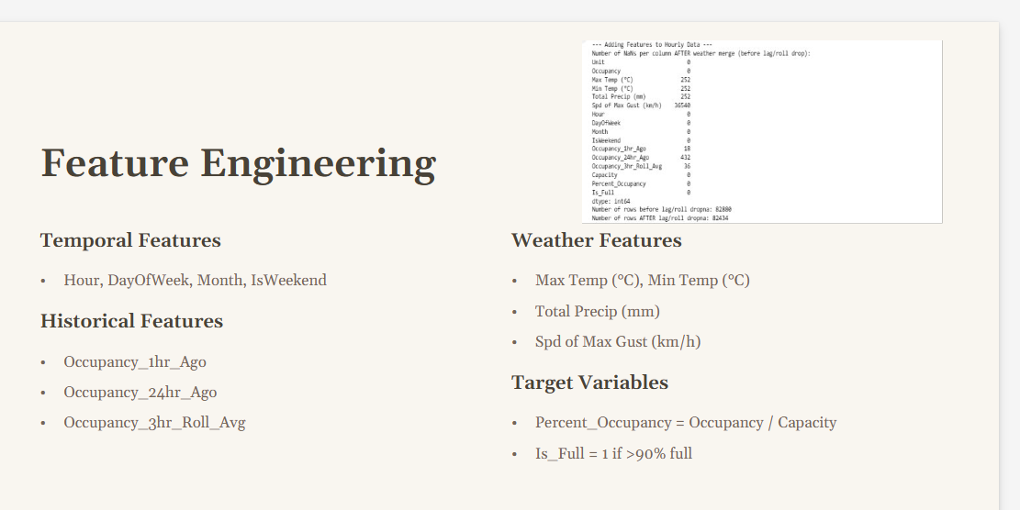
Feature Engineering Support (Sukhvir): Contributed to selecting temporal, historical, and weather-based features. Helped define key target variables such as Percent Occupancy and Is_Full (>90%). Worked with team to validate rolling averages and lag features used for forecasting.

Objective 3 | Key results
Generate model explainability outputs using SHAP to interpret which features most strongly influence occupancy and fullness predictions. | Produced SHAP analyses for both regression (Occupancy) and classification (Is_Full) models.  Identified the top 3 influential features: current occupancy, past occupancy, and parking lot capacity.  Shared explainability findings with the team to guide interpretation and presentation decisions.

Report & Reflection
SHAP helped make our machine learning predictions transparent by showing why a parking lot was predicted to be full or not full. The explainability results confirmed that occupancy history (1-hour and 24-hour lag) and lot capacity are the biggest determinants of fullness, while weather had a much weaker influence. This insight matched real-world expectations and helped our team trust the model rather than treat it as a “black box.”
I also explained these results during model selection and presentation work, allowing our team to decide which features to emphasize. Going forward, I would focus on integrating explainability directly into a dashboard so that end users (e.g., town planners) can understand model reasoning in real time.
Supporting Documentation
- SHAP summary interpretation (occupancy + Is_Full)
- Feature importance insights shared in presentation.

This work reflects industry practices in transparent ML, aligning with responsible deployment standards used in modern MLOps workflows.

