PROJECT

Sukhvir

August 20, 2020

## R Markdown

Prediction Assignment Writeup

# Analysis

Loading data:

training<- read.csv("C:/Users/Sukhvir/Downloads/PML/pml-training.csv")  
testing<- read.csv("C:/Users/Sukhvir/Downloads/PML/pml-testing.csv")  
dim(training)

## [1] 19622 160

dim(testing)

## [1] 20 160

# First look at the data  
head(training)  
head(testing)

# str data  
str(training)  
str(testing)

# summary  
summary(training)  
summary(testing)

## Cross Validation

Cross-validation will be performed by spliting the training dataset into:

1. A training dataset, containing 70% of the observations. The models for prediction will be built using this dataset.
2. A testing dataset, containing 30% of the observations. The accuracy of our prediction models will be evaluated using this dataset.

# load packages  
library(caret)  
library(randomForest)  
# Index for training dataset (70%) and testing dataset (30%)   
# from the pml-training data set  
set.seed(12345)  
inTrain = createDataPartition(y=training$classe,p=0.7, list=FALSE)  
# training dataset  
training.set = training[inTrain,]  
# testing dataset  
testing.set = training[-inTrain,]

## Training and Testing

Training and testing data consist of 160 variables. The choice of specific predictors is based on removing near zero variance predictors, with the nearZeroVar function, and also variables containing many NAs.

# Remove near zero variance predictors  
ind.nzv = nearZeroVar(x = training, saveMetrics = T)  
# Remove variables with more than 50% NA values  
ind.NA = !as.logical(apply(training, 2, function(x){ mean(is.na(x)) >= 0.5}))  
# Cleaning data  
ind2 = ind.NA*1 + (!ind.nzv$nzv)*1  
ind3 = ind2 == 2  
sum(ind3)

## [1] 59

#View(data.frame(ind.NA, !ind.nzv$nzv, ind2, ind3))  
training.set = training.set[,ind3]  
testing.set = testing.set[, ind3]  
training.set = training.set[, -1]  
testing.set = testing.set[, -1]  
testing = testing[,ind3]  
testing = testing[,-1]  
# Coerce the data into the same type in order to avoid  
# "Matching Error" when calling random forest model, due to different levels in variables  
for (i in 1:length(testing) ) {  
 for(j in 1:length(training.set)) {  
 if( length( grep(names(training.set[i]), names(testing)[j]) ) == 1) {  
 class(testing[j]) <- class(training.set[i])  
 }   
 }   
}  
# To get the same class between testing and training.set  
testing = testing[,-ncol(testing)]  
testing <- rbind(training.set[2, -58] , testing)  
testing <- testing[-1,]

## Prediction Model

We will use two approaches to create a prediction model for the values of classe variable.

Firstly prediction with trees will be attempted, using the ‘rpart’ method and the caret package.

# Prediction with Trees  
# Build model  
set.seed(12345)  
tree.fit = train(y = training.set$classe,  
 x = training.set[,-ncol(training.set)],  
 method = "rpart")  
# Plot classification tree  
rattle::fancyRpartPlot(  
 tree.fit$finalModel  
)

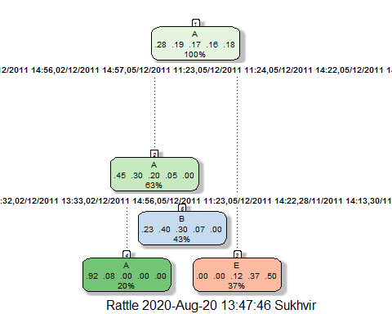

# Predictions with rpart model  
pred.tree = predict(tree.fit, testing.set[,-ncol(testing.set)])  
# Get results (Accuracy, etc.)  
confusionMatrix(pred.tree, testing.set$classe)

## Confusion Matrix and Statistics  
##   
## Reference  
## Prediction A B C D E  
## A 1042 108 0 0 0  
## B 632 1023 763 167 0  
## C 0 0 0 0 0  
## D 0 0 0 0 0  
## E 0 8 263 797 1082  
##   
## Overall Statistics  
##   
## Accuracy : 0.5347   
## 95% CI : (0.5219, 0.5476)  
## No Information Rate : 0.2845   
## P-Value [Acc > NIR] : < 2.2e-16   
##   
## Kappa : 0.4127   
##   
## Mcnemar's Test P-Value : NA   
##   
## Statistics by Class:  
##   
## Class: A Class: B Class: C Class: D Class: E  
## Sensitivity 0.6225 0.8982 0.0000 0.0000 1.0000  
## Specificity 0.9744 0.6709 1.0000 1.0000 0.7776  
## Pos Pred Value 0.9061 0.3957 NaN NaN 0.5033  
## Neg Pred Value 0.8665 0.9648 0.8257 0.8362 1.0000  
## Prevalence 0.2845 0.1935 0.1743 0.1638 0.1839  
## Detection Rate 0.1771 0.1738 0.0000 0.0000 0.1839  
## Detection Prevalence 0.1954 0.4393 0.0000 0.0000 0.3653  
## Balanced Accuracy 0.7984 0.7845 0.5000 0.5000 0.8888

## Second Prediction

Secondly a prediction model using random forest method will be created.

# Prediction with Random Forest  
# Build model  
set.seed(12345)  
rf.fit = randomForest(  
 classe ~ .,  
 data = training.set,  
 ntree = 250)  
# Plot the Random Forests model  
plot(rf.fit)

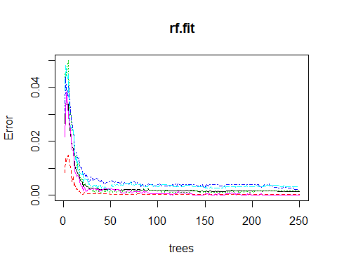

# Predict with random forest model  
pred2 = predict(  
 rf.fit,  
 testing.set[,-ncol(testing.set)]  
)  
# Get results (Accuracy, etc.)  
confusionMatrix(pred2, testing.set$classe)

## Confusion Matrix and Statistics  
##   
## Reference  
## Prediction A B C D E  
## A 1674 0 0 0 0  
## B 0 1139 1 0 0  
## C 0 0 1019 5 0  
## D 0 0 6 959 0  
## E 0 0 0 0 1082  
##   
## Overall Statistics  
##   
## Accuracy : 0.998   
## 95% CI : (0.9964, 0.9989)  
## No Information Rate : 0.2845   
## P-Value [Acc > NIR] : < 2.2e-16   
##   
## Kappa : 0.9974   
##   
## Mcnemar's Test P-Value : NA   
##   
## Statistics by Class:  
##   
## Class: A Class: B Class: C Class: D Class: E  
## Sensitivity 1.0000 1.0000 0.9932 0.9948 1.0000  
## Specificity 1.0000 0.9998 0.9990 0.9988 1.0000  
## Pos Pred Value 1.0000 0.9991 0.9951 0.9938 1.0000  
## Neg Pred Value 1.0000 1.0000 0.9986 0.9990 1.0000  
## Prevalence 0.2845 0.1935 0.1743 0.1638 0.1839  
## Detection Rate 0.2845 0.1935 0.1732 0.1630 0.1839  
## Detection Prevalence 0.2845 0.1937 0.1740 0.1640 0.1839  
## Balanced Accuracy 1.0000 0.9999 0.9961 0.9968 1.0000

The accuracy of the random forest model is, as expected, much higher than the rpart model, over 0.99!

Random Forest model performed better and constitutes the model of choice for predicting the 20 observations of the original pml-testing.csv dataset.

# Get predictions for the 20 observations of the original pml-testing.csv  
pred.validation = predict(rf.fit, testing)  
pred.validation

## 1 21 3 4 5 6 7 8 9 10 11 12 13 14 15 16 17 18 19 20   
## B A B A A E D B A A B C B A E E A B B B   
## Levels: A B C D E

# Saving predictions for testing dataset  
testing$pred.classe = pred.validation  
write.table(  
 testing,  
 file = "testing_with_predictions",  
 quote = F  
)