plotly

Sukhvir

August 21, 2020

## R Markdown

R Markdown & Plotly

library(plotly)

## Warning: package 'plotly' was built under R version 3.6.3

## Loading required package: ggplot2

##   
## Attaching package: 'plotly'

## The following object is masked from 'package:ggplot2':  
##   
## last_plot

## The following object is masked from 'package:stats':  
##   
## filter

## The following object is masked from 'package:graphics':  
##   
## layout

library(tidyr)

## Warning: package 'tidyr' was built under R version 3.6.3

library(dplyr)

## Warning: package 'dplyr' was built under R version 3.6.3

##   
## Attaching package: 'dplyr'

## The following objects are masked from 'package:stats':  
##   
## filter, lag

## The following objects are masked from 'package:base':  
##   
## intersect, setdiff, setequal, union

library(data.table)

## Warning: package 'data.table' was built under R version 3.6.3

##   
## Attaching package: 'data.table'

## The following objects are masked from 'package:dplyr':  
##   
## between, first, last

dat <- data.table(mtcars, keep.rownames = TRUE)  
dat[rn %like% "^M"]

## rn mpg cyl disp hp drat wt qsec vs am gear carb  
## 1: Mazda RX4 21.0 6 160.0 110 3.90 2.620 16.46 0 1 4 4  
## 2: Mazda RX4 Wag 21.0 6 160.0 110 3.90 2.875 17.02 0 1 4 4  
## 3: Merc 240D 24.4 4 146.7 62 3.69 3.190 20.00 1 0 4 2  
## 4: Merc 230 22.8 4 140.8 95 3.92 3.150 22.90 1 0 4 2  
## 5: Merc 280 19.2 6 167.6 123 3.92 3.440 18.30 1 0 4 4  
## 6: Merc 280C 17.8 6 167.6 123 3.92 3.440 18.90 1 0 4 4  
## 7: Merc 450SE 16.4 8 275.8 180 3.07 4.070 17.40 0 0 3 3  
## 8: Merc 450SL 17.3 8 275.8 180 3.07 3.730 17.60 0 0 3 3  
## 9: Merc 450SLC 15.2 8 275.8 180 3.07 3.780 18.00 0 0 3 3  
## 10: Maserati Bora 15.0 8 301.0 335 3.54 3.570 14.60 0 1 5 8

## Distribution of Cars by Mileage

library(ggplot2)  
ggplot(mtcars, aes(mpg)) +  
 geom_histogram(binwidth = 4) + xlab('Miles per Gallon') + ylab('Number of Cars') +   
 ggtitle('Distribution of Cars by Mileage')

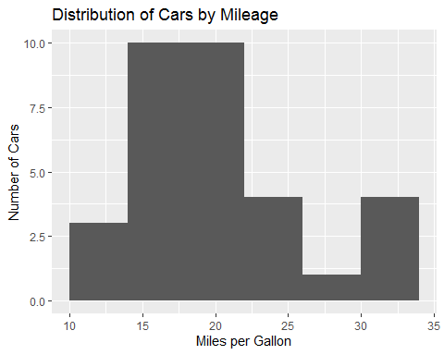

## Distribution of Cars by Cylinders

ggplot(mtcars, aes(cyl)) +  
 geom_histogram(binwidth=1) + xlab('Cylinders') + ylab('Number of Cars') +  
 ggtitle('Distribution of Cars by Cylinders')

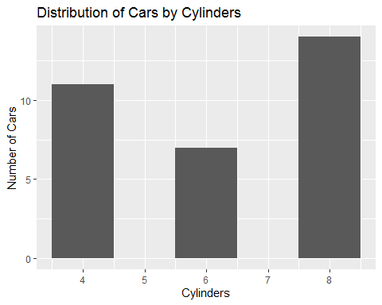

## Distribution of Cars by Horsepower

ggplot(mtcars, aes(hp)) +  
 geom_histogram(binwidth=20) + xlab('horsepower') + ylab('Number of Cars') +  
 ggtitle('Distribution of Cars by Horsepower')

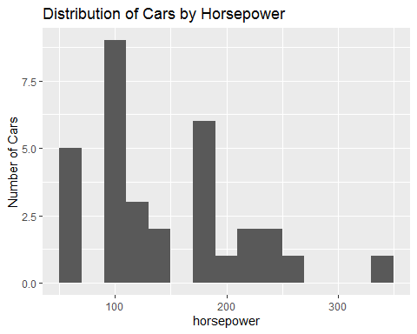

## correlation of hp and mpg

cor(mtcars$mpg, mtcars$hp)

## [1] -0.7761684

## Plotting the data - HP vs MPG

ggplot(mtcars, aes(hp, mpg)) + geom_point() +  
 geom_smooth(method = "lm", se = FALSE) +  
 ylab("Miles per Gallon") +  
 xlab("No. of Horsepower") +  
 ggtitle("Impact of Number of Horsepower on MPG")

## `geom_smooth()` using formula 'y ~ x'

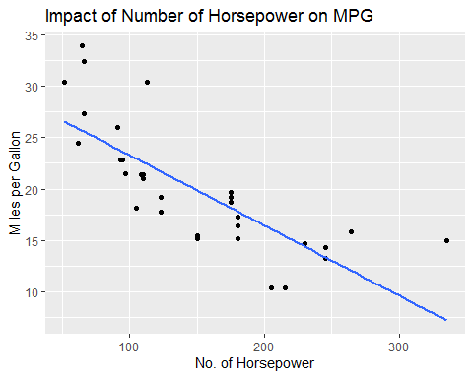

## Impact of Number of Horsepower on MPG

ggplot(mtcars, aes(hp, mpg)) +  
 stat_smooth() + geom_point() +  
 ylab("Miles per Gallon") +  
 xlab ("No. of Horsepower") +  
 ggtitle("Impact of Number of Horsepower on MPG")

## `geom_smooth()` using method = 'loess' and formula 'y ~ x'

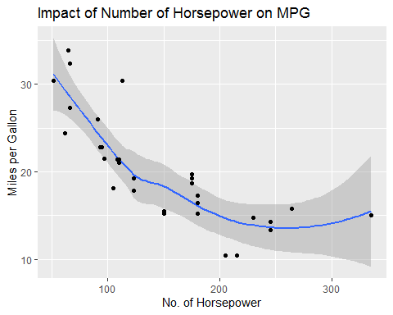

## Impact of Number of Cylinders on MPG

ggplot(mtcars, aes(cyl, mpg)) + geom_point() +  
 geom_smooth(method = "lm", se = FALSE) +  
 ylab("Miles per Gallon") + xlab("No. of Cylinders") +  
 ggtitle("Impact of Number of Cylinders on MPG")

## `geom_smooth()` using formula 'y ~ x'

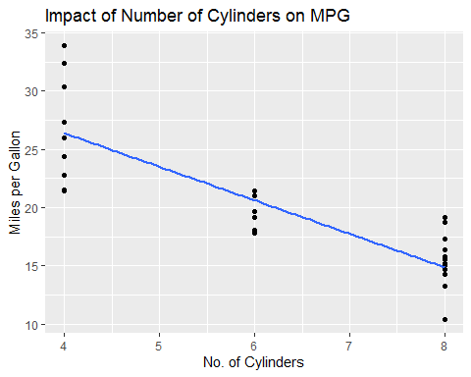

## Result

The analysis indicates a strong negative correlation for both number of horsepower (-0.77) as well as number of cylinders (-0.85) on miles per gallon.