DigitalCronjobUser Configuration Steps
High Level Steps:
- Deploy new Scope i.e. “cronjob_api_client”
- Deploy new Access Token Management i.e. “DigitalCronJob”
- Deploy new OAuth Client i.e. “DigitalCronjobUser”
- Click on Scope Management as follows:
PATH | OAuth Server > Scope Management
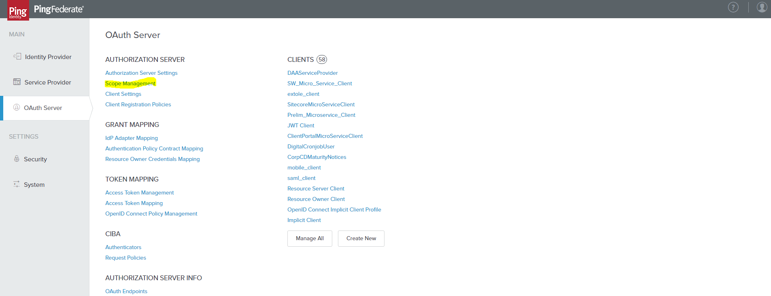
- Add new scope as follows:
Scope Value | Scope Description
cronjob_api_client | Cronjob API Client
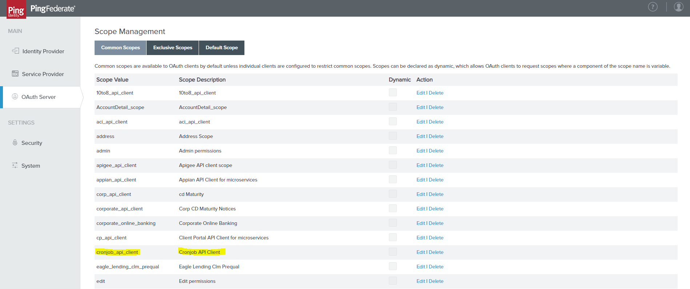

- Click on Access Token Management to deploy new ATM as follow:
PATH | OAuth Server > Access Token Management
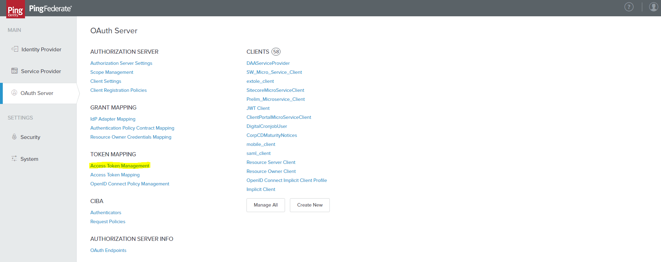
- Click on Create New Instance as follows:
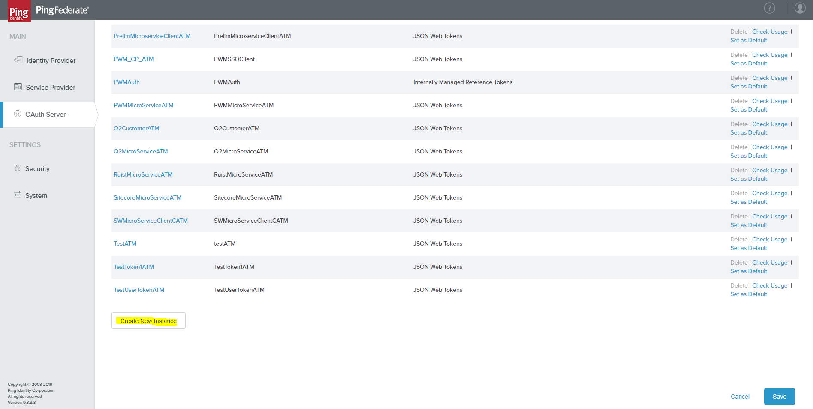
- Add the following details from Type perspective as follows:
INSTANCE NAME | DigitalCronJob
INSTANCE ID | DigitalCronJob
TYPE | JSON Web Tokens
CLASS NAME | com.pingidentity.pf.access.token.management.plugins.JwtBearerAccessTokenManagementPlugin
PARENT INSTANCE | None
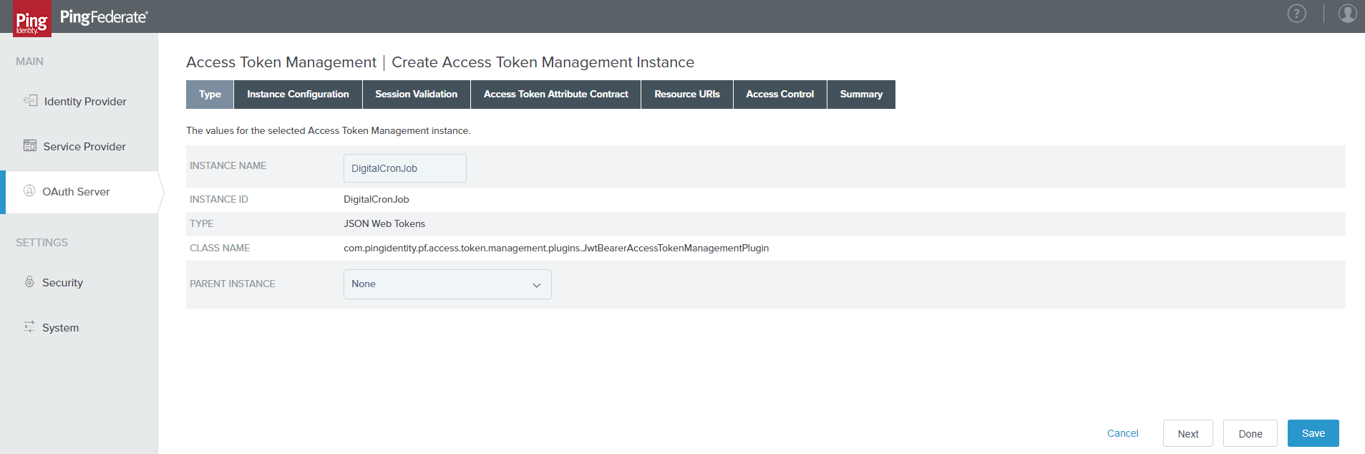
- Provide the following details from instance configuration perspective as follows:
Key ID | Certificate
JWT_CERT | CN=JWTTokenCERT, OU=Digital Technologies, O=First Republic Bank, L=San Francisco, ST=CA, C=US
TOKEN LIFETIME | 1440
JWS ALGORITHM | RSA using SHA-256
ACTIVE SIGNING CERTIFICATE KEY ID | JWT_CERT
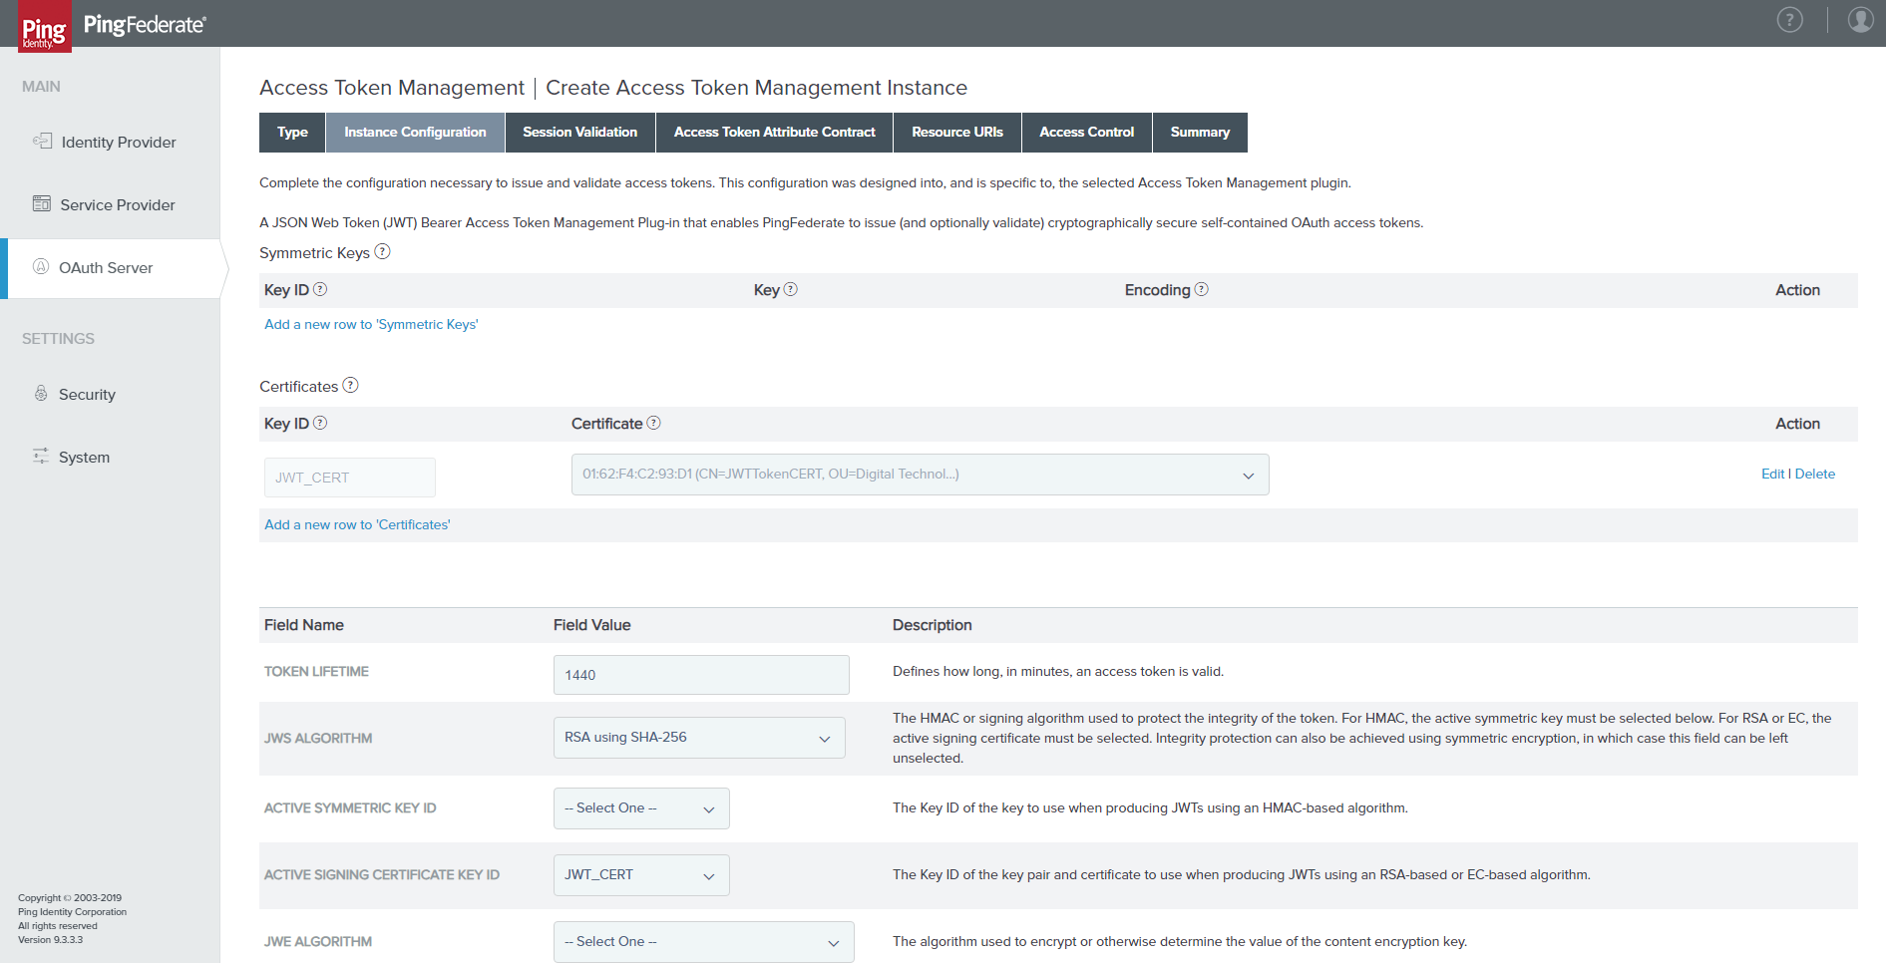
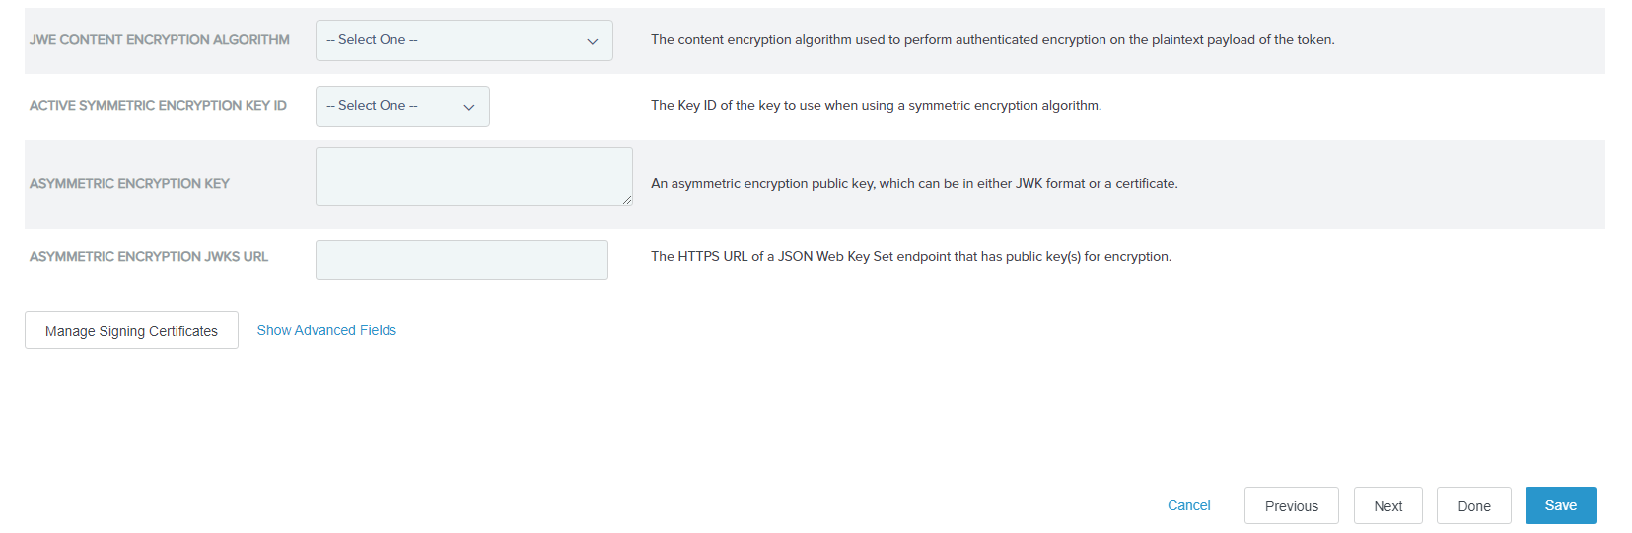
- Click on Next.
- No change under session validation columns as follows:
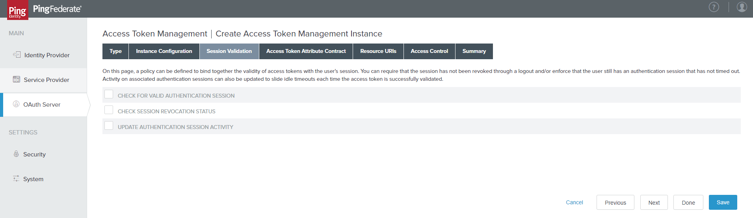
- Extend the Access Token Attribute Contract as follows:
Extend the Contract | Action
CN | Click on Add
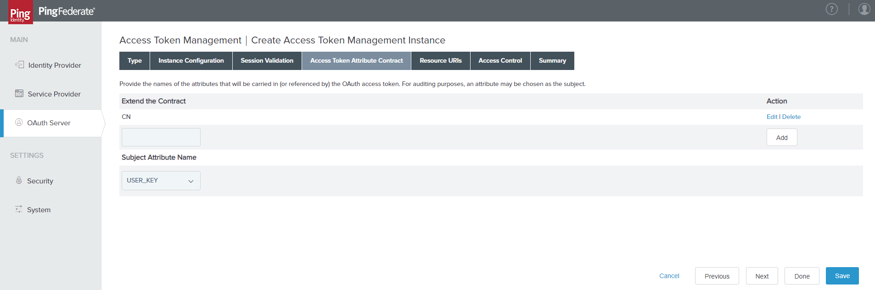
- Click on Next.
- No change under Resource URI’s as follows:
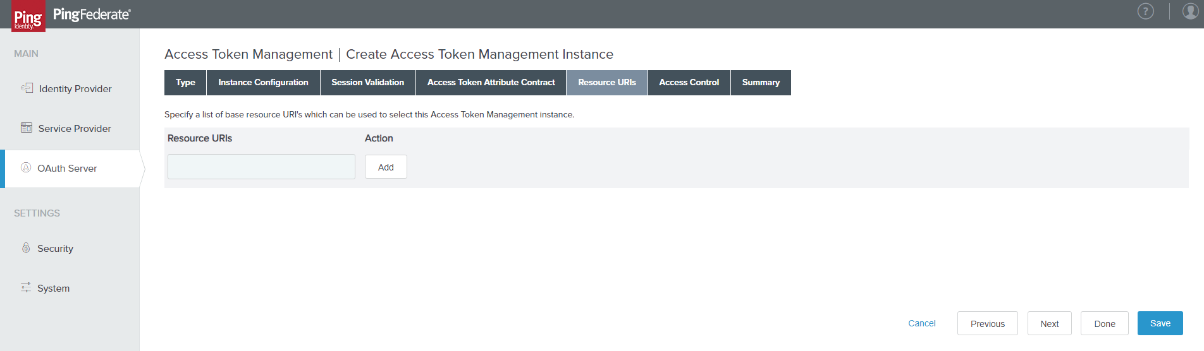
- Restrict Access Control as follows:
Allowed Clients | Action
DigitalCronjobUser | Click on Add
MuleSoft | Click on Add
PingAccessClient | Click on Add
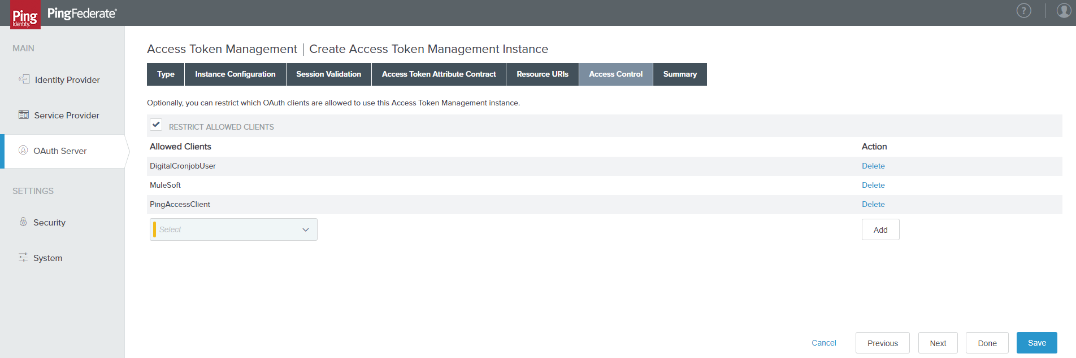
- Click on Next.
- Review the full Summary as follows:
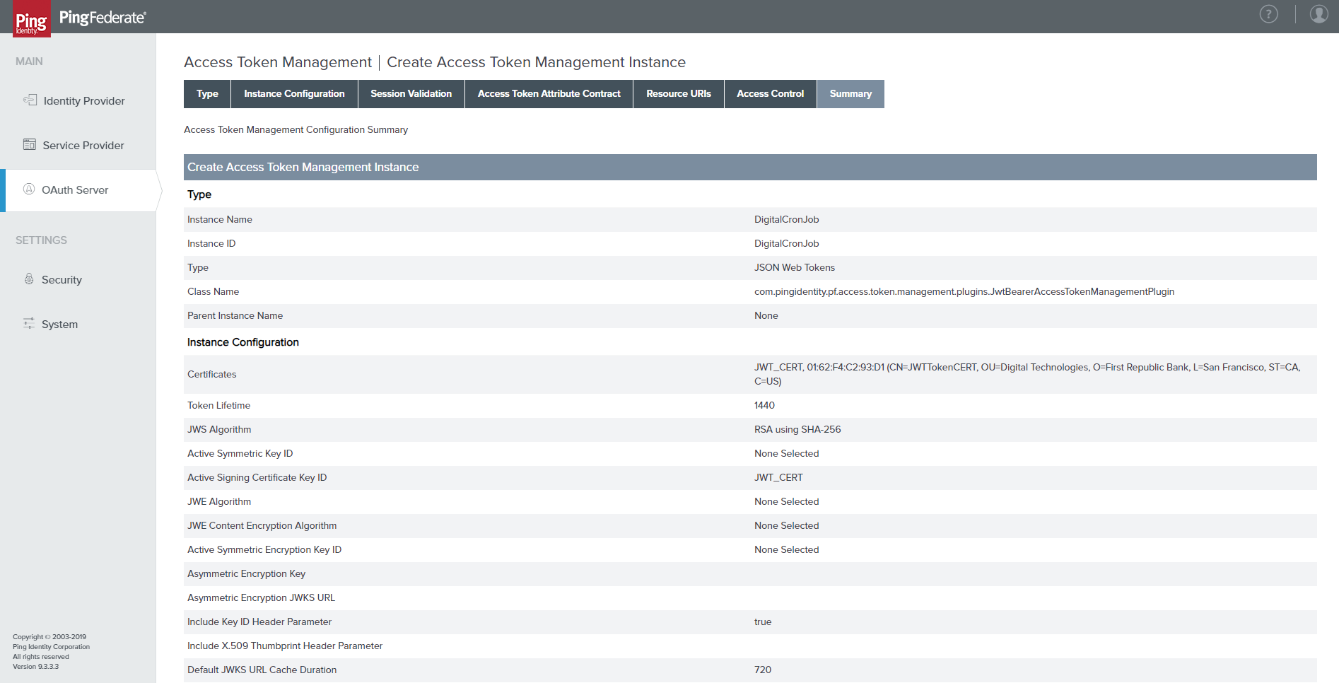
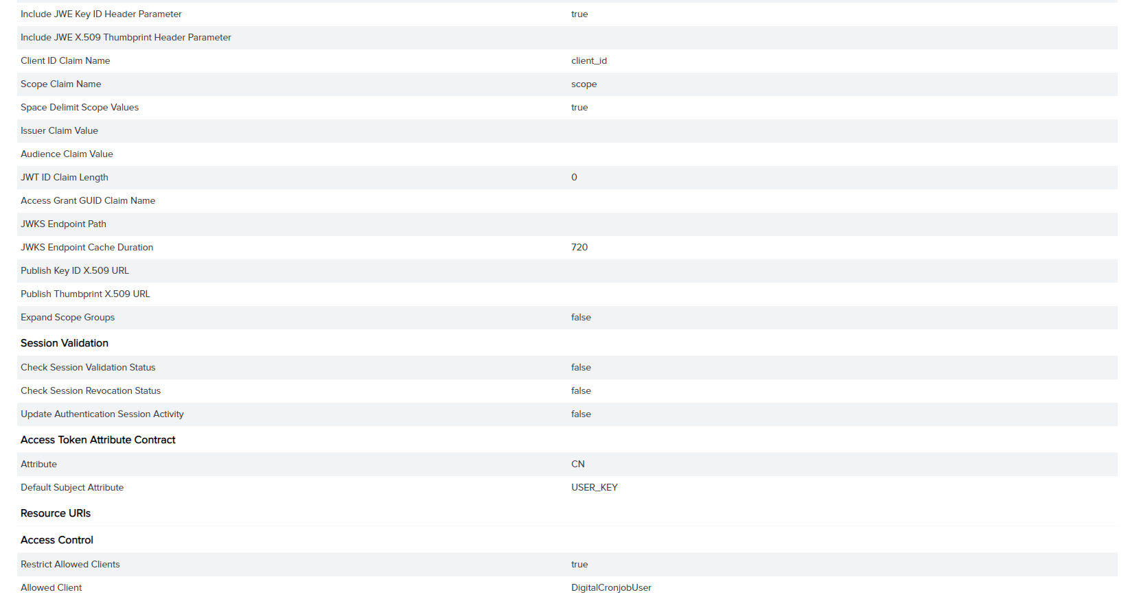
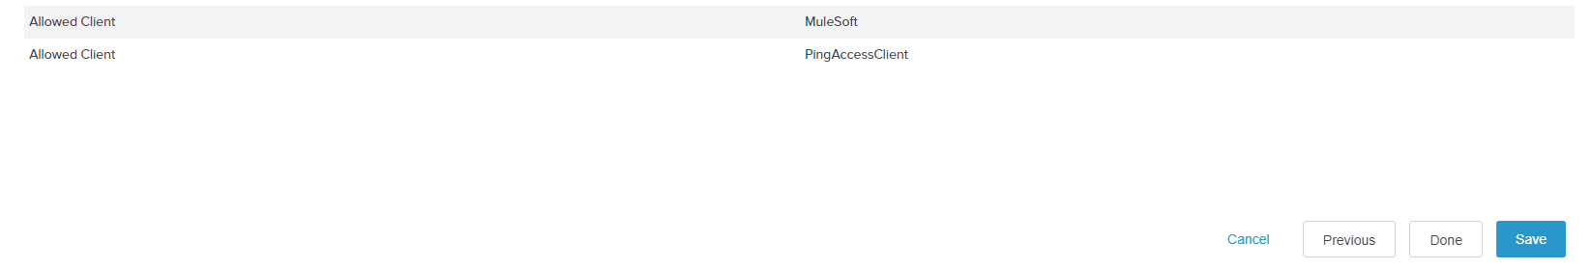
- Configure new OAuth Client as follows:
PATH | OAuth Server > Client > Create New
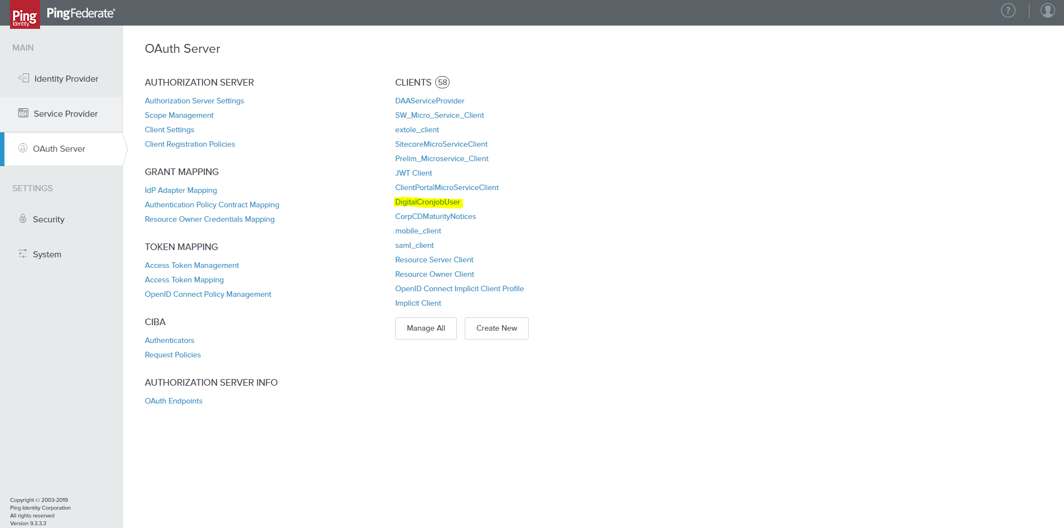
- Provide the following details to configure the OAuth client as follows:
CLIENT ID | DigitalCronjobUser
NAME | DigitalCronjobUser
DESCRIPTION | DigitalCronjobUser
CLIENT AUTHENTICATION | CLIENT SECRET
CLIENT SECRET | Click on Generate Secret (for new)
REQUEST OBJECT SIGNING ALGORITHM | RSA using SHA-256
RESTRICT COMMON SCOPES | cronjob_api_client
ALLOWED GRANT TYPES | Client Credentials
DEFAULT ACCESS TOKEN MANAGER | DigitalCronJob
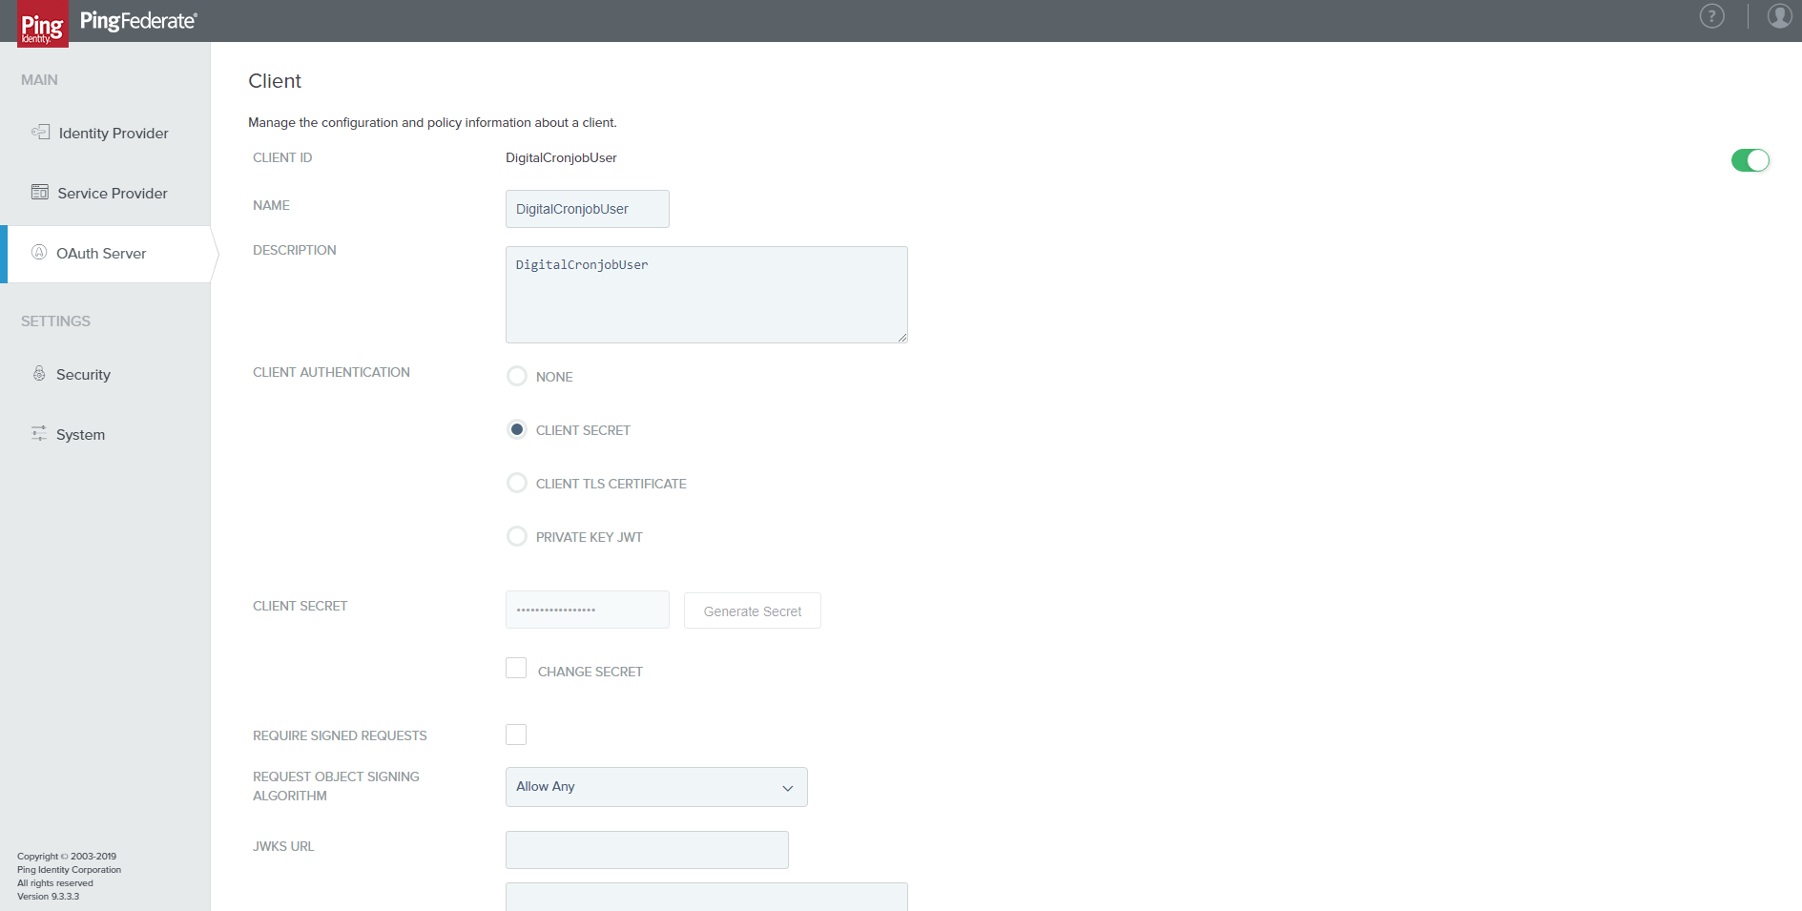
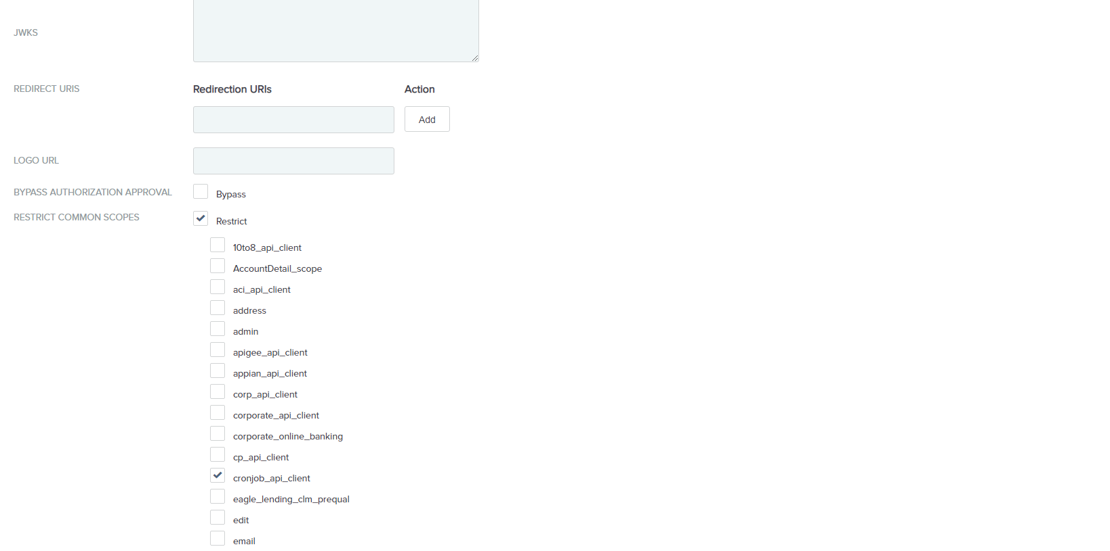
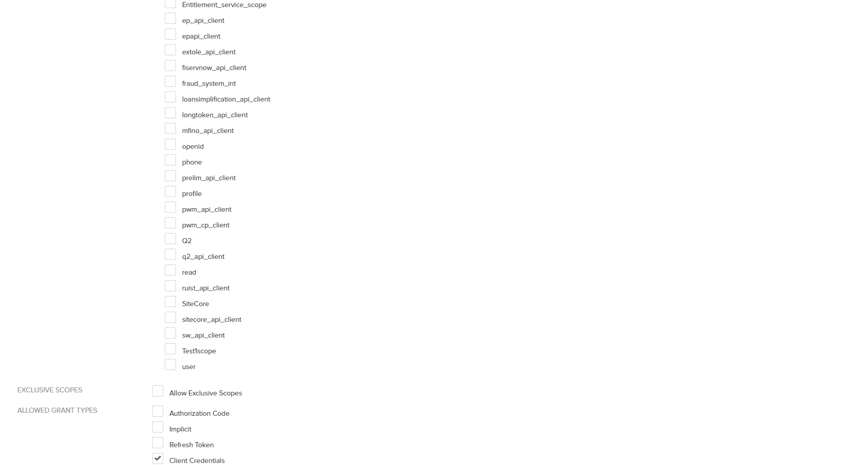
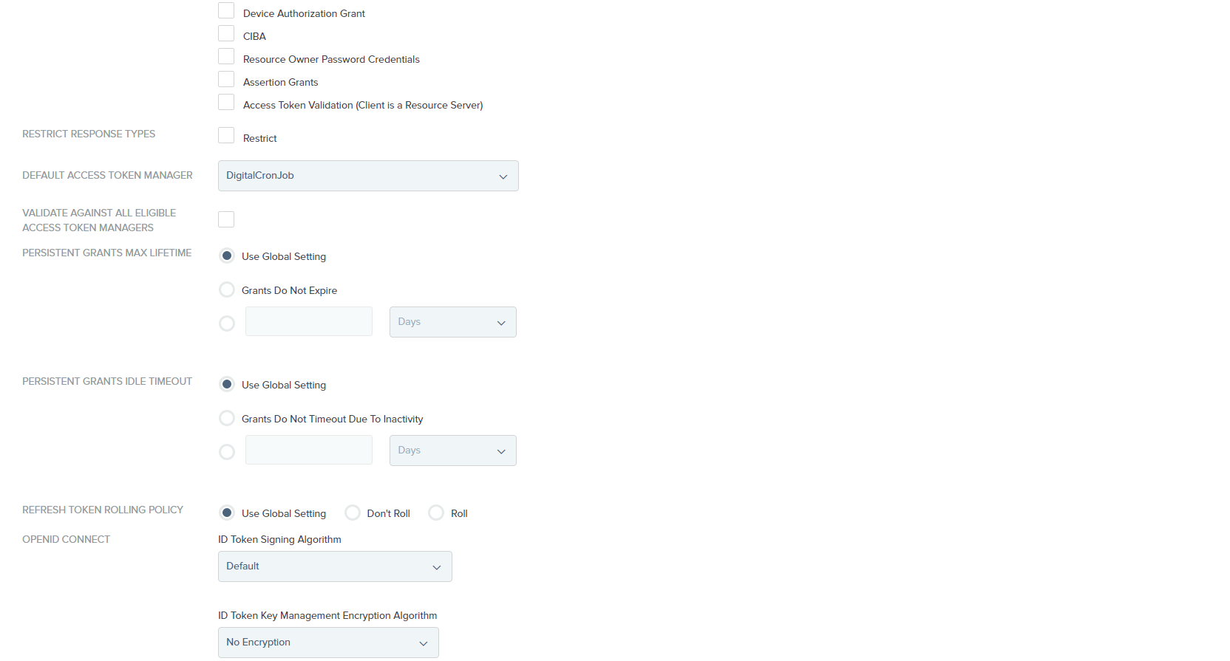
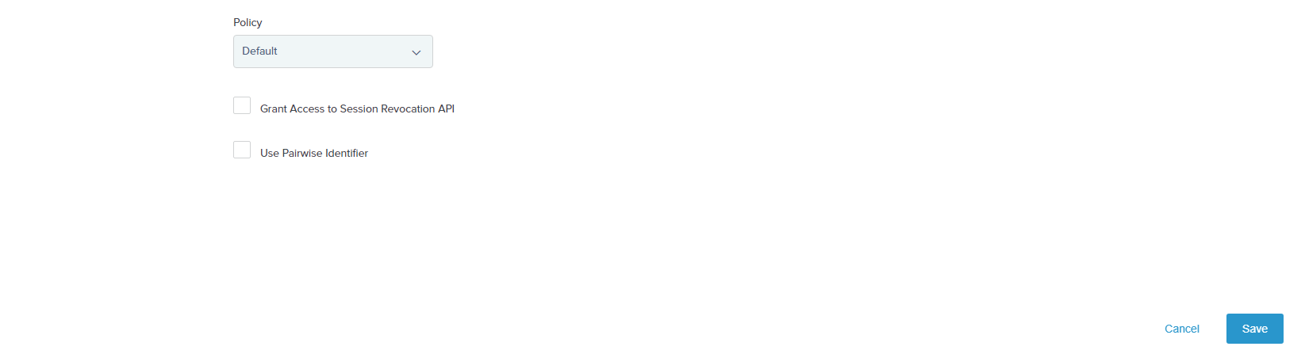
- Click on Save.

