NAME : SRAVANI KAMISETTY
SID : 304414410
STAT 231 - CS276

PROJECT 1 : PRINCIPAL COMPONENT ANALYSIS FOR HUMAN FACES

QUESTION 1:

MEAN FACE

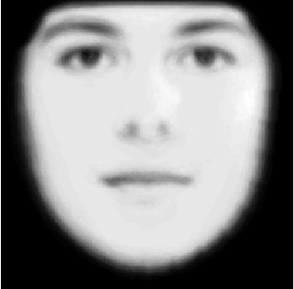

EIGEN FACES WITH K = 20

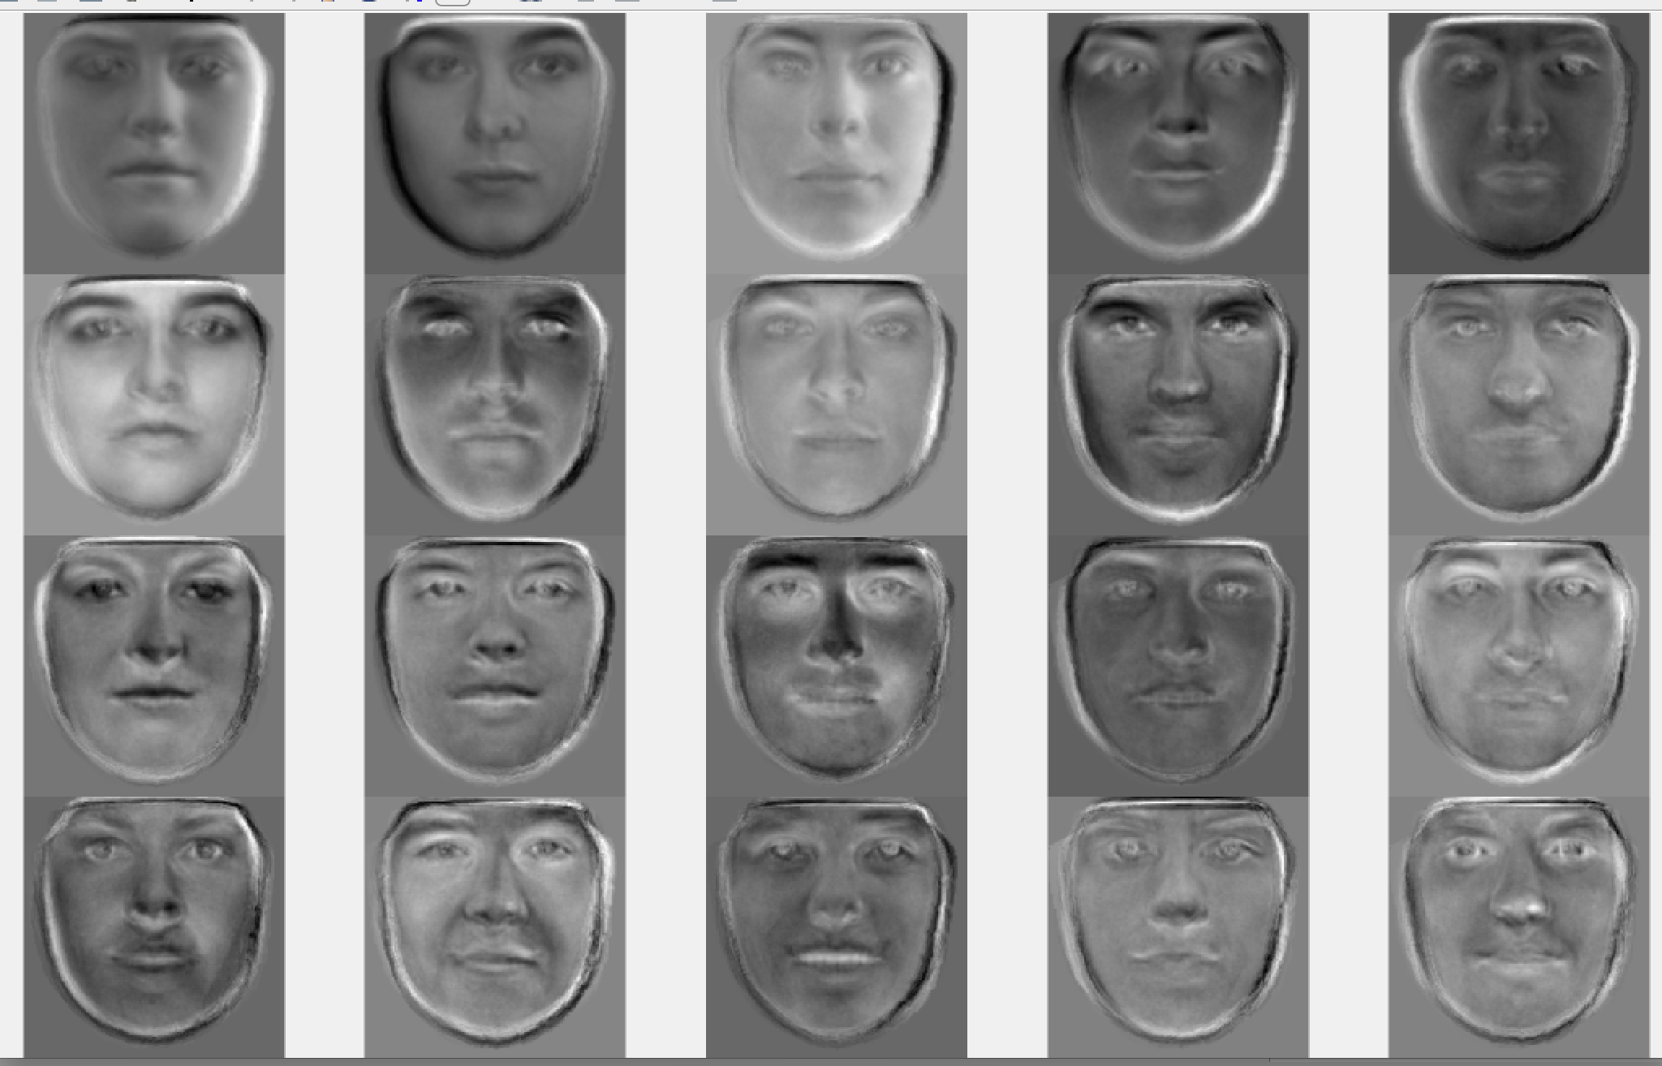

RECONSTRUCTED FACES

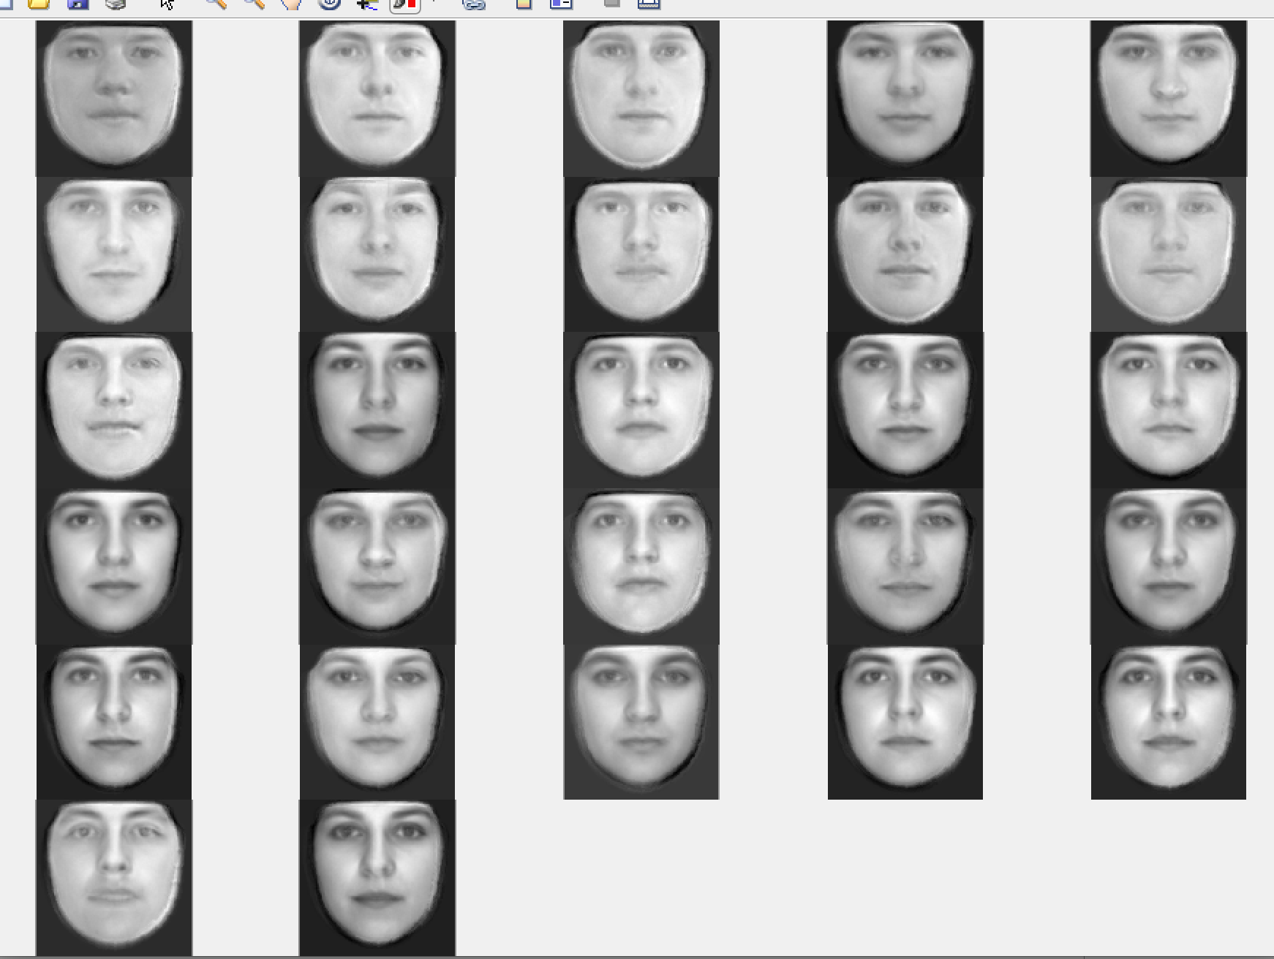

ERROR BY PIXEL NUMBER

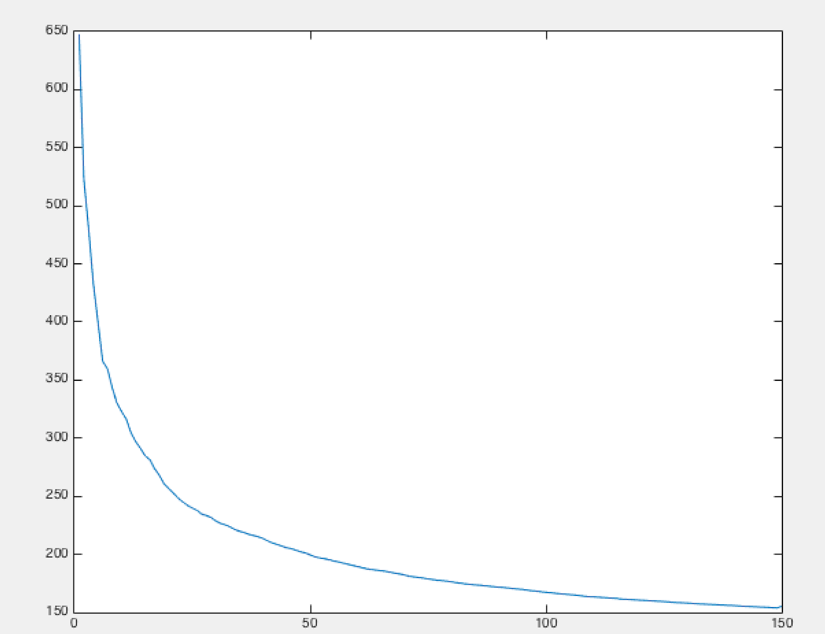

QUESTION 2:

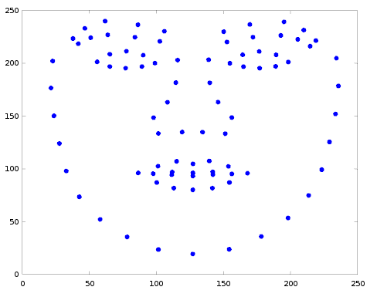
MEAN LANDMARK FACE

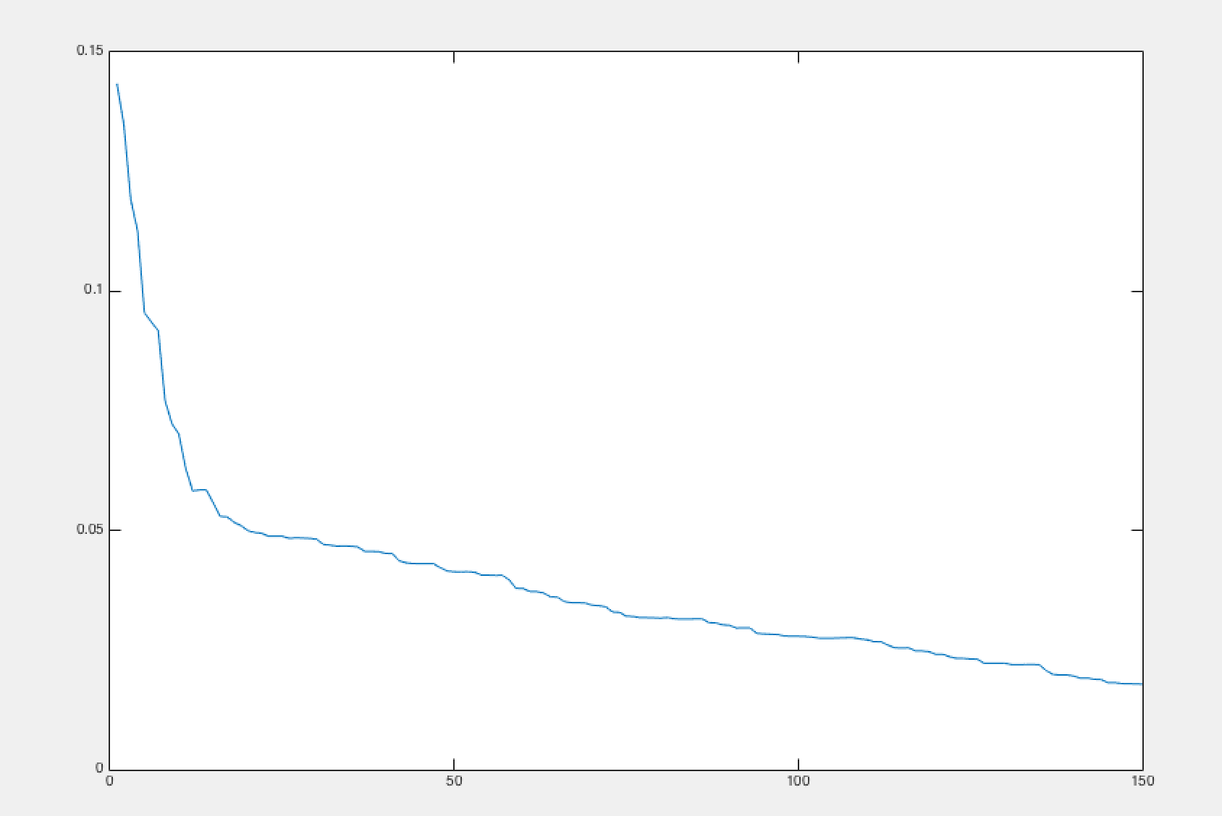
LANDMARKS RECONSTRUCTION ERROR

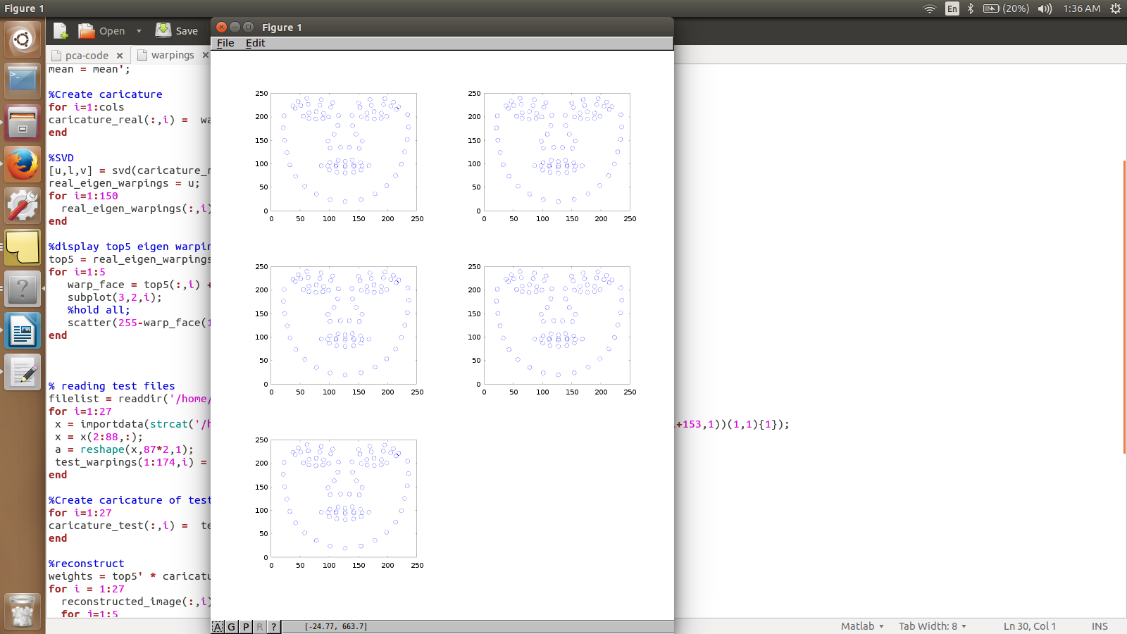
TOP 5 EIGEN LANDMARKS

QUESTION 5:

FISCHER FACE THAT DISTUINGUISHES MALE AND FEMALE

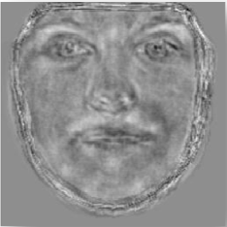

FISHER FACES PERCENTAGE OF SUCCESS

TESTING SET : 10 MALE AND 10 FEMALE SETS

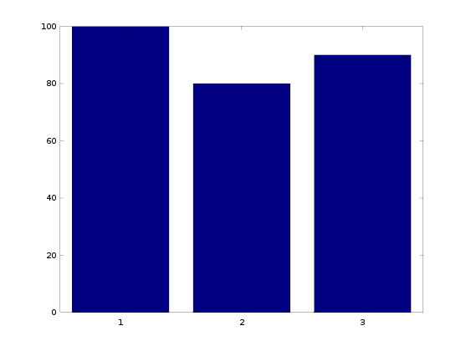

FEMALE MALE OVERALL

Female test faces = 0.0157, 0.0147, 0.0045, 0.0078, 0.0063, 0.0094, 0.0021, 0.0156, 0.0159, 0.0223

Male test faces = 0.0002, -0.0075, -0.0170, -0.0147, -0.0079, -0.0042, -0.0078, -0.0124, -0.0089, 0.0045

Classifying as male if the final value of the equation wx + w0 is negative, female if it is positive

Choosing w0 = (w' * male_mean + w' * female_mean)/2;

QUESTION 6:

FISCHER FACE FOR APPERRANCE AND GEOMETRY

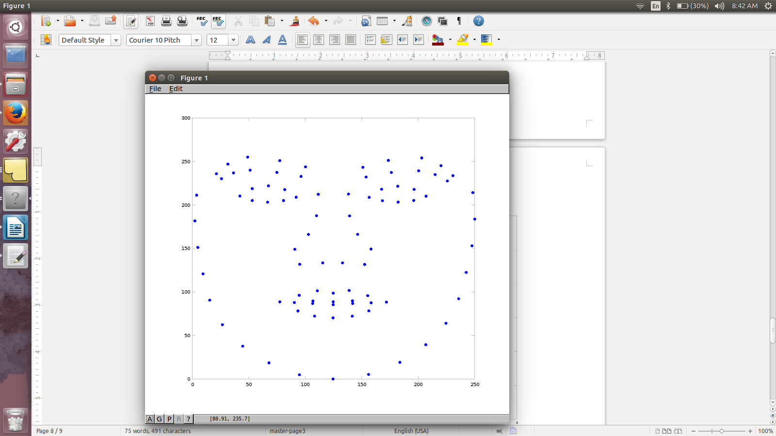

2D plot of Fisher face for the key point (geometric shape) VS Fisher face for the appearance

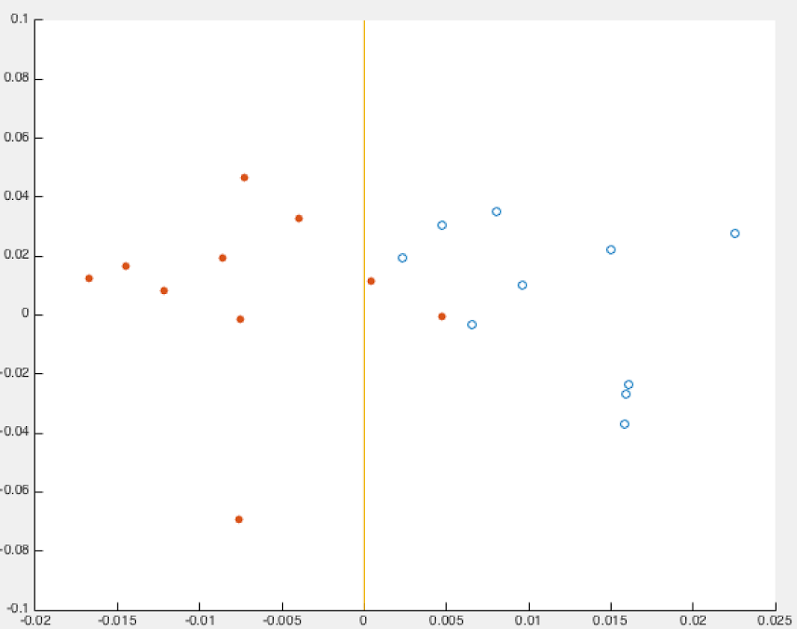

LEGEND
MALE : FILLED
FEMALE : HOLLOW

QUESION 4

RANDOM FACES GENERATED WITH K=10 EIGEN FACES AND K=10 LANDMARKS

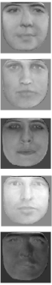
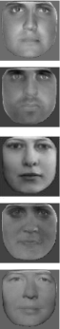

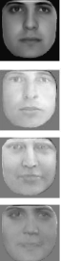

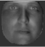

QUESTION 3:

MEAN WARPED IMAGE

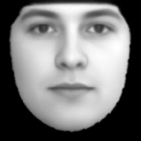

RECONSTRUCTED IMAGES WITH K=10

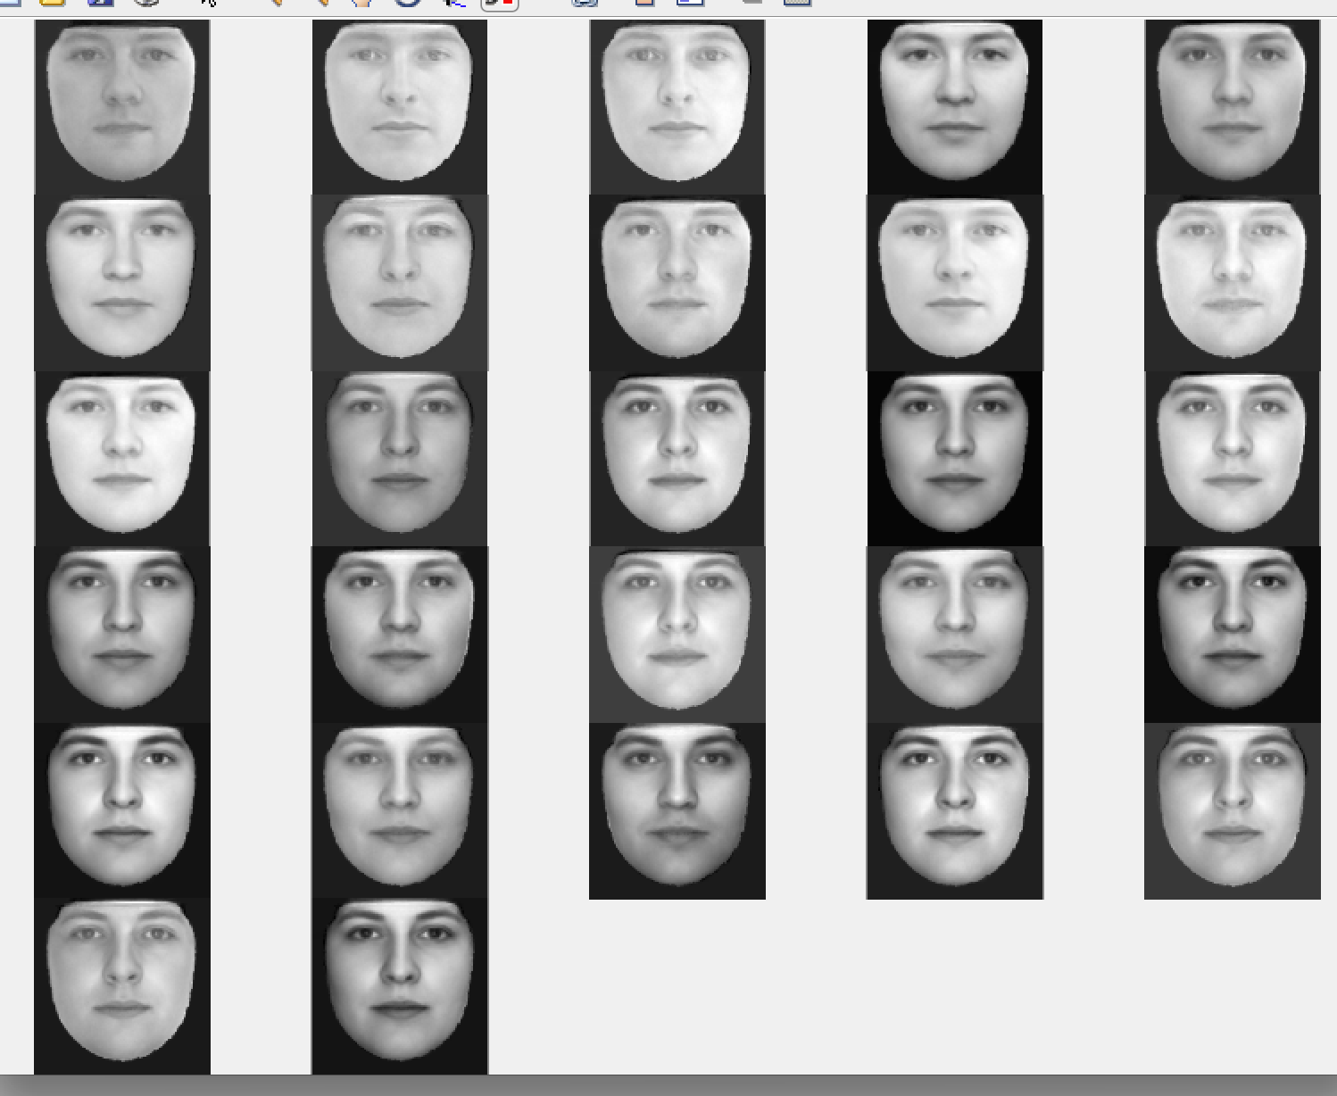

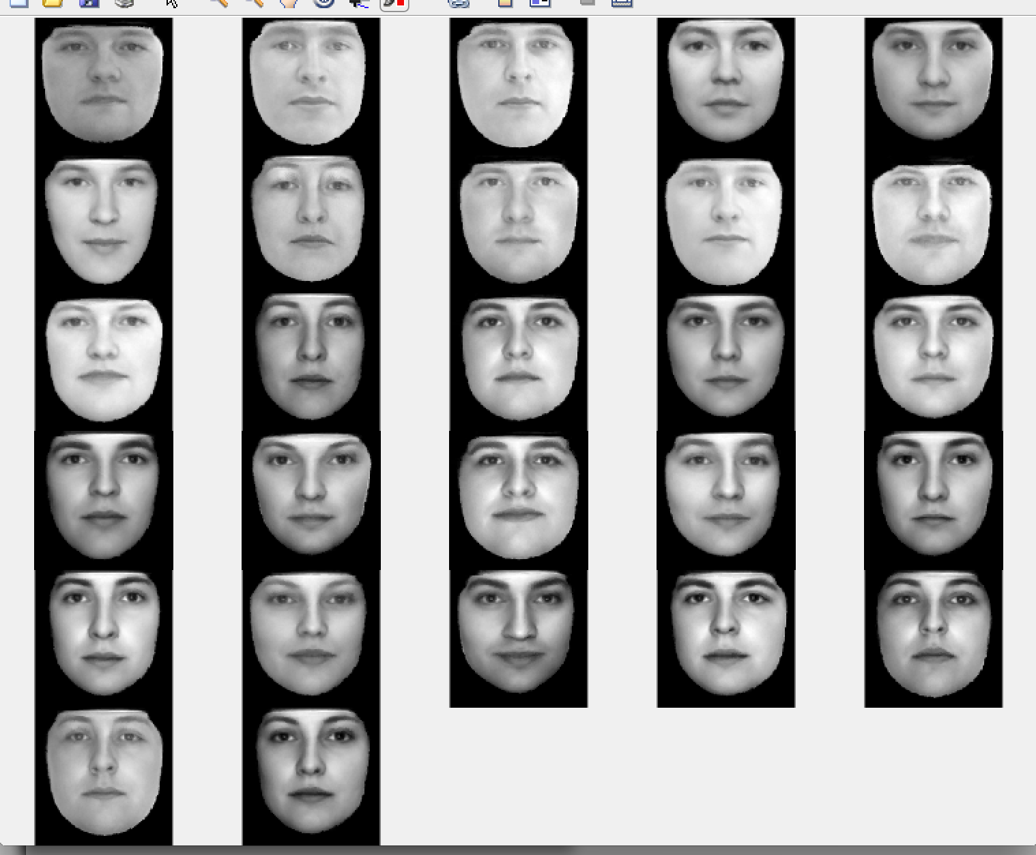

UNWARPED IMAGES WITH K=10

RECONSTRUCTION ERROR PER PIXEL AGAINST K EIGEN FACES

