NAME : SRAVANI KAMISETTY
SID : 304414410
MATHEMATICAL MODELLING – CS170 – ASSIGNMENT 2

QUESTION 2:

c) Coefficients for 4 degree polynomial fit exponential fit:

Name | cases_poly | cases_expo | death_poly | death_expo
GUINEA | -0.0000  0.0007  -0.1143  8.5771  63.3879 | 0.0118  4.7876 | 0.0000  0.0001  -0.0279  3.5991  53.1402 | 0.0115  4.4142
LIBERIA | -0.0001  0.0194  -1.2931  30.2170  -99.6852 | 0.0454  2.8798 | -0.0000  0.0088  -0.5858  13.9945  -42.7402 | 0.0432  2.5062
SIERRA LEONE | 0.0000  0.0010  -0.0731  9.0056  0.7709 | 0.0287  4.2917 | 0.0000  -0.0025  0.2100  -1.7810  8.2319 | 0.0309  3.0423

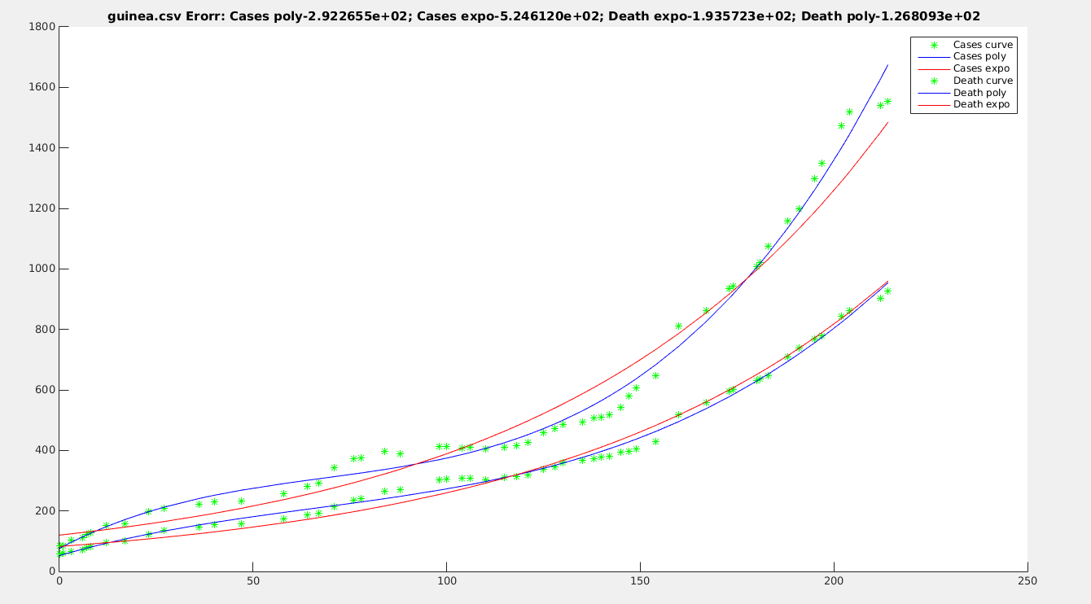

The polynomial fit is better than exponential fit for both cases and deaths for guinea
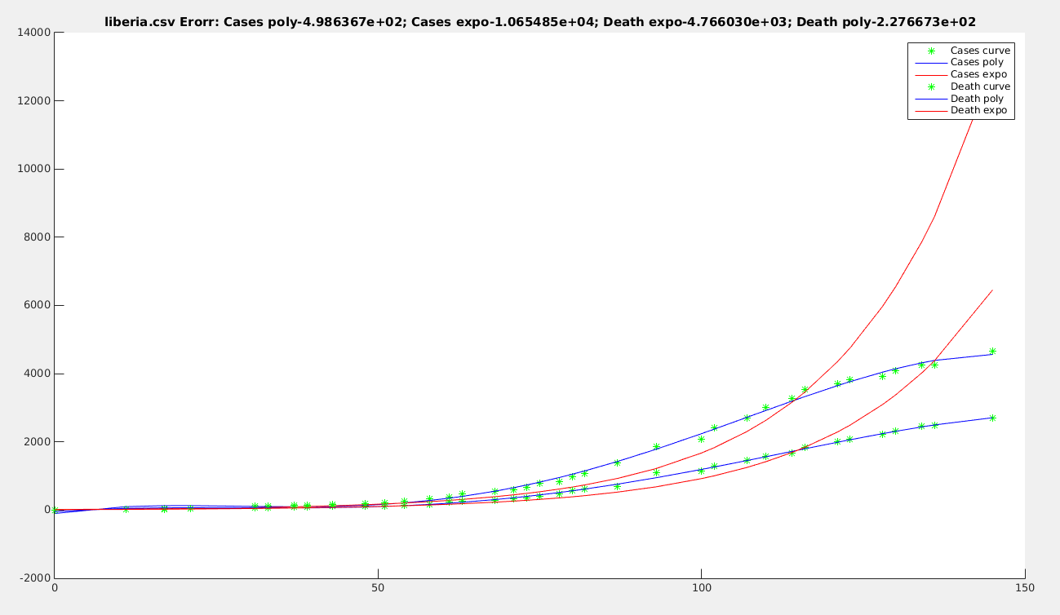
The polynomial fit is better than exponential fit for both cases and deaths for liberia.

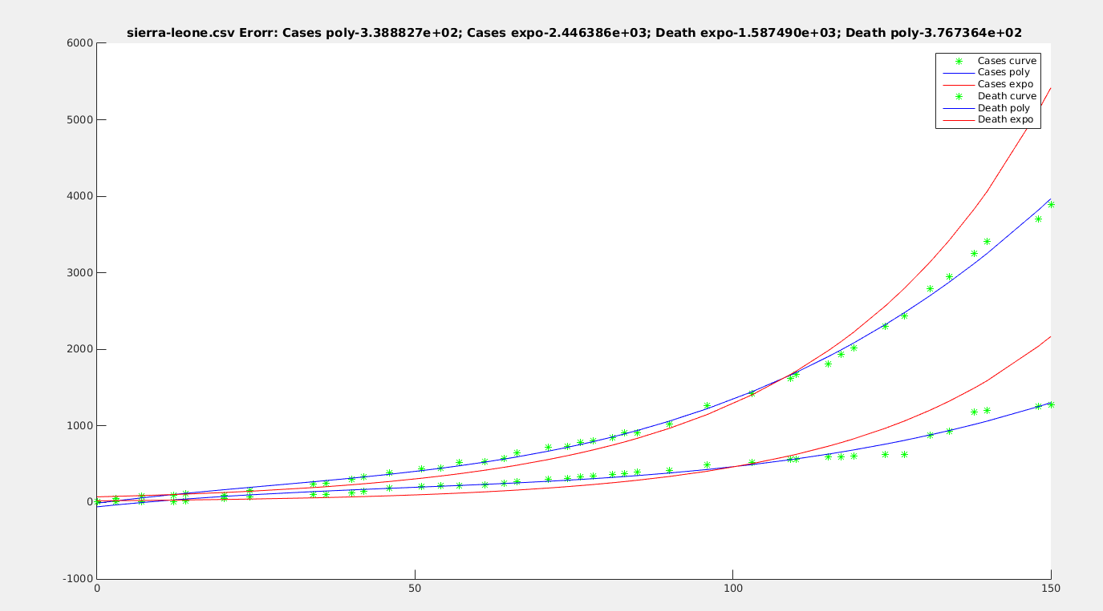
The polynomial fit is better than exponential fit for both cases and deaths for sierra-loeone as well.

clear all;
folder = '/home/kami/Documents/FALL/modelling/hw2/Homework2Updated/';
csvfile = { 'guinea.csv' 'liberia.csv' 'sierra-leone.csv' };

for i=1:3
filename = strcat(folder,csvfile{i});
clear data time dateNum;
data = csvread( filename, 1, 0 );
%figure
time = 1:size(data,1);
[rows,cols] = size(data);
for j=1:rows
dateNum(j) = datenum(2014,data(j,1),data(j,2)) - datenum(2014,data(1,1),data(1,2));
end
times = [dateNum(:).^4, dateNum(:).^3, dateNum(:).^2, dateNum(:).^1];
times(:,5) = times(:,3) ./ times(:,3);
times(1,5) = 1;
cases_poly = pinv(times)* data(:,3);
death_poly = pinv(times) * data(:,4) ;
times_expo = dateNum(:);
times_expo(:,2) = times_expo(:,1) ./ times_expo(:,1);
times_expo(1,2) = 1;
cases_expo = pinv(times_expo) * log(data(:,3));
death_expo = pinv(times_expo) * log(data(:,4));
figure;
%Plot cases poly and expo
hold all;
plot(dateNum(:),data(:,3),'g*');
plot(dateNum(:),times*cases_poly,'b-');
plot(dateNum(:),exp(times_expo*cases_expo),'r');
r_cases_poly = norm((times*cases_poly) - data(:,3));
r_cases_expo = norm(exp(times_expo*cases_expo) - (data(:,3)));

%Plot deaths poly and expo
plot(dateNum(:),data(:,4),'g*');
plot(dateNum(:),times*death_poly,'b-');
plot(dateNum(:),exp(times_expo*death_expo),'r');
r_death_poly = norm((times*death_poly) - data(:,4));
r_death_expo = norm(exp(times_expo*death_expo) - (data(:,4)));

title(strcat(csvfile{i},sprintf(' Erorr: Cases poly-%d',r_cases_poly),sprintf('; Cases expo-%d',r_cases_expo),sprintf('; Death expo-%d',r_death_expo),sprintf('; Death poly-%d',r_death_poly)));
legend('Cases curve','Cases poly', 'Cases expo','Death curve','Death poly','Death expo');
hold off;

%plot( time, data(:,3), 'r.-', time, data(:,4), 'b.-')
%title( csvfile{i}, 'FontSize', 24 )
end

QUESTION 3:

a)
clear all;
folder = '/home/kami/Documents/FALL/modelling/hw2/Homework2Updated/';
csvfile = 'mpg.csv';
filename = strcat(folder,csvfile);
data = csvread( filename, 1, 0 );
mpg = data(:,8);
displacement = data(:,6);
%part 1: coefficients and error
A = [log(displacement), ones(7287,1)];
x = A \ log(mpg)
A1 = A*x ;
R = norm(A1-log(mpg));
R2_a = norm(A1)/norm(log(mpg));

x =

-0.6237
3.8273
R = 12.9807

b)
cylinders = data(:,5);
classsize = data(:,10);
guzzler = data(:,11);
A_b = [ones(7287,1), displacement, cylinders, classsize, guzzler];
mpg_1 = mpg.^-1;
x_b = A_b \ mpg_1
A1_b = A_b * x_b;
norm(mpg_1-A1_b)
R2_b = norm(A1_b)/norm(mpg_1);

>> x_b

x_b =

0.0157
0.0060
0.0014
0.0007
0.0037

>>R2_b

R2_b = 0.9921

c)

origin=data(:,3);
auto_trans=data(:,4);
drive=data(:,7);

A=[];

r_max=0;

flag=0;

for i=0:1 %origin
for j=0:1 %auto_trans
for k=0:1 %cyl
for l=0:1 %displ
for m=0:1 %drive
for n=0:1 %cl_sz
A=[];
if(i==1)
A=[A origin];flag=1;
end
if(j==1)
A=[A auto_trans];flag=1;
end
if(k==1)
A=[A cylinders];flag=1;
end
if(l==1)
A=[A displacement];flag=1;
end
if(m==1)
A=[A drive];flag=1;
end
if(n==1)
A=[A classsize];flag=1;
end
if(flag==1)
A=[A classsize.^0]; %Just adding the 1s
y=mpg.^-1;
A_pseudo=pinv(A);
x_coeff=A_pseudo*y;
new_y=A*x_coeff;
r_square_six=norm(new_y)/norm(y);
if(r_square_six>r_max)
r_max=r_square_six;
r_set=[i j k l m n];
end
flag=0;
end
end
end
end
end
end
end

Maximum R-Squared Error for 1/(cityMPG): 0.992845
Sets included (1 1 1 1 1 1)
The best fit is with all the 6 variables taken together.

d)
origin = data(:,3);
drive = data(:,7);
autotrans = data(:,4);
A_3 = [origin, autotrans, cylinders, displacement, drive, classsize];

year = data(:,2);
A_d = [cylinders, displacement, drive, classsize, year, mpg_1];
A_cor = corr(A_d);
[u,s,v] = svd(A_cor);

u =

-4.9397e-01 -1.8880e-01 3.4746e-01 -3.0601e-02 -4.7278e-01 -6.1250e-01
-5.0976e-01 -1.1387e-01 3.2562e-01 -9.5907e-02 -1.6661e-01 7.6432e-01
-3.3615e-01 4.7453e-01 -2.9199e-01 7.4484e-01 -1.4385e-01 3.3003e-02
-2.9443e-01 5.5786e-01 -3.9397e-01 -6.5944e-01 -9.7887e-02 -4.9501e-02
1.7321e-01 6.3258e-01 7.2989e-01 -7.3703e-04 1.8254e-01 -6.1489e-02
-5.1619e-01 -1.2182e-01 5.7037e-03 1.4840e-02 8.2773e-01 -1.8256e-01

octave:236> s
s =

Diagonal Matrix

3.264634 0 0 0 0 0
0 1.091556 0 0 0 0
0 0 0.862701 0 0 0
0 0 0 0.555754 0 0
0 0 0 0 0.163063 0
0 0 0 0 0 0.062291

octave:237> v
v =

-4.9397e-01 -1.8880e-01 3.4746e-01 -3.0601e-02 -4.7278e-01 -6.1250e-01
-5.0976e-01 -1.1387e-01 3.2562e-01 -9.5907e-02 -1.6661e-01 7.6432e-01
-3.3615e-01 4.7453e-01 -2.9199e-01 7.4484e-01 -1.4385e-01 3.3003e-02
-2.9443e-01 5.5786e-01 -3.9397e-01 -6.5944e-01 -9.7887e-02 -4.9501e-02
1.7321e-01 6.3258e-01 7.2989e-01 -7.3703e-04 1.8254e-01 -6.1489e-02
-5.1619e-01 -1.2182e-01 5.7037e-03 1.4840e-02 8.2773e-01 -1.8256e-01

e)plot(1:6, s);
Plot of singular values

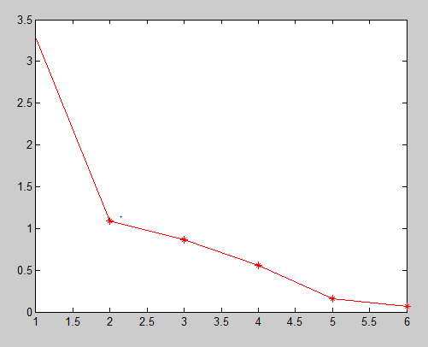

for i=1:6
variance(i) = s(i,i)/trace(s);
end
plot(1:6, variance);
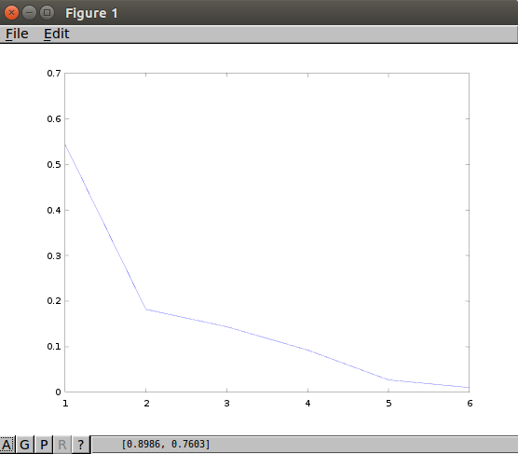
Plot of ratio of singular values.

Elbow is at 2.

f)
The first 3 eigen vectors are:
octave:31> u(:,1:3)
ans =

-0.4939721 -0.1888034 0.3474625
-0.5097648 -0.1138690 0.3256194
-0.3361468 0.4745285 -0.2919902
-0.2944298 0.5578587 -0.3939745
0.1732060 0.6325838 0.7298870
-0.5161855 -0.1218247 0.0057037

The dominant loadings are:
First eiegen vector = -0.5161 = 1/cityMPG
Second eigen vector = 0.6325 = year
Third eigen vector = 0.72988 = year
This can be interpreted as: the fuel economy depends on the year in which the vehicle was manufactured and the city gallons/mile value of the engine.

g)
pc = A_d * u(:,1:3);

c1=0;c2=0;c3=0;
for i=1:rows(pc)
if origin(i) == 1
c1 = c1+1;
color1(c1,:) = pc(i,:);
elseif origin(i) == 2
c2 = c2 +1;
color2(c2,:) = pc(i,:);
else
c3 = c3 + 1;
color3(c3,:) = pc(i,:);
end
end

plot3(color3(:,1),color3(:,2),color3(:,3),'g.');
hold on
plot3(color2(:,1),color2(:,2),color2(:,3),'b.');
hold on
plot3(color1(:,1),color1(:,2),color1(:,3),'r.');
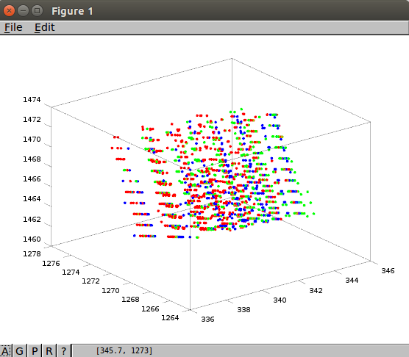

The 3 principal components do not separate the data which is visible in the above plot. Hence the column origin is not an separating factor in the data.
QUESTION 4:

a)

clear all;
folder = '/home/kami/Documents/FALL/modelling/hw2/Homework2Updated/';
csvfile = 'LApower.csv';
filename = strcat(folder,csvfile);
data = csvread( filename, 1, 0 );

logPowerJul = data(:,7);
logSqMts = data(:,27);
avglogTempJul = data(:,19);
b = logPowerJul - logSqMts;
a = [avglogTempJul.^3, avglogTempJul.^2, avglogTempJul.^1,ones(2322,1)];
x = a \ b;

x =

0.0009
-0.1936
13.4209
-311.2345

b)

plot( data(:,19),logPowerJul - logSqMts,'r*');
hold on;
plot( data(:,19), a*x,'b*');

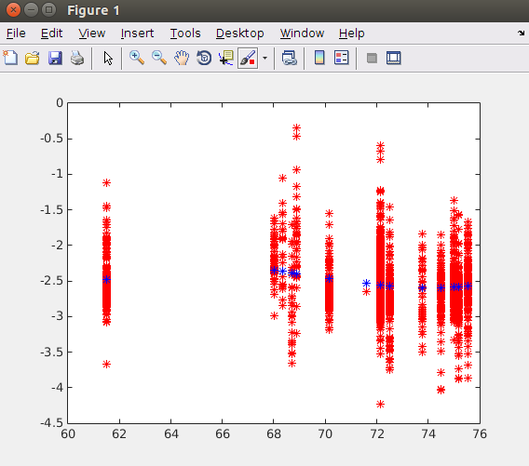

c)

b1 = logPowerJul;
a1 = [ones(2322,1), avglogTempJul, data(:,29), data(:,28), logSqMts];
x2 = a1 \b1;
b1_recon = a1*x2;
error = norm(b1_recon)/norm(b1);

x2 =

0.5933
-0.0003
-0.0001
0.0151
0.4522

error =

0.9944

d)
count = 0;
for i=1:2322
if data(1,30) > 50
count = count +1;
matrix(count,1:7) = [logPowerJul(i,1) - logSqMts(i,1), avglogTempJul(i,1), data(i,25), data(i,26), data(i,28), data(i,29), data(i,38)];
end
end
plotmatrix(matrix);
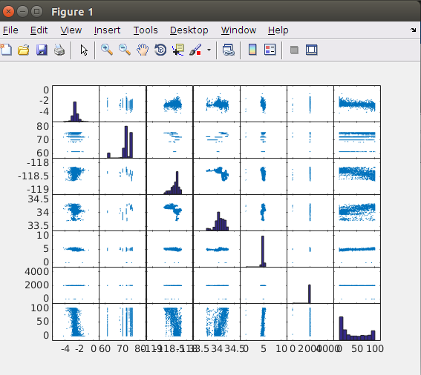

e)
corr_data = corr(matrix);
[u,s,v] = svds(corr_data,3 )

octave:366> corr_data
corr_data =

1.0000e+00 -1.4713e-02 1.1919e-01 -5.3941e-02 -2.0106e-01 3.2594e-02 -3.4383e-01
-1.4713e-02 1.0000e+00 -3.4876e-01 4.1746e-01 1.6299e-01 4.1257e-04 3.4425e-01
1.1919e-01 -3.4876e-01 1.0000e+00 -5.8200e-01 -2.9617e-01 2.0962e-02 -6.2075e-01
-5.3941e-02 4.1746e-01 -5.8200e-01 1.0000e+00 2.0234e-01 -3.1553e-02 4.8836e-01
-2.0106e-01 1.6299e-01 -2.9617e-01 2.0234e-01 1.0000e+00 4.0938e-01 4.7079e-01
3.2594e-02 4.1257e-04 2.0962e-02 -3.1553e-02 4.0938e-01 1.0000e+00 -3.7132e-02
-3.4383e-01 3.4425e-01 -6.2075e-01 4.8836e-01 4.7079e-01 -3.7132e-02 1.0000e+00

u =

-0.1970757 -0.1572453 -0.8032445
0.3517073 -0.2102558 -0.3423795
-0.4901318 0.1619316 0.0682201
0.4503140 -0.2545647 -0.2219935
0.3528940 0.5682655 -0.0060950
0.0556704 0.7190736 -0.3626823
0.5165442 -0.0069838 0.2281751

s =

Diagonal Matrix

2.6980 0 0
0 1.3325 0
0 0 1.0796

v =

-0.1970757 -0.1572453 -0.8032445
0.3517073 -0.2102558 -0.3423795
-0.4901318 0.1619316 0.0682201
0.4503140 -0.2545647 -0.2219935
0.3528940 0.5682655 -0.0060950
0.0556704 0.7190736 -0.3626823
0.5165442 -0.0069838 0.2281751

Dominant loadings are marked in Bold. In the first principal component, the max eigen vector value corresponds to last element I.e : Percent SFR. Hence this part shows the max spread. Similarly second principal component has maximum spread about the AvgYearBuilt. And the third has the max spread about logPowerJul(i,1) – logSqMts(i,1). In simpler words this means that the variation in the data is best shown by Percent SFR followed by Avg year built and logPowerJul(i,1) – logSqMts(i,1).

QUESTION 5:

a)
function [ avgFace, ksingularValues, eigenFaces ] = eigFaces( loc, s, k )
%row wise
% Read all the images

filelist = readdir(loc);
for i=1:s
x = imread(strcat(loc,filelist(i+2,1))(1,1){1});
a = reshape(x,1,64*64);
images(i,:) = a;
end

%Calculate mean
[rows,cols] = size(images);
for i=1:cols
mean(i) = round(sum(images(:,i)/rows));
end

im = reshape(mean,64,64);
im=(im-min(im(:)))/(max(im(:))-min(im(:)));
imshow(im);
avgFace = im;

%Create caricature
for i=1:rows
caricature(i,:) = images(i,:) - mean(1,:);
end

replacement = cov(caricature);
[u,l,v] = svds(replacement,k);
ksingularValues = diag(l)
eigenFaces = v;

for i=1:k
figure
im = reshape(eigenFaces(:,i),64,64);
im=(im-min(im(:)))/(max(im(:))-min(im(:)));
imshow(im);
axis off
end
end

ocatve:4> eigFaces('/home/Documents/FALL/hw2/Homework2Updated/eigenfaces/', 177,4);
ksingularValues =

1.5880e+05
1.1480e+05
7.6793e+04
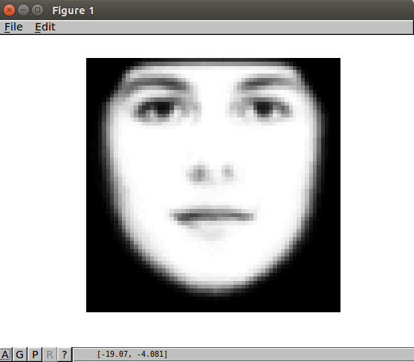
5.9086e+04

Mean Face :

Eigen Faces for k=4 , sample size = 177

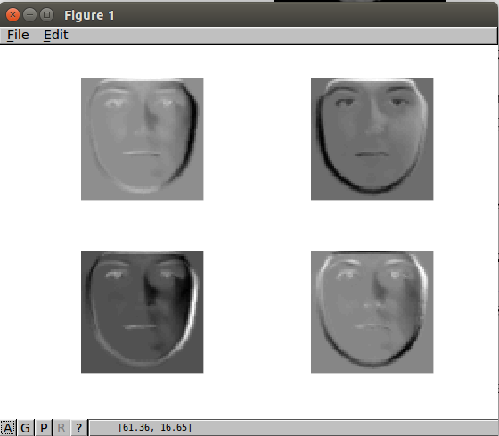

b)
function [ avgFace, ksingularValues, eigenFaces ] = eigFaces( loc,k )
%row wise
% Read all the images

filelist = readdir(loc);
cf =0; cm=0;
for i=1:168
x = imread(strcat(loc,filelist(i+2,1))(1,1){1});
a = reshape(x,1,64*64);
images(i,:) = a;
if strcmp(face_features{i,2}, 'Female') && strcmp(face_features{i,3}, 'Blue')
cf += 1;
images_female_blue(cf,:) = a;
end

if strcmp(face_features{i,2}, 'Male') && strcmp(face_features{i,3}, 'Blue')
cm += 1;
images_male_blue(cm,:) = a;
end
end

%Calculate mean
[rows,cols] = size(images_male_blue);
for i=1:cols
mean_m(i) = round(sum(images_male_blue(:,i)/rows));
end

[rows,cols] = size(images_female_blue);
for i=1:cols
mean_f(i) = round(sum(images_female_blue(:,i)/rows));
end

%Create caricature
for i=1:rows
caricature_f(i,:) = images_female_blue(i,:) - mean_f(1,:);
end

for i=1:rows
caricature_m(i,:) = images_male_blue(i,:) - mean_m(1,:);
end

replacement = cov(caricature_f);
[uf,lf,vf] = svds(replacement,k);
ksingularValues = diag(lf)
eigenFaces = vf;

replacement = cov(caricature_m);
[um,lm,vm] = svds(replacement,k);
ksingularValues = diag(lm)
eigenFaces = vm;

for i=1:k
figure
%subplot(6,5,i);
im = reshape(eigenFaces(:,i),64,64);
im=(im-min(im(:)))/(max(im(:))-min(im(:)));
imshow(im);
axis off
end
end
FEMALE K=30 EIGEN FACES
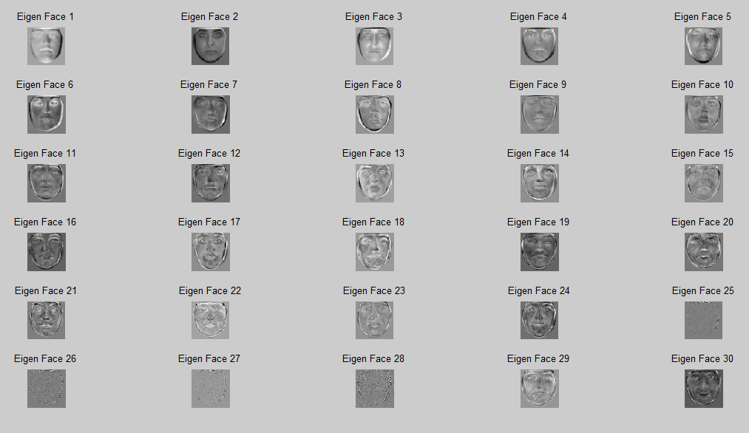
MALE K=30 EIGEN FACES
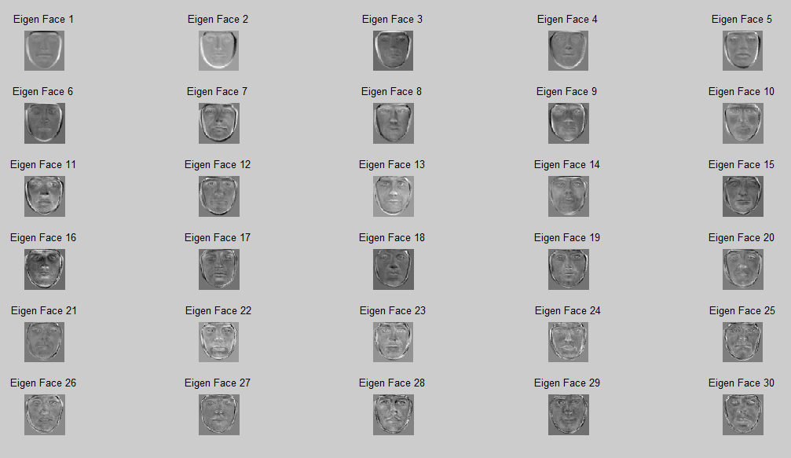

function [ avgFace ] = eigFaces( loc, face_features, image_to_omit )
%row wise
% Read all the images

filelist = readdir(loc);
cf = 0; cm = 0;
for i=1:168
x = imread(strcat(loc,filelist(i+2,1))(1,1){1});
a = reshape(x,1,64*64);
images(i,:) = a;
if strcmp(face_features{i,2}, 'Female') && strcmp(face_features{i,3}, 'Blue')
flag = 1;
for j = 1:10
if strcmp(filelist(i+2,1),image_to_omit{j,1})
flag = 0;
end
if flag == 1
cf += 1;
images(cf,:) = a;
end
end

if strcmp(face_features{i,2}, 'Male') && strcmp(face_features{i,3}, 'Blue')
flag = 1;
for j = 1:10
if strcmp(filelist(i+2,1),image_to_omit{j,1})
flag = 0;
end
if flag == 1
cf += 1;
images(cf,:) = a;
end
end
end

%Calculate mean
[rows,cols] = size(images_female_blue);
for i=1:cols
mean_f(i) = round(sum(images_female_blue(:,i)/rows));
end
[rows,cols] = size(images_male_blue);
for i=1:cols
mean_m(i) = round(sum(images_male_blue(:,i)/rows));
end

figure
im = reshape(mean_f,64,64);
im=(im-min(im(:)))/(max(im(:))-min(im(:)));
imshow(im);
avgFace = im;

figure
im = reshape(mean_m,64,64);
im=(im-min(im(:)))/(max(im(:))-min(im(:)));
imshow(im);

figure
im = reshape(mean_f-mean_m,64,64);
im=(im-min(im(:)))/(max(im(:))-min(im(:)));
imshow(im);
end

Female mean- Male mean

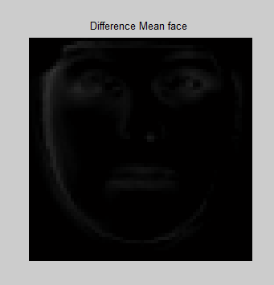

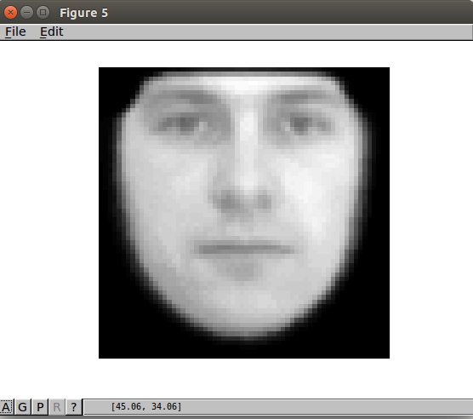
Avg Male Face

Avg Female Face

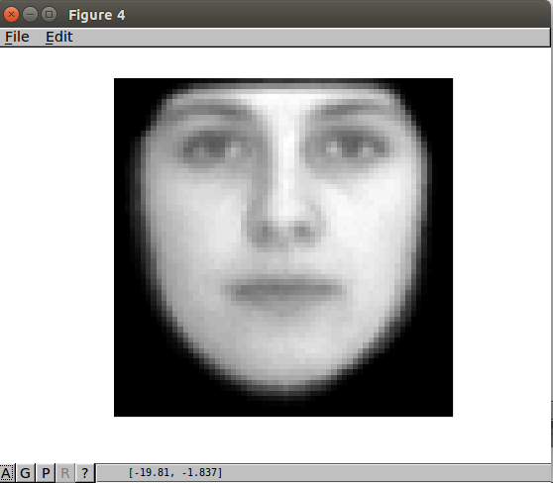

female_singular_Values =

run_eigen_faces
1.0e+05 *

8.7041
5.3455
2.7811
2.0929
1.6299
1.3608
1.0906
0.9244
0.7754
0.6539
0.5806
0.4975
0.4802
0.4248
0.3715
0.3484
0.3117
0.2819
0.2632
0.2287
0.1958
0.1649
0.1598
0.0000
0.0000
0.0000
0.0000
0
0
0

1.0e+05 *

4.2833
3.2753
1.7863
1.2890
1.0972
0.9487
0.6857
0.6806
0.5425
0.4383
0.4070
0.3817
0.3633
0.3147
0.2977
0.2884
0.2602
0.2363
0.2147
0.2064
0.1878
0.1766
0.1603
0.1372
0.1347
0.1215
0.1202
0.1137
0.1045
0.0985

c) function [ female_face, male_male ] = eigFaces( loc, face_features, k )
%row wise
% Read all the images

filelist = readdir(loc);
cf = 0; cm = 0; count = 0;
for i=1:177
x = imread(strcat(loc,filelist(i+2,1))(1,1){1});
a = reshape(x,1,64*64);
if strcmp(face_features{i,2}, 'Female') && strcmp(face_features{i,3}, 'Blue')
cf += 1;
count += 1;
images_female_blue(cf) = count;
images(count,:) = a;
end

if strcmp(face_features{i,2}, 'Male') && strcmp(face_features{i,3}, 'Blue')
cm += 1;
count += 1;
images_male_blue(cm) = count;
images(count,:) = a;
end
end

%Calculate mean
[rows,cols] = size(images);
for i=1:cols
mean(i) = round(sum(images(:,i)/rows));
end

%Create caricature
[rows,cols] = size(images);
for i=1:rows
caricature(i,:) = images(i,:) - mean(1,:);
end

replacement = cov(caricature);
[u,l,v] = svds(replacement,k);
c = v' * double(caricature');
[rows,cols] = sizeof(c)

max = 0;
[rows,cols] = size(images_female_blue);
for i=1:rows
index = images_female_blue(i,1);
coeff = norm(c(:,index));
if (max < coeff)
max = coeff;
coeff_female = c(:,index);
%female_face = images(index,:);
end
end

female_face = mean + v' * coeff_female;
figure
im = reshape(female_face,64,64);
imshow(im);

max = 0;
[rows,cols] = size(images_male_blue);
for i=1:rows
index = images_male_blue(i,1);
coeff = norm(c(:,index));
if (max < coeff)
max = coeff;
coeff_male = c(:,index);
%male_face = images(index,:);
end
end

male_face = mean + v' * coeff_male;
figure
im = reshape(male_face,64,64);
imshow(im);
end

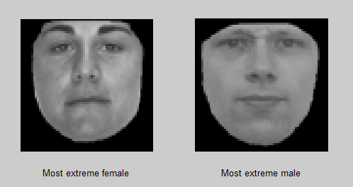

d)
To classify images I calculated the squared difference Zm, Zf between each face and the mean female and male faces. A face is classified as female face if Zf< Zm else as male face. After comparing the classification with the real values from the face_features.m we can tell weather a decesion is right ot wrong. At the end, after classifying all images percentage of success is calculated.

function [ decesion ] = eigFaces( filename, loc,face_features )
%row wise
% Read all the images

filelist = readdir(loc);
cf = 0; cm = 0;
for i=1:168
x = imread(strcat(loc,filelist(i+2,1))(1,1){1});
a = reshape(x,1,64*64);
images(i,:) = a;
if strcmp(face_features{i,2}, 'Female') && strcmp(face_features{i,3}, 'Blue')
cf += 1;
images_female_blue(cf,:) = a;
end

if strcmp(face_features{i,2}, 'Male') && strcmp(face_features{i,3}, 'Blue')
cm += 1;
images_male_blue(cm,:) = a;
end
end

%Calculate mean
[rows,cols] = size(images_female_blue);
for i=1:cols
mean_f(i) = round(sum(images_female_blue(:,i)/rows));
end
[rows,cols] = size(images_male_blue);
for i=1:cols
mean_m(i) = round(sum(images_male_blue(:,i)/rows));
end

x = imread(filename);
a = reshape(x,1,64*64);
input_image = a;

diff_f = norm(double(images(i,:)) - mean_f);
diff_m = norm(double(images(i,:)) - mean_m);
if diff_m < diff_f
decesion = 0;
else
decesion = 1;
end
end

Classifier which uses the difference between the mean and every face to find out the percentage of success foe this classifier

function [ percentage ] = eigFaces( loc, face_features )
%row wise
% Read all the images

filelist = readdir(loc);
cf = 0; cm = 0;
for i=1:168
x = imread(strcat(loc,filelist(i+2,1))(1,1){1});
a = reshape(x,1,64*64);
images(i,:) = a;
if strcmp(face_features{i,2}, 'Female') && strcmp(face_features{i,3}, 'Blue')
cf += 1;
images_female_blue(cf,:) = a;
end

if strcmp(face_features{i,2}, 'Male') && strcmp(face_features{i,3}, 'Blue')
cm += 1;
images_male_blue(cm,:) = a;
end
end

%Calculate mean
[rows,cols] = size(images_female_blue);
for i=1:cols
mean_f(i) = round(sum(images_female_blue(:,i)/rows));
end
[rows,cols] = size(images_male_blue);
for i=1:cols
mean_m(i) = round(sum(images_male_blue(:,i)/rows));
end

true =0; false =0;
for i=1:168
diff_f = norm(double(images(i,:)) - mean_f);
diff_m = norm(double(images(i,:)) - mean_m);
if (strcmp(face_features{i,2}, 'Male') && diff_m < diff_f) || ( strcmp(face_features{i,2}, 'Female') && diff_f<diff_m)
true += 1;
else
false +=1;
end
end
percent = true/(true+false) * 100
end

Percentage of success :
percent = 64.286

QUESTION 1:

d)

octave:11> sort(roots(poly(hilb(7))),'descend')
ans =

1.6609e+00
2.7192e-01
2.1290e-02
1.0086e-03
2.9386e-05
4.8568e-07
3.4939e-09

octave:12> sort(roots(poly(magic(7))),'descend')
ans =

175.000
56.485
31.088
25.397
-25.397
-31.088
-56.485

octave:16> sort(roots(poly(pascal(7,1))),'descend')
ans =

1.00013 + 0.00000i
-1.00000 + 0.00000i
1.00000 + 0.00013i
1.00000 - 0.00013i
-1.00000 + 0.00000i
-1.00000 - 0.00000i
0.99987 + 0.00000i

octave:17> svd(pascal(7,1))
ans =

34.958043
6.857853
2.160743
1.000000
0.462804
0.145818
0.028606

They are not the same in the case of Pascal(7,1)

octave:18> sort(roots(poly(vander(1:7))),'descend')
ans =

5.5645e+02
1.4196e+02
5.1654e+00
1.0014e-02
-3.7270e-01
-3.5714e+01
-4.5750e+02

octave:19> svd(vander(1:7))
ans =

1.2899e+05
1.4653e+03
4.8179e+01
4.0750e+00
9.3089e-01
1.3659e-01
5.2738e-03

They are not the same in case of Vander(1:7)

octave:20> sort(roots(poly(rosser())),'descend')
ans =

1.0201e+03 + 0.0000e+00i
-1.0200e+03 + 0.0000e+00i
1.0199e+03 + 3.8475e-02i
1.0199e+03 - 3.8475e-02i
1.0000e+03 + 4.8404e-03i
1.0000e+03 - 4.8404e-03i
9.8049e-02 + 0.0000e+00i
-1.1304e-13 + 0.0000e+00i

octave:21> svd(rosser())
ans =

1.0200e+03
1.0200e+03
1.0200e+03
1.0199e+03
1.0000e+03
1.0000e+03
9.8049e-02
9.6347e-15

e)
octave:23> digits(50);
octave:23> s = svd(hilb(7));
octave:29> for i=1:7
> x = vpa(s(i))
> end
x =

1.660885338926931353853433392941951751708984375
x =

0.271920198149345149207789518186473287642002105712890625
x =

0.0212897549083279243042898798421447281725704669952392578125
x =

0.0010085876107701306769737215063287294469773769378662109375
x =

2.938636814593281233482652270438961750187445431947708129883E-5
x =

4.856763361741647858072206539459259033719717990607023239136E-7
x =

3.493898595023221180814080802238055789565862596646184101701E-9
octave:41> %cond num
octave:41> 1.660885338926931353853433392941951751708984375/3.493898595023221180814080802238055789565862596646184101701E-9
ans = 4.7537e+08

octave:31> s = svd(magic(7))
s =

175.000
57.436
57.436
31.553
31.553
24.609
24.609

octave:32> for i=1:7
> x = vpa(s(i))
> end
x =

175.0
x =

57.43562359326133304193717776797711849212646484375
x =

57.4356235932613259365098201669752597808837890625
x =

31.55255885444730523659018217585980892181396484375
x =

31.55255885444730523659018217585980892181396484375
x =

24.608640193839217857885159901343286037445068359375
x =

24.608640193839196541603087098337709903717041015625
octave:42> %cond num
octave:42> 175.0/24.608640193839196541603087098337709903717041015625
ans = 7.1113

octave:33> s = svd(pascal(7,1))
s =

34.958043
6.857853
2.160743
1.000000
0.462804
0.145818
0.028606

octave:34> for i=1:7
> x = vpa(s(i))
> end
x =

34.9580431092000623038984485901892185211181640625
x =

6.85785251495807113286673484253697097301483154296875
x =

2.1607434783941936728979271720163524150848388671875
x =

0.9999999999999988897769753748434595763683319091796875
x =

0.462803664571591222287594291628920473158359527587890625
x =

0.1458182423461046595125623070998699404299259185791015625
x =

0.028605720202250765893392525640592793934047222137451171875
octave:43> %cond num
octave:43> 34.9580431092000623038984485901892185211181640625/0.028605720202250765893392525640592793934047222137451171875
ans = 1222.1

octave:35> s = svd(vander(1:7))
s =

1.2899e+05
1.4653e+03
4.8179e+01
4.0750e+00
9.3089e-01
1.3659e-01
5.2738e-03

octave:36> for i=1:7
> x = vpa(s(i))
> end
x =

128993.3575442936853505671024322509765625
x =

1465.273250697774756190483458340167999267578125
x =

48.17945739251121040069847367703914642333984375
x =

4.074977241020729223919261130504310131072998046875
x =

0.93089037201777291574700257115182466804981231689453125
x =

0.1365864819040193689492213025005185045301914215087890625
x =

0.00527383954289458410646940222932244068942964076995849609375

octave:37>%condition-num 128993.3575442936853505671024322509765625/0.00527383954289458410646940222932244068942964076995849609375
ans = 2.4459e+07

octave:38> s = svd(rosser())
s =

1.0200e+03
1.0200e+03
1.0200e+03
1.0199e+03
1.0000e+03
1.0000e+03
9.8049e-02
9.6347e-15

octave:39> for i=1:8
> x = vpa(s(i))
> end
x =

1020.049018429996749546262435615062713623046875
x =

1020.04901842999652217258699238300323486328125
x =

1019.999999999999772626324556767940521240234375
x =

1019.901951359278655218076892197132110595703125
x =

999.999999999999772626324556767940521240234375
x =

999.9999999999996589394868351519107818603515625
x =

0.09804864072158099574938461273632128722965717315673828125
x =

9.634722438889376192608137485197386978467244331159058390313E-15
octave:40> %cond num
octave:40> 1020.049018429996749546262435615062713623046875/9.634722438889376192608137485197386978467244331159058390313E-15
ans = 1.0587e+17

f)

function imagesvd(varargin)
% IMAGESVD Principal component analysis of monochrome and color images.
% IMAGESVD('file1.fmt','file2.fmt', ... ) reads the specified image
% files. Any format known to IMREAD is acceptable.
% IMAGESVD, with no arguments, provides popup menu access to several
% images from the NCM and demos directories.

% Copyright 2013 Cleve Moler and The MathWorks, Inc.

% imagesvd('slide') is the callback from the rank slider.
% imagesvd('menu') is the callback from the popup menu.

if nargin == 0 || ~isequal(varargin{1},'slide')
if nargin == 0 || ~isequal(varargin{1},'menu')

% Initialize uicontrols

shg
clf
set(gcf,'menu','none','numbertitle','off','name','Imagesvd');
X = []; %Store numeric values in X if the input is a matrix.
if nargin > 0
L = {'Your Matrix'};
X = varargin{1};
else
L = {'detail.mat','durer.mat','fern.png','clown.mat', ...
'earth.mat','mandrill.mat','gatlin.mat'};
end
startwith = 1;
h.popup = uicontrol('units','norm','pos',[.10 .03 .20 .05], ...
'style','popup','val',startwith,'string',L, ...
'callback','imagesvd(''menu'')');
h.slider = uicontrol('units','norm','pos',[.38 .02 .24 .04], ...
'style','slider','value',0,'callback','imagesvd(''slide'')');
h.limit = uicontrol('units','norm','pos',[.62 .02 .05 .04], ...
'style','text');
h.rank = uicontrol('units','norm','pos',[.42 .06 .16 .04], ...
'style','text','string',' ');
h.close = uicontrol('units','norm','pos',[.80 .03 .10 .05], ...
'string','close','callback','close');
h.X = X; %Copy numeric matrix into structure h.
set(gcf,'userdata',h)
end

% Read or load a new image.
% Monochrome is a single 2-D array of intensities.
% Color is a 3-D array of red, green and blue intensities.

h = get(gcf,'userdata');
L = get(h.popup,'string');
name = L{get(h.popup,'val')};

if isempty(strfind(name,'.mat')) %If it does not find .mat in the name, assume we passed a numeric matrix.
% Read numeric matrix.
X = h.X;

%If X is not between 0 and 1, normalize it!
maximum = max( max( X ) );
minimum = min( min( X ) );
X = ( X - minimum ) / ( maximum - minimum );

else
% Load .mat file containing indexed image 'X' and colormap 'map'.
% Convert to intensities.
load(name)
if norm(diff(map'),1) == 0
% Monochrome image
T = map(X,1);
X = reshape(T,size(X));
else
% Color image
T = [map(X,1) map(X,2) map(X,3)];
X = reshape(T,[size(X) 3]);
end
end

% Resize large images to reduce computation time.

[m,n,p] = size(X);
while m >= 768
i = 1:2:m-1;
j = 1:2:n-1;
X = (X(i,j,:)+X(i+1,j,:)+X(i,j+1,:)+X(i+1,j+1,:))/4;
[m,n,p] = size(X);
end

% Slider parameters depend upon size the image.

mn = min(m,n);
set(h.slider,'val',1,'min',0,'max',mn,'sliderstep',[1/mn 10/mn])
set(h.limit,'string',int2str(mn))
set(h.rank,'string','')

% Compute the singular value decomposition of the image.

msg = uicontrol('units','norm','pos',[.25 .56 .50 .10], ...
'style','text','fontsize',14, ...
'string',['Computing ' int2str(n*p) '-by-' int2str(m) ' SVD...']);
drawnow

X = reshape(X,m,p*n);
[V,S,U] = svd(X',0);

% Save the SVD in the figure's user data.

h.U = U;
h.S = S;
h.V = V;
h.m = m;
h.n = n;
h.p = p;
set(gcf,'userdata',h)
delete(msg);
end

% Update the plot.

h = get(gcf,'userdata');
U = h.U;
S = h.S;
V = h.V;
m = h.m;
n = h.n;
p = h.p;

% Obtain the rank from the slider.

r = round(get(h.slider,'value'));
set(h.slider,'value',r)
set(h.rank,'string',['rank = ' num2str(r)]);

% Rank r approximation.

%************************* Modify/Add your code here **********************

k = 1:r;
Y = U(:,k)*S(k,k)*V(:,k)';
X = U * S * V';
error = X - Y;
maximum = max( max( error ) );
minimum = min( min( error ) );
error = ( error - minimum ) / ( maximum - minimum );
error = reshape(error,m,n,p);
imager(error)
drawnow

% ------------------------------------

function imager(X)

% Display the image.

X(X<0) = 0;
X(X>1) = 1;
if ndims(X) == 3
image(X)
else
image(255*X)
colormap(gray(256));
end
axis image
axis off

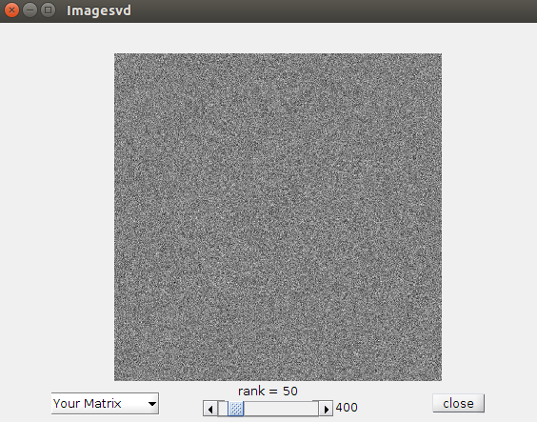

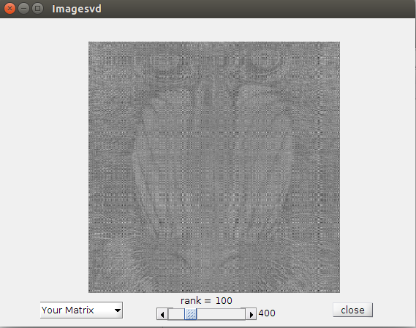

(a) Implementation of mysvd()
function [U,S,V] = mysvd(X)
[Q1 L] = Jacobi(X' * X);
[Q2 L] = Jacobi(X * X');
U = Q2;
V = Q1;
S = L.^(1/2);
end

function [Q L] = Jacobi(X)
n = size(X,1);
Q = id_function(n);

for j = 1 : (n-1)
for i = (n-1) : (-1) : (j+1)
i1 = i+1;
x = X(i,j);
y = X(i1,j);
T = QRotation(x,y);
Q( 1:n, i:i1 ) = Q( 1:n, i:i1 ) * T;
X( i:i1, j:n ) = T' * X( i:i1, j:n );
X( j:n, i:i1 ) = X( j:n, i:i1 ) * T;
end
end

OffDiagonal = 1 - id_function(n);
OffDiagonal = (OffDiagonal == 1);
while( ((X(OffDiagonal)' * X(OffDiagonal))^(1/2)) / ((ones_function(1,n) * (X' * X) * ones_function(n,1))^(1/2)) > n * n * eps )
for i = 1:(n-1)
i1 = i+1;
x = X(i,i);
y = X(i1,i);
T = QRotation(x,y);
Q( 1:n, i:i1 ) = Q( 1:n, i:i1 ) * T;
X( i:i1, 1:n ) = T' * X( i:i1, 1:n );
X( 1:n, i:i1 ) = X( 1:n, i:i1 ) * T;
end
end
L = X .* id_function(n);

end

function T = QRotation(x,y)
c = 1;
s = 0;

if (abs_function(y) > 0)
if (abs_function(y) >= abs_function(x))
cotangent = x/y;
s = 1/((1 + cotangent^2)^(1/2));
c = s * cotangent;
else
tangent = y/x;
c = 1/((1 + tangent^2)^(1/2));
s = c * tangent;
end
end
T = [c -s ; s c];
end

function I = id_function(n)
I (1:n, 1:n) = 0;
I (1: n+1 : end) = 1;
end

function O = ones_function(n,p)
O(1:n,1:p) = 1;
end

function X = abs_function(X)
X = -1 .* X .* (X<0) + X.* (X>=0);
end

Results of implementation:

>> A = hilb(7)

A =

1.0000 0.5000 0.3333 0.2500 0.2000 0.1667 0.1429
0.5000 0.3333 0.2500 0.2000 0.1667 0.1429 0.1250
0.3333 0.2500 0.2000 0.1667 0.1429 0.1250 0.1111
0.2500 0.2000 0.1667 0.1429 0.1250 0.1111 0.1000
0.2000 0.1667 0.1429 0.1250 0.1111 0.1000 0.0909
0.1667 0.1429 0.1250 0.1111 0.1000 0.0909 0.0833
0.1429 0.1250 0.1111 0.1000 0.0909 0.0833 0.0769

>> [U S V] = mysvd(A)

U =

0.7332 -0.6232 0.2608 -0.0752 0.0160 -0.0025 0.0002
0.4364 0.1631 -0.6706 0.5268 -0.2279 0.0618 -0.0098
0.3198 0.3215 -0.2953 -0.4257 0.6288 -0.3487 0.0952
0.2549 0.3574 0.0230 -0.4617 -0.2004 0.6447 -0.3713
0.2128 0.3571 0.2337 -0.1712 -0.4970 -0.1744 0.6825
0.1831 0.3446 0.3679 0.1827 -0.1849 -0.5436 -0.5911
0.1609 0.3281 0.4523 0.5098 0.4808 0.3647 0.1944

S =

1.6609 0 0 0 0 0 0
0 0.2719 0 0 0 0 0
0 0 0.0213 0 0 0 0
0 0 0 0.0010 0 0 0
0 0 0 0 0.0000 0 0
0 0 0 0 0 0.0000 0
0 0 0 0 0 0 0.0000 + 0.0000i

V =

0.7332 -0.6232 0.2608 -0.0752 0.0160 -0.0025 0.0002
0.4364 0.1631 -0.6706 0.5268 -0.2279 0.0618 -0.0098
0.3198 0.3215 -0.2953 -0.4257 0.6288 -0.3487 0.0952
0.2549 0.3574 0.0230 -0.4617 -0.2004 0.6447 -0.3713
0.2128 0.3571 0.2337 -0.1712 -0.4970 -0.1744 0.6825
0.1831 0.3446 0.3679 0.1827 -0.1849 -0.5436 -0.5911
0.1609 0.3281 0.4523 0.5098 0.4808 0.3647 0.1944

>> B = magic(7)

B =

30 39 48 1 10 19 28
38 47 7 9 18 27 29
46 6 8 17 26 35 37
5 14 16 25 34 36 45
13 15 24 33 42 44 4
21 23 32 41 43 3 12
22 31 40 49 2 11 20

>> [U S V] = mysvd(B)

U =

0.3780 -0.5972 -0.0000 0.5462 0.0000 -0.4496 0.0000
0.3780 -0.3478 -0.3820 -0.1169 0.3883 0.6377 -0.1385
0.3780 0.1237 -0.5200 -0.5326 -0.0452 -0.4937 0.2049
0.3780 0.3602 -0.2274 0.3002 -0.6425 0.2039 -0.3621
0.3780 0.5227 0.1120 0.3764 0.3795 0.0808 0.5284
0.3780 0.1952 0.4783 -0.2228 0.3389 -0.2122 -0.6171
0.3780 -0.2569 0.5391 -0.3505 -0.4189 0.2331 0.3844

S =

175.0000 0 0 0 0 0 0
0 57.4356 0 0 0 0 0
0 0 57.4356 0 0 0 0
0 0 0 31.5526 0 0 0
0 0 0 0 31.5526 0 0
0 0 0 0 0 24.6086 0
0 0 0 0 0 0 24.6086

V =

0.3780 -0.4269 -0.0000 0.7054 0.0000 0.4210 -0.0000
0.3780 -0.3260 0.4065 -0.0049 0.3638 -0.6617 -0.1240
0.3780 0.1280 0.5622 -0.4481 0.1172 0.5413 0.1314
0.3780 0.6275 0.1841 0.2907 -0.4759 -0.1902 -0.2870
0.3780 0.4114 -0.4039 0.1002 0.4522 -0.0901 0.5496
0.3780 -0.0547 -0.5182 -0.3215 0.1704 0.1438 -0.6577
0.3780 -0.3593 -0.2306 -0.3220 -0.6277 -0.1642 0.3877

>> C = pascal(7,1)

C =

1 0 0 0 0 0 0
1 -1 0 0 0 0 0
1 -2 1 0 0 0 0
1 -3 3 -1 0 0 0
1 -4 6 -4 1 0 0
1 -5 10 -10 5 -1 0
1 -6 15 -20 15 -6 1

>> [U S V] = mysvd(C)

U =

0.0013 -0.0313 0.2674 -0.7385 0.5778 -0.2144 0.0472
0.0084 -0.1163 0.4827 -0.3693 -0.4652 0.5833 -0.2457
0.0309 -0.2684 0.5473 0.1231 -0.3255 -0.4597 0.5431
0.0876 -0.4598 0.3342 0.3693 0.2747 -0.1901 -0.6490
0.2096 -0.5871 -0.1263 0.1231 0.3404 0.5196 0.4411
0.4452 -0.4265 -0.4714 -0.3693 -0.3777 -0.3043 -0.1613
0.8655 0.4189 0.2146 0.1231 0.0993 0.0611 0.0248

S =

34.9580 0 0 0 0 0 0
0 6.8579 0 0 0 0 0
0 0 2.1607 0 0 0 0
0 0 0 1.0000 0 0 0
0 0 0 0 0.4628 0 0
0 0 0 0 0 0.1458 0
0 0 0 0 0 0 0.0286

V =

-0.0472 0.2144 0.5778 -0.7385 0.2674 0.0313 0.0013
0.2457 -0.5833 -0.4652 -0.3693 0.4827 0.1163 0.0084
-0.5431 0.4597 -0.3255 0.1231 0.5473 0.2684 0.0309
0.6490 0.1901 0.2747 0.3693 0.3342 0.4598 0.0876
-0.4411 -0.5196 0.3404 0.1231 -0.1263 0.5871 0.2096
0.1613 0.3043 -0.3777 -0.3693 -0.4714 0.4265 0.4452
-0.0248 -0.0611 0.0993 0.1231 0.2146 -0.4189 0.8655

>> D = vander(1:7)

D =

1 1 1 1 1 1 1
64 32 16 8 4 2 1
729 243 81 27 9 3 1
4096 1024 256 64 16 4 1
15625 3125 625 125 25 5 1
46656 7776 1296 216 36 6 1
117649 16807 2401 343 49 7 1

>> [U S V] = mysvd(D)

U =
0.0000 -0.0008 0.0269 -0.3393 0.8313 -0.4324 0.0779
0.0005 -0.0180 0.1943 -0.6473 0.1015 0.6583 -0.3150
0.0059 -0.1021 0.4913 -0.4455 -0.3811 -0.2467 0.5861
0.0326 -0.3078 0.6230 0.1669 -0.0586 -0.3160 -0.6205
0.1234 -0.5934 0.2282 0.3794 0.3306 0.4228 0.3854
0.3667 -0.6485 -0.5084 -0.3019 -0.1977 -0.1974 -0.1315
0.9215 0.3491 0.1465 0.0667 0.0388 0.0343 0.0191

S =
1.0e+05 *

1.2899 0 0 0 0 0 0
0 0.0147 0 0 0 0 0
0 0 0.0005 0 0 0 0
0 0 0 0.0000 0 0 0
0 0 0 0 0.0000 0 0
0 0 0 0 0 0.0000 0
0 0 0 0 0 0 0.0000

V =
0.9891 -0.1445 0.0263 -0.0062 0.0024 -0.0011 0.0002
0.1454 0.9347 -0.3063 0.0950 -0.0424 0.0223 -0.0053
0.0215 0.3142 0.7855 -0.4386 0.2490 -0.1639 0.0502
0.0032 0.0799 0.4913 0.4415 -0.4884 0.5114 -0.2391
0.0005 0.0184 0.2029 0.5859 -0.0854 -0.5089 0.5907
0.0001 0.0041 0.0726 0.4297 0.4246 -0.3653 -0.7045
0.0000 0.0009 0.0249 0.2751 0.7142 0.5645 0.3081

>> E = rosser()
E =
611 196 -192 407 -8 -52 -49 29
196 899 113 -192 -71 -43 -8 -44
-192 113 899 196 61 49 8 52
407 -192 196 611 8 44 59 -23
-8 -71 61 8 411 -599 208 208
-52 -43 49 44 -599 411 208 208
-49 -8 8 59 208 208 99 -911
29 -44 52 -23 208 208 -911 99

>> [U S V] = mysvd(E)

U =

0.6325 0.0000 -0.2236 -0.0623 -0.3847 -0.0000 0.6294 0.0447
0.3162 -0.0000 0.4472 0.0312 -0.2495 -0.7278 -0.3147 0.0894
0.3162 -0.0000 0.4472 -0.0312 0.7694 0.0000 0.3147 -0.0894
0.6325 0.0000 -0.2236 0.0623 0.1248 0.3639 -0.6294 -0.0447
-0.0000 0.3162 -0.4472 -0.3147 0.3327 -0.3119 -0.0312 0.6261
0.0000 0.3162 0.4472 0.3147 -0.1872 0.4159 0.0312 0.6261
-0.0000 -0.6325 -0.2236 0.6294 0.1664 -0.1560 0.0623 0.3130
0.0000 -0.6325 0.2236 -0.6294 -0.0936 0.2080 -0.0623 0.3130

S =

1.0e+03 *

1.0200 0 0 0 0 0 0 0
0 1.0200 0 0 0 0 0 0
0 0 1.0200 0 0 0 0 0
0 0 0 1.0199 0 0 0 0
0 0 0 0 1.0000 0 0 0
0 0 0 0 0 1.0000 0 0
0 0 0 0 0 0 0.0001 0
0 0 0 0 0 0 0 0.0000 +0.0000i

V =

0.6325 0.0000 -0.2236 -0.0623 -0.3847 -0.0000 0.6294 0.0447
0.3162 -0.0000 0.4472 0.0312 -0.2495 -0.7278 -0.3147 0.0894
0.3162 -0.0000 0.4472 -0.0312 0.7694 0.0000 0.3147 -0.0894
0.6325 0.0000 -0.2236 0.0623 0.1248 0.3639 -0.6294 -0.0447
-0.0000 0.3162 -0.4472 -0.3147 0.3327 -0.3119 -0.0312 0.6261
0.0000 0.3162 0.4472 0.3147 -0.1872 0.4159 0.0312 0.6261
-0.0000 -0.6325 -0.2236 0.6294 0.1664 -0.1560 0.0623 0.3130
0.0000 -0.6325 0.2236 -0.6294 -0.0936 0.2080 -0.0623 0.3130

(b)

function checkEquivalence(A)
[n,p] = size(A);
[U S V] = mysvd(A);
[U1 S1 V1] = svd(A);
X1 = [cos(0) sin(0)];
X2 = [cos(pi) sin(pi)];
Y = [1; i];
flag1 = 0; flag2 = 0;

%Checking for U
for I = 1: size(U,2)
if( ~((uint8((X1*Y) * U(:,I)' * U1(:,I)) == 1) || (uint8((X2*Y) * U(:,I)' * U1(:,I)) ==1)))
flag1 = 1;
end
end

%Checking for V
for I = 1:size(V,2)
if( ~((uint8((X1*Y) * V(:,I)' * V1(:,I)) == 1) || (uint8((X2*Y) * V(:,I)' * V1(:,I)) ==1)))
flag2=1;
end
end

if(flag1==1 || flag2==1)
disp('The two SVD results are not unit equivalent');
else
disp('The two SVD results are unit equivalent');
end
end

>> checkEquivalence(A)
The two SVD results are unit equivalent

>> checkEquivalence(B)
The two SVD results are not unit equivalent
-The difference is that column number 4 and 5 are flipped in the two results, because the corresponding singular values are equal.

>> checkEquivalence(C)
The two SVD results are unit equivalent

>> checkEquivalence(D)
The two SVD results are unit equivalent

>> checkEquivalence(E)
The two SVD results are not unit equivalent
-The SVD that has been implemented appears to have a few columns different from the built in SVD.

(c)function c = condition_number(A)
[U S V] = mysvd(A);
[n,p] = size(A);
c = S(1,1)/S(n,p)

>> condition_number(A);
c =

2.8764e-08 - 4.6975e+08i

>> condition_number(B);
c =

7.1113

>> condition_number(C);
c =

1.2221e+03

>> condition_number(D);
c =

2.4457e+07

>> condition_number(E);
c =

6.0093e-09 – 9.8139e+07i

