NAME : SRAVANI KAMISETTY
SID : 304414410
COURSE : MATHEMATICAL MODELLING
ASSIGNMENT #4

QUESTION 1:

function data = text_file_read(filename)
idx=0;

fid = fopen(filename)
if fid == -1
error(['Error Opening ',filename]);
end
while ~feof(fid)
data_to_split = fgetl(fid);
split = strsplit(data_to_split,',');
[rows,cols] = size(split);
while(cols ~= 0)
idx=idx+1;
data(idx) = split(1,cols);
cols = cols -1;
end
end
fclose(fid);
end

unique_data = unique(data);
[rows,cols] = size(unique_data);
count_arr(1:10) = 0

for i=1:cols
clear x;
x = unique_data(1,i){1};
ans = strsplit(strtrim(x),' ');
[rows1,cols1] = size(ans);
j = 1;
while(j<= cols1)
clear ans;
ans = strsplit(strtrim(x),' ');
clear ans1;
ans1 = str2num(ans(1,j){1});
if(ans1 ~= 0)
break;
end
j++;
end
if(j >cols1)
ans1 = 10;
end
count_arr(ans1) += 1;
end
statPercent = count_arr(1:9)/ sum(count_arr (1:9));
bar(statPercent);

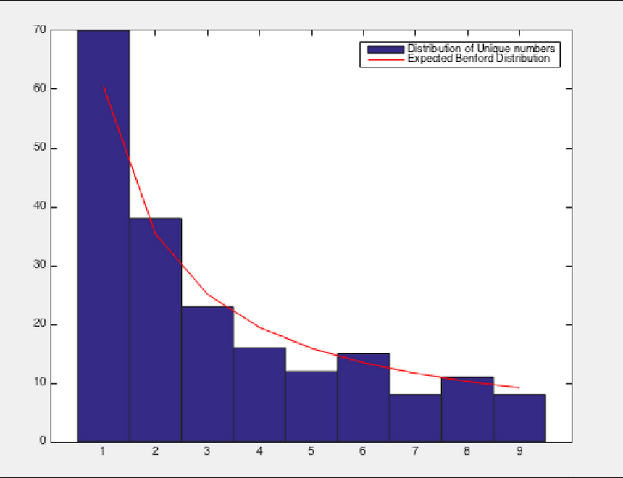

QUESTION 4:

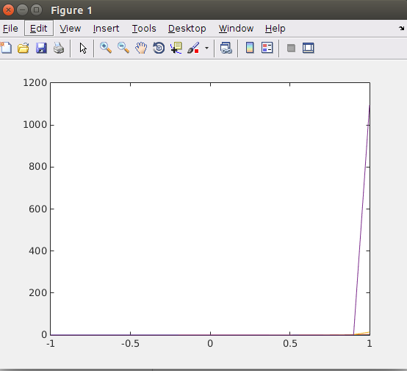
a)

function [ x,y ] = henyey_greenstein( g )
j=1;
i=-1;
g
while(i<=1)
i
x(j) = i;
clear numerator;
clear denominator;
numerator = 1-g*g;
denominator = (1+g*g-2*g*i)^1.5;
product = numerator/denominator;
value = 0.5*product;
y(j) = value;
j = j+1;
i = i+0.1;
end
end

hold all;
[x2,y2] = henyey_greenstein(0.97);
plot(x2,y2);
[x2,y2] = henyey_greenstein(0.75);
plot(x2,y2);
[x2,y2] = henyey_greenstein(0.50);
plot(x2,y2);
[x2,y2] = henyey_greenstein(0.25);
plot(x2,y2);
[x2,y2] = henyey_greenstein(0);
plot(x2,y2);

b)

function [ hits_array, misses_array ] = monte_carlo( total_points )
hits = 0;
misses = 0;
g = 0.25;
for i=1:total_points
x = 2*rand -1;
y = rand + 0.2;
numerator = 1-g*g;
denominator = (1+g*g-2*g*x)^1.5;
product = numerator/denominator;
value = 0.5*product;
if (value - y >= 0)
hits = hits+1;
hits_array(hits,1) = x;
hits_array(hits,2) = y;
else
misses = misses+1;
misses_array(misses,1) = x;
misses_array(misses,2) = y;
end
end
end

>> [hits,misses] = monte_carlo(5000);
>> scatter(hits(:,1),hits(:,2));
>> hold all
>> scatter(misses(:,1),misses(:,2),'r');
>> [hits,misses] = monte_carlo(10000);
>> scatter(hits(:,1),hits(:,2));
>> hold all
>> scatter(misses(:,1),misses(:,2),'r');
>> [hits,misses] = monte_carlo(20000);
>> scatter(hits(:,1),hits(:,2));
>> hold all
>> scatter(misses(:,1),misses(:,2),'r');

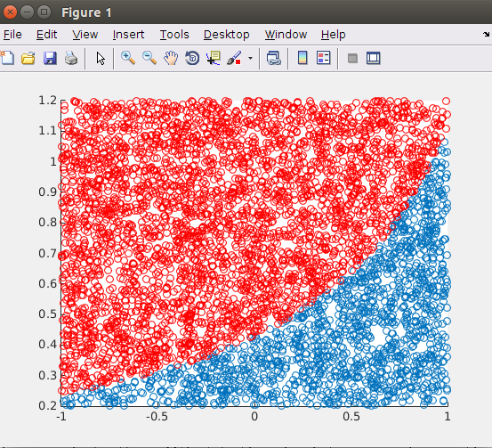

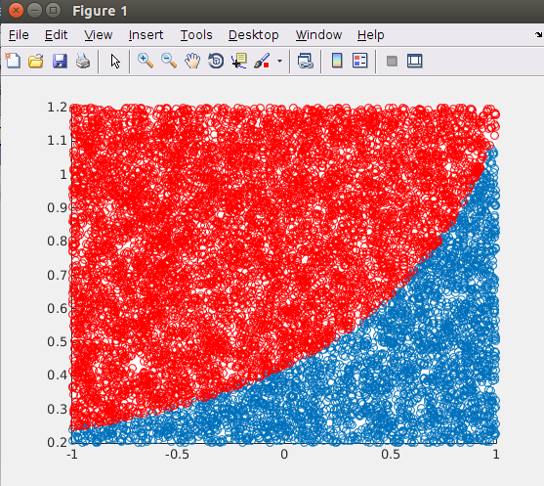

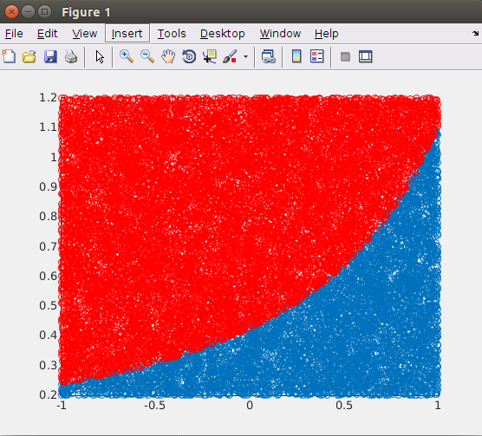

4c)
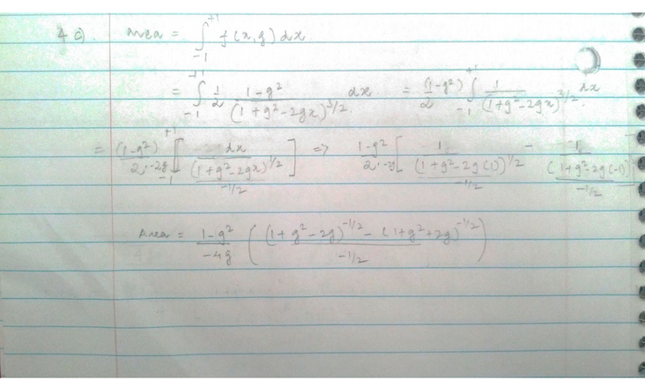

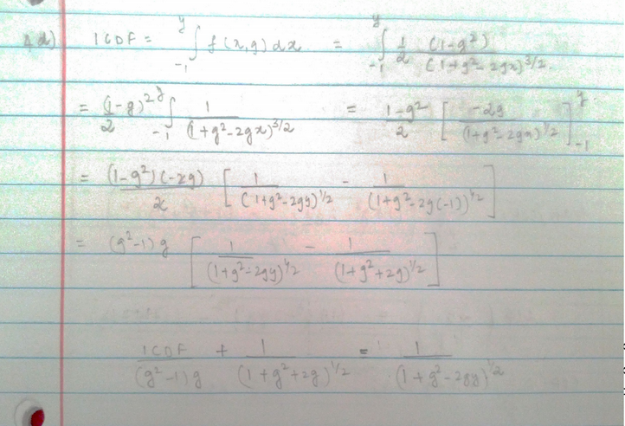
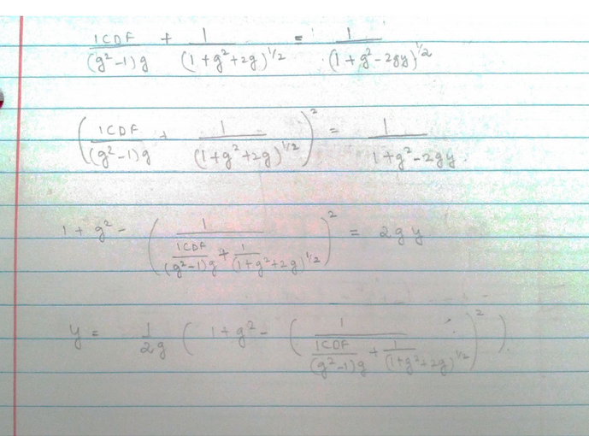
4d)

4e)
function [ y ] = henyey(g )
cdf = rand(1) ;
inner = ((cdf*2*g/(1-g^2)) + (1+g^2+2*g)^-0.5)^-2;
y = (1+ g^2 - inner)/(2*g);
end

4f)
function [x,y] = henyey_rand( g, samples )
for i=1:samples
x(i) = henyey(g);
numerator = 1-g*g;
denominator = (1+g*g-2*g*x(i))^1.5;
product = numerator/denominator;
value = 0.5*product;
y(i) = value;
end
end

>> hist(x)
>> scatter(x,y)

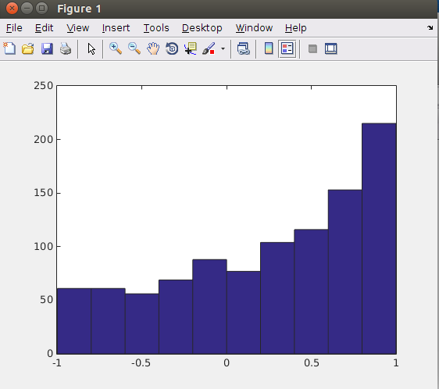

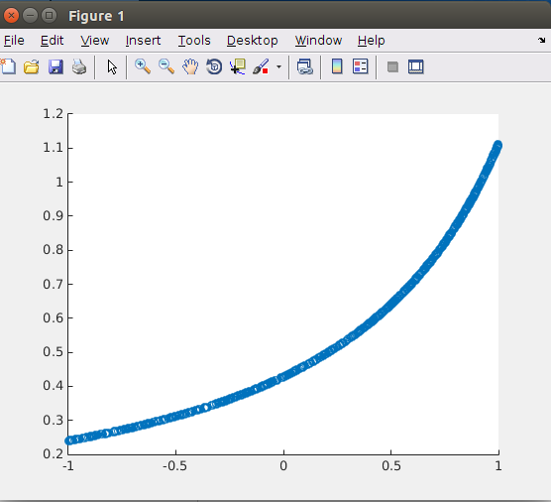

QUESTION 3:

3a)
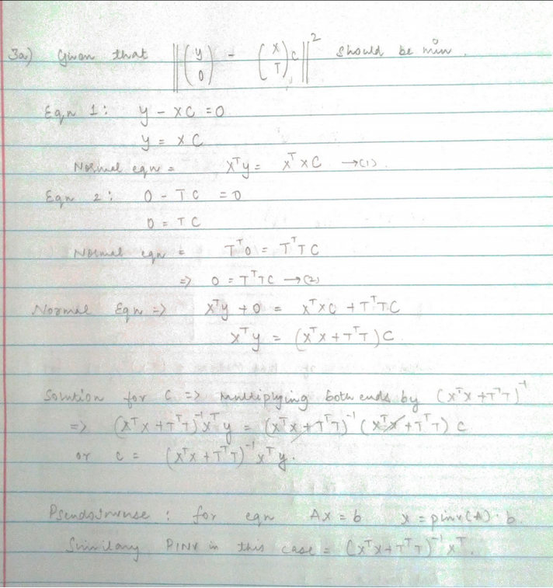

3b)
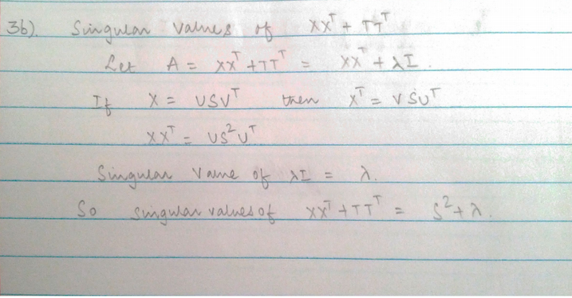
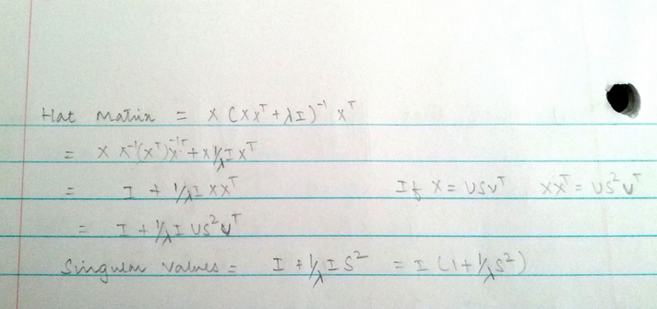

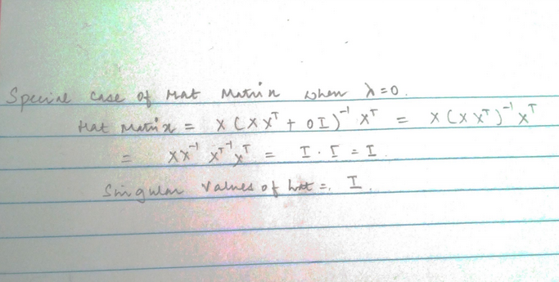
3d)
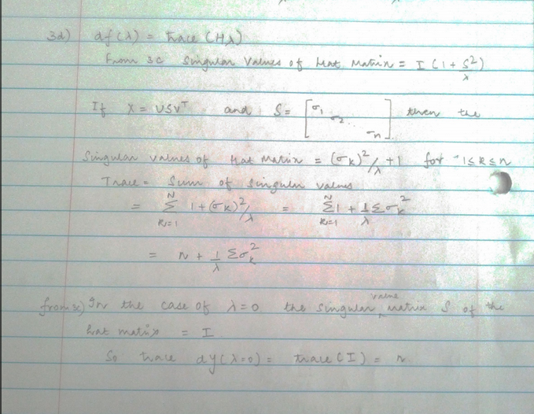

3c)
function [lamda,c] = ridge(autos)
one = ones(389);
autos(:,1) = 1./autos(:,1);
autos = zscore(autos);
x = [autos(:,5), autos(:,4),autos(:,3)];
limit = 2*norm(x'*x);
increment = limit/200;
i = 0;j=1;
while(i<=limit)
y = autos(:,1);
pseudoinv = inv(x'*x+i*eye(3));
pseudoinv = pseudoinv * x';
c(:,j) = pseudoinv*y;
lamda(j) = i;
j = j+1;
i = i+increment;
end
end

>>[lamda,c] = ridge(autos);
>>plot(lamda,c(1,:);
>>hold all;
>>plot(lamda,c(2,:);
>>plot(lamda,c(3,:);
>>legend('coeff','coeff2',coeff3');

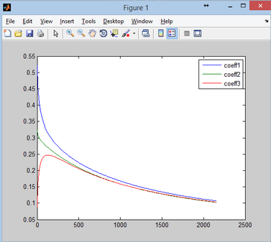

QUESTION 2:

2a)

- The timestep dt is defined in the variable deltaT in the template file. It is given a value of 0.01.
- The only force acting on the particles is the gravity. It is represented by the vector : gravity = [0; -9.81];

2b)
for I = 1:particlesCount
% Notice that both position and velocity are 2x1 vectors.
% *********************************************************************
posX = (maxX-minX)*rand + minX;
posY = (maxY-minY)*rand + minY;
particles(I).position = [posX;posY]; % TODO: Random position within the boundaries minX to maxX, and minY to maxY.
particles(I).velocity =(maxV-minV).*rand(2,1) + minV; % TODO: Random velocity within the range minV to maxV for both x and y components.
particles(I).color = rand(3,1); % TODO: Random color triplet: [R, G, B] between 0 and 1 each.
% *********************************************************************
end;

2c)
oldV = particles(I).velocity;
particles(I).velocity = particles(I).velocity + deltaT .* gravity; % TODO: integrate acceleration to get new velocity.

% Integrate velocity to find new position.
particles(I).position = particles(I).position + deltaT .* oldV;

2d)

fun = @(x)2*(particles(I).position(1)-x)+ 2*(particles(I).position(2)-sin(x)) - cos(x);
xSol = fzero(fun,1);
particles(I).position = [xSol; sin( xSol )];

Entire code :

% Code to generate a particle system that simulates collisions with a sine
% curve, using the Matlab builtin fzero function.

% Boundaries in the plot.
minX = -10;
maxX = +10;
minY = 0;
maxY = +20;

% Initial velocity limits.
minV = -5;
maxV = +5; % Apply for both x and y components.

% Particles array.
particlesCount = 5;
for I = 1:particlesCount
% Notice that both position and velocity are 2x1 vectors.
% *********************************************************************
posX = (maxX-minX)*rand + minX;
posY = (maxY-minY)*rand + minY;
particles(I).position = [posX;posY]; % TODO: Random position within the boundaries minX to maxX, and minY to maxY.
particles(I).velocity =(maxV-minV).*rand(2,1) + minV; % TODO: Random velocity within the range minV to maxV for both x and y components.
particles(I).color = rand(3,1); % TODO: Random color triplet: [R, G, B] between 0 and 1 each.
% *********************************************************************
end;

% The only force acting on particles is gravity. This is the constant g.
gravity = [0; -9.81];

% Coefficient of restitution to handle Newtonian collisions; modify this to
% get different behaviors.
restCoeff = 0.5; %0 - inelastic, 1 - fully elastic.

% The ground for collisions (a sinusoidal function).
xSine = linspace( minX, maxX, 100 );
ySine = sin( xSine );

% The optimization parameters.
x0 = 0; %Initial search point.

% Define time control variables.
deltaT = 0.01;
simulationTime = 0.0;
maxSimulationTime = 10.0;

% Set up window.
set( 0, 'Units', 'pixels' ); %Set default units to pixels.
screenSize = get( 0, 'ScreenSize' ); %Get screen size and position.
figure( 'Renderer', 'OpenGL', ...
'OuterPosition', [screenSize(3)/2-350 screenSize(4)/2-350 700 700]);

%create a viedo
%nFrames = maxSimulationTime/deltaT;
writerObj = VideoWriter('peaks.avi');
open(writerObj);

% Begin simulation.
while( simulationTime < maxSimulationTime )
plot( xSine, ySine, 'Color', 'black', 'LineWidth', 2 ); % Draw sinusoidal ground.
hold on;

% Iterate over each particle.
for I = 1:particlesCount %Solve for each particle: find its new position.

% *****************************************************************
% Integrate acceleration to find new velocity.
oldV = particles(I).velocity;
particles(I).velocity = particles(I).velocity + deltaT .* gravity; % TODO: integrate acceleration to get new velocity.

% Integrate velocity to find new position.
particles(I).position = particles(I).position + deltaT .* oldV; % TODO: integrate velocity to get new 'candidate' position.
% *****************************************************************deltaT .* particles(I).velocity; % TODO: integrate velocity to get new 'candidate' position.
% *****************************************************************

% Check collision with ground.
if( particles(I).position(2) < sin( particles(I).position(1) ) ) % Is particle below ground?

% Move particle above the ground, to the location on the sine
% function where the distance between the current position and
% the curve is minimal.

% *************************************************************
% TODO: Use "fzero" to minimize your distance function.
% xSol should be the x-coordinate that minimizes your distance
% function.
% *************************************************************
fun = @(x)2*(particles(I).position(1)-x)+ 2*(particles(I).position(2)-sin(x)) - cos(x);
xSol = fzero(fun,1);
particles(I).position = [xSol; sin( xSol )]; % Move particle on the ground.

% Compute a new velocity based on the normal at the point where
% the particle went through the ground (found in previous step).
commonFactor = 1/sqrt( 1 + cos( xSol )^2 );
groundNormal = commonFactor * [ -cos( xSol ); 1 ];
projOntoN = particles(I).velocity' * groundNormal;
particles(I).velocity = particles(I).velocity - ...
projOntoN*groundNormal - restCoeff*projOntoN*groundNormal;
end;

% Draw particle at its new position.
plot( particles(I).position(1), particles(I).position(2), ...
'Marker', 'o', ...
'MarkerEdgeColor', particles(I).color*0.5, ...
'MarkerSize', 10, ...
'MarkerFaceColor', particles(I).color );

end;
xlabel( sprintf( 'Simulation time: %f', simulationTime ) );
axis( [minX, maxX, minY-2, maxY] ); % Give some room to sinusoidal ground.
hold off;

% Instruct MatLab to refresh plot.
drawnow;

%frame(k) = getframe;
%k = k + 1;
frame = getframe;
writeVideo(writerObj,frame);
simulationTime = simulationTime + deltaT; % Advance time.
end;

%close the vedio writer
%movie2avi(mov, 'myPeaks.avi', 'compression', 'None');
close(writerObj);

