Nama: Sukma Arif Wibowo NIM: A11.2022.14144 Kelp: A11.4506

- Exploratory Data Analysis for Machine Learning
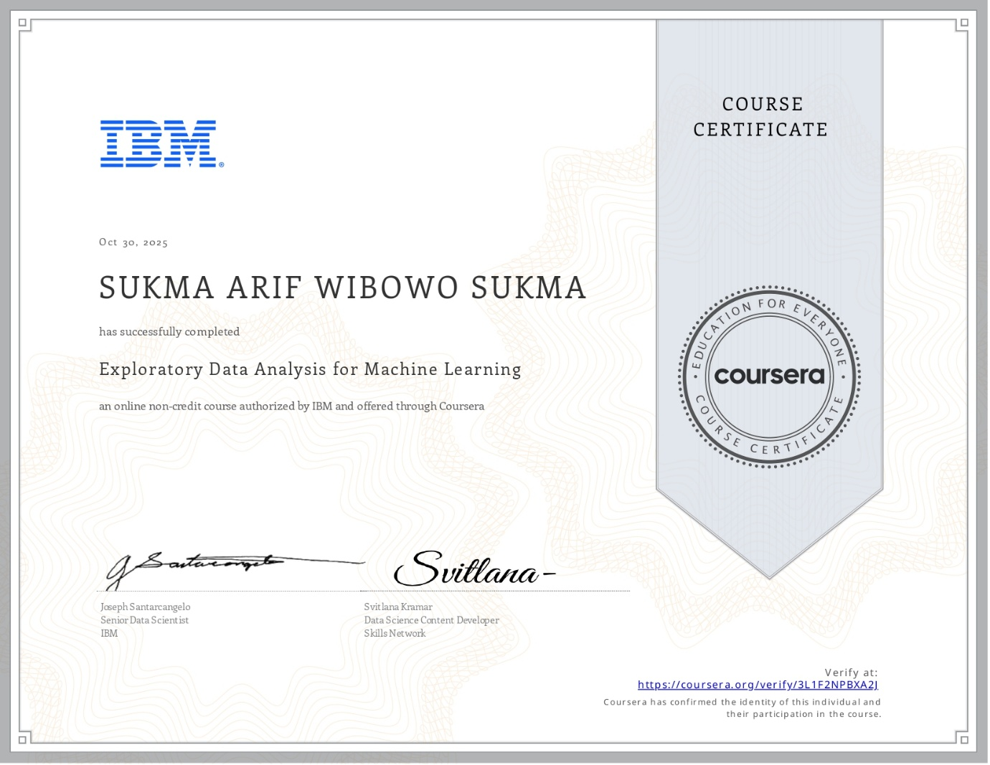
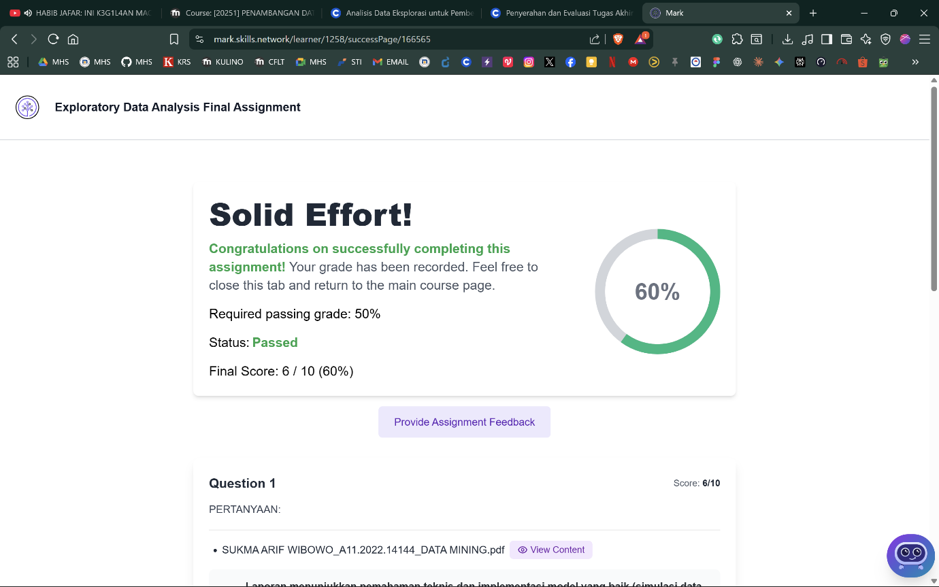

- Supervised Machine Learning: Regression
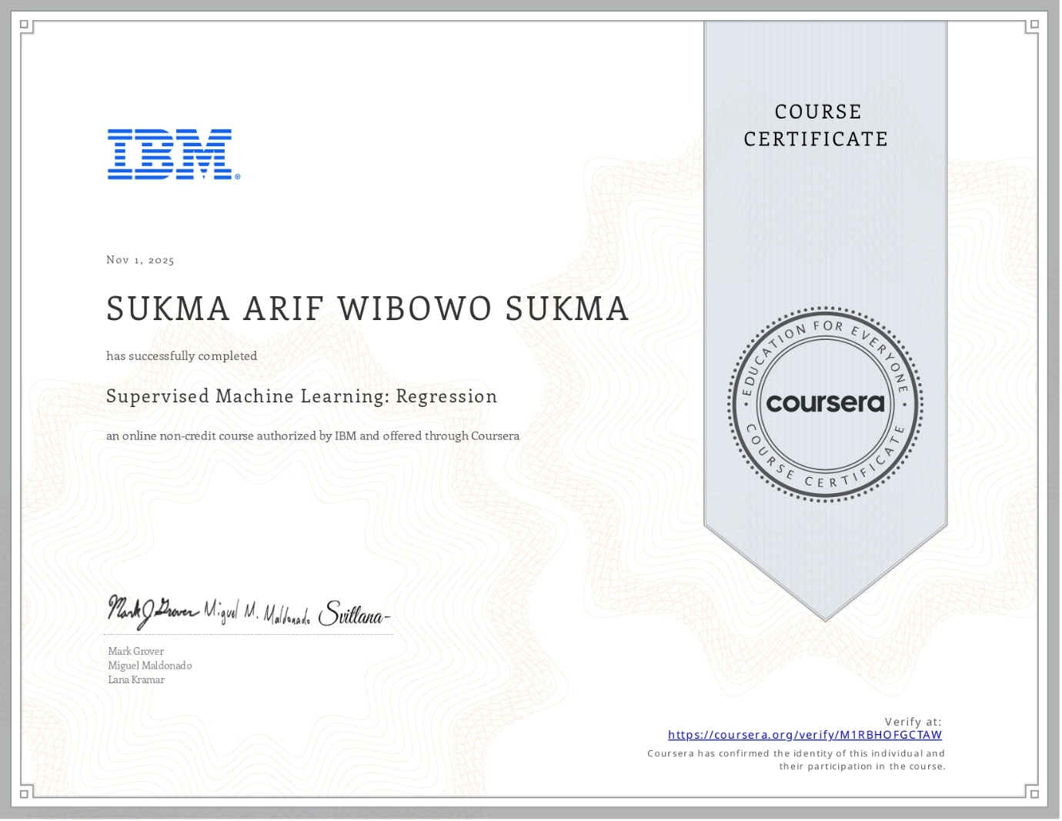
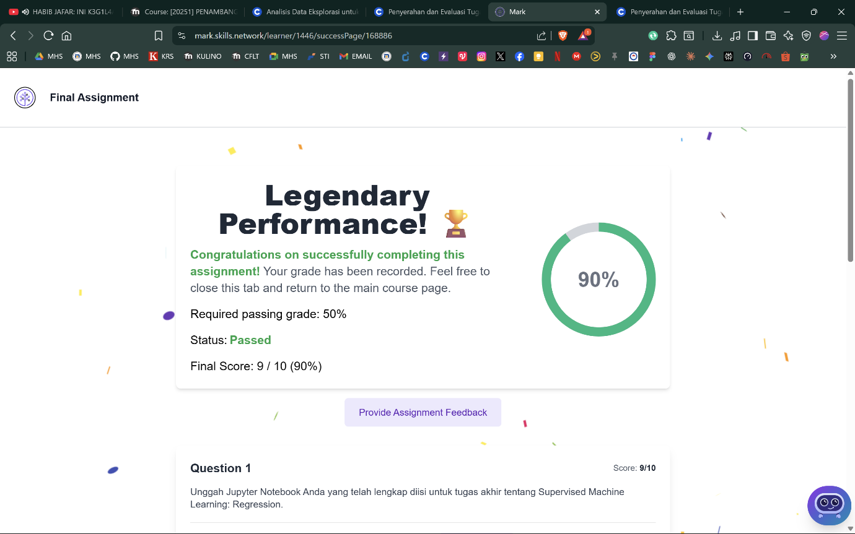

- Supervised Machine Learning: Classification
