NAMA: SUKMA ARIF WIBOWO NIM: A11.2022.14144 KELP: A11.4506

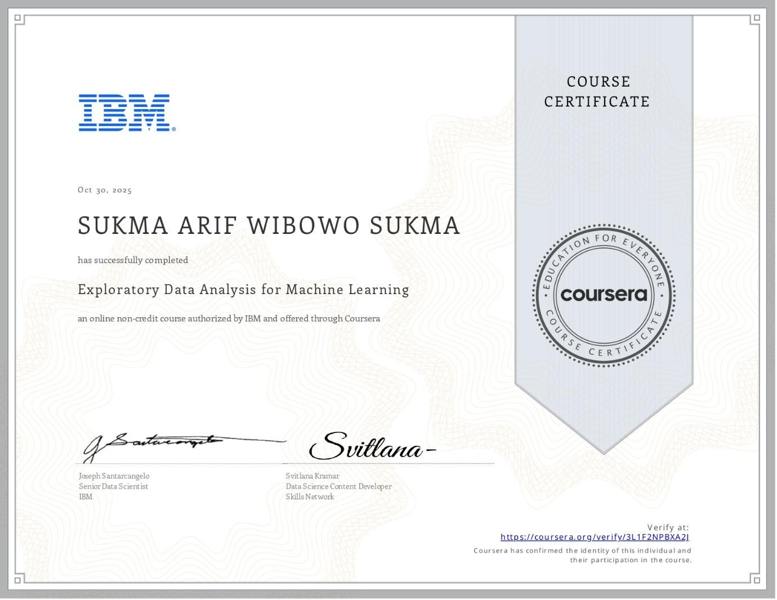
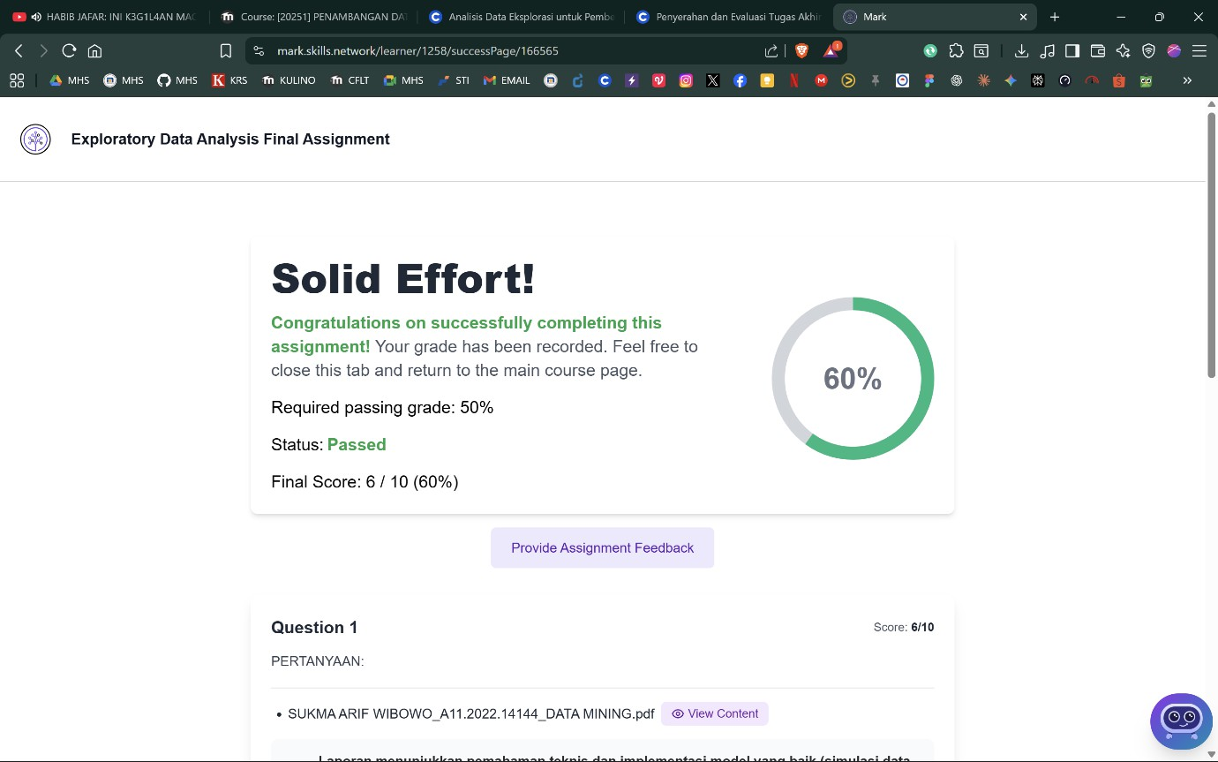
- EXPLORATORY DATA ANALYSIS FOR MACHINE LEARNING

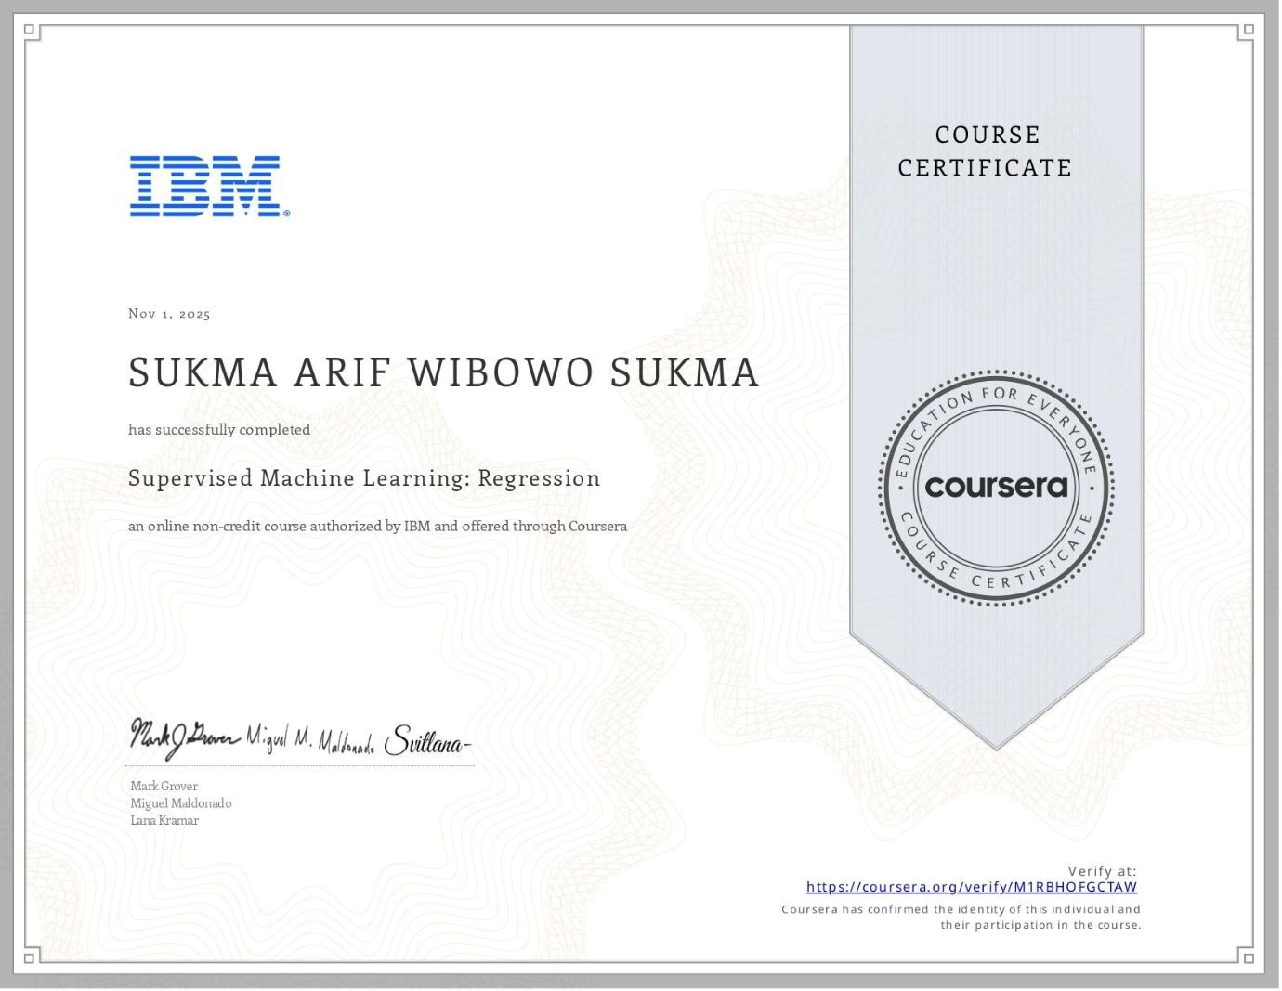
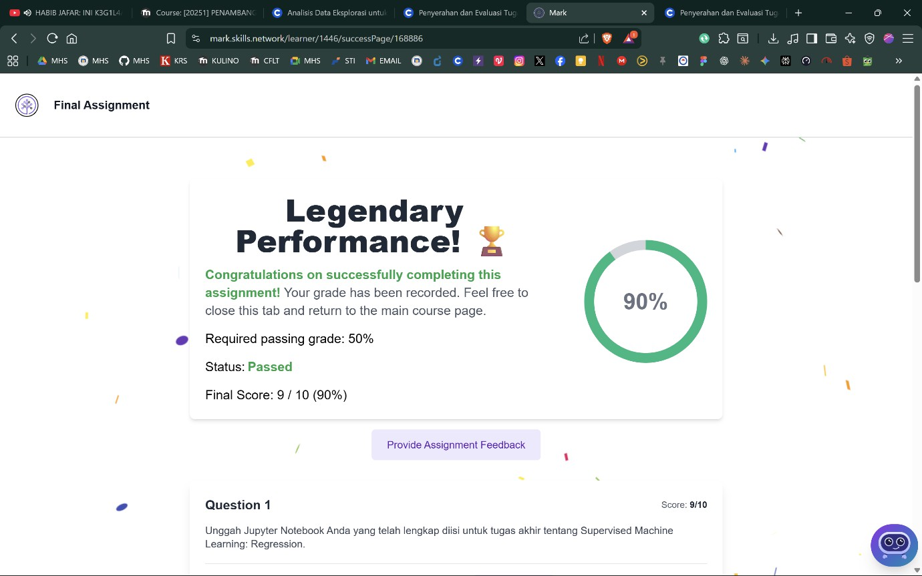
- SUPERVISED MACHINE LEARNING: REGRESSION

- SUPERVISED MACHINE LEARNING: CLASSIFICATION
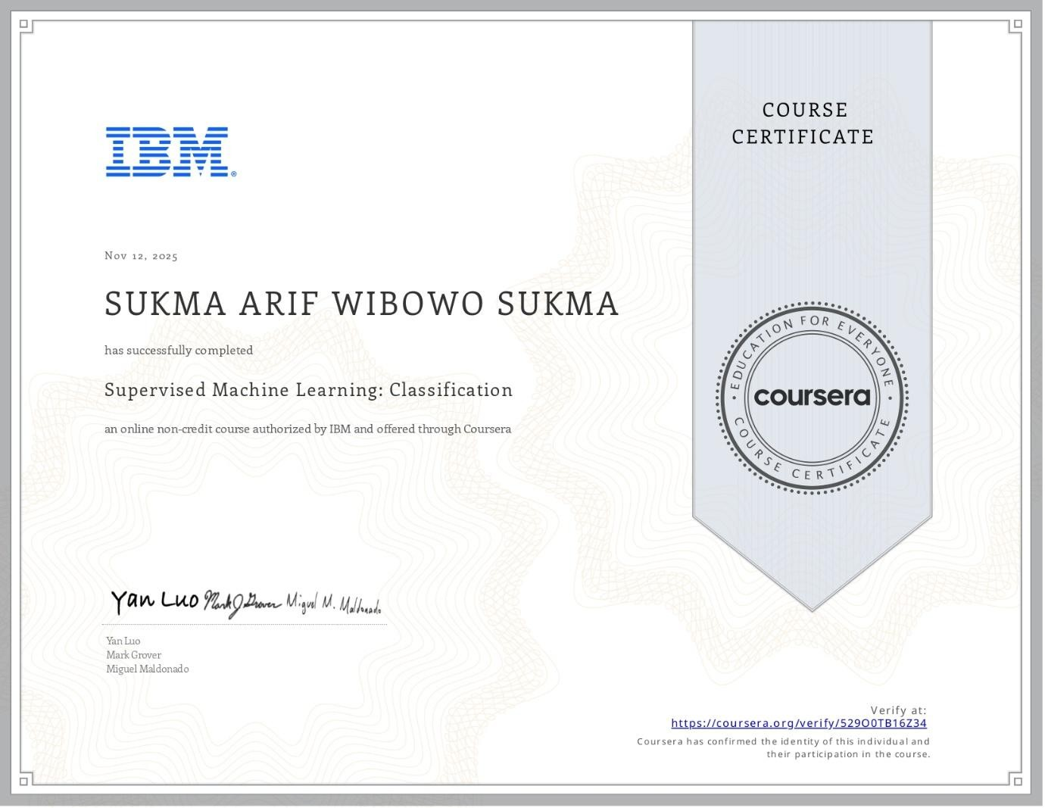

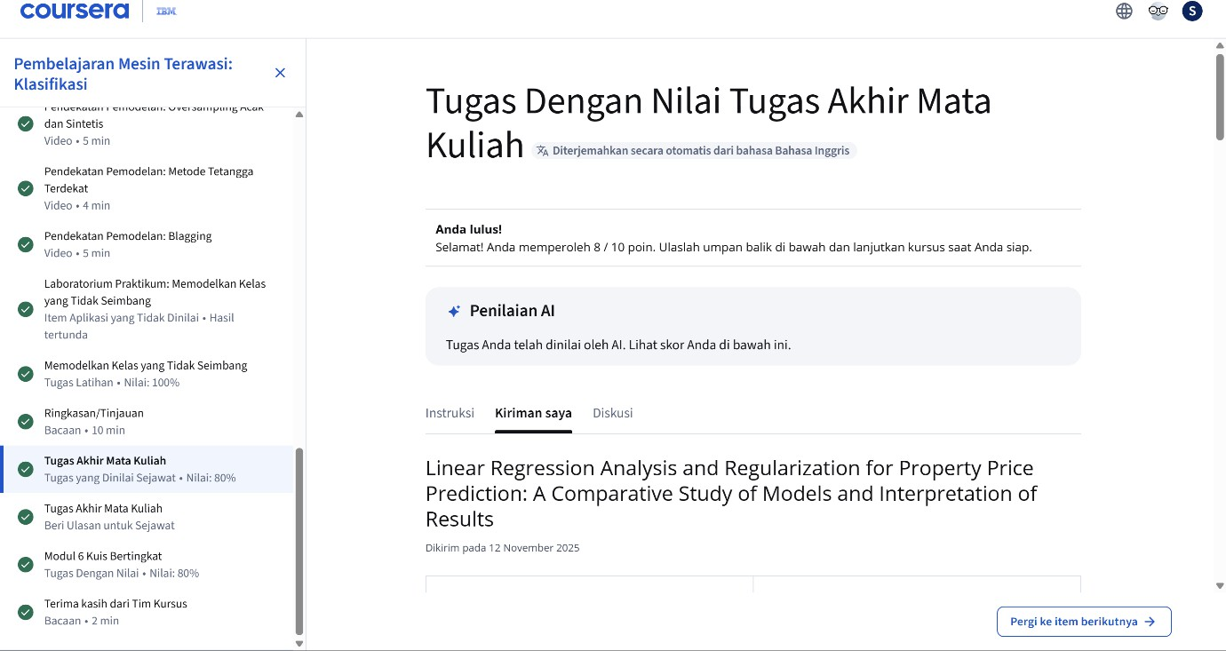
- UNSUPERVISED MACHINE LEARNING
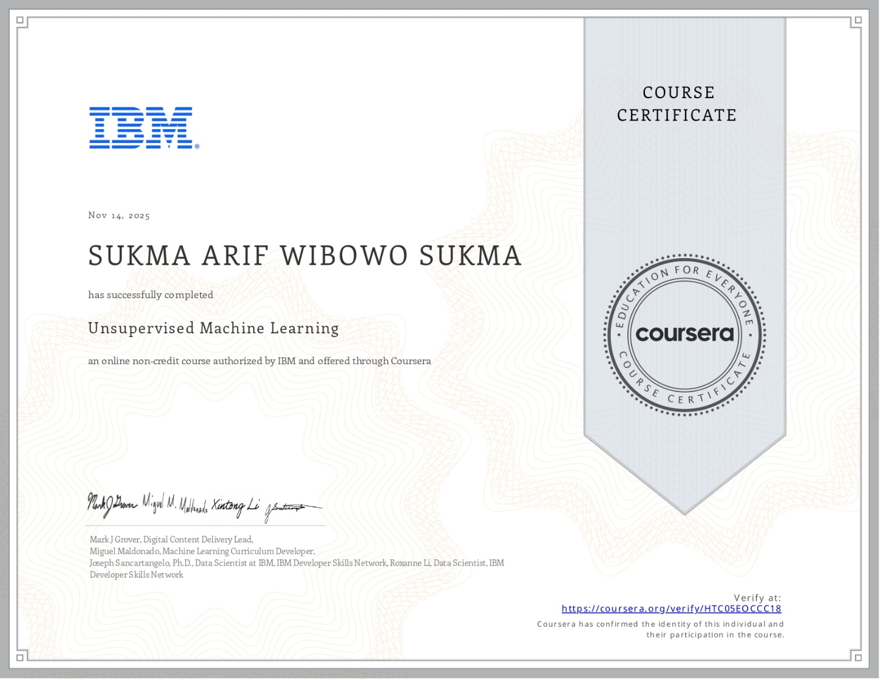
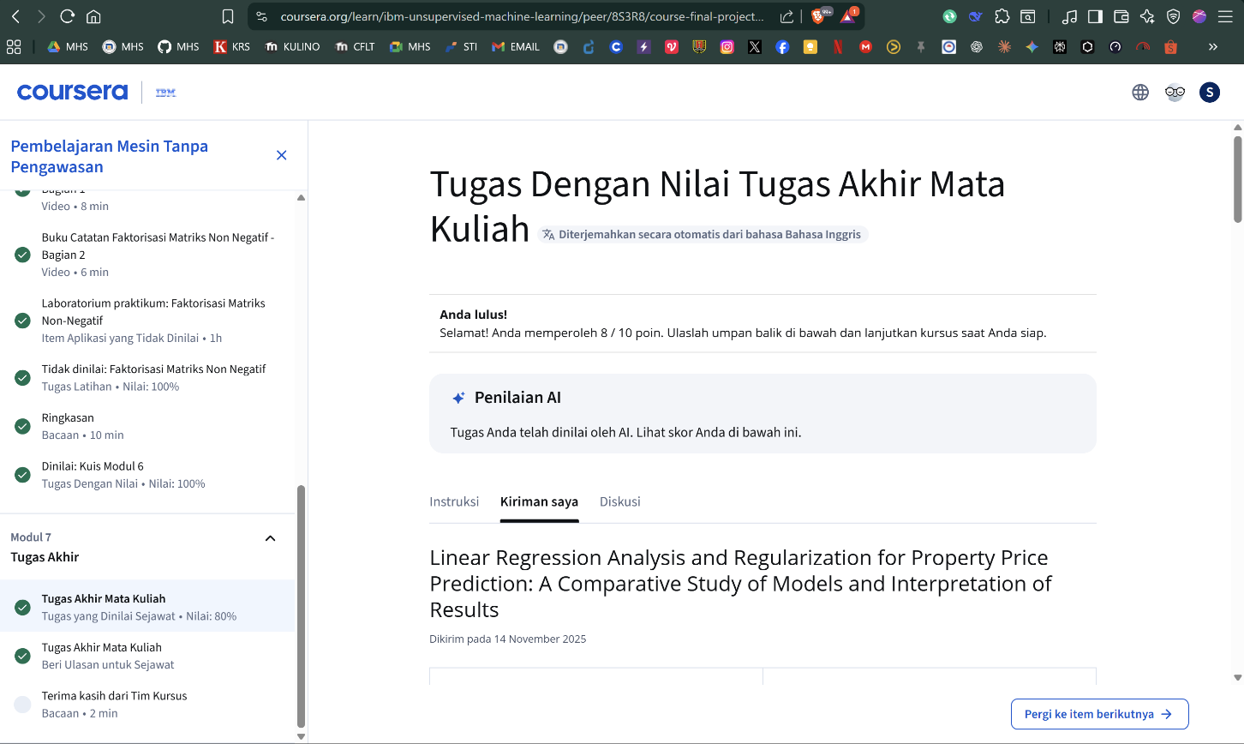

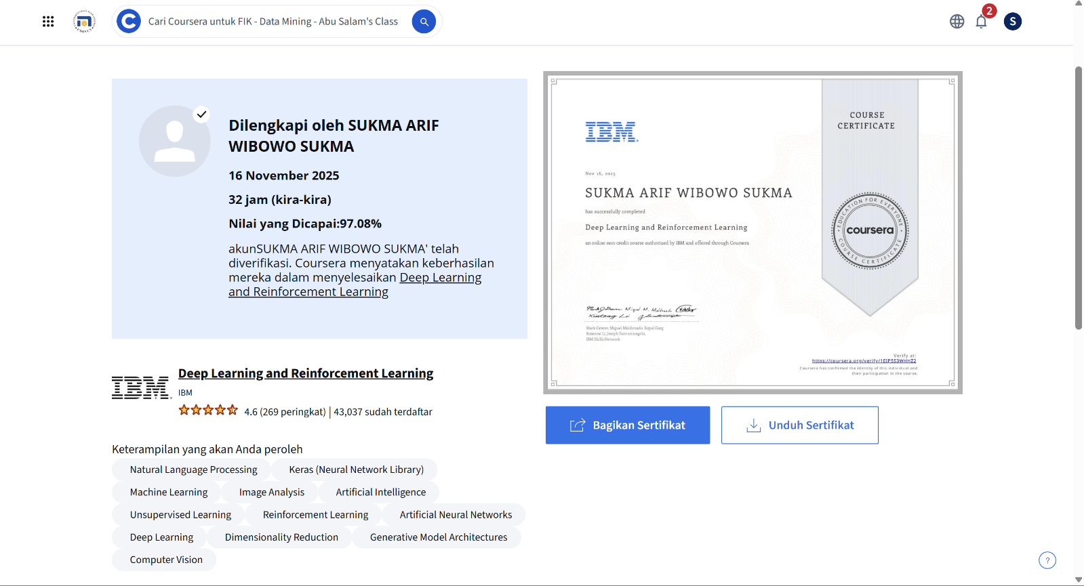
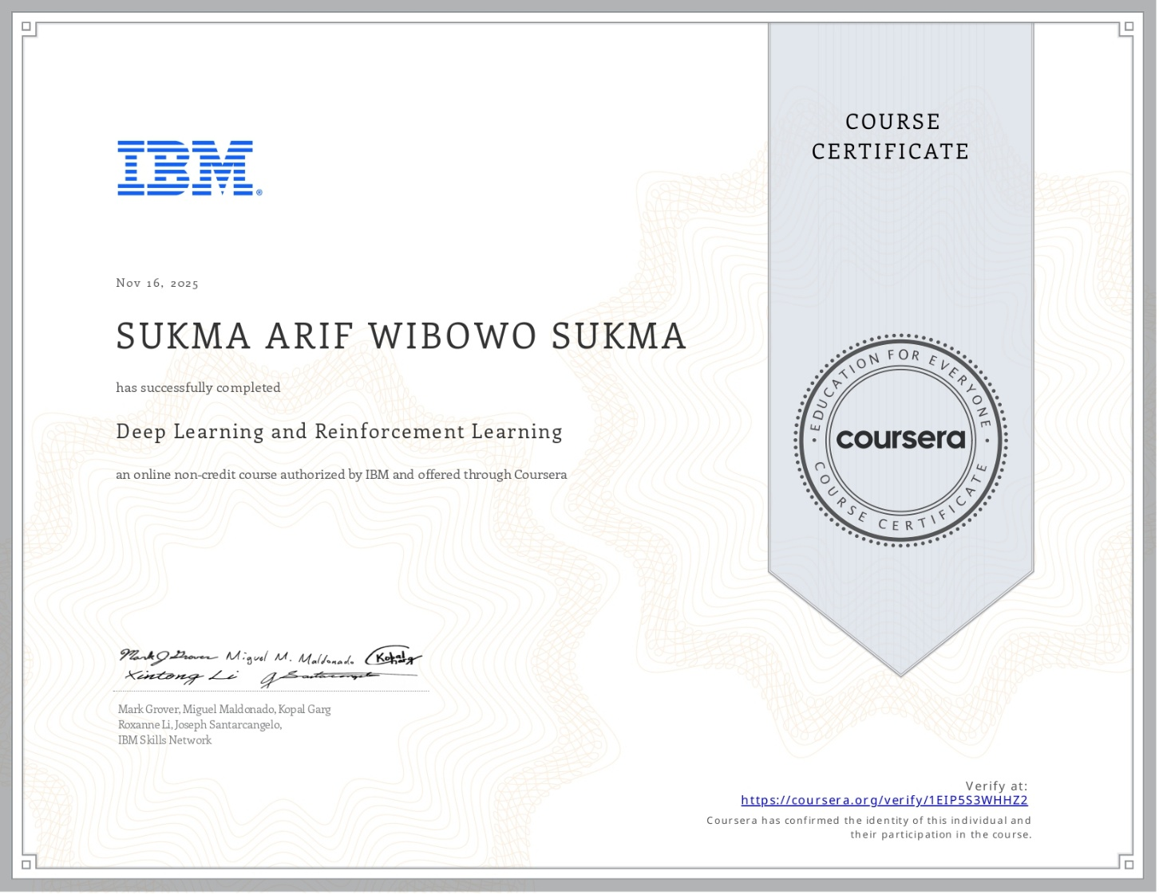
- DEEP LEARNING AND REINFORCEMENT LEARNING
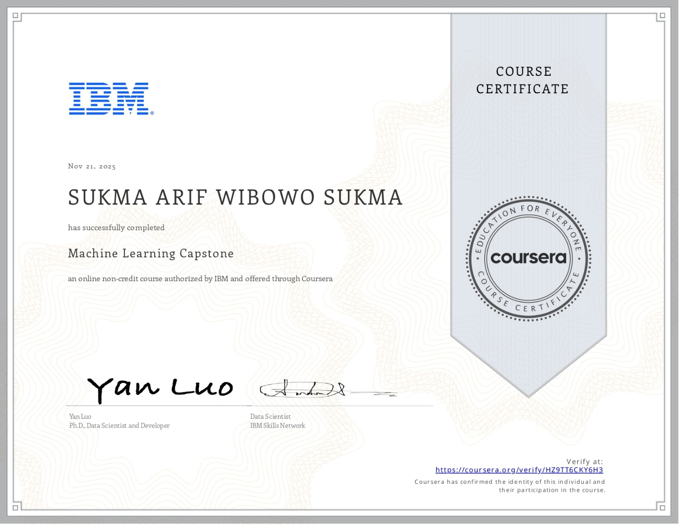
- MACHINE LEARNING CAPSTONE
