**Front End Engineering II**

Project Report 3

Semester-IV (Batch-2022)

SportX Website

**Supervised By: Submitted By:**

Raveesh Samkaria Sukoon, 2210990870, G-13

**Department of Computer Science and Engineering**

## Chitkara University Institute of Engineering & Technology,

## Chitkara University, Punjab

**TABLE OF CONTENTS**

|  |  |  |
| --- | --- | --- |
|  | **TITLE** |  |
|  | **ABSTRACT** | 3 |
| **1.0** | **INTRODUCTION** | 4 |
| **2.0** | **FILE STRUCTURE** | 5 |
| **3.0** | **CODE SCREENSHOTS** | 6 |
| **4.0** | **RESULT SCREENSHOTS** | 20 |

ABSTRACT

This frontend project is an e-commerce website for sports equipment and apparel, built using React, Tailwind CSS, and Framer Motion. The website features a bold and visually striking design with a yellow and black color scheme, prominent hero sections with calls-to-action, and action shots of athletes in various sporting activities.

The homepage design includes sections for highlighting featured products, promotions, and fitness/performance messaging. The e-commerce functionality allows users to browse and purchase products like athletic shoes, apparel, and gear.

The use of React enables a dynamic and interactive user experience, while Tailwind CSS utility classes provide a flexible and maintainable approach to styling the application. Framer Motion is likely used to create smooth animations and transitions, adding to the engaging visual appeal.

The project incorporates modern web development practices, such as component-based architecture and responsive design, to deliver a seamless experience across different devices and screen sizes. The design aims to captivate users, promote the brand's athletic identity, and drive product engagement and sales.

INTRODUCTION

**Technologies and Techniques Employed:**

1. **Tailwind CSS**: The application utilizes the Tailwind CSS utility-first framework for styling, allowing for rapid development and easy customization of the user interface. The tailwind.config.js file is used to configure and extend the default Tailwind settings.
2. **ReactJS:** The website is build using ReactJS, which make it easier for us to reuse components and add dynamicity.
3. **Framer Motion:** With use of framer motion we can easily add animations in react.
4. **Component-Based Architecture**: The application follows a component-based architecture, with reusable components such as dateInput.js for rendering date input fields with a calendar picker, and displayArea.js for formatting and displaying the calculated age information.
5. **Accessibility Considerations**: The application incorporates accessibility best practices, such as proper use of semantic HTML, keyboard navigation, and focus management, to ensure a inclusive experience for all users.

FILE STRUCTURE

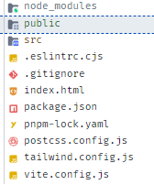

File Structure 1

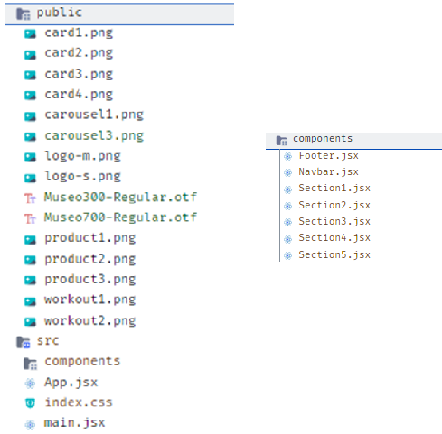

File Structure 2

CODE SCREENSHOTS

Code and preview can also be found at <https://github.com/sukoon870/fee-project-sem4.3/>

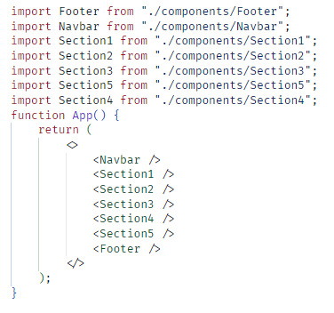

Code 1 – App,jsx

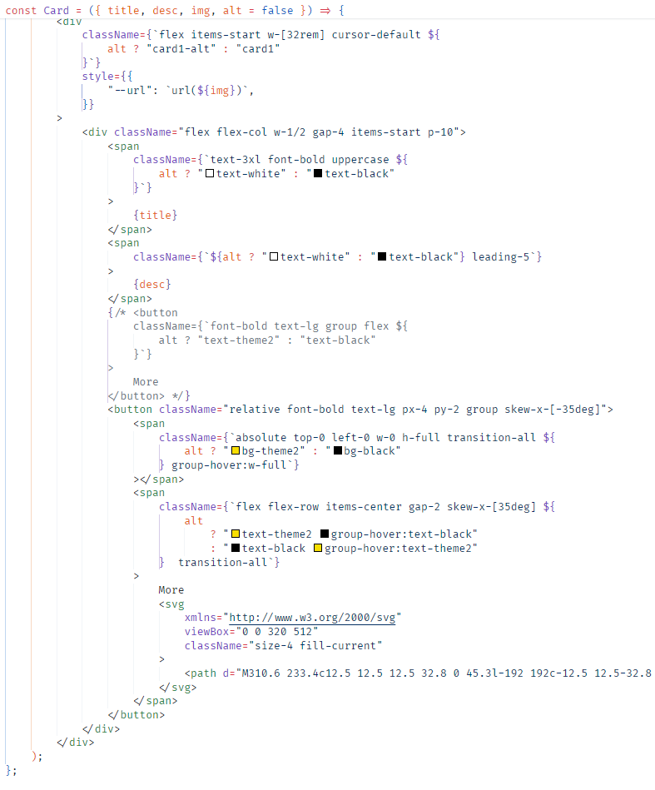

Code 2 – Card1

Code 3 – Section1 -1

Code 4 – Section1 – 2

Code 5 – Section2

Code 6 – Section3

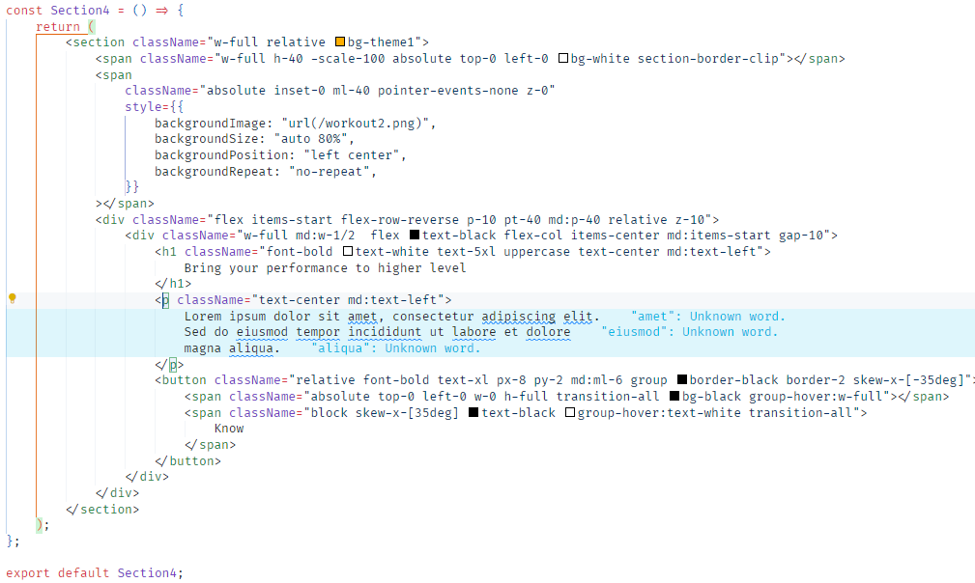

Code 7 – Section4

Code 8 – Section5

Code 9 – Navbar

Code 10 – Footer

RESULT SCREENSHOTS

Preview available at



