Steps With ScreenShots
- Clone repo
- git clone https://github.com/sukrity1/terraform-gitops.git
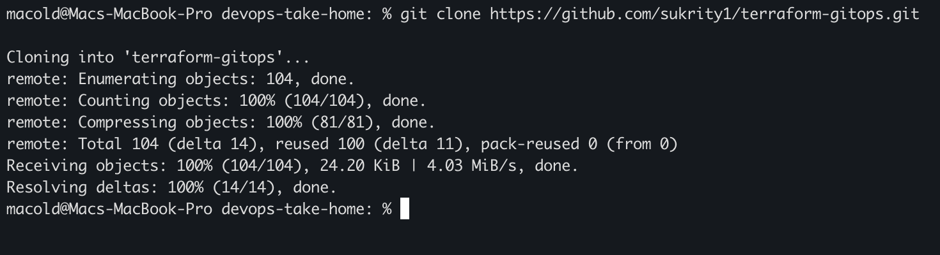

- Bootstrap Dev Environment
- cd terraform-gitops/terraform/bootstrap
- aws login (Best practice to test from local is to use aws configure sso)
- terraform init
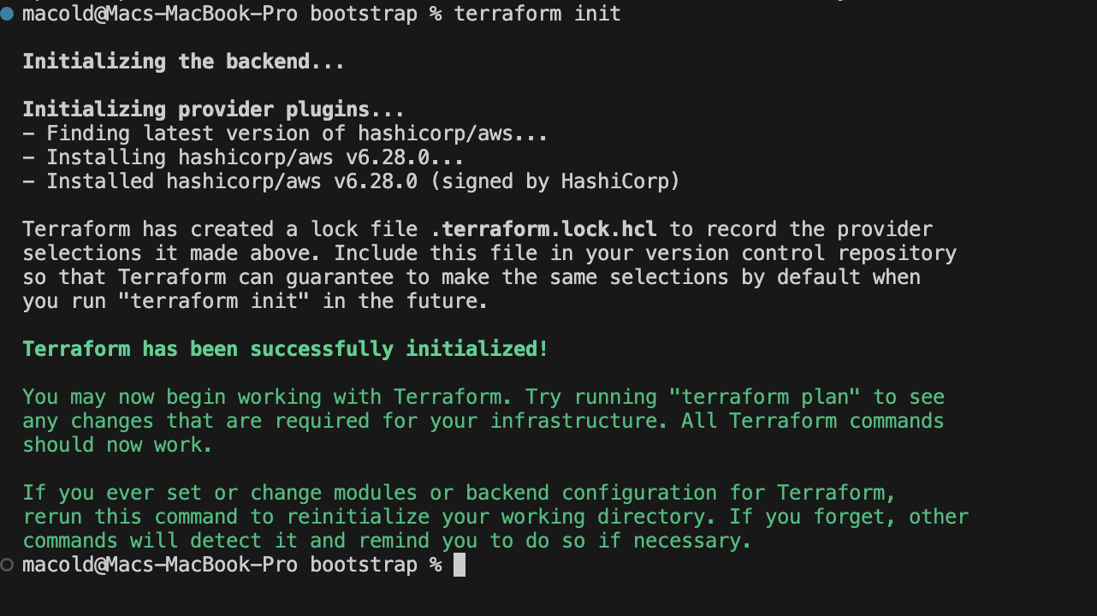

- terraform plan -var-file=tfvars/dev.tfvars
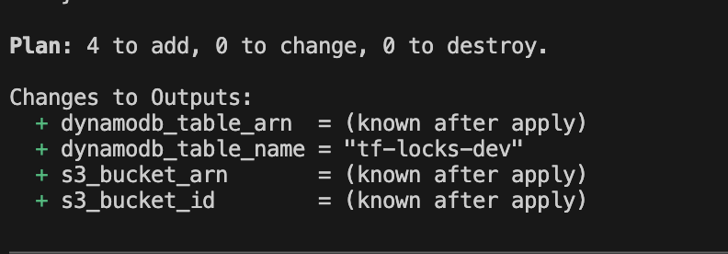

- infracost breakdown --path . --terraform-var-file="tfvars/dev.tfvars"
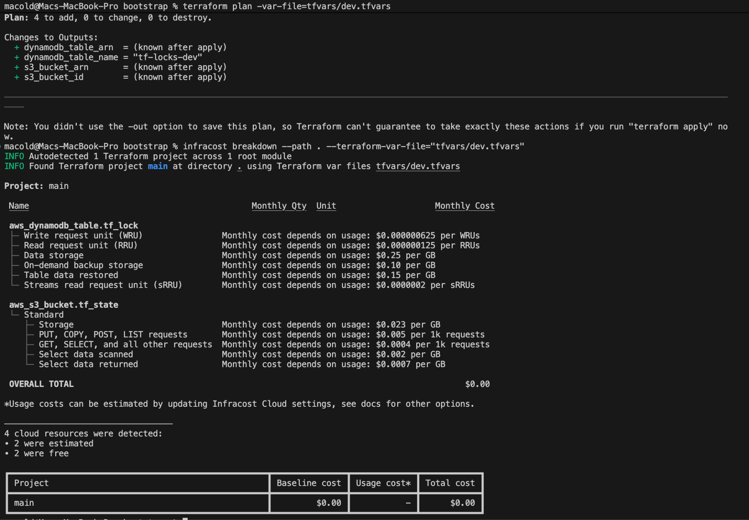

- terraform apply -var-file=tfvars/dev.tfvars
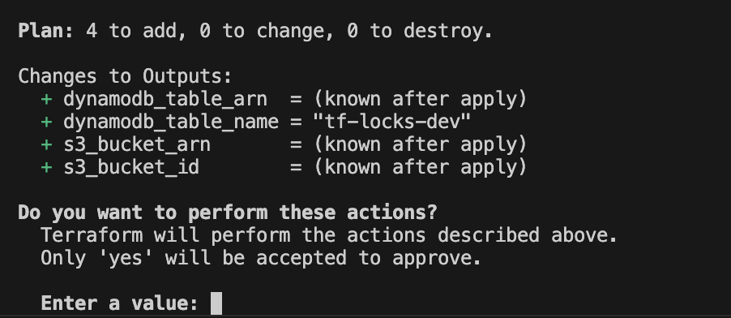

- Setup Dev Environment Infra
- cd terraform-gitops/terraform/resources
- eval $(aws configure export-credentials --profile default --format env)

- terraform init -backend-config=environments/dev/dev.config
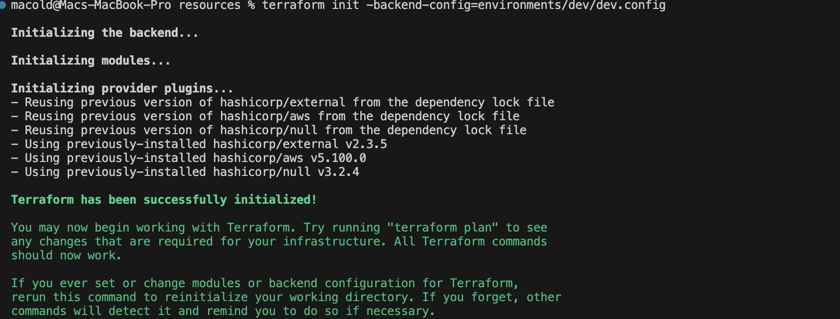

- terraform plan -var-file=environments/dev/dev.tfvars
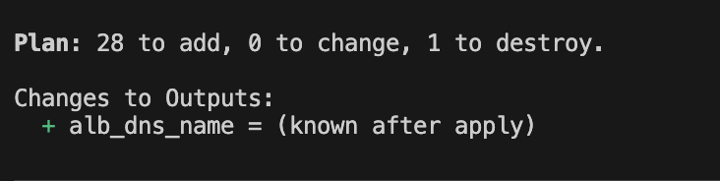

- infracost breakdown --path . --terraform-var-file="environments/dev/dev.tfvars"
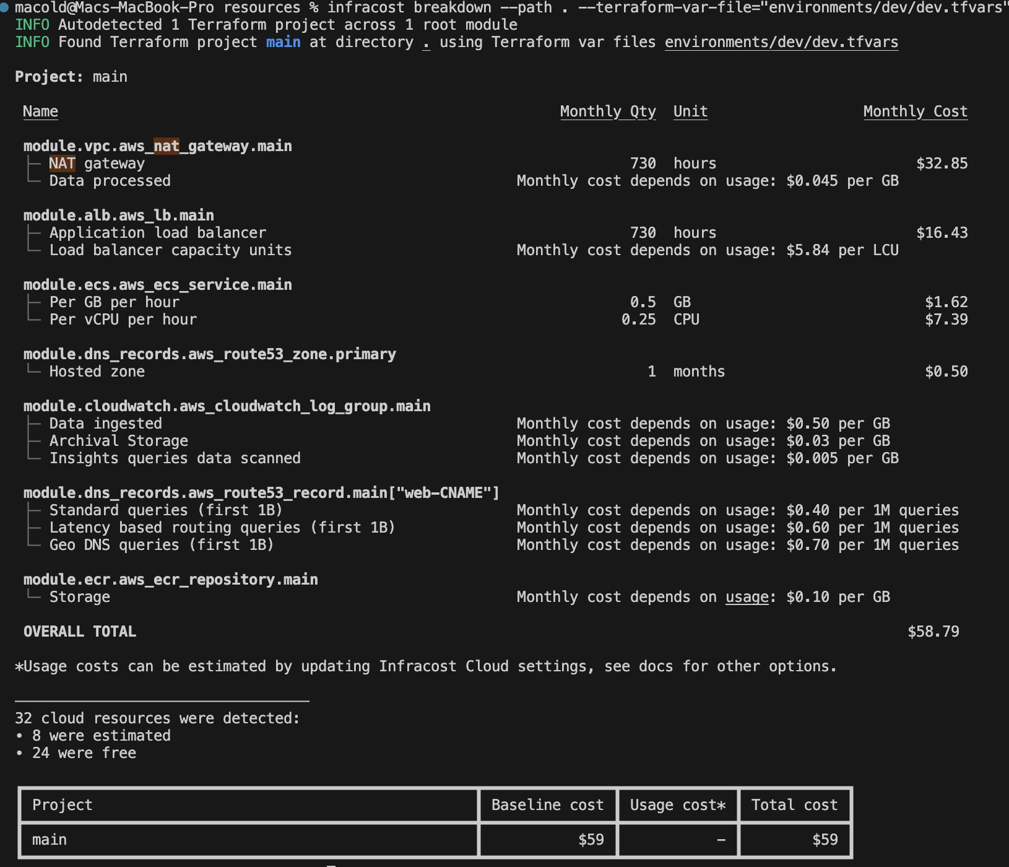

- terraform apply -var-file=environments/dev/dev.tfvars
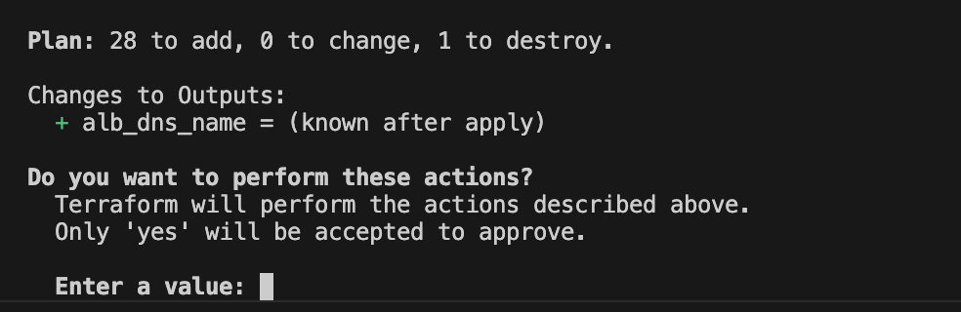

Note :- setup stage/prod Infra just by using configs from their respective env folders
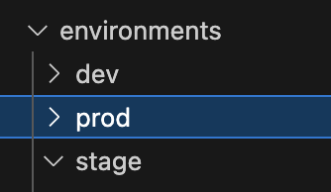

Above steps were tested locally. Github workflow terraform.yml can be used for automatic infra updates if there are any changes in the terraform folder. I will successfully run once credentials & github secrets are configured.

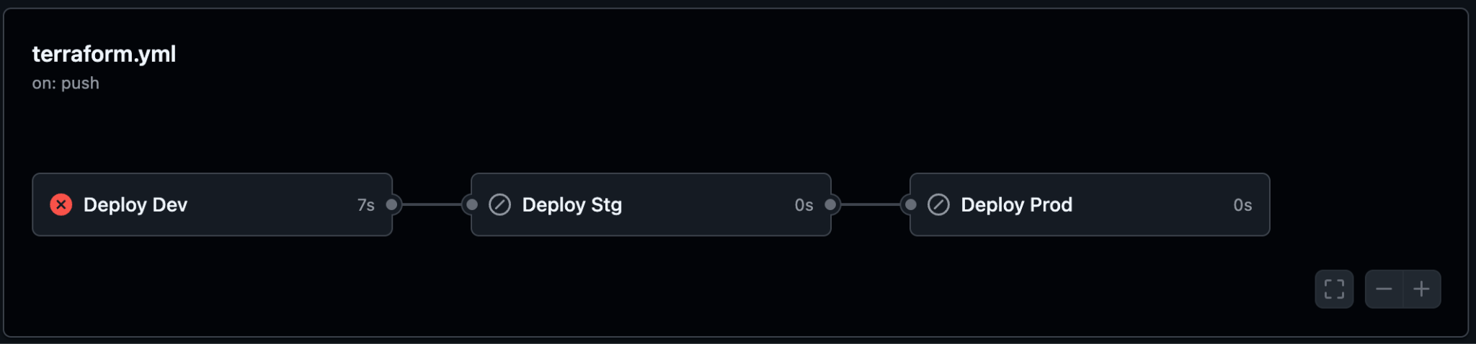

- Setup CI/CD
From Local (Tested Successfully):-
- Build Once :-
docker build -t java-api -f docker/Dockerfile .
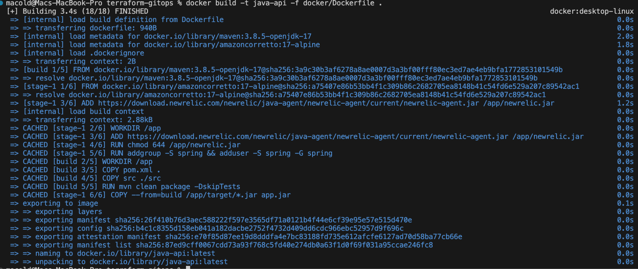

- Deploy linearly on all env :-
- export NEW_RELIC_LICENSE_KEY="<XXX>"

- docker run -e NEW_RELIC_LICENSE_KEY="${NEW_RELIC_LICENSE_KEY}" --name java-app -p 80:8080 my-java-api
App Startup Logs
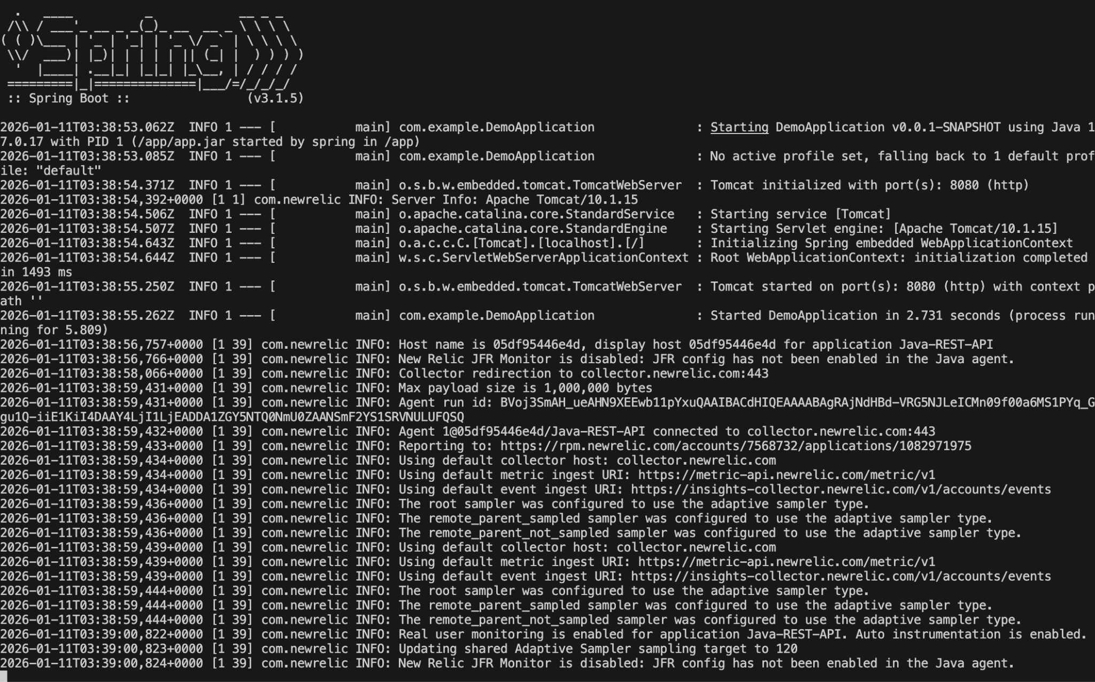
App UI
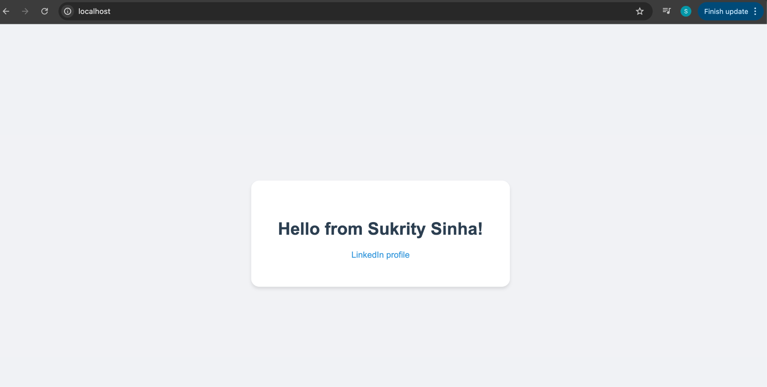
NewRelic APM
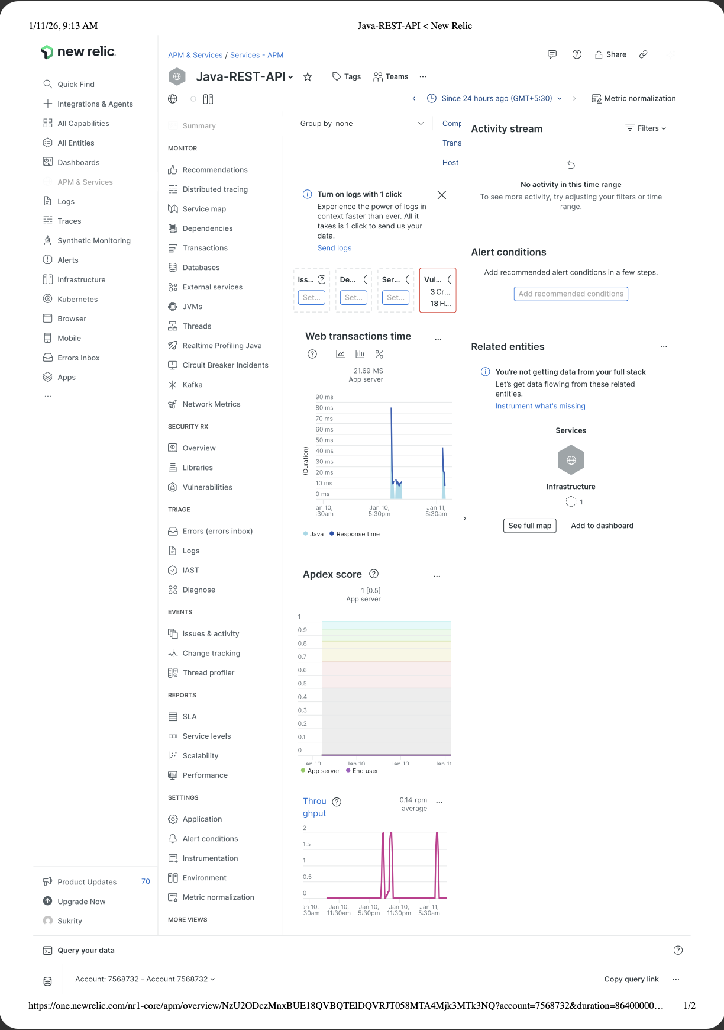

From Github Actions :- Will be successful post terraform apply which will deploy ecr and all environments infra.
