CSE 333 - OPERATING SYSTEMS

Programming Assignment # 1

DUE DATE: 23/11/2020 - 23:59

BONUS MENU PART - RÜMEYSA ÖZTÜRK 150117057

In menu part, the code is written using case structure. When we run the Shell script file, the program wants the user to enter a choice. The program wants input arguments from the user according to programs’ requirements. The choices are the programs that are explained below.

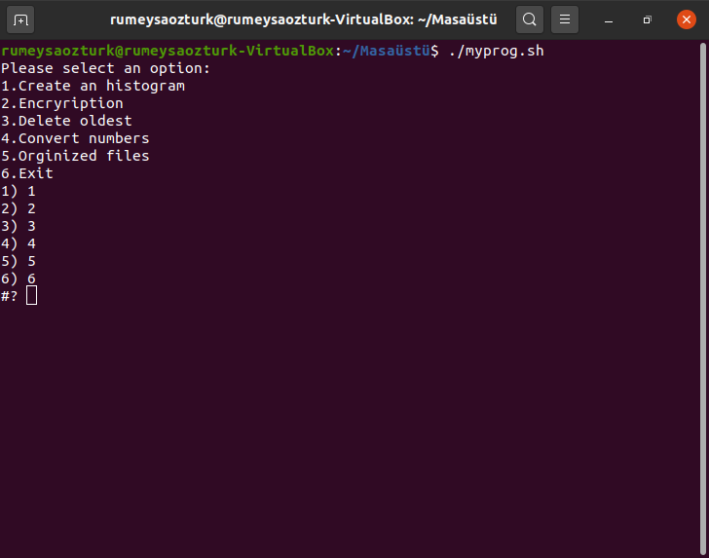

1. BERRA MERCAN 150117034

In this part, when we run the shell script file the program wants an input file, sort the file .Read file context ,count the occurance of number which in 0-9 .For numbers which in not 0-9 give error mesage.

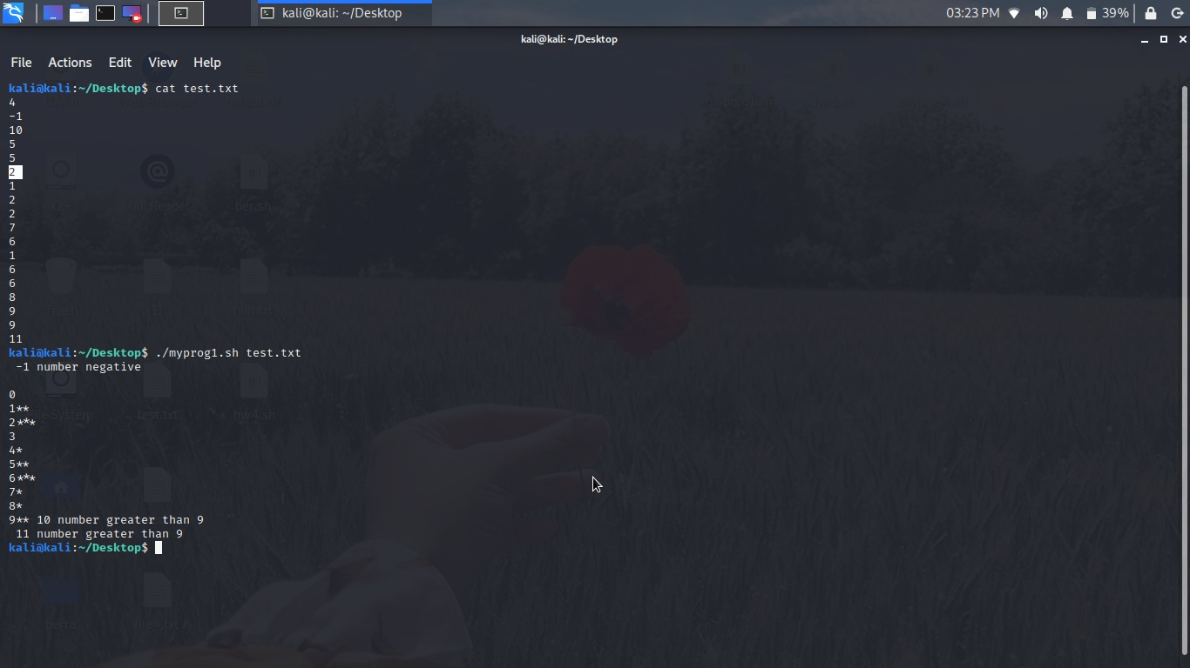

1. RÜMEYSA ÖZTÜRK 150117057

In this part, when we run the shell script file the program wants an input with letters and numbers. The code seperates the letter and number parts of the input and finds another letter in the English alphabet advancing over the alphabet corresponding digit times. The input form must be like this ; the number of letters and numbers in string must be equal or the number of numbers must be 1. Otherwise, the program will give an error mesage.

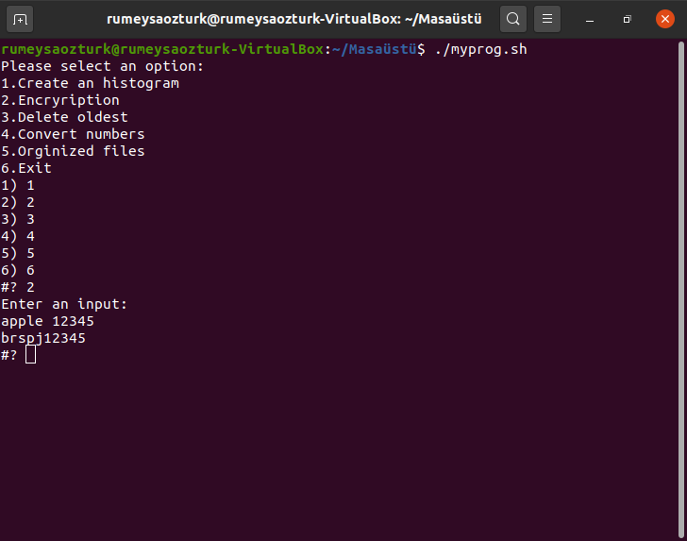

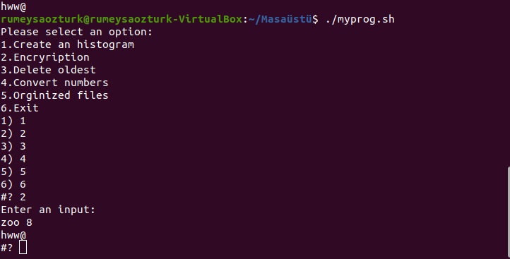

1. ŞÜKRİYE SOYER 150116010

This implementations can find and delete oldest data in an file. Also ask to user delete oldest file. This implementation deletes the oldest file in the file it is in, if input is entered, it deletes the oldest file there.

metin içeren bir resim

Açıklama otomatik olarak oluşturuldu

1. ŞÜKRİYE SOYER 150116010

Firsty read and store the file context in list.If there ıs a integer ,convert integer to character array and change the corrensponding stringand character one by one . I try to covert repeater numbers also convert negative values.

metin içeren bir resim

Açıklama otomatik olarak oluşturuldu

1. BERRA MERCAN 150117034

Read option and wilcard .If without -r option ,find the files which obeys wilcard with **find command and copy the files with cp command.**

If with R option find the subdirectory with **find type -d command and** store the list.make same thing without -R option every subdirectory

metin içeren bir resim

Açıklama otomatik olarak oluşturuldu