Slide 1 – Research
  - Main Cause of AI issues: -
AI systems generate text probabilistically (pattern matching), without true understanding, and can be confidently wrong in ways that neither the system nor the average user can easily detect.
  - ISSUES OF AI -
- Hallucinations - confidently make up false information
- Misinformation - AI can create Fake Data, citations etc
- Bias - Because AI learns from data, it can inherit blind spots.
- context loss in extended conversations
- token width change result in brittleness of Ai output.

  - REAL GEMINI USERS PAIN POINTS (SOURCED FROM GEMINI COMMUNITY):
- Inventing and Defending False Data
- Destructive Loops
- Ignoring Direct User Instructions and Constraints
- Visual Pattern Hallucinations
- Context Abandonment & Truncation
- Tool Function Hallucinations
- Arithmetic Failure, Calculation Deviations

Only 39% of individuals verify AI-generated information using external sources
In a 2025 cross-industry survey,44% of organisations reported experiencing negative consequences from generative AI use, with average financial losses of $4.4 million per incident.

Slide 2 – competitive analysis and real-world mishaps
  - PILLARS OF TRUSTWORTHY AI
- fair/unbiased
- transparent and faith - confidence it is telling the truth
- private - no misuse of shared data
- robust and reliable - consist and adaptable
- explainable and understandability - accessible logic and relevant explanation
- technical competence - the ability to complete complex, specialized tasks and clearly disclose its limits and fallibility
  - DIMENSIONS OF EVALUATION
- clarity (can a regular person understand it?)
- coherence (does it stay consistent throughout?)
- human-likeness (does it sound natural?)
- interpretability (can someone who isn't an expert understand why the AI said what it said?)
  - Evaluation FRAMEWORKS
- TRACE
- ALCE
- RAGBench
- SAFE
- FacTool
- Yours Truly
- franq
  - EXISTING APPROACHES AND THEIR NEGATIVES
- LLM Council - high API costs, increased system complexity, slower generation speeds
- AI to check AI - requirement of reliable dataset for judge AI
- Confidence scores - calibration of confidence is hard
- Adding citations - fake citations by AI, wrong deduction of information
- XAI - Authoritatively wrong explaining, cognitive load on users, wrong deduction of information
- Gemini "Double Check"
- Vertex AI Gen AI Evaluation Service - more of model comparison based on human rubrics, that too only Gemini models, more effort and time required
Users today rely on a mix of gut feeling, manual cross-checking, and simple quality rubrics. whether the tone feels fair and unbiased
users form trust based on fluency, tone, and perceived authority

Slide 3 – user segmentation and opportunity size calculation
  - User Segmentation
- Casual Explorers & Communicators They use AI freely and frequently for low-stakes personal tasks, rarely questioning outputs because nothing critical breaks if it's wrong
- Speed Executors They treat AI as a fast-lane shortcut to get work done, accepting outputs at face value to hit deadlines.
- Structured Builders They direct AI with enough context to get structured deliverables built, but not enough depth to catch the silent logic errors quietly embedded inside them.
- Strategic Thinkers & Professional Validators They bring sharp domain expertise to the table but let AI's polished confidence do the heavy lifting — skimming where they should be scrutinizing, and letting flawed inferences shape real decisions.
- High-Stakes Experts They use AI to handle complexity where errors carry real liability — and while they scrutinize harder than anyone. They operate where a single missed error carries legal, clinical, or financial consequences.
  - Opportunity size calculation
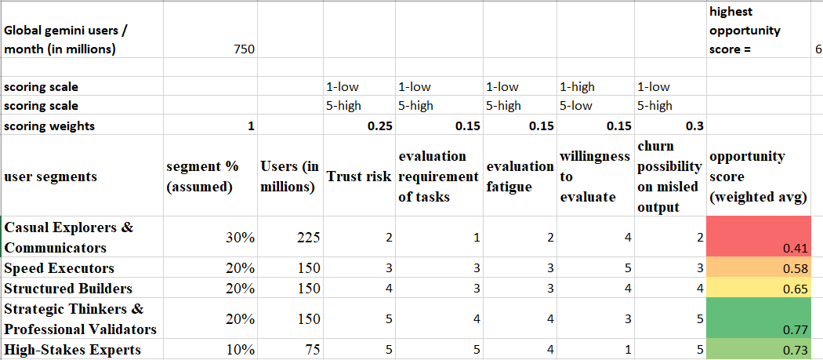
https://docs.google.com/spreadsheets/d/19yZoYp3UcPLABKg05xOFIeKBHo2IdX8GCdiuaGKave0/edit?usp=sharing

Slide 4 – User interviews and target segment
  - User Interviews
User persona 1
Avinash, 34, Bengaluru,
Senior Solution Consultant, infrastructure & cloud practice, 10 years in IT consulting, primarily enterprise digital transformation
Psychographic - Analytical, highly detail-oriented, and risk-averse when it comes to client deliverables. Operates in high-pressure, time-poor environments
AI Literacy: High. Understands how large language models function fundamentally and uses advanced prompting techniques.
Gemini Usage: Drafting technical architecture documents and SOWs; comparing technology stacks and vendor capabilities; summarising large procurement documents to extract key deliverable requirements.
What he trusts: Responses that align with his technical knowledge clear his first-pass review quickly.
What he questions:
- Specific technical claims he can cross-reference against his own expertise.
- Recommendations that feel incongruous with the stated use case or appear without justification.
- When Gemini makes a technical claim outside his immediate expertise area, he has no signal for how much weight to give it
Pain Points
- Gemini quietly drops a compliance requirement mid-session
- Tonal uniformity of Gemini's outputs —The uniformity forces him into a full manual audit of every deliverable, turning a productivity tool into a productivity tax.
Goals and needs
- Clear inline distinction between logically derived claims and inferred or assumed claims, so review effort can be allocated intelligently
- A mechanism to flag when a response deviates from constraints or requirements
User persona 2
Utkarsh, 36, Bengaluru,
Presales Manager, SaaS company, 13 years in presales and solution consulting
Psychographic: Strategic, highly competitive, and persuasive. Focuses heavily on framing, positioning, and dismantling competitor claims. Highly organized.
AI Literacy: High. Actively looks for ways to automate repetitive workflows and integrate AI into daily sales operations.
Gemini Usage: drafting tailored solution narratives for specific client verticals; Churns through massive Request for Proposal (RFP) documents
What he trusts: Structural completeness and strategic coherence.
What he questions:
- He manually verifies competitor data points before including them.
- Pricing-adjacent figures and technical specifications that directly touch a client's stated hard requirements.
What he fail to notice:
- The subtle abandonment of constraints
- outputs are highly susceptible to the danger of hidden inferences
- missing false underlying assumptions about competitor capabilities
Pain points
- he cannot tell whether the AI logically deduced a competitor's weakness or confidently hallucinated it
- A technically plausible recommendation that violated a hard compliance constraint
- The effort required to verify fabricated or uncertain claims scales poorly against his high-volume workload — he either slows down or accepts risk
Goals and needs
- A system to efficiently build competitive pitch decks with zero risk of fabricated product claims or compliance breaches
- A contradiction alert when a response violates a hard constraint, with a clear, user-controlled resolution path.
- A way to verify factual claims of market and competitors.

  - Task based observation
Observation 1 - Pavan Kumar
Marketing Manager — Sprint Planning for Phase 2 Deployment
Task: Build a sprint plan for the Phase 2 deployment of a campaign analytics dashboard for project X
- He had given AI access to all his work documents, G-drive, Gmail, Jira, Meeting notes, PRDs, etc.
- Designed a detailed prompt mentioning sprint completion time, available resources, and end goal.
- Gemini produced a well-formatted, visually clean sprint plan.
- The sprint plan come up too optimistic. Time and resources were not properly mapped.
- Several items were ambiguous and vague
- He rewrote the prompt with even more detail — pace, task-splitting logic, better reasoning of task instructions, and explicit callouts of what was missed the first time.
- Regenerated, reviewed, found more mistakes, prompted for corrections, and ended up partially designing the sprint himself.
Pain points
- Missing supporting assumptions and rules led to a structurally wrong plan
- Significant extra time and effort spent rewriting the prompt, with no guarantee of a correct output on the next pass
- Vague and ambiguous items were presented with the same formatting confidence as concrete, well-reasoned ones
Goals and needs
- Produce a feasible, implementation-ready sprint plan without manually aggregating data
- A method that surfaces the assumptions and inferences, so he can validate the reasoning, not just the output
- AI that explicitly lists the requirements it identified from his inputs and checks the generated output against them

Observation 2 - Sandeep
HR – June 2026 appraisal report
Task: Create the company's May monthly appraisal report.
- Uploaded several files — employee salary data, employee self-assessment docs, manager appraisal reviews, department budget docs, etc.
- Submitted a prompt to create the May appraisal report
- AI generated a clean document with tables and structured blocks
- He skimmed through the revised salary figures for verification as that is on top of his head.
- Noticed the report was too employee-focused and submitted a follow-up prompt to incorporate company financials
- Sent only the company finances section to the finance team for approval before submitting the full report
Pain points
- The output had a perspective bias — it defaulted to an employee lens without surfacing critical organisational dimension
- Sandeep only caught the gap because he noticed the absence himself; had he not, it would have gone out incomplete
- He only verified the salary figures because those were salient to him — calculations and reasoning for other sections went entirely unchecked
Goals and needs
- AI should actively surface the completeness and coverage of the output
- Calculations and reasoning chains should be visible and verifiable as the user just checked the final results and proceeded.

  - Target Segment
Strategic Thinkers & Professional Validators
  - Reason
Own scoring model makes the case — they score 0.77
They sit at the exact intersection of high trust stakes and a broken verification instinct
Highest trust risk + willingness to evaluate. They want to validate, but currently lack the right tools to do it efficiently.
If an exec or consultant gets burned by a flawed AI-generated analysis, they don't come back. This segment shapes organizational AI adoption decisions.
  - Unmet needs
- Claim evaluation with less efforts and time
- Clear inline distinction between logically derived claims and inferred or assumed claims, so review effort can be allocated intelligently
- A contradiction alert when a response violates a hard constraint, with a clear, user-controlled resolution path.
- A way to verify factual claims
- AI that explicitly lists the requirements it identified from his inputs and checks the generated output against them
- AI should actively surface the completeness and coverage of the output
- Calculations and reasoning chains should be visible and verifiable

Slide 5 – Survey analysis and user journey
Step | User Phase | Emotion | User Journey | AI Journey
1 | Discovery / Entry | Curious, Hopeful | User accesses Gemini on Laptop | Gemini app loads, authenticates session, initializes model context
2 | Problem Framing | Frustrated (with original problem), Motivated | User encounters a problem and seeks AI-driven solution | No AI action — idle, awaiting input
3 | Engagement | Focused, Uncertain (did I prompt well?) | User writes and submits a prompt with relevant context | Gemini receives raw input, tokenizes text, processes attached files or knowledge
4 | Anticipation | Curious, hopeful | User waits for response generation | Model interprets intent, routes to appropriate model, builds context window
5 | First Impression | Surprised or Disappointed | Gemini returns output (text, code, images, etc.) | Model generates response via next-token prediction, renders output in appropriate format
6 | Evaluation – Surface | Analytical, Skeptical | User validates output for completeness and context (Round 1 validation) | No AI action — awaiting user signal
7 | Decision Point | Confident (if exiting) or Doubtful (if iterating) | User iterates or exits early or trust the output and moving to Step 11 | Gemini receives follow-up prompt, retains conversation history as context
8 | Re-engagement | Cautiously Optimistic | Gemini returns refined output | Model re-inferences using updated prompt + prior context window
9 | Evaluation – Deep | Critical, Deliberate | User validates for factual accuracy and reasoning (Round 2 validation) | No AI action — awaiting user signal
10 | Feedback & Trust Calibration | Empowered or resigned | User signals feedback via thumbs up/down while continuing to refine if needed | Feedback logged; prompt edits trigger new inference cycle
11 | Resolution | Accomplished or defeated | User downloads, exports, copies, or abandons | Session context cleared or saved; feedback signals fed to model improvement loop

  - User Survey Analysis
Survey response - https://docs.google.com/spreadsheets/d/1LWWHflBuqL7SvkdEk2oTH3Eue2ydHBhNUh4c1obvsTQ/edit?usp=sharing
Inference from Survey
What They Trust: Users trust surface-level heuristics—specifically, response length/completeness and structural formatting (bullet points, bold text). They also rely heavily on historical momentum and lower their guard when operating under tight deadlines or dealing with lower-stakes tasks.
What They Question: Users heavily scrutinize conversational consistency (detecting when the model contradicts its own previous responses within the same chat session) and obvious factual anomalies that run counter to their prior knowledge. When errors occur, users prefer an iterative "co-editing" relationship (manually correcting or re-prompting) over immediate abandonment.
What They Fail to Notice: Users are systematically blinded by authoritative tone and prolixity. Lengthy, highly structured responses serve as an accidental "cloaking device," burying fundamental flaws, missed situational nuances, and false underlying assumptions deep inside polished walls of text.

Slide 6 – problem analysis
Problem statement
"Gemini users lack an efficient way to verify AI-generated outputs which require more effort and time from users, causing them to skim responses and unknowingly propagate errors downstream."
  - How do we know the problem is real?
Real incidents - A staggering 44% of organizations have already suffered negative consequences—averaging $4.4 million in losses per incident
User Survey proves that our target segment is systematically blinded by Gemini's polished, authoritative formatting and lengthy outputs
  - Why solve this problem right now for target customers?
In today’s high-volume, time-poor corporate environments, the effort required to spot subtle context abandonment scales horribly, forcing users to either slow down drastically or swallow catastrophic compliance risks.
  - Why solve this problem right now for Gemini business?
With increase in AI at high stake works output trust matters most and when denied right evaluation the business will shift to other providers. Improved user evaluation betters the engagement and increases retention
  - What is the value of solving this?
It shifts the target segment's behaviour from a skeptical, high-friction manual cross-checking loop into a seamless, high-velocity "co-editing" relationship that keeps them locked into the Gemini ecosystem.

Slide 7– Solution ideation and proposed solution and reason for choosing
Solution focus area – Text based responses
Solution scope – Engagement & Retention
  - Solution ideation
- Vector Insights - A breakdown showing semantic segments of the user’s input and uploaded files for users to understand on what context the output was generated.
- Guardrail Layers - An automated evaluation layer that scrutinizes the AI's reasoning against industry-specific rulebooks to provide a domain-alignment check.
- Consistency Ledger - A session-based memory tracker that logs all assumptions and logical claims to ensure subsequent responses do not contradict prior statements.
- Deduction Trees - A structured deduction tree visualizing the User requirement, assumptions, tool selection, boundaries, uncertainties and AI's logic.
- Outcome Rubrics - A dual-validation framework that breaks a prompt into micro-tasks, generates success criteria, and audits the final answer against those metrics.
- Automated Stress-Testing - A self-interrogation loop where the AI launches simulated user "quiz tests" against its own output to uncover hidden logical or mathematical flaws.
  - Proposed Solution
Stateful Ledger = Consistency Ledger + Outcome rubrics (partial) + Gemini “G” double verification
A dual-layer, automated verification engine that evaluates Gemini’s outputs concurrently against session-based memory ledger and real-world facts. By automatically flagging contextual contradictions and tagging responses, it eliminates logical drift, minimizes user cognitive load, and verification fatigue.
Justification for choosing the proposed solution
- Directly addresses Above user pain points
- no model changes, no new infrastructure
- Self-audited checklist lets users instantly spot gaps without reading full output
- Already Present of Gemini “G” dual verification.

Slide 8 – Detail Orientation in the Proposed Solution

  - 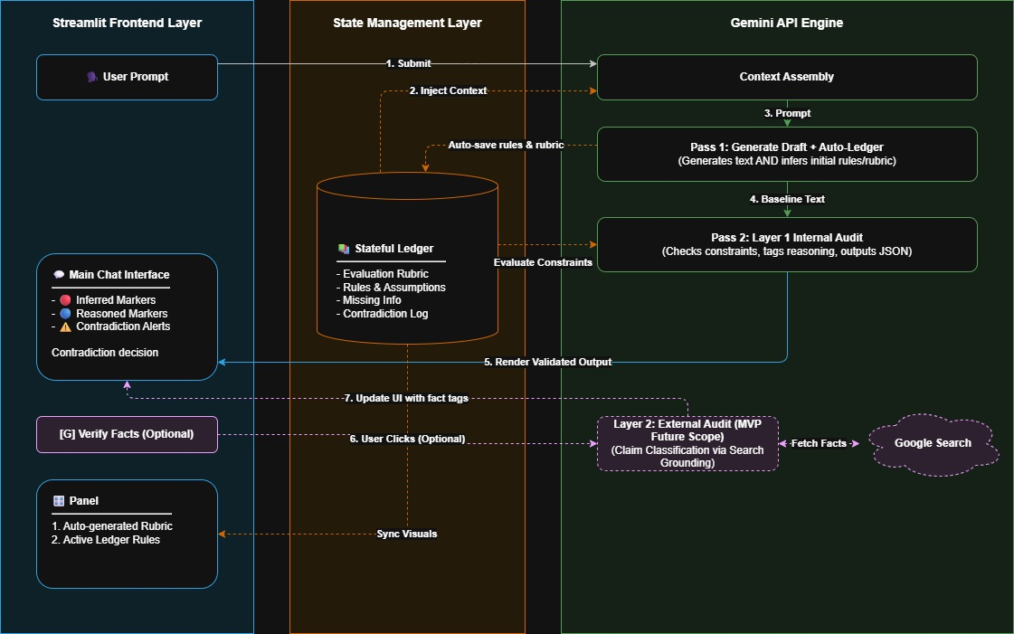

  - Layer 1- Internal Audit (always on)
WHAT THE LEDGER TRACKS
Evaluation Rubric — A set of quality dimensions (e.g. Logical Coherence, Factual Accuracy, Completeness) auto-generated from the user's first message and used to score every response that follows.
Active Rules — Boundary conditions the conversation must not violate (e.g. scope constraints, stated assumptions). Auto-seeded on session start; user-editable at any time.
Active Assumptions — Implicit beliefs the AI is operating on, surfaced explicitly so users can challenge or invalidate them.
Missing Information Registry — Gaps in the AI's response that reduce answer quality
Contradiction Log — A record of instance where a response conflicts with an established rule. Stays open until the user resolves it.
WHY TRACK IT
By anchoring every response to a persistent record of what has been established, what has been agreed, and what has been assumed, the system prevents the AI from contradicting its own reasoning and prevents users from unknowingly inheriting errors buried in polished, authoritative-sounding text.
EVALUATION LOGIC
Every AI response goes through a mandatory internal audit before it reaches the user.
Once Gemini generates a response, a second dedicated audit pass evaluates it against every active rule, every active assumption, and every rubric dimension tracked in the Ledger.
This audit is run at zero-variance to ensure consistency. It outputs a structured verdict: which rules were satisfied or violated, which rubric dimensions were covered or missed.
Every sentence in an AI response is classified as either Reasoned or Inferred. This distinction is rendered visually in the chat, inline, on every turn. Users no longer have to guess which parts of a response are solid and which are the model filling in gaps.
When a contradiction is detected, the Ledger marks the violated rule and a banner appears in the chat with three explicit options:
- Accept the response anyway — the rule stays active and the deviation is logged.
- Override the rule — the user provides a reason; the rule is updated and the Ledger records the change.
- Flag for later review — the contradiction stays open in the log, visible on every subsequent turn.
The system flags. The user decides.
  - Layer 2 — External Grounding; Gemini “G” double check concept (user-triggered; not built in this MVP)
A single click on "Verify Facts" sends the response's factual claims to Google Search. Each claim is classified as: Grounded (confirmed by search), Contested (multiple credible sources disagree), or Unverified (no search evidence found). The user chooses when to invoke it.
When a response scores highly on internal logic — appearing well-reasoned and consistent — but external grounding reveals that 30% or more of its claims are actively contested by credible sources, the system triggers a high-severity "Overconfidence Divergence" alert.
The user is shown both the AI's internal confidence and the external reality — and they decide what to do with the gap.

Slide 9 – Metrics and critique of proposed solution
  - Metrics
NSM - % of sessions with a satisfied action after engaging with the Stateful Ledger

This NSM tracks the successful user engagement with the new feature

Leading metrics
L1
# of clicks/edits on ledger panel (individual: rubric, rules, assumptions, missing info, contradiction log)
Contradiction resolve rate
# of “G” double verification click rate
Inferred to Reasoned ratio
% of cross actions per session

L2
Avg time to resolve a violation/contradiction
Avg rubric scores
Avg # of turns in a conversation before satisfied action
Avg time between AI response to next Stateful action
Avg # of contradictions per response
% of satisfied action sessions

Guard rail
Avg Response time
Avg # of contradictions/ violations per session, Avg # of contradictions per response
Re-prompt rate

  - Critique
- High value for chosen segment users; accelerates user productivity
- model grades its own work — bias toward self-approval
- better for multi turn conversations
- no ledger disable option may turn off the users

