Invoice Processing Process Improvement Project

Executive Summary
The current invoice process includes manual data entry and email-based approvals, resulting in processing delays, errors and time consuming. This project will show an automated way of invoice processing workflow using Optical Character Recognition (OCR), automated validation and real time status which will improve the efficiency and reduce approval cycle time.

Business Problem Statement
After analyzing the current invoice processing workflow, the following challenges were identified:
- Depending more on manual data entry
- Mail based approvals
- Delay in Processing
- Increase in errors
- Lack of visibility of status
- Increase in duplicity
- Time consuming – approx. 5 days for approval

Business Objectives
- Reduce the approval cycle from 5 days to 2 days
- Automate the process to minimize manual errors.
- Implementing Real time Status updates
- Reduce duplicate invoice processing.
- Improve invoice tracking and visibility

Scope
In Scope:
- Invoice Submission
- Invoice Validation
- Approval workflow
- Payment processing
- Status tracking
Out of Scope:
- Vendor onboarding
- ERP replacement
- Contract Management
- Procurement process changes

Stakeholder Analysis

Stakeholder | Role
Vendor | Submit Invoices
Accounts Payable team | Process Invoices
Manager | Approve invoices with high value
Finance team | Process payments
System Administrator | Maintain system

AS-IS Process Overview

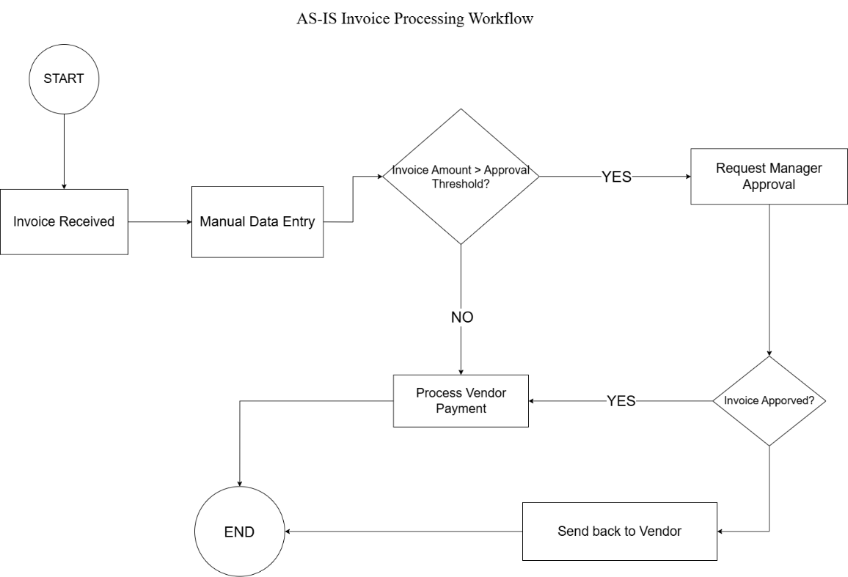

The AS-IS BPMN diagram illustrates the current invoice processing workflow. The process begins when an invoice is received from a vendor. Invoice details are manually entered into the system and reviewed based on approval thresholds. High-value invoices require manager approval before payment processing, while rejected invoices are returned to the vendor for correction.

Gap Analysis
Process Step | Current State | Issue | Impact
Invoice Entry | Manual entry | Human errors | High
Approval Process | Email/manual approval | Delays | High
Invoice Tracking | No centralized tracking | Poor visibility | Medium
Duplicate Validation | Manual verification | Duplicate payments risk | High
Approval turnaround time | Approx. 5 days | Slow processing | High

TO-BE Process Overview
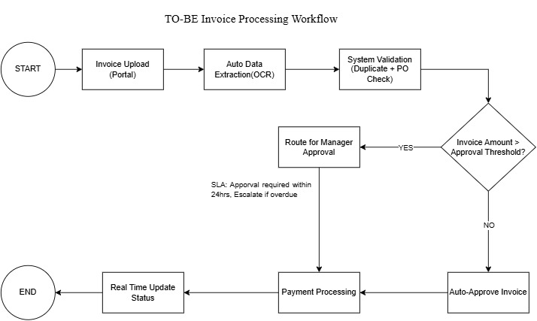

The TO-BE workflow begins with invoice submission through a vendor portal. OCR is used to automatically extract invoice details, followed by automated validation checks and workflow-based approval routing. SLA monitoring and real-time status updates improve visibility and processing efficiency while reducing manual effort.

Functional Requirements

ID | Requirement
FR- 01 | System shall allow invoice upload through portal
FR-02 | System shall extract invoice details using OCR
FR-03 | System shall validate duplicate invoices
FR-04 | System shall route invoices based on approval thresholds
FR-05 | System shall provide real-time status updates
FR-06 | System shall escalate overdue approvals

Non-Functional Requirements

ID | Requirement
NFR-01 | System availability shall be 99%
NFR-02 | Response time shall be less than 30 seconds
NFR-03 | System shall maintain audit logs
NFR-04 | User authentication shall be required

Expected Benefits

KPI | Current State | Future State
Approval Time | 5 Days | 2 Days
Manual Entry | High | Low
Visibility | Low | High
Duplicate Risk | High | Low
Approval Cycle TIme | 5 Days | 2 Days

Conclusion
The proposed TO-BE invoice processing workflow addresses the key challenges identified in the AS-IS process, including manual data entry, approval delays, limited visibility, and duplicate invoice risks.
By introducing the portal-based invoice submission with the use of OCR driven data extraction, automated validation, workflow-based approval, SLA monitoring and real time status tracking, will make the process more efficient and reliable.
This solution is expected to reduce the approval cycle time from Approx. 5 days to 2 days, improve the data accuracy, enhance process visibility and provide a better experience for the internal teams and vendors.
Overall, this redesigned workflow will support operational efficiency, improved compliance and better process control.

