TravelMemory
MERN Deployment Guide
AWS EC2 | Ubuntu 22.04 | Node.js | React | Nginx | MongoDB Atlas
Deployment region: US East (N. Virginia) — us-east-1
Architecture: 2 frontend EC2 instances + 2 backend EC2 instances
Prepared: November 2026

Document contents
1. Setting MongoDB Atlas
2. Pre-requisites for preparing the setup
2.1 VPC creation
2.2 Subnet configuration
2.3 IGW & Route table
2.4 Security group
2.5 Two Ubuntu 22.04 instances
3. Configure the backend master instance for backend
3.1 Installing packages
3.2 Creating backend .env
3.3 Configuring systemd travelmemory-backend.service
3.4 Configuring Nginx as reverse proxy
4. Configure the frontend master instance for frontend
4.1 Installing packages
4.2 Configure frontend and Nginx
5. Preparing the base image template AMI
6. Launch instance from AMI image
7. Create target group for frontend and backend
8. Create ALB for frontend and backend
9. Point frontend at the backend load balancer

1. Setting MongoDB Atlas
MongoDB Atlas is used as the database for the TravelMemory application. The backend connects to Atlas using a MongoDB connection URI stored in the backend environment file.
- Open MongoDB Atlas and create or select a cluster.
- Under Database Access, create a database user and securely record the username and password.
- Under Network Access, configure an IP access rule that permits the EC2 backend instances to connect.
- Select Connect → Drivers and copy the MongoDB connection string.
- Replace the placeholders with the database user, password, cluster hostname, and database name travelmemory.
MONGO_URI=mongodb+srv://<username>:<password>@<cluster-host>/travelmemory?retryWrites=true&w=majority

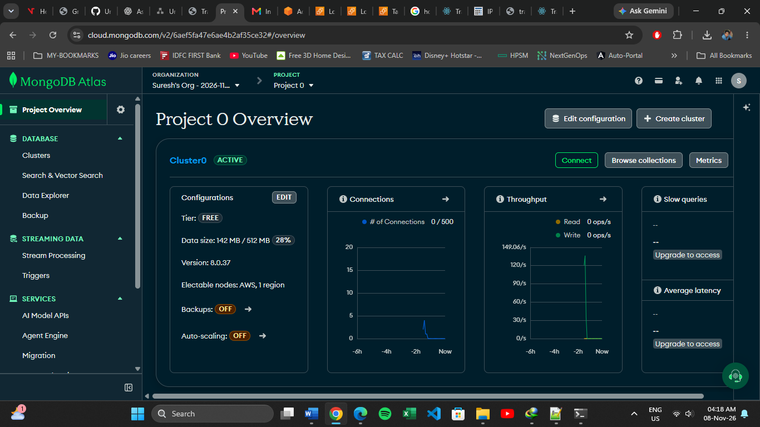
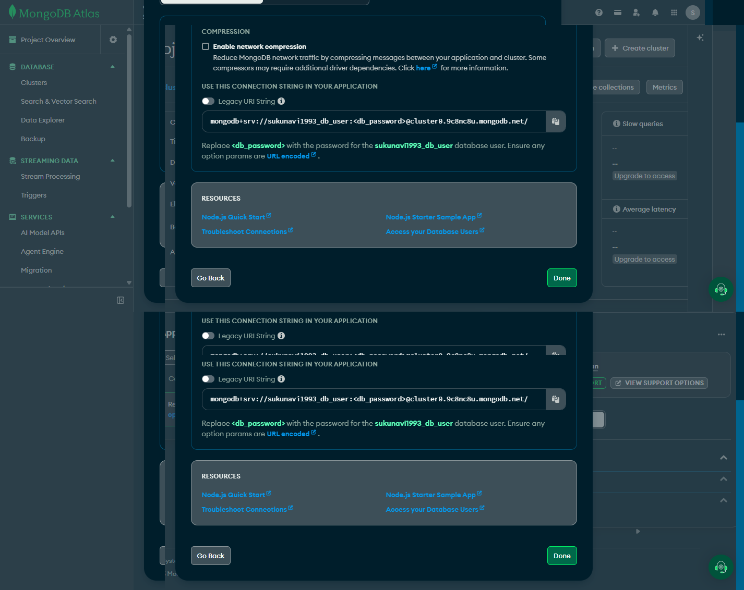

2. Pre-requisites for preparing the setup
The deployment uses one VPC with four subnets in separate Availability Zones. Two as private subnet and 2 as public subnets. The two master EC2 instances are launched first and later used to create AMIs.

2.1 VPC creation
In the AWS Console, open VPC → Your VPCs → Create VPC. Create a VPC for the TravelMemory deployment.
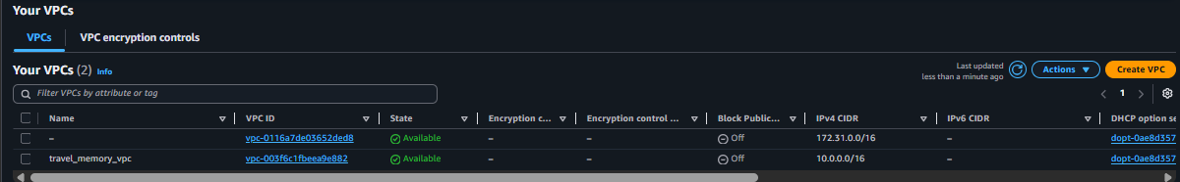
The VPC ID shown in the deployment console was vpc-003f6c1fbeea9e882.

2.2 Subnet configuration
Create two non-overlapping subnets within the VPC and place them in different Availability Zones so the Application Load Balancers can use two zones.
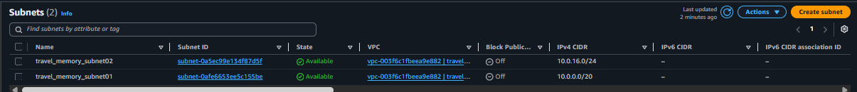
The AWS ALB detail screenshots later displayed the load balancers using us-east-1b and us-east-1d. Confirm the current subnet-to-AZ association in the VPC console if reproducing the setup; the ALB screenshot is the evidence of the final selected ALB zones.

2.3 IGW & Route table
Internet Gateway used for internet routing for public subnets.
- Open VPC → Internet Gateways and confirm an IGW is attached to travel_memory_vpc.
- Open Route Tables and identify the route table associated with the public subnets.
- Add or confirm the default route 0.0.0.0/0 with target set to the attached Internet Gateway.
- Associate the public route table with the subnet(s) intended for internet-facing ALBs.
- Enable auto-assign public IPv4 on an EC2 subnet only if instances in that subnet need public IPv4 addresses.
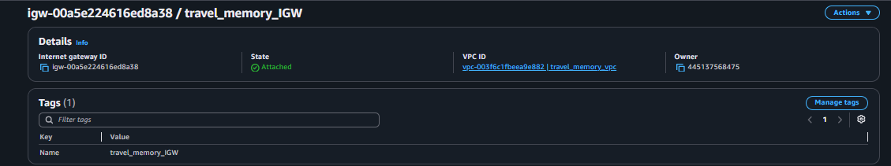
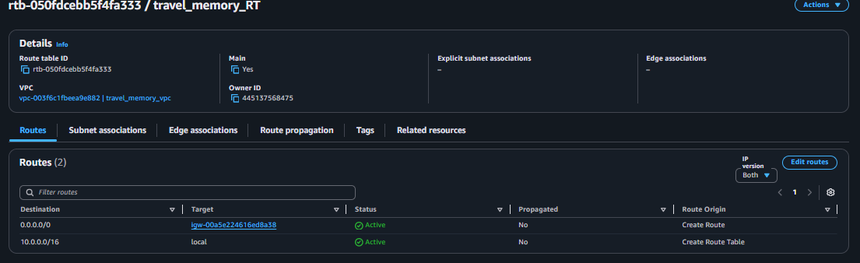

2.4 Security group
Create or select security groups for the load balancers and EC2 instances. A recommended tiered rule design is shown below;
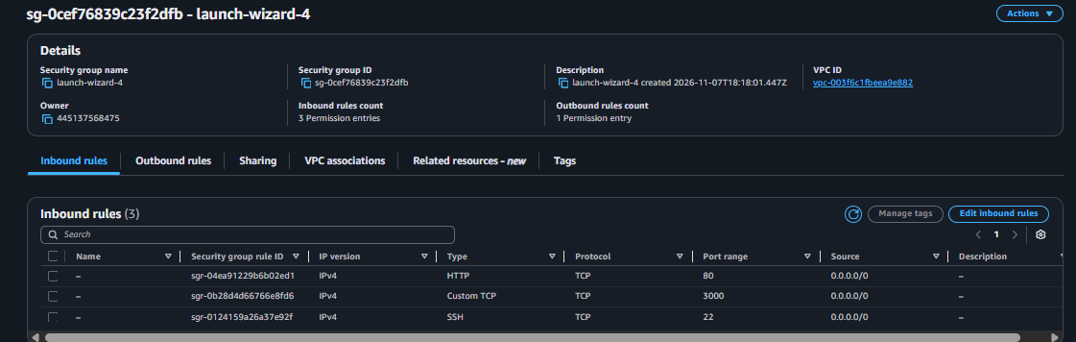

2.5 Two Ubuntu 22.04 instances
Launch the initial two Ubuntu 22.04 EC2 instances:
- backend-master — initial backend template instance.
- frontend-master — initial frontend template instance.

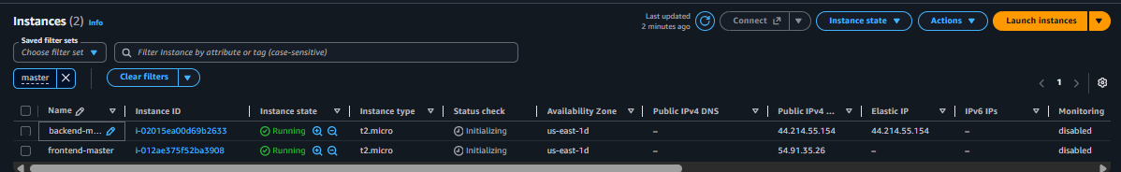

ssh -i <your-key.pem> ubuntu@<instance-public-ip>

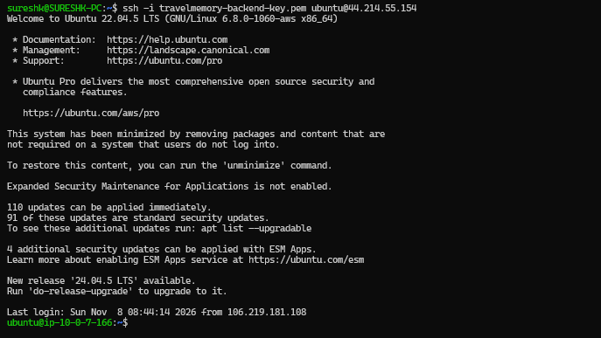

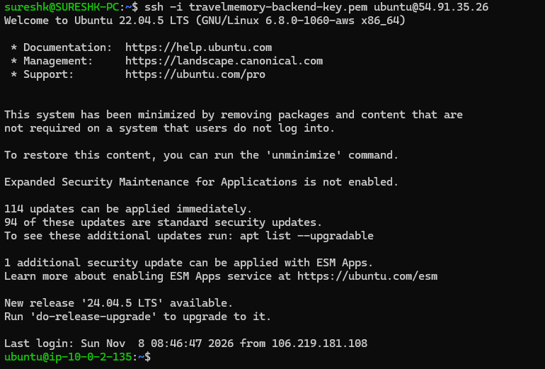
The deployment was configured in AWS Region us-east-1. The initial instances were used as the base for the AMIs created later.

3. Configure the backend master instance for backend
Perform the backend installation and configuration on backend-master first. Once verified, the instance is used to create the backend AMI.

3.1 Installing packages
sudo apt update
sudo apt install -y nodejs npm git nginx
git clone https://github.com/UnpredictablePrashant/TravelMemory.git
cd TravelMemory/backend
npm install
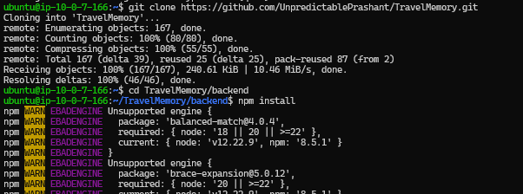
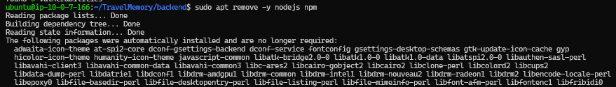
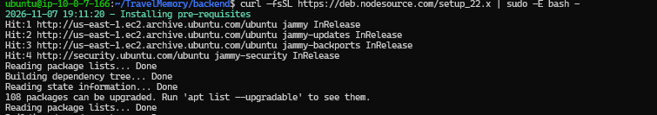
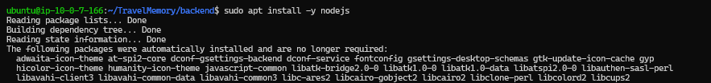
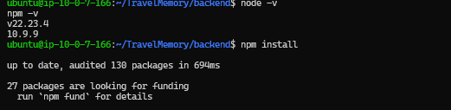
The initial Ubuntu package version of Node.js was not compatible with the project's dependency requirements. During this deployment, Node.js was upgraded; the final terminal screenshot shows Node.js v22.23.4.

3.2 Creating backend .env
Create the .env file inside the backend directory. It contains the MongoDB connection URI, application port, and CORS origin.
cd ~/TravelMemory/backend
nano .env
MONGO_URI=<MongoDB-Atlas-connection-string>
PORT=3000
CORS_ORIGIN=http://<frontend-ALB-DNS-name>
Use the actual frontend ALB DNS name for CORS_ORIGIN after the frontend ALB is available. Do not add a trailing slash or URL path. The same CORS setting must be present on backend-2. Keep the .env file private and do not commit it to Git.

3.3 Configuring systemd travelmemory-backend.service
systemd manages the Node.js backend process. It starts the service during boot and restarts it if the process exits.
sudo nano /etc/systemd/system/travelmemory-backend.service
[Unit]
Description=TravelMemory Backend
After=network.target
[Service]
Type=simple
User=ubuntu
WorkingDirectory=/home/ubuntu/TravelMemory/backend
EnvironmentFile=/home/ubuntu/TravelMemory/backend/.env
ExecStart=/usr/bin/node index.js
Restart=always
RestartSec=5
[Install]
WantedBy=multi-user.target
sudo systemctl daemon-reload
sudo systemctl enable --now travelmemory-backend
sudo systemctl status travelmemory-backend
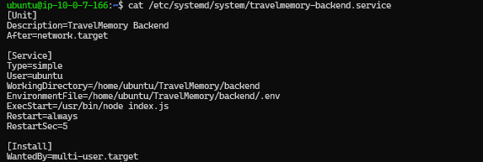
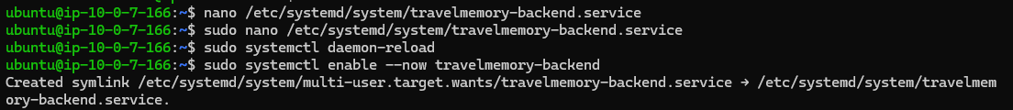
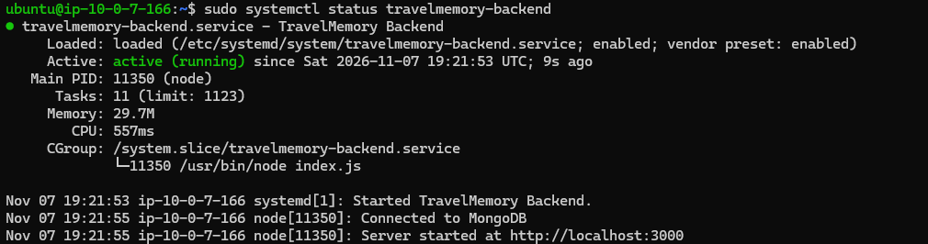
Expected validation: Active (running). The service log should show a successful MongoDB connection and the backend listening on localhost:3000.
Important: do not start a second manual node index.js process while the systemd service is active. It will fail with EADDRINUSE because port 3000 is already in use. Use systemctl status/restart to manage the service.

3.4 Configuring Nginx as reverse proxy
Nginx listens on HTTP port 80 and forwards requests to the Node.js backend on localhost port 3000. Edit /etc/nginx/sites-available/default and configure the location block:
location / {
proxy_pass http://localhost:3000;
proxy_set_header Host $host;
proxy_set_header X-Real-IP $remote_addr;
proxy_set_header X-Forwarded-For $proxy_add_x_forwarded_for;
}
sudo nginx -t
sudo systemctl restart nginx
sudo systemctl status nginx
Test the backend locally:
curl -i http://localhost:3000/hello
The captured test returned HTTP/1.1 200 OK and Hello World!. The backend service log also showed Connected to MongoDB.
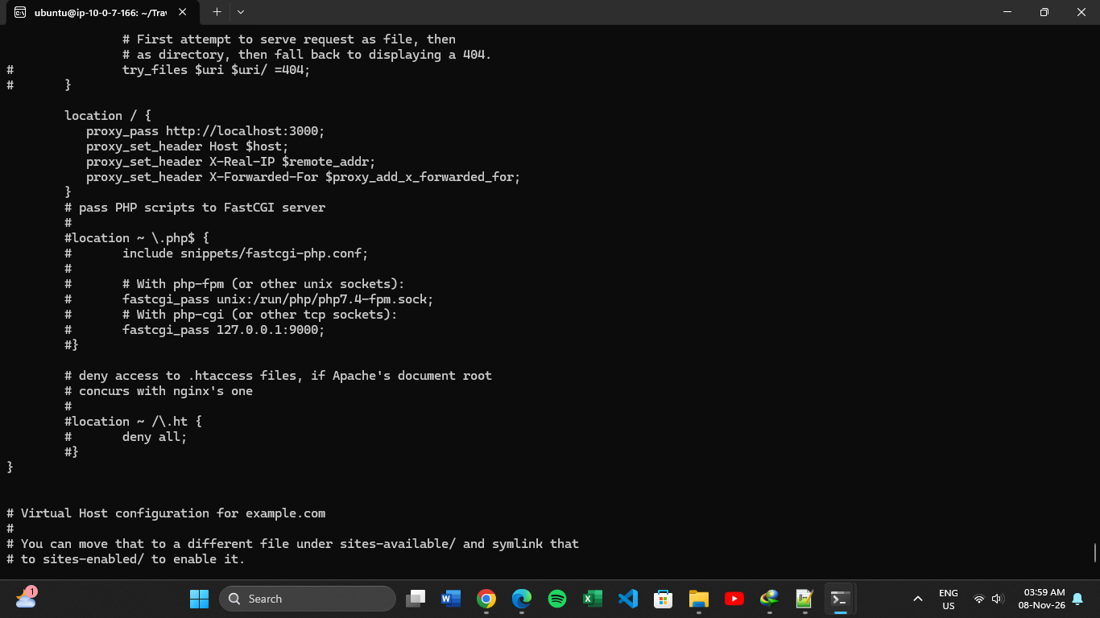
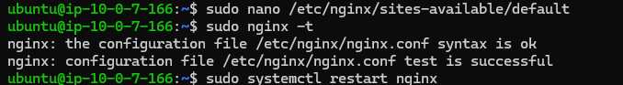
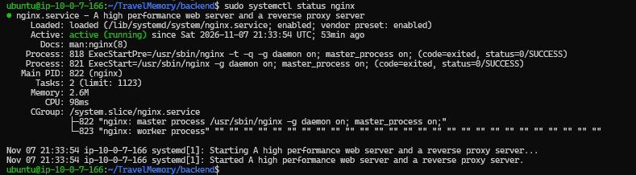
Figure 2. Backend systemd and Nginx services active; MongoDB connection log.
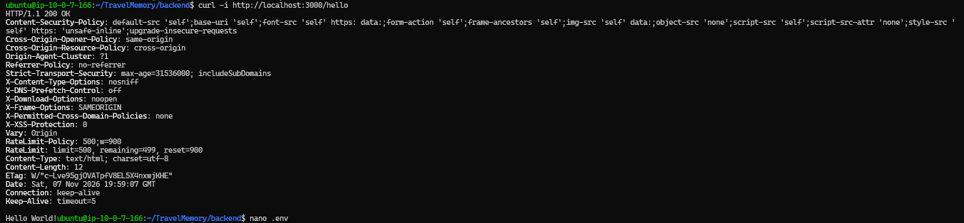
Figure 3. Backend /hello API test returns HTTP 200 OK.

4. Configure the frontend master instance for frontend
Configure the React frontend on frontend-master. The frontend build is served by Nginx.

4.1 Installing packages
sudo apt update
sudo apt install -y nodejs npm git nginx
git clone https://github.com/UnpredictablePrashant/TravelMemory.git
cd TravelMemory/frontend
npm install
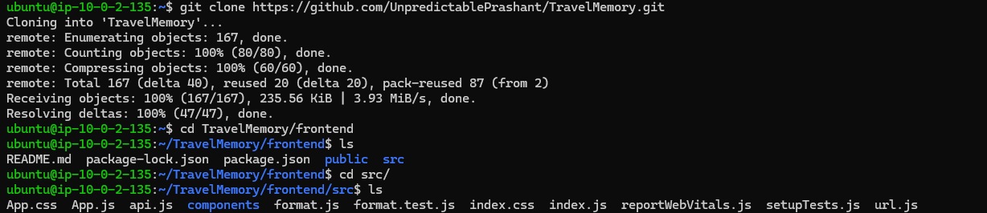
Install the project dependencies using npm. The browser application is built into static files and served by Nginx.

4.2 Configure frontend and Nginx
Edit src/url.js and configure the backend endpoint. Initially the guide uses the backend master public IP for baseline testing. After the backend ALB is created, update the URL to the backend ALB DNS name.
export const baseUrl = "http://<backend-ALB-DNS-name>";
Build and publish the frontend:
npm run build
sudo rm -rf /var/www/html/*
sudo cp -r build/* /var/www/html/
sudo systemctl restart nginx
sudo systemctl status nginx
Repeat the same configuration and build on frontend-2 after it is launched. In the captured terminal screenshot, src/url.js points to the backend ALB DNS name.
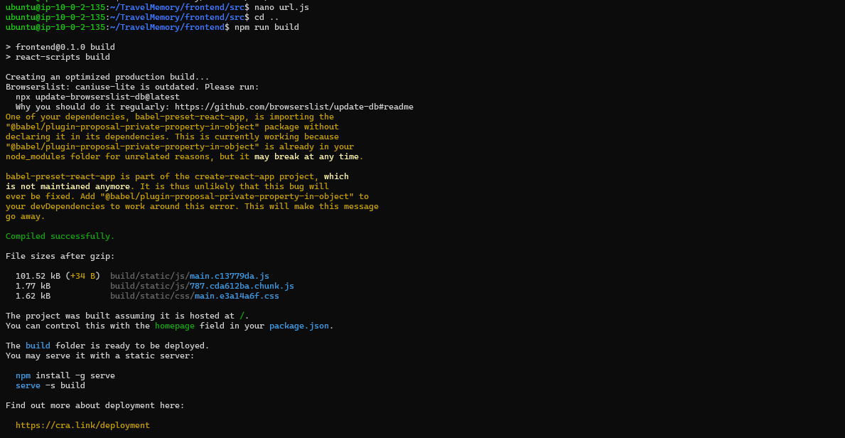
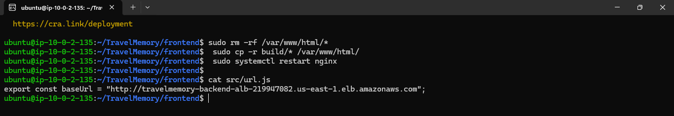
Figure 4. Frontend API base URL configured with the backend ALB DNS name.
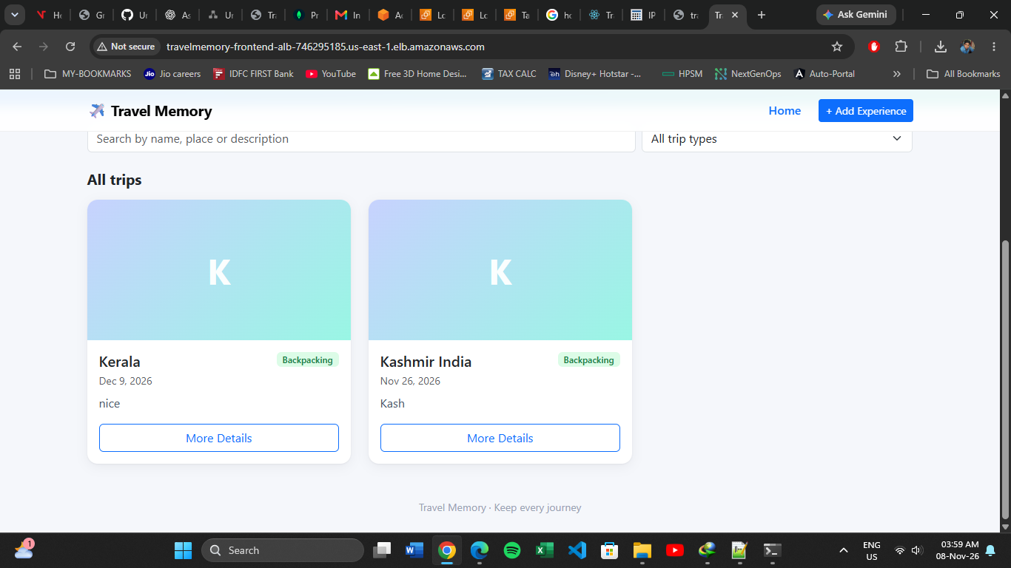
Figure 5. TravelMemory frontend displaying saved trips through the frontend ALB.

5. Preparing the base image template AMI
After the master instances are fully configured and tested, create Amazon Machine Images (AMIs). The AMIs capture the installed software and application configuration so additional instances can be launched consistently.
- In the EC2 console, select backend-master.
- Choose Actions → Image and templates → Create image.
- Name the image travelmemory-backend-ami and create it.
- Repeat the process for frontend-master and name the image travelmemory-frontend-ami.
- Wait until both AMIs show Available before launching new instances.

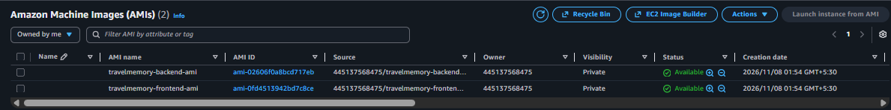

6. Launch instance from AMI image
Launch the second instance in each application tier from its corresponding AMI.
- Launch backend-2 from travelmemory-backend-ami.
- Launch frontend-2 from travelmemory-frontend-ami.
- Place the instances in the intended VPC subnets and Availability Zones, and attach the appropriate security groups.
- Wait for EC2 instance status checks to pass.
- Confirm the backend service and Nginx start automatically on backend-2.
Final instance names:
The backend systemd service was enabled before imaging, allowing the backend application to start automatically on the second instance.

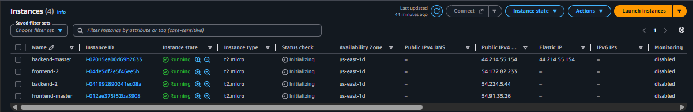

7. Create target group for front and backend

7.1 Backend target group
- Open EC2 → Target Groups → Create target group.
- Choose Instances as target type, HTTP protocol, and port 80.
- Set the health check path to /hello.
- Register backend-master and backend-2, then create the target group travelmemory-backend-tg.

7.2 Frontend target group
- Create another target group with Instances target type, HTTP protocol, and port 80.
- Set the health check path to /.
- Register frontend-master and frontend-2, then create travelmemory-frontend-tg.
The screenshots show both target groups with two registered targets, two Healthy, and zero Unhealthy.
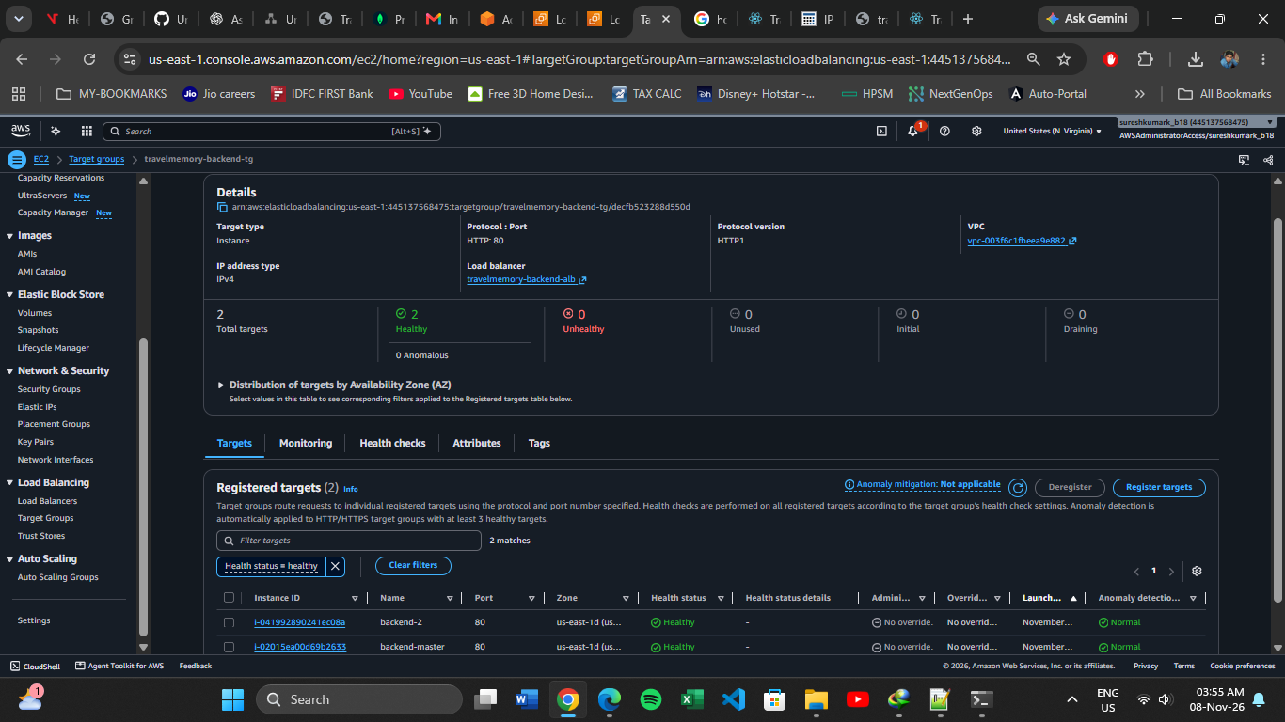
Figure 6. Backend target group – both backend EC2 targets healthy.
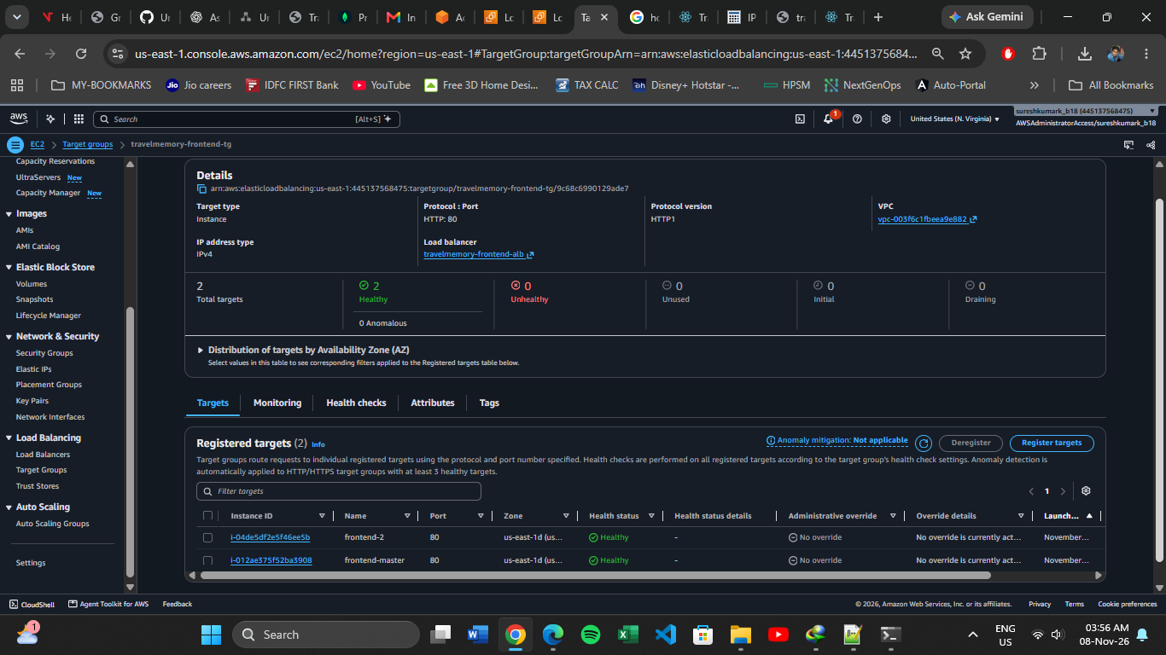
Figure 7. Frontend target group – both frontend EC2 targets healthy.

8. Create ALB for front and backend

8.1 Backend Application Load Balancer
- Open EC2 → Load Balancers → Create load balancer → Application Load Balancer.
- Name it travelmemory-backend-alb and select Internet-facing with IPv4.
- Select the VPC and two suitable public subnets in separate Availability Zones.
- Attach a security group that permits HTTP port 80 from the intended API clients.
- Create an HTTP listener on port 80 and forward requests to travelmemory-backend-tg.
- After creation, copy the ALB DNS name.

8.2 Frontend Application Load Balancer
- Create a second Application Load Balancer named travelmemory-frontend-alb.
- Select Internet-facing, IPv4, the same VPC, and subnets across two Availability Zones.
- Attach a security group that permits HTTP port 80 from web clients.
- Create an HTTP listener on port 80 and forward requests to travelmemory-frontend-tg.
- Copy the frontend ALB DNS name; this is the browser entry point for the application.
The AWS console screenshots show both ALBs Active and Internet-facing. The details page displays the two Availability Zones used by the ALBs.
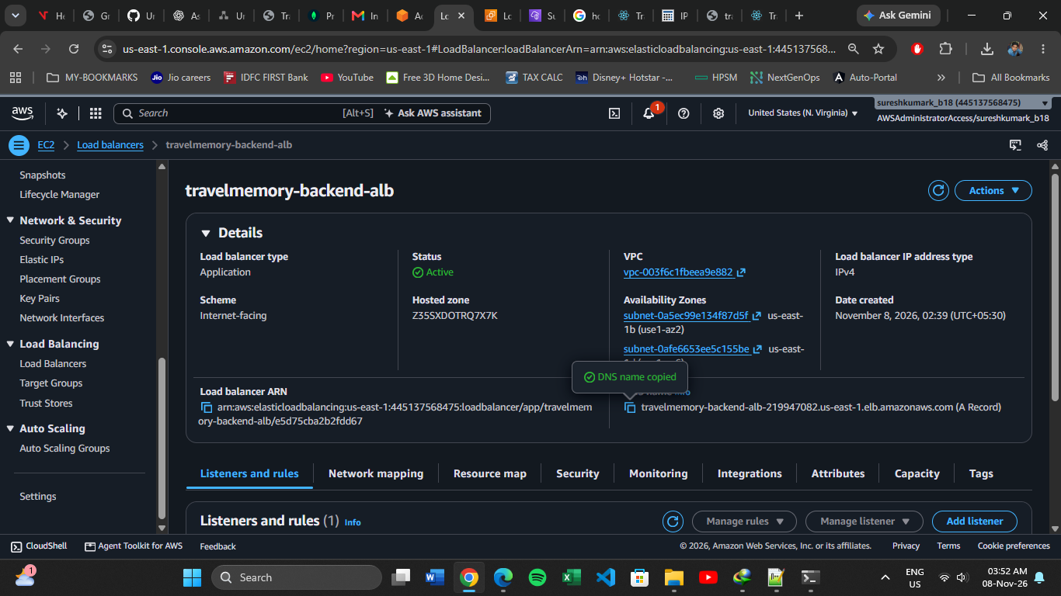
Figure 8. Backend ALB – Active, internet-facing.
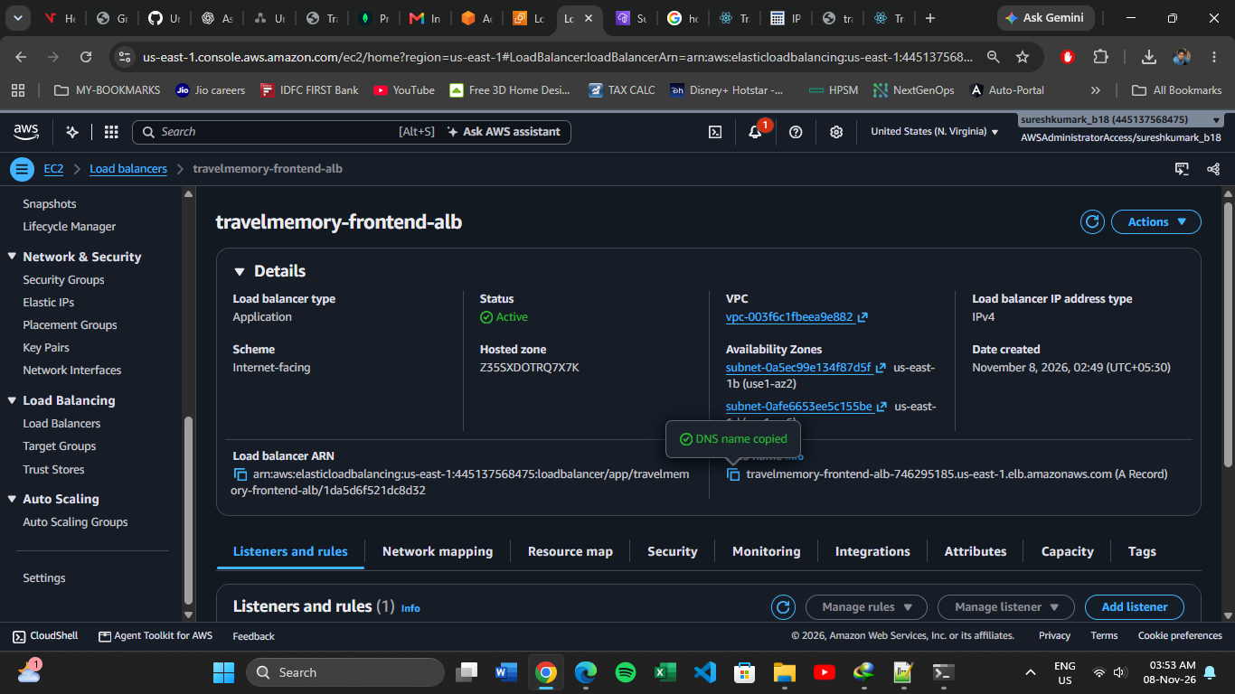
Figure 9. Frontend ALB – Active, internet-facing.

9. Point Frontend at the Backend Load Balancer
After the backend ALB is created, update both frontend instances to use the backend ALB DNS name. This replaces the temporary backend master public IP and allows API requests to be distributed across both backend instances.
export const baseUrl = "http://<backend-ALB-DNS-name>";
npm run build
sudo rm -rf /var/www/html/*
sudo cp -r build/* /var/www/html/
sudo systemctl restart nginx
Perform these steps on both frontend-master and frontend-2. On both backend instances, configure CORS_ORIGIN to the frontend ALB origin and restart the backend service:
sudo systemctl restart travelmemory-backend
sudo systemctl status travelmemory-backend
The browser loads the React application from the frontend ALB and sends API calls to the backend ALB. The backend CORS policy must allow the frontend ALB origin. The captured frontend screenshot shows the application displaying saved trip records through the frontend ALB.

9.1 Final application validation
- Open the frontend ALB DNS name in a browser.
- Confirm the trips load from MongoDB Atlas.
- Add a new experience from the UI.
- Confirm the new experience appears in the list after saving.
- Verify that both target groups still show two healthy targets.

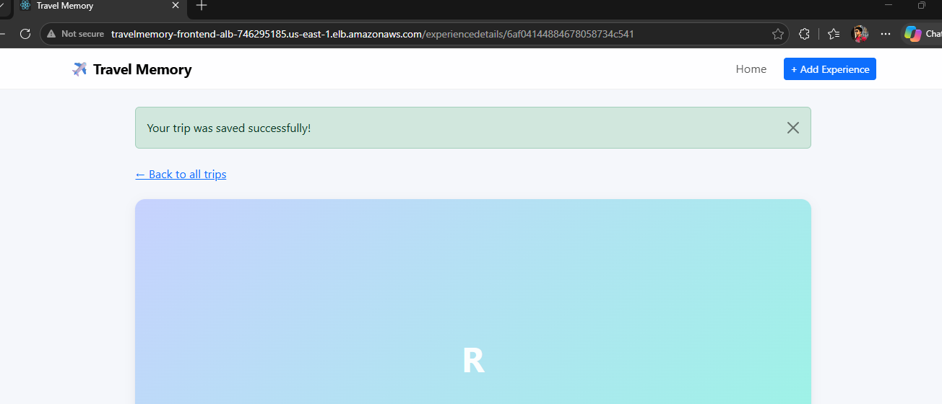
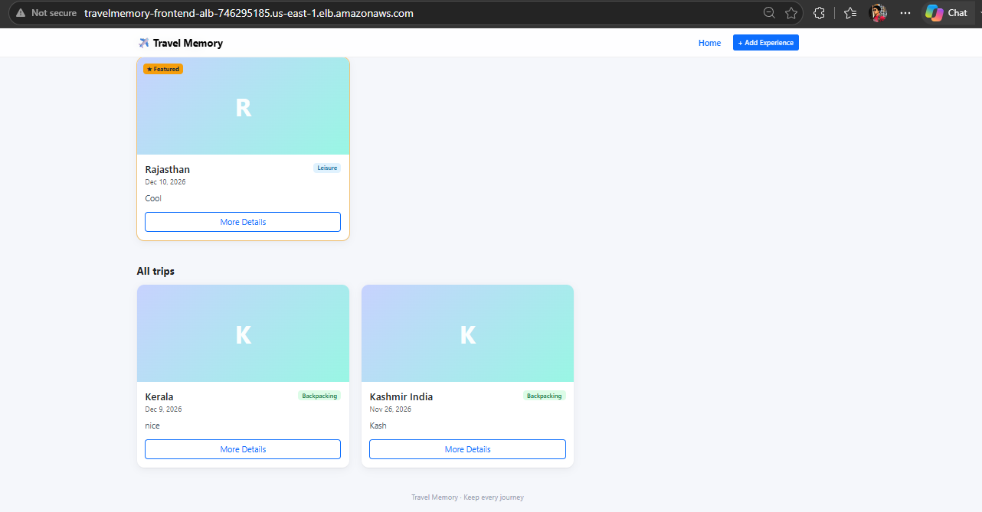

10. Deployment Architectural Diagram



