**Hackaton**

**YouSearch**

Team Members:

Rainigari, Vishnu Chander (vrpq8@mail.umkc.edu)

Kinnera, Shyam Raj (sky6c@mail.umkc.edu)

Sharvirala, Venkata Sai Karthik (vshh4@mail.umkc.edu**)**

Ram Nikhil Voora (rvxk8@mail.umkc.edu)

Semester: Spring 2015

Submission Date: 19th Apr 2015

Team Name:

The Masters.

**Login/LogOut Fuctionality:**

**Operational Discription:**

If a user wants to access the home page, he/she has to login with his/her login details that would be his/her registered username and password. A valid user is directed to the home page. If the user enters invalid details then the user is redirected to login page again. In case if the user is a non-registered user then he/she has to register by providing his/her new username and password. Once the user registration is successful he/she can login on the login page. If a user forgets his password he/she has the option named ‘forgot password’ to reset his password.

**Constraints/Exceptions:**

A non-registered user is not provided any access to the home page. A registered user with invalid details will not be able to login and an exception is raised.

**Service Flow:**

User fills out his/her user name and password

If details are valid then directed to home page or else he/she will be again directed to the login page.

Access to home page services.

**Flow Chart:**

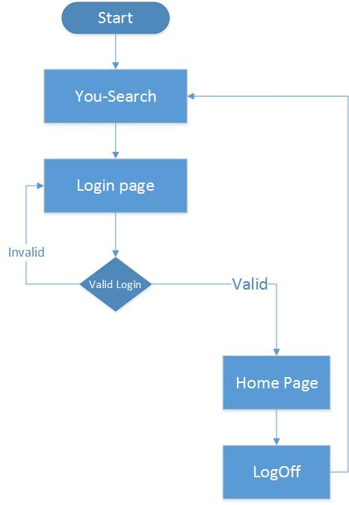

**Sequence Diagram:**

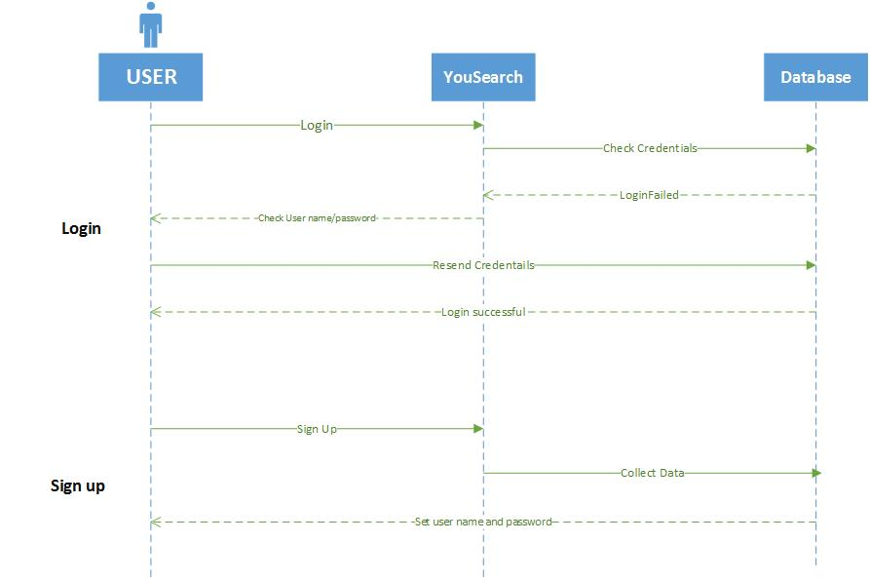

**Youtube API Functionality:**

**Operational Description:**

The YouTube API (Application Programming Interface) allows user to access video statistics and Youtube channels’ data. A listType parameter value has to be provided as search which specifies the search query. The listType parameter, in association with the list parameter will identify the contents that will load in the player. Valid parameter values are playlist, search, and user uploads. The search request string provided in the search is passed as a query parameter and the values (list of videos in this case) that specify to this relative string are retrieved. This returns the list of related videos that contains the search value provided by the user.

**Input/Output:**

A register user can access to the home page provided with a search option. He/she has to provide a search keyword(s) (a part of the name of the video) to find videos that he/she wants to view. The input search key(s) that are provided by the user is used to retrieve the list of videos that are related to the key string. If the user provide a valid key string in the search the list of videos related to his search are displayed.

**Service Flow:**

The user enters the search page.

User provide the search string in the search box.

Related videos list is displayed with thumbnails.

**Flow chart:**

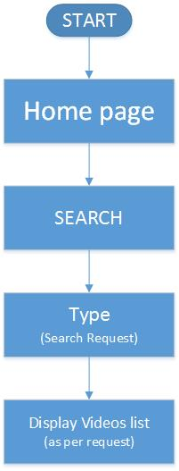

**Sequence Diagram:**

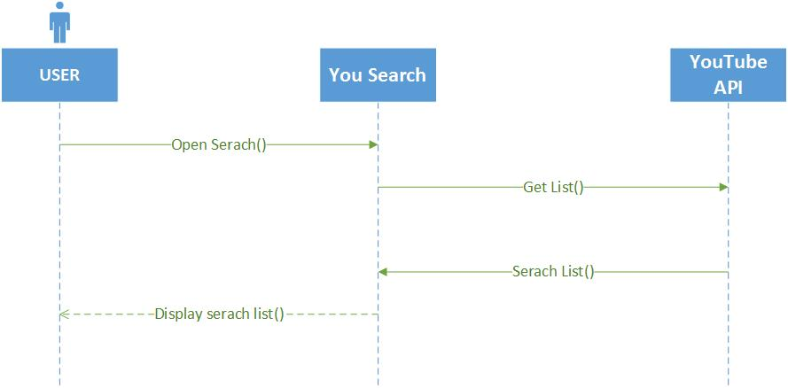

**ScreenShots:**

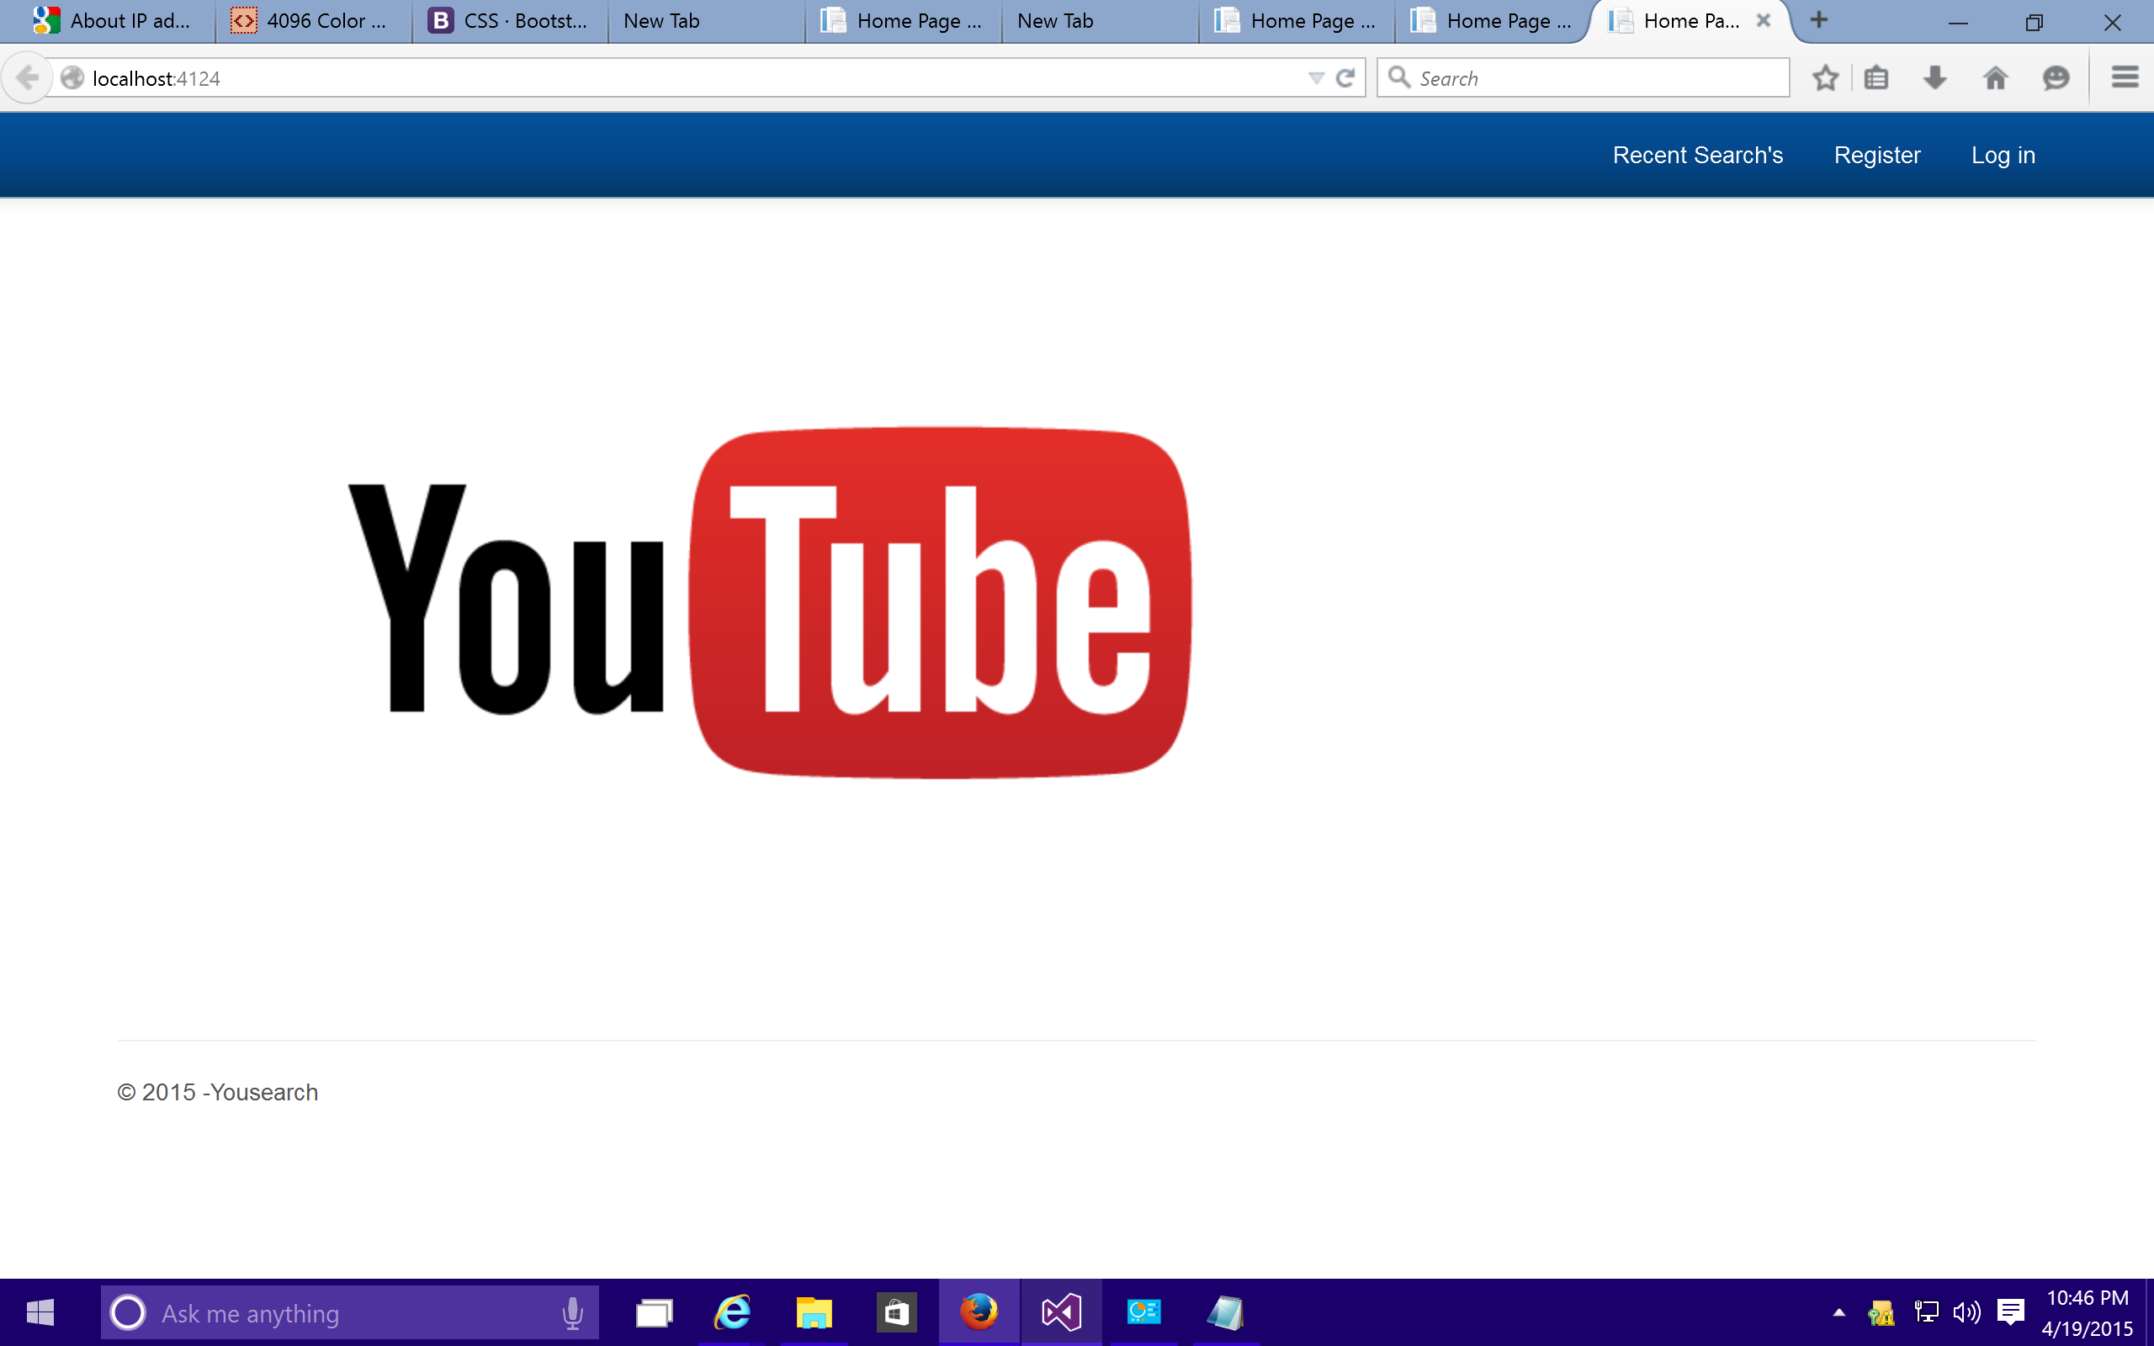

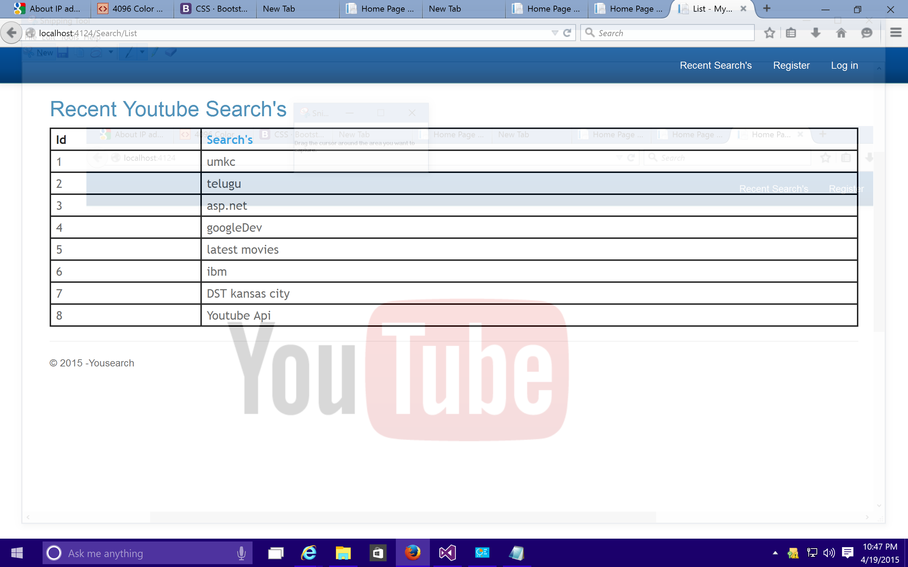

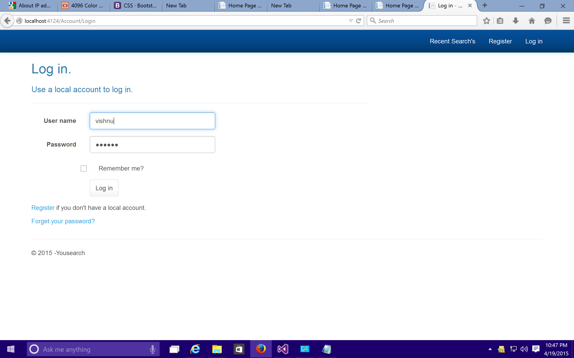

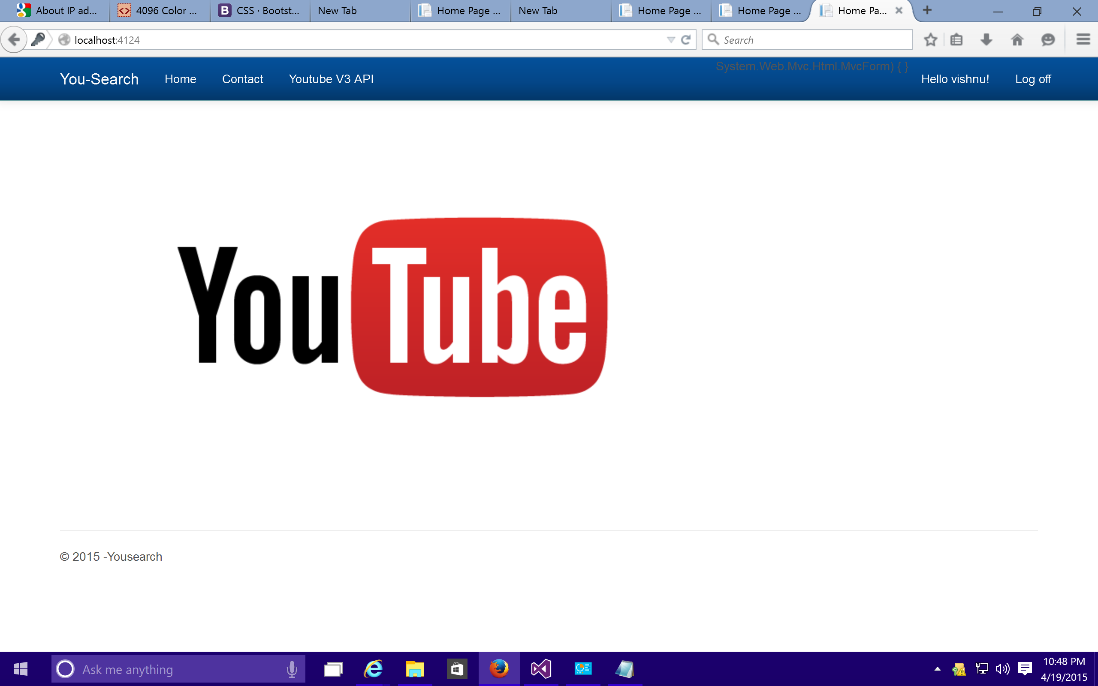

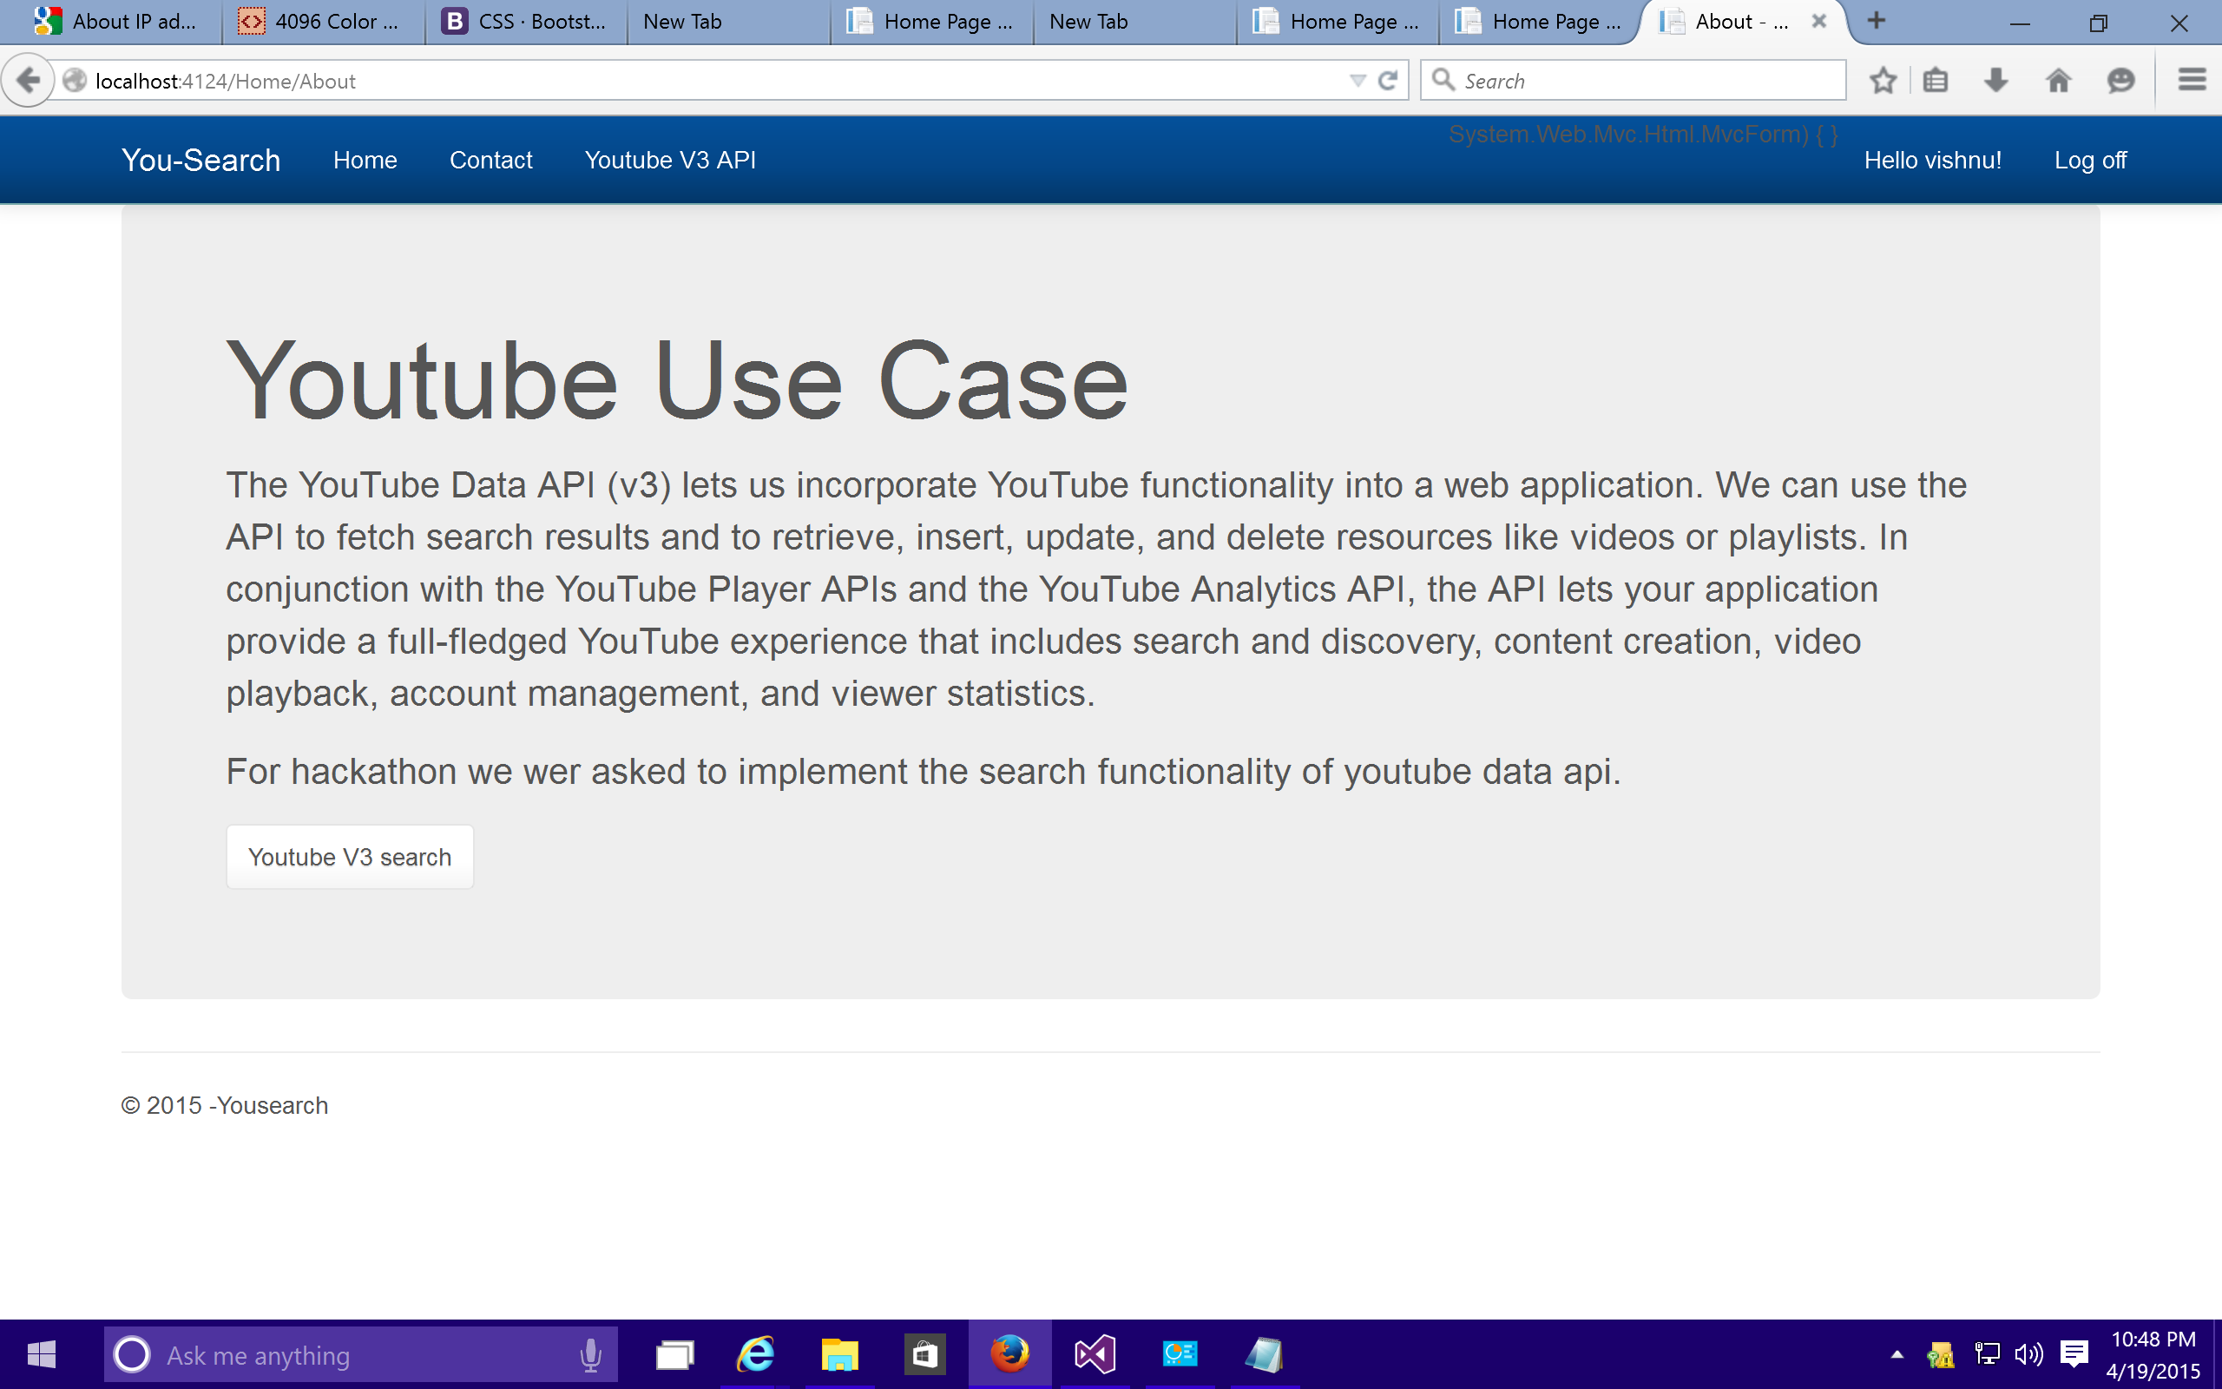

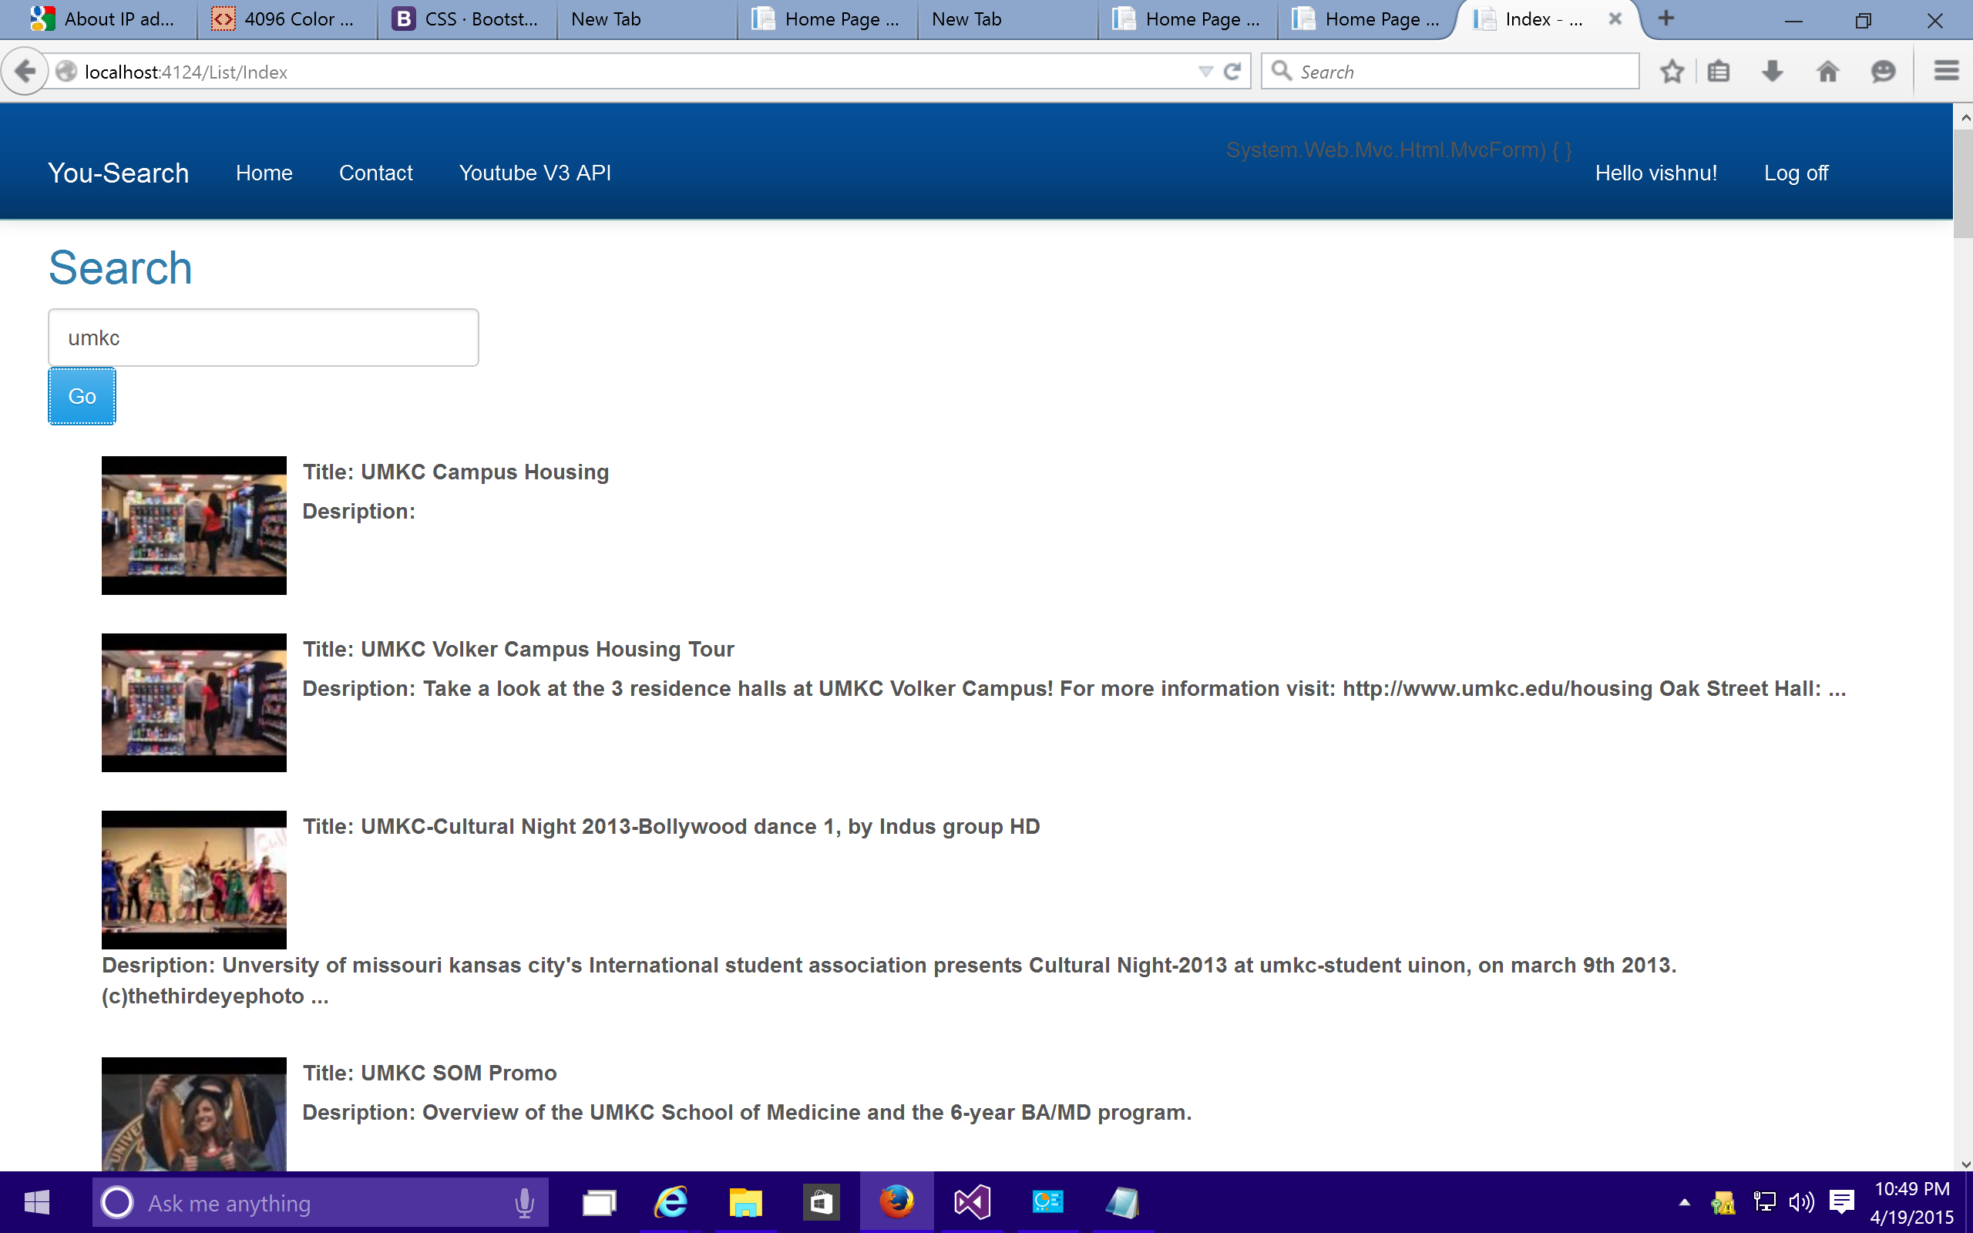

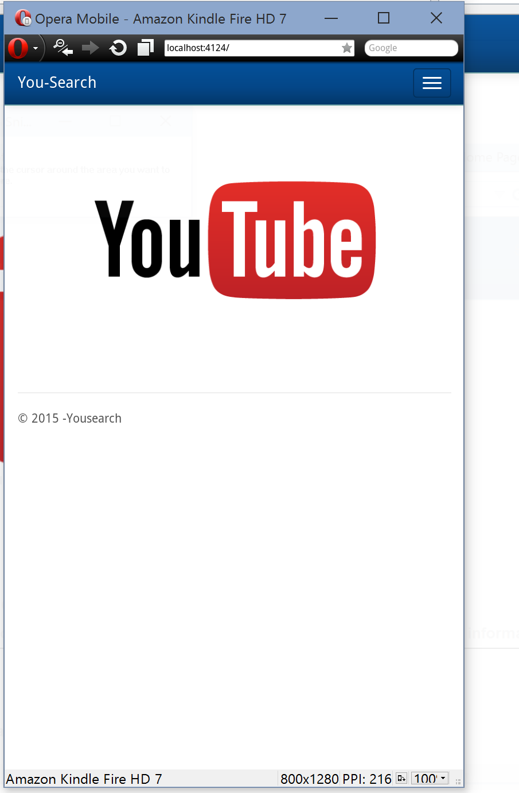

**Youtube Link:** **https://www.youtube.com/watch?v=f8cZvtI6jGc**

**Software:**

**Visual Studio 2012:**

Visual Studio Professional 2012 is a complete collection of developer tools and services to enable a developer to create applications for the Microsoft platform and beyond. It is a set of IDEs (Integrated Development Environments) developed by Microsoft that simplifies the tasks of creating, debugging, and deploying soft wares for windows, Microsoft Office and the web.

**Opera Mobile Emulator:**

Opera Mobile Emulator is a software developed by Opera for the use of web developers and designers to test websites on the Opera Mobile browser. It consists of the same engine and UI as of the Opera Mobile on mobile phones. Some other debugging tools are also available, such as keyword shortcuts, the profile selector etc.

**References:**

<http://en.wikipedia.org/wiki/YouTube_API>

<http://www.smashingmagazine.com/2012/08/30/responsive-designs-opera-mobile-emulator/>

<https://www.visualstudio.com/>

getbootstrap.com