**1.Logical DB:-**

The logical db is logical partition of physical db or logical copy of physical db. It will be created on per 1 JDBC application/project. The project related db tables, procedures, functions and …etc are placed in logical DB. In oracle DB software, The logical db is identified by its name/SID(Service Id).

By Default, oracle DB software give one logical db whose sid is XE( for Expression Edition) or ORCL (for Enterprise Edition).

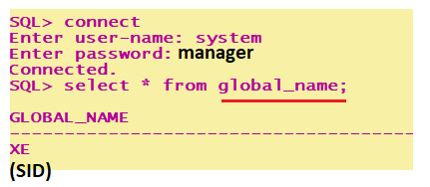

**2.Protocol:-**  It is a set of rules followed by two parties who wants participate in communication. There are two types of protocols:

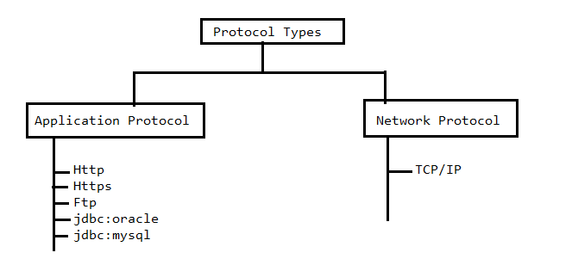

2.1. NetWork Protocol:- For communicating two computers over network with each, Network protocol gives set of rules.

2.2. Application Protocol:- Application protocol gives set of rules to get interaction between two applications of same computer or two different computers of network.

Note:- If two applications are in two different machines of network then applications uses application protocol over the network protocol for communication.

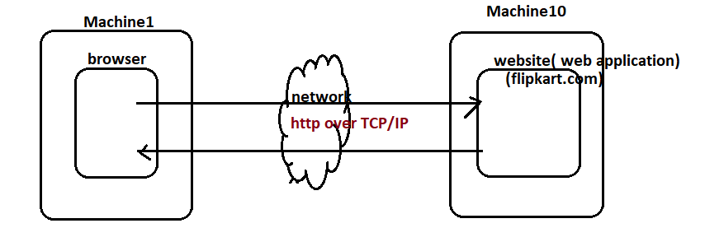

**3. port Number and Socket Number:-**  we use different hardware ports to connect external devices to computer.

Example to Hardware ports:

1.USB Port

2.Printer port.

3.console port.

…etc.

In windows, total 65535 ports are available. In that ,From 1 to 1025 are reserved for OS services. These OS service run on top of one of these port.

Rest of the ports are used by external softwares like (oracle,tomcat,…etc). while installing the external software, default port or any other port is allocated to it. On top of allocated port , The external software will run. Every port is identified by “Unique number”.

Example:

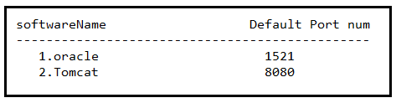

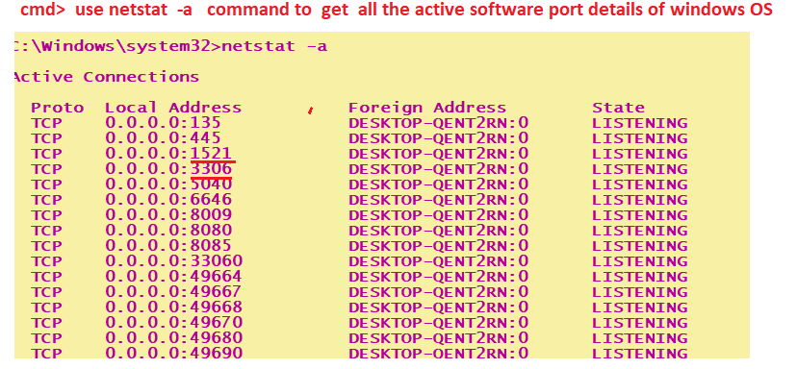

Socket:- socket number is <IPaddress/HostName>+port number.

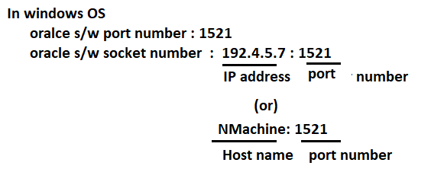

**4.Database** [**URL:-**](URL:-)

Syntax:-

Protocol:subname:@<IP address>|<HostName>:<port>:<sid>

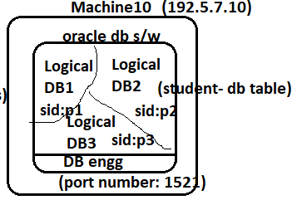

Example:1 Oracle Software and Java app , both are in same machine.

1.Jdbc:oracle:thin:@Localhost:1521:p1

2. jdbc:oracle:thin:@localhost:1521:p2

Example:2 Oracle software and java app, both are placed in different machine.

1.jdbc:oracle:thin:@192.5.7.10:1521:p2

Or

Jdbc:oracle:thin:@Machine10:1521:p2.

Note:- Subname is “thin” for Type-4 Driver.

Subname is “oci8” for Type-2 Driver.