Cursor is **a special variable of** oracle pl/Sql. It stores the bunch of records given by SQL select query execution.

In PL/SQL programming, cursor holds bunch of records.

In Oracle pl/Sql programming, SYS_REFCURSOR is cursor data type.

Syntax to Declare the SYS_REFCURSOR type variable:

Var_name sys_refcursor;

Syntax to Store the bunch of records in sys_refcursor type variable:

Open var_name for select query;

The select query generates records which will be stored in var_name automatically.

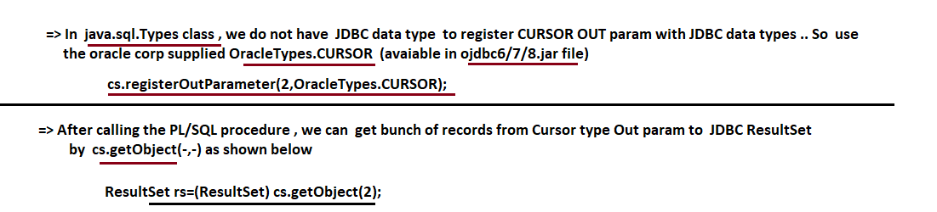

Example:-

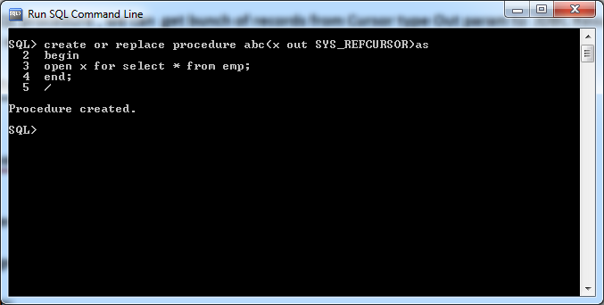

**import** java.sql.CallableStatement;

**import** java.sql.Connection;

**import** java.sql.DriverManager;

**import** java.sql.ResultSet;

**import** java.sql.SQLException;

**import** java.util.Scanner;

**import** oracle.jdbc.OracleTypes;

**public** **class** Sample {

**public** **static** String *qur*="{call abc(?)}";

**public** **static** **void** main(String[] args) {

**try**(Scanner s=**new** Scanner(System.***in***);

Connection con=DriverManager.*getConnection*("jdbc:oracle:thin:@localhost:1521:xe","sukumar","sukumar");

CallableStatement c=con.prepareCall(*qur*)

){

**if**(c!=**null**) {

c.registerOutParameter(1, OracleTypes.***CURSOR***);

c.execute();

ResultSet r=(ResultSet)c.getObject(1);

**while**(r.next()!=**false**) {

System.***out***.println(r.getInt(1)+" "+r.getString(2));

}

}

}

**catch**(SQLException e) {

System.out.Pringln(e.getMessage());

}

}

}//main

}//class

Output:-

1 suku

2 samba