1. **JDBC:**-

Def1:- JDBC is an JAVA API.

Def2:- JDBC is java technology.

Def3:- JDBC is java based persistence technology.

The JDBC technology is not outdated but Its direct utilization is bit reduced and Its indirect utilization is more increased.

Example:-

* Hibernate internally uses JDBC.
* Spring data jpa internally uses the hibernate.

Note:- with out JDBC support directly or indirectly, Java application can’t communication with DB software.

1. **JDBC API:-**  The JDBC api is given in the **form of jar files**. This API provides

* Rules(Interfaces) and guide lines(classes) for vendor companies to develop the JDBC Driver softwares.

**Upto java1.7,**

The Interface represents the rules.

The class represents the guilde lines.

**Java 1.8 onwards,**

The interface represents the both rules and guide lines.

The class represents the guide lines.

Note:-

1. java language api and java frame work apis gives more classes and less interfaces.

2. java technology apis give more interfaces and less classes.

* Base for developers. The developers uses JDBC API to develop the persistence logic(JDBC code) in Java applications.

**Latest version of JDBC API is 4.x.**

**3.ODBC(Open database connectivity) Driver:-** It is bridge software between non-java app and DB software. It converts non-java call(Instructions) to DB calls(Instructions) vice versa.

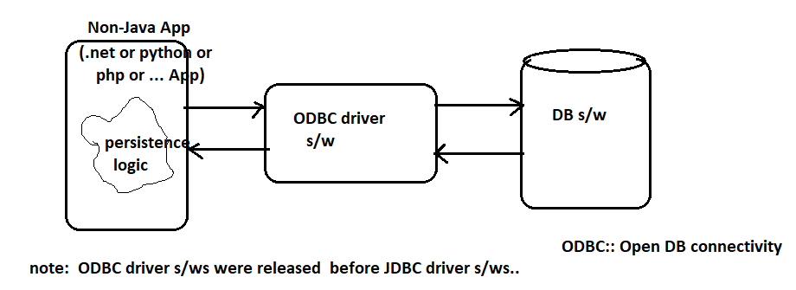

These ODBC driver softwares are developed by following vendor company categories:

1. ODBC group(32 companies).
2. DB software Vendors.
3. OS vendors
4. Third party Vendors.

Note:- Everybody recommends to use database vendor provided driver software.

Q) Why does java app’s requires separate driver software other than ODBC?

* ODBC driver softwares are usually developed in c language. It takes support/helping of pointer concept. The java does not support pointers.
* ODBC driver software is plat form dependent. When java-app works with ODBC driver, java will loss the plat form independent feature.
* Converting pointer based code to non-pointer based code is very difficult and it kills application performance.

By above reasons, java apps are not using ODBC driver for communicating with DB s/ws.java app’s requires separate type of driver software.

**4.JDBC Driver:-** JDBC Driver is bridge software between java App and DB s/w. It converts java calls(java instructions) to DB calls( DB Instructions) and vice versa.

**The collection of implementation classes of various interfaces present in JDBC API is called Driver software.**

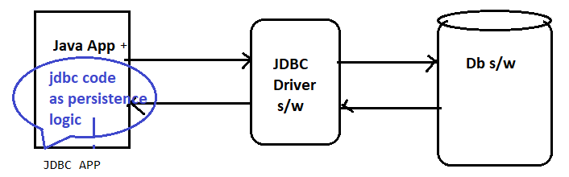

Vendor Company:- The company which develops software and releases it into market for selling is called Vendor company.

Example:- KFC is food vendor.

Oracle,Microsoft are software vendors.

Above 100 companies creates JDBC software as JDBC technology implementation software. These companies are responsible for providing implementation classes for JDBC API interfaces(Rules) in jdbc API.

The Driver software vendors have been categorized into 3 types:

1. Java Vendor.
2. Database Vendors (Oracle, Microsoft …etc).
3. Third party Vendors

Ex:- Inet is third party vendor and provided several Driver software for different databases.

a.INet ORacxo for oracle database.

b.Inet Merlia for Microsoft SQL Server.

Note:- 1. Everybody recommends to use database vendor provided driver software.

2. If driver software is developed using only java language, then such type of driver software is “Pure Java Driver”.

3. If driver software is developed using java and other native languages(C,C++), thenSuch type of driver software is “partial java driver”.

The JDBC Driver software is identified by **implementation class of Driver Interface of JDBC API**. The JDBC Driver software is also available in the form of jar file.

Example:- The JDBC Driver software for oracle DB is given in the form of **ojdbc<n>.jar file**.

Ojdbc6.jar ------- oracle 11g (Expression Edition, Enterprise Edition)

Ojdbc7.jar ------- oracle 12c (Expression Edition, Enterprise Edition)

Ojdbc10.jar ------- oracle 21c

In all these JDBC driver softwares, the jdbc driver class name is “**oracle.jdbc.driver.OracleDriver**”.

Where oracle.jdbc.driver is package name.

OracleDriver is Implementation class Name.

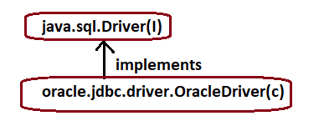

**4.1. JDBC Driver software Types:-** The software vendor companies uses 4(Official)+ 1(UnOfficial) architectures for creating JDBC driver softwares. They are

a.Type1 JDBC Driver[JDBC-ODBC Driver software]

b.Type2 JDBC Driver[Native API/partially java Driver]

c.Type3 JDBC Driver[Net Protocol Driver]

d. Type4 JDBC Driver[thin driver software/Native Protocol Driver]

e.Type5 JDBC Driver[No- Technical name]

Note:- 1.First four JDBC Drivers were recognized by Sun Micro system. But SUN Micro system does not recognize the Type5 JDBC Driver.

2.Type1 and Type2 JDBC drivers are outdated.

3. For Standard alone applications, small scale web applications and one application always communicates one type of database then it is recommend for type-4 driver.

4. For large scale web applications , enterprise applications and application want to communicates with different types of databases then it is recommend for type-3 driver.

**4.2 Type-4 Driver:-**  It is developed to interact with local and remote DB software. It was completely developed in java. Therefore It is called “pure Java Driver” . with out having extra component, this driver communicate with DB software ,so It is **called “thin driver”**.

