1. History.

2. JSP Features.

3. Structure of JSP File/Comp

4. Implicit Objects.

5. Diff between Html and JSP.

**1.History:-**First and Foremost, The ASP was market leader . It was tag based programming language. Many Industries of IT sector were being used ASP in development of web application.

At that time,The sun micro system developed servlet technology which is useful to develop the web application. The representative of sun micro system visited IT companied. They explained features and benefits of servlet technology by seminars. Everybody appreciated servlet technology features but no one used servlet technology in web application development. Because of following reasons or Limiations in servlet:

* Servlet technology is not tag based programming language.
* Strong java knowledge is required to work with servlet technology.
* It is not suitable for non-Java Programmers.
* There are no implicit objects in servlet programming.
* Programmer must perform exception handling manually.
* Placing html code in servlet component is very complex and error prone process.
* We mix up presentation logic(html code) and business logic togaher in servlet program. so modifications done in one kind logic will affect other kind of logic.
* The servlet comp must be mapped with url comp because it is placed in private area of web application.

To overcome this problem, The sun micro system gave JSP technology. It is also “Tag based programming Language”. It use internally servlet technology features.

In the early days, Java industry used JSP completely alternative to servlet technology. But now days java industry is using servlet & jsp together in web application development.

* Servet for monitoring logic and business logic.
* JSP for presentation logic.

2. JSP Features:

===========

* It provides 9 implicit objects.
* It is tag based programming language.
* It is suitable to both java and non-java programmers.
* We can separate the presentation logic(html code) from b.logic.
* Every JSP comp is translated into equivalent servlet code so all servlet features can be used here.
* The JSP comp can be placed in public area or private area of web application. If JSP comp is placed in private area then only the jsp comp must be mapped with url pattern.
* Takes care of exception handling.

Note:-

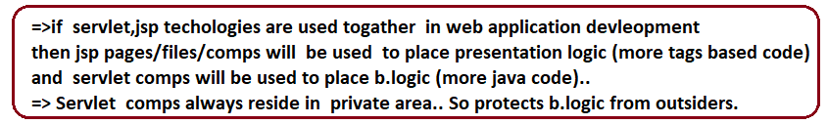

* JSP Latest version is 3.0
* Container is Required:JSP container/JSP engine
* Internally every jsp container /jsp engine internally uses servlet container or servlet engine and also gives one JSPC(jsp compiler). The process of converting jsp page into equalent servlet comp is called page compilation ..For this we need jsp page compiler.

In Tomcat Server

=============

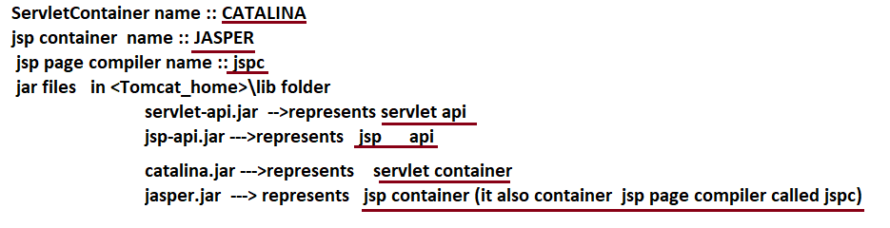

3. Structure of JSP File/Comp

=====================

* The JSP comp executes in server so it is called Server side web component.
* The JSP comp generates the dynamic web pages so it is called dynamic web component.

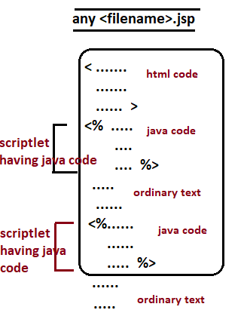

* HTML code + ordinary text is called **“Template text”.** The template text output is “Fixed output”. It will not change from request to request.
* The tag that contains java code is called “Scriplet”. The java code which is placed in scriplet changes output time to time or request to request. So we can say this output is dynamic output.
* JSP pages generate dynamic web page. In that dynamic web pages the fixed content will come through template text and varying content comes from scriplet code.

Example:

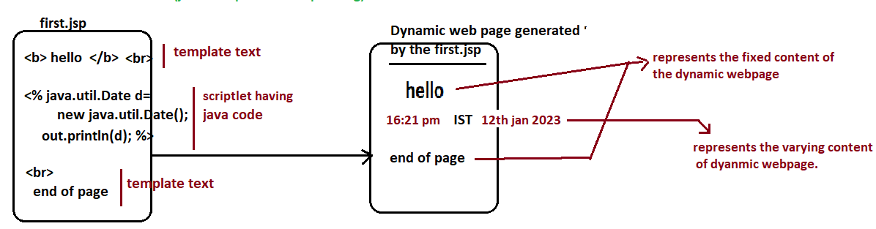

4. Implicit Object

=============

The implicit object can be used in scriplet tag directly with out writing any additional logic to create and access them. So this is called jsp implicit object.

JSP provided the 9 implicit objects.

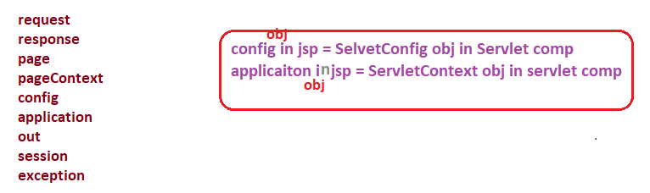

The implicit objects are automatically created in JSP equalent servlet (JES) which will be generated internally for the request.

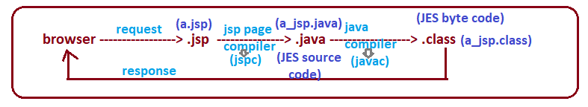

We feel that jsp page/file/comp is executing and we are getting output.. technically speaking for every jsp page internally the jsp equalent servlet comp will be executed which will be generated dynamically by JSP page compiler for the request given to JSP page.

5. Diff between Html and JSP.

=====================

