**1.HttpRequest Format:-**  Generally , the HttpRequest is generated by client(browser). The HttpRequest is generated by typing URL in address bar or pressing hyperlinks or by using submit button. This HttpRequest has specific structure. This structure have 2 sections.

a. Head

b. Body.

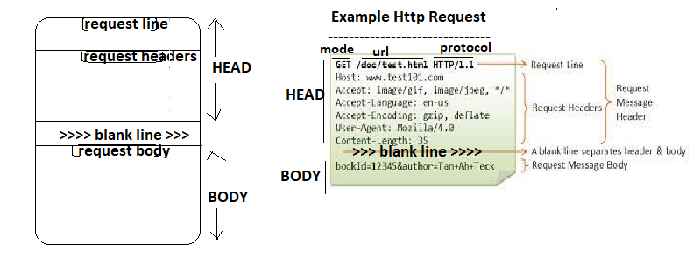

* The request line contains basic information of current request like mode of request, url , protocol name and version.
* The request header carry information about browser to web server along with request.

The browser information is

1. Content-Length:- It is applied to only POST request and gives size of content in bytes.
2. Browser-knows language.
3. Browser-knows encoding type.
4. Cookie:- This header returns cookies to servers that previously sent them to the browser.
5. Host: This header specifies the host and port as given in the original URL.

* Form data or request param names and values of the query string becomes request body.
* The request body and request header is separated with “blank line”.

**The HttpRequest Object Methods:**

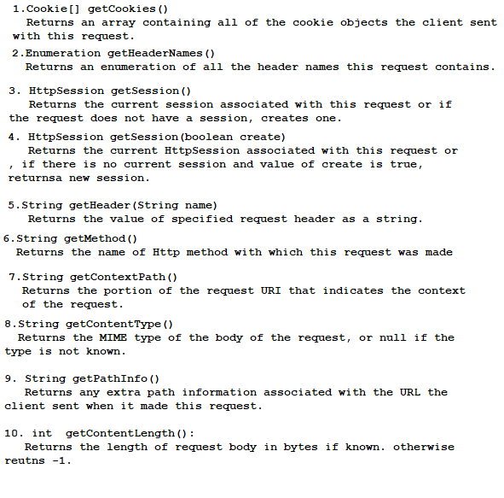

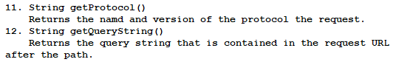

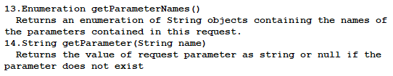

Example: This request Demonstrates the “HttpRequest Object”.

**package** com.ser.domain;

**import** jakarta.servlet.ServletException;

**import** jakarta.servlet.annotation.WebServlet;

**import** jakarta.servlet.http.HttpServlet;

**import** jakarta.servlet.http.HttpServletRequest;

**import** jakarta.servlet.http.HttpServletResponse;

**import** java.io.IOException;

**public** **class** Demo2 **extends** HttpServlet {

**private** **static** **final** **long** ***serialVersionUID*** = 1L;

**protected** **void** service(HttpServletRequest req, HttpServletResponse response) **throws** ServletException, IOException {

System.***out***.println("=========================");

System.***out***.println(" Http Request Headers ");

System.***out***.println("=========================");

System.***out***.println("protocol:"+req.getProtocol());

System.***out***.println("URL:"+req.getRequestURI());

System.***out***.println("contentType:"+req.getContentType());

System.***out***.println("contentLength:"+req.getContentLength());

System.***out***.println("Request Mode:"+req.getMethod());

}

}

**Output:**

