1. Software Required To develop web Application.
2. Tomcat.

**1.Software Required To develop web Application:-** In the development and execution of web application, we need following softwares.

a. Browser s/w.

b. Web server software.

c. Client Side web Technologies.

d. Server Side web Technologies.

e. DB s/w.

1.1.Browser Software:- It is used to send request and receive the response.

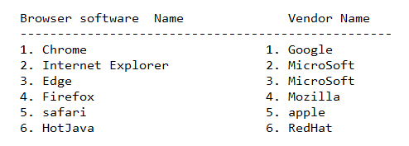

1.2.Client Side Web Technologies:- The technologies are used to develop the client side web components.

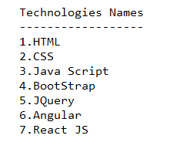

1.3.Server Side Web Technologies:- The technologies are used to develop the server side web components. These technologies related API’s are available in form of jar files.

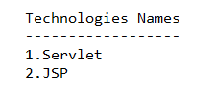

1.4.Web Server Softwares:- To manage and execute the web applications in automated environment.

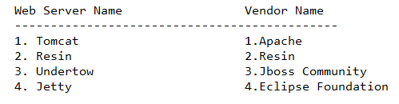

Note:- web server s/w and server side technologies should have compatability.

Ex:- If web server is java based server, then we should choose servlet, JSP technologies to develop the server side web components.

1.5.DB s/w:- It is used to store and manage the data in persistence media.

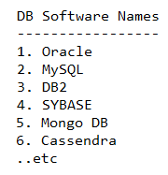

**2.Tomcat:-**

a. It is java based web server upto version-6.

b. version7 onwards, It is java based application server.

c. Latest version is 10.x. This version is compatability with JDK1.8+

d. It is oper source s/w and free ware software.

e. Its default port number is 8080.

Note:- we can change default port number during the installation.



f. default admin username:

username: admin

password: to be choosen during the installation.

If required, we can change the user name and password while installing the Tomcat.

g.



h. The tomcat server gives two containers.

a. servlet Container: Name is CATALINA.

b. JSP container:Name is JASPER.

* 1. **Download & Install the Tomcat:-**
  2. **Start the Tomcat:-**

GoTo <Tomcat_home>\bin directory and use tomcat10.exe file to start the Tomcat server.

It start the one daemon process on port number(8080) to listen to client requests continuously).

* 1. **Open the Home of the Tomcat:**