The response generated by web component have specific structure.

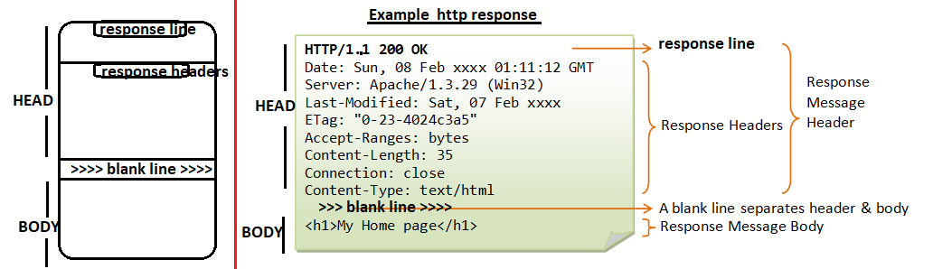

The response header have basic information of response. The basic information is protocol name and its version,status code and status message.

The status code ranges are 100 to 599

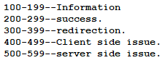

The web application gives additional instruction to browser by response headers.

Ex:- contentType,refresh…etc.

The output generated by web comp(servlet,jsp,html) goes to browser along with response as response body.

**HttpServletResponse Properties:**

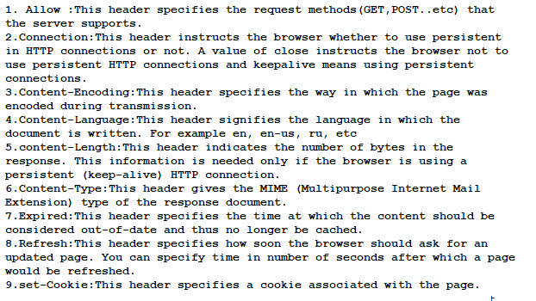

**HttpServletResponse Methods:**

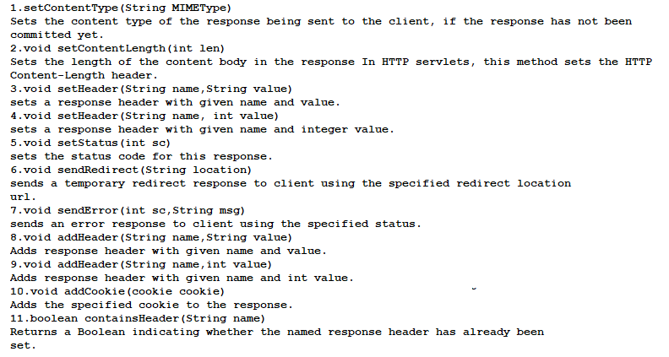

Example:- This program demonstrates the HttpServlet Response object.