### Reflection

###1. Describe your pipeline. As part of the description, explain how you modified the draw_lines() function.

My pipeline consisted of following steps.

1) First, I converted the images to grayscale, using the helper function grayscale. The below image was obtained after running this helper function on image whiteCarLaneSwitch.jpg

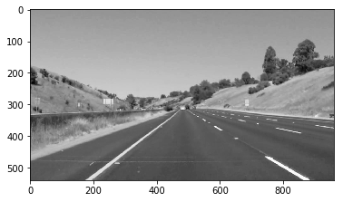

2) Next I applied gaussian blur to smoothen the image. Used helper function gaussian_blur() .A kernel size of 5 was used.Image after gaussian blur given below

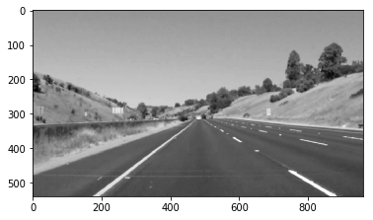

3) Next applied the canny detection algorithm to find the gradients within the image. Used helper function canny() to get this done. Low Threshold of 100 and High Threshold of 240 is used. Image after canny is given below:

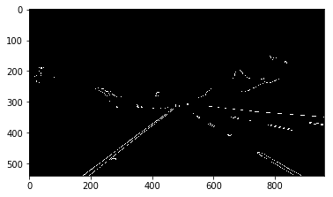

4) After application of canny, we define a range of region where we are interested in. We can define a quadrilateral region from the above image within which the two lanes would be detected. The points of the quadrilateral is given by array “vertices”.

5) Next apply hough transform to the region of interest from canny image. This would return all the edges in the region of interest. All the edges are added to give the image below

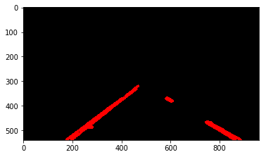

6) Now as you can see the lines are not continous and are jagged. To over come this, my program divides the lines into left and right lines using the slopes. After finding the co-ordinates of all points in left and right lanes, we fit a linear equation to the xpoints. After the linear parameters are found, we fit a line from the two side vertices of the quadrilateral. This returns the following image

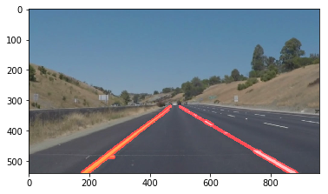

###2. Identify potential shortcomings with your current pipeline

1) Does not work with challenge problem. So if there are edges detected closer to lanes such as shoulder walls, the lane mean value goes for a toss.

2) If the road has a very tight curve, the algorithm might not work

###3. Suggest possible improvements to your pipeline

1) Can use quadratic fits for roads which have very tight curves.

2) For curvy roads, the region of interest should be a curvy quadrilateral which can remove noises at the edges.

