**Disease Drug Prediction using ML**

INTRODUCTION Since the arrival of advanced computing, the doctors’ still requires the technology in various possible ways like surgical representation process and x-ray photography, but the technology perceptually stayed behind. The method still requires the doctor’s information and experience due to alternative factors starting from medical records to weather conditions, atmosphere, blood pressure and numerous alternative factors. The huge numbers of variables are consider as entire variables that are required to understand the complete working process itself, however no model has analyzed successfully. To tackle this drawback, Medical decision support systems must be used. This system is able to assist the doctors to make the correct decision. Medical decision support system refers to both the process of attempting to determine or identify possible diseases or disorder and the opinion reached by this process. The diagnostic opinion in the sense, it indicates either degree of abnormality on a continuum or a kind of abnormality in a classification. It’s influenced by non medical factors such as power ethics and financial incentives for patient or doctor. It can be a brief summation or an extensive formulation, even taking the form of story or metaphor. It might be a means of communication such as computer code through which it triggers payment, prescription, notification, information or advice. Indication of medical diagnostic includes knowledge of what is normal and measuring of patient’s current condition. Automated decision support systems are rule based systems that are automatically providing solutions to repetitive management problems.

Medical decision could be extremely specialized and difficult job due to alternative factors or incase of rare diseases. The alternative factors include stress; tired misdiagnosis might vary from ignorance of doctors and incomplete information. Standard algorithm may go through the entire variables like prevailing conditions history of medical records, history of family records and various factors relating to the patient records, sheer magnitude of obtainable hidden factors. Differential diagnosis methods can be used to identify the presence of an entity where multiple alternatives are possible and also refers to include the candidate alternatives. This method is needs a process of elimination or obtaining information that shrinks the probability of candidate conditions to negligible levels. It contains four steps: 1) The doctor gather all information about the patients and create a symptoms list.2) The doctor should make a list of all possible causes of symptoms.3) The doctor should prioritize the list by which is the most dangerous possible cause of symptoms put in the top of the list. 4) The doctor should rule out or treat the possible causes beginning with the most urgently dangerous conditions.”Rule Out” in the sense to use the test method or other scientific method. If there will be no such diagnosis means removing the diagnosis from the list and using tests that should have distinct results, depends on which diagnosis is correct. This can be done based on the doctor’s knowledge and experience. This method is very easy to implement.

To reduce the large number of variables and find the most probable diseases by using the K-Means algorithm. This algorithm is more suitable to cluster the more number of diseases. K-Mean is one of the unsupervised learning algorithms which are used to solve the clustering problem. The main idea is to determine the k centroids, one for each cluster. Different tests performed on the patients will served as a attributes for clustering. By using this algorithm it reduce the number of iterations, boundries of clusters are well define without overlapping, to produce the accurate result for each and every diagnosis. This system uses Service oriented architecture (SOA), anyone can access with internet connections and LAMSTAR Network can be used to calculate the weight, to increase the accuracy of algorithm, overall speed test and produce the better result.

Dataset:

itching,

skin_rash

nodal_skin_eruptions

continuous_sneezing

shivering

chills

joint_pain

stomach_pain

acidity

ulcers_on_tongue

muscle_wasting

vomiting

burning_micturition

spotting_ urination

fatigue

weight_gain

anxiety

cold_hands_and_feets

mood_swings

weight_loss

restlessness

lethargy

patches_in_throat

irregular_sugar_level

cough

high_fever

sunken_eyes

breathlessness

sweating

dehydration

indigestion

headache

yellowish_skin

dark_urine

nausea

loss_of_appetite

pain_behind_the_eyes

back_pain

constipation

abdominal_pain

diarrhoea

mild_fever

yellow_urine

yellowing_of_eyes

acute_liver_failure

fluid_overload

swelling_of_stomach

swelled_lymph_nodes

malaise

blurred_and_distorted_vision

phlegm

throat_irritation

redness_of_eyes

sinus_pressure

runny_nose

congestion

chest_pain

weakness_in_limbs

fast_heart_rate

pain_during_bowel_movements

pain_in_anal_region

bloody_stool

irritation_in_anus

neck_pain

dizziness

cramps

bruising

obesity

swollen_legs

swollen_blood_vessels

puffy_face_and_eyes

enlarged_thyroid

brittle_nails

swollen_extremeties

excessive_hunger

extra_marital_contacts

drying_and_tingling_lips

slurred_speech

knee_pain

hip_joint_pain

muscle_weakness

stiff_neck

swelling_joints

movement_stiffness

spinning_movements

loss_of_balance

unsteadiness

weakness_of_one_body_side

loss_of_smell

bladder_discomfort

foul_smell_of urine

continuous_feel_of_urine

passage_of_gases

internal_itching

toxic_look_(typhos)

depression

irritability

muscle_pain

altered_sensorium

red_spots_over_body

We will predict the disease with the dataset and we have implemented to suggest medicine for diabetes and Hypertension problems.

**Execution:**

Click on run.bat file in your project directory

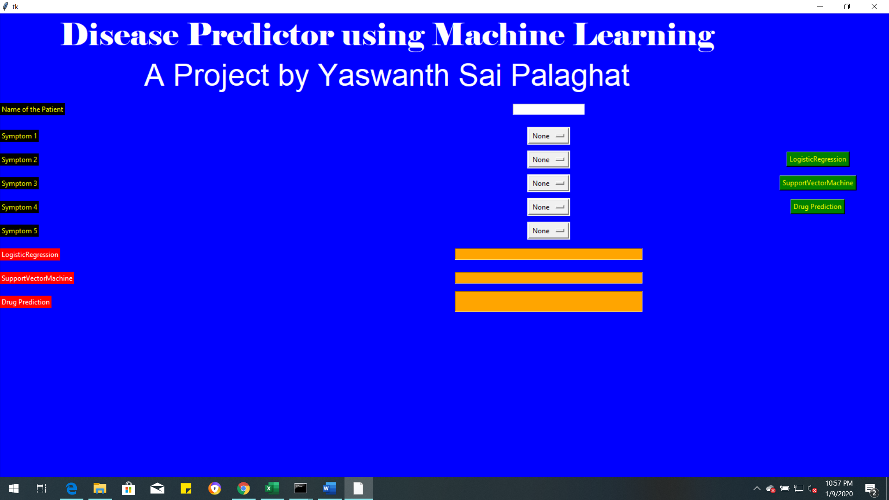

Enter the Name of patient and enter the symptoms of the patient to prediction the disease. And then click on algorithm from which you want to predict.

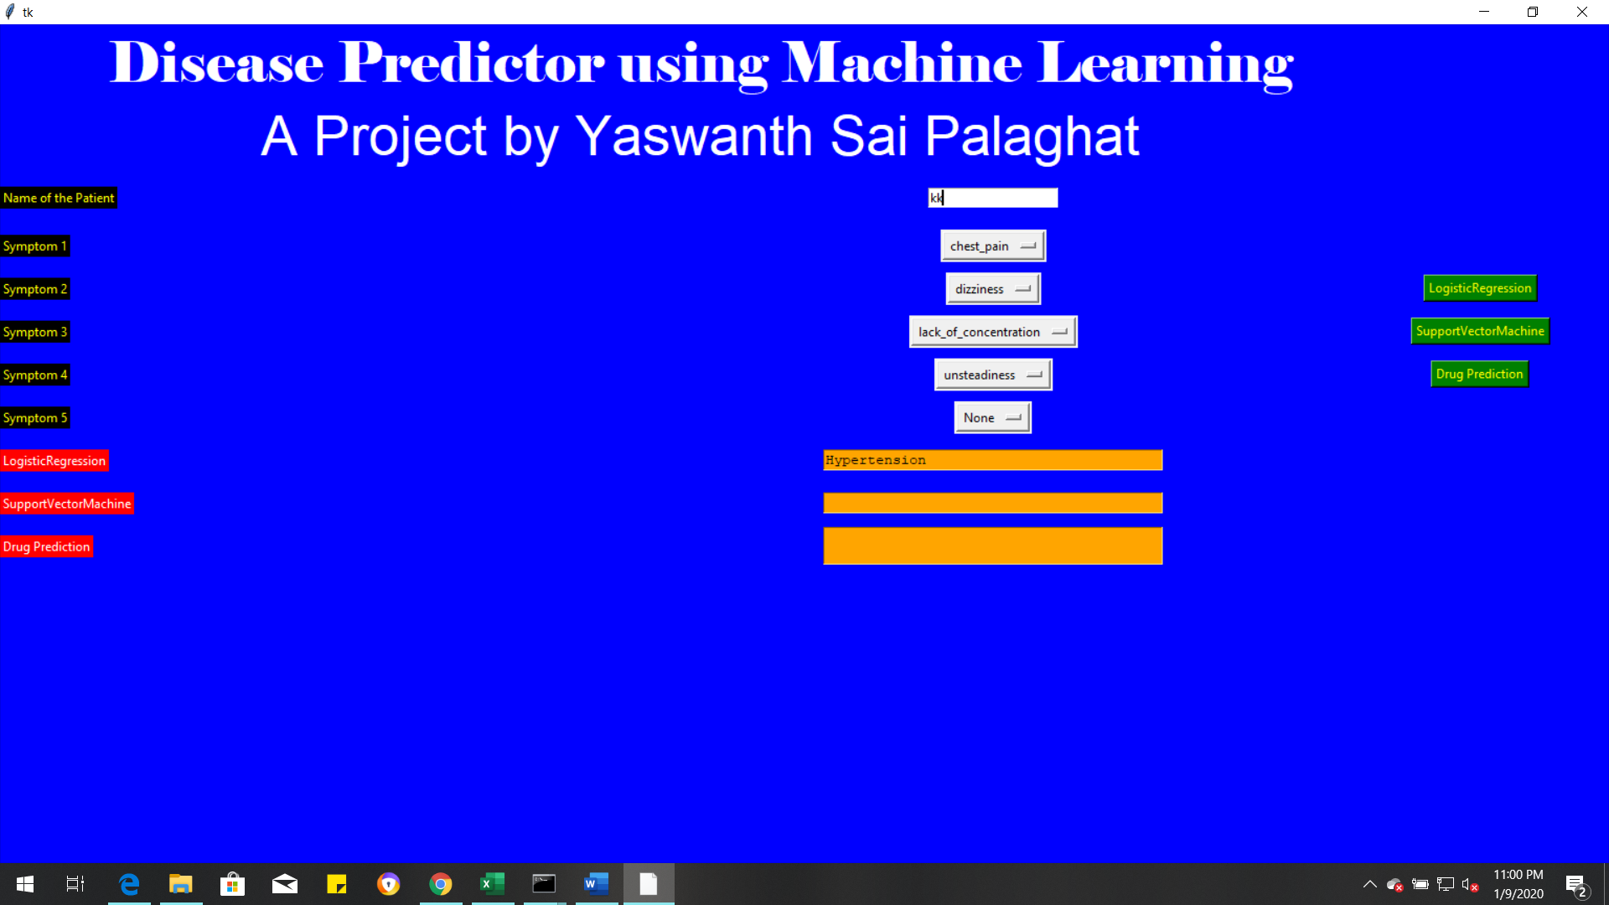

From the above figure for given symptoms it predicted Hypertensio by using Logistic regression

Now test for SVM also.

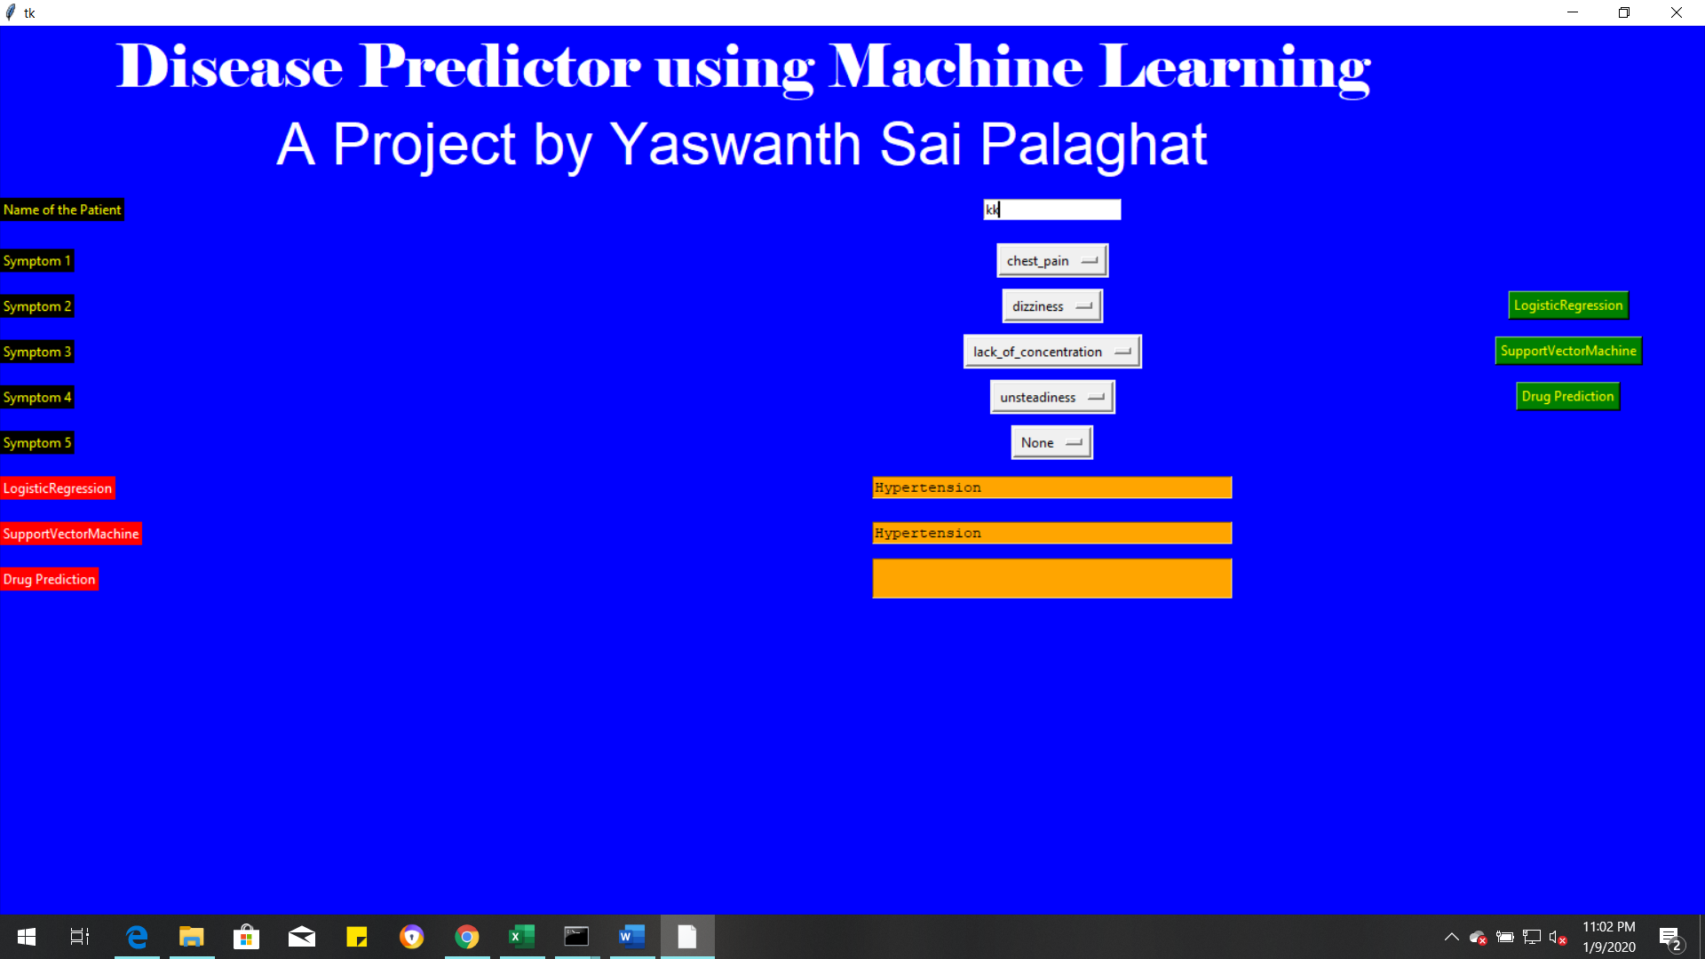

For SVM also for the given symptoms it predicted Hypertension. Now predict the Drug for the disease.

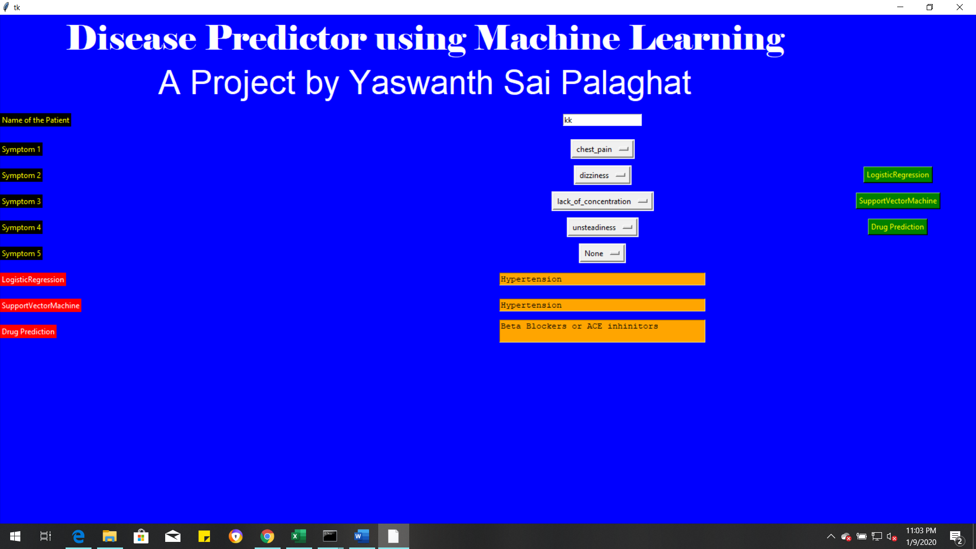

For Hypertension it suggest 2 drugs for relieve the pain

Symptoms for Diabetes:

Blurred & Distored Vision,

Obesity,

Excessive hunger

Polyuria

Increased appetite

Symptoms for Hypertension:

Lack of concentration, Unsteadiness,

Diziness, chest pain,