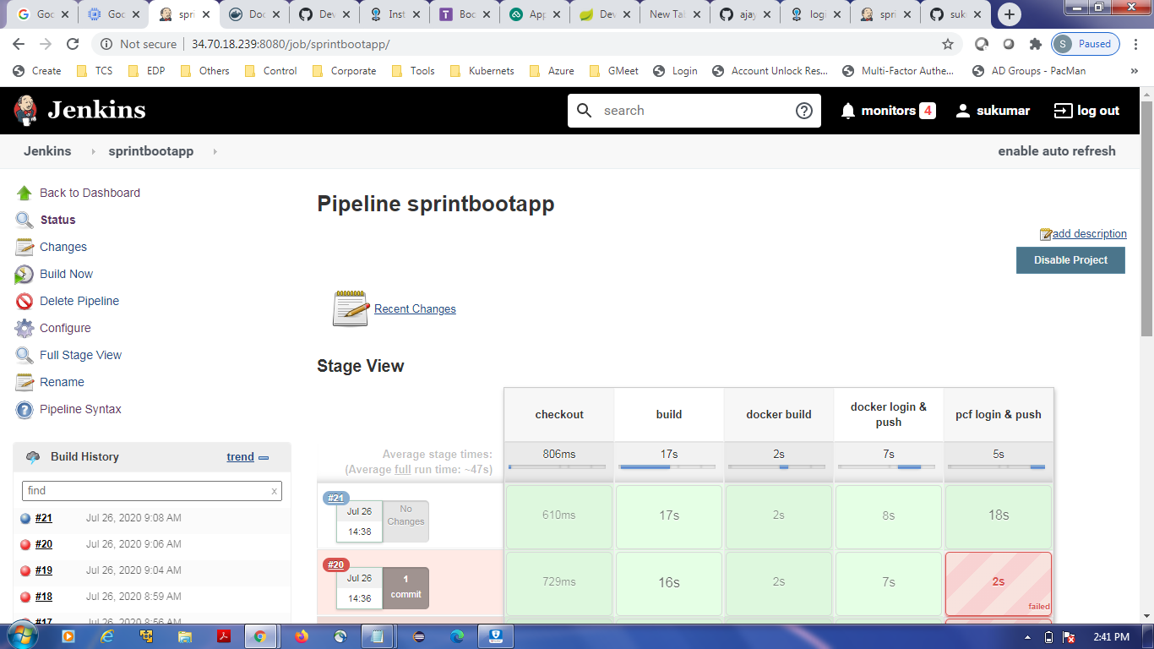

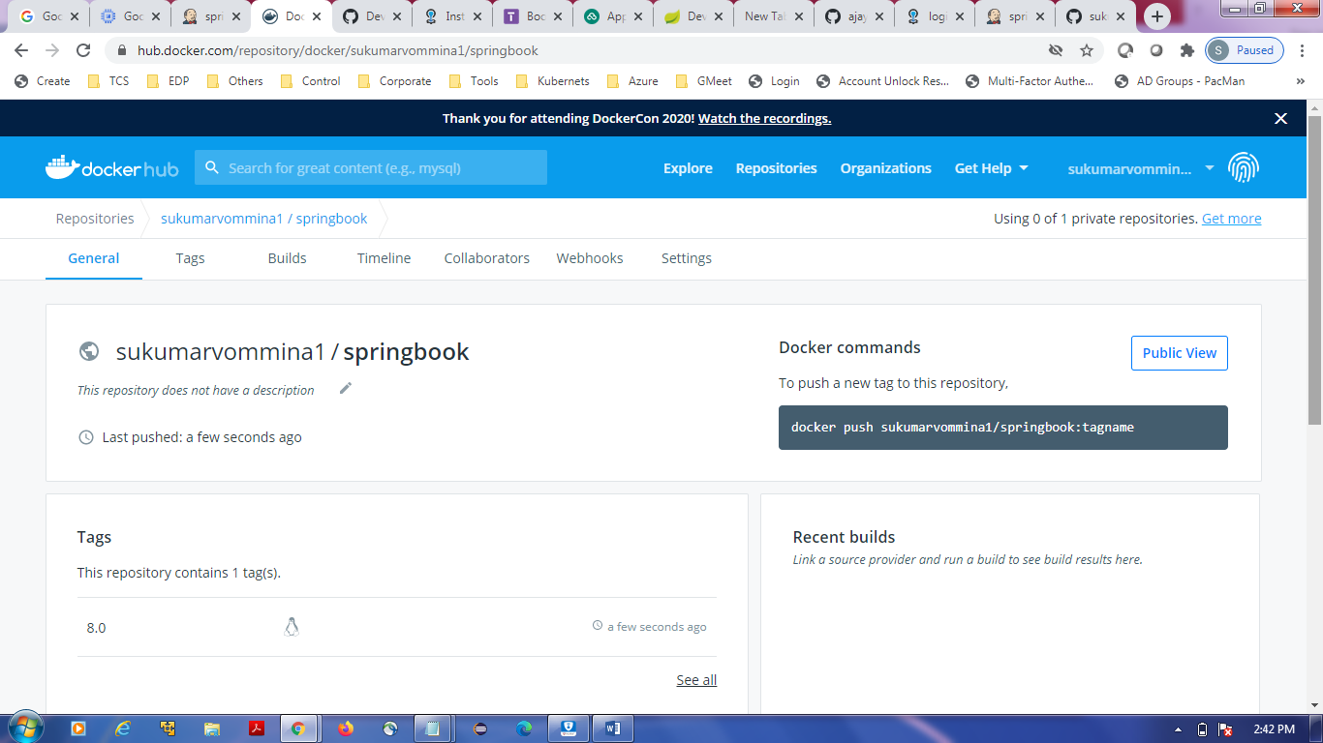

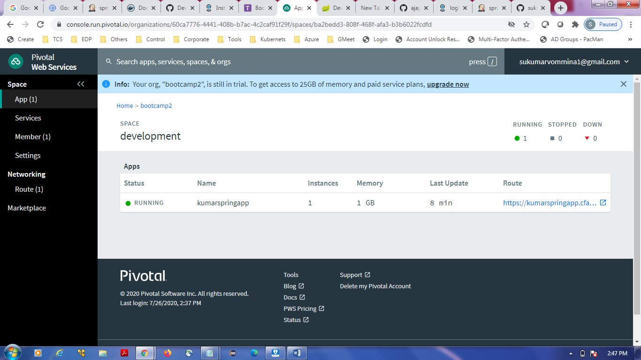

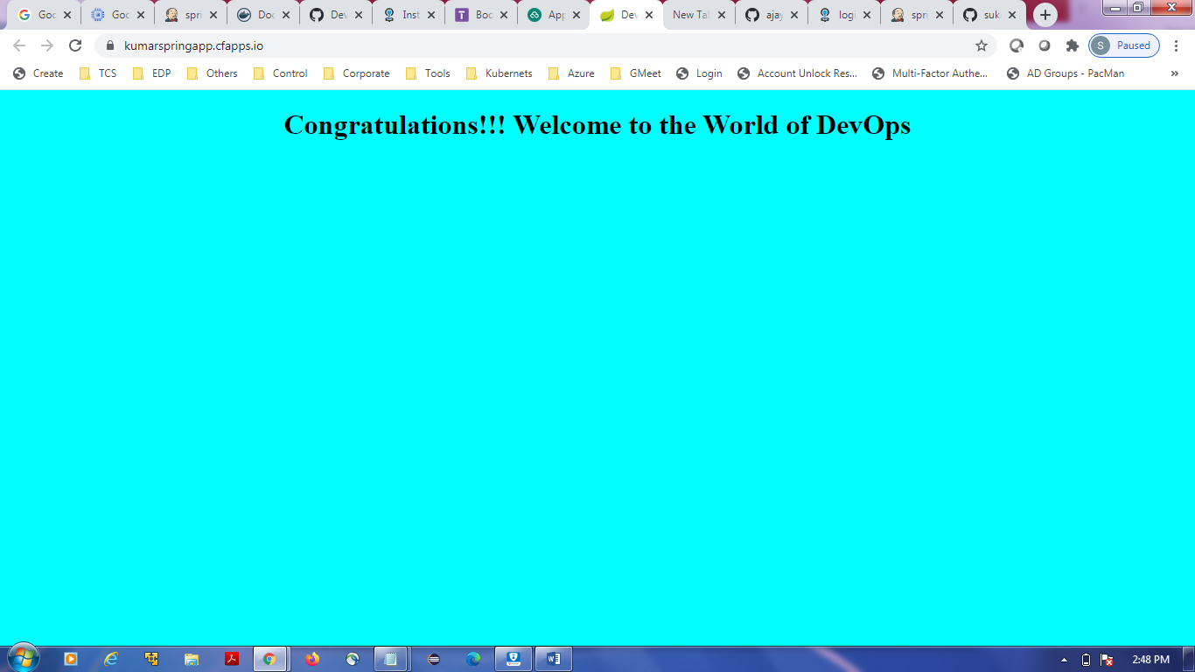

node {

def dockerHome = tool name: 'docker1',type: 'dockerTool'

def dockerCMD = "${dockerHome}/bin/docker"

stage ('checkout') {

git credentialsId: 'github', url: 'https://github.com/sukumarvmv/bootcampday2work.git'

}

stage ('build') {

echo 'build is in progress'

def mavenHome = tool name: 'maven3',type: 'maven'

def mavenCMD = "${mavenHome}/bin/mvn"

sh "${mavenCMD} clean package"

}

stage ('docker build') {

echo 'deploy is in progress'

sh "${dockerCMD} build -t sukumarvommina1/springbook:8.0 ."

}

stage ('docker login & push') {

withCredentials([usernamePassword(credentialsId: 'dockerhub', passwordVariable: 'pass', usernameVariable: 'user')]) {

sh "${dockerCMD} login -u $user -p $pass"

sh "${dockerCMD} push sukumarvommina1/springbook:8.0"

}

}

stage ('pcf login & push') {

withCredentials([usernamePassword(credentialsId: 'pcfcred', passwordVariable: 'pass', usernameVariable: 'user')]) {

sh "cf login -a https://api.run.pivotal.io -u $user -p $pass"

sh "cf push kumarspringapp --docker-image sukumarvommina1/springbook:8.0"

}

}

}