Introduction:

Calendar matrix page comes after search page and before results page. If the user requested a flexible search, then calendar matrix comes into screen.

Terminology:

Flexible search - Search scenario having atmost two legs and in anyone of the legs +/- days is selected.
Cheaper results - Cheaper results among all the items available in calendar matrix

Different possibilities of calendar matrix:

1. Calendar matrix with both inbound and outbound dates:

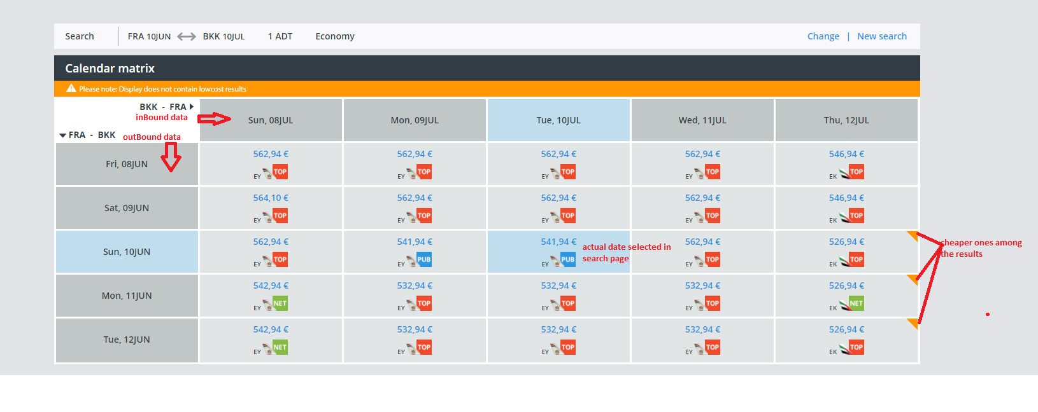
POST#availableFare/calendar service is used to fetch calendar matrix results. In calendar matrix, the results are plotted like a 2-dimensional table. Outbound dates are plotted vertically and inBound dates are plotted horizontally in the table. The actual selected date in search page is highlighted with blue color and placed in center of calendar matrix.

Each cell in the matrix contains the information about the airline, fareType and cost. The cheaper ones among the results are highlighted with orange banner at the top right side of the cell. Upon click on any cell, the results related to selected inbound date and outbound date are requested from the front-end.

Front-end is handling the logic of plotting the data like a table by parsing data from Redbox webservice.

2. Matrix with two legs and only outbound is flexible:

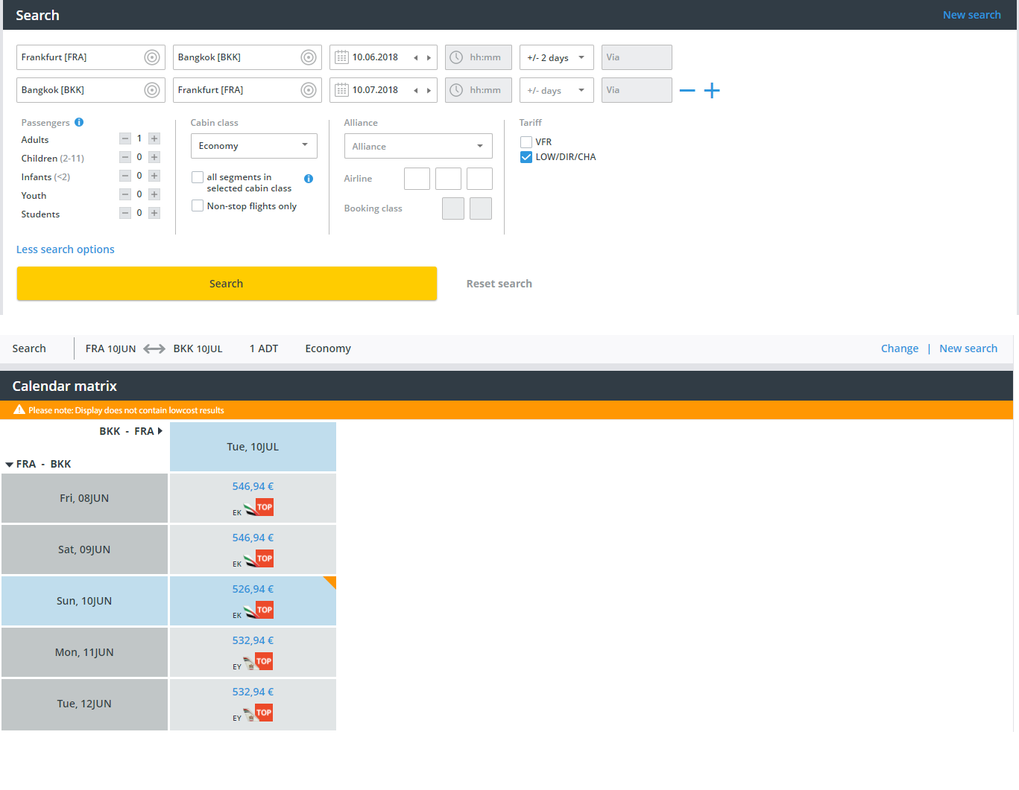
In this case, the results are plotted like a cloumn.

3. Matrix with two legs and only inbound is flexible:
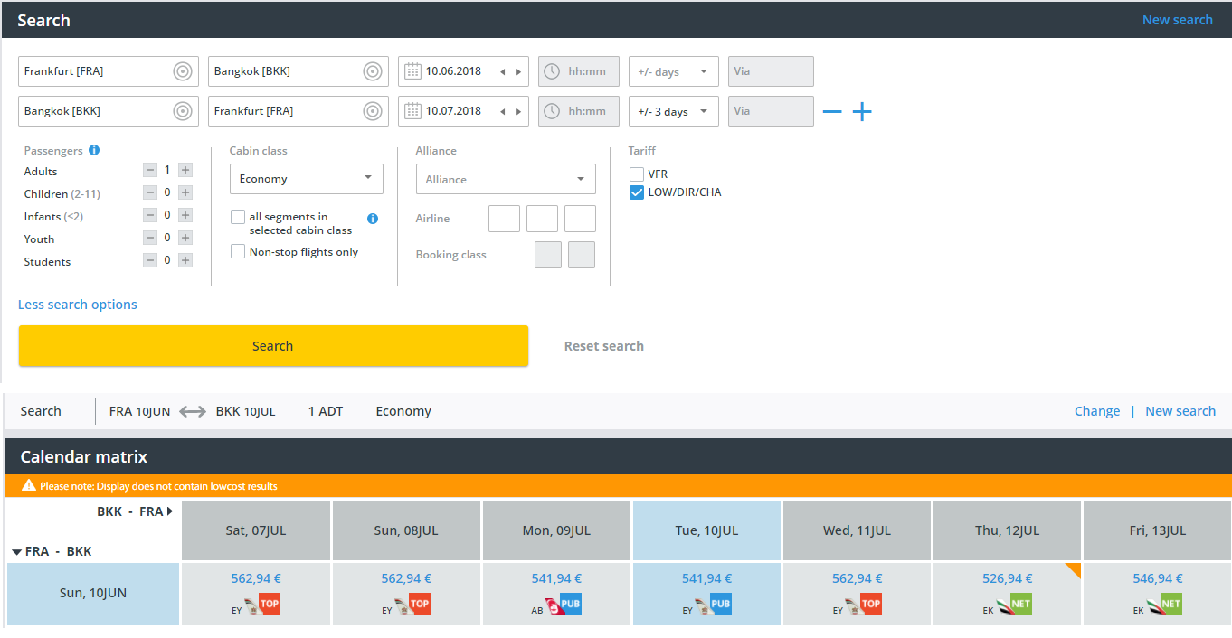
In this case the results are plotted like a row.

4. Matrix with only one leg:

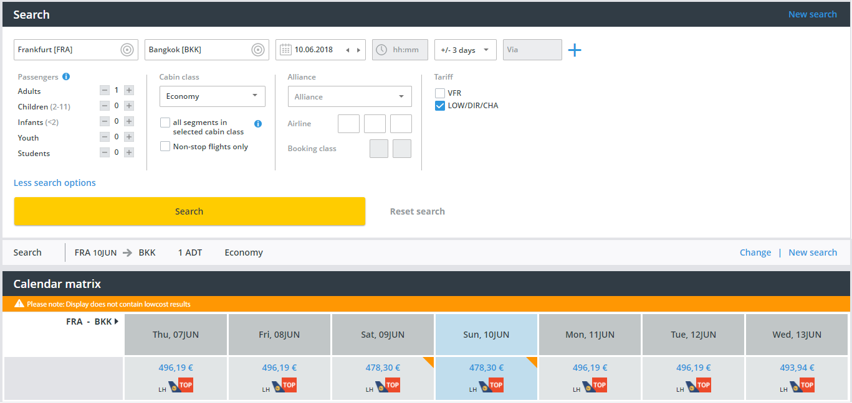
In this case the results are plotted like a row.

FS ticket: PAC-569 – FS- calendar matrix

