Introduction
Zanata is a language server used for AERTicket. Url for this:
http://translate.aerticket-it.de/zanata/account/sign_in
Terminology:
- POT – Pootle object template.
- PO – Pootle object
- Project – Project is a bucket which holds the stuff related to a specific app
- Version – Translations version which goes in increament modal. After each release the version will be changed.
- Language
Commands:
- zanata-cli push – Command to push pot files to zanata server.
- Zanata-cli pull – Command pull the po files from zanata.
There are many applications maintained in this server, each one is called a project. packit is one of the project in that list which is used for AERTicket pakcit application.
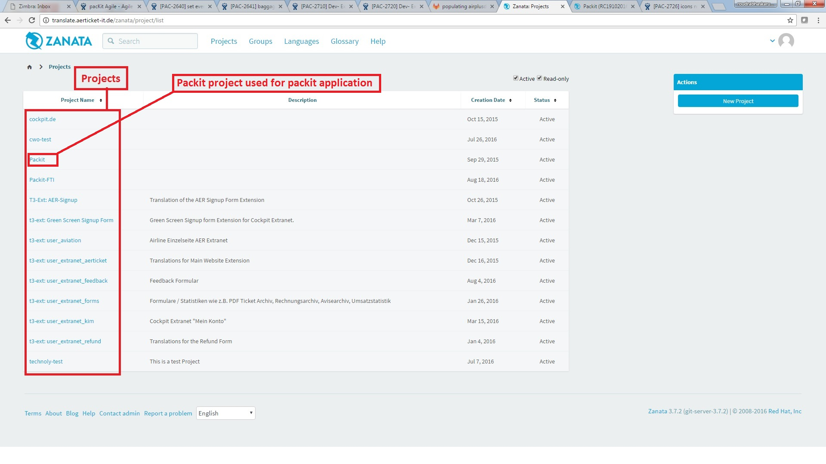
In this project there are versions in which each server(QA, STG and PROD) points to a version.
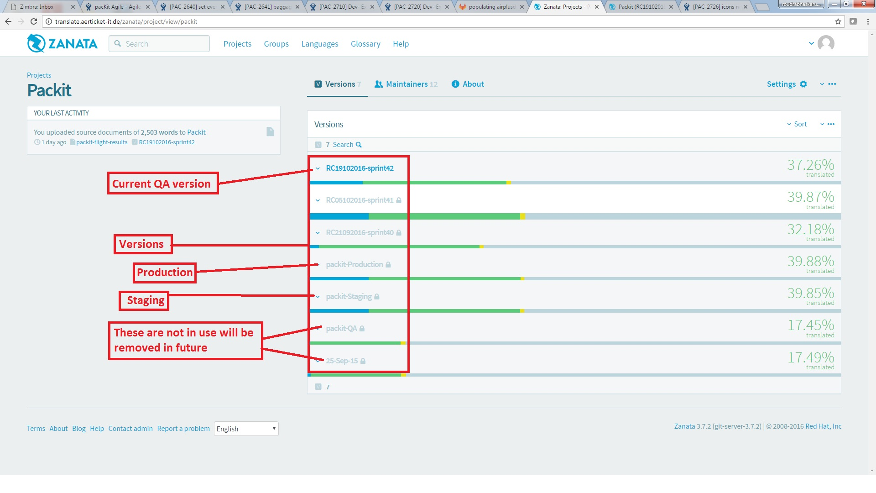
- Staging server is pointed to packit-Staging version.
- Production server is pointed to packit-Production version.
- QA server is pointed to a version which is named on sprint release date. (Ex QA version for sprint-42 maps to RC19102016-Sprint42).
In each version there are multiple languages. At present there are 9 languages active in packit.
In each language, there are documents. The document is created based on a module in the application (ex: packit-search, packit-om-results etc.)
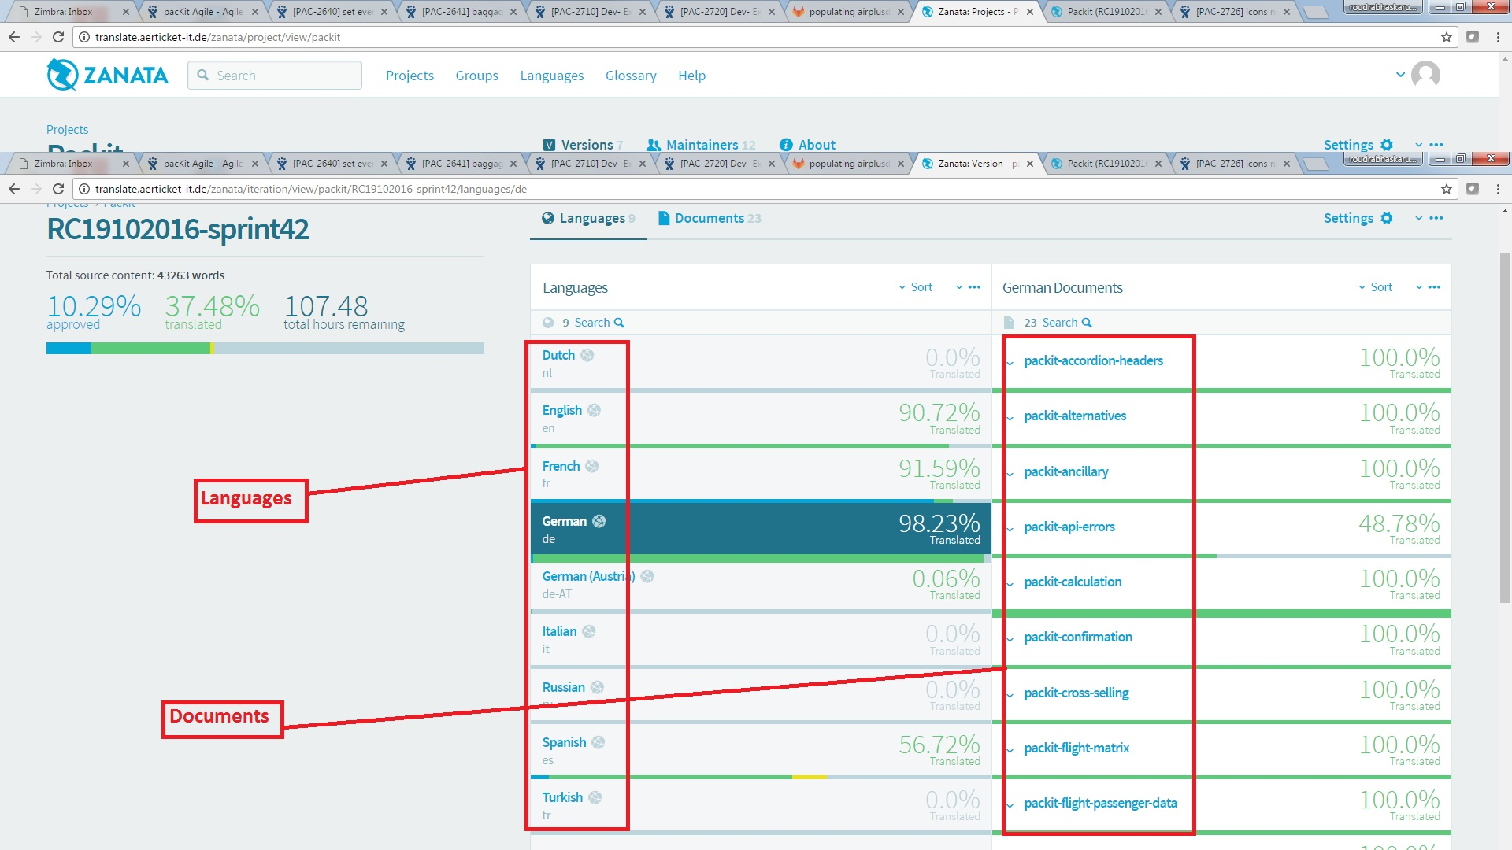
In each document there are Keys and Values.
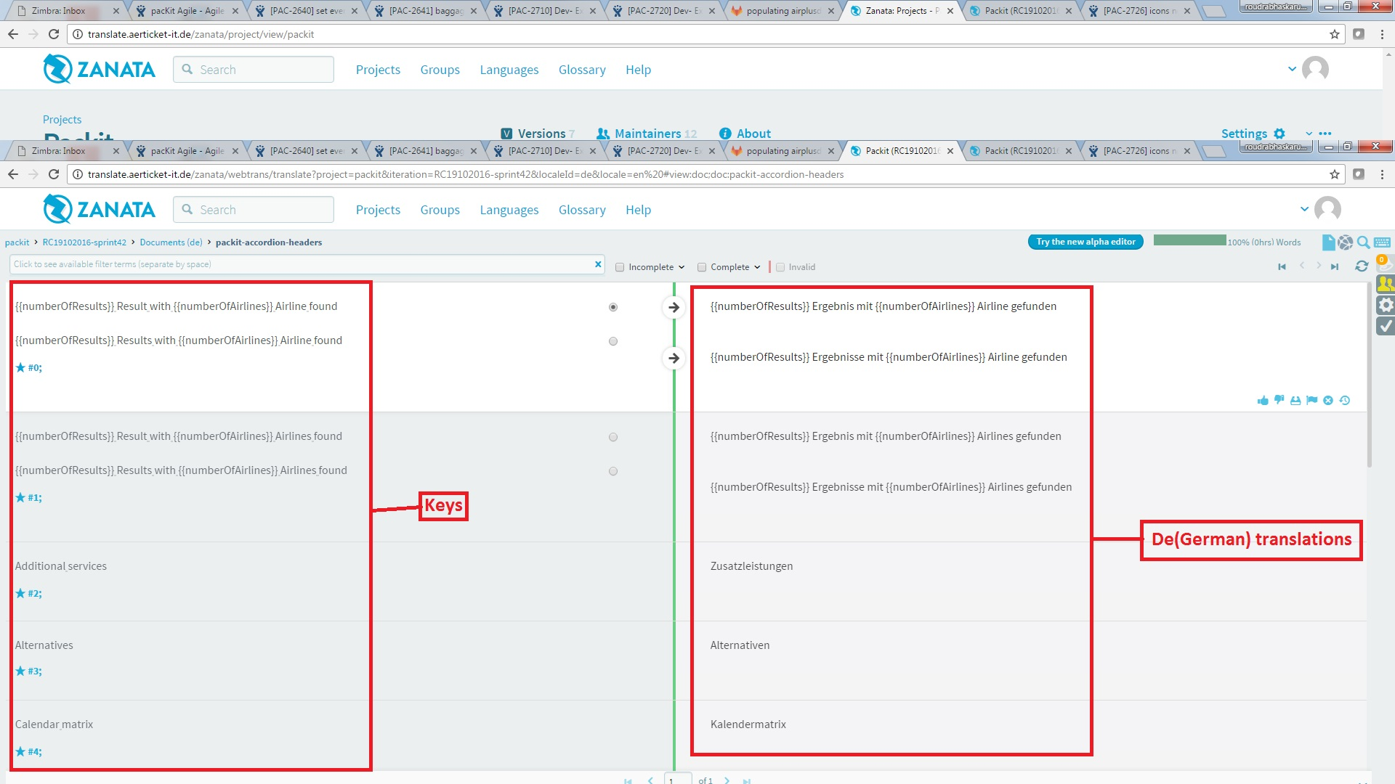
By default, all the versions other than current QA version are locked. Before merging into each version, they have to be unlocked and locked back again after merge is done.

Zanata operations during deployment:
- During staging deployment QA version has to be merged to packit-Staging. Then pull the packit-Staging version in to project code and then build.
- Packit-Staging version has to be merged to packit-Production
Zanata operations during Sprint:
- During initiation of a new sprint, a new QA version has to be created and the last QA version.
- Every QA update push the documents to zanata, so that translators will be working on translationg the strings.
Zanata Operations during regular development:
- We run the command grunt lang:QA to create pot files and check whether our label is being exported to pot files. We can see all the pot files under app/anguages/templates folder.
- Download the translated string from zanata url and place them in your local folder app/languages/translations
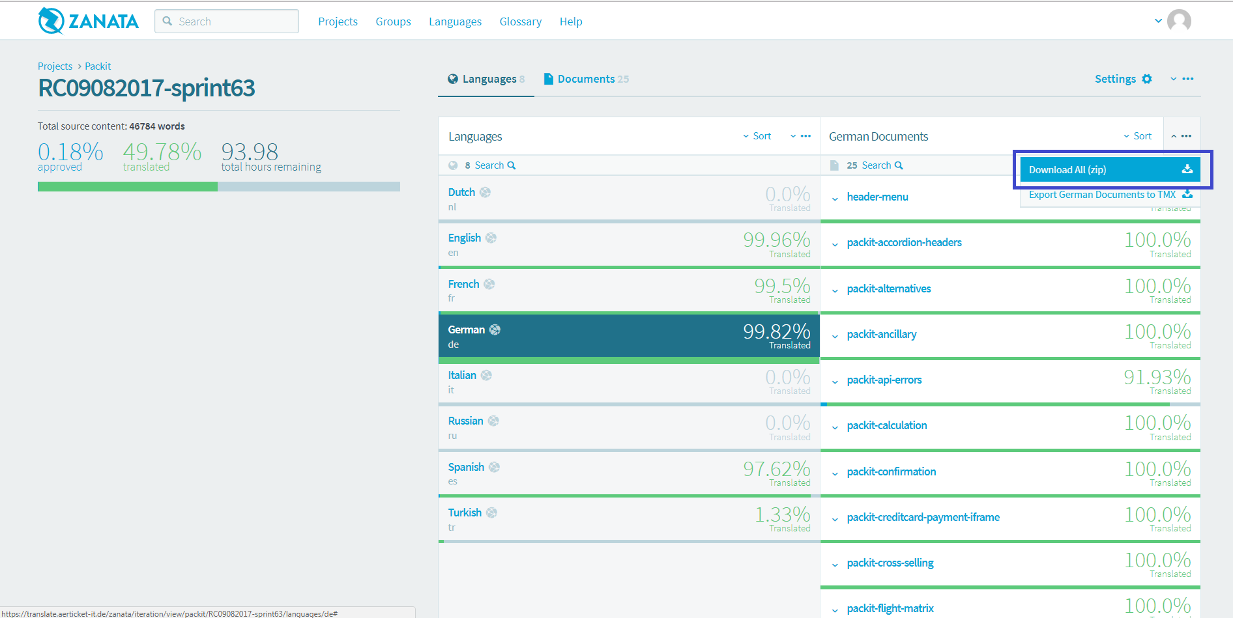

- Run the command grunt translate and verify that the translations effected in the front-end.
Notes:
- Packit uses zanata for localization.
- Every static string or dynamically composed string in application has to be translated depending on the agent preferences
- English is the dfault language in pakcit.
- All the keys in documents are majorly English texts.
- Values will be changed in POs depending on language.

