**Paperless Clinic Management System With Integrated Machine Learning For Clinical Predictions.**

**Abstract:**

At present, clinics use the traditional methodology where patients can use online platform to book an appointment. Currently, systems are designed to store only certain personal information of the patient such name, age, address, contact-details, appointment related information, such as doctor, appointment date, etc. is stored in the database. As per our project, as soon as a patient comes to the doctor, the doctor will first check the patient’s pulse, temperature, blood-glucose, height, weight, age and gender. We have integrated an API which will take the previous mentioned parameters and display a balanced diet-plan for the patient. In the proposed system, we will not only store the above information, but also information such as the prescription brought in by the patient(which may be prescribed by some other doctor). The database will also store the current prescription(including the symptoms experienced by the patient, and disease concluded), prescribed by the current consulting doctor. The doctor will also be able to store all the tests reports of the patient. For the later part of the project, all the diseases and symptoms along with the date of prescription is taken from the database. AI algorithms like KNN, Naive Bayes and Logistic Regression are used on the dataset to predict the rise of certain endemic diseases such as malaria, dengue, monkey-pox, cholera, typhoid, coronavirus, etc. This system will help clinics and hospitals to reserve beds, ventilators, and all the medicines related to the predicted disease over a period. This application can be used in both urban and rural clinics, as all the patient information will become accessible to the doctor and the patient, and will be stored permanently in the database. The prediction mechanism of the application will allow hospitals to be prepared for any future mishaps.

The project contains four main entities namely the user(patient), doctor, admin and the clerk. For the doctor to be able to access the registered user’s records, he/she should be logged in to the platform, and must be given the view only access by the admin. The privilege to edit the records lies with only the admin. The clerk handles all the monetary transactions that are made by the user, regarding the consultation fees, etc.

**Introduction:**

These days hospitals generate a lot of data which includes the health records of patients, the medical history, the prescriptions generated for each patient, the monetary transactions associated with it, etc. are included in it. If all this data has to be stored on paper, it becomes very difficult for the hospitals to maintain all this data which keeps accumulating over the years the hospital functions. Not only is storage the problem, but also the speed of data recovery also poses a problem. Manual searching through huge amounts of data to retrieve a specific small piece from it is very time consuming.

Also, sometimes it is possible that while visiting a new clinic, a patient forgets to bring the his/her files of the previous clinic visited by them, which results in the doctor again asking the basic questions to the patient to get an idea about the patient’s health, including the medical history which is time consuming. In order to prevent this we present a Paperless clinic management, which as the name suggests is a platform which has been designed in order to help the clinics operate in a manner where there is no requirement of paper in order to record the transactions,the medical history, prescriptions, etc. All of this data will be stored digitally in a database which will make it easier to retrieve whenever required.Once the patient registers on this platform, all of the patient's medical data will be recorded and hence it will be much easier for a doctor who has already registered on the platform to retrieve the medical history of the person, which saves a lot of time and helps the doctor to quickly start further diagnostics of the patient's condition.

Along with this platform we have also tried to design a machine learning model which is used to predict the presence of vector borne diseases using various machine learning algorithms.

Vector borne disease refers to a disease which are infections transmitted by the bite of infected arthropod species, such as mosquitoes, ticks, triatomine bugs, sandflies, and blackflies.

According to a statistic in a 2019 journal, disease carrying mosquitos are expected to reach 500 million more people than they do today, which is a cause for serious concern because this means a more increased risk of malaria, dengue,etc among more people which if not controlled might lead to an endemic situation. Hence we have tried to implement a machine learning model which will predict the presence of such diseases based on the symptoms exhibited by the patient. When integrated on this platform, the symptoms data entered by the patient in the form of answers to the Pre-written questions on the platform will be used to predict the presence of such diseases. If more number of such cases are found, this can be used as a type of early warning for the doctors to reserve beds and ensure that there is no shortage of medicine supply required for the treatment.

**Similar Works:**

[1] This paper studies the effects of climate change on the transmission of various vector-borne diseases in Europe . Climate change is associated with the observed movement of mites to higher altitudes and latitudes, including the tick species Ixodes ricinus, which is a vector of Lyme disease and tick-borne encephalitis. Climate change is also believed to be a factor in the spread of other major disease-carrying animals in Europe: Aedes albopictus, which carries diseases such as deer, dengue, and chikungunya, and Aedes albopictus, which carry such diseases. In addition, globalization and international air travel contribute to the international spread of pathogens and vector organisms. Nevertheless, monitoring forecasts of weather conditions helps identify the precursors to epidemics of outbreaks of vector-borne infections and acts as an early warning system for risk reduction.

[2] This paper studies the effect of various climactic factors on the spread of vector borne diseases.This paper also found that many important factors, such as the mobility of people, animals and supplies, affect the spread and severity of human illness. Existing controls; availability of effective medicines; quality of public health services; human behavior; political stability and conflict. As resistance to drugs and pesticides increases, significant funding and research efforts need to be continued to continue the fight against existing and emerging infectious diseases, especially those that are transmitted by carriers.

[3] This paper focuses on the effective prediction of the development of vector infections (multiclass classification) of three diseases (chikungunya, malaria, and dengue) in the Indian subcontinent. The author investigated and refined the model using data collected throughout India between 2013 and 2017. They also proposed an algorithm for predicting the risk of convolutional neural networks using contrasting data. The prediction accuracy of the proposed CNN algorithm is 88%.

[4] In this document, the Clinic Management System (CMS for short) is a management system specifically designed for most common clinics, allowing you to track day-to-day operational information. This clinic management system is an offline system that can be used by clinic staff and doctors. The system covers all basic modules including staff management module, clinic information management module, patient profile management module, patient appointment module, patient queue module, patient visit module, inventory management module and reporting module.

[5] This document proposes an online clinical management system, which is developed using a web-based concept. The methodology used to develop the system includes the iterative waterfall model approach, data flow, and logical and entity relationships diagrams used to design the system. The presence of this system allows the enrollment process to avoid data redundancy, find patient data records more quickly, and all manual tasks performed on this system allow the patient to be treated by a doctor. You can reduce the waiting time. You can switch to a computerized system.

[6] This paper is a comprehensive computerized booking, registration, information and evaluation (ARISE) system of medical information and finance analyzed for the management of family planning programs that serve 30,000 patients annually. And presents the logistic aspect. An overview of the existing computer system network is displayed, along with key interactive patient indexes, collection booking processes, management statistics packages, and a description of the Department of Health, Education and Welfare (HEW) report. The methodology and implementation aspects of ARISE have the potential to be broadly applicable to other family planning and similarly structured clinical programs.

[7] In this paper a new clinic management system has been introducrd in order to replace the old paper based system as it causes the expenditure of much more time and more physical space to track paper records, find information, and ensure data security. A data-based clinic management system is being proposed to replace an old manual clinic management system with the digitalized system. The clinic management program is committed to the routine workload of the hard-worked doctors and receptionists. The system combines all the processes between medical personnel and other necessary functions to make it easier for medical personnel to cooperate with each other.

[8] This document is about a clinic management system developed to support routine clinical work before it is performed manually. The system covers the entire clinical operation, from patient and physician registration to patient validation. The main thing is that it makes it easier to collect and retrieve data. Target users of this system are clinics, doctors, patients, and administrative staff. The scope of this project includes the booking module, login / registration module, validation module, reporting module, and mapping in user notifications. The waterfall approach is used in the development of this system. It involves an iterative process to make this system user-friendly and easy to use. The system is designed according to the Systems Development Lifecycle (SDLC) approach. This design includes an Entity Relationship Diagram (ERD) and a Data Flow Diagram (DFD) to show the logical flow of the system. Apache is used as the web server, MySQL is used as the database, PHP is used as the scripting language, and the browser is used for implementation.

[9] In this paper a new system was developed with an iterative model and system design based on structured approach, which was specially developed for veternary clinics. The language that had been selected for this project was hypertext pre-processor (PHP) and other software used for this project are notepad as a programming tool, lucidchart, XAMPP as a platform to access the database and for webserver, MySQL which is for design and build database and lastly is Microsoft window 10 as an operating system. There are three users for this new system which are the Administrator of the clinic, clinic’s staff and clients of the clinic. Moreover, this system provide functions likes clinic information, appointments details about treatment packages for animals, schedule for booking appointments, online payments and provide appointment notification as a reminder for clients. Therefore, this system will help veterinary clinic’s clients of making appointment at time that most convenient and will help all the user of system to save time.

# Architecture:

The first diagram in the methodology explains the overall architecture of the project. The clinic management and the machine learning modules were developed simultaneously. First the machine learning model is trained on a sample dataset to get an idea about the algorithms. The plan is to expand to include the data from the clinic management system

# 

# 

# Methodology:

**Project Modules:**

This project has two main entities: The clinic management system nd the machine learning module. The main entities of clinic management module are the user(customer/patient), the doctor, the admin and the receptionist. All the modules in the clinic management system have been developed using html, css, javascript , php and mysql. And python has been used to develop the machine learning module.

**Modules of Clinic Management System:**

***The User:***

The user here refers to the patient who will be using the platform to schedule the appointments with the doctor. Once the user visits the platform, he/she has the option to either sign-up/ register to the platform or directly book an appointment. The benefit of being a registered user is that the medical data of the patient gets saved in the database which helps the doctor when the patient books another appointment. This the booking page for the user who doesen’t want to register.

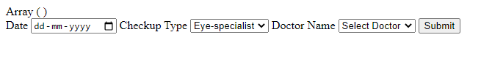

This is the login page for the user.

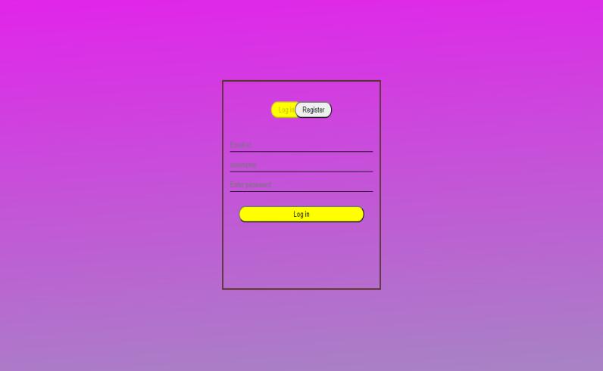

The user can register for the platform by filling up certain details about himself/herself. A registered user can login and view his medical records.

This is the register page for the user.

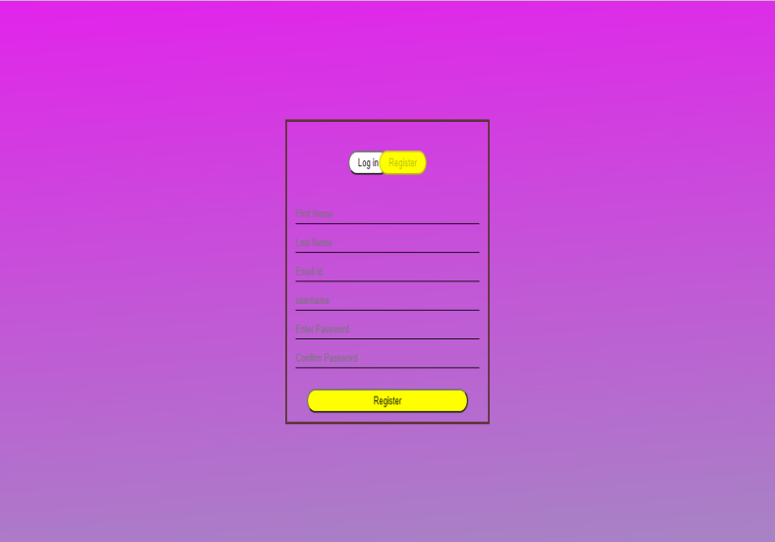

This is the page the user views once he/she logs in to the platform.



By clicking profile setting, the user can view his medical and personal profile.

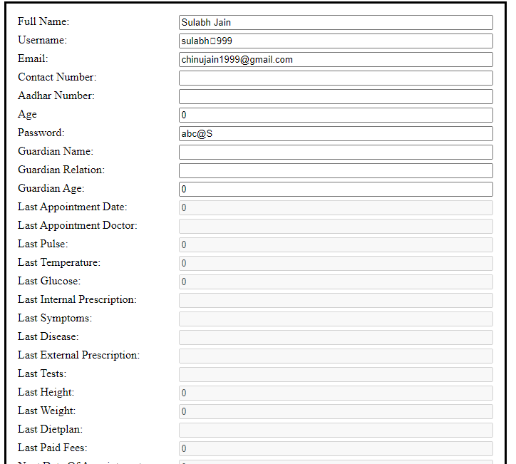

***The Doctor:***

The doctor is the second main entity in this project. The doctor first has to log into the platform where he/she has the option to view their personal details and the privileges to edit some of them. There is another button labeled check patient which redirects the doctor to another page, where he can fill in all the details of the patient currently under consultation. He/she can also generate prescription along with a complete diet with calorie count for the patient by taking in information like bmi, gender , activity level of the patient. This is the page which comes up after the doctor logs in.



This is the check patient page for the doctor.

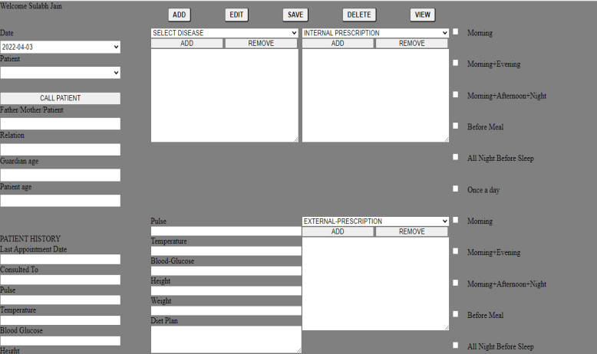

As soon as a patient comes to the doctor, the doctor will first check the patient’s pulse, temperature, blood-glucose, height, weight, age and gender. We have integrated an API which will take the previous mentioned parameters and display a balanced diet-plan for the patient. In the proposed system, we will not only store the above information, but also information such as the prescription brought in by the patient(which may be prescribed by some other doctor). The database will also store the current prescription(including the symptoms experienced by the patient, and disease concluded), prescribed by the current consulting doctor. The doctor will also be able to store all the tests reports of the patient. As soon as he checks up the patient, he will generate the an e-prescription after giving discount to patient.

***The Receptionist:***

The receptionist is the third entity of this project. The main role of the receptionist is to take care of the monetary transactions between the doctor and the patient, like consultation fees, etc. The receptionist only has a login page. The receptionist can also book an appointment for a patient if necessary along with keeping track of the booked appointments for that particular day. After the receptionist logs in, this page appears.



***The Admin:***

The admin as such doesen’t have an active role on this platform. The only role admin has is to provide a new doctor with login credentials, along with checking the integrity of the medical data stored in the database.

**The Machine Learning module:**

The machine module consists of training various machine learning algorithms on a vector disease dataset. This dataset makes use of ten features which are the presence of ten different symptoms to provide a prognosis for the presence of eleven different vector based disease. This model will be used as a blueprint to create a model which will b trained on the data provided by the clinic.

The algorithms used in this module are: Logistic regression, K Nearest Neighbors, Random Forest and Naive Bayes.

Another dataset is created by using feature selection techniques like chi2-test and Select K best. The models are trained on both, the original dataset and the one which is created after feature selection.

# Result:

We have successfully implemented a “Paperless Clinic Management system” where paper is not required to store any kind of details. All the details, right from booking the appointment to collecting the payment are stored digitally, making it much easier for to access and retrieve them much easily and quickly.

**Results for the machine learning module:**

|  |  |  |  |
| --- | --- | --- | --- |
| S.No | Model | Accuracy | |
|  |  | Original | After Feature Selection |
| 1. | Logistic regression | 91% | 88% |
| 2. | K Nearest Neighbors | 70% | 75% |
| 3. | Random Forest | 97% | 95% |
| 4. | Naive Bayes. | 88% | 91% |

# Conclusion and future works:

This project is a basic model of clinic management system with a small module of machine learning , but we would like to expand it further to include machine learning for different purposes like analysis of patient profile to see which type of medical profile attracts which type of disease, or which diseases are more common during a particular time of the year.

**References:**

1. Semenza, Jan C., and Jonathan E. Suk. "Vector-borne diseases and climate change: a European perspective." *FEMS microbiology letters* 365.2 (2018): fnx244.
2. Caminade, Cyril, K. Marie McIntyre, and Anne E. Jones. "Impact of recent and future climate change on vector‐borne diseases." *Annals of the New York Academy of Sciences* 1436.1 (2019): 157-173.
3. Raizada, Sandali, Shuchi Mala, and Achyut Shankar. "Vector borne disease outbreak prediction by machine learning." *2020 International conference on smart technologies in computing, electrical and electronics (ICSTCEE)*. IEEE, 2020.
4. “Lay, C.M(2010). Clinic Management System”
5. Teke, Aniket, et al. "Online Clinic Management System." *International Journal (Toronto, Ont.)* 4.2 (2019).
6. Mize, SG. , Heartwell, SF. , [Ellis, RG](https://europepmc.org/search?query=AUTH:"Ellis RG"). , [Walther, MD](https://europepmc.org/search?query=AUTH:"Walther MD"). , [Mishelevich, DJ](https://europepmc.org/search?query=AUTH:"Mishelevich DJ"). ,[Baine, MS](https://europepmc.org/search?query=AUTH:"Baine MS"). ,[MacDonald, PC](https://europepmc.org/search?query=AUTH:"MacDonald PC").(01 Aug 1977)An automated clinic management system for a family planning network”
7. Huan,PZL(2022).Clinic Management System(Admin and Doctor’s system)”
8. “Hui CB. , Salleh MNM.(2021).Clinic management system for hope clinic.”

# “Jaffar NB. , Zin NAM.(2021).The Development of Veterinary Clinic Management System Using Structured Approach”