Full Stack Engineering

Project Report Semester-V (Batch-2023)

**404 Job Found**



**Supervised By: Submitted By:**

Rahul Sir Anmol Garg -2310990285(G-4)

Sulabh Saluja -2310991060(G-4) Tanish Gupta -2310991060(G4) Tarun Garg -2310991149(G-4)

**Department of Computer Science and Engineering Chitkara University Institute of Engineering & Technology,**

**Chitkara University, Punjab**

# ABSTRACT

*404 Job Found* is a next-generation job application platform designed to streamline and personalize the hiring process for both job seekers and recruiters. The platform ensures accessible, efficient, and secure interactions through AI-driven job recommendations, real-time application tracking, and anonymous profile viewing options. It aims to create a supportive digital ecosystem where candidates can explore opportunities, apply with ease, and track their progress, while employers can manage listings, screen applicants, and connect with the right talent effortlessly.

The platform leverages advanced technologies such as AI-powered resume parsing, skill-matching algorithms, and real-time chat systems for recruiter–applicant communication. Through AI-driven recommendations, job seekers receive tailored listings based on their skills, experience, and preferences, while recruiters benefit from automated candidate shortlisting and analytics. The interactive user dashboard provides a seamless experience, enabling users to manage profiles, monitor application status, and access career resources efficiently.

*404 Job Found* is built using a scalable MERN stack architecture to handle high traffic and diverse user interactions while maintaining performance. The integration of cloud services like AWS/Firebase ensures smooth data storage, secure authentication, and real-time synchronization. Moreover, the use of WebSocket’s enables instant notifications and updates, ensuring users never miss crucial opportunities.

This report presents the project’s background, objectives, problem definition, methodology, results, and future scope. It highlights how *404 Job Found* addresses key challenges in the job market, such as lack of personalization, inefficient communication, and time-consuming hiring processes, while maintaining a secure, scalable, and user-friendly experience.

# Table of Content

1. Abstract/Keywords
2. Introduction to the project
   1. Background
   2. Problem Statement
3. Problem Definition and Requirements
   1. Methods
   2. Programming/Working Environment
   3. Requirements to run the application
4. Proposed Design / Methodology
5. Results

# Introduction

The job market today is highly competitive, with millions of individuals struggling to find opportunities that align with their skills, experience, and career goals. Many job seekers face challenges such as irrelevant listings, lack of personalized recommendations, and inefficient communication with recruiters. On the other hand, employers often find it difficult to filter through large applicant pools to identify the right candidates quickly and effectively. These inefficiencies create barriers for both applicants and recruiters, making the hiring process more time-consuming and less effective.

*404 Job Found* is a web-based job application platform designed to bridge this gap by streamlining the hiring process through smart technology. The platform connects job seekers with recruiters using AI-driven recommendations, real-time application tracking, and automated resume parsing, ensuring that the right candidates meet the right opportunities. By leveraging modern technologies, including React.js for the frontend, Node.js and Express.js for the backend, and MongoDB as the database, the platform provides a secure, scalable, and efficient environment. Additionally, features such as WebSocket-powered instant notifications and an AI-based recommendation engine ensure seamless interaction and timely updates for users.

With its user-friendly design and robust technological foundation, *404 Job Found* aims to simplify the job-hunting experience, reduce inefficiencies in recruitment, and create a reliable digital ecosystem that benefits both job seekers and employers.

## Background and Significance

In today’s competitive job market, applicants often face irrelevant listings, lack of personalized guidance, and delayed responses from recruiters. Similarly, employers struggle with filtering large applicant pools and identifying the right candidates efficiently. These issues highlight the need for a smarter and more accessible hiring platform.

*404 Job Found* is significant because it integrates AI-powered recommendations, resume parsing, and real-time communication to simplify the recruitment process. Its key advantage lies in connecting the right talent with the right opportunities, reducing inefficiencies for recruiters while making job hunting easier and more transparent for applicants.

## Objectives

The primary goal of *404 Job Found* is to bridge the gap between job seekers and recruiters by creating a streamlined, intelligent, and user-friendly hiring platform. The specific objectives of the project include:

To connect job seekers with relevant opportunities through AI-driven recommendations and skill- matching algorithms.

To enable recruiters to efficiently filter, shortlist, and engage with potential candidates using automated tools.

To provide an interactive, secure, and accessible platform that ensures smooth communication between applicants and employers.

To enhance transparency in the hiring process with real-time application tracking and instant notifications.

To reduce inefficiencies in recruitment by offering a digital-first solution that benefits both job seekers and organizations.

## Features and Functionality

To achieve these objectives, *404 Job Found* incorporates the following features:

* 1. User Registration and Profile Management
     + Job seekers can create accounts with details such as skills, experience, and career preferences.
     + Recruiters can register by providing company information, job listings, and hiring requirements.
  2. Smart Job Matching System
     + An AI-driven algorithm recommends jobs to seekers based on skills, qualifications, and interests.
     + Recruiters can view automatically shortlisted candidates who best match their job requirements.
  3. AI-Powered Resume Parsing and Recommendations
     + The platform analyses resumes to highlight key skills and suggest relevant job opportunities.
     + Provides career insights and recommendations to improve candidate profiles.
  4. Real-Time Communication and Notifications
     + Instant messaging enables secure interaction between job seekers and recruiters.
     + WebSocket-powered notifications alert users about new job matches, application status, and recruiter messages.
  5. Application Tracking and Dashboard
     + Job seekers can track the status of their applications in real time.
     + Recruiters can monitor applicant progress, filter candidates, and manage multiple job postings from a single dashboard.
  6. Career Resources and Support
     + Provides access to interview tips, resume-building guides, and career development resources.
     + Encourages skill development through personalized resource recommendations.

## Technology Stack

To ensure high performance, scalability, and security, *404 Job Found* is developed using a modern web-based technology stack:

* **Frontend:** HTML, CSS, and JavaScript (for a clean, responsive, and interactive user interface)
* **Backend:** PHP (for handling business logic, server-side processing, and API integration)
* **Framework:** Express.js (for routing and middleware support where required)
* **Database:** MongoDB (for storing user profiles, resumes, applications, and job listings)
* **AI Integration:** Resume parsing and smart job-matching algorithm powered by machine learning techniques
* **Authentication:** JWT (JSON Web Tokens) and session management for secure user access
* **Hosting & Deployment:** Cloud-based services (AWS/Firebase) for scalability, global access, and real-time updates

# Problem Definition and Requirements

## Problem Statement:

The hiring process today is often inefficient for both job seekers and recruiters. Applicants struggle with irrelevant job postings, lack of personalized recommendations, and delayed updates on their applications. Recruiters, on the other hand, face difficulties filtering large volumes of resumes, identifying suitable candidates quickly, and maintaining timely communication. These challenges result in frustration, wasted time, and missed opportunities for both parties. *404 Job Found* seeks to address these issues by providing an AI-powered platform that integrates smart job matching, resume parsing, real-time communication, and secure application tracking in one seamless system. **Software & Hardware Requirements:**

* **Frontend:** HTML, CSS, JavaScript (for a responsive, user-friendly interface)
* **Backend:** PHP (for handling server-side logic, authentication, and application workflows)
* **Database:** MongoDB (for storing user profiles, resumes, job listings, and application status)
* **AI Integration:** Resume parsing and skill-based job recommendation system
* **Security:** JWT and session-based authentication (for secure logins and data protection)
* **Cloud Services:** AWS/Firebase (for hosting, scalability, real-time notifications, and secure data storage)
* **Hardware:** Server with a minimum of 8GB RAM, SSD storage, and cloud deployment capabilities to handle high traffic and concurrent users

# Proposed Design / Methodology

## System Architecture:

*404 Job Found* follows a modular architecture, ensuring scalability, security, and efficient user interactions. The platform consists of:

* **Frontend:** Developed with HTML, CSS, and JavaScript to deliver a responsive and interactive interface. The UI is designed to be simple, professional, and intuitive, allowing both job seekers and recruiters to navigate effortlessly.
* **Backend:** Powered by PHP, handling authentication, database queries, and application workflows. Optimized routing and middleware ensure secure data handling and smooth user operations, even under high traffic.
* **Database:** MongoDB, structured for scalable storage and retrieval of diverse data such as user profiles, resumes, job postings, and application history. Indexed collections support fast searches and filtering.
* **AI-Powered Modules:** Resume parsing, skill-based job matching, and recommendation systems suggest relevant opportunities for seekers and suitable candidates for recruiters.
* **Notifications:** Real-time alerts powered by WebSockets/Firebase, ensuring instant updates about application status, new job postings, and recruiter messages.

## File Structure:

* **Frontend:** Organized into Pages (job listings, dashboard, application tracking), Stylesheets, and Utility Scripts for reusability.
* **Backend:** Modular design including Controllers (application logic), Routes (request handling), Models (data schemas), Middleware (security/authentication), and Configurations (database, APIs).
* **Database Models:** Efficient structures for storing Job Seeker Profiles, Recruiter Profiles, Resumes, Job Listings, Applications, and System Logs.

## Algorithms Used:

* **AI-based Job Recommendation Engine:** Suggests job postings to seekers based on skills, experience, and preferences. For recruiters, it recommends candidates by analyzing resumes and job requirements.
* **Resume Parsing Algorithm:** Extracts key skills, education, and experience from uploaded resumes to automate profile creation and improve candidate-job matching.
* **Real-time Notification System:** Uses WebSocket’s /Firebase to ensure instant updates on job status, application tracking, and recruiter communications.
* **Application Tracking System:** Monitors candidate progress from application submission to hiring, enabling transparency for both parties.
* **Anomaly Detection System:** Flags incomplete or inconsistent job postings and resumes to maintain platform quality and data integrity.
* **Personalized Learning Model:** Provides applicants with career resources, interview tips, and resume improvement suggestions based on their history and engagement.

# Results

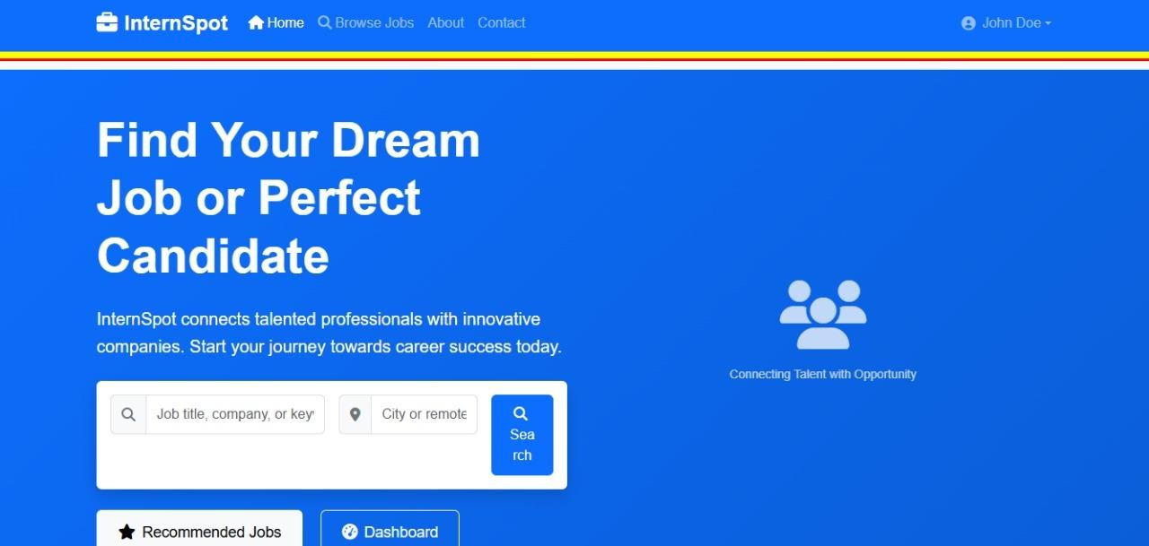

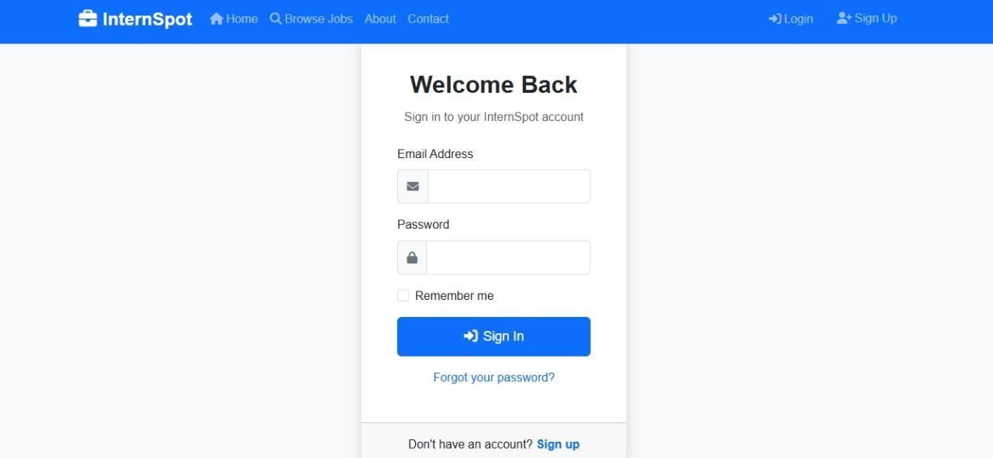

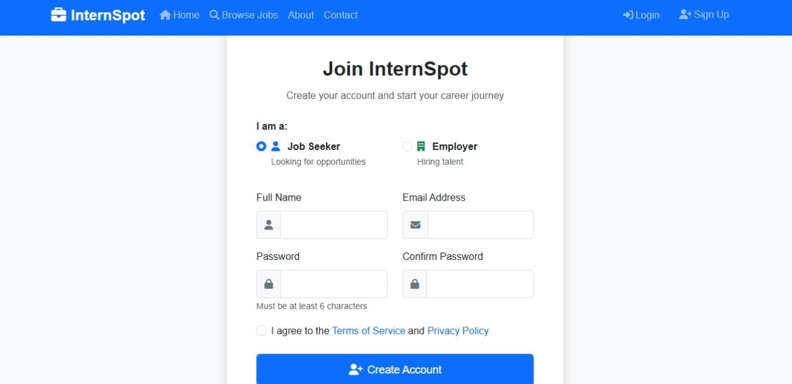

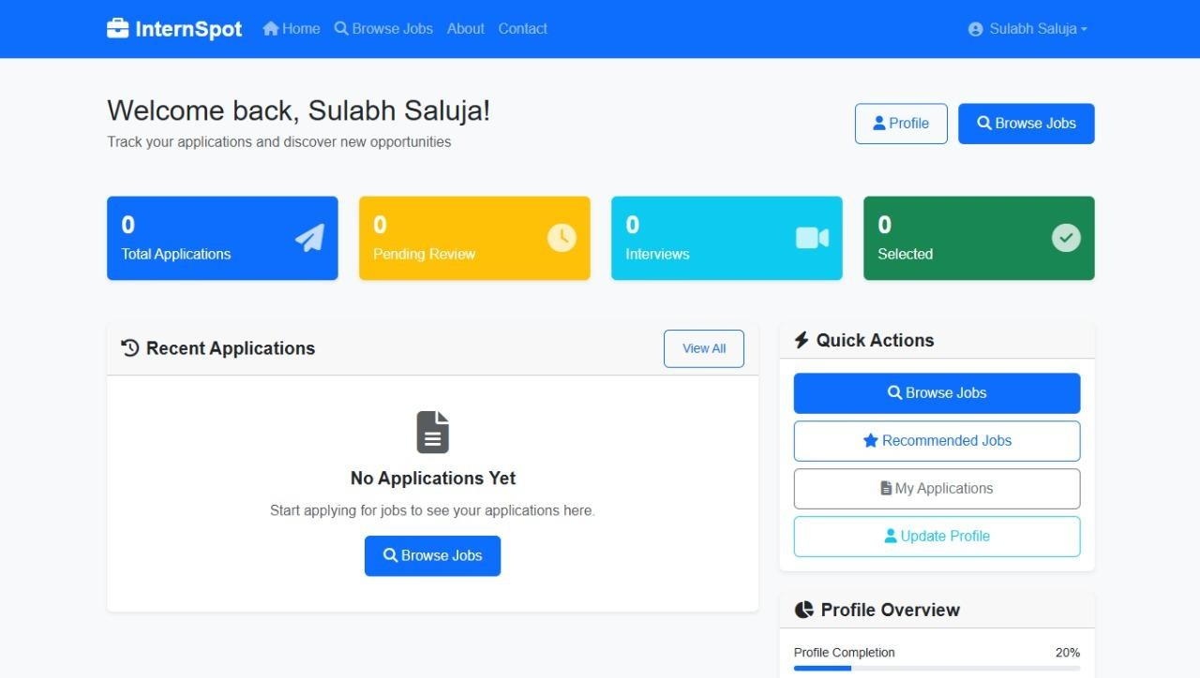

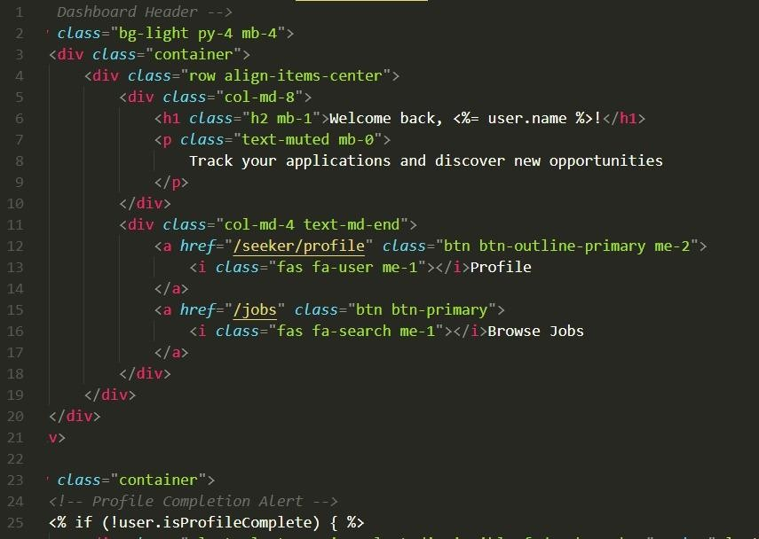

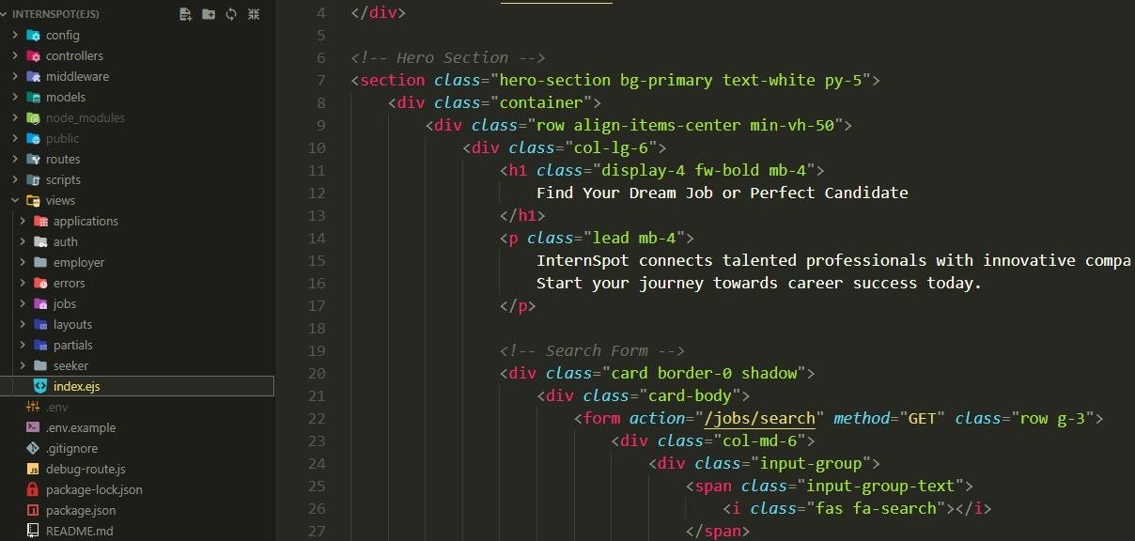

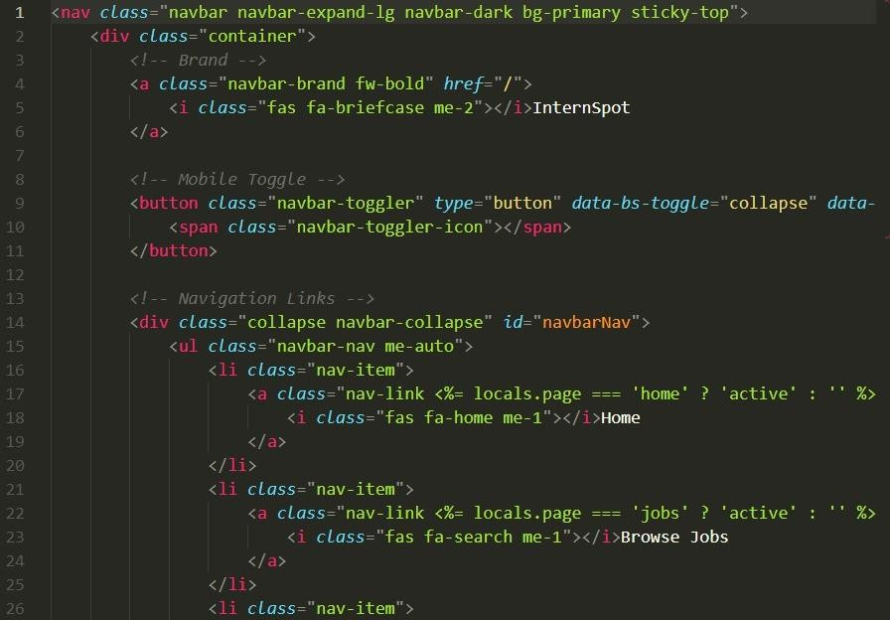

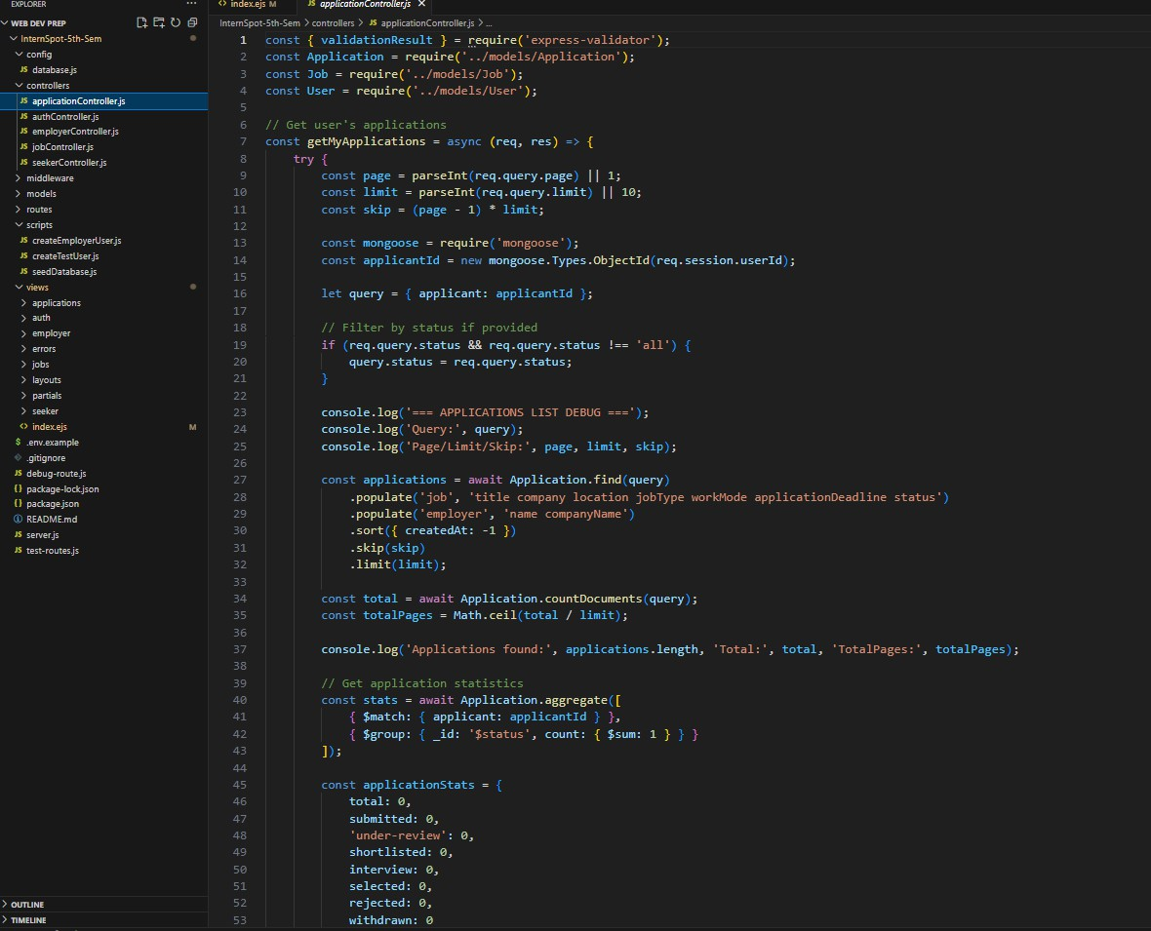

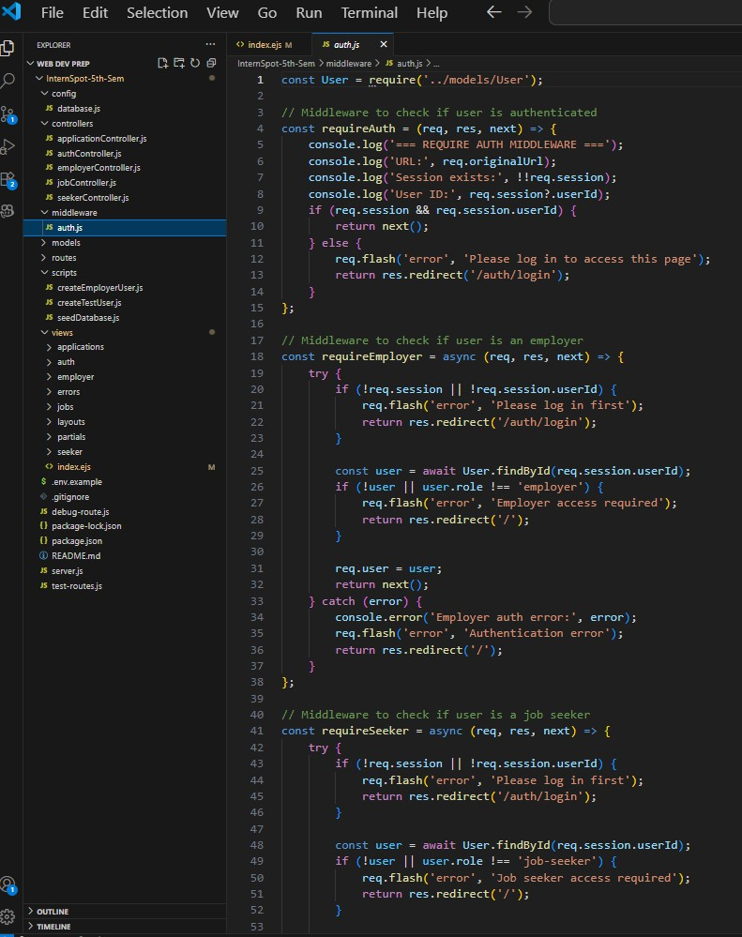

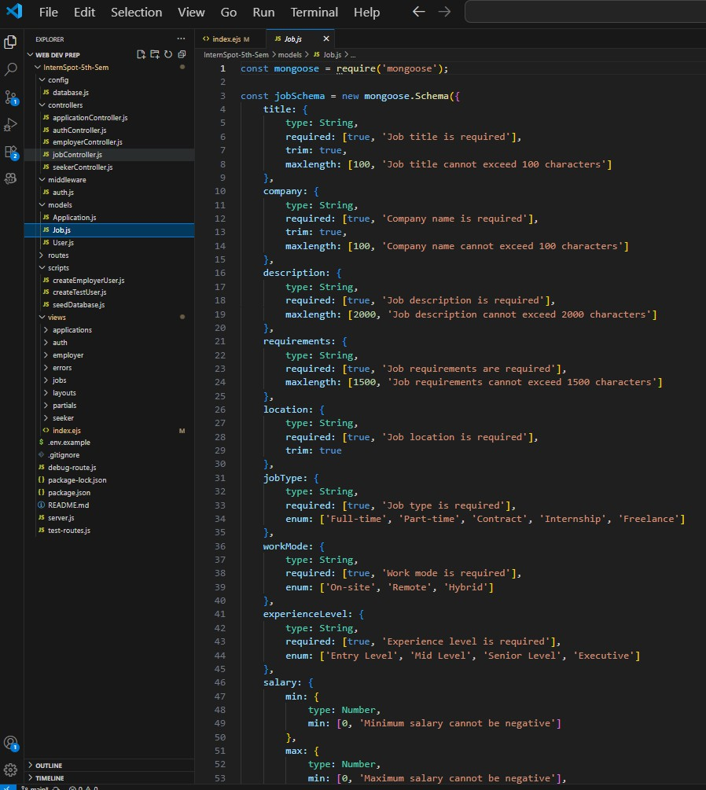

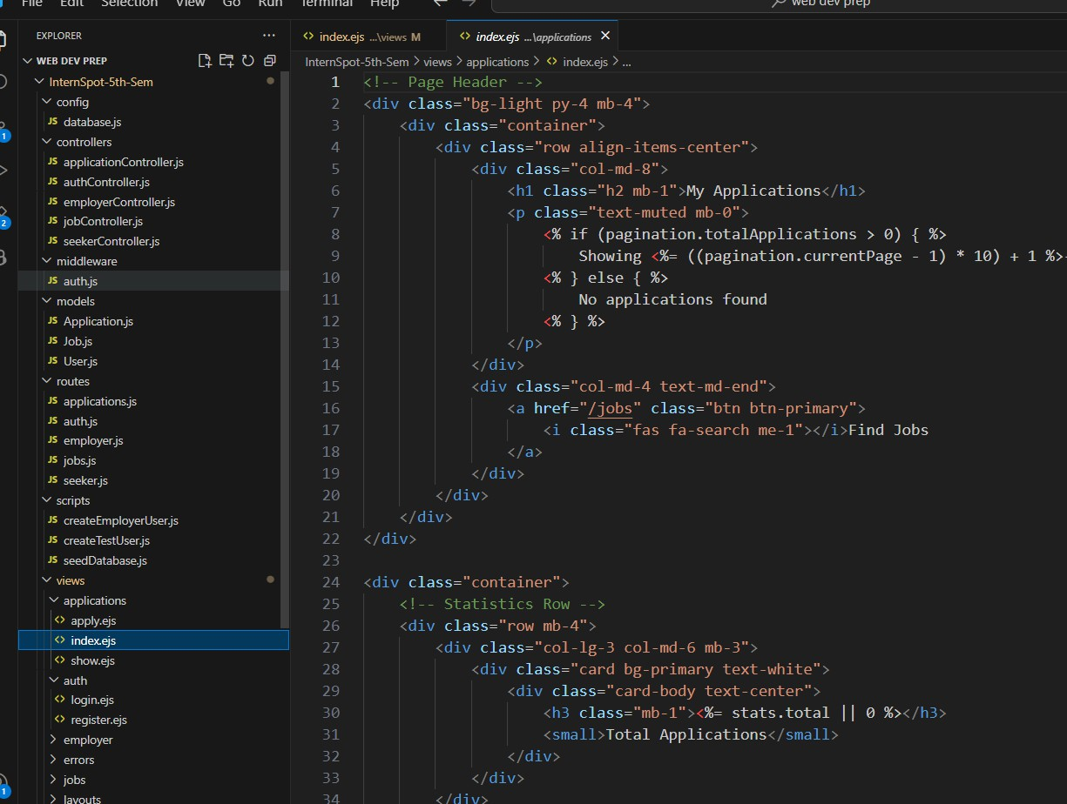

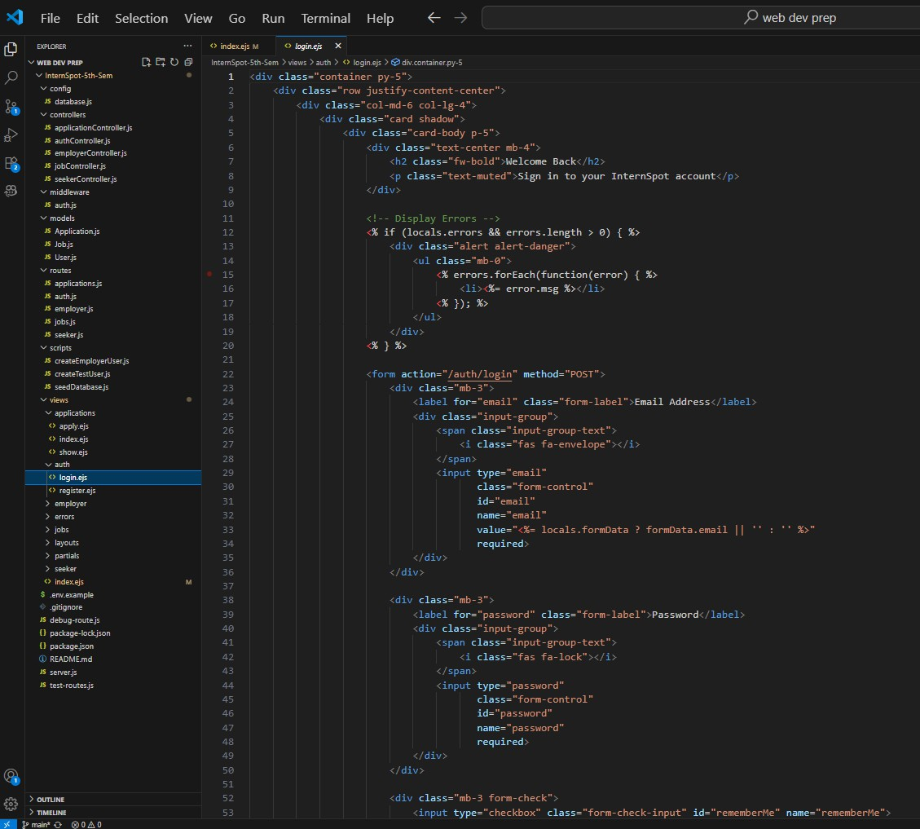

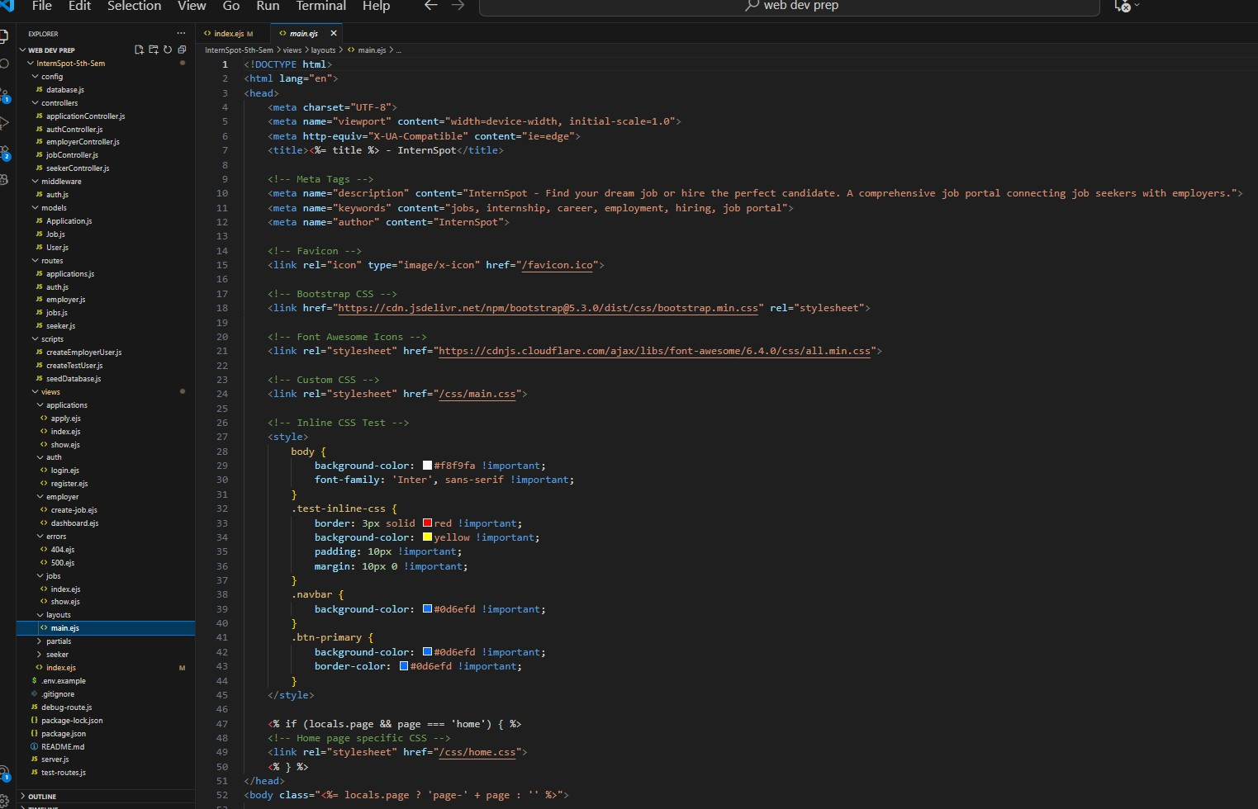

**References:**

**Official Documentation:** Documentation for libraries, frameworks, and tools used in the project, as well as APIs or services integrated for job matching, notifications, and database management.

**Tutorials and Guides:** Online tutorials, guides, blog posts, and educational videos that provided assistance or insights during the development of frontend interfaces, backend logic, and AI-powered recommendation modules.

**Code Repositories:** GitHub repositories or other code repositories where code snippets, examples, or inspiration were referenced for implementing features such as resume parsing, real- time notifications, and secure authentication.

**Forums and Communities:** Online forums such as Stack Overflow, Reddit, and developer communities where questions were asked, advice was sought, or discussions were participated in regarding development challenges and best practices.

**Personal Communication:** Mentors, peers, and industry professionals who provided guidance, feedback, or support throughout the planning, development, and testing of the project.