**AMB Model United Nations**

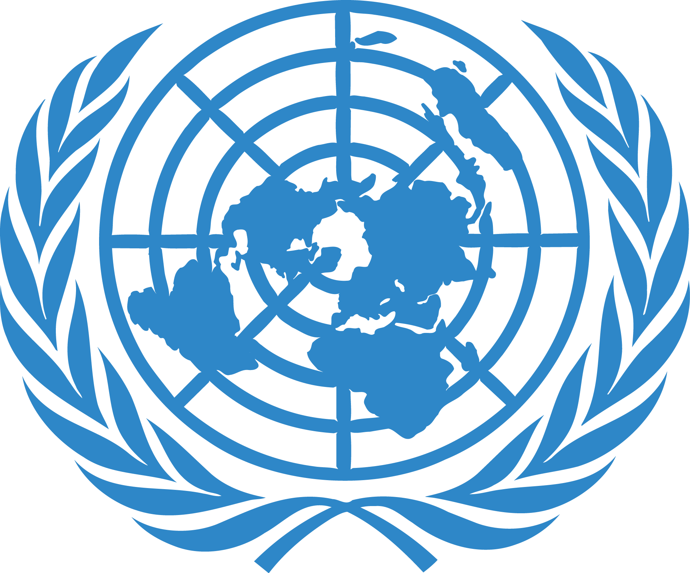

**General Assembly 1**

Chairs: Ghina Alnahlawi, [Ghina.alnahlawi@amb.sch.ae](mailto:Ghina.alnahlawi@amb.sch.ae)

Talal Albastaki, [Talal.albastaki@amb.sch.ae](mailto:Talal.albastaki@amb.sch.ae)

Co-Chair: Reyn Santos, [Reyn.santos@amb.sch.ae](mailto:Reyn.santos@amb.sch.ae)

**Intro to General Assembly First Committee**

General Assembly 1 (GA1), also known as the Disarmament and International Security Committee, is a primary committee within the United Nations framework. It is dedicated to discussing and formulating responses to global issues concerning disarmament, threats to peace, and challenges to international security. Delegates in this committee address a wide range of topics, including but not limited to, nuclear disarmament, regulation of weapons of mass destruction, arms trade, and measures to combat terrorism. GA1 plays a significant role in shaping international policies related to security and disarmament. It provides a platform for member states to negotiate agreements, foster cooperation, and develop strategies to reduce global tensions. The committee's focus extends to emerging security threats, such as cyber warfare and the use of drones, emphasizing the evolving nature of international security dynamics.

**Topic:** Reforming the Veto Power in United Nations Security Council.

**Summary & History**

The veto power within the United Nations Security Council has been a fundamental aspect of the organization since its inception in 1945. The five permanent members of the UNSC are the United States, the United Kingdom, France, Russia, and China. The five permanent members of the UNSC were granted the right to veto any substantive resolution. This power reflects the post-World War II global order and was intended to ensure that the decisions of the UNSC had the backing of the major powers, thereby preventing conflicts among them.

Over the years, the veto power has been a subject of intense debate and controversy. Critics argue that it often leads to a deadlock in the Security Council, hindering the UN’s ability to respond effectively to international crises. Instances where veto power has been used to block resolutions, even in the face of significant global issues like genocide, wars, and humanitarian crises, have raised questions about the effectiveness and fairness of the UNSC's decision-making process.

The call for reforming the veto powers gained momentum in the late 20th and early 21st centuries. Many member states, especially from the developing world and small nations, have voiced concerns that the veto power is outdated and does not reflect the current geopolitical realities. Proposals for reform have included limiting the use of the veto in cases of mass atrocities, expanding the membership of the Security Council to include new permanent members without veto power, or even abolishing the veto altogether.

**Current Situation:**

As of the present, there have been no substantial changes to the veto power. The debate around reforming the veto remains a critical issue in discussions on the effectiveness and legitimacy of the United Nations. The outcome of this debate has profound implications for global governance, international law, and the ability of the UN to respond to future international crises.

**Questions a resolution must answer:**

-What are the key goals of the proposed veto r eforms?

-How will the reforms address the current limitations of the veto system?

-What changes to the United Nations are necessary for these reforms?

-How will these reforms impact the balance of power in the UNSC?

-What steps will ensure fair representation of all United Nations members?

-How will the resolution deal with potential resistance from five permanent members of UNSC?

-What mechanisms are proposed to assess the effectiveness of these reforms?

