***AMBMUN***

**United Nations International Children Emergency Fund**

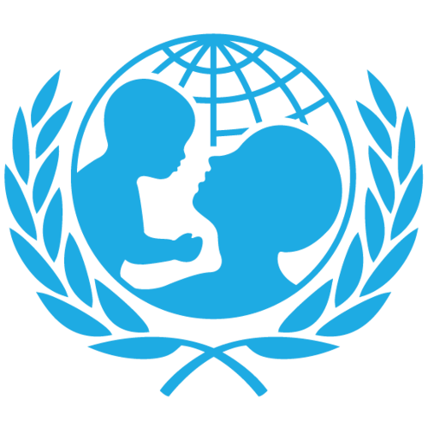**(UNICEF)**

**Background Guide**

**Chair Information:  
Mehdi Ibn Moussa:** [**ibnmoussamehdi777@gmail.com**](mailto:ibnmoussamehdi777@gmail.com)

**Maryam AbuDaif:** [**Maryam.abudaif@gmail.com**](mailto:Maryam.abudaif@gmail.com)

**Ahmad Amiri:** [**ahmad.amiri@amb.sch.ae**](mailto:ahmad.amiri@amb.sch.ae)

***Topic: Addressing the Humanitarian Crisis and Displacement of Children Due to Conflicts***

*Intro on Committee*

*UNICEF, the United Nations Children's Fund, is an organization dedicated to ensuring the health, well-being, and protection of children worldwide. One of their primary focuses is on improving child and adolescent health and well-being, which has seen significant progress in recent decades. However, challenges still persist, and millions of children continue to miss out on essential health services, such as immunizations and adequate nutrition.*

*Conflict and wars have a profound impact on children's lives, often resulting in displacement, loss of life, and lasting psychological trauma. UNICEF works tirelessly to provide support and assistance to children affected by these situations, offering life-saving vaccines, healthcare services, and psychological support. They are committed to reaching the most vulnerable children, including those in hard-to-reach areas and those with developmental delays and disabilities, ensuring that every child has the right to lead a healthy life.*

*History on the Topic*

*One persistent subject that crosses many eras and geographical locations is the history of children who have been uprooted by conflict. Millions of children were uprooted during World War II as a result of bombs, invasions, and persecution; many of them ended up as refugees or were split apart from their families. Children now face difficulties like limited access to healthcare and education as a result of the Vietnam War, the Balkan Wars, the Rwandan Genocide, the Darfur conflict, the Syrian Civil War, the Rohingya crisis, and the conflict in the Central African Republic.*

*Following the start of the Rohingya crisis in 2017, a large number of refugees—many of them children—were forcibly relocated to Bangladesh, where they now confront challenges like inadequate access to healthcare and education.*

*These examples, both historical and modern, demonstrate the terrible effects of conflict on kids, with outcomes that might include exposure to violence, loss of schooling, and family separation. Children who are displaced continue to have their needs met by international organizations and humanitarian initiatives, which provide assistance for their future chances and general well-being.*

*Past actions*

*Children in the Ghwayran/Sinai detention center in northeastern Syria are very vulnerable and in desperate need of protection as long as the fighting persists there. UNICEF has collaborated with partners to offer life-saving aid, including as clean water and essential hygiene products, to displaced children and their families. Volunteers with UNICEF have provided food, clothing, blankets, beds, medication, and assistance to individuals in need while also increasing public awareness of the dangers posed by explosive ordnance. Services and medication, including as health consultations, free medication, screening, and ready-to-use supplemental food, are being given to vulnerable children and their mothers by a mobile health and nutrition team funded by UNICEF.*

*Additionally, UNICEF informs families on how to avoid separation and have access to psychosocial help. Nine separated and unaccompanied children have been identified. UNICEF has remained in Ukraine throughout the conflict, providing aid to families and children. UNICEF provides emergency relief and support services in refugee-hosting nations in collaboration with national and local government agencies as well as civil society groups.*

*UNICEF is still working to provide children and caregivers with mental health and psychosocial support, make sure that the heating infrastructure is operational, give winter clothing and blankets, involve children in formal and informal schooling, and facilitate access to safe water and healthcare. UNICEF collaborates with regional administrations and municipalities that welcome refugees in adjacent nations to meet household needs and provide basic healthcare services for women and children displaced by violence.*

*Current situation:*

*In 2022, 43.3 million children worldwide have been forcibly displaced, according to UNICEF projections. The number of children who have been forcefully removed from their homes has doubled in the past ten years, surpassing the efforts made to include and safeguard internally displaced and refugee children. Over 1 million children inside Ukraine have been displaced by the conflict, and over 2 million have been forced to leave their country.*

*Cascade crises, such as lengthy and intense conflicts like those in Afghanistan, instability in nations like Yemen and the Democratic Republic of the Congo, and linked shocks made worse by the effects of climate change, are directly responsible for the record number of displaced children. Similar to fragility, child displacement is rapidly increasing.*

*Access to vital assistance and services, such as healthcare, education, and protection, is being impeded as the number of displaced and refugee children hits a historic high. Only around one-third of refugee adolescents attend secondary school, compared to about two-thirds of all refugee children who are enrolled in elementary education.*

*UNICEF calls on Member States to uphold their pledges to protect the rights of all displaced children, including those made under the Global Compacts on Migration (GCM) and Refugees (GCR), and to increase their funding for studies and data that accurately depicts the scope of the problems that displaced, migrant, and refugee children face.*

*Questions to be answered in your resolutions:*

*The resolution addressing the humanitarian crisis and displacement of children due to conflicts should aim to answer the following detailed and insightful questions:*

1. *How can international and local organizations effectively enhance the protection and welfare of displaced children, especially in high-risk areas like conflict zones and detention centers?*
2. *What strategies can be implemented to ensure continuous access to education and psychosocial support for displaced children?*
3. *How can healthcare services, including vaccinations, maternal care, and treatment for chronic diseases, be made more accessible to displaced children and their families, especially in remote or conflict-affected areas?*
4. *What mechanisms can be established to prevent the separation of children from their families during displacement, and to reunite children who have been separated or orphaned as a result of conflict?*
5. *What strategies can be implemented to ensure adequate and sustained funding for the initiatives supporting displaced children?*