***The first edition of AMB presents:***

**United Nations Women**

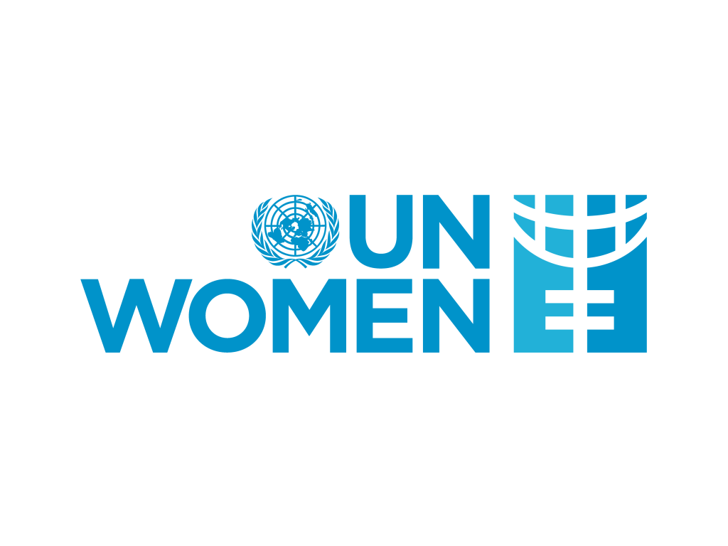**(UNW)**

**Background Guide**

**Chairs and Co-Chairs information:**

Yousef Al Sadoon: [yousf.alsadoon@amb.sch.ae](mailto:yousf.alsadoon@amb.sch.ae)

Sara Zaid Kasem: [sarazaid.kasem@gmail.com](mailto:sarazaid.kasem@gmail.com)

Jannah Mohamed: [jannah.mohamed@amb.sch.ae](mailto:jannah.mohamed@amb.sch.ae)

**Introduction on United Nations Women:**

For many years, the United Nations faced serious challenges in its efforts to promote gender equality globally, including inadequate funding and no single recognized driver to direct UN activities on gender equality issues. To address these issues, the UN General Assembly established UN Women, the UN Entity for Gender Equality and the Empowerment of Women, in July 2010. By adopting this, UN Member States accelerated the Organization's goals for women's empowerment and gender equality, marking a historic stride forward.

UN Women is the UN organization that advocates gender equality and women's empowerment. UN Women was established with the goal of accelerating the global response to the needs of women and girls.

UN Women supports UN Member States as they set global standards for achieving gender equality and works with governments and civil society to design laws, policies, programmes and services needed to ensure that the standards are effectively implemented and truly benefit women and girls worldwide. It works globally to make the vision of the Sustainable Development Goals a reality for women and girls and stands behind women’s equal participation in all aspects of life, focusing on four strategic priorities:

-Women lead, participate in and benefit equally from governance systems.

-Women have income security, decent work and economic autonomy.

-All women and girls live a life free from all forms of violence.

-Women and girls contribute to and have greater influence in building sustainable peace and resilience and benefit equally from the prevention of natural disasters and conflicts and humanitarian action.

Along with coordinating and promoting the UN system's efforts to advance gender equality, UN Women is also involved in all discussions and agreements related to the 2030 Agenda. The organization seeks to establish gender equality as a foundation for both a more inclusive world and the Sustainable Development Goals.

1. **Bridging the gender pay gap and ensuring fairness in the workplace**

**Background and history information on the topic:**

Concerns about workplace equality have focused a lot of attention on the gender wage gap, which is a widespread and deeply ingrained problem. By highlighting the pay gap between men and women, it draws attention to the systemic differences in salary based on gender. The pay gap endures in a number of industries and geographical areas despite notable progress made toward gender equality over time, which is a reflection of underlying structural and societal injustices. In fact, most women all around the world earn around 82% less than men. The reality that women are routinely paid less than men is a complicated phenomenon that is caused by a variety of variables, including occupation segregation, unequal career progression possibilities, and subtle biases.

Many reasons contribute to the gender pay gap, from cases of direct discrimination to more problems including the undervaluation of women's skills and the maintenance of gender stereotypes and traditional roles. In addition, factors such as race, ethnicity, disability, access to education, and age all contribute to the presence of gender pay gaps. Gender pay gaps reduce women’s lifetime earnings and also affects their pensions, which is one of the significant causes of poverty in later life for women. Furthermore, this problem can cause women to evolve depression or anxiety. Research shows that women who earn less than their male counterparts are 2.5 times more likely to be diagnosed with anxiety and depression. Unfortunately, less money is available to women and their families for self-support, savings and investments in the future, and purchases of goods and services. As a result, women, families, businesses, and the economy all suffer.

Since the gender wage gap affects not only individual lives but also general economic advancement and social well-being, it is crucial to address it in order to promote a more fair and inclusive society.

**Past actions:**

In the last 20 years, there has been very little progress made in closing the gender pay gap in the US. This is the difference in incomes between men and women. In 2022, the average income earned by American women was 82 cents for every $1 made by men. They were paid 80 cents to the dollar in 2002, so that was approximately the same. The gender wage gap has shrunk this century, although at a snail's pace compared to the previous two decades' progress: Women only made 65 cents for every dollar earned by males in 1982. The reason that efforts to close the pay gap have essentially stopped in the twenty-first century cannot be explained by a single factor. Over time, women have consistently lost ground to men as they age and advance in their careers, while starting their careers closer to income parity than males. Even while women are now more likely than males to have completed college, there is still a pay disparity. In actuality, there is no more income disparity between men and women with college degrees than there is between those without. This highlights the importance of other factors that continue to disadvantage women or give men the upper hand. Parenthood is one of these variables.

Mothers between the ages of 25 and 44 are less likely to be employed than women in the same age range who do not have children living at home, and when they are, they typically work less hours per week. While data suggests the effect is either minor overall or short-lived for many, this can lower the wages of certain moms. However, compared to males without children living at home, fathers are more likely to be employed and to put in more hours each week. This tends to deepen the gender pay gap and is associated with fathers earning more money, a phenomenon known as the "fatherhood wage premium."

In recent years, younger women—those between the ages of 25 and 34 and those just starting their careers—have come closer to earning the same as men. When compared to men of the same age, their earnings have continuously been at least 90 cents to the dollar since 2007. However, the income difference tends to widen as women age, even though pay parity may seem achievable for them in their early careers. Think about women who were between the ages of 25 and 34 in 2010. They made 92% more money that year than men their age, whereas the average income for women was 83%. However, by 2022, same women—who are now between the ages of 37 and 46—only made 84% of what men did at the same age. For groups of women who were 25 to 34 years old in previous years, like 2005 or 2000, this trend recurs, and it could very well be the future for women who are starting to enter the workforce now.

Whether by necessity or choice, parenthood causes some women to put their careers on wait, while it has the opposite effect on men. Compared to 84% of women of the same age who did not have children at home, 70% of moms between the ages of 25 and 34 had a job or were searching for one in 2022. This translated into 1.4 million younger mothers leaving the workforce. Furthermore, compared to other women their age, younger moms typically work two fewer hours per week when they are employed. Another long-standing issue is younger moms' decreased engagement with the job.

However, fathers are more likely than men without children to be employed or actively seeking employment, and this is the case from the age of 25 to 54, when fathers are at the peak of their working lives. Fathers who work also put in a little bit more hours each week on average than males without children living at home.

Because of this, there is a bigger gender disparity in workplace participation between those who have children at home and those who do not. For instance, 94% of fathers and 75% of women between the ages of 35 and 44 are employed, representing a 19 percentage point difference. However, 84% of males and 78% of women in this age bracket who do not have children at home are employed, a 6-point difference.

**Current situation:**

On September 18, we commemorate International equitable Pay Day, which honors the ongoing efforts to provide equitable compensation for equally valuable work. It strengthens the UN's commitment to upholding human rights and opposing discrimination in all its manifestations, especially that which targets women and girls. Women are paid less than males everywhere; the gender pay gap is estimated to be about 20% worldwide. The persistence of historically and structurally entrenched power relations between men and women, poverty and other inequalities, and barriers to opportunities and resources that restrict women's and girls' potential are the main reasons why gender equality and the empowerment of women and girls remain stalled. The process of closing that gap has not moved quickly. Although most people support equal pay for men and women, it has not always been easy to implement in reality.

The Sustainable Development Goals (SDGs) focus on gender equality and the empowerment of all women and girls in order to guarantee that no one is left behind. Additionally, by aiming for full and productive employment, decent work for all women and men, including youth and people with disabilities, and fair compensation for labor of equal worth, the SDGs support both economic growth and decent work. The 2030 Agenda for Sustainable Development must be implemented with a gender perspective mainstreamed.

A significant turning point for gender equality and human rights is the achievement of equal pay. There is still work to be done, and it requires the combined efforts of the entire global community. The International Labour Organization (ILO), UN Women, and member states of civil society, as well as businesses, workers' and employers' organizations, and feminist groups, are all invited by the UN to support equal pay for equal work and the financial empowerment of women and girls. In charge of the Equal Pay International Coalition (EPIC) are the OECD, UN Women, and ILO. Equal pay for men and women worldwide is the Coalition's ultimate goal. EPIC assists governments, employers, employees, and their organizations in making tangible and well-coordinated progress toward this objective by bringing together a varied group of players with varying areas of concentration and skill. Currently, the only multi-stakeholder collaboration attempting to close the gender wage gap at the national, regional, and international levels is EPIC.

Economic variables also influence changes in the gender pay gap, as they can occasionally drive men's and women's incomes differently. Men and women typically work in various industries and types of occupations, so how they react to outside pressures may have an impact on their earnings in different ways. More precisely, between 1982 and 2002, men's incomes largely remained unchanged. Possible explanations for this include a faster fall in male union membership, a move away from jobs requiring higher levels of physical competence, and more global competition, which caused a steep decline in manufacturing employment in the 1980s. Concurrently, women's incomes rose significantly as they became more educated and pursued higher-paying professions.

However, this century's economic environment has proven to be less advantageous for women in several respects. It's unclear why women's employment recovered from the Great Recession of 2007–2009 more slowly than that of men's. The COVID-19 recession gained the nickname "she-cession" in more recent times because to the strain on occupations that are disproportionately held by women. The closing of the gender pay gap during this period was limited since women's wages from 2002 to 2022 increased less than men's earnings, notwithstanding a general decrease in earnings growth from 2000 to 2015.

*Questions a resolution must answer:*

1. What initiatives will be introduced to educate employees and leadership about unconscious bias and gender stereotypes that may contribute to pay disparities?
2. What strategies will be implemented to address gender imbalances in promotions and career advancement?
3. What measures will be in place to prevent discrimination in salary negotiations and hiring processes?
4. What criteria will be used to evaluate roles and determine fair compensation?
5. What systems will be put in place to monitor the career progression of employees, ensuring that opportunities for skill development and advancement are equally distributed?
6. How can feedback mechanisms be improved to ensure that employees feel comfortable reporting concerns related to pay disparities and workplace fairness?