***The first edition of AMBMUN presents:***

**United Nations Development Programme**

**(UNDP)**

**Background Guide**

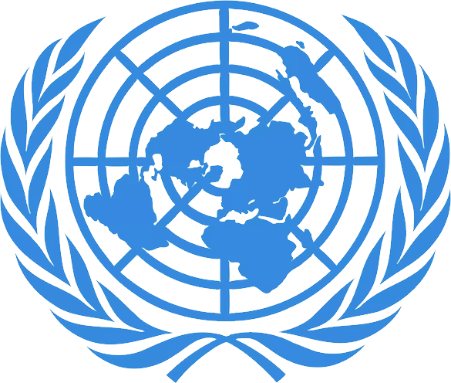

**Chair Info:**

**Abdullah Kalaji:** [**abdullah.kalaji.ams@gmail.com**](mailto:abdullah.kalaji.ams@gmail.com)

**Angelina Kakoun:** [**angelina.amb6@gmail.com**](mailto:angelina.amb6@gmail.com)

**Co-chair:**

**Maryam Bani-Hani:**

***Welcome letter***

Dear Respected Delegates,

Greetings and a warm welcome to AMBMUN 2024! We are pleased to extend our greetings as we prepare for the annual Al Mawakeb Model United Nations (AMBMUN). As the United Nations Development Programme (UNDP) committee chairs, we are excited to lead you through a thought-provoking discussion.

This guide will serve as your resource for preparing for the conference. We are eager to meet each of you and anticipate an experience filled with interaction, effective communication, and productive collaboration. Over the course of our two-day conference, our primary focus will be on the topic; "Corruption as an Obstacle to Development." We strongly encourage you not to explore the contents of this guide but also to conduct research on your assigned countries' perspectives, positions, and capacities in order to foster a robust and enriching debate.

We firmly believe this year's conference will have a lasting impact on all participants. As you delve into your preparations we extend our wishes for your research endeavors and thoughtful deliberations. We eagerly look forward to meeting you at AMBMUN 2024. Should you have any questions or concerns along the way, please feel free to contact us.

Best regards,

The Chairs of UNDP

**Topic: “Corruption as a Barrier to Sustainable Development”**

***Introduction***

In the quest for sustainable progress, the adoption of Sustainable Development Goals (SDGs) by member nations of the United Nations reflects a strong commitment to tackling the widespread corruption problem. SDG 16, titled "Promote peaceful and inclusive societies for sustainable development, provide access to justice for all and build effective, accountable and inclusive institutions at all levels," envisions societies that are free from the grip of corruption, where justice's accessible to all and institutions are pillars of fairness and reliability.

As we approach the 2030 deadline, recent conflicts pose a risk by suppressing freedoms and fueling violence, which challenges our pursuit of development. As an ever-present threat, corruption stands in the way of sustainable development, obstructing advancement and preventing the achievement of our common objectives. Together we will explore methods to strengthen our fight against corruption, uphold justice, and fortify institutions so that sustainable development can thrive without being hindered by corruption.

***Background on topic and past actions***

Corruption is a ongoing issue that has had a significant impact on global development for many years. In this part of the century, there was an increased recognition of how corruption negatively affects economic growth and governance. The 1990s marked a moment when international organizations like the United Nations acknowledged corruption as an obstacle to sustainable development. This acknowledgment was further emphasized by incorporating corruption goals into the Sustainable Development Goals (SDGs), highlighting the necessity for global cooperation.

The consequences of corruption reach across political and social spheres distorting markets undermining institutions and perpetuating inequalities. The UNDP committee in Model United Nations conferences provides a platform for delegates to delve into this trajectory and work together to develop solutions to overcome the barriers that corruption poses to sustainable development in the 21st century.

⁤ Additionally, The Agency for Prevention of Corruption, in partnership with the United Nations Development Program (UNDP), has developed a methodology for assessing the application of anti-corruption measures as an additional weapon in the fight against corruption. ⁤⁤The technique aims to evaluate the effectiveness of authorities in implementing anti-corruption measures and encourage them to plan and execute optional anti-corruption actions independently. ⁤

***Current Situation***

Corruption is still a challenging issue for growth till today, even with the last ten years of success. Eliminating corruption is a top goal for the UNDP and essential to achieving the SDGs. Goal 16 and its anti-corruption targets serve as the foundation for the other SDGs in the 2030 Agenda for Sustainable Development, all of which depend on institutions to effectively meet the needs of all people around the world.

⁤ As things are, UNDP's many anti-corruption programs uphold public authorities' legitimacy and public confidence in governance. ⁤⁤They serve as catalysts for achieving the SDGs, which depend on inclusive, transparent, and efficient institutions and governance systems to address the needs of all citizens. ⁤⁤Through its national offices and regional hubs, UNDP organises its internal work and offers policy and program support related to anti-corruption efforts. ⁤⁤It improves measures against corruption, accountability, and transparencyᅳall of which are essential for successfully executing public goods. ⁤

Truly, and considering the worldwide cost of corruption is estimated to be US$2.6 trillion, or five percent of the global gross domestic product (GDP), making it an enormous burden. Startling data shows that one in five individuals globally has admitted to using bribes to get governmental services. Transparency International reports that since 2012, 155 nations have either made no significant progress in combating corruption or experienced an increase in these issues. This emphasizes how urgent it is to eliminate corruption as a major obstacle to sustainable development by persistent group effort.

***Analysis***

The impact of the Sustainable Development Goals (SDGs), on SDG 16 which focuses on combating corruption is intricate and diverse. The pursuit of development can have both negative effects on the effectiveness of SDG 16. It can influence aspects such as matters, societal dynamics, economic stability, community well being and behavioral patterns.

Certain SDGs like SDG 8 (Decent Work and Economic Growth) and SDG 9 (Industry, Innovation and Infrastructure) may potentially impede progress towards SDG 16. While it is important to strive for growth and develop infrastructure doing so might unintentionally create an environment that's susceptible to corruption. This can pose challenges in ensuring transparency and justice.

On a note SDGs such as SDG 5 (Gender Equality) and SDG 17 (Partnerships for the Goals) can significantly contribute to the fight against corruption. Achieving gender equality empowers women and girls to participate in decision making processes. This fosters transparency while reducing the likelihood of practices. Additionally international cooperation emphasized in SDG 17 encourages efforts worldwide to combat corruption.

However there is a risk if we fail to achieve SDG 5 since gender inequality and discrimination perpetuate corruption while hindering access, to justice.

Likewise if progress, in SDG 17 which advocates for cooperation remains stagnant the global efforts to combat corruption could be hindered. This highlights how interconnected these goals are.

In line with SDG 16 addressing corruption as a barrier to development necessitates solutions rather than conflicts. Conflicts, as emphasized in SDG 17 can undermine the pursuit of inclusive institutions. Therefore it is crucial to prioritize connections over confrontations.

To fully comprehend the relationship between corruption and sustainable development it is important to acknowledge both the challenges and benefits. While certain SDGs might unintentionally contribute to difficulties others offer opportunities to strengthen the fight against corruption. Striking a balance between achieving growth, infrastructure development and fostering transparency becomes imperative in order to achieve the overarching goal of development free, from the burdens of corruption.

***Questions a resolution must answer?***

1. How can countries in the UNDP cooperate and collaborate to minimize and control corruption affecting sustainability?
2. What actions could be taken by countries in order to progress in combating corruption?
3. What are the necessary steps that countries should take to ensure that corruption does not affect sustainable development?
4. How can the UNDP, other international organizations, and cooperating countries support state members in addressing the increase in corruption and its effect on sustainable development?
5. What mechanism or framework can be established to ensure that the increase of sustainable development is not compromised by corruption?

***Bibliography***

1. “Anti-Corruption.” *UNDP*, www.undp.org/governance/inclusive-and-future-smart-public-goods-and-services/anti-corruption.
2. “Assessment Report on Enforcement of Anti-Corruption Measures in the State Administration and Other Public Authorities.” *UNDP*, www.undp.org/montenegro/publications/assessment-report-enforcement-anti-corruption-measures-state-administration-and-other-public-authorities.
3. Sarah Lister, et al. “Celebrating the Progress and Confronting the Challenges of Anti-Corruption.” *UNDP*, 15 Dec. 2023, www.undp.org/blog/celebrating-progress-and-confronting-challenges-anti-corruption.
4. *Development Approaches to Migration and Displacement in Asia and The ...*, www.undp.org/sites/g/files/zskgke326/files/migration/asia_pacific_rbap/RBAP-DG-2018-Development-Approaches-to-Migration-and-Displacement-Asia-Pacific.pdf.