AMBMUN2024

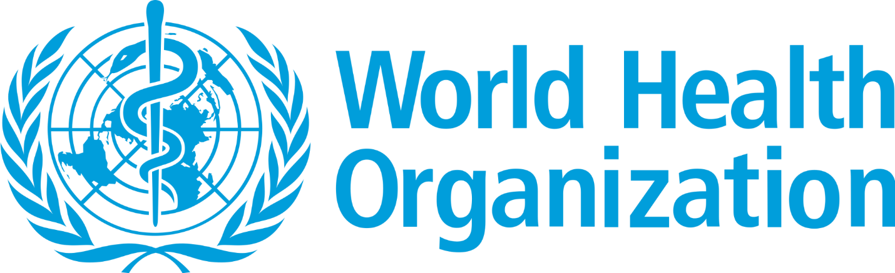

The need to ensure fair worldwide access to food supplies

Chairs:

Layan Al Khalidy: [layanalkhalidy16@gmail.com](mailto:layanalkhalidy16@gmail.com)

Zaid Ali: [zaid.mohammedali@amb.sch.ae](mailto:zaid.mohammedali@amb.sch.ae)

Co-Chair:

Amin Mechraoui: [amin.mechraoui@amb.sch.ae](mailto:amin.mechraoui@amb.sch.ae)

**Intro on the committee:**

The World Health Organization, established in 1948, is an institution of the United Nations that integrates nations, partnerships, and individuals to enhance health, ensure global security, and assist the most disadvantaged populations in order for everyone to obtain the greatest available level of health. WHO is in charge of advancing universal health care internationally. The organization oversees and manages the global response to health emergencies. Furthermore, they support healthier lifestyles from prenatal care to old age. With the help of science-based policies and programs, their Triple Billion targets set forth an ambitious plan for the globe to achieve universally good health.

The Constitution of the World Health Organization was effective from 7th April 1948

onwards, a date that is globally and annually recognized and celebrated as World Health Day.

Furthermore, developed and established in 2004, the Global Health Histories project

historically stems from the pivotal principle that acquiring a coherent understanding of the

history of health, peculiarly over the past 6 decades, empowers and supports the public health

community around the world to optimally react to and resolve the obstacles that face us today

and to actively create a healthier future for everyone, everywhere.

**History:**

As the human population continues to increase rapidly, concerns related to the unequal distribution of food sources have taken greater urgency. Despite article 11 of the International Covenant on Economic, Social, and Cultural Rights emphasizing that “Every State is obliged to ensure for everyone under its jurisdiction access to the minimum essential food which is sufficient, nutritionally adequate and safe, to ensure their freedom from hunger.” (Office of the High Commissioner for Human Rights, 1976), the world still struggles with worrying levels of malnourishment in which food is unevenly distributed and food security is vulnerable to patterns of socioeconomic development, international trade, and the availability and appropriation of natural resources. In 2010, food production was 20% higher than that required globally, yet approximately 1 billion people remained undernourished and emaciated. This clearly suggests that the problem does not stem from the lack of resources or the unavailability of food, but rather the poor distribution of the resources.

The uneven distribution of hunger and malnutrition in all its forms is rooted in inequalities of social, political, and economic power. For instance, in the first months of the Russia Ukraine war, the world experienced a dramatic drop in the trade of several necessities including wheat, cooking oil, and fertilizer. Together, Russia and Ukraine provide wheat for more than 36 countries including the most vulnerable and impoverished nations specifically in the regions of Africa and the Middle East. This conflict severely wounded the global food supplies leading to soaring prices; approximately 222 million individuals in 53 different countries suffered from food insecurity and crises.

The primary reasons behind malnutrition and hunger are poverty, inequality, and marginalization. Developing nations are home to 98% of the world’s starving people due to the lack of distribution of food resources to those vulnerable areas. The problem lies within the fact that families in poorer countries spend up to 80% of their income on food, meaning that if prices were to increase, the family would not be able to survive anymore. Unfortunately, this is the reality of millions and millions of people across the globe.

**Past Actions:**

The matter of ensuring equal food supplies towards all nations has been an ongoing issue, and throughout this issue many different measures have been taken in order to find the most practical way to provide fair, adequate, and clean food supplies to all nations, specifically developing nations.

For instance, UN bodies such as the United Nations Food and Agriculture Organization (UNFAO) have collaborated with the WHO by setting up the Codex Alimentarius in May 1963 to ensure that nations are able to attain food supplies that are nutritious and containment-free. In addition, the United Nations aims to tackle this issue by including it in its Sustainable Development Goals. The 2nd goal in the SDG states that it wishes to accomplish Zero Hunger worldwide by 2030. According to the UN SDG, a variety of methods must be taken to ensure food security, ranging from social protection to ensure that children have access to safe and nutritious food to changing food systems to create a more sustainable and inclusive global community. To guarantee that the impoverished have access to food and can enhance their standard of living, investments in social protection, rural and urban areas, and both are required.

In addition, multiple NGOs have taken action to tackle this issue. According to the World Food Program, they have collaborated with around 1000 NGOs dedicated to supplying and delivering food worldwide. With this initiative being put in place, the WFP has been able to assist 128.2 million people in over 120 countries. In addition to the WFP’s collaborations, NGOs such as Feed The Children have implemented an initiative which supports them in providing healthy and nutritious food to children around the world. This initiative, called the Child-Focused Community Development approach (CFDC), is being implemented in multiple countries such as Honduras, Kenya, Guatemala, El Salvador, and many more nations that suffer from food scarcity.

**Current Situation:**

As of today, food scarcity remains a pressing global issue, as over 300 million people scattered all around the globe are faced with an intense food shortage, and as many as 783 million people facing chronic hunger (WFP), with the figures only worsening by the day. Factors like climate change, for instance, play a pivotal role in the deteriorating conditions related to food availability, as extreme weather events disrupt agricultural productivity through droughts and floods, negatively impacting crop yields. Moreover, social and political factors, such as conflict and instability, contribute to disruptions in food production, distribution, and access, especially in regions facing turmoil. Poverty is another significant driver of food scarcity, preventing a substantial portion of the global population from affording a nutritious diet due to limited economic opportunities, inadequate education, and insufficient social support systems; a problem which almost 700 million individuals are facing, with over half of them living in Sub-Saharan Africa alone (World Bank).

Nonetheless, there are several measures currently being enacted in an effort to combat food shortage; namely organizations such as International Fund for Agricultural Development (IFAD), which targets mainly rural and smallholder farmers, with a focus on improving agricultural productivity, reducing poverty, and enhancing food security. As of 2020, the IFAD has dispensed millions of dollars into the agricultural infrastructure of over 100 different nations in line with its efforts to combat food scarcity. Additionally, the FAO, or Food and Agriculture organization has supported nutritional and agriculture related projects in over 140 countries, helping over 91 million individuals.

Unfortunately however, despite the international community’s efforts, the most recent projections from the FAO indicate that since 2015, the surge in the number of undernourished individuals worldwide has essentially negated nearly all advancements achieved in the previous decade. Additionally, there has been a notable rise in food insecurity, escalating from 25.3 percent of the global population in 2019 to 29.6 percent in 2022. Although the prevalence of severe food insecurity globally exhibited a slight decrease from 11.7 percent in 2021 to 11.3 percent in 2022, it remains well above pre-pandemic levels, equating to an additional 180 million people compared to the figures in 2019. (FAO)

**Questions a resolution must answer:**

* What measures can be implemented to guarantee the even distribution of food sources in developing nations?
* How can multinational agencies, organizations, and governments enhance their existing and current efforts to facilitate the distribution of food to the globe?
* How might the needs of disadvantaged individuals, such women, and children, be given priority while providing food security to the vulnerable?
* What approaches are feasible to tackle the illnesses and diseases that follow after the unequal distribution of resources across the world ?
* What can developed countries do in order to resolve the issue of uneven distribution of food sources?