Anisble-task-02

What is Ansible?
Ansible is an automation tool used to:
• Configure servers
• Install software
• Deploy applications
• Manage infrastructure
It works using YAML playbooks and agentless architecture.
Importance of Ansible
Agentless (Very Important)
• No agent/software needed on worker nodes
• Uses SSH (Linux) and WinRM (Windows)
• Easy to manage thousands of servers
Less maintenance
More secure
Simple & Human-Readable
• Written in YAML
• Easy to learn compared to scripts
Example: - name: Install nginx
apt:
name: nginx
state: present
Even non-programmers can understand it

Automation Saves Time
Instead of manually:
• Logging into 100 servers
• Running same commands
Ansible does it in one command.
Faster deployments
No human errors
Idempotent Nature
Means:
Running the same playbook multiple times will not break anything.
If software already exists → Ansible skips it.
This is very important for production stability.

Used with DevOps Tools
Ansible integrates with:
- Jenkins
- Docker
- Kubernetes
- AWS / Azure / GCP
That’s why Ansible is widely used in CI/CD pipelines.

Ansible Architecture
Ansible Controller
|
SSH / WinRM
|
--------------------
| | |
Worker Worker Worker
Node Node Node

What is Ansible Controller?
The controller is the main machine where:
• Ansible is installed
• Playbooks are written
• Inventory is stored
• Commands are executed
Controller contains:
• Playbooks (YAML)
• Inventory file
• Roles
• Variables
• SSH keys
Example:
Your laptop or Jenkins server can be controller.

What are Worker Nodes?
Worker nodes are:
• Target servers
• EC2 instances
• Linux / Windows machines
They do not need Ansible installed.
They only need:
• SSH access
• Python (usually preinstalled)
Importance of Controller–Worker Communication
This is one of the most important concepts in Ansible
Uses Secure Communication (SSH)
Controller → Worker communication happens via:
• SSH (port 22) for Linux
• WinRM for Windows
Benefits:
• Encrypted
• Secure
• No agents required
Push-Based Model
Ansible uses push model:
• Controller pushes tasks to workers
• Workers just execute commands
Unlike Puppet/Chef (pull model).
Better control
Immediate execution
Inventory-Based Management
Controller uses inventory file:
[web]
server1
server2
[db]
server3
This allows:
• Group-wise execution
• Environment separation (dev, qa, prod)
Scalability
One controller can manage:
• 10 servers
• 100 servers
• 10,000 servers
Because communication is lightweight SSH.
Centralized Control
Only controller has:
• Logic
• Credentials
• Playbooks
Workers never store sensitive data.
Better security model.
Flow of Communication (Easy)
1. Controller reads playbook
2. Controller checks inventory
3. Controller connects to worker via SSH
4. Executes module temporarily
5. Gets result
6. Disconnects
No permanent service running on worker
Real-Time Example
You want to install nginx on 50 servers.
Without Ansible:
• Login 50 times
• Run same command
With Ansible:
ansible-playbook install-nginx.yml
Done in seconds
Tasks :
- Watch ansible-02 video and write down notes.
- Install httpd using ansible playbook, use handlers,notifiers.
- Write a ansible playbook to install apache tomcat.
- Write a ansible playbook to provision one ec2 on aws.
- Write a ansible playbook to copy one file from node-1 to node-2.
- Write a ansible playbook to create different files with different
names using single playbook.
Task 2:
2. Install httpd using ansible playbook, use handlers, notifiers.
Step 1:
—> first connect to your two workers servers with
Ssh password less authentication
—> generate ssh-keygen in ansible controller
—> copy pub-key and paste it inside the worker1(node1)and
worker2(node2)—>.ssh—>authentication-keys
—> add paste the public key and save exit
create ssh key as a ubuntu user
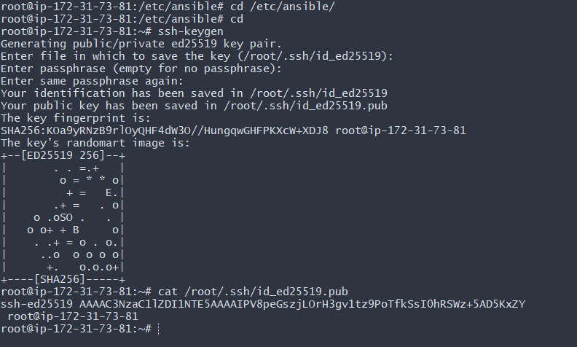
Now we need add our ssh keyworker in worker-01and paste the key in it save and exit
Now same steps with working-02 that’s it now we need save and exit
Now lets test it we gonna type ansible -m all ping for testing we can use it you notice showing pin two two worker ip address it means successfully test it
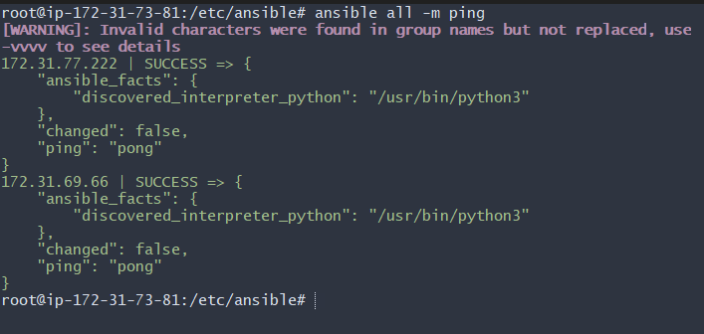
Deleted apache2 package from all machines- using this command
ansible all -m apt -a "name=apache2 state=absent" –become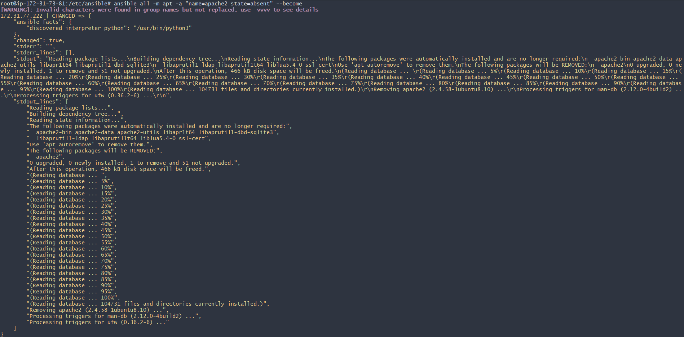
Verified in worker-01 machine if the package is destroyed
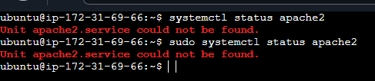
Requirement for this task-
Install apache2 using ansible playbook, use handlers, notifiers
  - Mkdir playbooks- first we need to create a playbook
  - Cd playbooks
  - Vi apache.yaml- create a playbook called apache.yaml
First go inside cd /etc/ansinle/ type ls
Now need create directory inside in it type mkdir playbooks
Now we need text editior we using vi so type vi apache.yam then ls
Paste our script and save it and exit
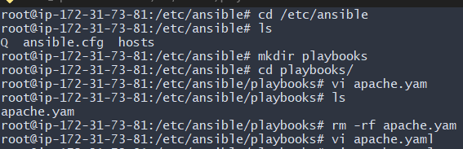

That’s our script - hosts: all
become: yes
tasks:
- name: Install Apache
apt: name=apache2 state=latest
- name: copy index.html
copy: src=index.html dest=var/www/html
notify: Restart apache2

handlers:
- name: Restart apache2
service: name=apache2 state=restarted

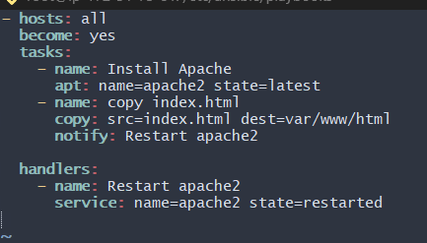
We added 3 requirements for the above task
- Install Apache2
- Copy index.html to var/www/html
- Restart Apache2
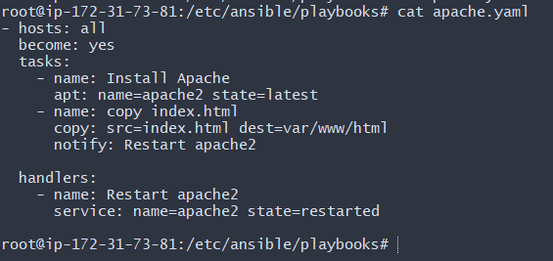
Here, we need to copy index.html, but we haven’t created one, so we shall create one index.html now.
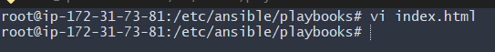
After create vi index paste this inside in it
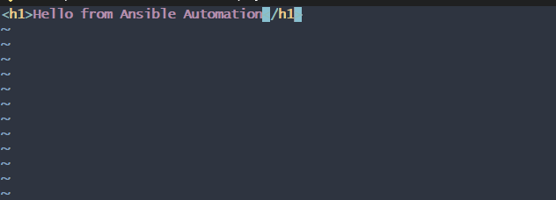
No, we shall do a run syntax check before executing the playbook
Syntax All good and ready
Dry-run ready for execution
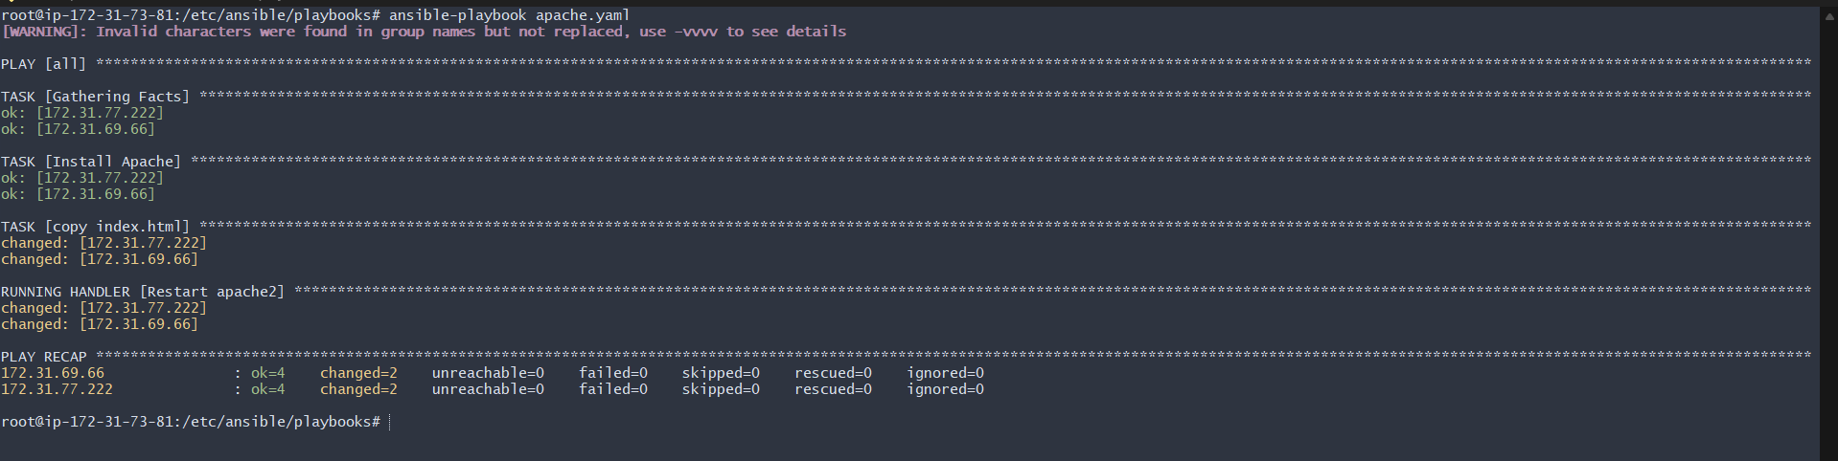
Now lets verfy it workimg or not as see photo it working!

3. Write an ansible playbook to install apache tomcat.
Step by step Implementation:
Requirement for this task-
Write an ansible playbook to install apache tomcat

- We have already created playbooks directory so we shall create a new playbook for tomcat.

Vi tomcat.yaml
---
- hosts: all
become: yes

tasks:
- name: Install Java
apt:
name: openjdk-11-jdk
state: present
update_cache: yes

- name: Download Tomcat
get_url:
url: https://archive.apache.org/dist/tomcat/tomcat-9/v9.0.85/bin/apache-tomcat-9.0.85.tar.gz
dest: /tmp/tomcat.tar.gz

- name: Create Tomcat directory
file:
path: /opt/tomcat
state: directory

- name: Extract Tomcat
unarchive:
src: /tmp/tomcat.tar.gz
dest: /opt/tomcat
remote_src: yes
extra_opts: [--strip-components=1]

- name: Start Tomcat
shell: /opt/tomcat/bin/startup.sh
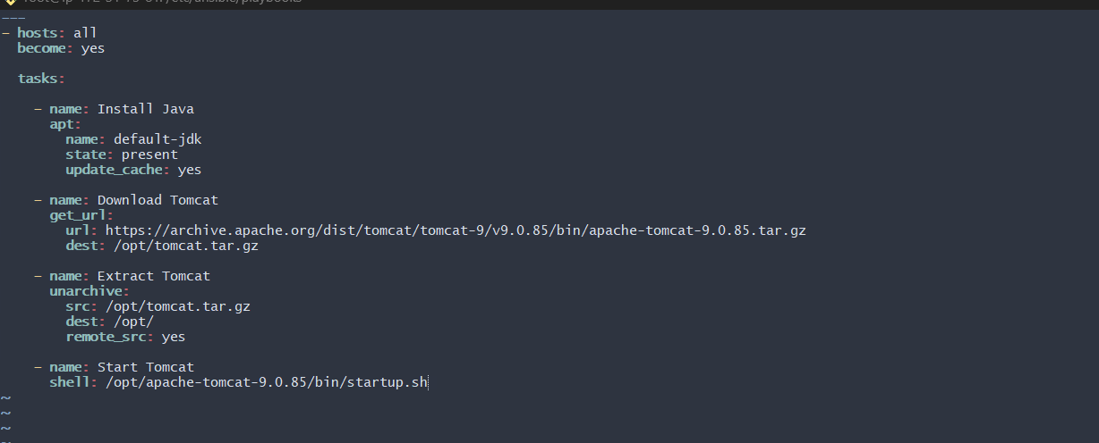
Now see successfully install tomcat
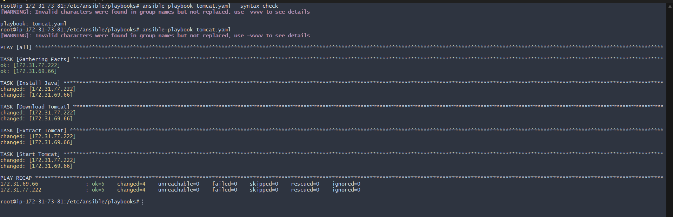
Now lets test it its working as see in our sever photo
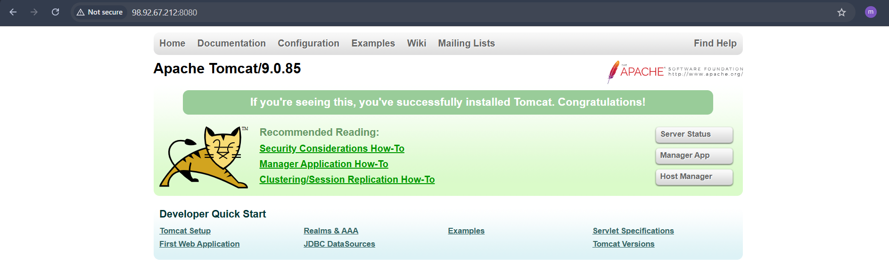
Now lets check out on our server 2 worker-02
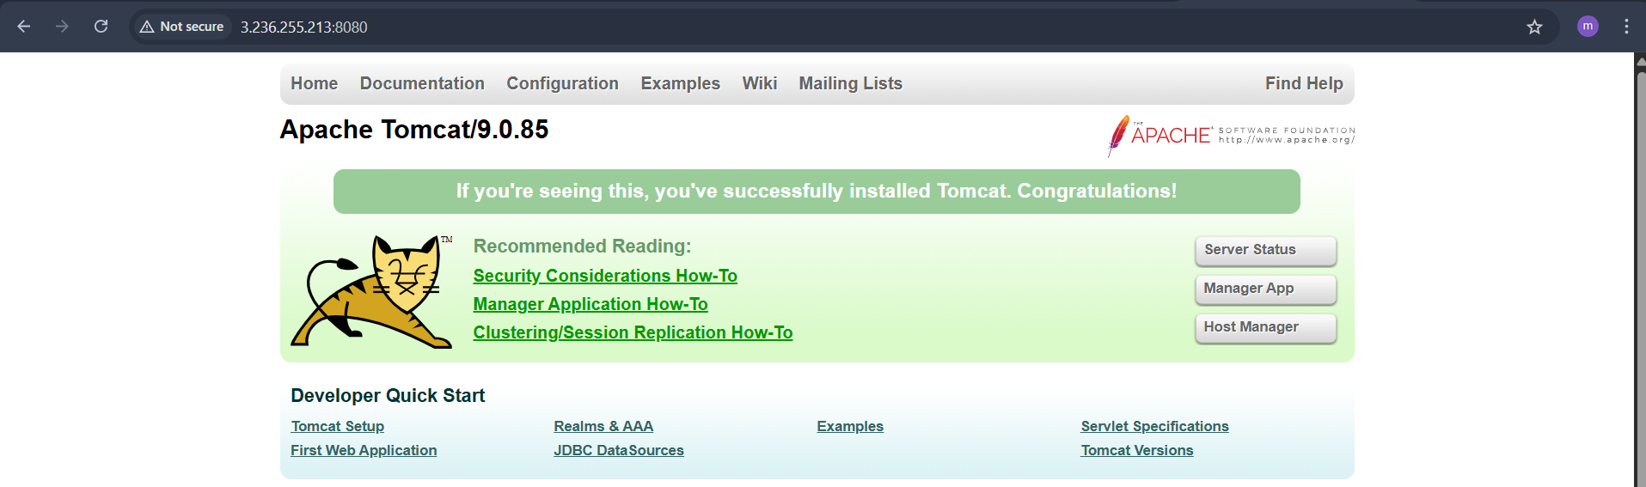
4. Write an ansible playbook to provision one ec2 on aws.
Step by step Implementation:
Requirement: Write an ansible playbook to provision one ec2 on aws

Step 1: Install required tools
apt update
apt install unzip curl -y
Update our machine
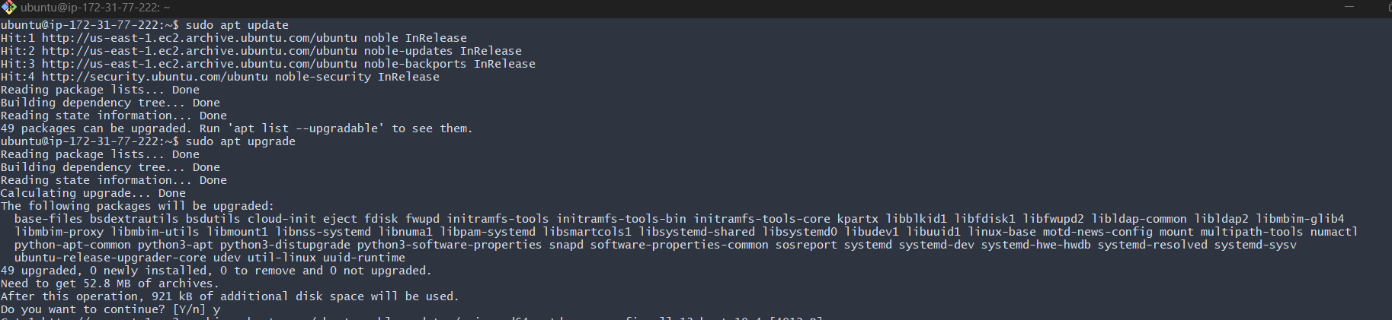
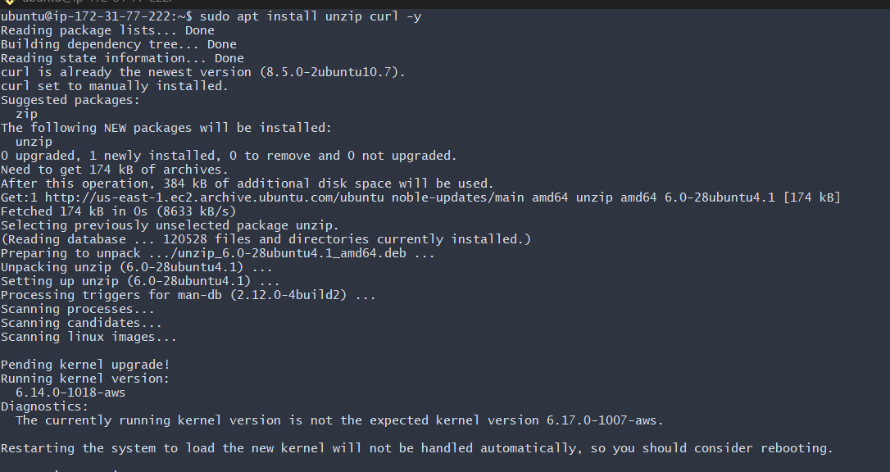
Step 2: Download AWS CLI v2
curl "https://awscli.amazonaws.com/awscli-exe-linux-x86_64.zip" -o awscliv2.zip
Step 3: Install
unzip awscliv2.zip
./aws/install
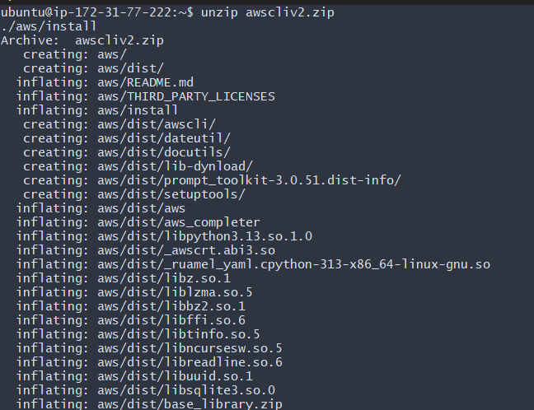

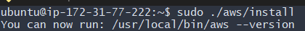
lets Verify
aws –version
We have to create a access key and configure in controller
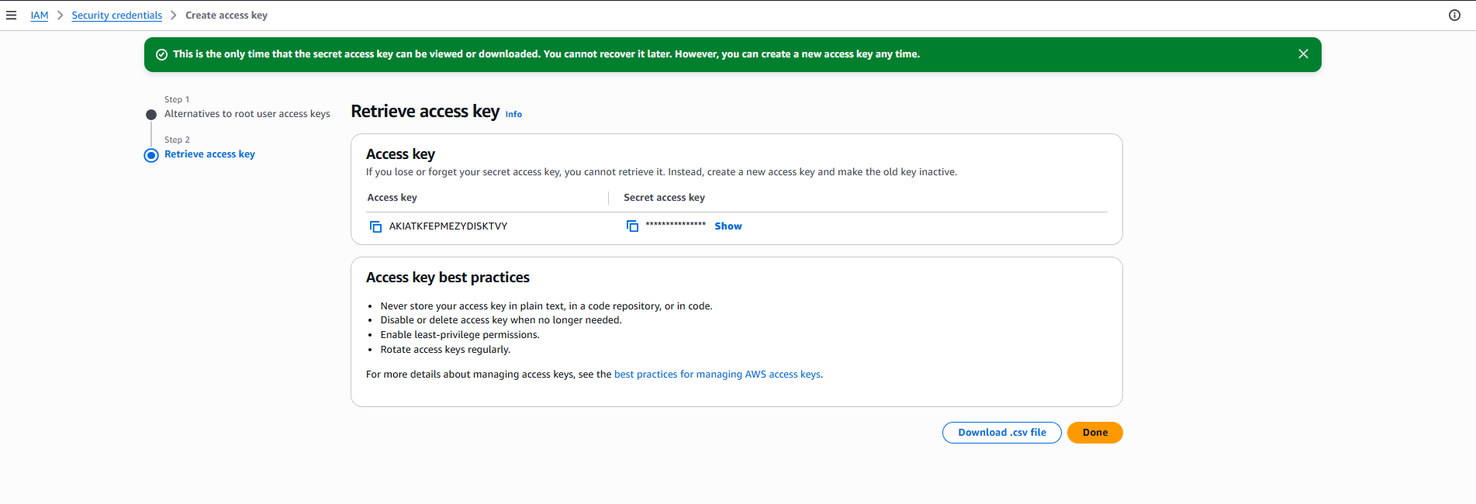
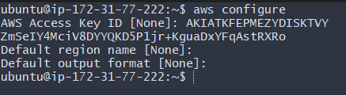
Vi ec2.yaml
---
- hosts: localhost
connection: local
gather_facts: no

tasks:
- name: Create EC2 instance
amazon.aws.ec2_instance:
name: ec2-yaml
region: us-east-1
instance_type: t2.micro
image_id: ami-0532be01f26a3de55
key_name: Ansible
security_group: default
wait: yes
lets create one ec2 instance
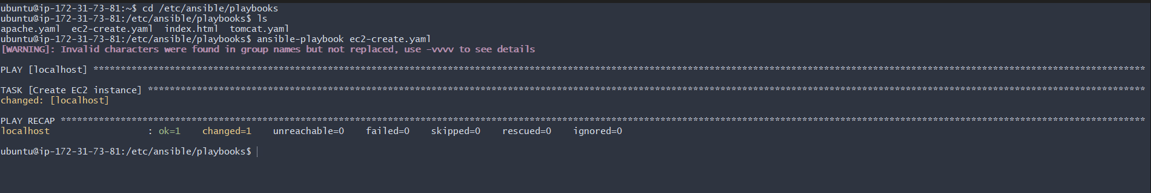
Now lets verfy its working
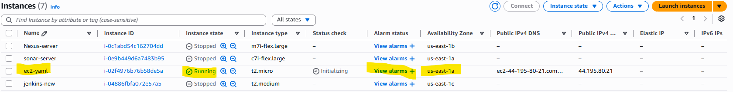

5. Write an ansible playbook to copy one file from node-1 to node-2.
Step by step Implementation:
Requirement: Write an ansible playbook to copy one file from node-1 to node-2
Step 1: First, we need to create a file in worker-01, so used command- ansible Worker-01 -m shell -a "echo 'Hello from Worker-01' > /tmp/ansible.txt"
Step 2: Let’s create a playbook now
Vi copyfile.yaml
we shall execute the script once dry run syntax errors are checked.
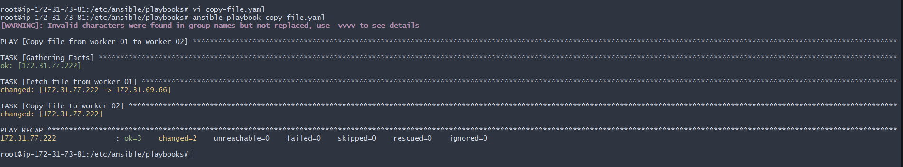
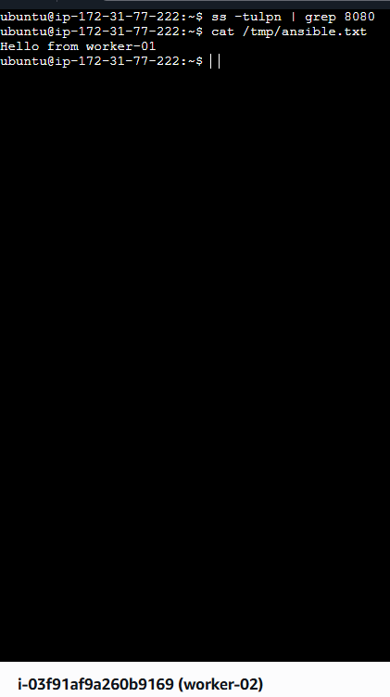
6. Write an ansible playbook to create different files with different names using single playbook.

Step by step Implementation:

Requirement: Write an ansible playbook to create different files with different names using single playbook

Ansible loops allow performing repetitive tasks efficiently.
Using a single playbook, multiple files with different names can be created.
---
- name: Create multiple files
hosts: worker-01
become: yes

tasks:
- name: Create different files
file:
path: "/tmp/{{ item }}"
state: touch
loop:
- dev.txt
- test.txt
- prod.txt
- demo.txt
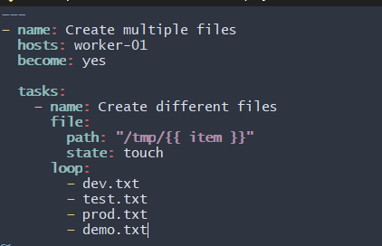
Ok now test it
