Task Title
Ansible-04
Objective
The objective of this task is to watch the Ansible-04 video posted on slack and worked on executing the Ansible tasks shown in video.
Prerequisites
List all requirements before starting:
- Master Controller server
- Nodes- workers
- Vault
- Variables types of variables
- Playbook
- Ad hoc commands
Issues Faced: Briefly mention issues and how you fixed them. Posted below in the last.
Conclusion
Conclusion has been provided for every task at the end.

Tasks

- Create ansible playbook to create ansible vault.

Objective
To securely store sensitive credentials using Ansible Vault and use those encrypted variables inside an Ansible playbook.
Prerequisites
- Ansible installed
- Inventory configured (/etc/ansible/hosts)
- Target hosts reachable
- Basic YAML knowledge

Step by step Implementation:

Step 1: Login to master controller and worker machines
By using command ansible-vault create secret.yml we can create it
Now paste your user and password inside in it
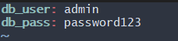
Now lets verfy with use cat command we see inside in secret.yml it show random number it encryption right now we are using AES256 Format as see it
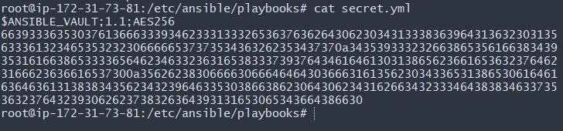
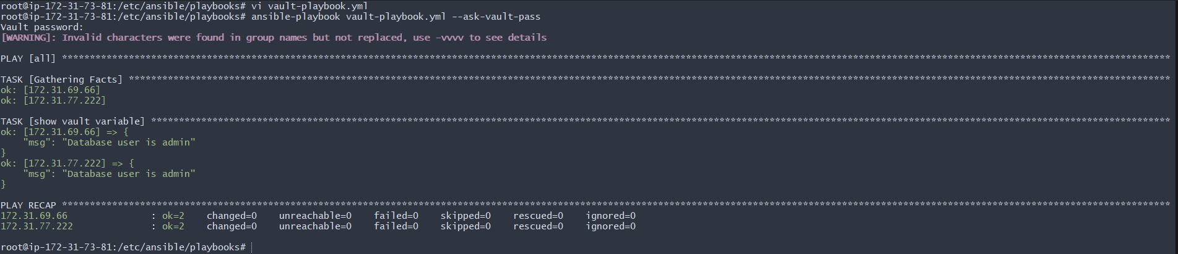

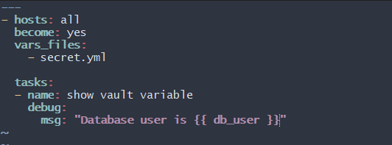
2. Write a ansible playbook to install apache in linux and ubuntu machine by using when condition.
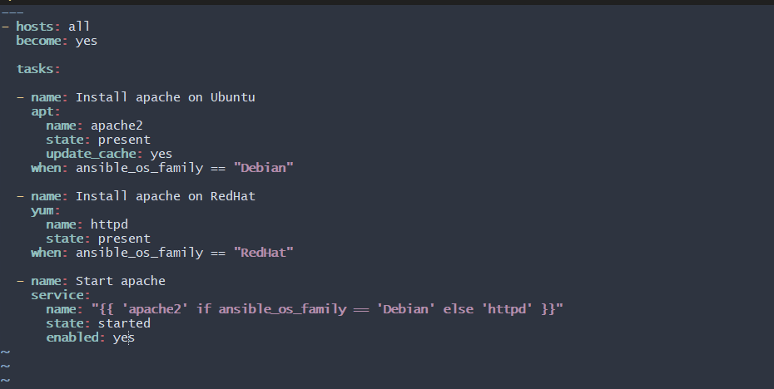
Now lets excute it now notice it work perfectly
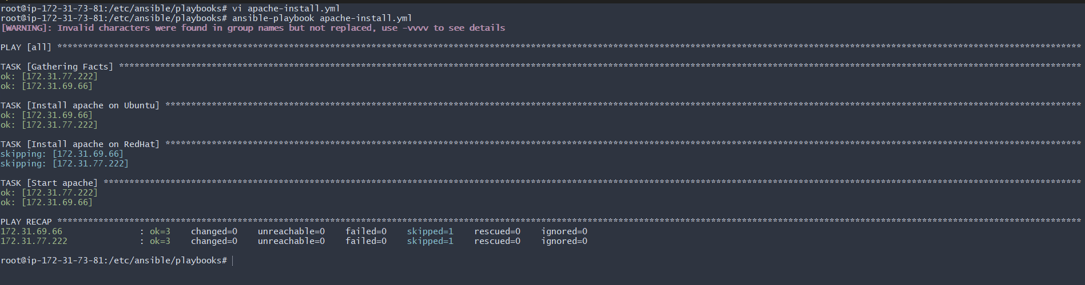

3. Create ansible playbook using roles to configure LAMP stack
lamp/
├── site.yml
└── roles/
├── apache/
│ ├── defaults/main.yml
│ ├── handlers/main.yml
│ ├── meta/main.yml
│ ├── tasks/main.yml
│ ├── templates/
│ └── vars/main.yml
├── mysql/
└── php/
Go to ansible, cd /root/ansible
Steps Followed to Configure LAMP Stack Using Ansible Galaxy Roles
Step 1: Set Up Ansible Environment
- Installed Ansible on the control node.
- Created an inventory file with:
- Controller (localhost)
- Worker nodes (Amazon Linux EC2 instances)
• Configured SSH key-based authentication for passwordless access.
Step 2: Verified Inventory and Connectivity
- Used the inventory file located at:
- /root/ansible/hosts
- Verified connectivity using:
- ansible -i /root/ansible/hosts workers -m ping
• Confirmed Ansible could communicate with all worker nodes.
Step 3: Created a New Project for LAMP Stack
- Created a dedicated project directory:
- /root/ansible/lamp
- Followed Ansible best practices by separating this project from other playbooks.
Step 4: Created Roles Using Ansible Galaxy
- Navigated to the roles directory:
- cd /root/ansible/lamp
- mkdir roles
- cd roles
- Used Ansible Galaxy to generate standard role structures:
- ansible-galaxy init apache
- ansible-galaxy init mysql
- ansible-galaxy init php
Step 5: Created the Main Playbook (site.yml)
• Created site.yml to orchestrate the roles.
• Ensured the playbook only referenced roles (no tasks inside it). - hosts: workers
become: yes
roles: - apache - mysql - php
Step 6: Configured Apache Role
• Added OS-based logic inside:
• roles/apache/tasks/main.yml
• Installed Apache using:
o apache2 on Ubuntu
o httpd on RHEL/Amazon Linux
• Started and enabled the Apache service.
Step 7: Configured MySQL (MariaDB) Role
• Added tasks inside:
• roles/mysql/tasks/main.yml
• Implemented OS-aware installation:
o Ubuntu → mariadb-server
o RHEL → mariadb-server
o Amazon Linux → mariadb105-server
• Handled the Amazon Linux edge case by excluding it from RHEL tasks.
• Started and enabled the MariaDB service.
Step 8: Configured PHP Role
• Added PHP installation logic inside:
• roles/php/tasks/main.yml
• Installed PHP packages based on OS:
o Ubuntu → php, php-mysql
o RHEL/Amazon Linux → php, php-mysqlnd
Step 9: Executed the LAMP Playbook
• Ran the playbook using the correct inventory:
• ansible-playbook -i /root/ansible/hosts site.yml
• Observed task execution based on OS conditions.
Step 10: Verified Successful Deployment
• Verified Apache installation via browser or curl.
• Checked MariaDB service status.
• Verified PHP installation using:
• php -v
• Confirmed there were no failures in the play recap.
Final Outcome
• Successfully deployed a LAMP stack on Amazon Linux worker nodes.
• Followed Ansible Galaxy standards.
• Used roles for modular and reusable configuration.
• Implemented OS-specific logic to handle package differences.
• Achieved a clean, production-ready automation setup.
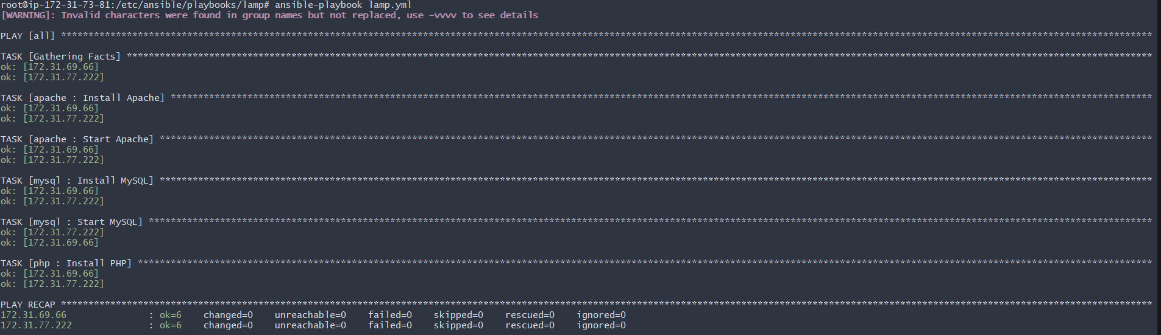
4. Setup ansible AWX and explore the options.
→created one instance with 20gb volume and t2.large instance type.
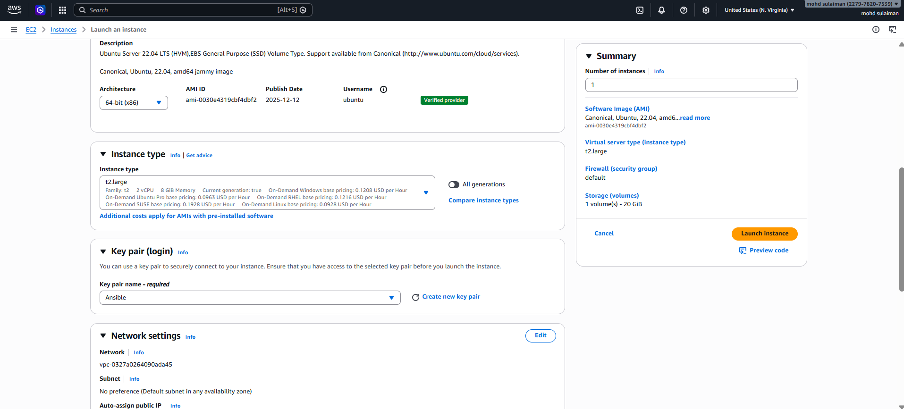
Now make sure update your machine apt update && apt upgrade -y then we install ansible in our machine
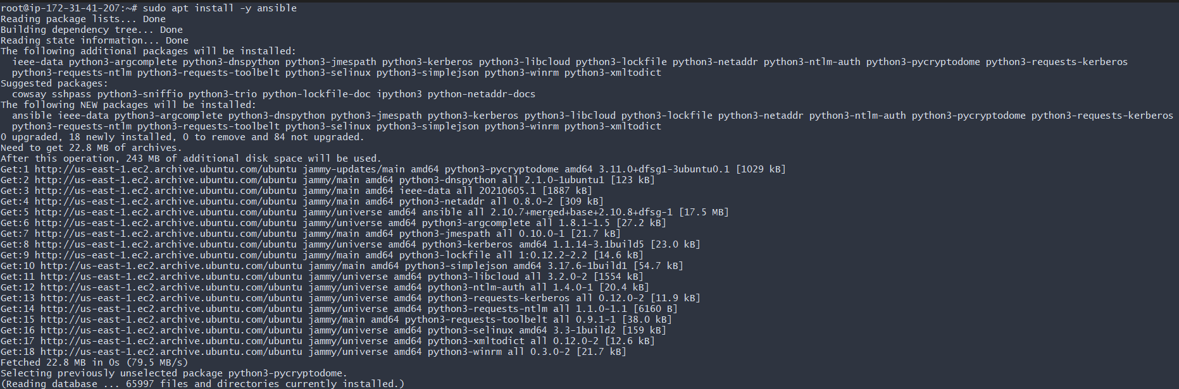
Once we install ansible we can install docker on our machine
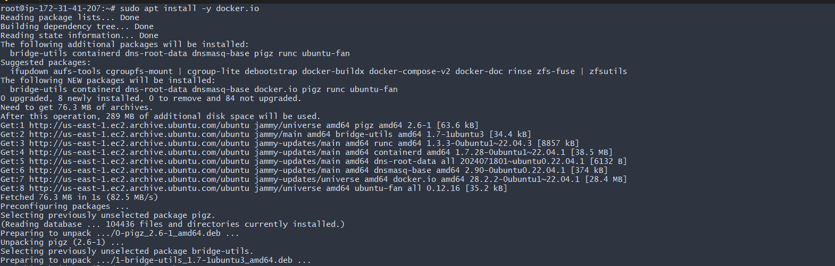
Lets start docker …
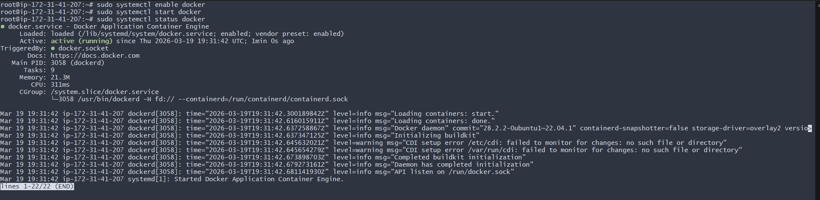
Now we need install docket apt install -y docker-compose
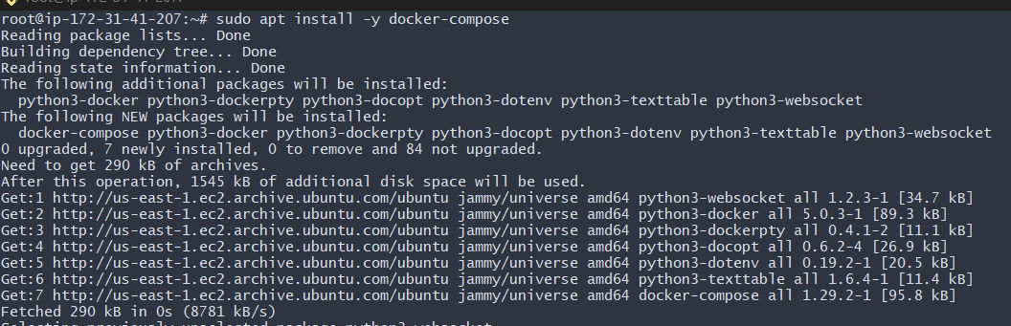
Make sure download git in your machine apt install git -y then we clone this url after clone lets get inside in it
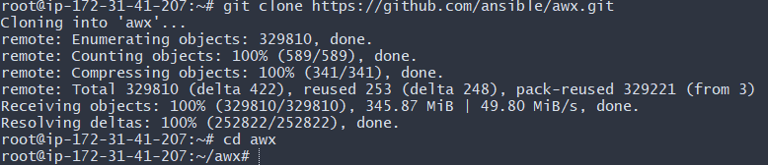
Now need some configuration inside in it go install type vi invernetory/
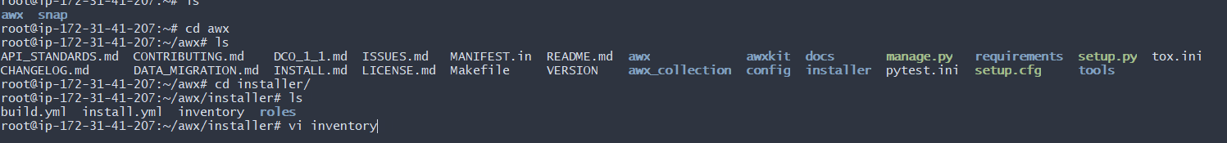
And paste this
→”vi ~/awx/installer/inventory”
→add admin_password=Admin@123
secret_key=Admin@123
pg_database=awx
pg_password=Admin@123
awx_alternate_dns_servers="8.8.8.8,8.8.4.4"
postgres_data_dir="/var/lib/awx/pgdocker"
docker_compose_dir="/var/lib/awx/awxcompose"
project_data_dir="/var/lib/awx/projects"
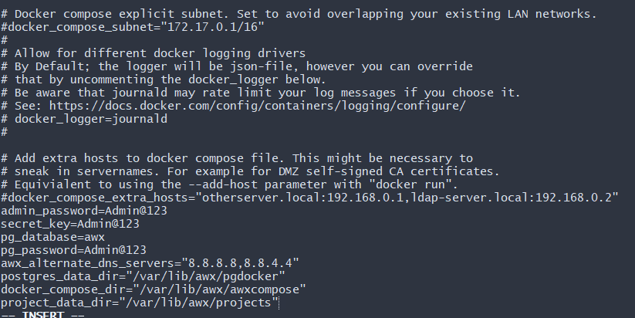
→login into the UI AWX
→username: admin
→password: Admin@123 (by default)
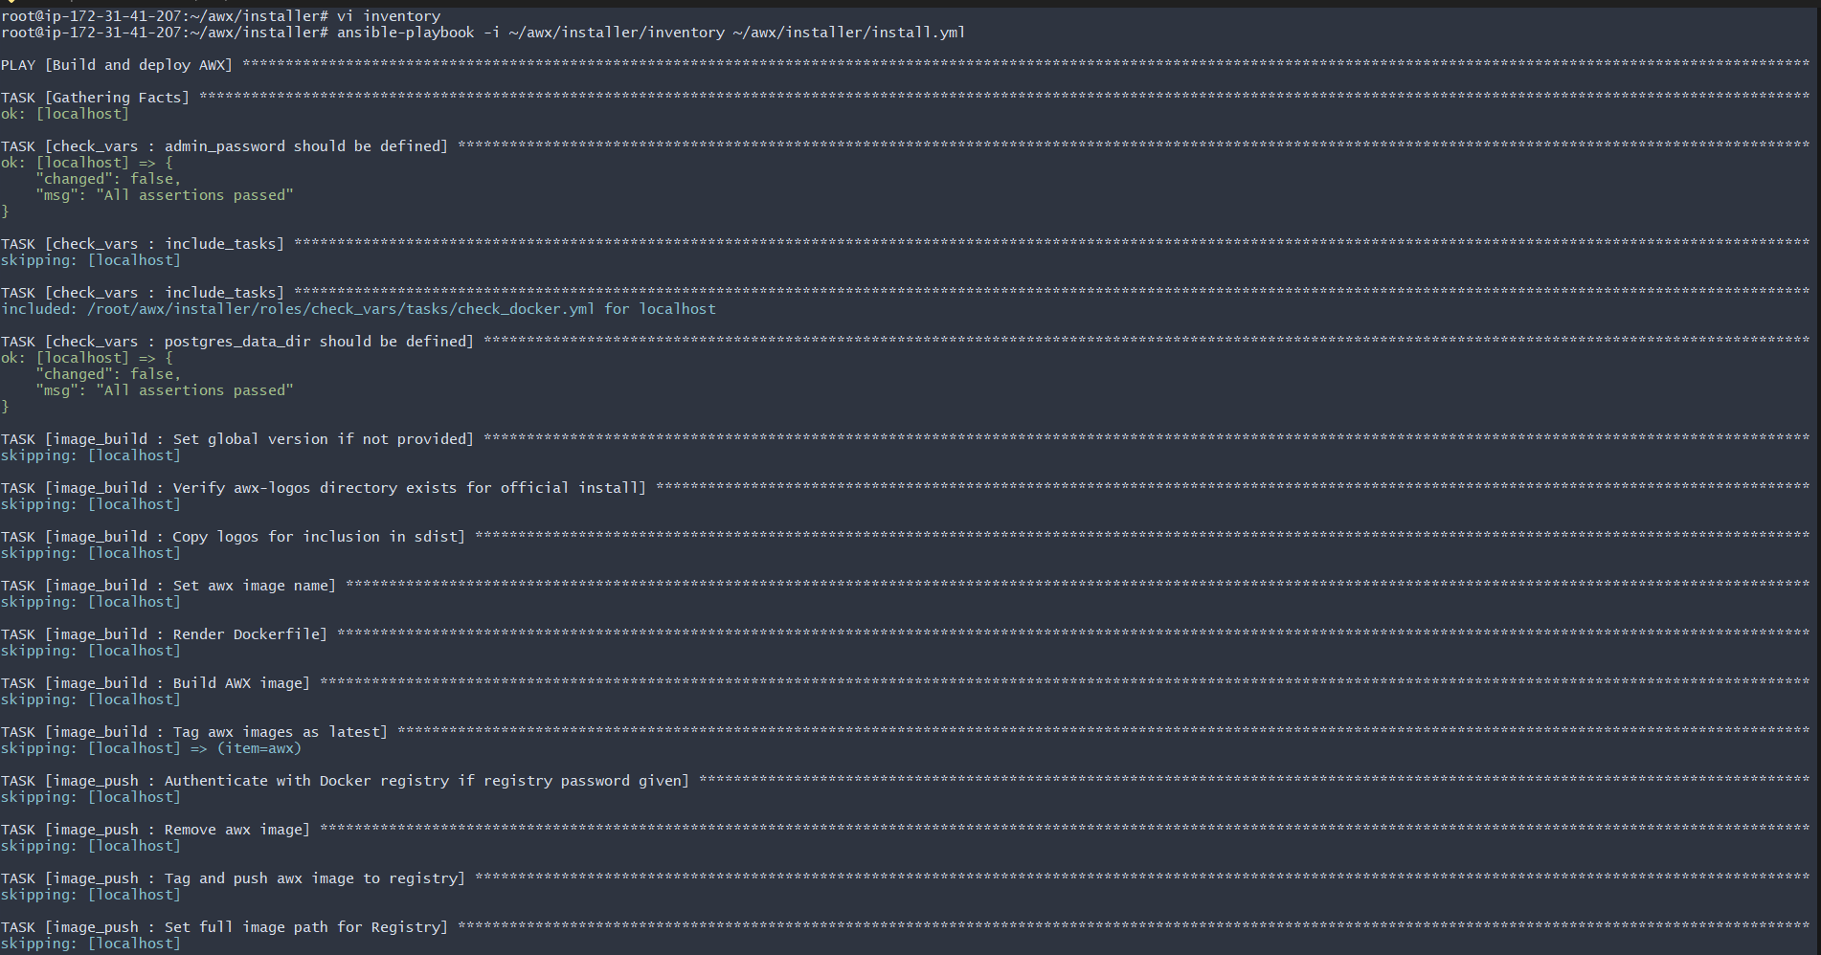
Now we need wait sometime to finish once it finished to ip check gpu page now we need login
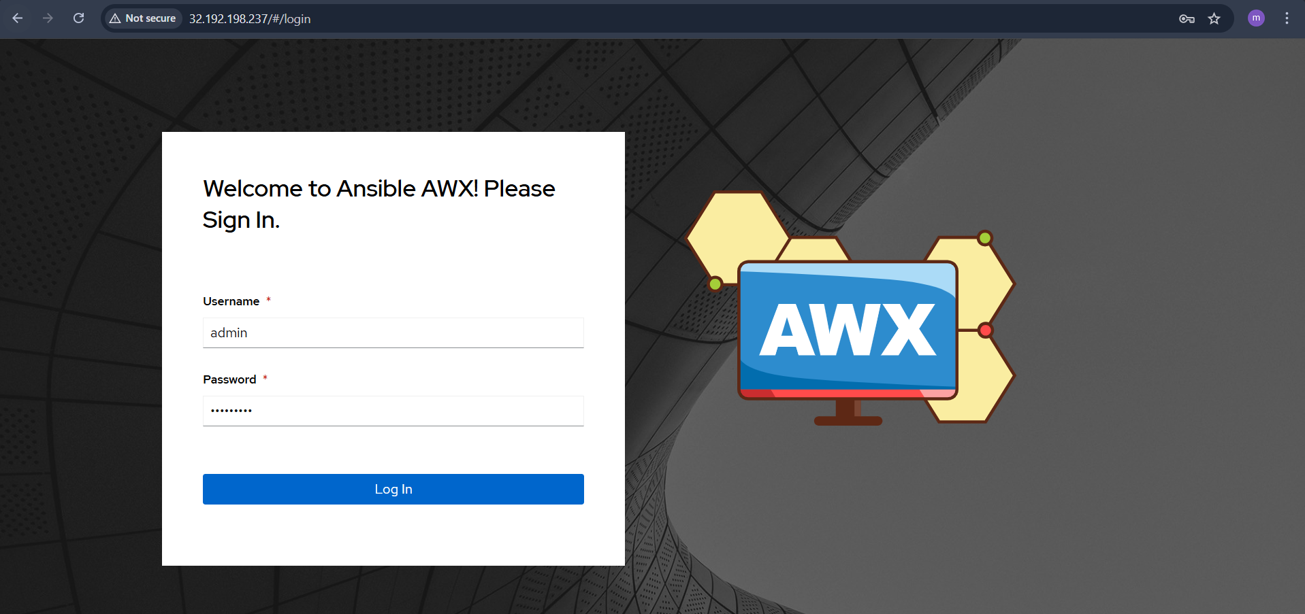
Now we successfully login to our awx server successfully




