ECS_TASK
Task:
❖ Setup a highly available ecs cluster with load balancer and dynamic
port mapping.
NOTE:
Your cluster should maintain atleast 6 tasks at any point of time and
should be highly availble across multiple AZ's.
Use the below image from deployment:
sabair0509/hiring-app:works
PHASE 1: Create ECS Cluster (EC2 + ASG)
On this screen set:
- Provisioning: On-demand
- Instance type: t3.medium (recommended)
- Instance role: Create default role
- Desired capacity: 2
- Minimum: 2
- Maximum: 4
- Select 2 subnets in different AZ
- Select key pair
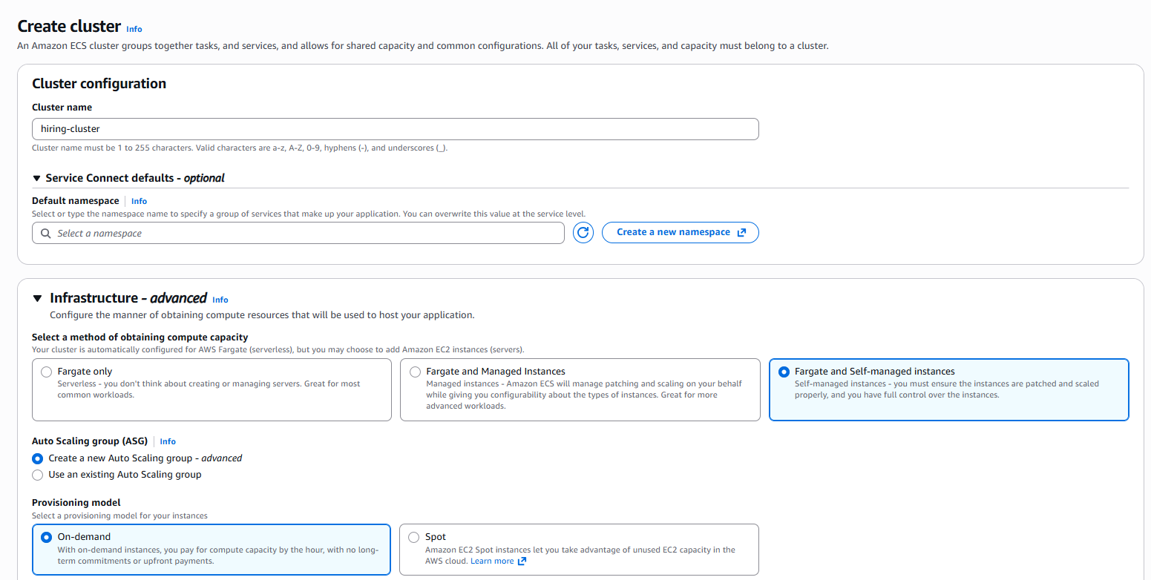

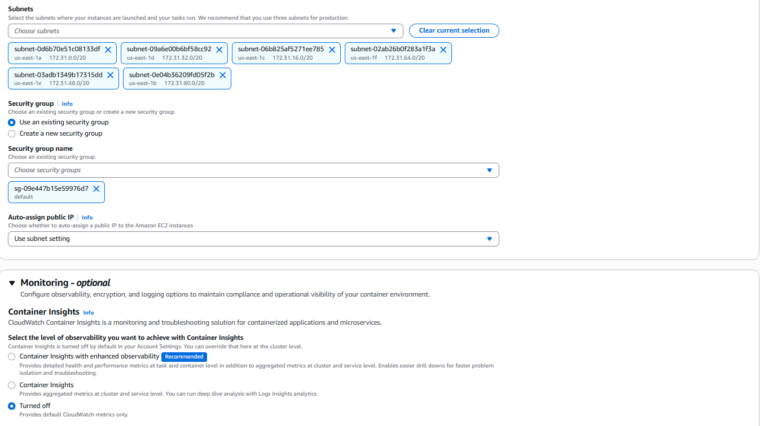
Now click: Create cluster Wait 5-10 mins.
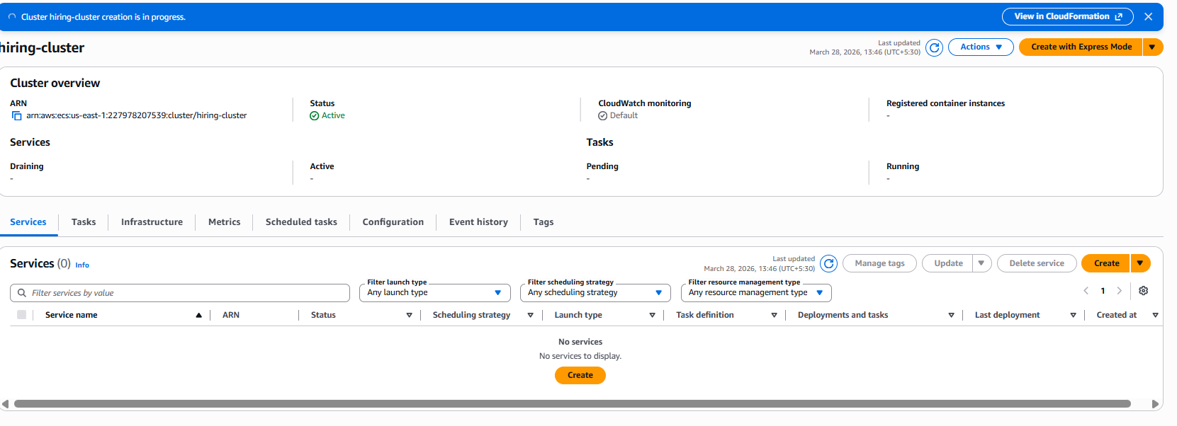
PHASE 2: Confirm EC2 Instances Registered in ECS
Go to:
ECS → Clusters → hiring-cluster → Infrastructure
Check:
• EC2 instances should show as ACTIVE
• Container instances should show registered
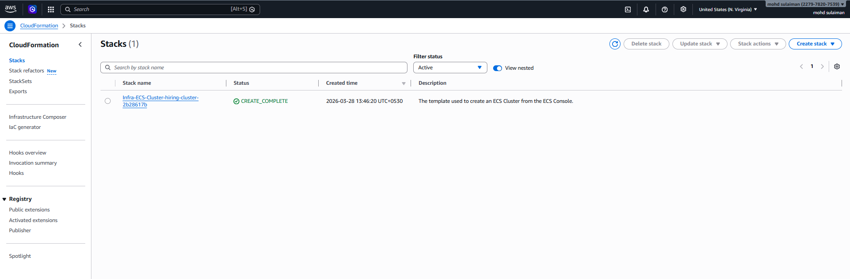
Step 2 onward (cluster already creating), do this exactly:
STEP 2: Verify EC2 Instances Joined ECS Cluster
Go to:
ECS → Clusters → your-cluster → Infrastructure
Check:
• Container instances = 2 (or more)
• Status = ACTIVE
If 0, wait 2-3 mins.
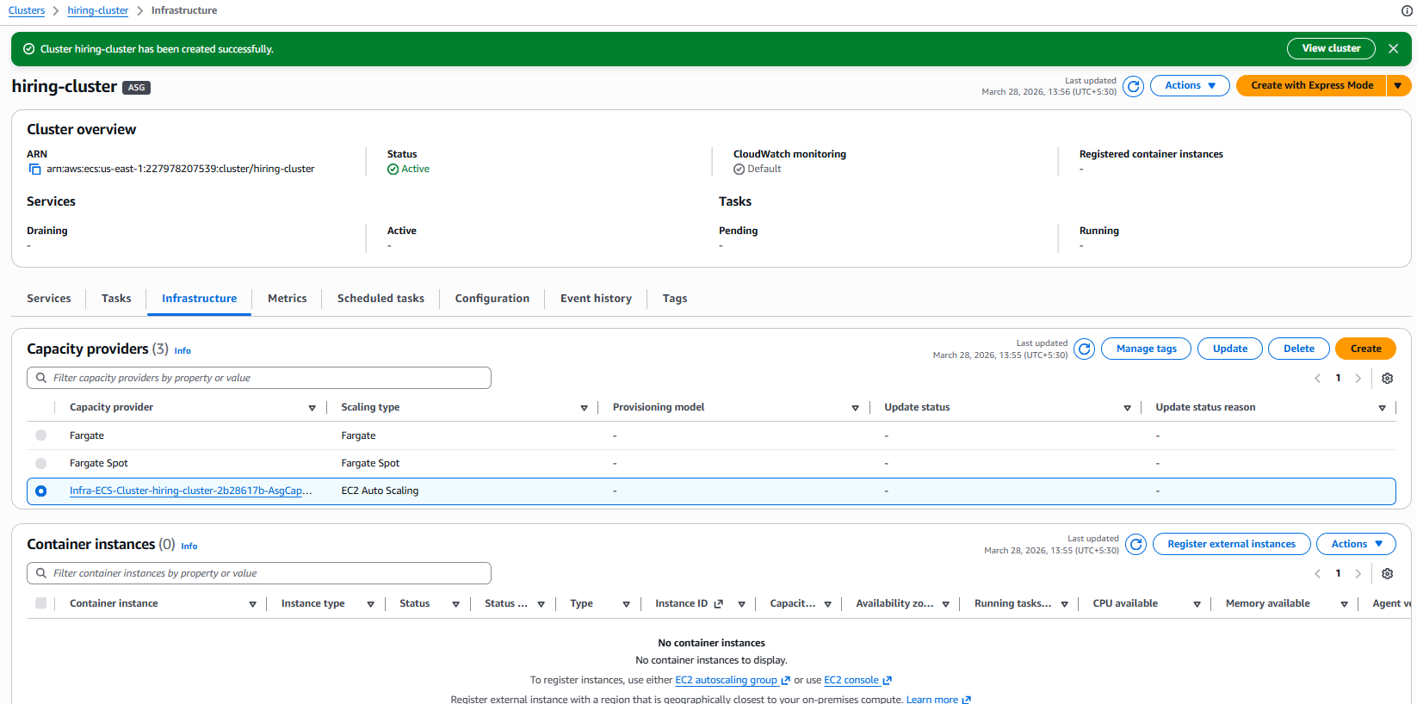
STEP 3: Create Application Load Balancer (ALB)
Go to:
EC2 → Load Balancers → Create Load Balancer → Application Load Balancer
Settings:
• Name: hiring-alb
• Scheme: Internet-facing
• Listener: HTTP 80
• VPC: Default VPC
• Subnets: select 2 subnets (2 AZ)
Create Security Group for ALB:
Name: alb-sg
Inbound rule:
• HTTP 80 from 0.0.0.0/0
Create ALB.
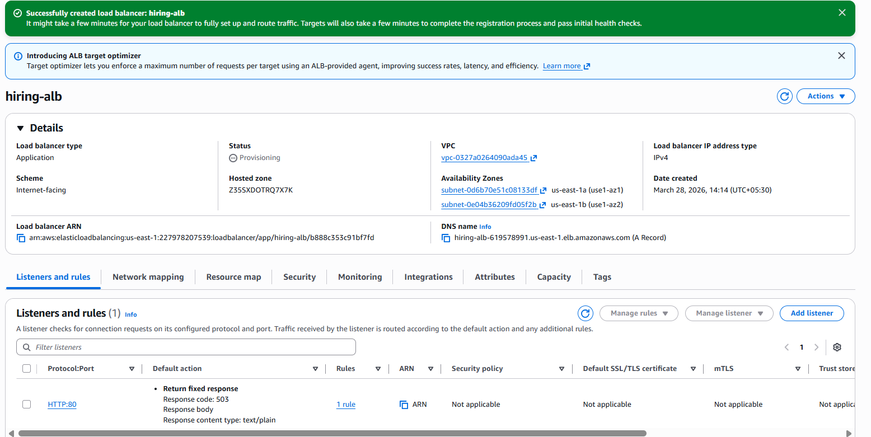
STEP 4: Create Target Group
Go to:
EC2 → Target Groups → Create target group
Settings:
• Target type:
Instance
• Protocol: HTTP
• Port: 80
• Name: hiring-tg
• Health check path: /
Create target group.
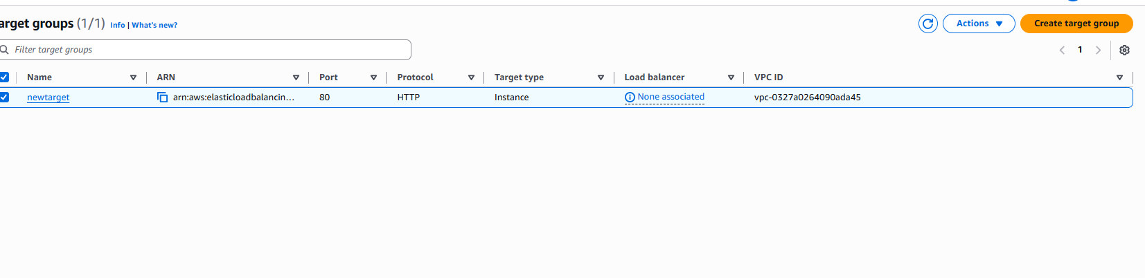
STEP 5: Attach Target Group to ALB Listener
Go to:
EC2 → Load Balancers → ECRloadbalancer → Listeners → HTTP:80
Edit rule → Forward to:
hiring-tg
Save
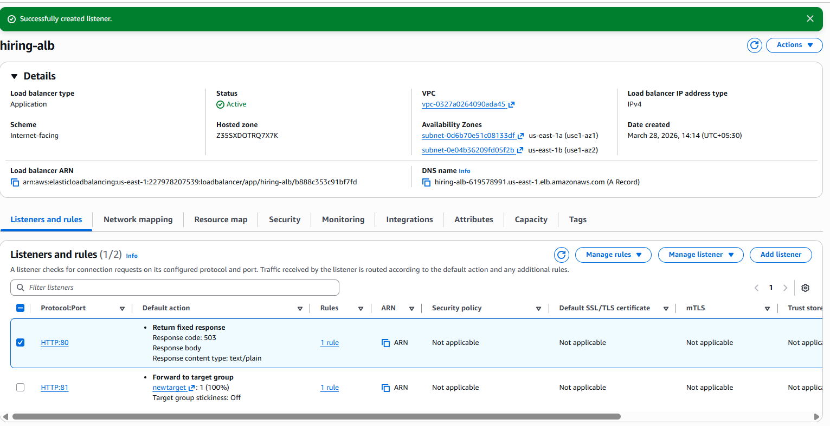
STEP 6: Update ECS EC2 Security Group (Very Important)
Go to:
EC2 → Instances → select ECS instance → Security → open Security Group
Edit inbound rules and add:
Allow from ALB SG:
• HTTP 80 → source: alb-sg
• TCP 32768-65535 → source: alb-sg
(These ports are needed for dynamic port mapping)

STEP 7: Create Task Definition (Using Given DockerHub Image)
Go to:
ECS → Task Definitions → Create new task definition
Choose:
EC2
Task definition name:
hiring-task
Container:
Container name: hiring-app
Image:
sabair0509/hiring-app:works
Port mapping:
• Container port: 8080
• Host port:
Memory reservation:
512
0 (dynamic port mapping)
CPU:
256
Create task definition.
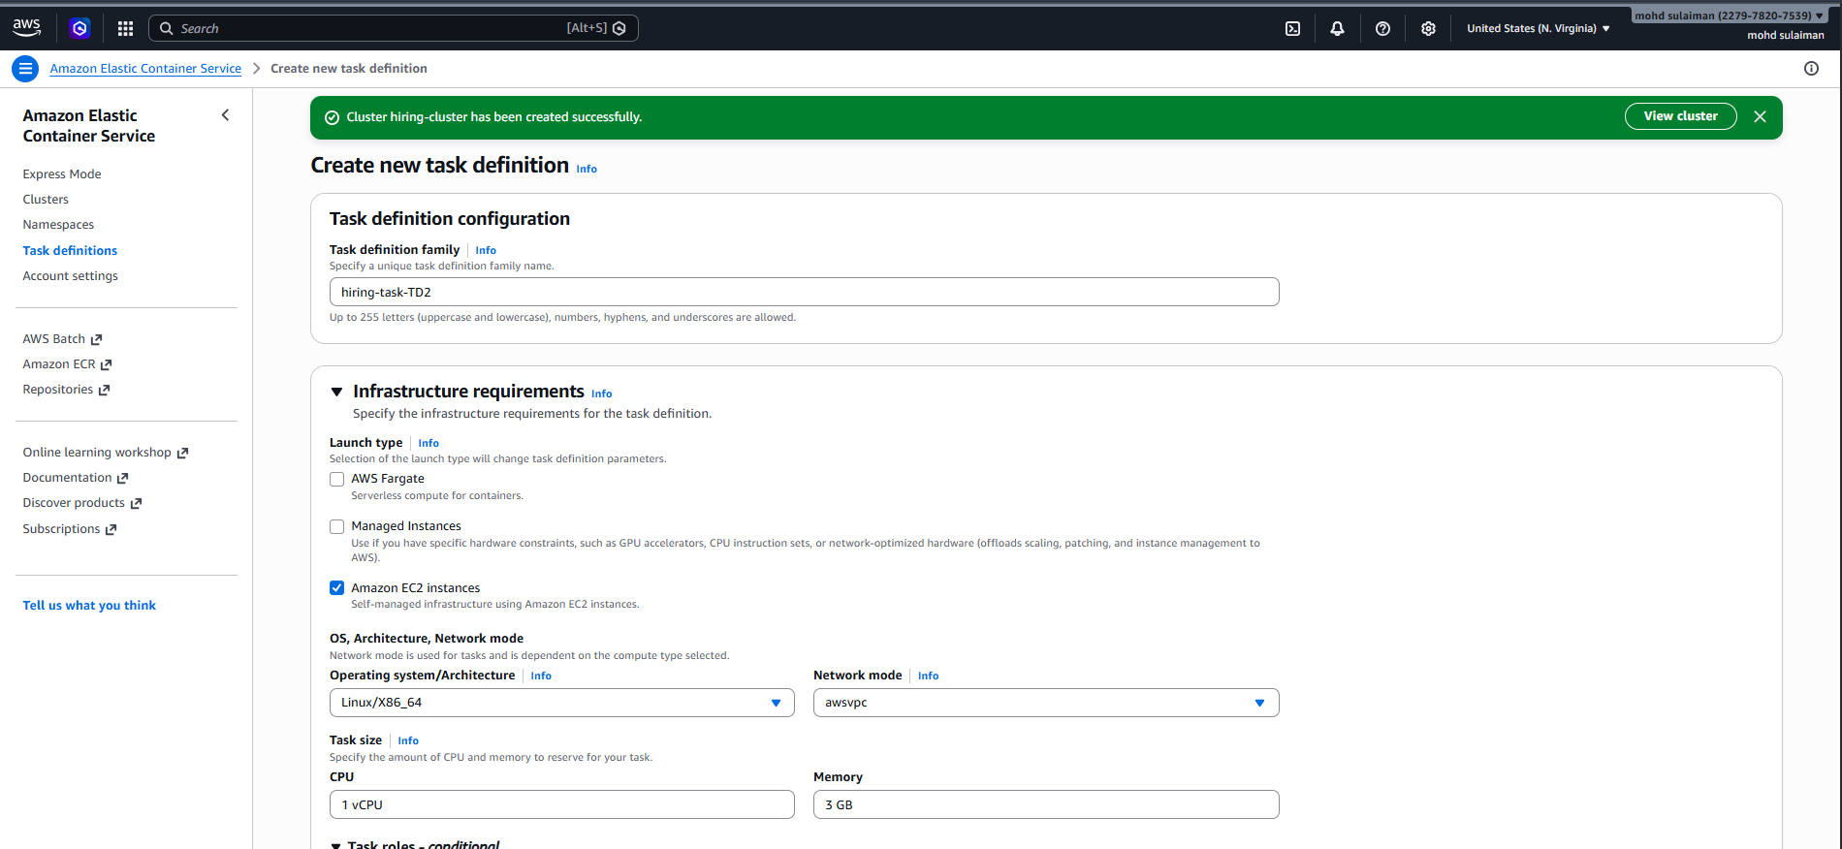
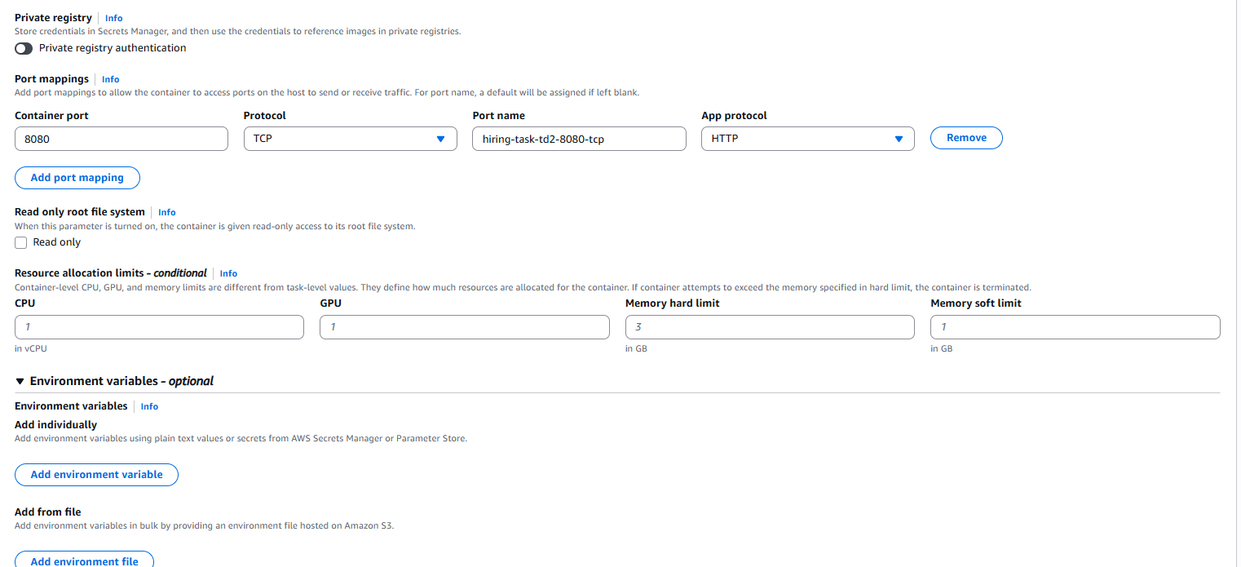
STEP 8: Create ECS Service (Maintain 6 Tasks Always)
Go to:
ECS → Clusters → your-cluster → Services → Create
Settings:
Launch type: EC2
Service name: hiring-service
Task definition: hiring-task
Desired tasks: 6
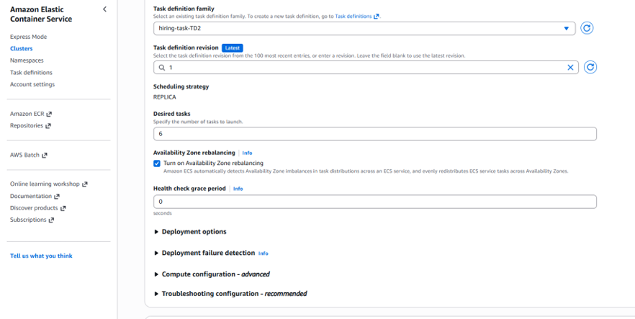
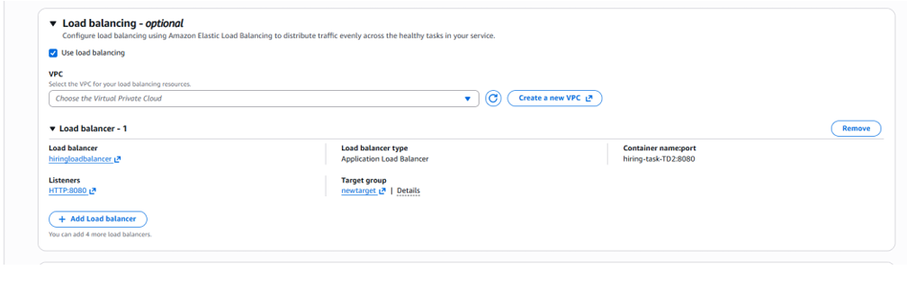
STEP 9: Configure Load Balancer in Service
In Load balancing section:
Enable:
Application Load Balancer
Select:
• Load balancer: hiring-alb
• Listener: HTTP 80
• Target group: hiring-tg
Container:
• hiring-app : 8080
Create service.
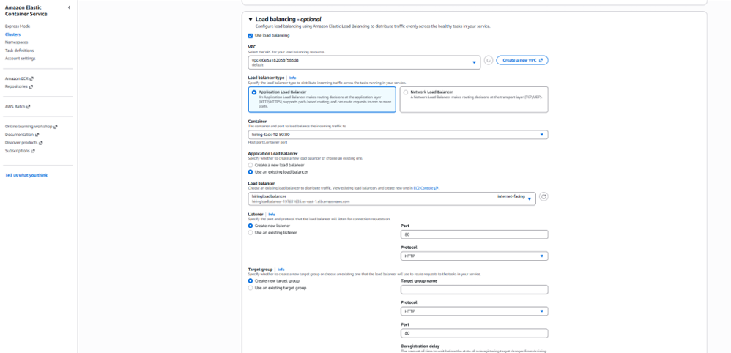
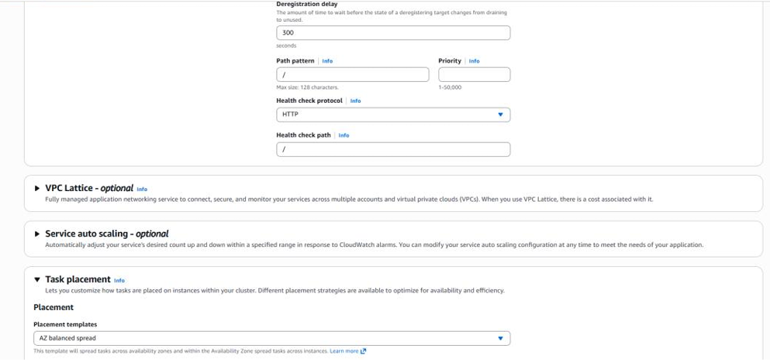
STEP 10: Validate Tasks Running
Go to:
ECS → Cluster → Services → hiring-service → Tasks
You must see:
6 tasks running
If only 2-3 run:
Your EC2 capacity is low.
Increase Auto Scaling desired instances to 3 or change instance type to t3.medium.
STEP 11: Validate Dynamic Port Mapping
Go to:
EC2 → Target Groups → hiring-tg → Targets
You should see registered targets like:
• i-xxxx : 32768
• i-xxxx : 32771
This confirms:
dynamic port mapping working
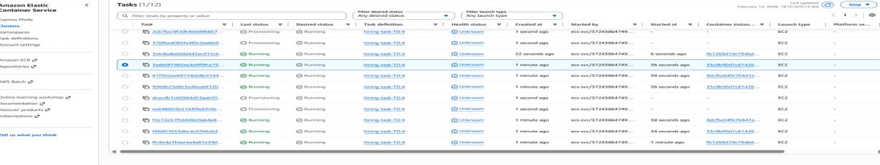
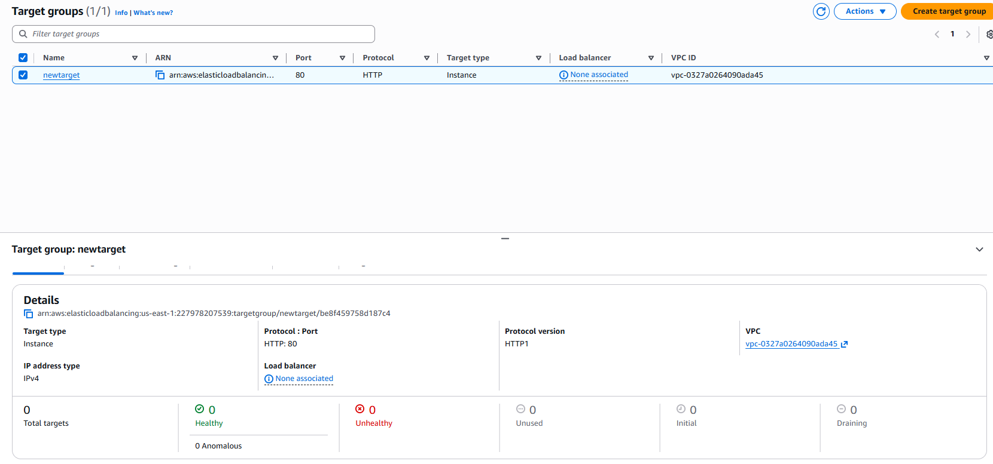

STEP 12: Final Test (ALB DNS)
Go to:
EC2 → Load Balancers → hiring-alb → DNS name
Open DNS in browser:
Example:
http://hiring-alb-xxxxx.us-east-1.elb.amazonaws.com
I should see the application running.
