Jenkins-04

Task Title
Freestyle Jenkins CICD Pipeline using Docker
1. Objective
To create a Jenkins Freestyle job that builds, analyzes, packages, uploads, notifies, and deploys a Java application using Docker-based tools.
Prerequisites
- Jenkins installed and running
- Docker installed on Jenkins server
- SonarQube server configured in Jenkins
- Nexus repository configured
- Slack webhook configured
- Tomcat server running

First we need access our jenkin server click on new item enter name test for now and select freestyle project
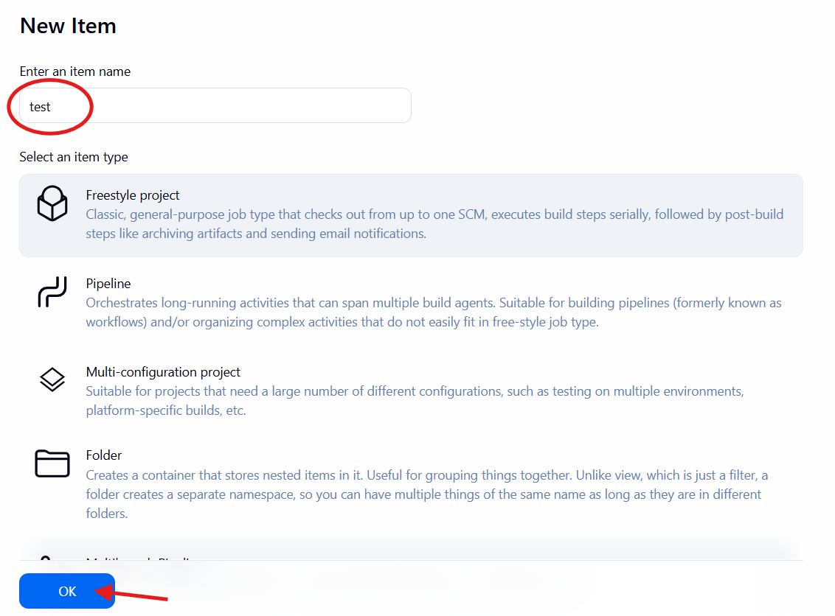
Now configure it and save and bulid go to source code management paste your git paste your url and repo url & select main because repo our branch is main if in case it master then need select master that’s it apply and save it
Source Code Management
- Git paste your url
- Repo URL:

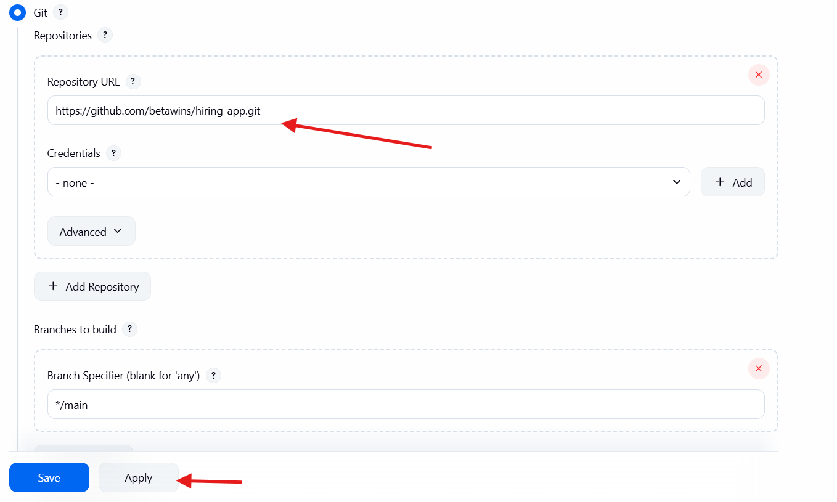
Now we press bluid now you see successfully
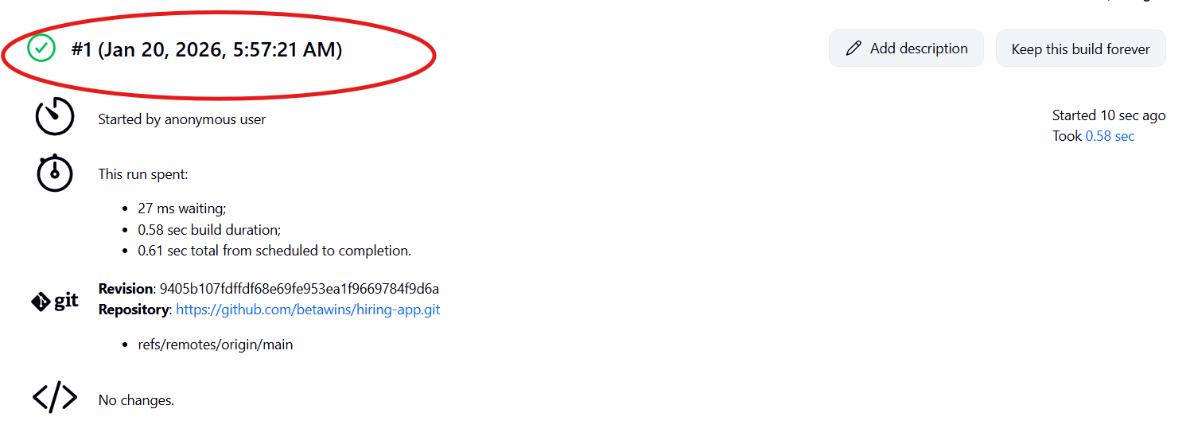
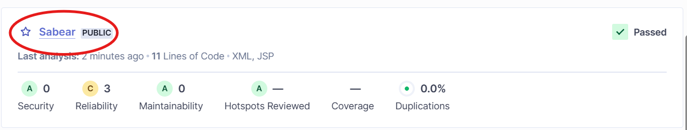

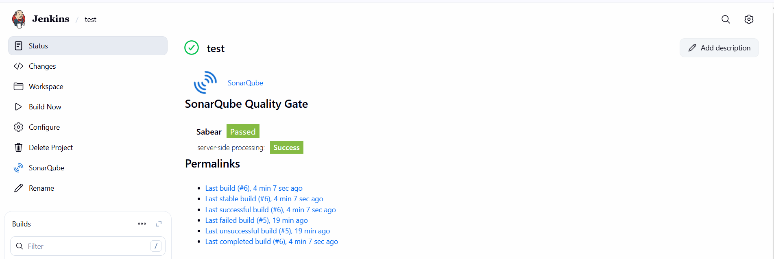
A) Now we need do Maven Compilation
Install & Configure Maven in Jenkins download apche maven in jenkins master cd /opt wget https://dlcdn.apache.org/maven/maven-3/3.9.12/binaries/apache-maven-3.9.12-bin.tar.gz
Now we successfully download it
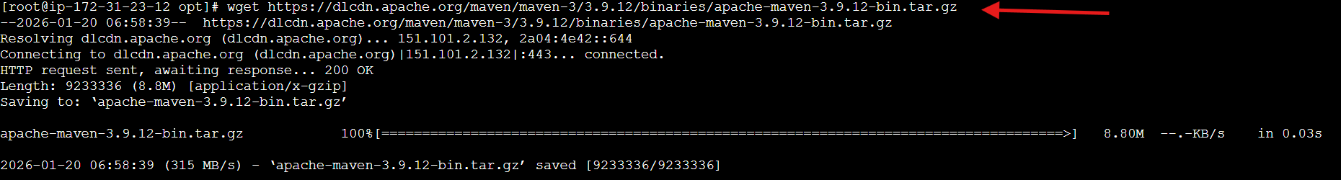
Now we have download it
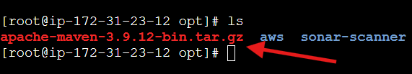
Now we need extract it type tar -xvf apache-maven-3.9.12-bin.tar.gz
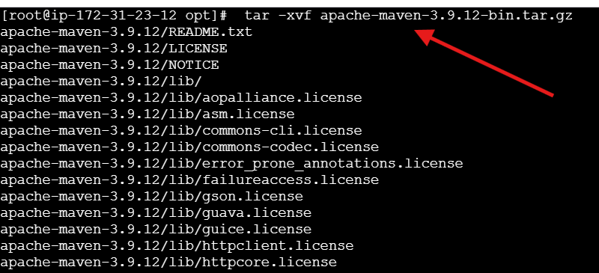
Now we extract it
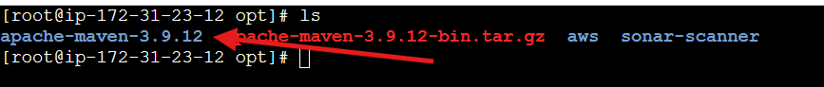
Now we can inside of maven
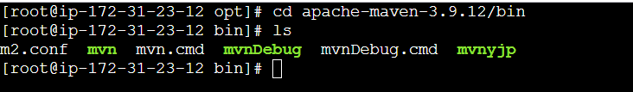
Now type this command go inside profile text
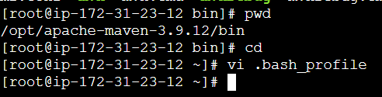
When go inside do some modification make sure remove that commant inside it then copy and paste
MVN_HOME=/opt/apache-maven-3.9.12/bin PATH=$PATH:$HOME/bin:$MVN_HOME
export PATH
now press :wq! That’s it
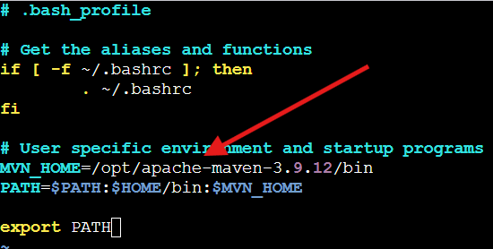
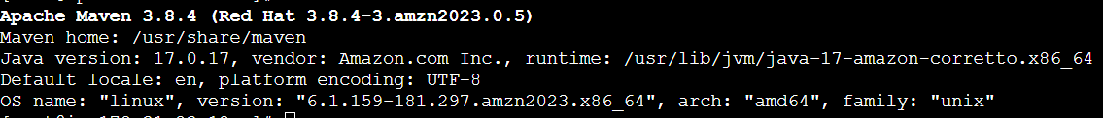
Now go to manage jenkins --> tools --> maven --> /opt/apache-maven-3.9.12
Now in our jenkin we have maven
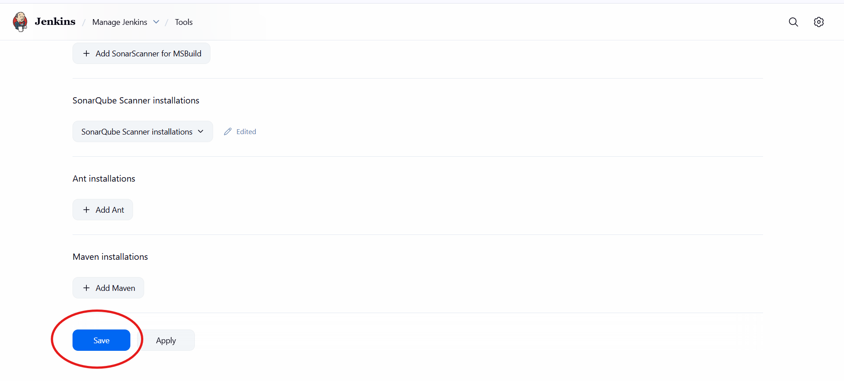
Maven we need add name and home
Name : MVN_Home
Maven_home: /opt/apache-maven-3.9.12
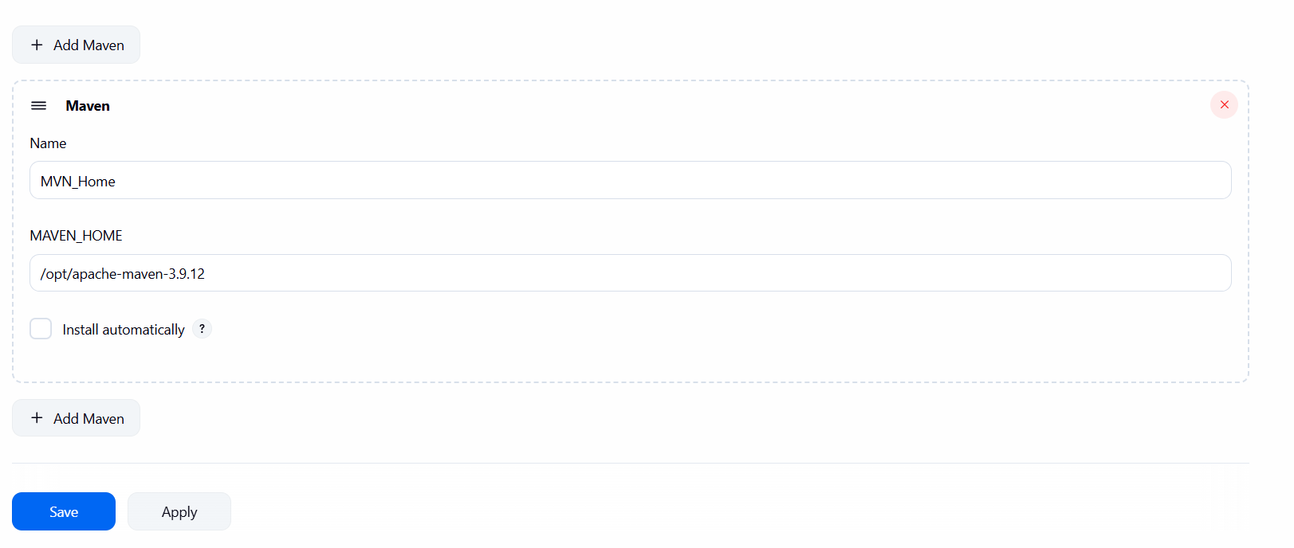
Now configure goes post-bulid actions in add bluid step select invoke top level maven targets

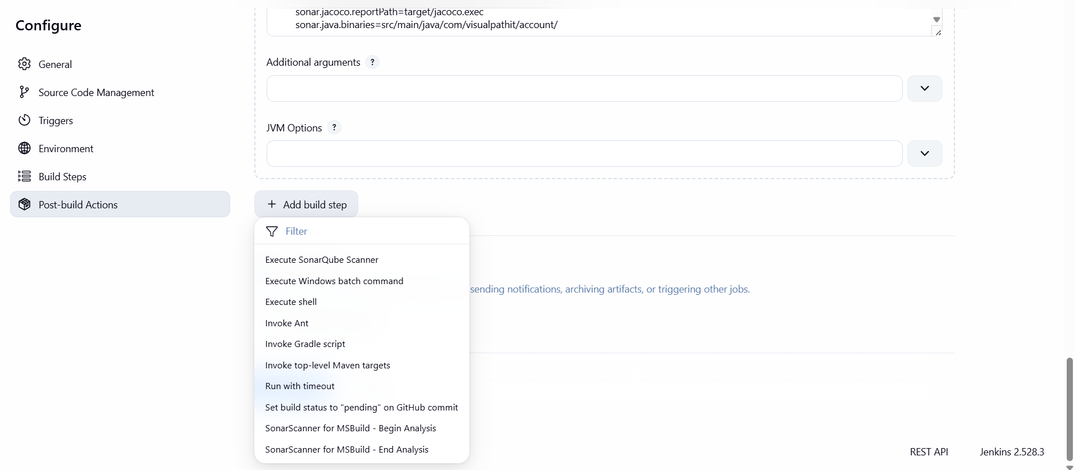
Now in place of goals write clean install that’s it now save it
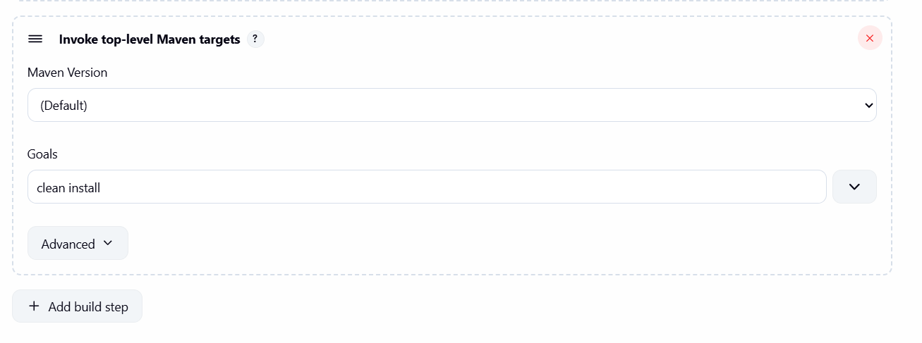
Now run job
Console output
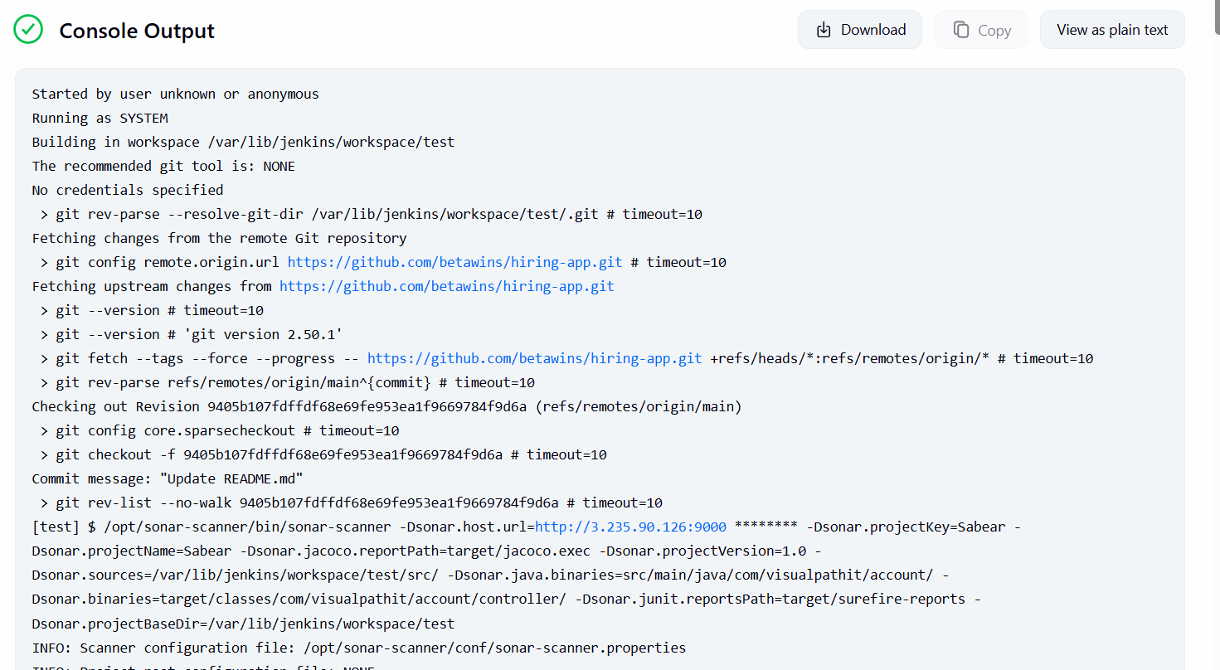
Now in Jenkin server type
Cd /var/lib/Jenkins/workspace/workspace/hiring-app/target
Ls
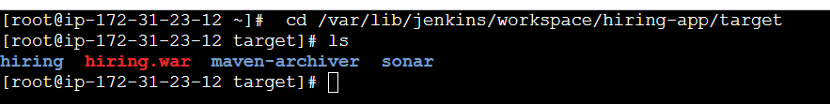
Now We can check dependencies in jenkins server cd /var/lib/jenkins/.m2/repository
B) Nexus Artifactory

Now we need one instace for installing nexus
- Now create nexus-ec2 with t2.large 2. Install java → yum -y install java-1.8*
Now we new instace update with sudo yum update -y
And now insall yum install -y java-1.8*
Now we successfully install java on our new machine
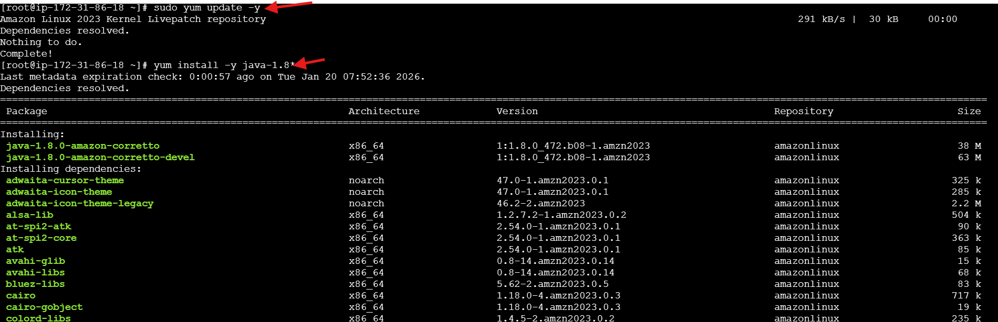
And now download nexus cd /opt sudo wget h ps://download.sonatype.com/nexus/3/nexus-3.68.1-02-unix.tar.gz

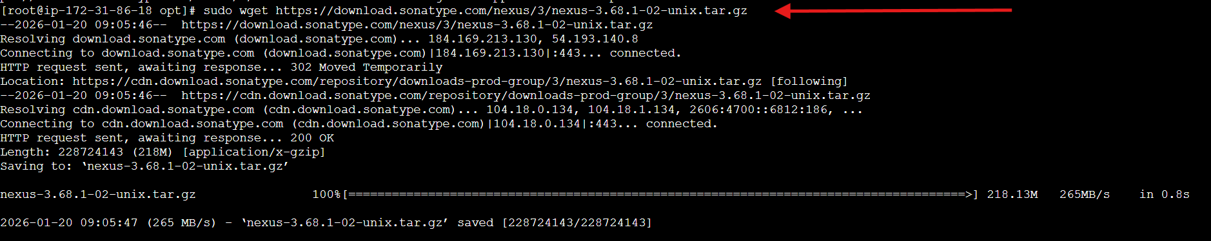
Now we need extract it just sudo -xvf nexus-3.68.1-02-unix.tar.gz
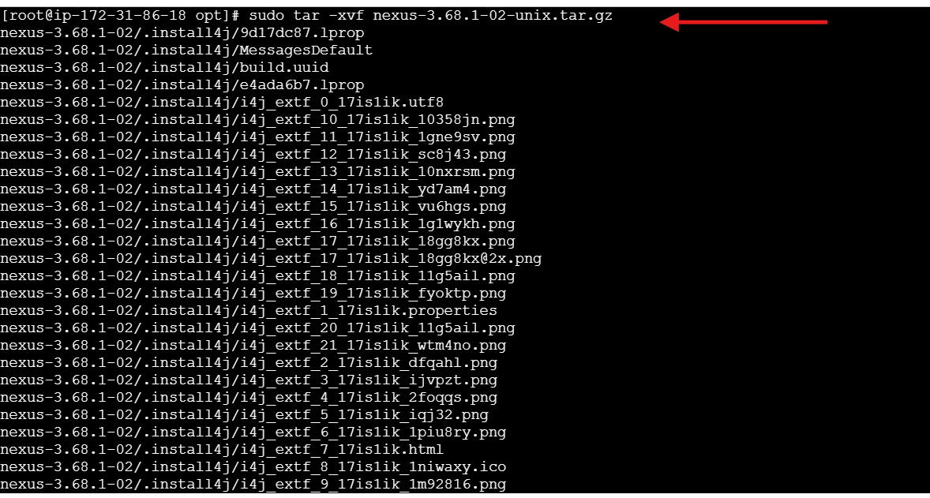
Now type sudo mv nexus-3.68.1-02 nexus and then type ll that’s it
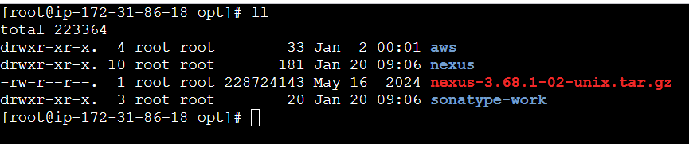
Open /opt/nexus/bin/nexus.rc file, uncomment run_as_user parameter and set it as following. vi /opt/nexus/bin/nexus.rc
Now we need to some change run_as_user="nexus" that’s it now press :wq! It will save it
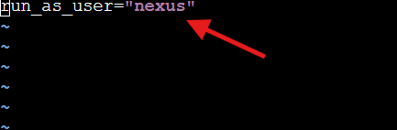
Now we need add user first type sudo useradd nexus it create user
Now type sudo chown -R nexus:nexus /opt/nexus /opt/sonartype-work
Now we need start our nexus repository type this command to start
To start ./nexus start
Tp check status just type ./nexus status
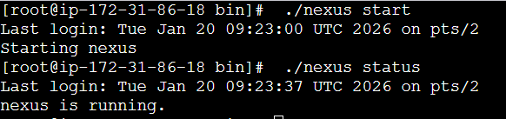
Remember configure your security group it work on 8081 port
Now go url type ur publicip:8080 that’s it
In my case my public ip is http://54.159.179.112:8081/ in your case diffrenet when goes that url it take loading wait ….
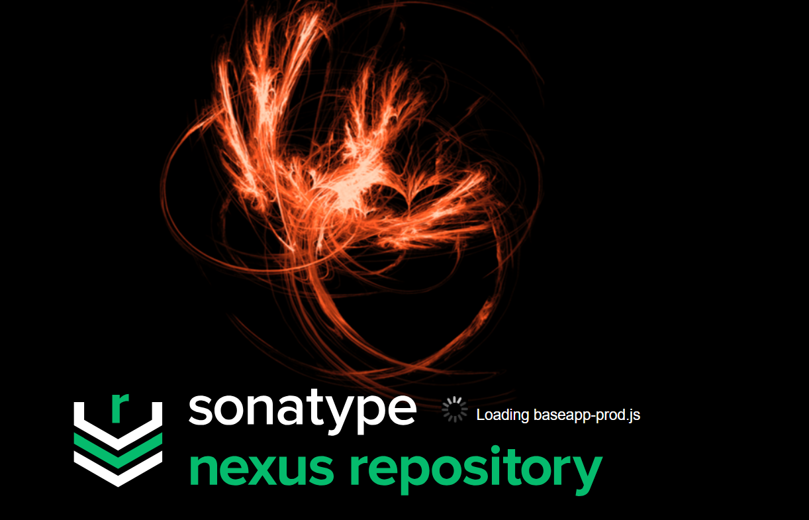
Now we are in nexus 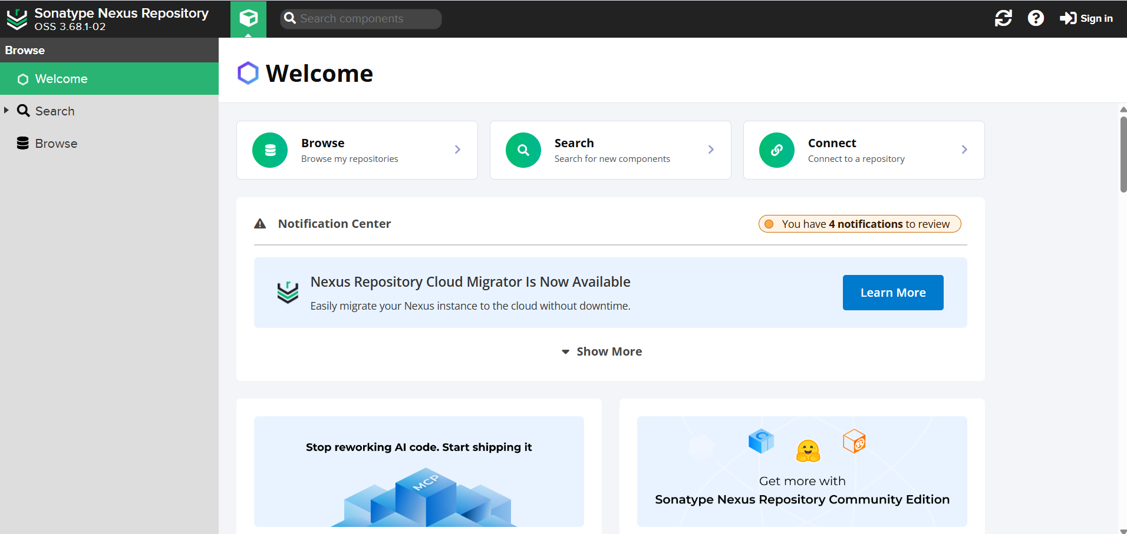
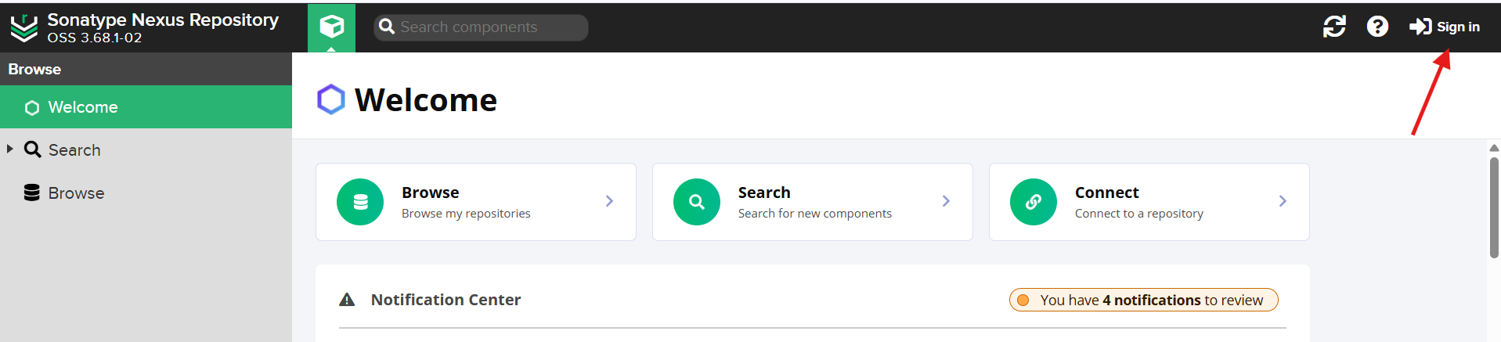
Now we need sing in to nexus click on sign in user name should be admin
In my case my password is 67ee4ad9-0177-44fe-9a72-4341f373892e in my case my password this so in your case in your case it might be different that’s it
Now we need login nexus after clicking on sign in username type admin and place of password paste that encryption code or hash password after that click on sign in
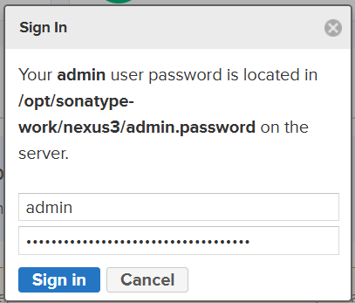
Now we need update our password so type your password make sure it strong password that’s it now click on next
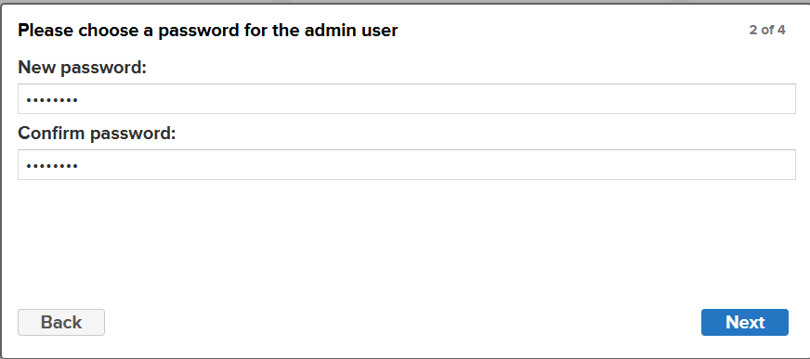
That’s we finally sign to nexus
Click on enable annymouse access and click on next

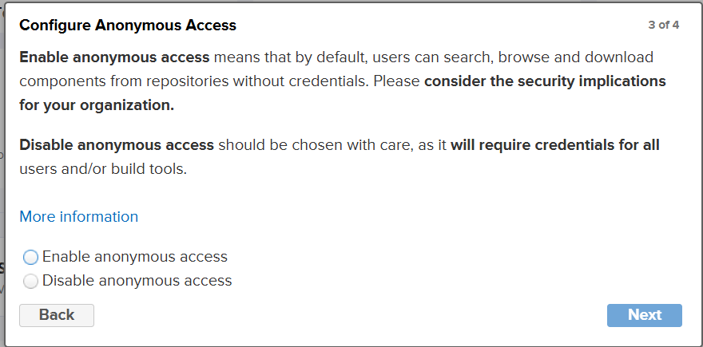
That’s it now need install plugin of nexus in our jenkin server
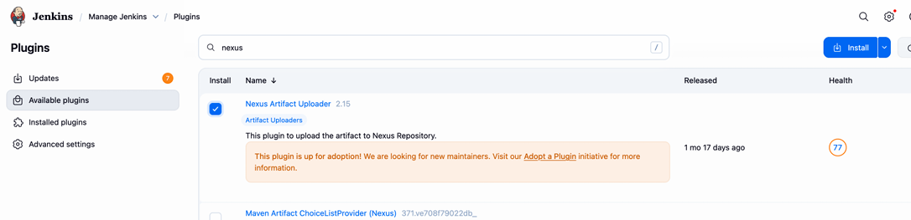

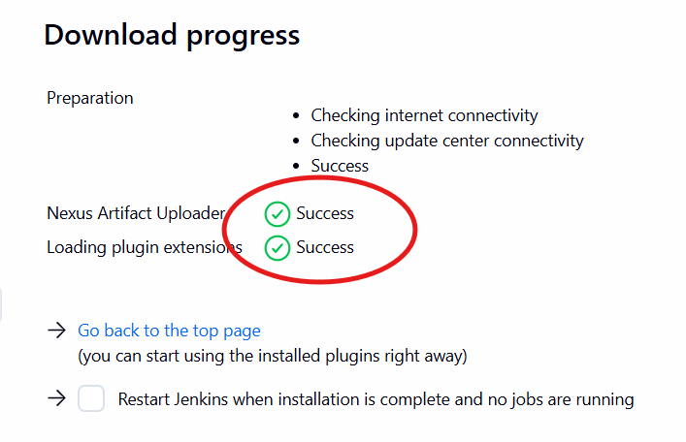
Now go to your job → configure → build step → nexus In git hub repo in pom.xml file we have some info group id and version, bring and enter here and goto nexus create repository → maven2(host) and take release.
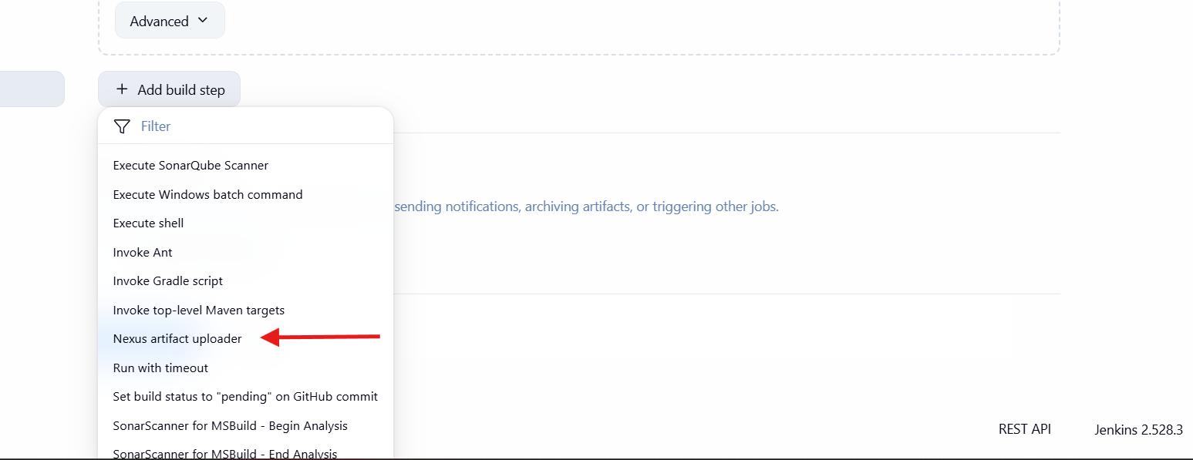
Now paste your nexus url
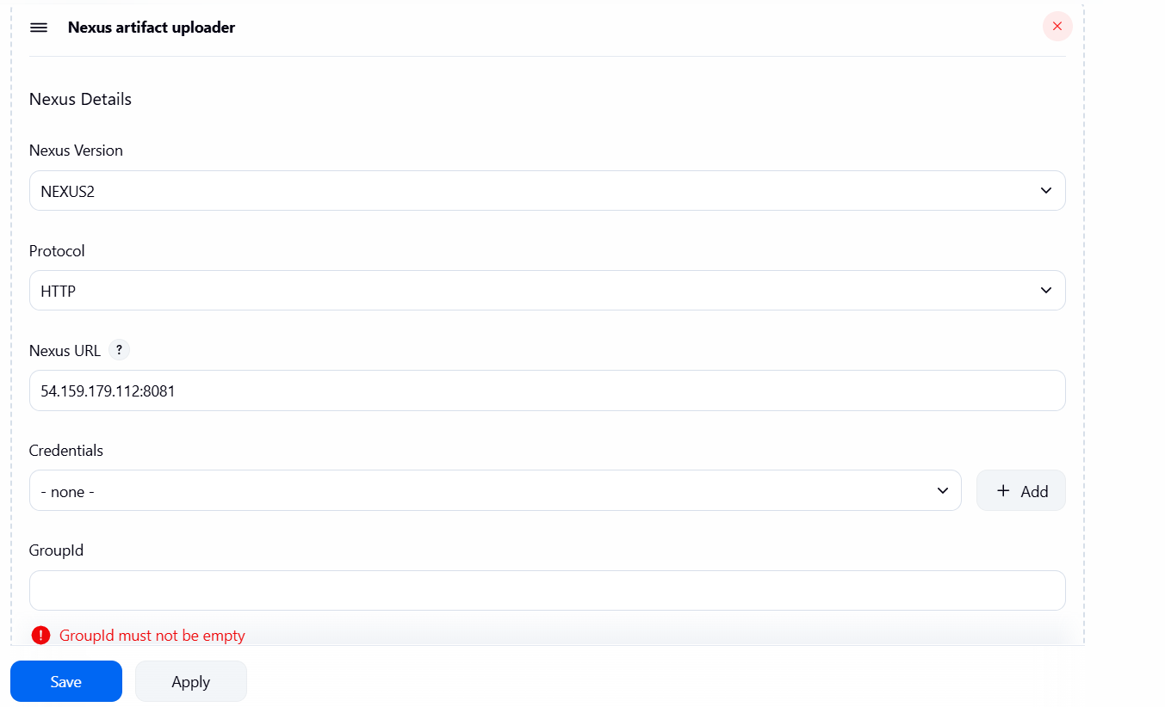
That’s now we need create creadentails
Now click on +add now click on jenkins
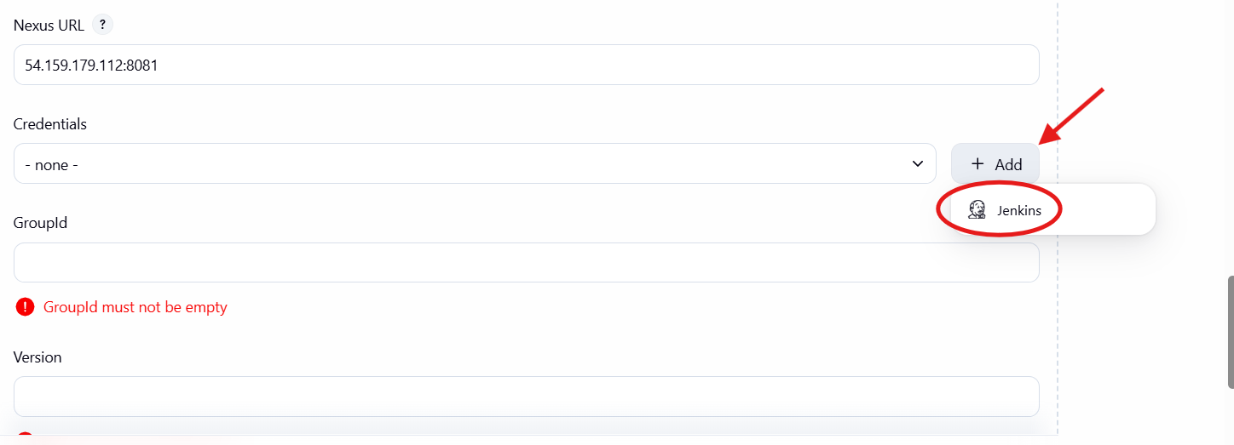
That’s it now create username as set on your nexus also make sure set password
Id nexus-user description nexus-user
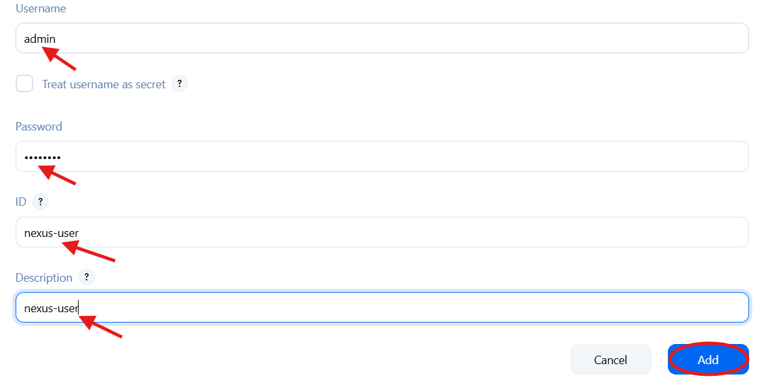
Now go to github
Open poem.xml
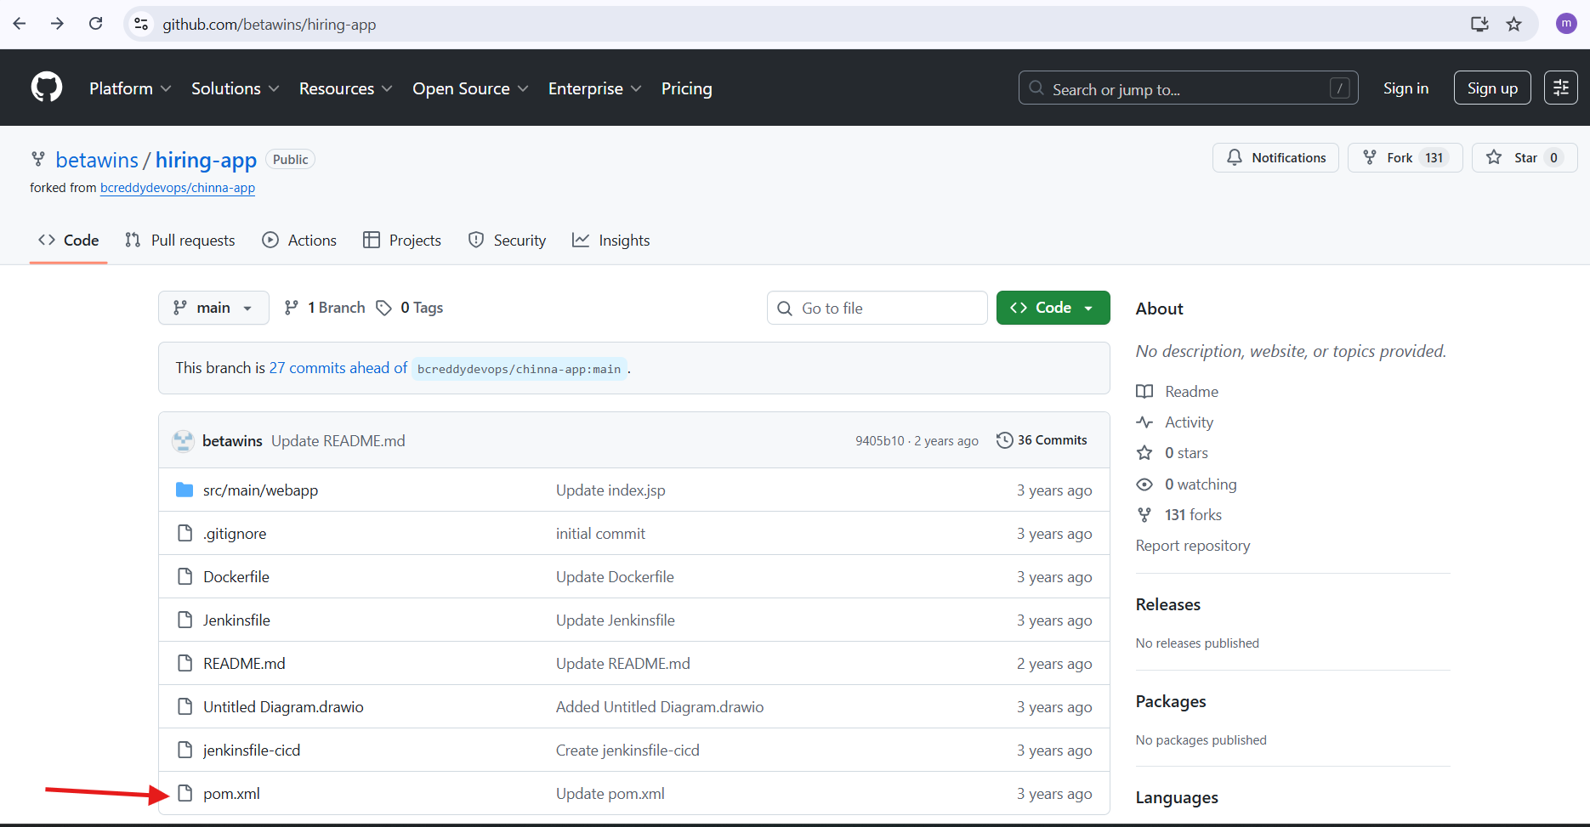
Now we code of it
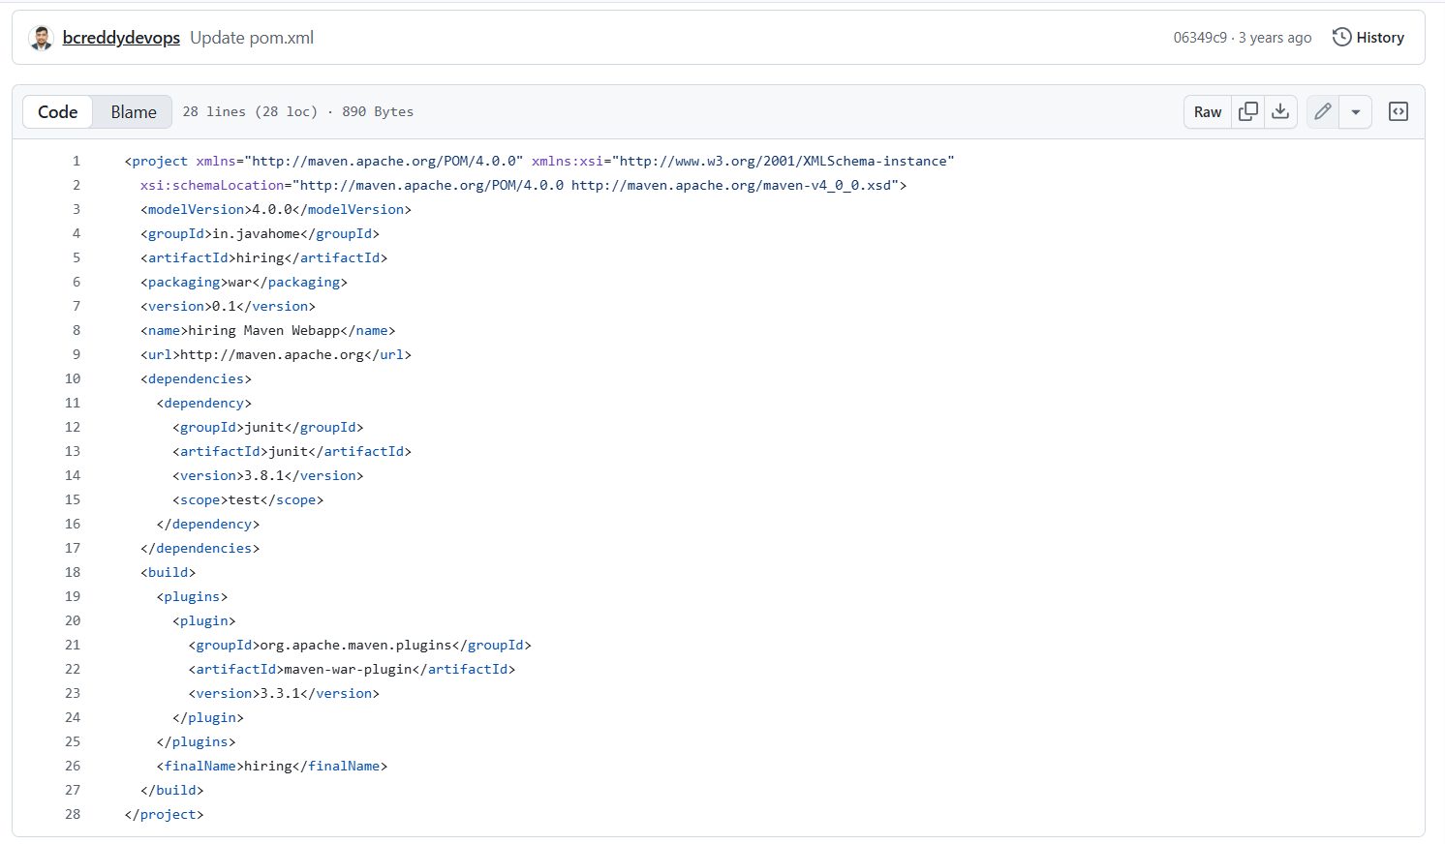
now go to your Job configuration and add above details. From repo
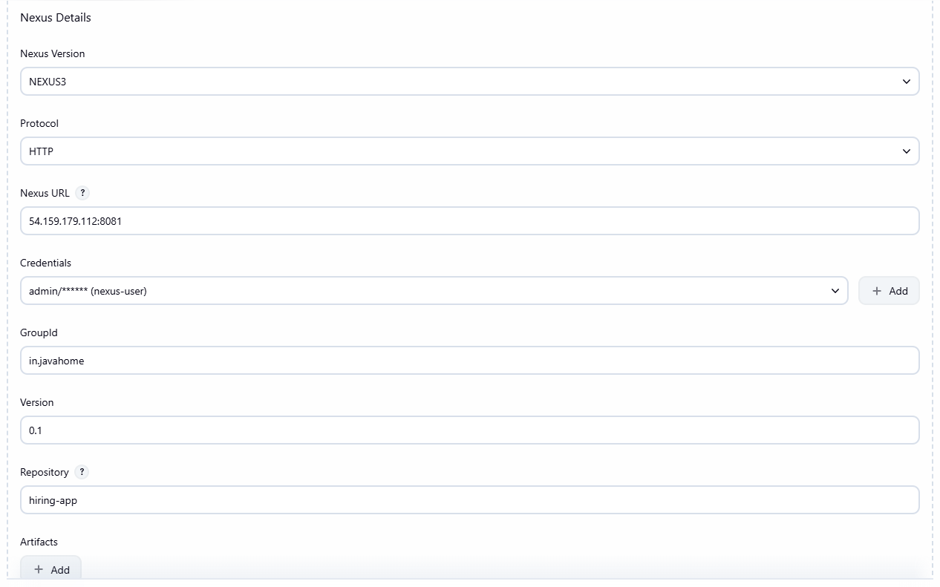
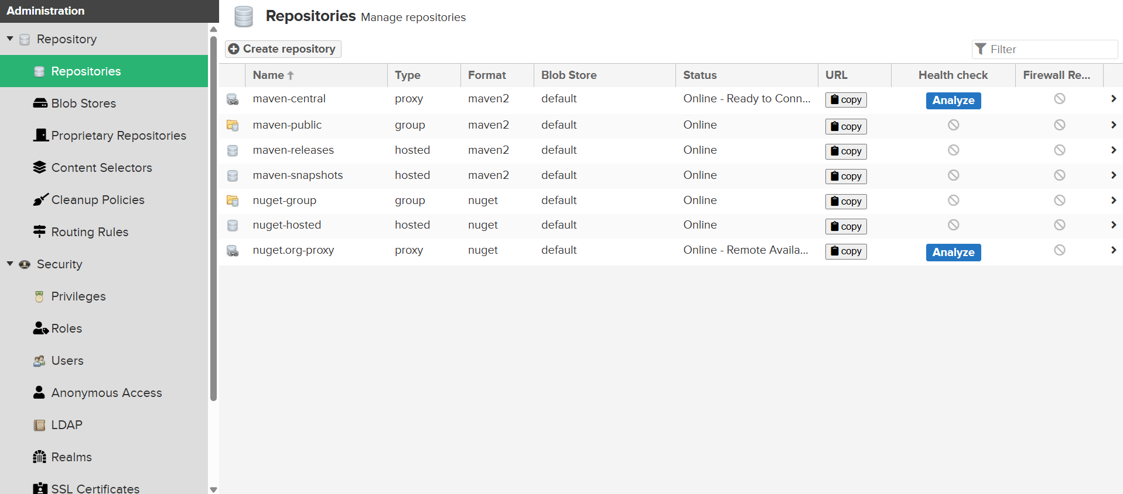
Now click on create repository

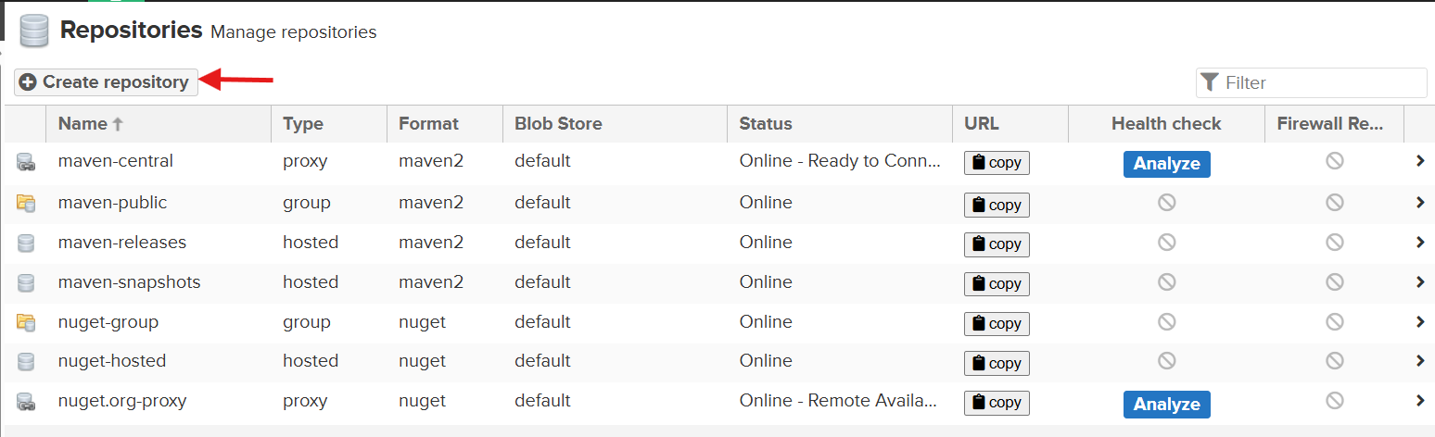
Now click on maven2 (hosted)
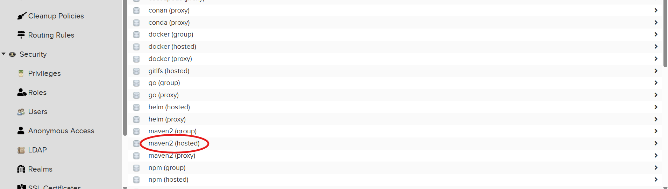
Now give your app name in our case we have
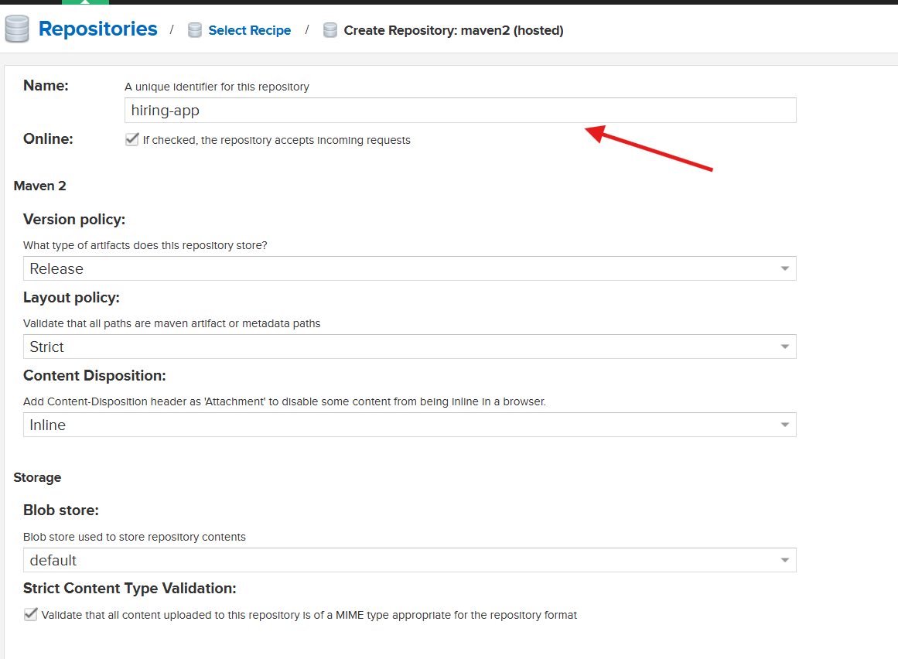
That’s it created hiring-app
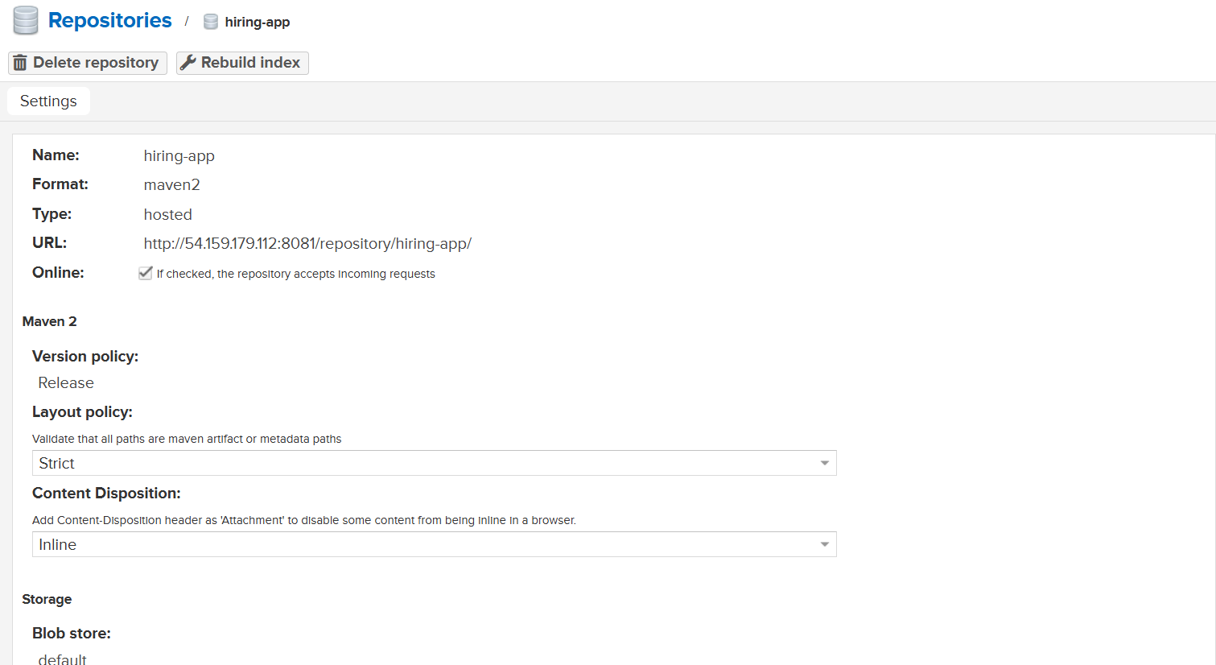
That’s it now save it
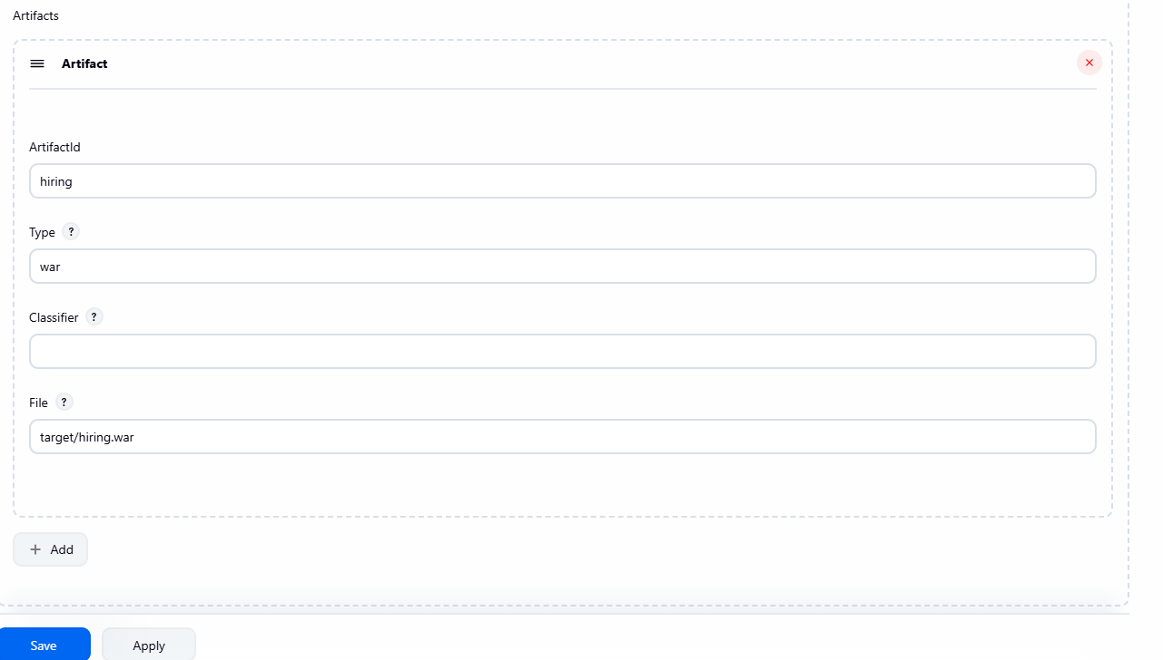
That’s it
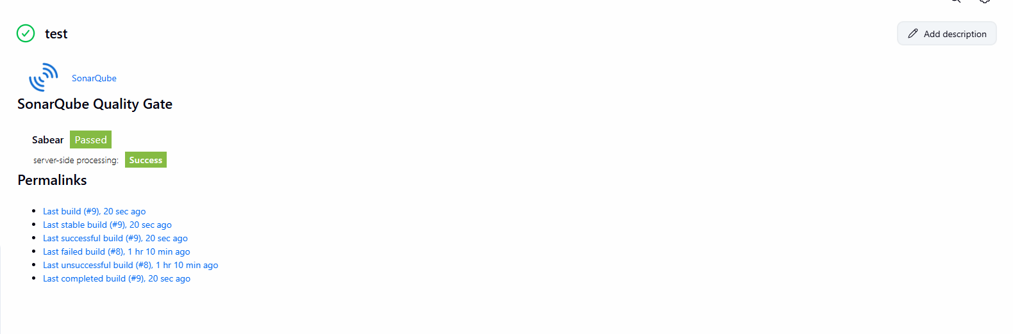
Console output
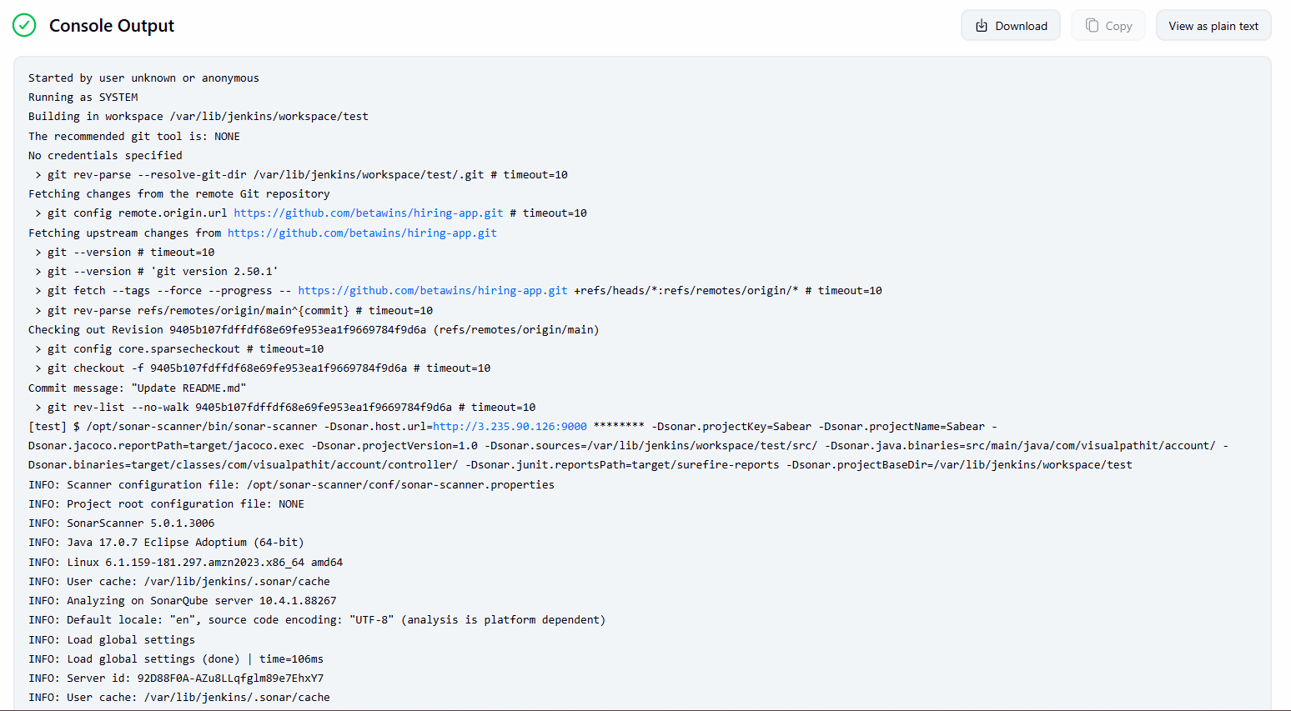
Check Nexus for war file
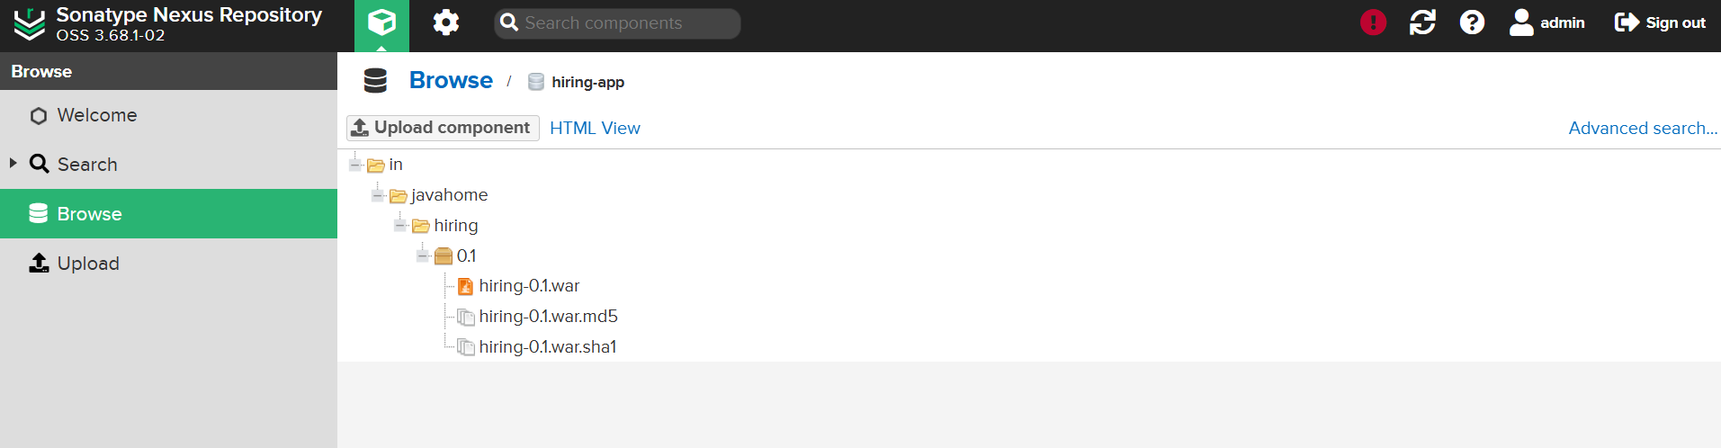
C slack notification
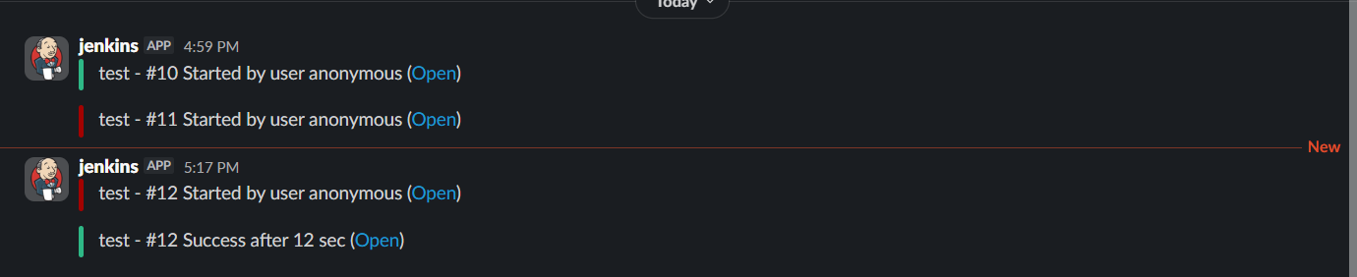
Deploy On tomcat
Now lunch new machine install java 17
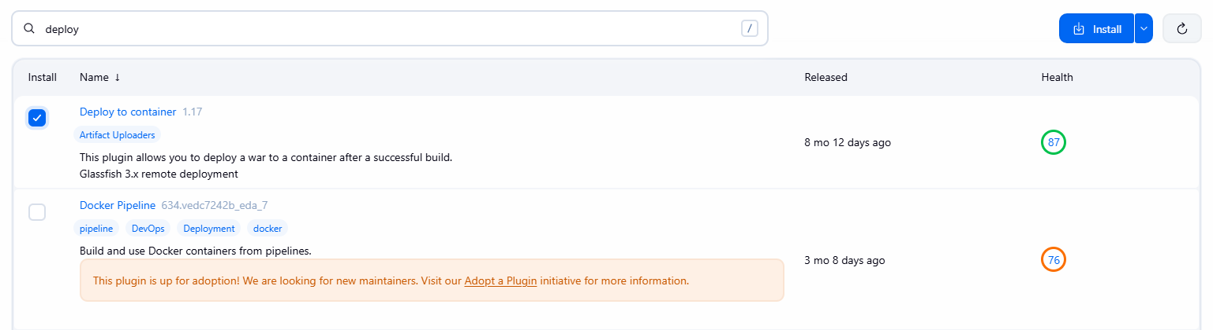
Install java on your new machine
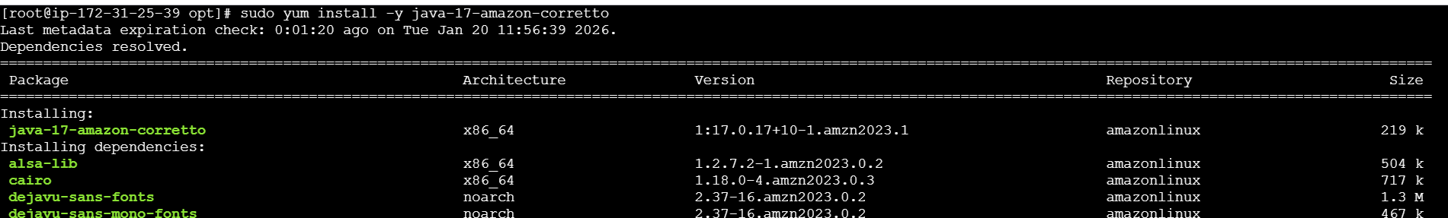
Now install tomcat on it
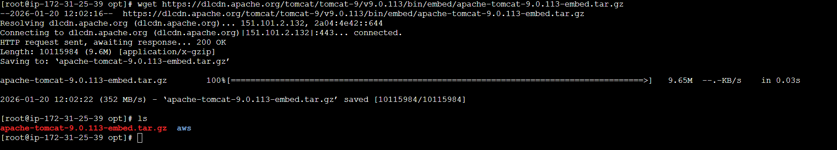
Now extract your apache-tomcat
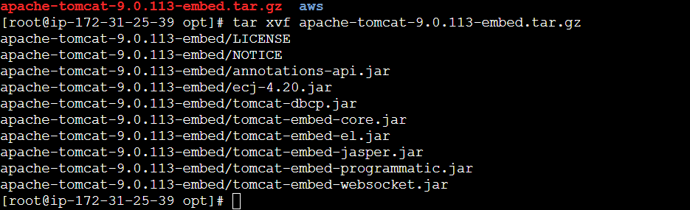
Now we have lunch our apache tomcat
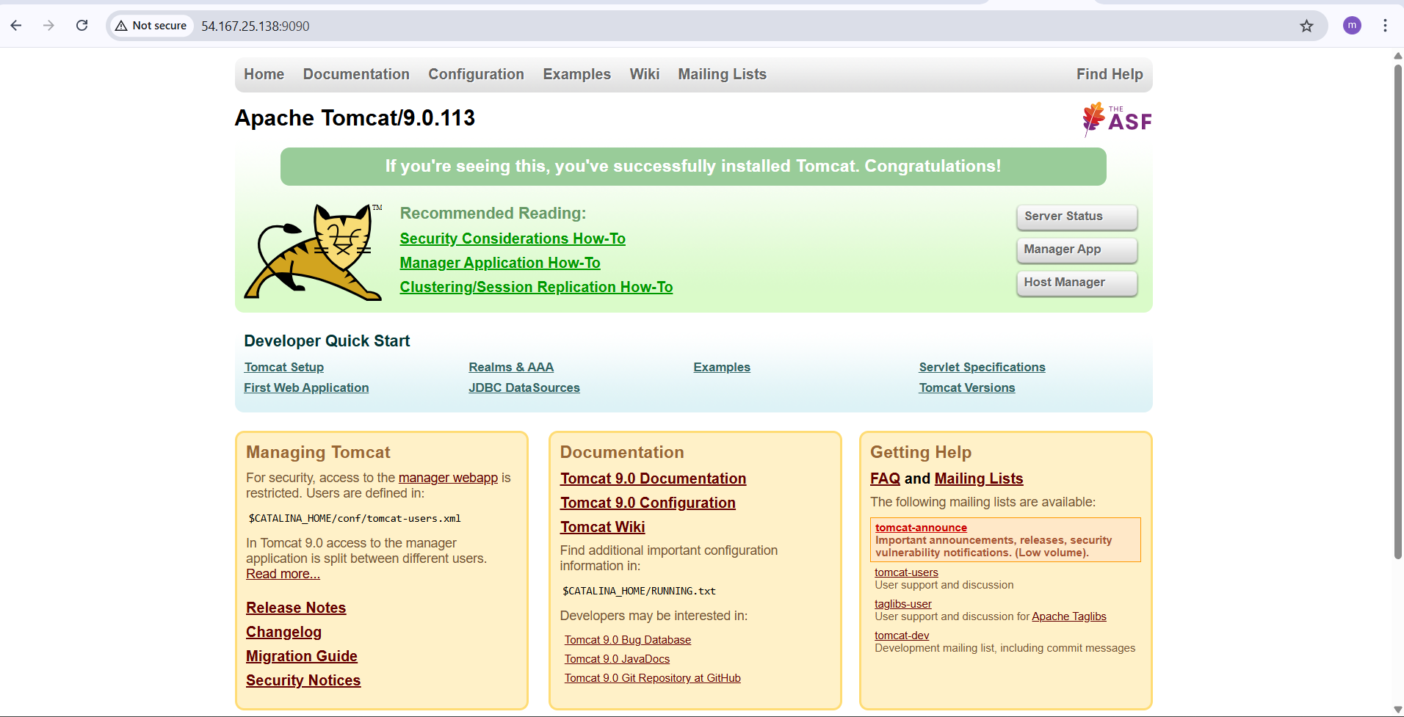
Now we create user in tomcat and take file webapps and edit for uncomment the four file
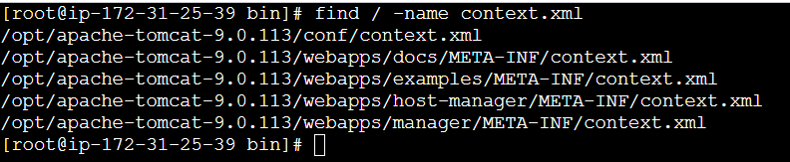
Change this
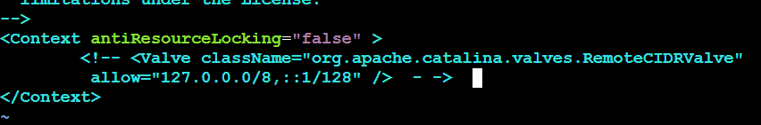
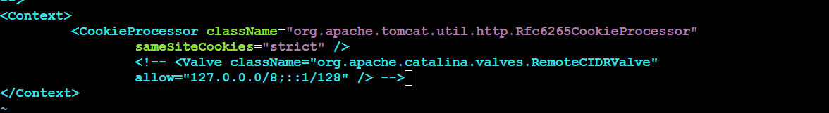
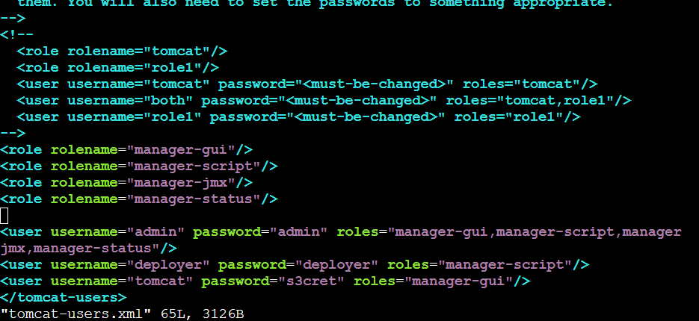
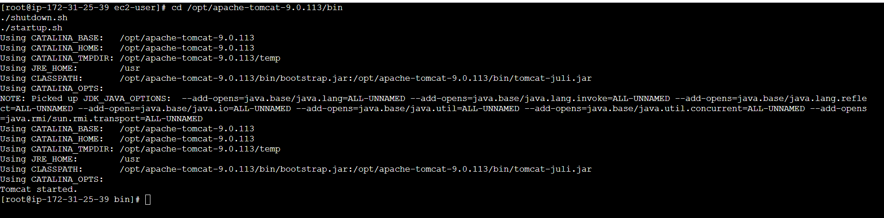
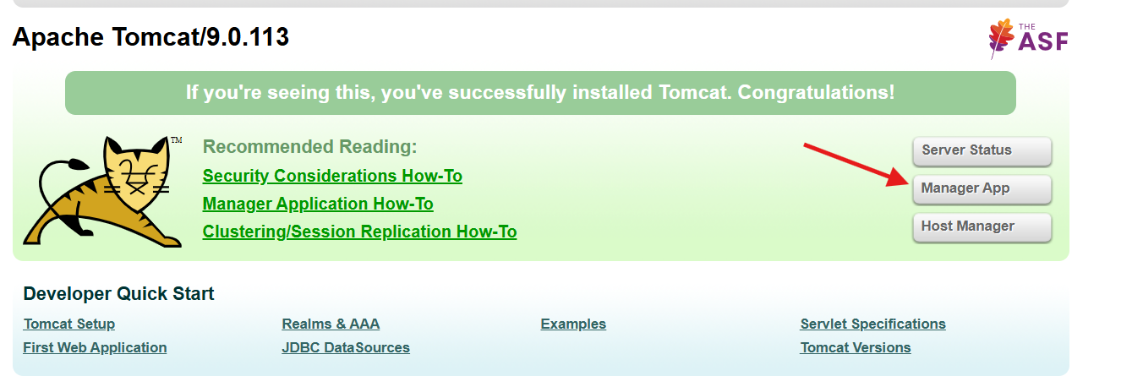
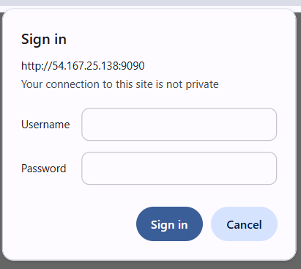
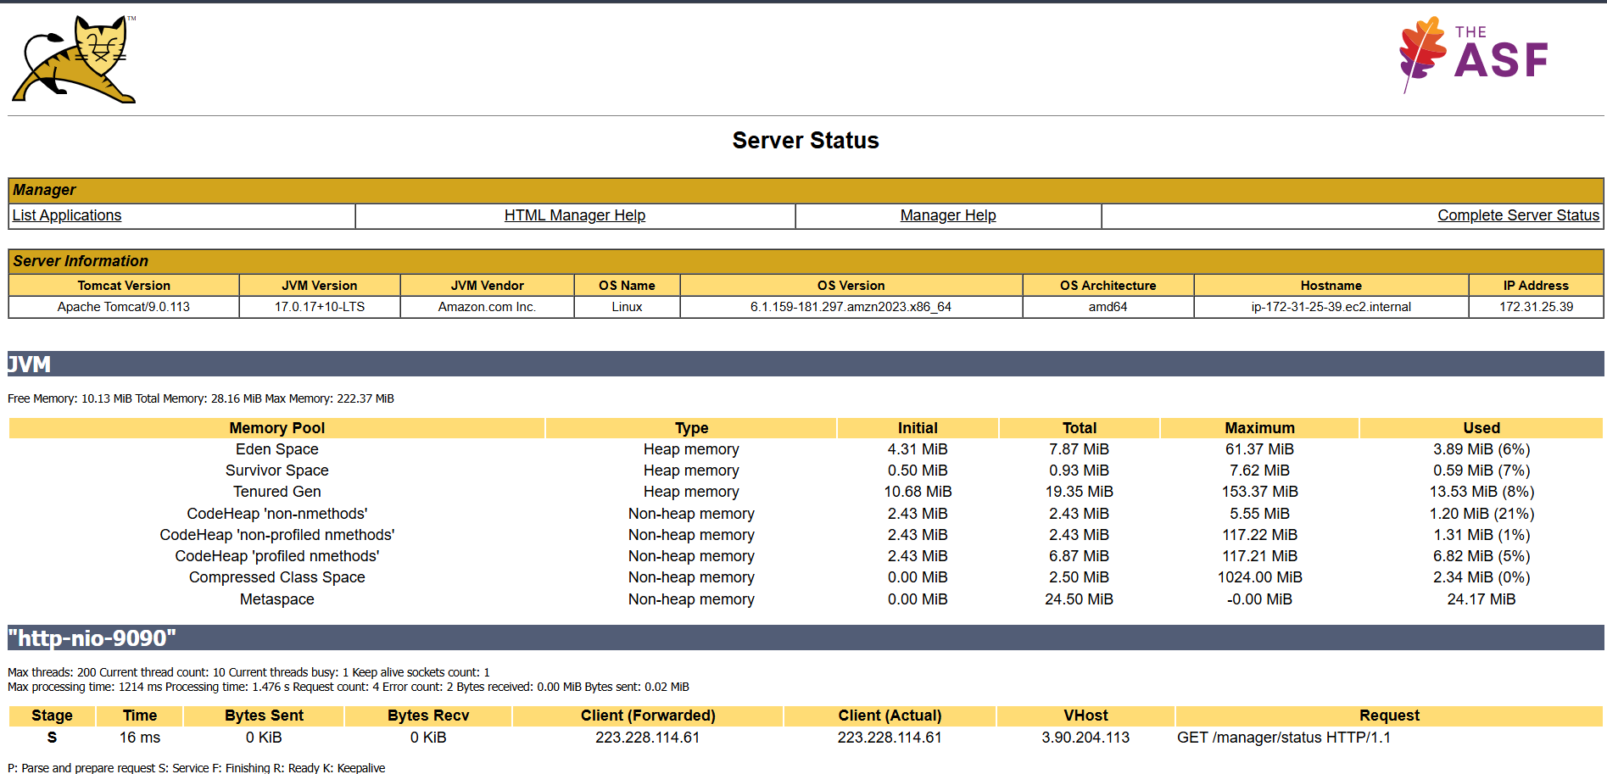

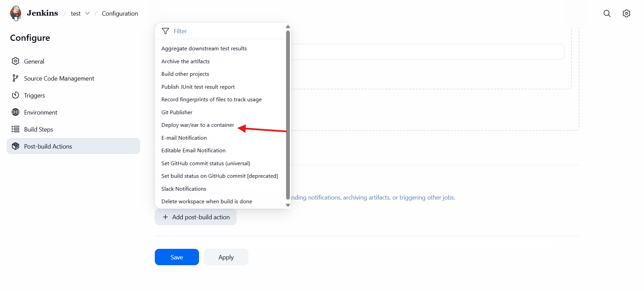
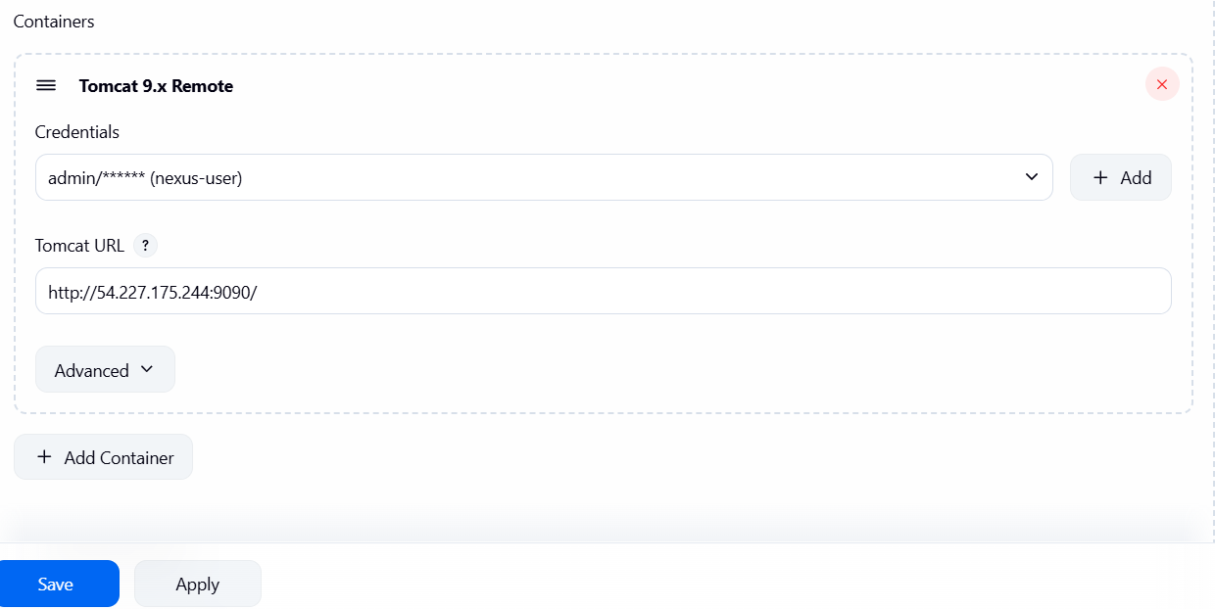
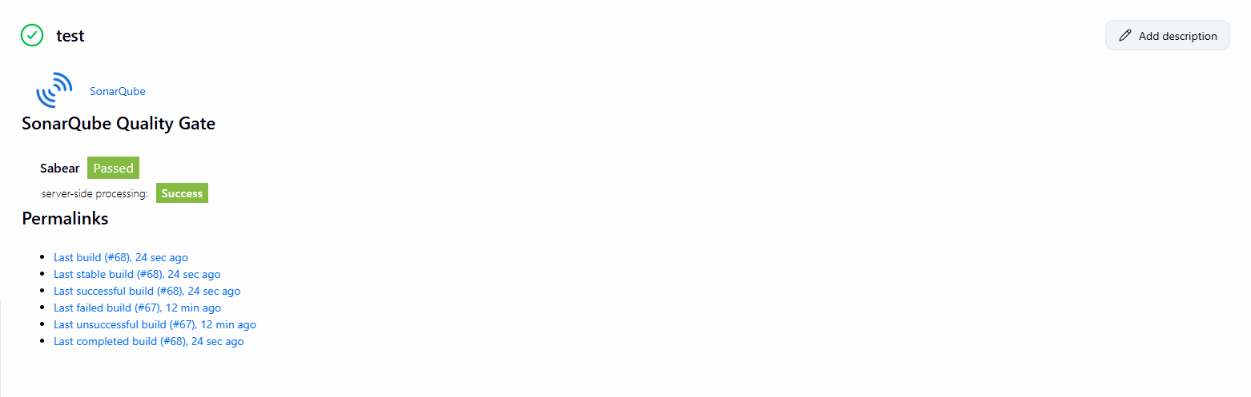
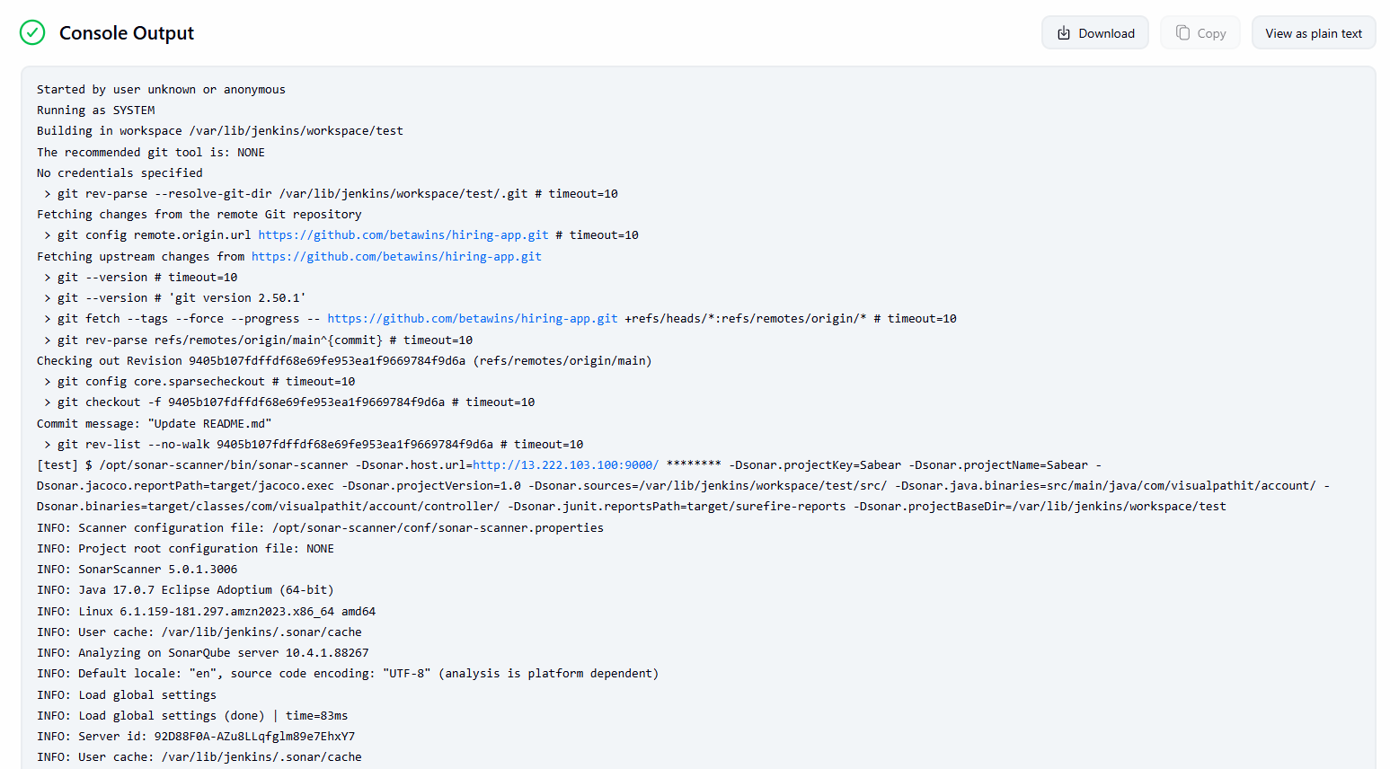
Now our deployment successfully done
