Task Title
Install and Secure Jenkins with Role-Based Access, Labels, and Job Configuration
Objective
Install Jenkins on an Ubuntu server, change the default port to 8081, secure the Jenkins server, create users with limited access, configure node labels, and create Jenkins jobs using both public and private GitHub repositories.
1. To install Jenkins first need on ec2 steup on you aws console then lunch it
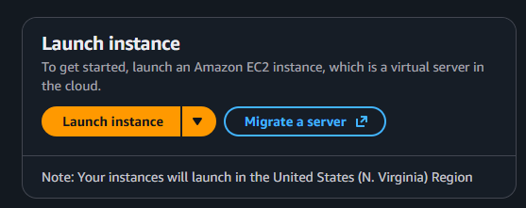
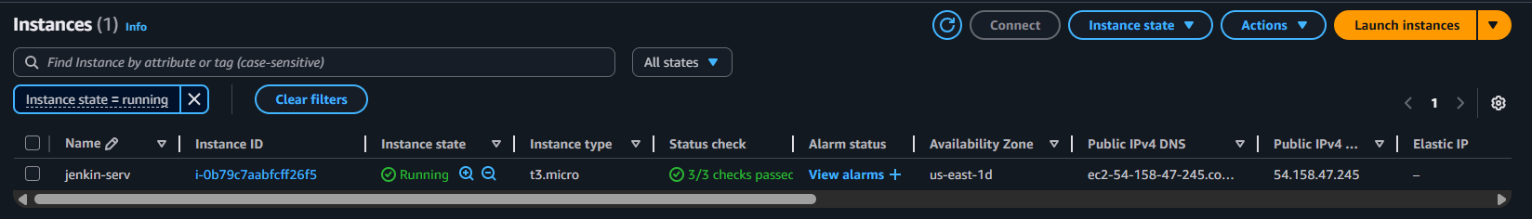
Now we successfully launch one instance then install on our machine java
Make sure your server up to date
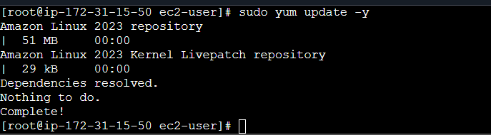
Now make sure you download java on your machine
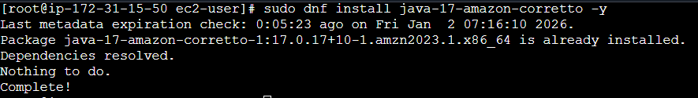
Now we install jenkins
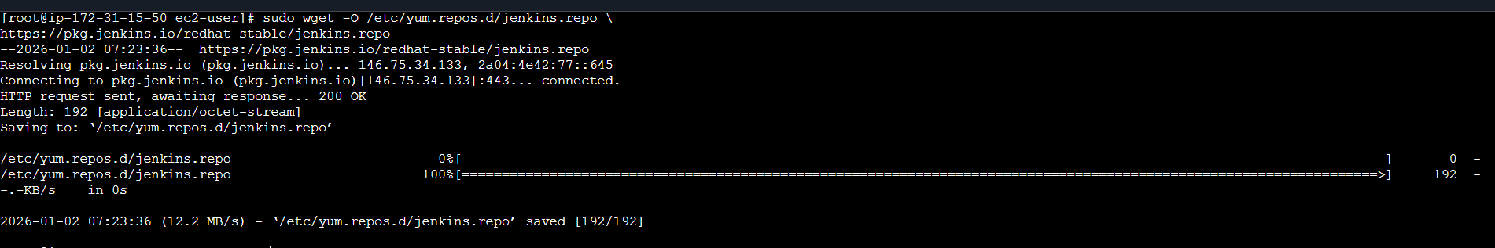
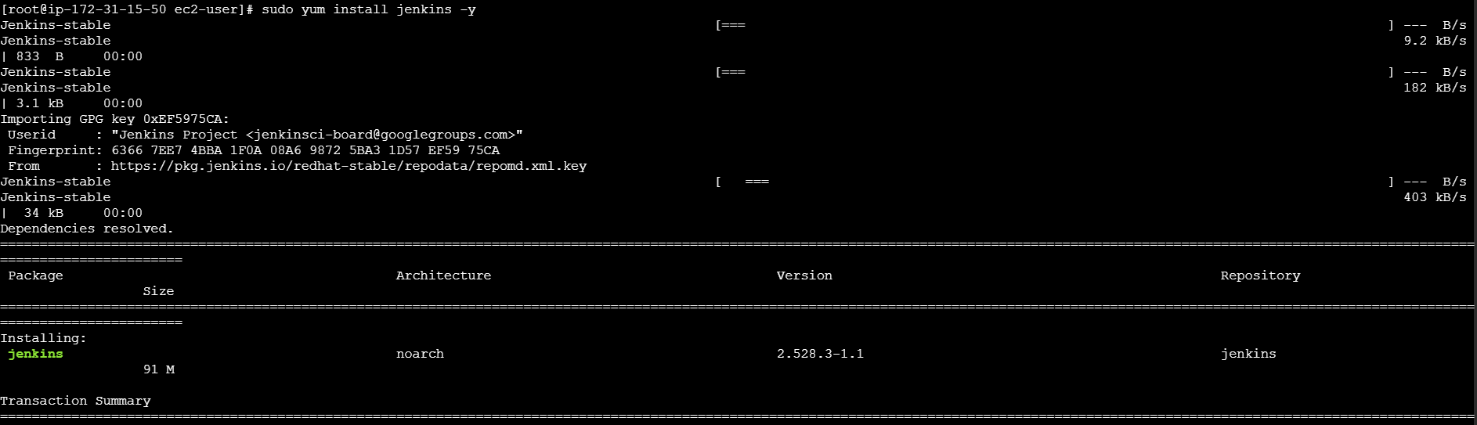
Now we have successfully install Jenkins on it you see it active message on it
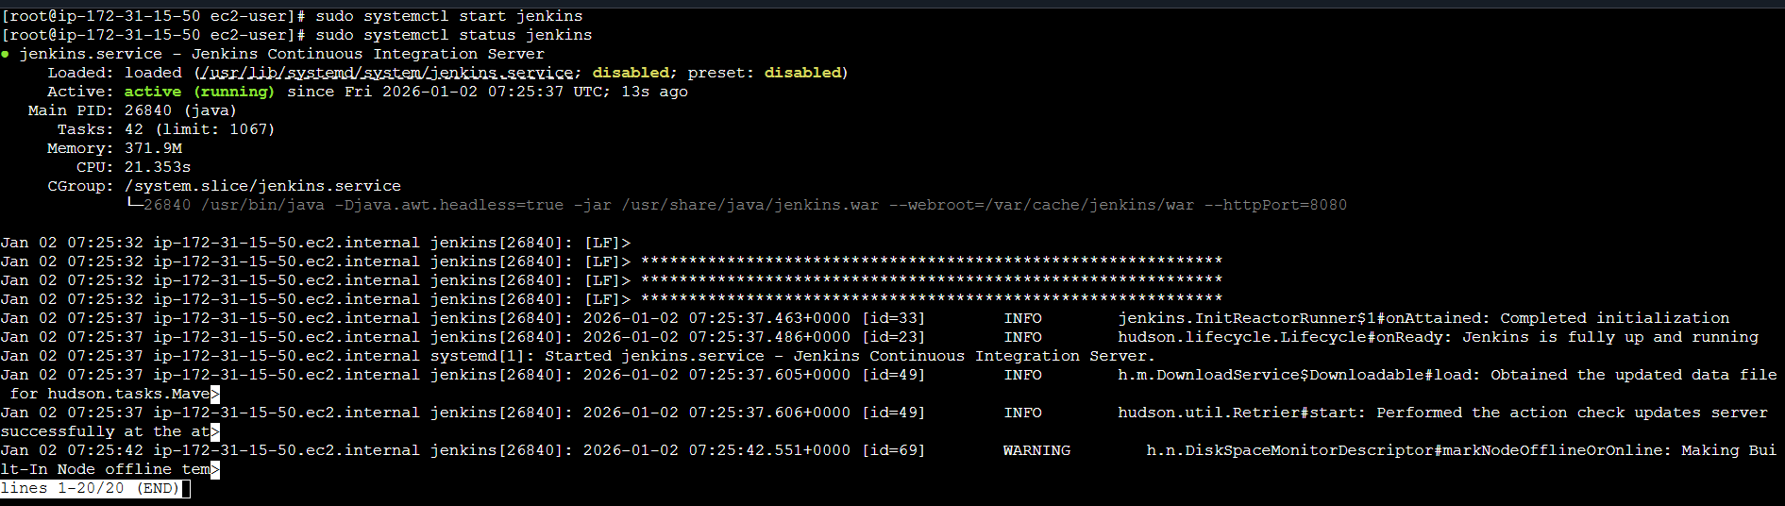
Now our Jenkins is working on 8080 port we need change its port 8081
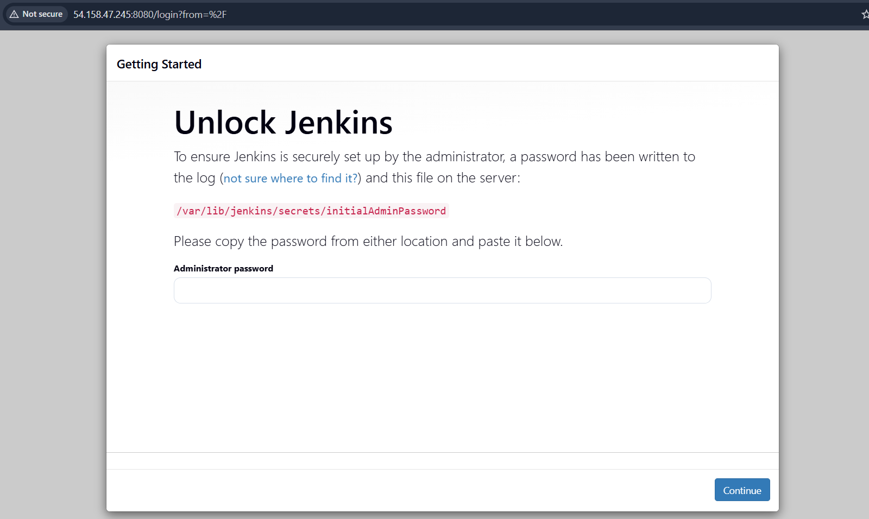
to change ports first go this path just type sudo nano /etc/sysconfig/Jenkins press enter
Now we
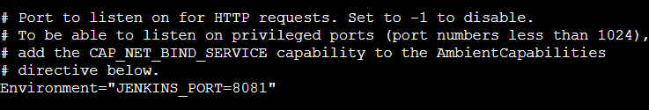
Now we have successfully changes it port make sure configure security group in inbund rules
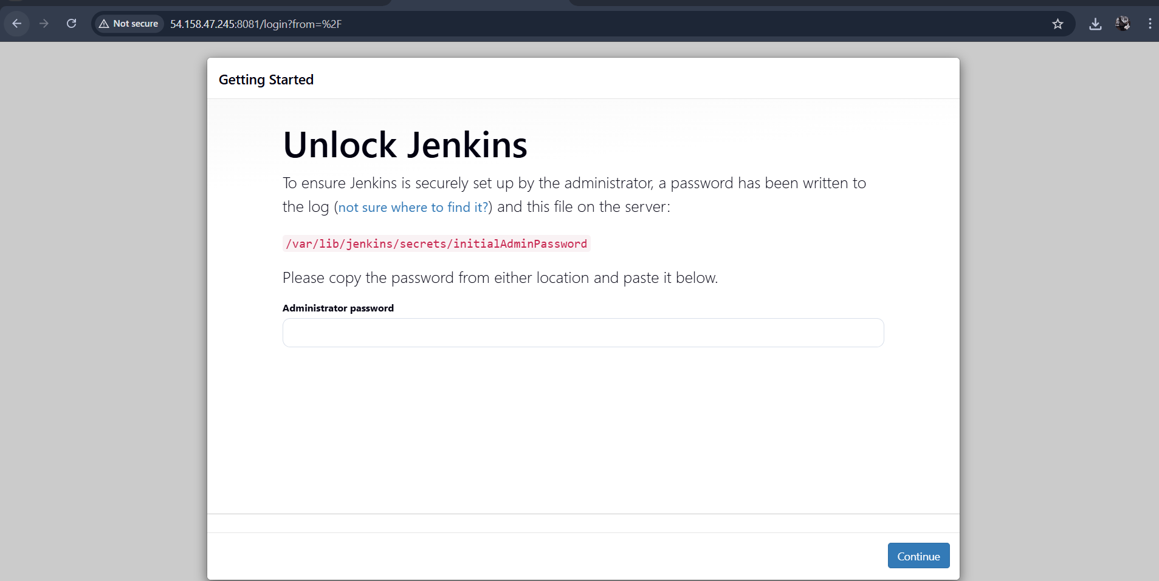

Now go that path /var/lib/Jenkins/secrets….
Type on your machine Cat path and its show you password your jenkin now copy it and paste on admininstor password
Select installation plugins after install all plusgines wait some times
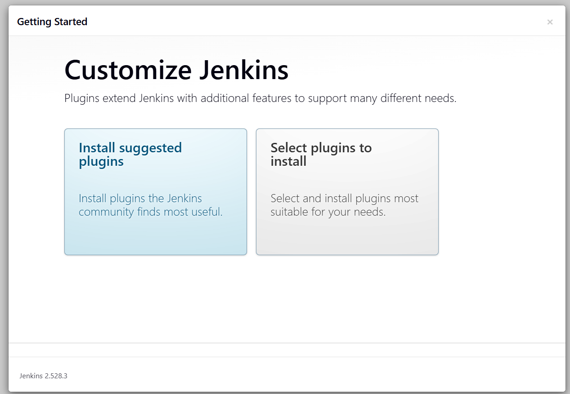
Now we need create user
Write user name :
Password :
Confirm password again ( make sure remember ur password)
Email address
Then click on save and continue
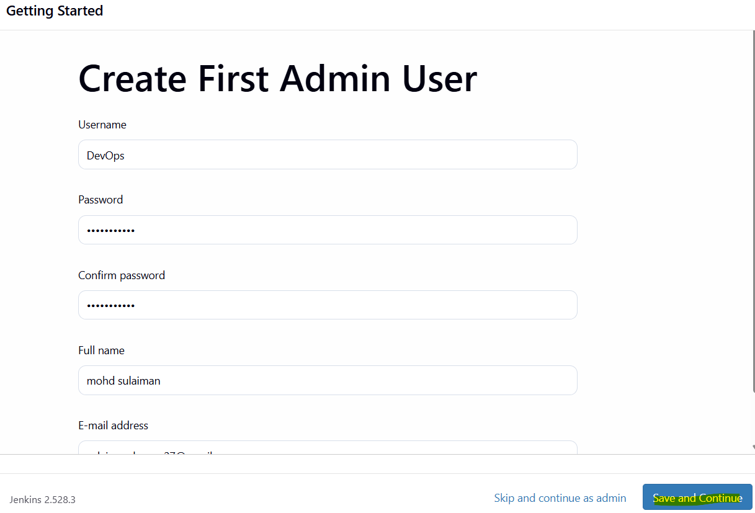
Now we login in to our Jenkins its our dash board
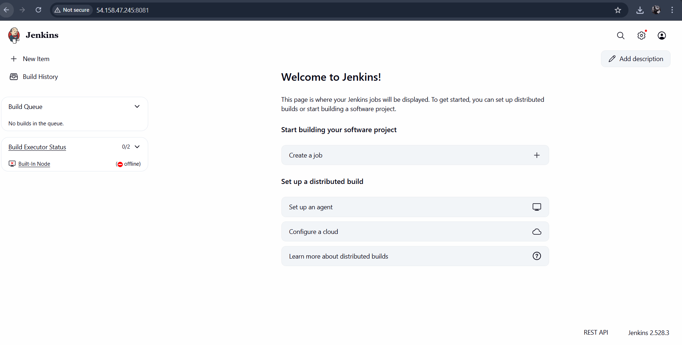

And now password file to delete
Evidence: successfully created the user and deleted the password file and tried to check with old password getting failed
Now we successfully secure our jenkins
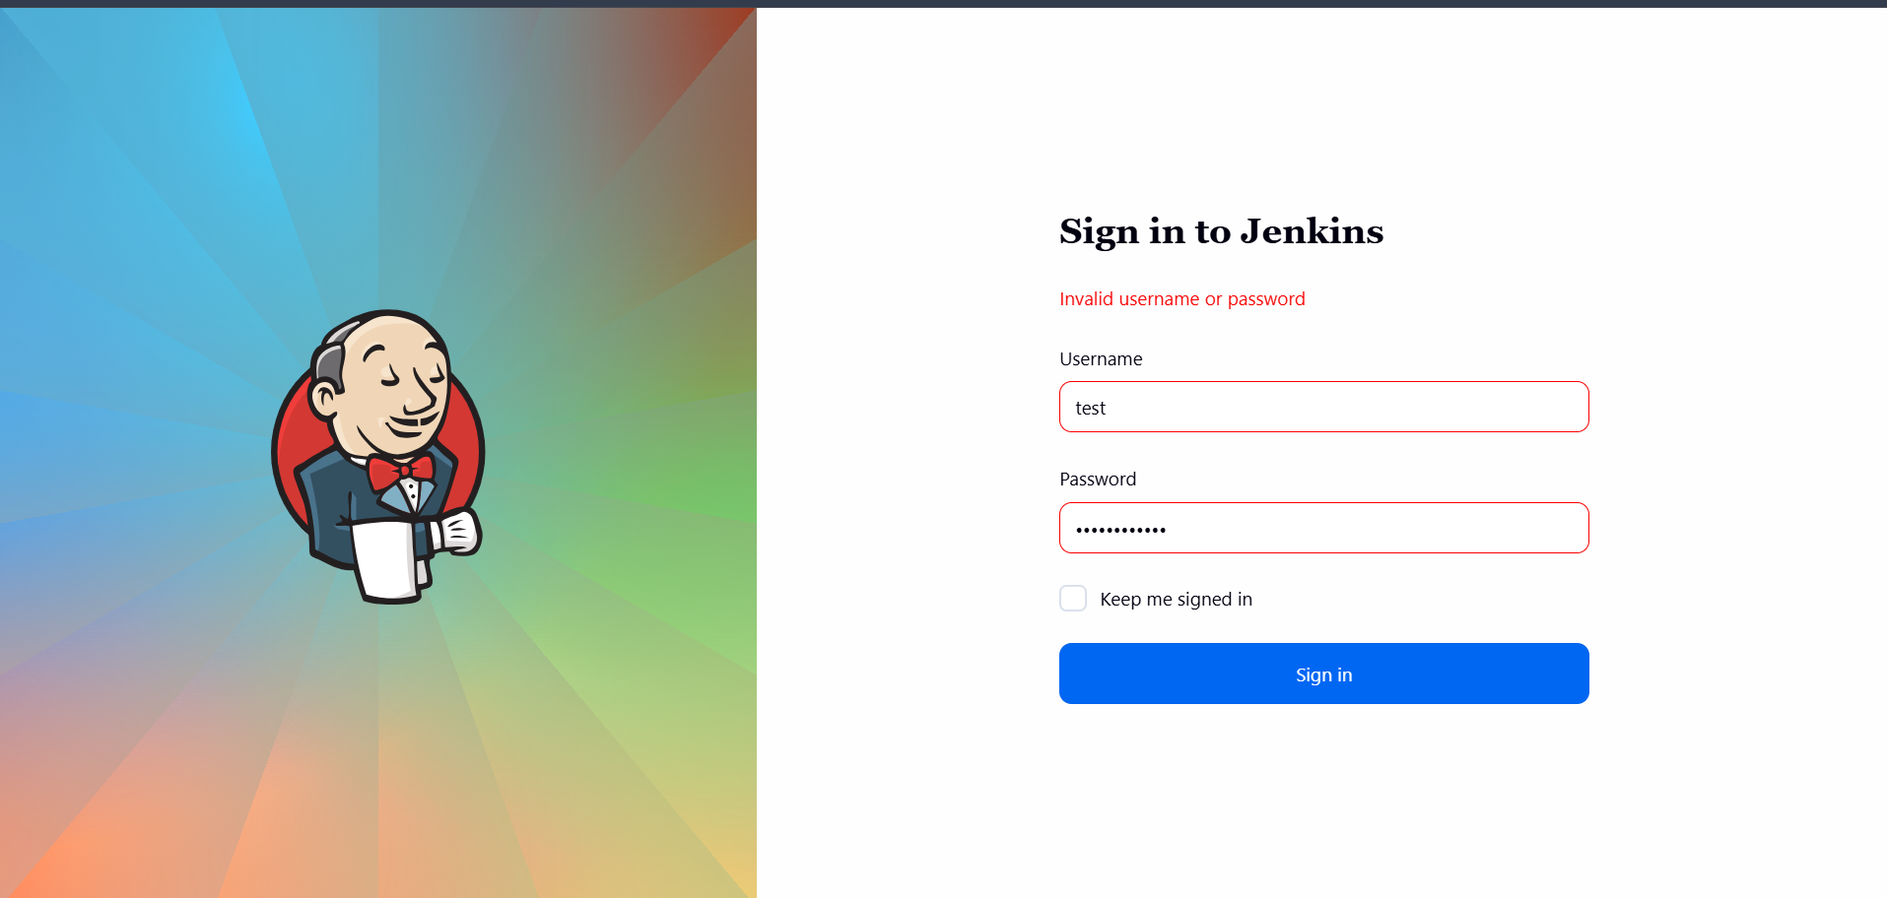

3 Create users called DevOps, Testing in Jenkins with Limited access.
Ans: objectives: adding a new user with limited access

Prerequisites:
Ec2 instance
Git bash
Jenkins

Go settings on top right
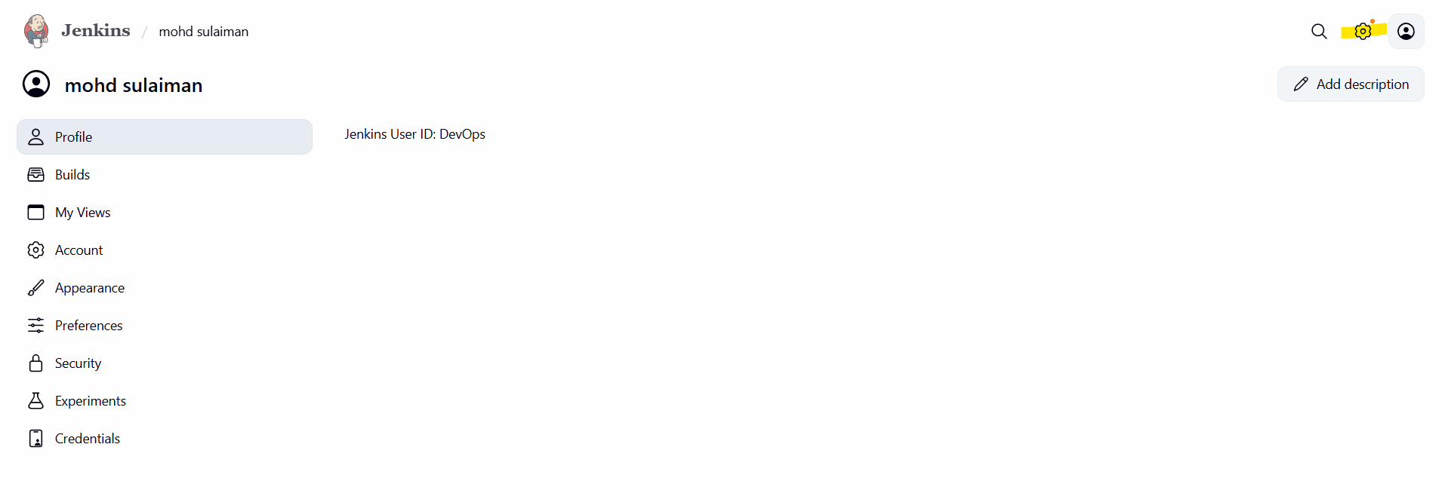
Then you will find security section on security section click on security click on it
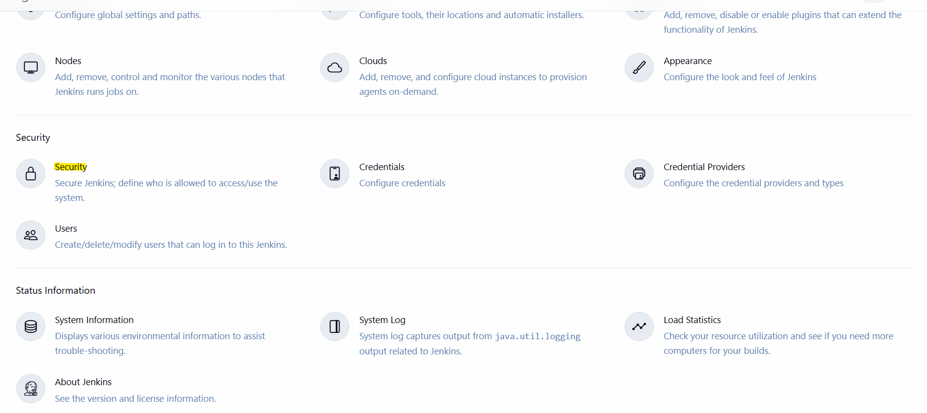
Then click on create user 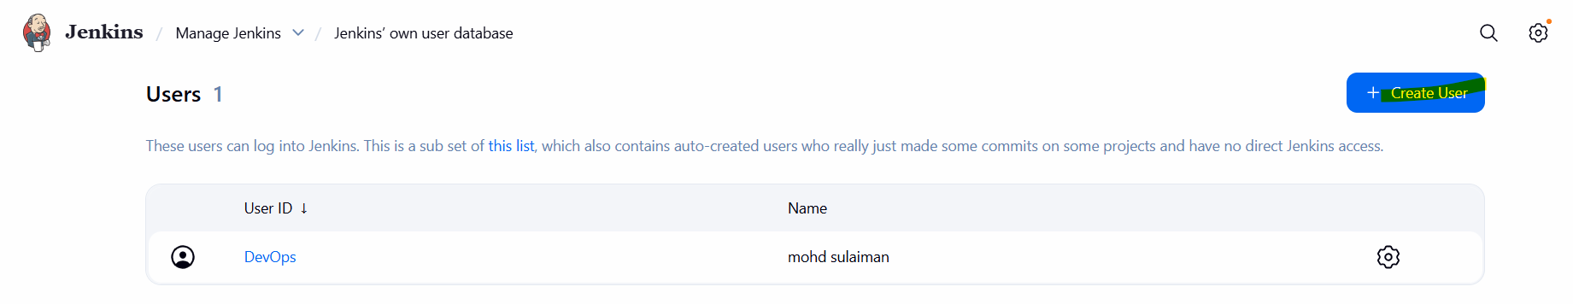
Now we successfully added our newuser
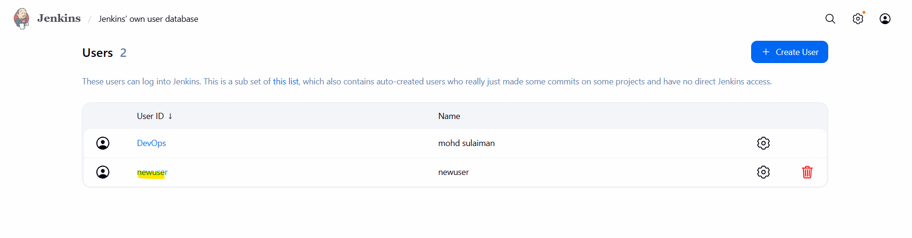
Now you need go settings click on security and you find option called authorization click on set matrix-based security
Now give permission to the user in my case I have given him only one permission which only read permission tick on it then click on add user

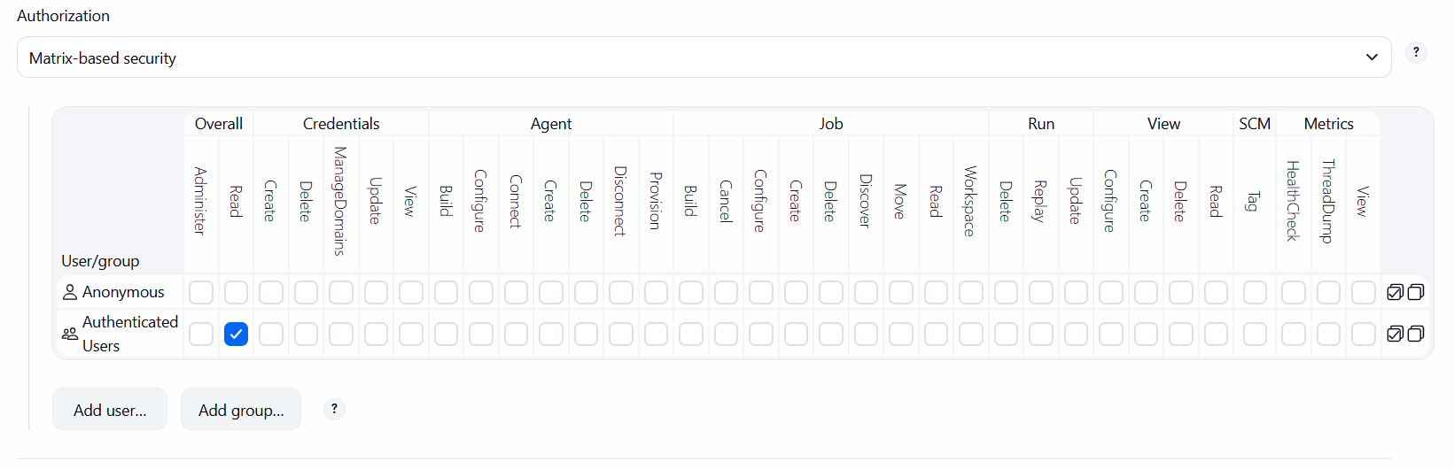
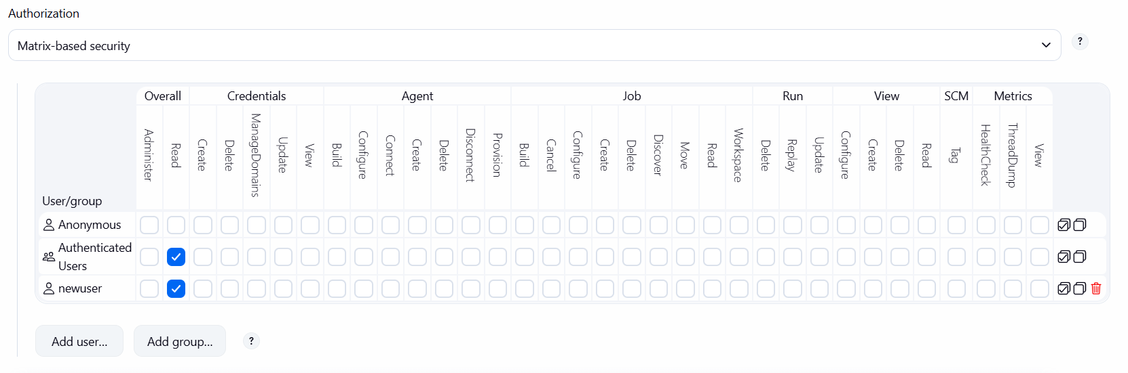
successfully given the limited access to devops user
4 Configure labels and restrict the jobs to execute based on label only.
Objectives: configuring labels and adding a plugin to restrict the jobs

Prerequisites:
Ec2 instance
Git bash
Jenkins

Under the Jenkins need to install the plugins you see we lots on plugins
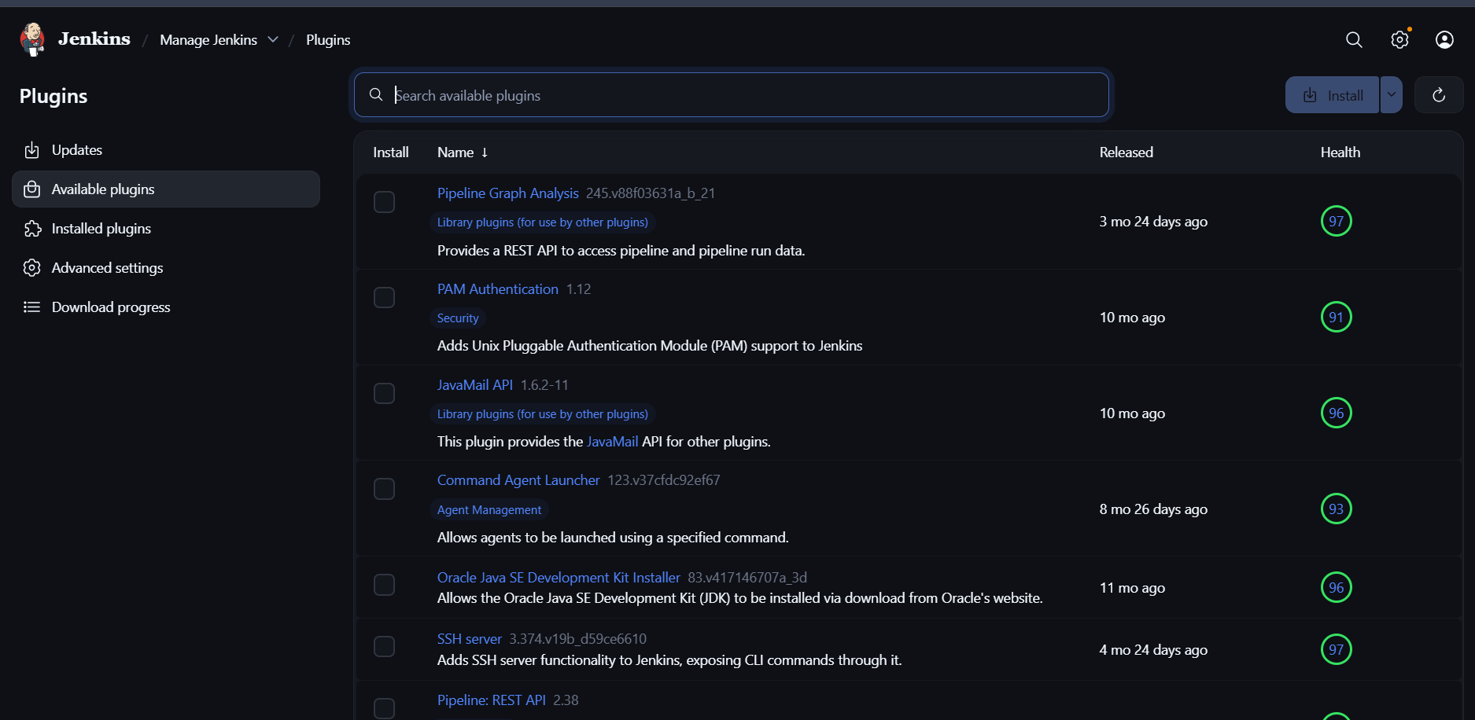
Under this we need install one plugin it
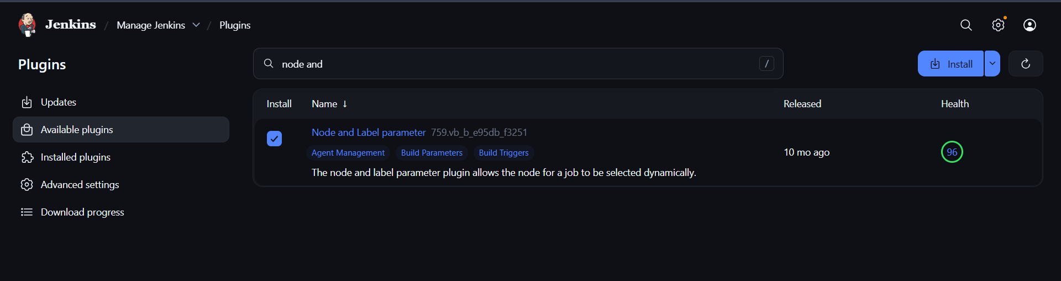
Now our plug in install successfully
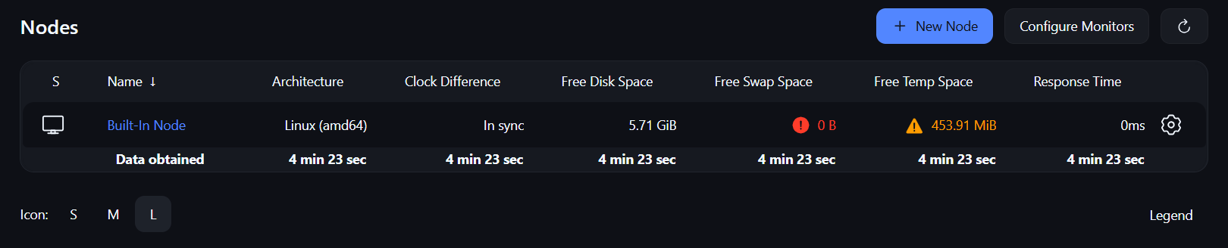
Once it get configure need to go to create first job
Click on create a job
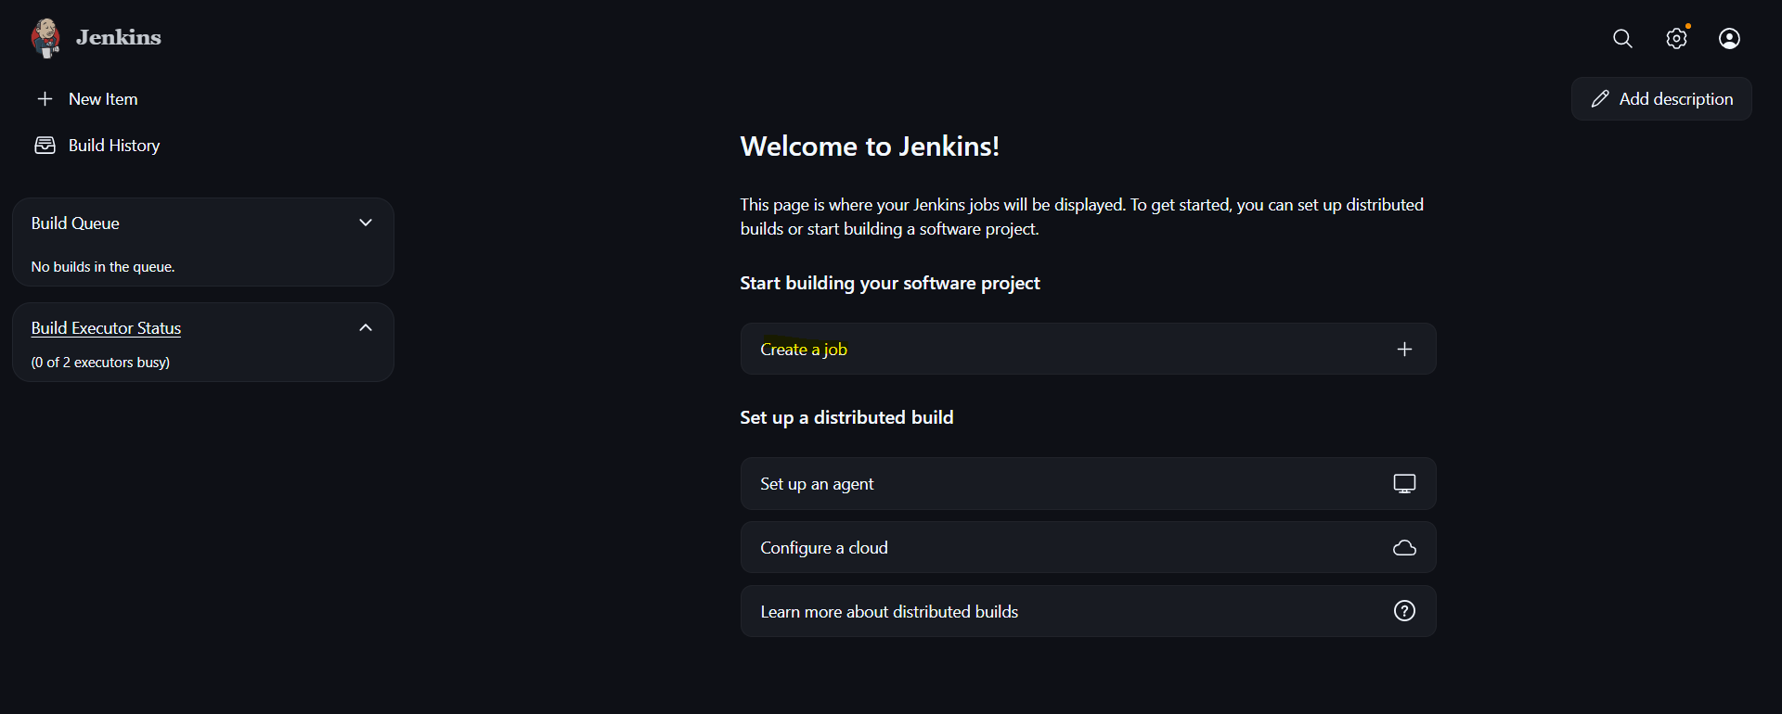
After clicking on create job now we need give name to iteam also select an intem type for now we using testing as a name and select an item type free style project
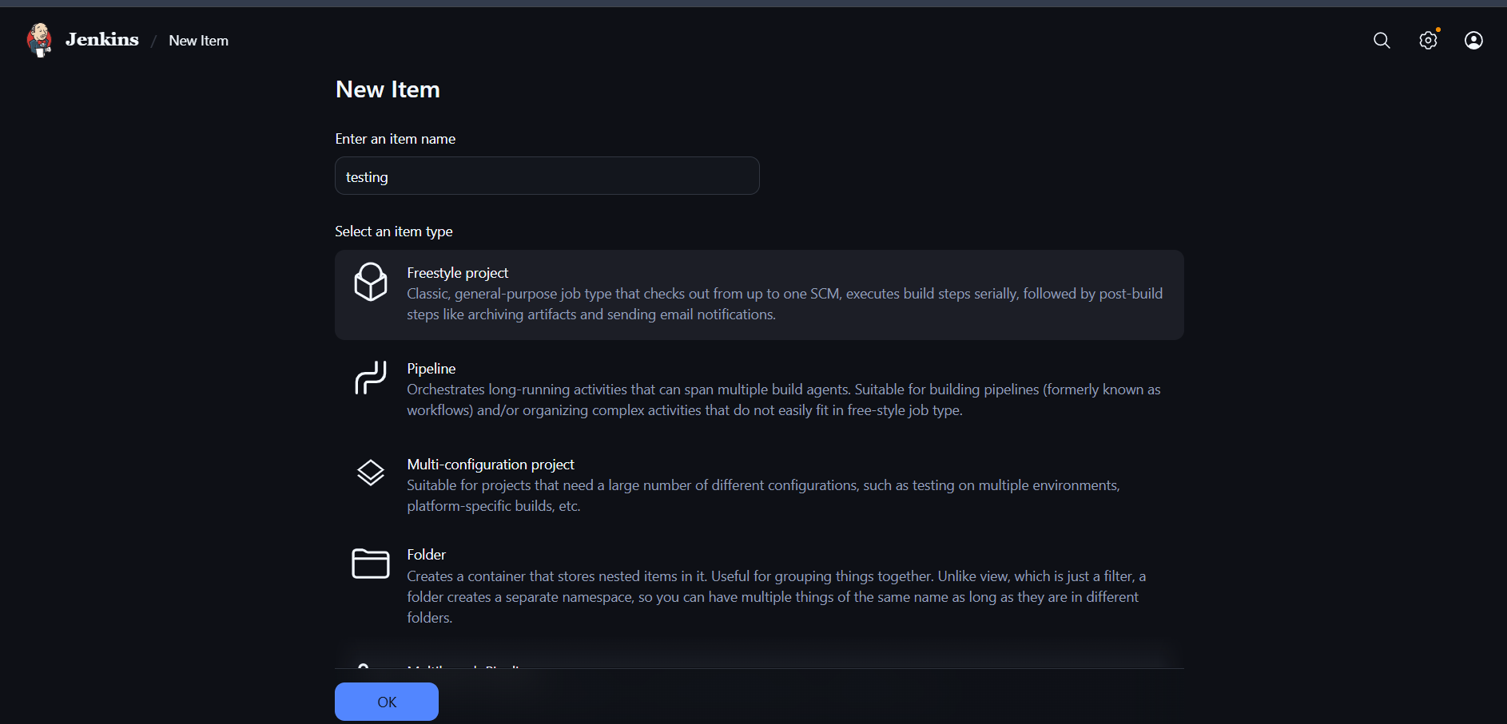
That’s now save it
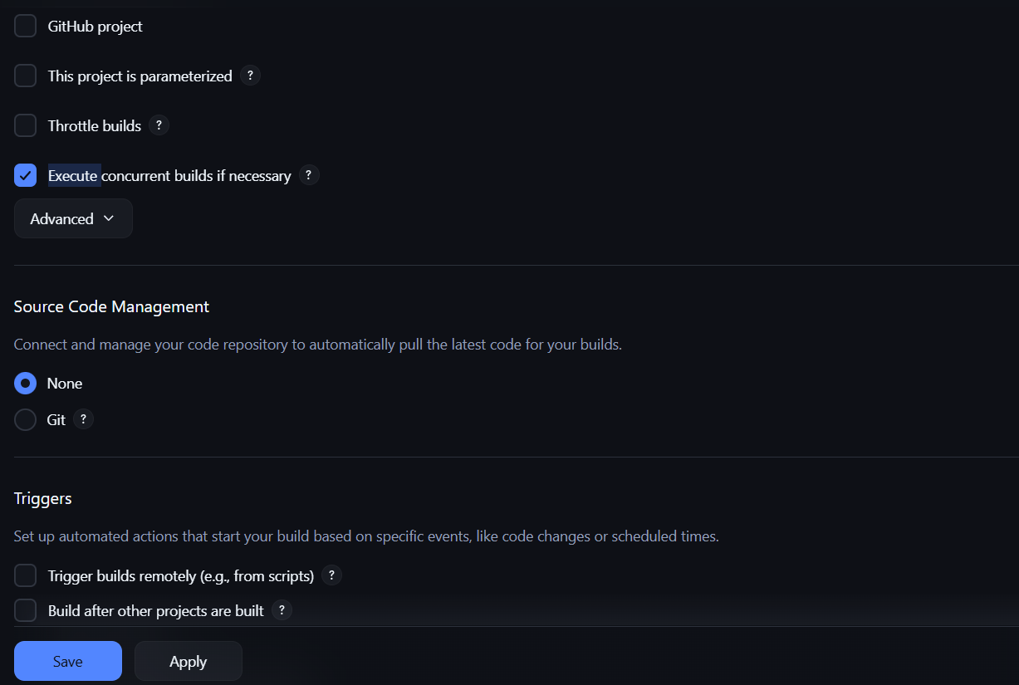
Make sure you install git on your machine
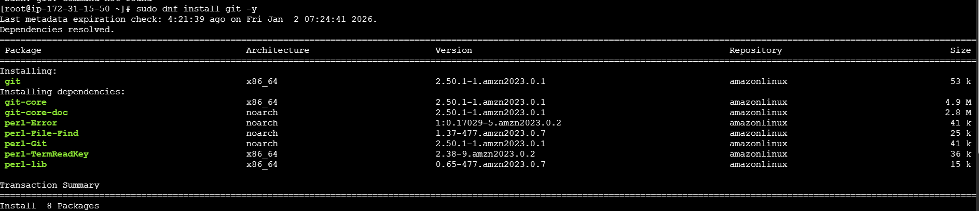
Now we can give repo url easily and now can save it
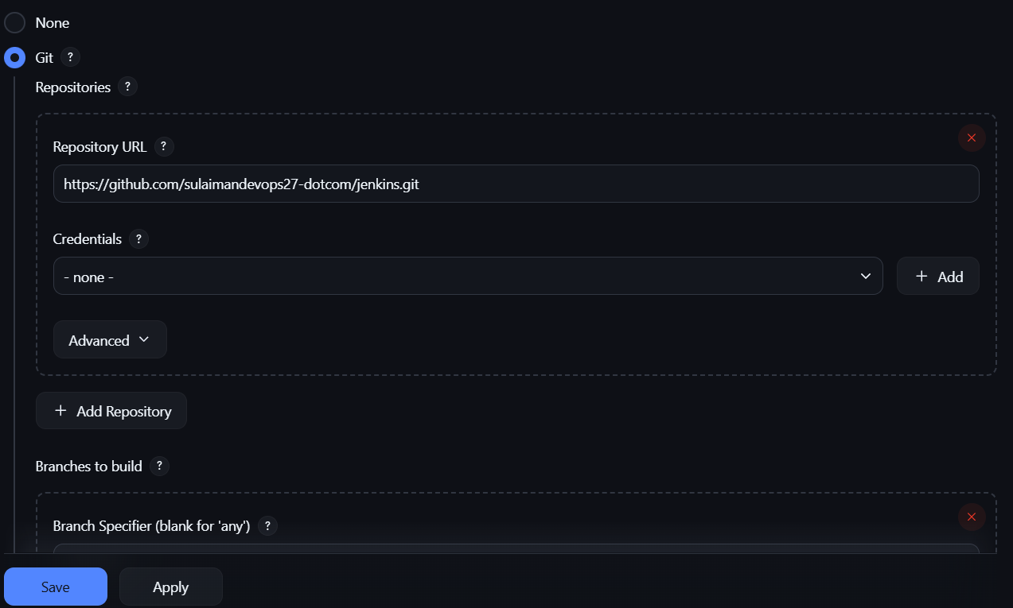
Now we configurate it
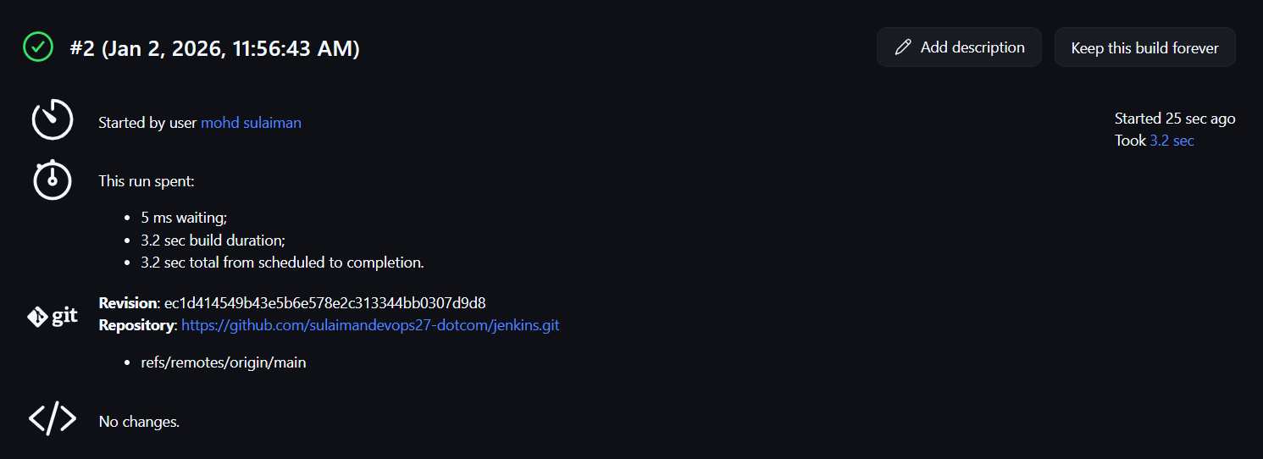
Now its Added the label it was working 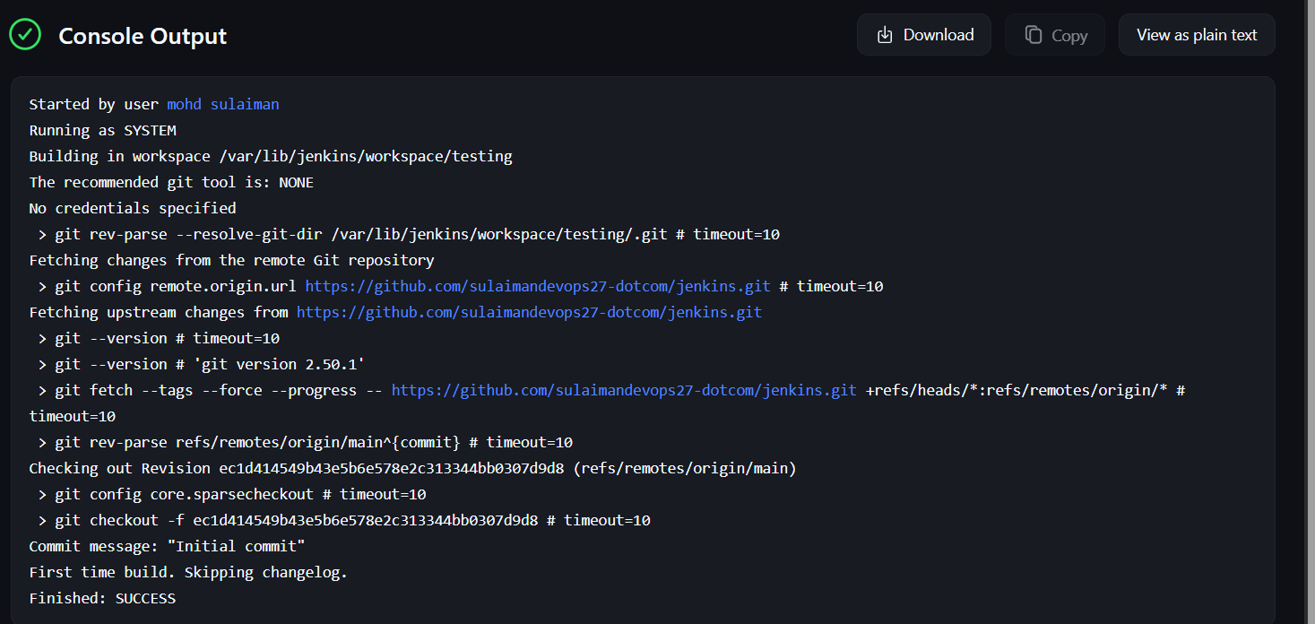
5. Create Three sample jobs using the below URL.
Ans: Objectives: creating three sample jobs using same url

Prerequisites:
Ec2 instance
Git bash
Jenkins
Need to click on create sample job and entre the name and select free style and need to select the nodes and entre the git url
Now go to your jenkin click create new item and then give any name select freestyle pr
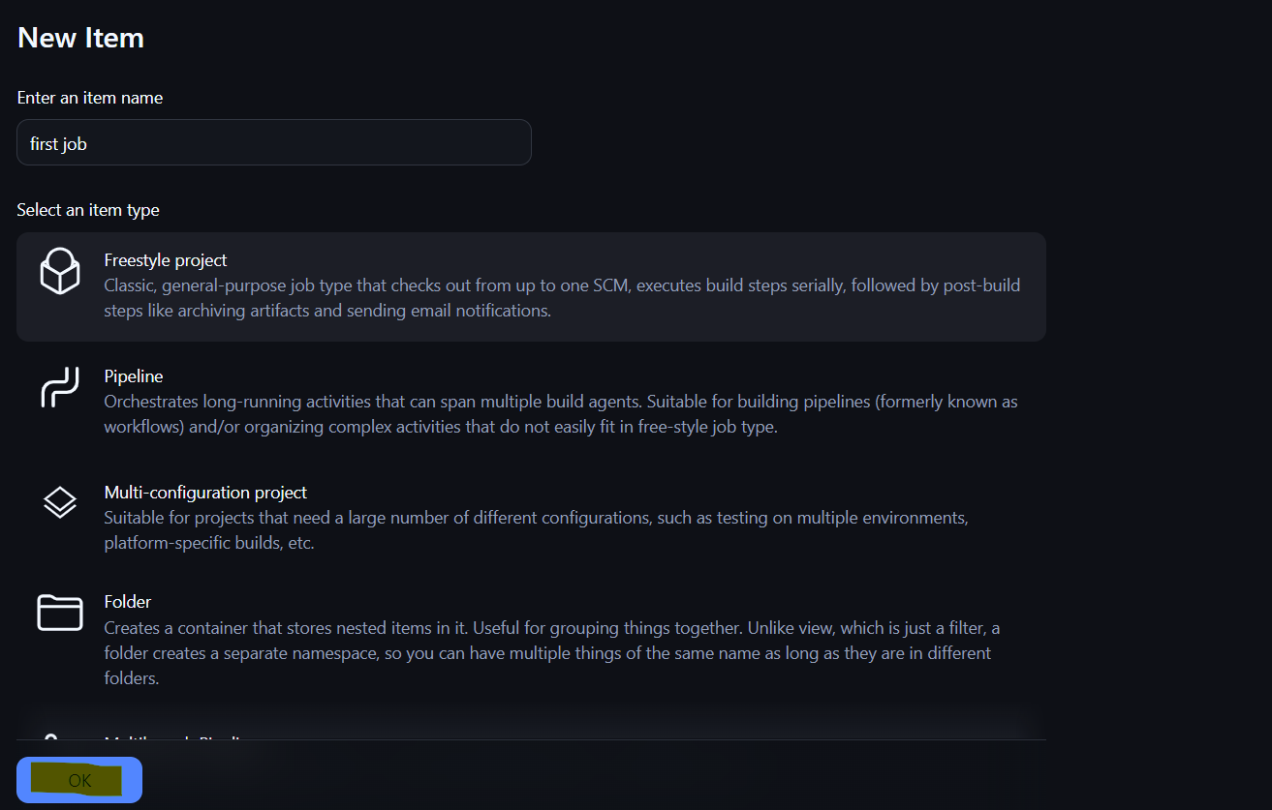
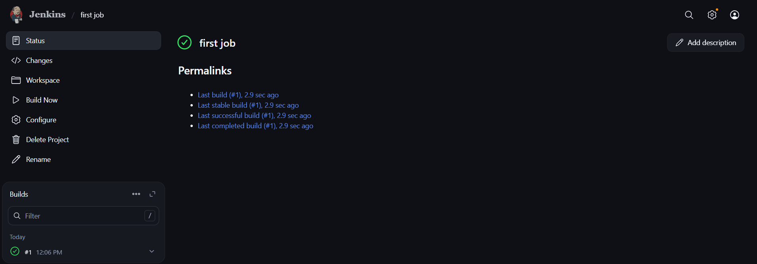
Make sure you label create in my case already created it 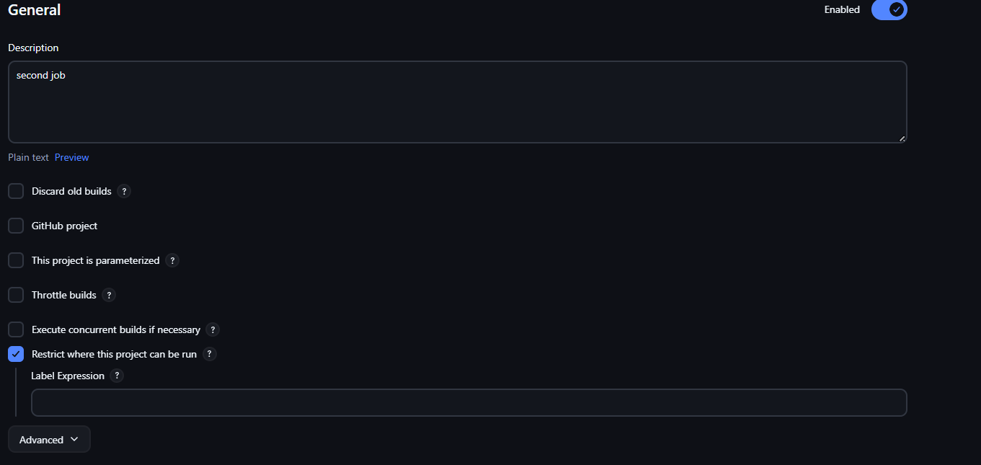
Once you change click save
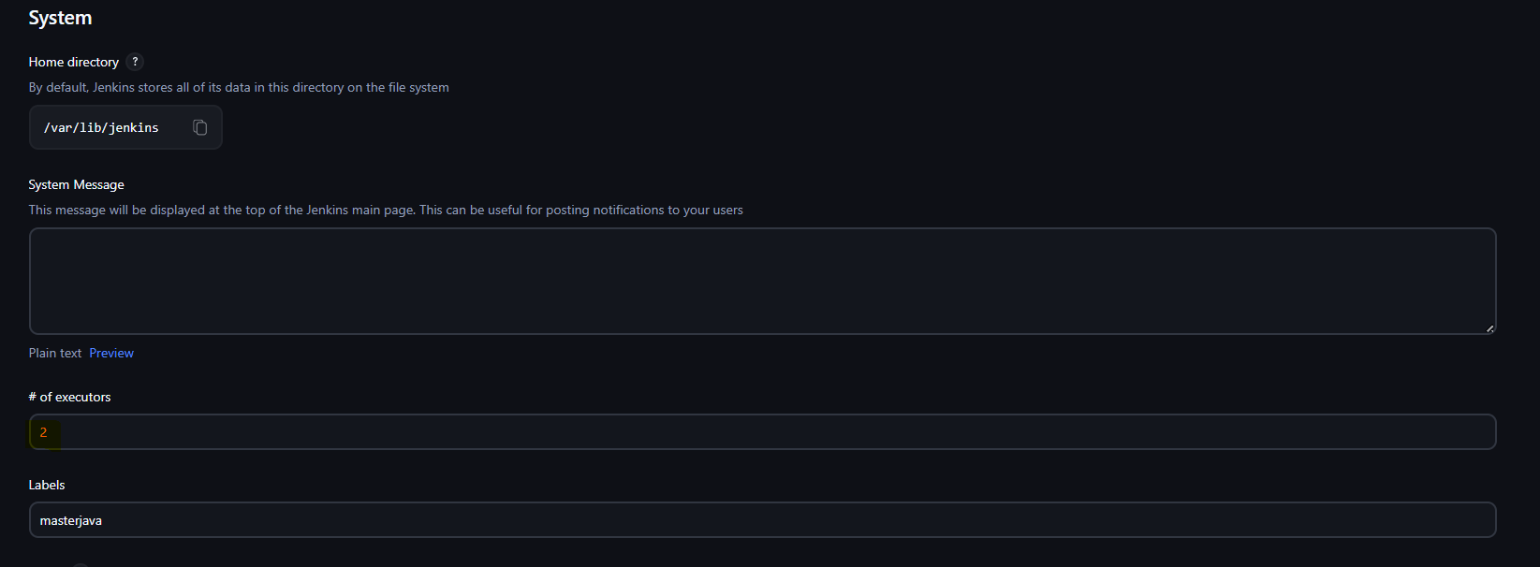
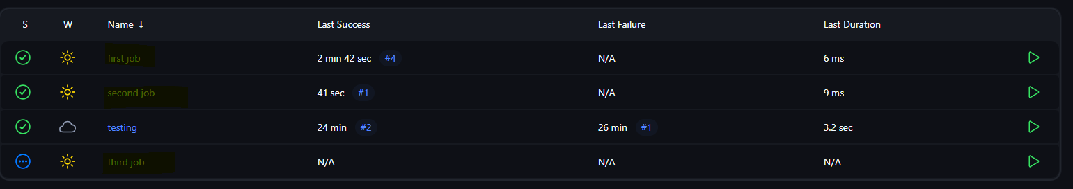
Now we successfully created 3 sample job by using same url
Make sure you one private repo If don’t have crate one private repo then settings and scroll down you will see option called dev settings then go personal access token then click on token classic select tick it that’s it create our token
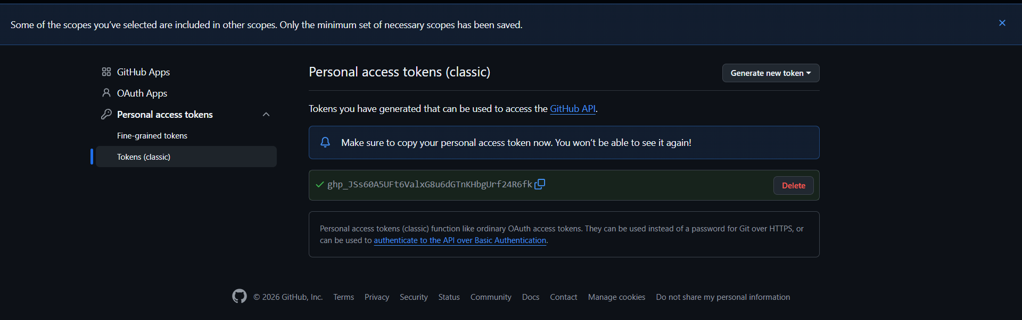
Now go credentials
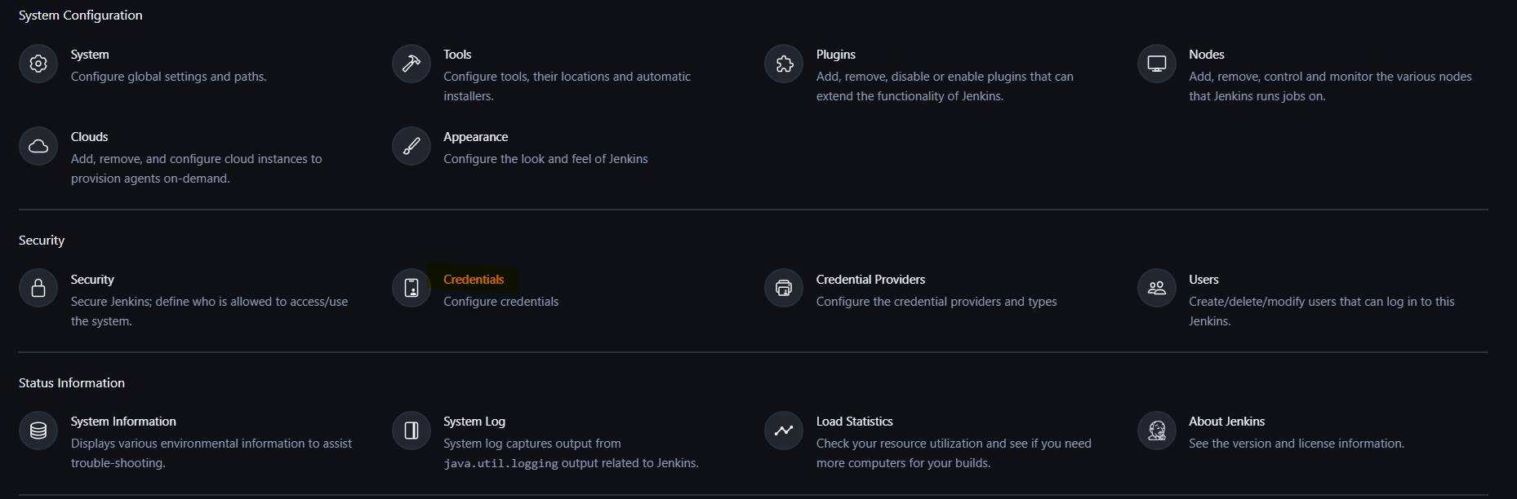
And need to entre the details of private key
Now click on systems
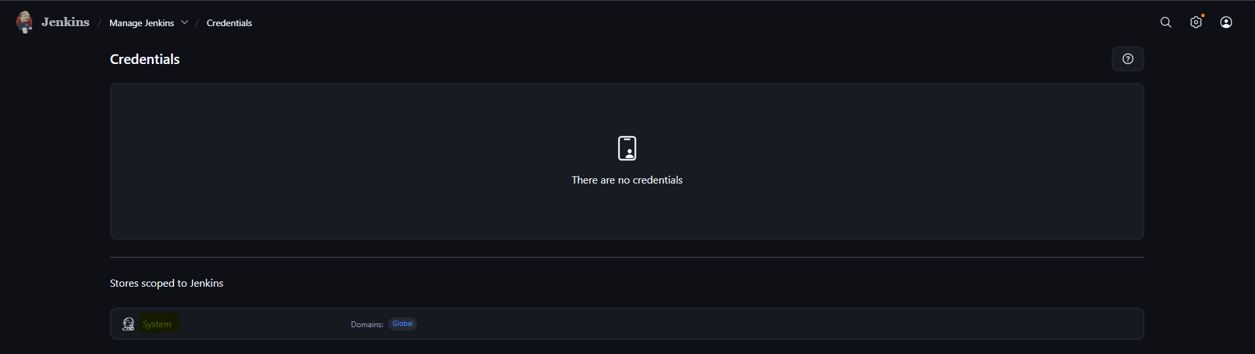
Now create creadentials
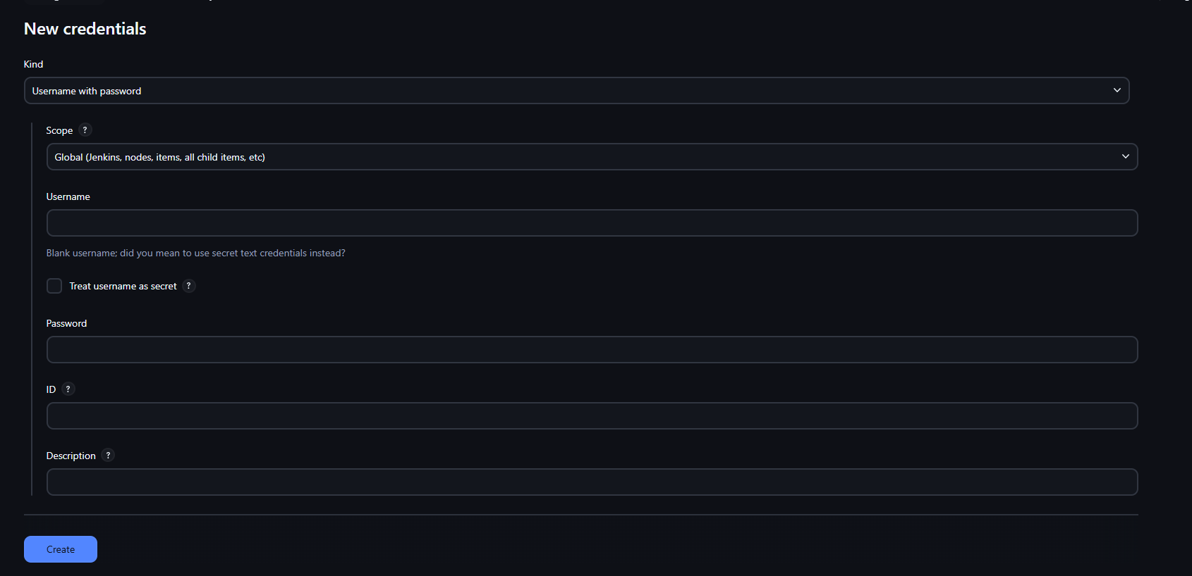
Now add your username and password then click on create
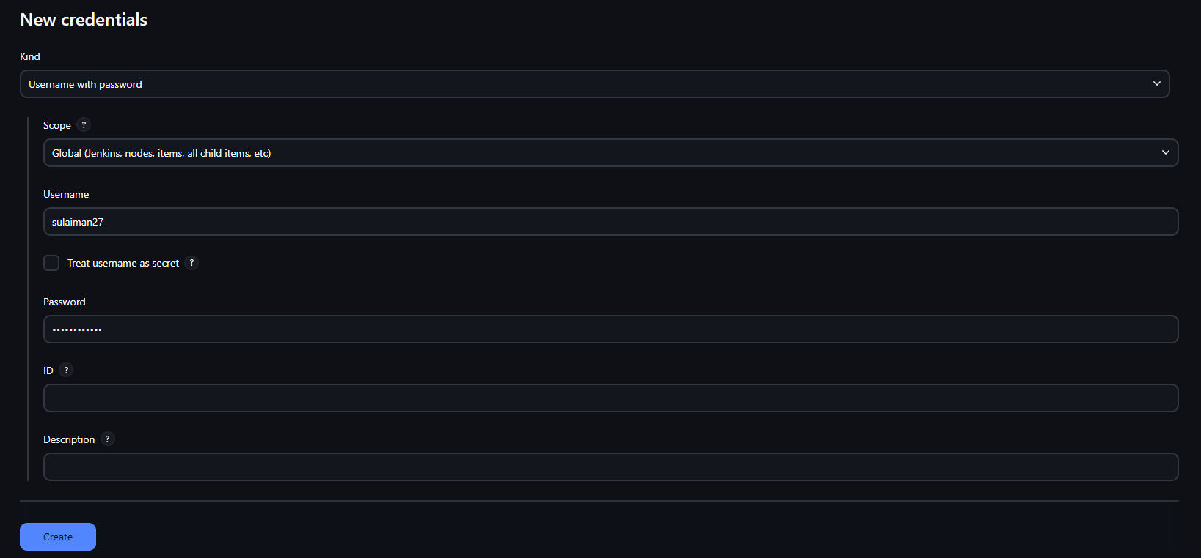
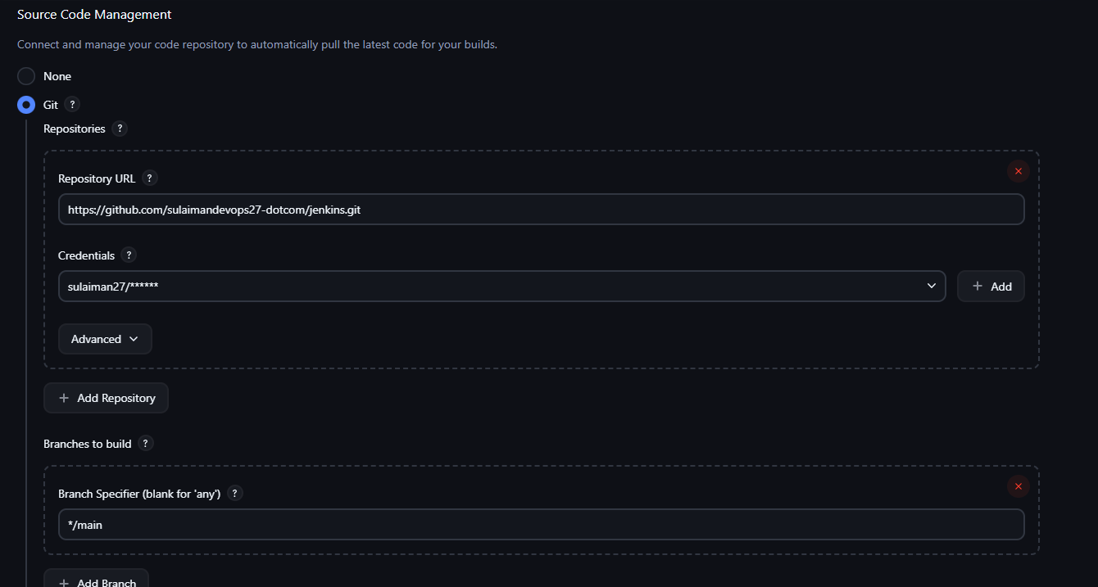
Now see our private token
