Task Title
Configure Jenkins Slaves, Webhooks, SCM Polling, Backup, and Restore on AWS

2 Objective
- Configure 2 Jenkins slave (agent) machines connected to Jenkins master
- Configure GitHub webhook to trigger Jenkins job automatically
- Configure Poll SCM and Build Periodically options
- Take Jenkins backup using:
  - Bash script
  - ThinBackup (referred as rethin backup) plugin
- Setup a new Jenkins server and restore backup from previous Jenkins

3 Prerequisites
- AWS Account
- 3 EC2 instances (Amazon Linux 2023)
  - 1 Jenkins Master
  - 2 Jenkins Slaves
- Jenkins installed & running on Master
- Java installed on all machines
- GitHub repository access
- SSH access between master & slaves
- Security Group allowing:
  - 8080 (Jenkins)
  - 22 (SSH)
1. Configure 2 slave machines in Jenkins master.
So first we need lunch two instace salve 1 and 2
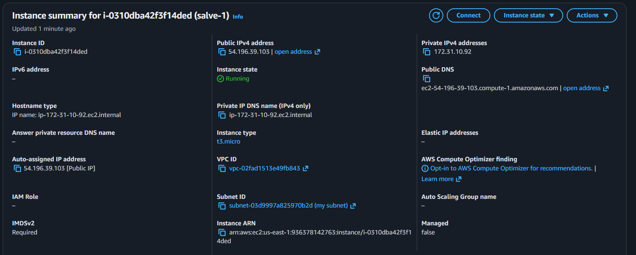

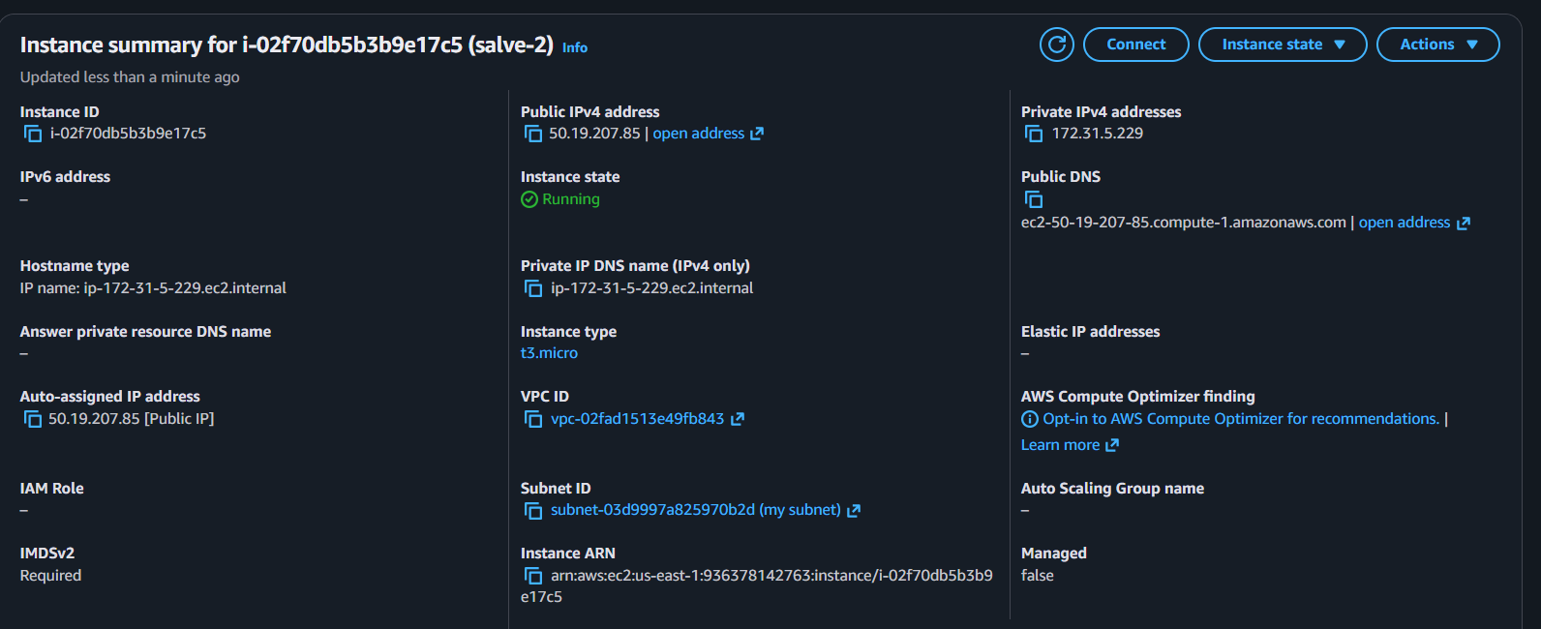
Now install java on your machine salve 1 and 2
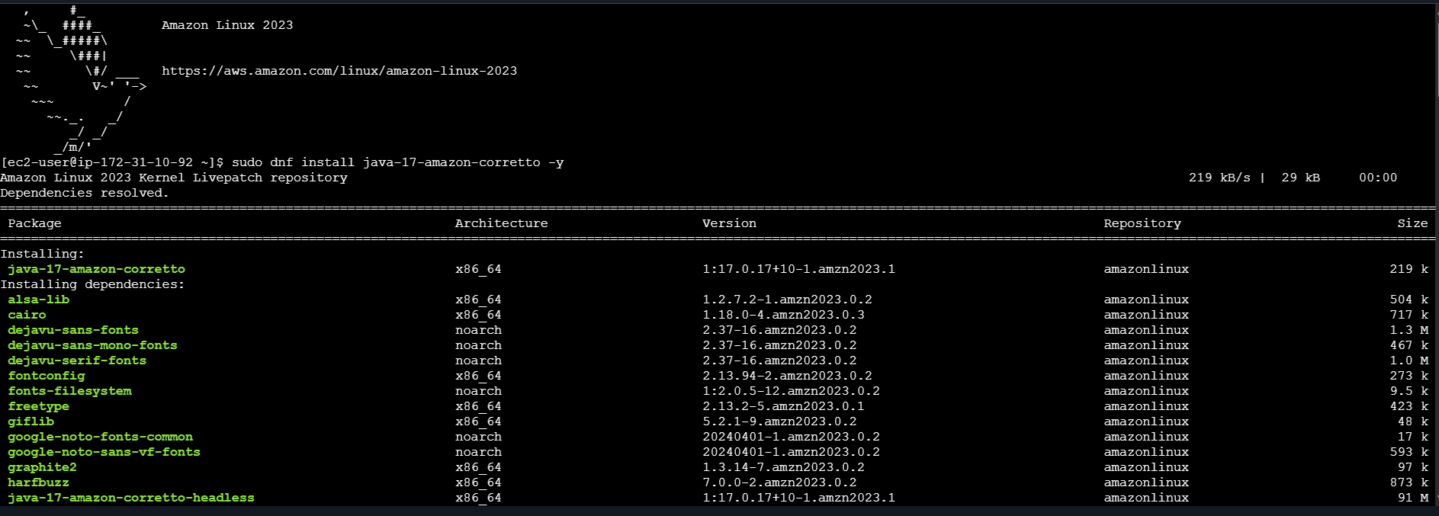
That’s now Create Jenkins User SSH Folder
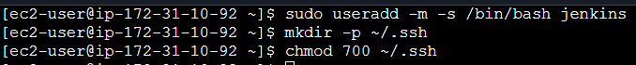
Now we need Generate SSH Key
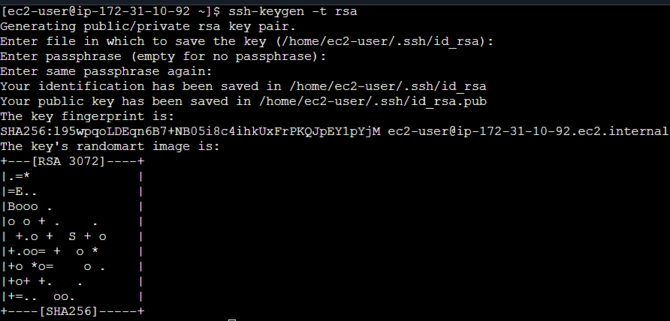
Now need to access the Jenkins-master through git bash
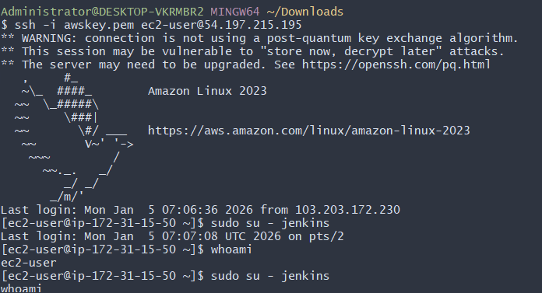

Now need to access the jenkins as a admin and go for nodes
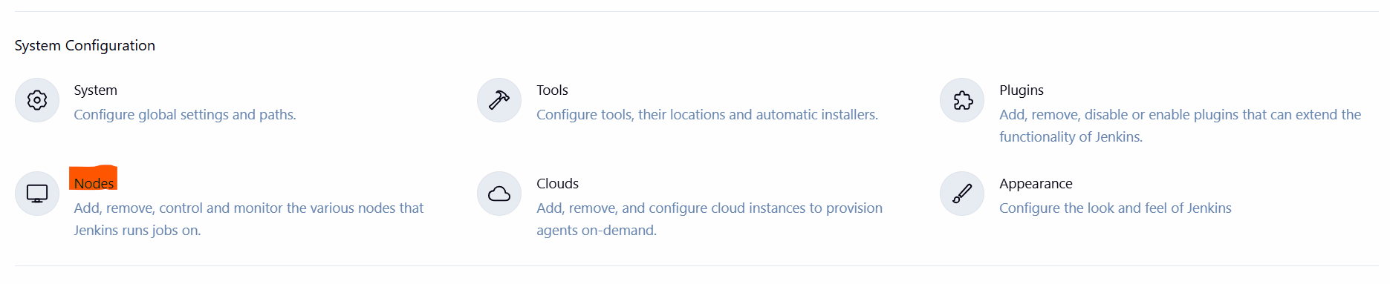
Now click on new nodes write name salve-1 create it
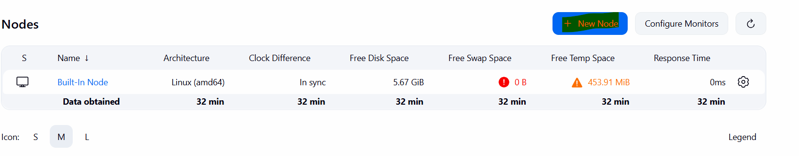
Now full fill your details in
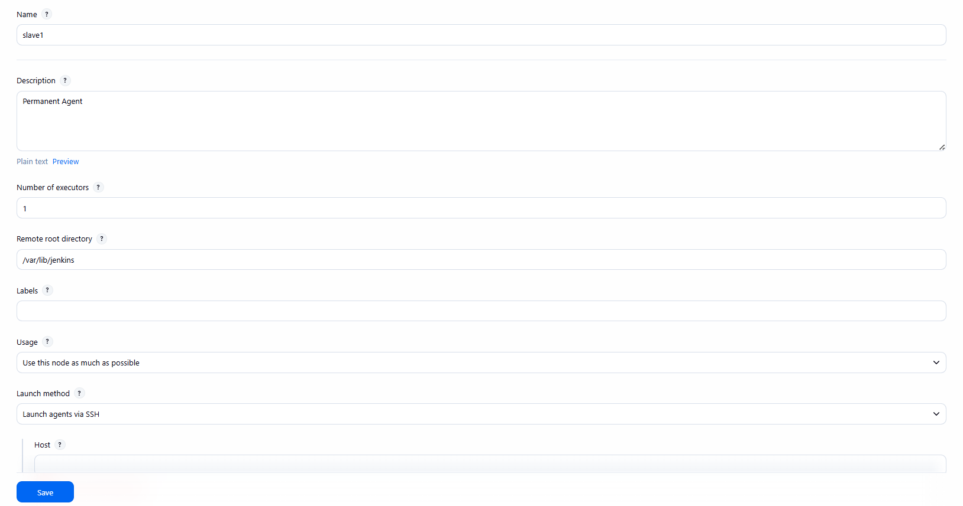
Same repeat it Now full fill details salve 2 then save it
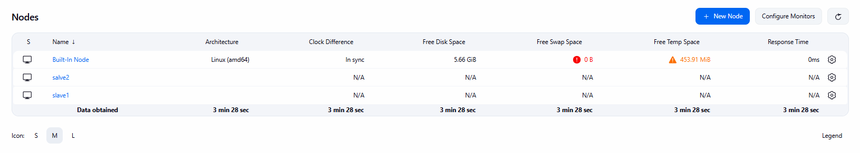
Now in my case it not working if in your case if it showing agent successfully that’s means it right
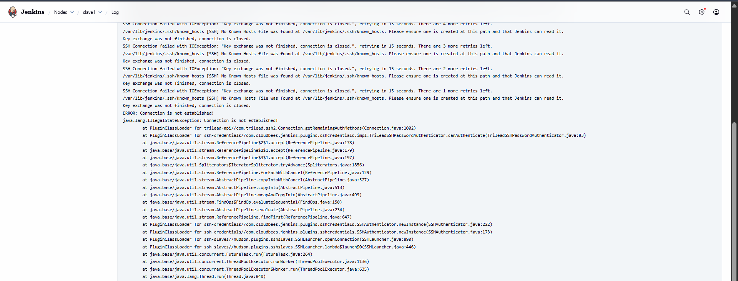
2. Configure webhooks to Jenkins job.
Ans: objectives: configuring webhooks to jenkins

Prerequisites:
Github repo
Jenkins
First you need login to your git github go to any repo and top click on settings
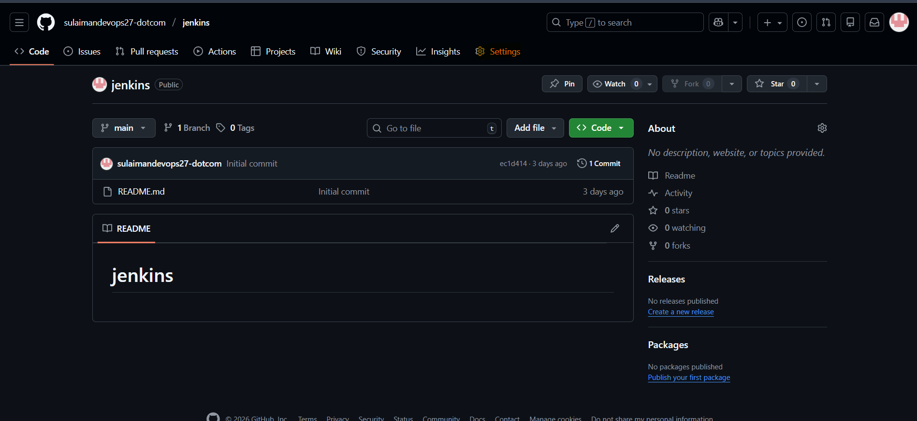
And here is option called webhooks click on it
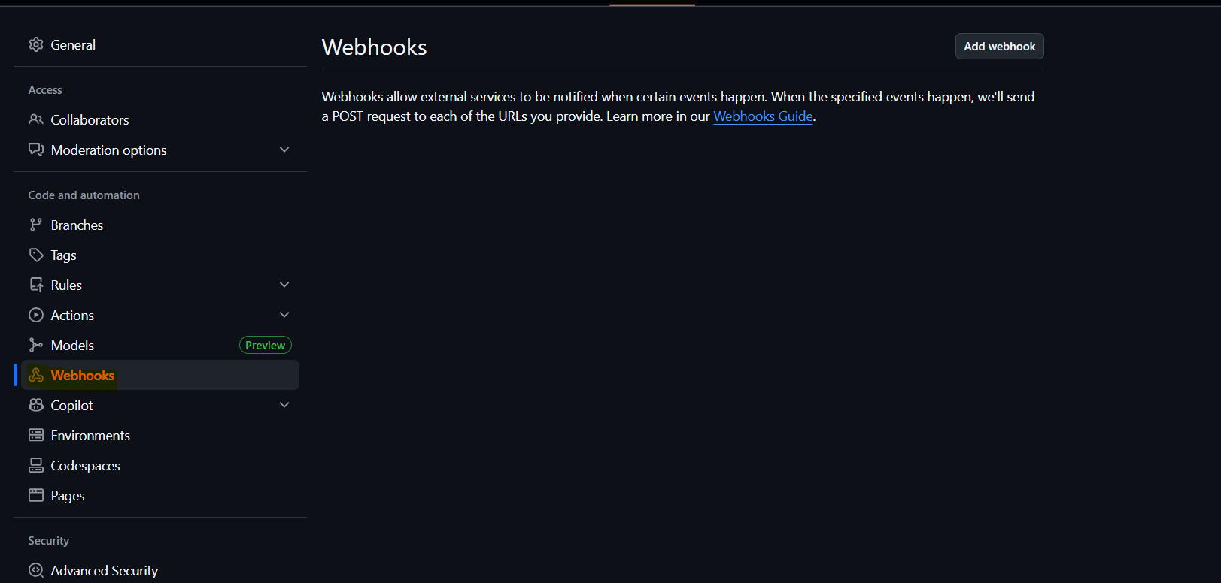
Add your Jenkins url also add /github-webhook/
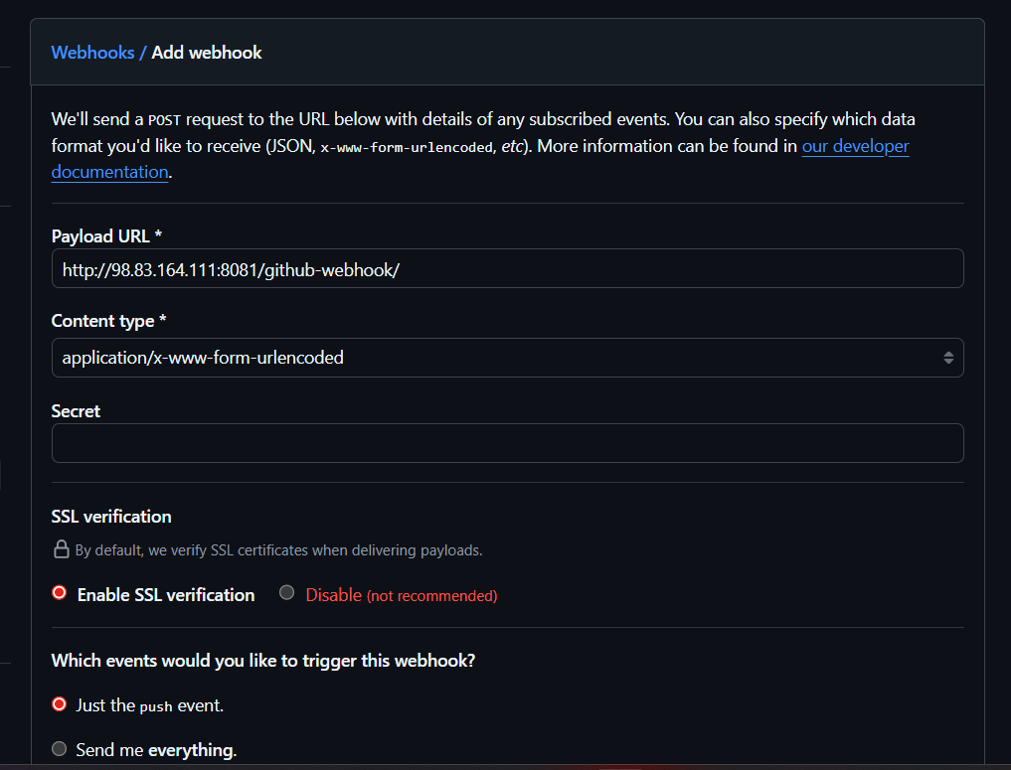
Now we successfully
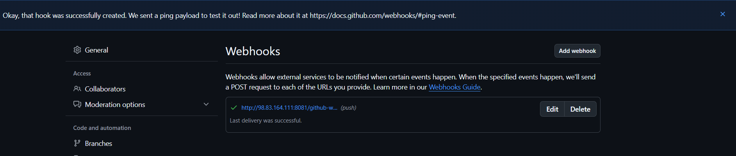
Once it get added need to go on jenkins and click on add job and entre the git repo url and select triggers

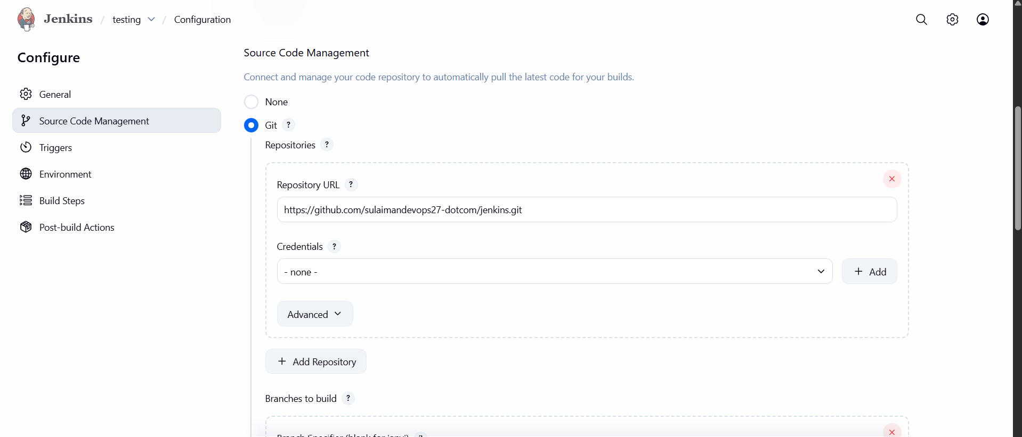
In that we need tick on github hook trigger
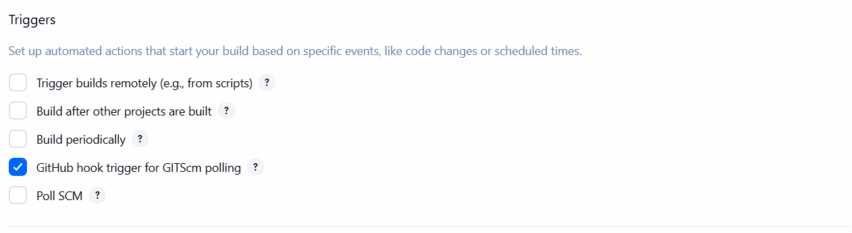
That’s it save click on save
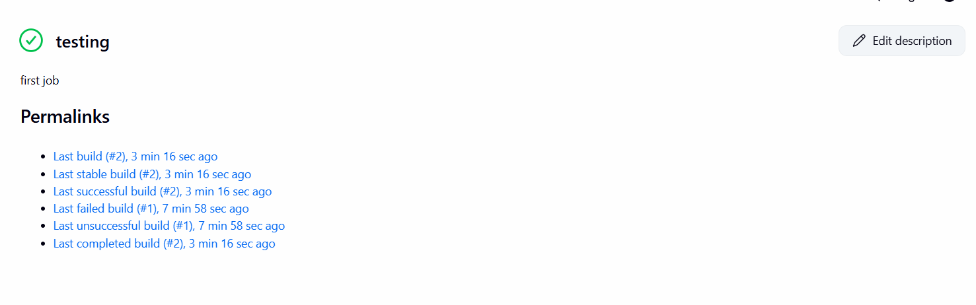

3 Configure poll scm and build periodical options in Jenkins job.
1 Task Title
Configure Poll SCM and Build Periodically Options in Jenkins Job

2 Objective
To automatically trigger Jenkins builds:
- Poll SCM → when code changes in GitHub
- Build Periodically → at fixed time intervals (cron-based)
First go jenkins creating the second job then go triggers select bulid prodically schedule it apply and save it
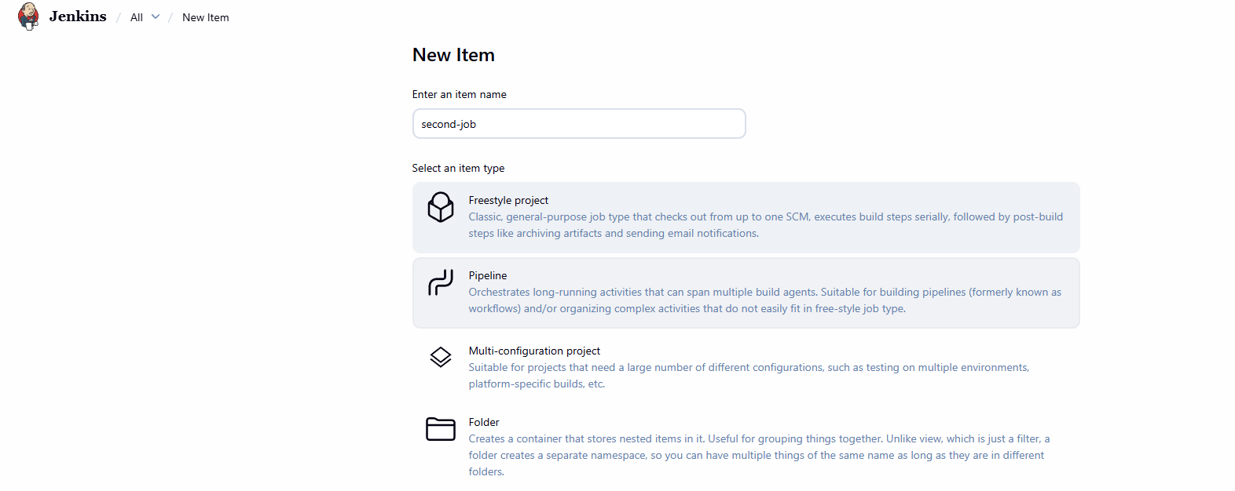
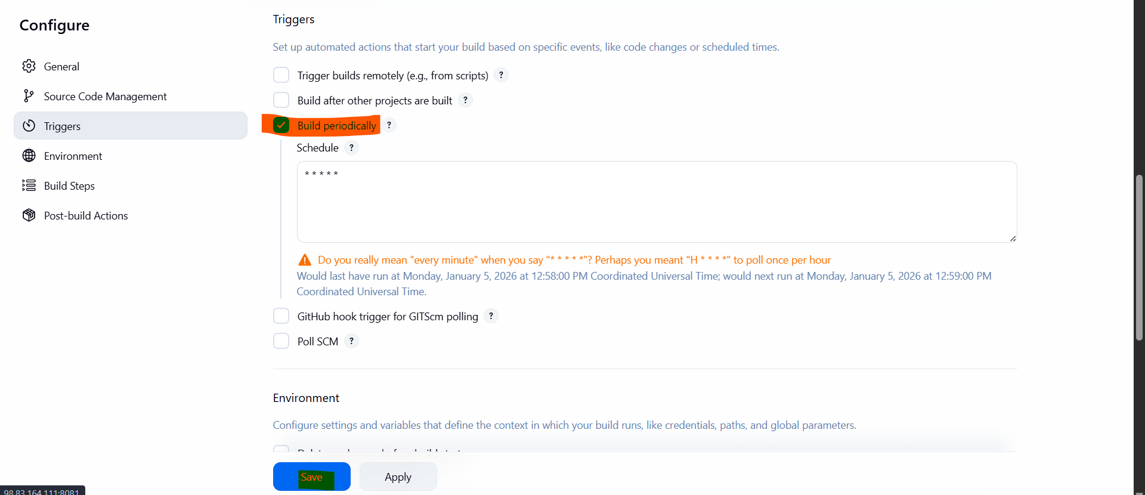
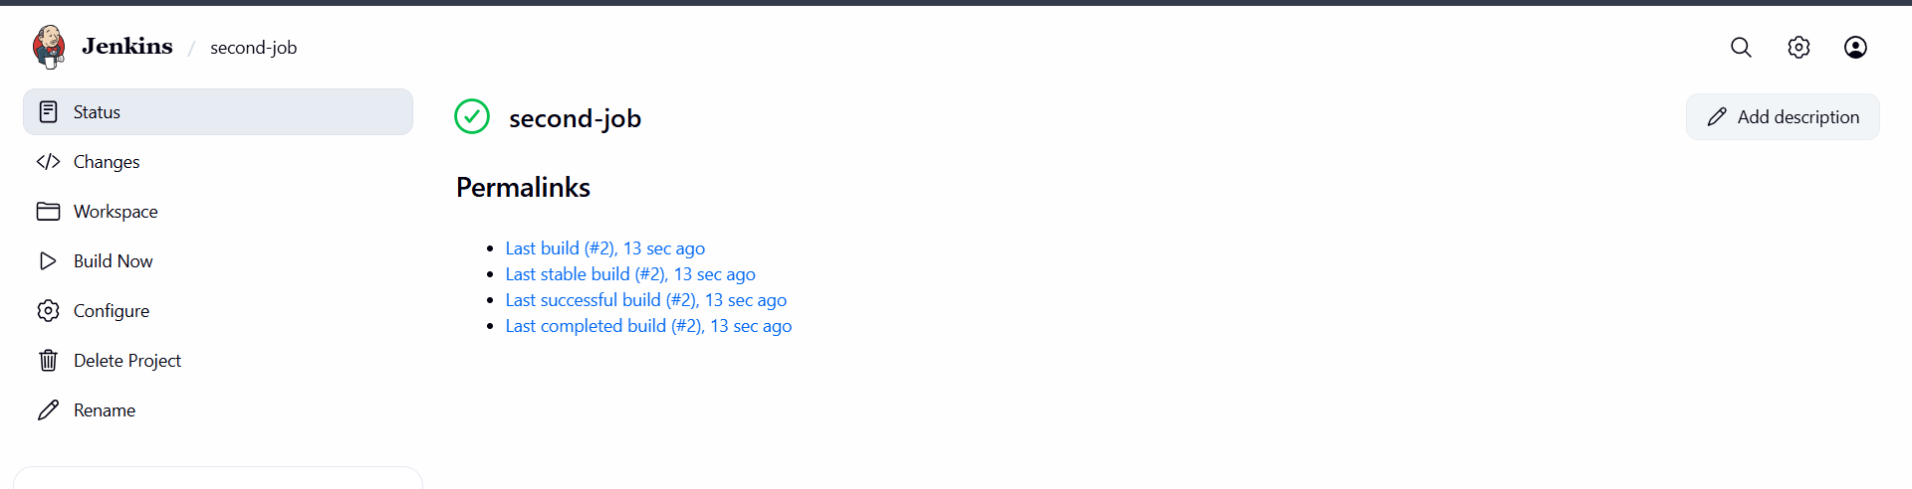
Conclusion: after making any change in repo getting in trigger in poll scm
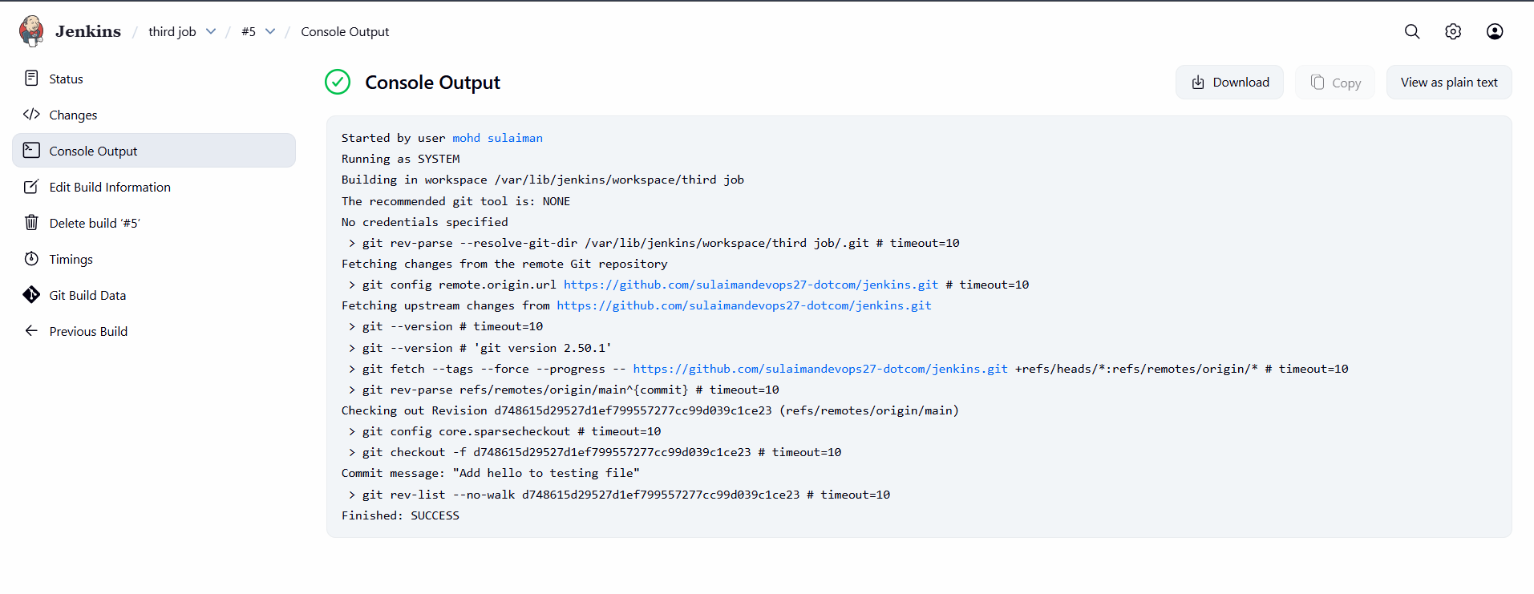
4. Take backup of Jenkins server by using bash script.
1 Task Title
Take Backup of Jenkins Server Using Bash Script

2 Objective
To safely take a complete backup of Jenkins including:
- Jobs
- Configurations
- Plugins
- Users
- Credentials
using a simple Bash script.
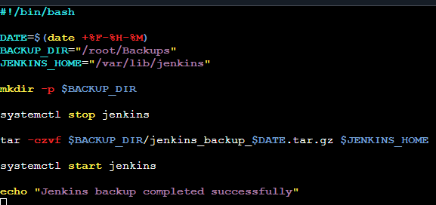
That’s it we finnaly taken backup
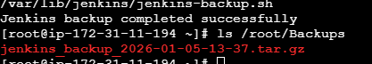
5. Take backup of Jenkins using thin backup plugin.
1 Task Title
Jenkins Backup Using ThinBackup Plugin

2 Objective
To safely take a complete backup of Jenkins configuration, jobs, plugins, and credentials using the ThinBackup plugin, so Jenkins can be restored in case of server failure or accidental deletion.
That’s it install

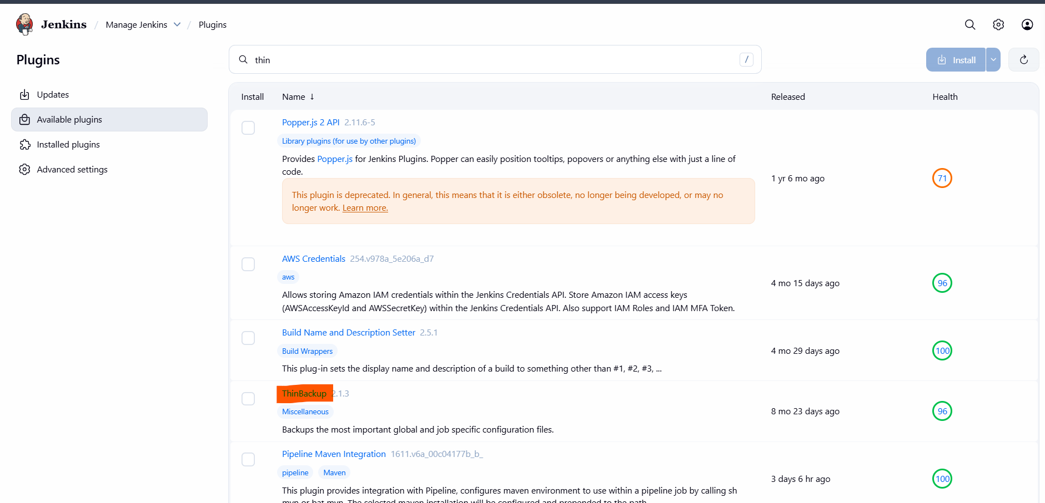
once it get installed need to go on system and scroll down and under thin plugin configure need to enter the path and cronjob
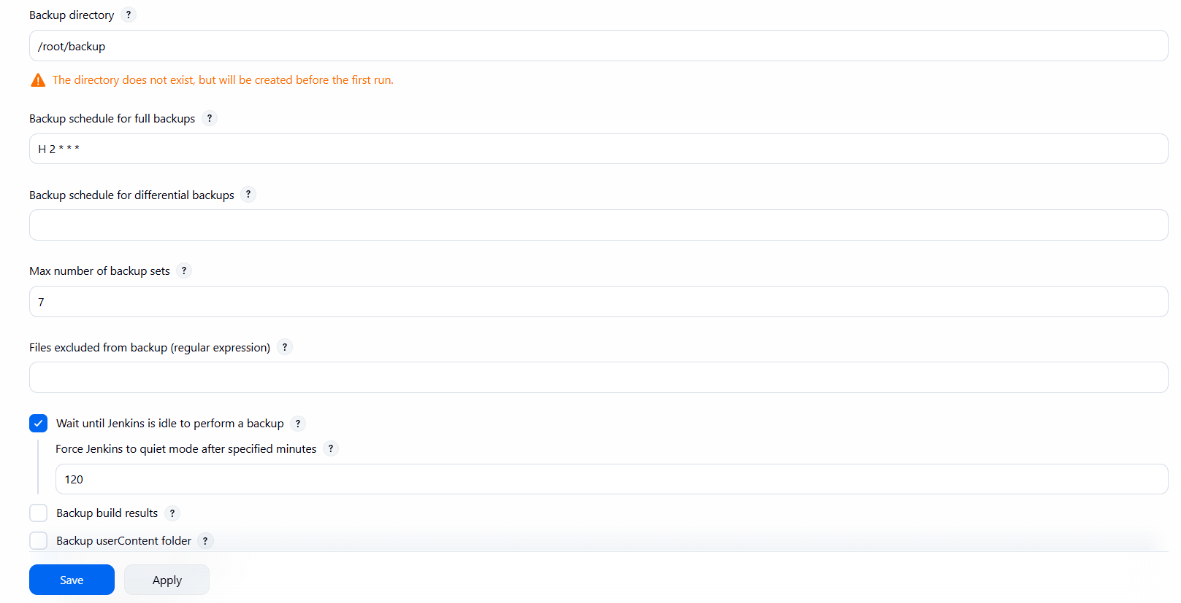
Now go confuration setting you will find thinkback
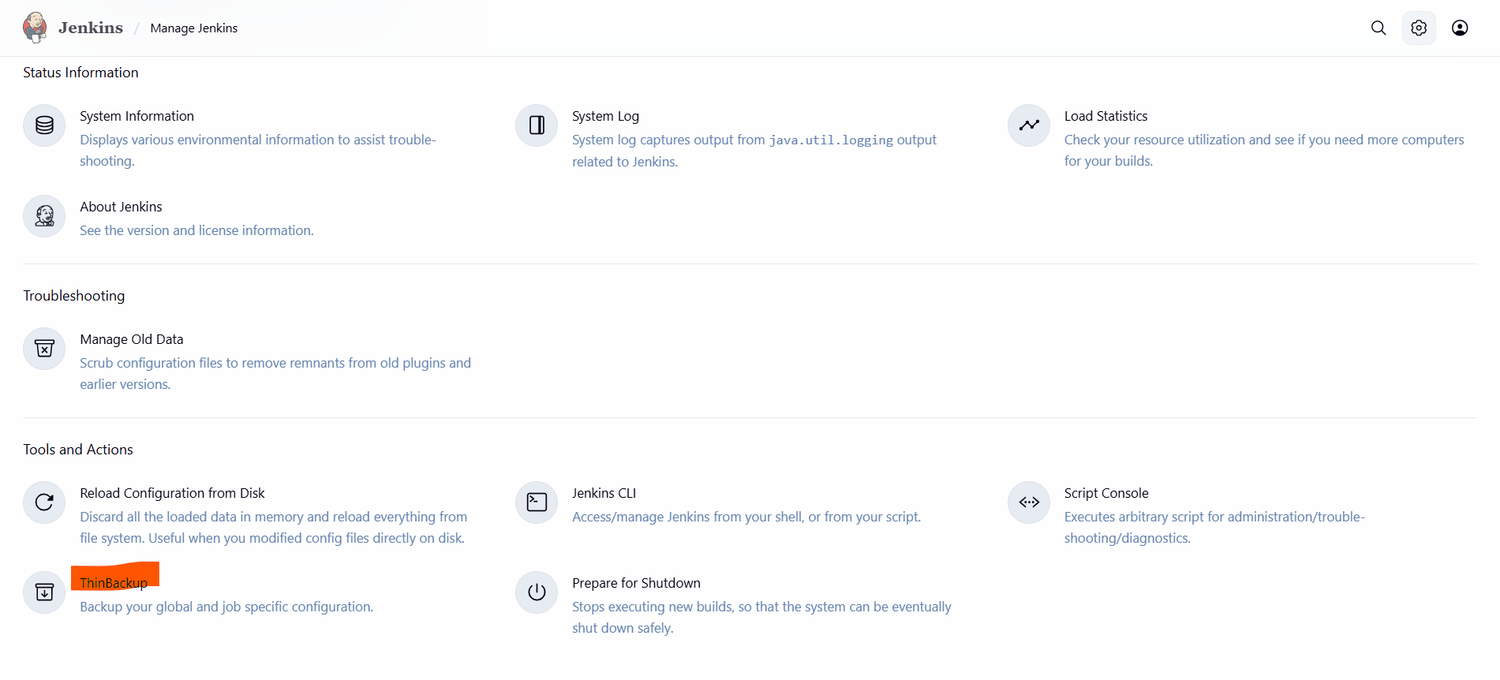
Now we successfully taken the backup through plugin

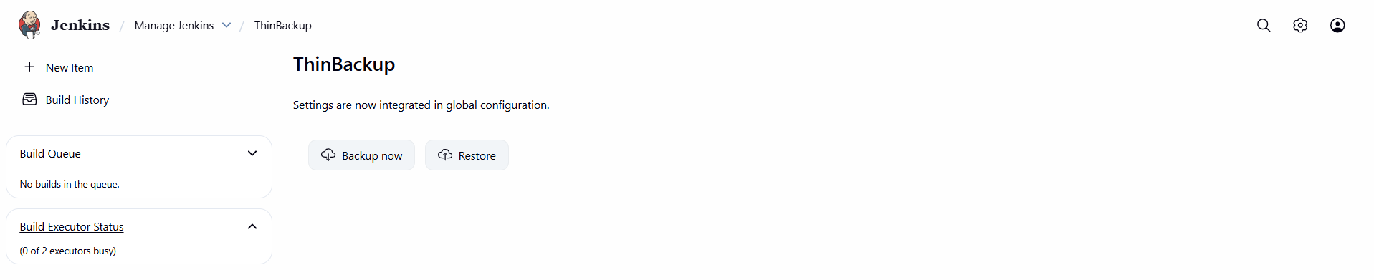
6 Setup a new Jenkins server and dump the backup taken in task4.
Objectives: creating a new isntance to dump the backup of jenkins

Prerequisites:
Ec2- instance
Git bash
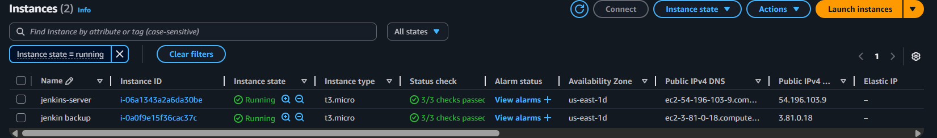
Now we backup instance install java and Jenkins on it

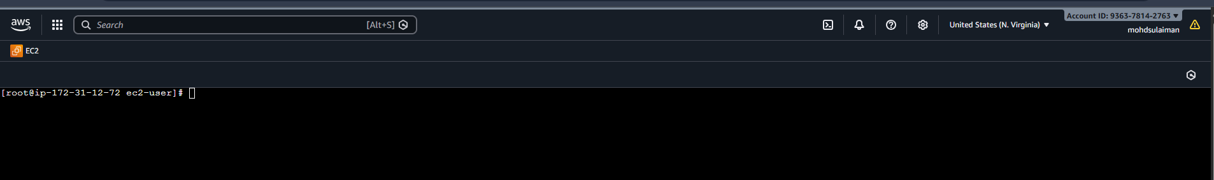
Now creating new testing.pem key
Now we have finnaly taken backup

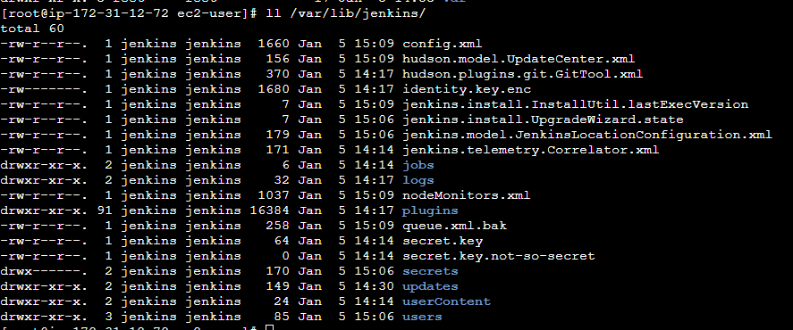
Now login to new instance and check the zip is available or not
Now the file available need to extact the zip under the jenkins folder once it got ectact its start working
