Jenkins-03

To install sonarqube :-
First we need lunch one instace on aws
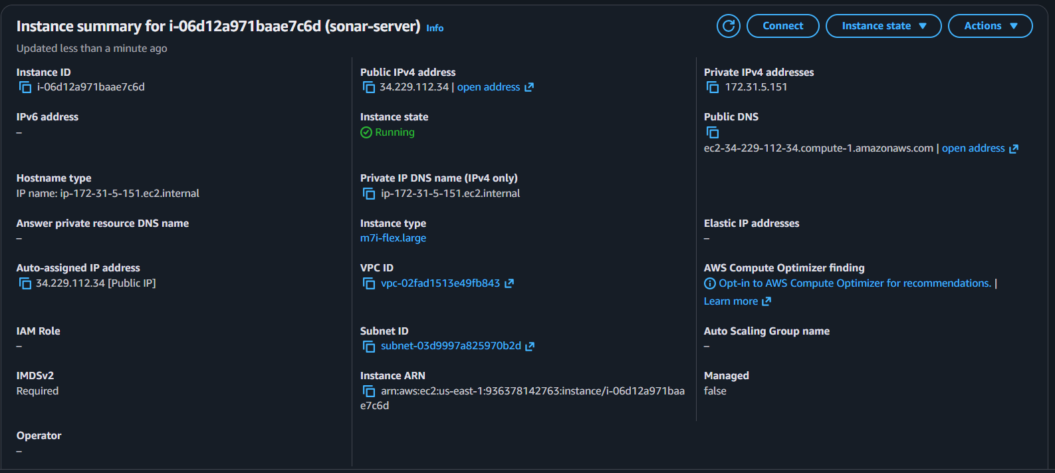
Now after lunching it we need install java-17 on it make sure download latest version
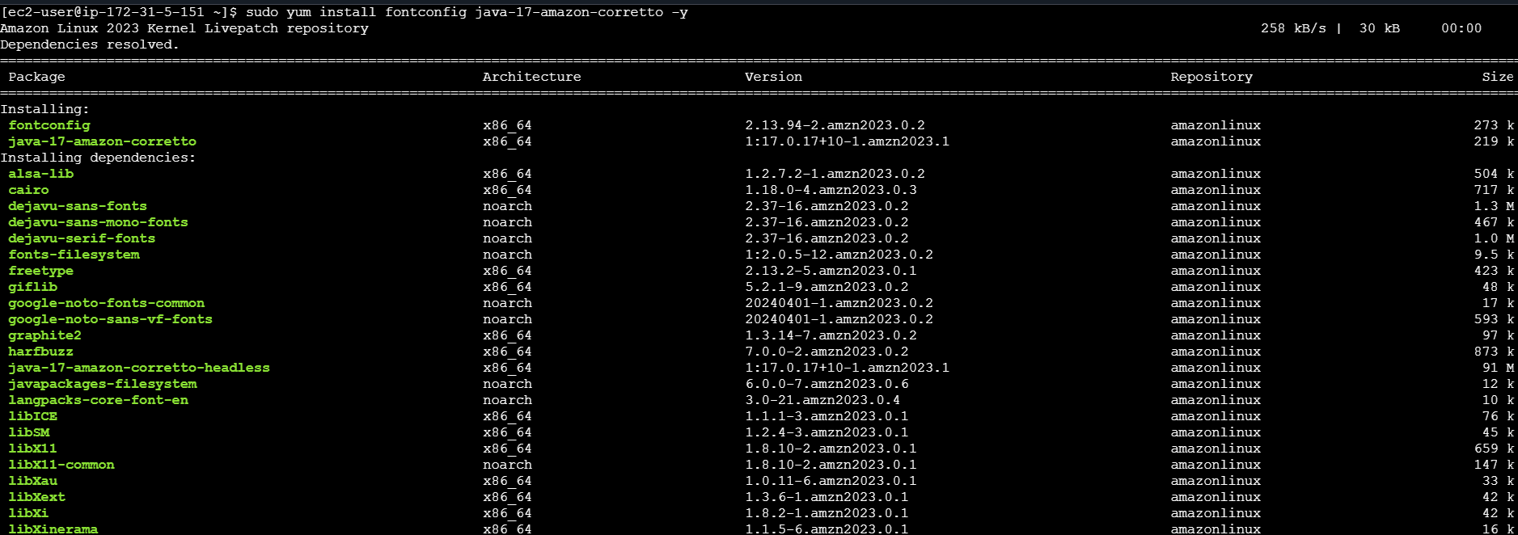
Now we verfy it install or not as you see it successfully we have install java-17 on our machine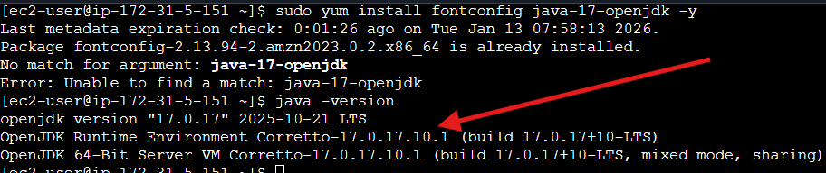
Now we need install one database so install postgresql -15 version on it
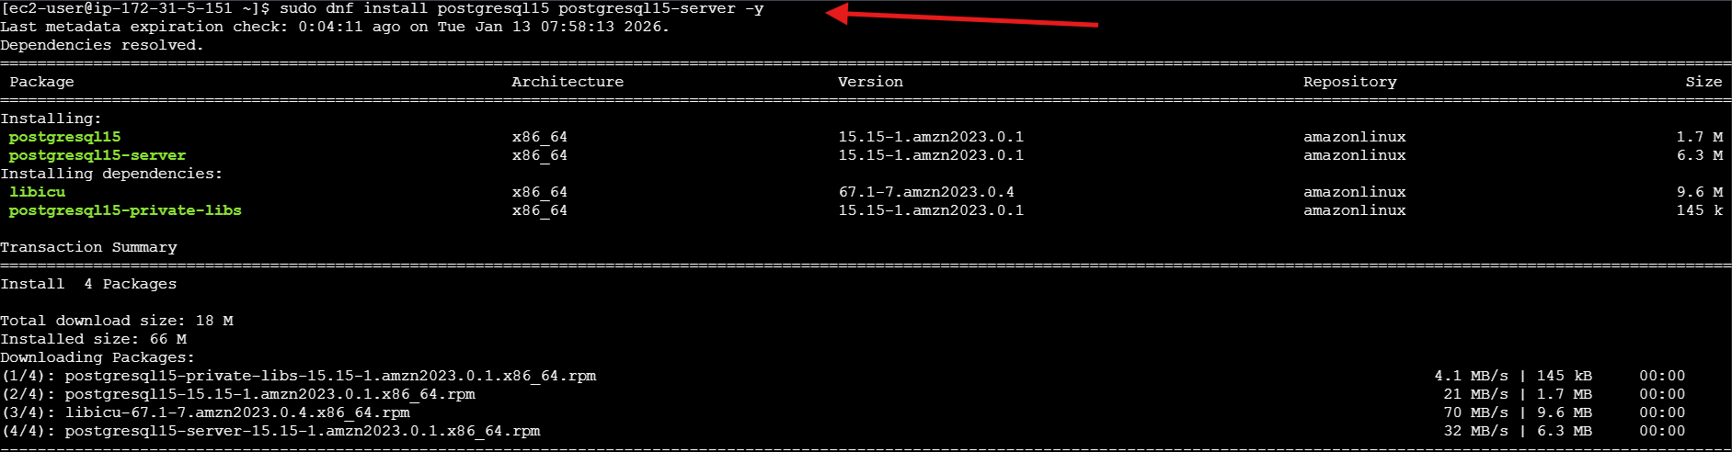
Ok now we install postgresql database on our machine now lets verfy it
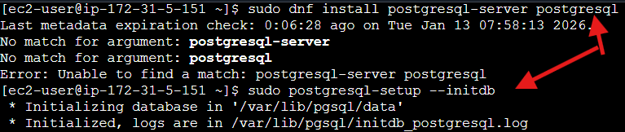
As you notice we have successfully install postgresql
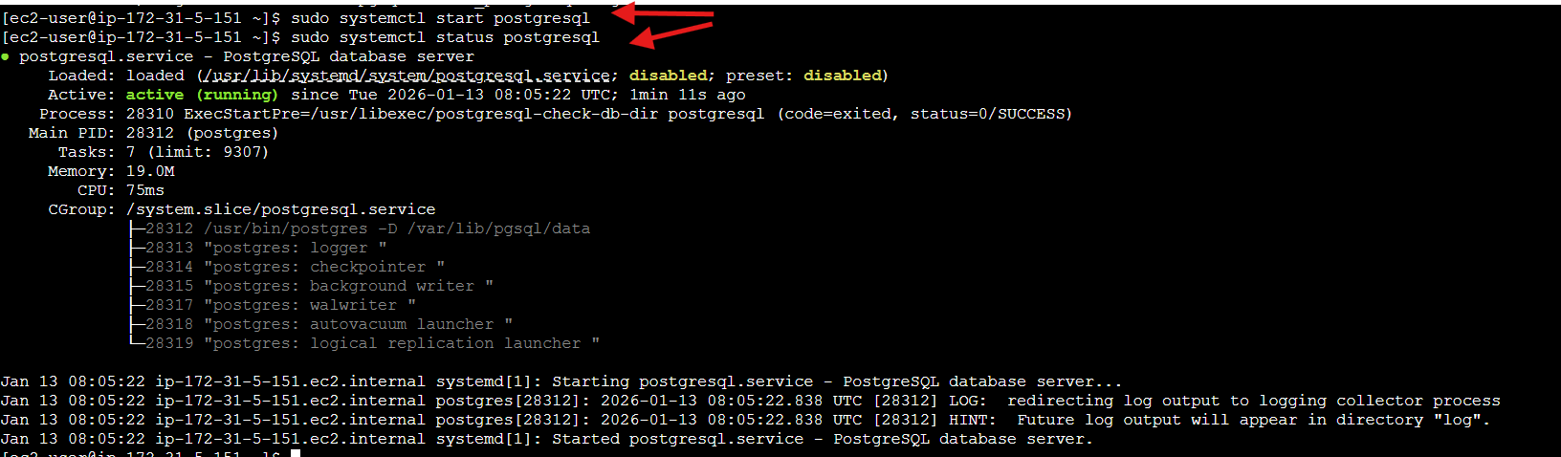
Now we need create database for sonarqube first type
sudo su – postgres then if your in postgrees it show you like postgres=# it means your inside then follow this command
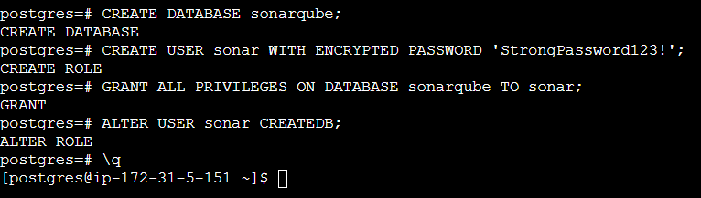

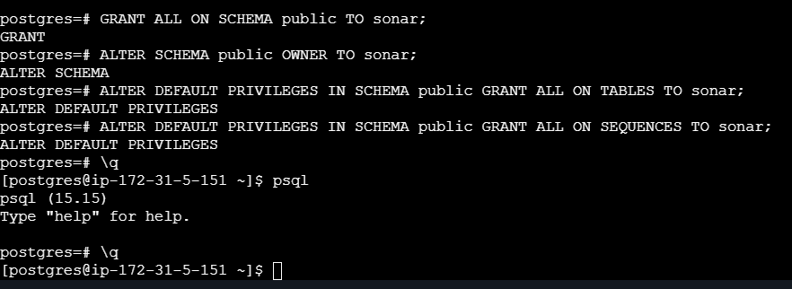
Now change this password hashes
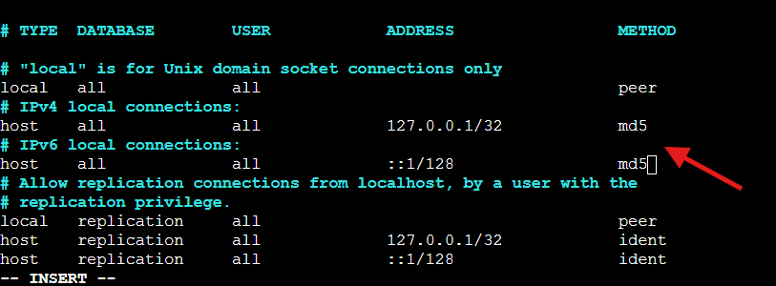
After change exit esc :wq! That it
Now we need remove one zip and install new
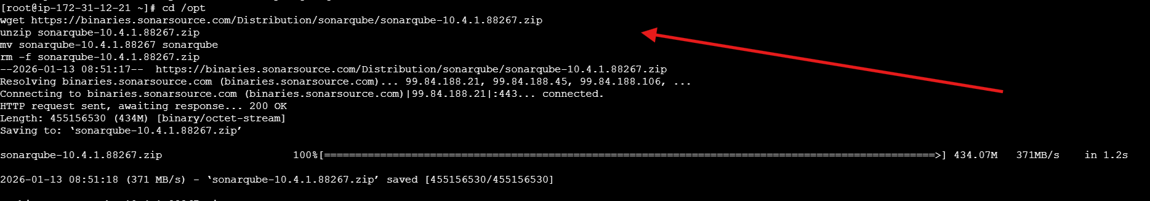
Now we need update our old password with new password
Now type username and password also paste url
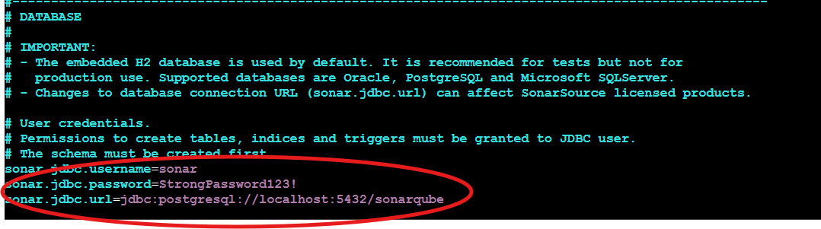
Ok now need some more configuration on it changes configuration
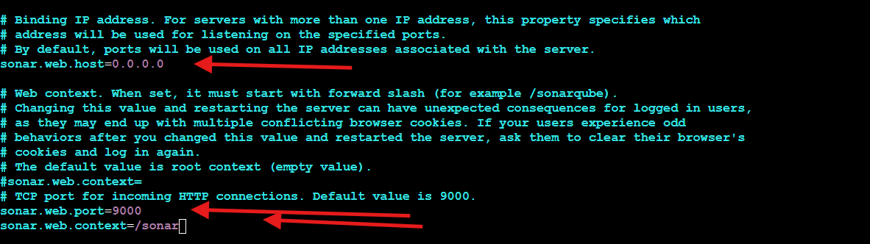
Now we have successfully lunch our sonar server default password & username is admin and admin
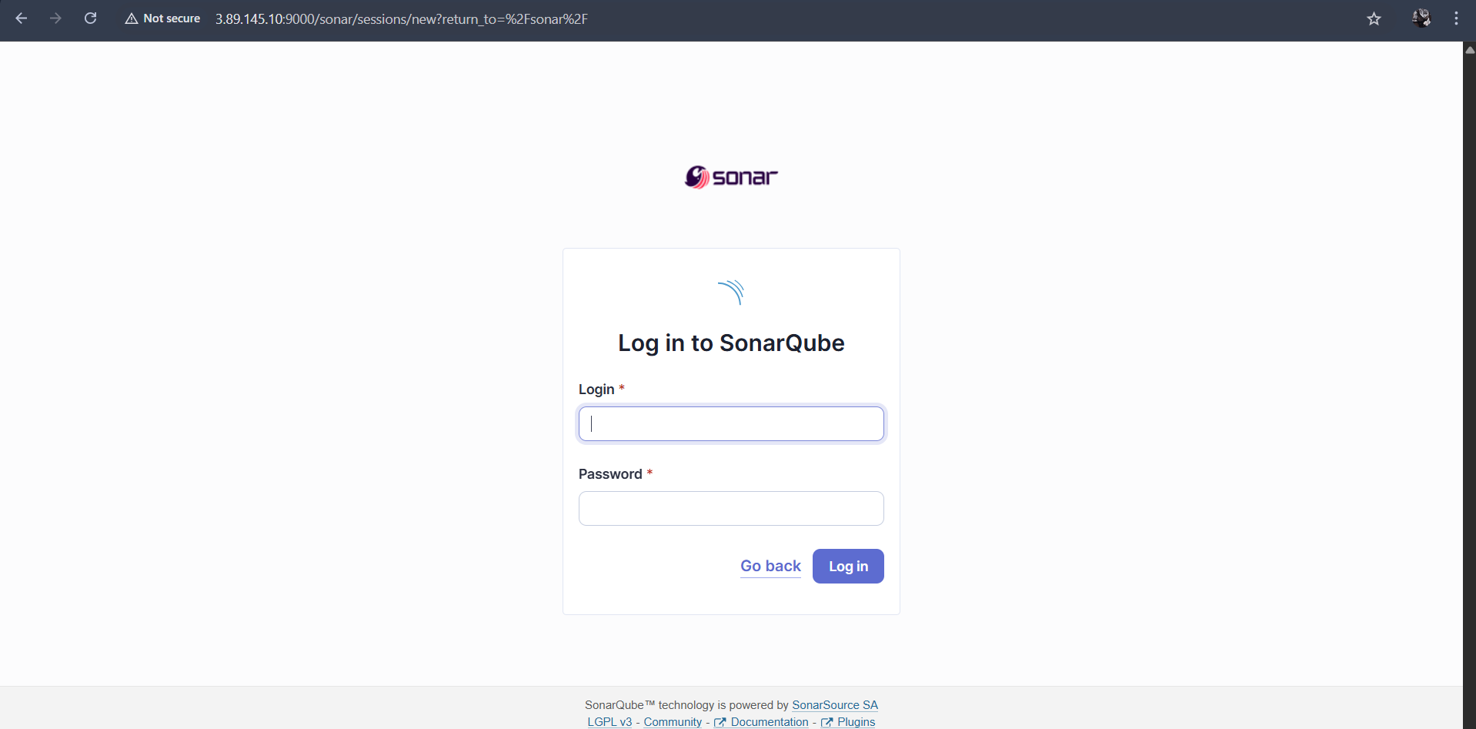

Now we need generate one token that’s it now type select token type click on generate copy that token
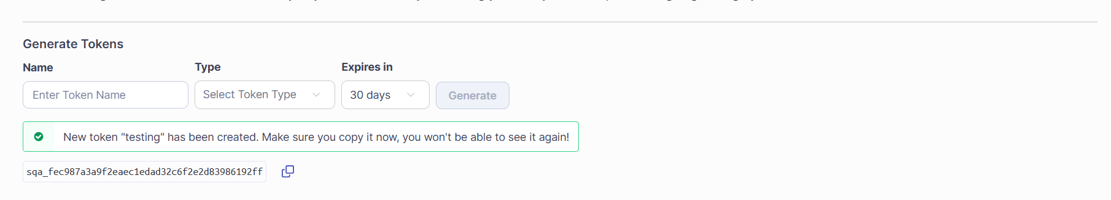
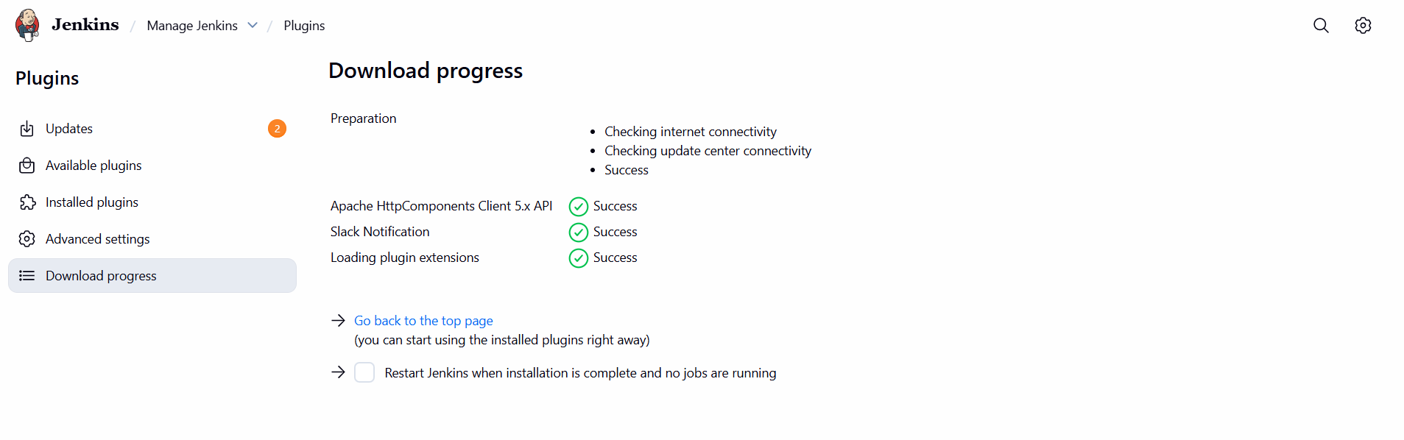
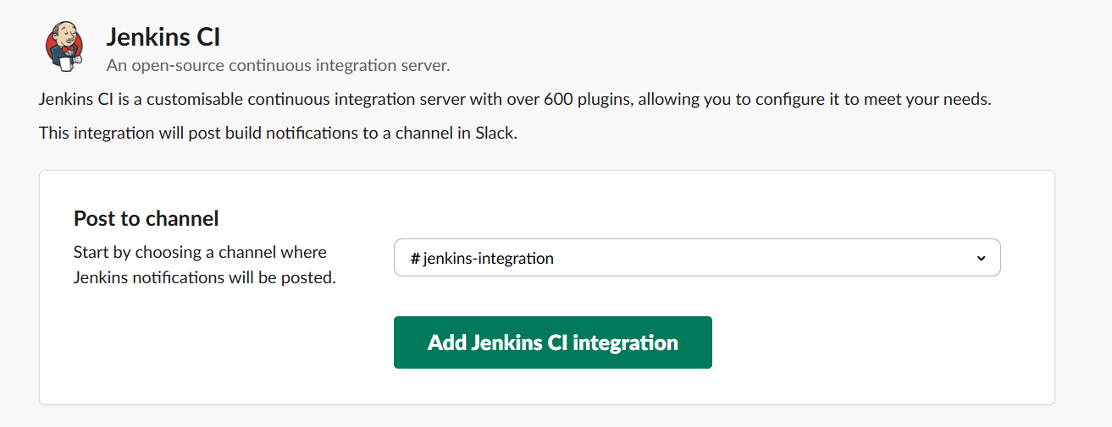

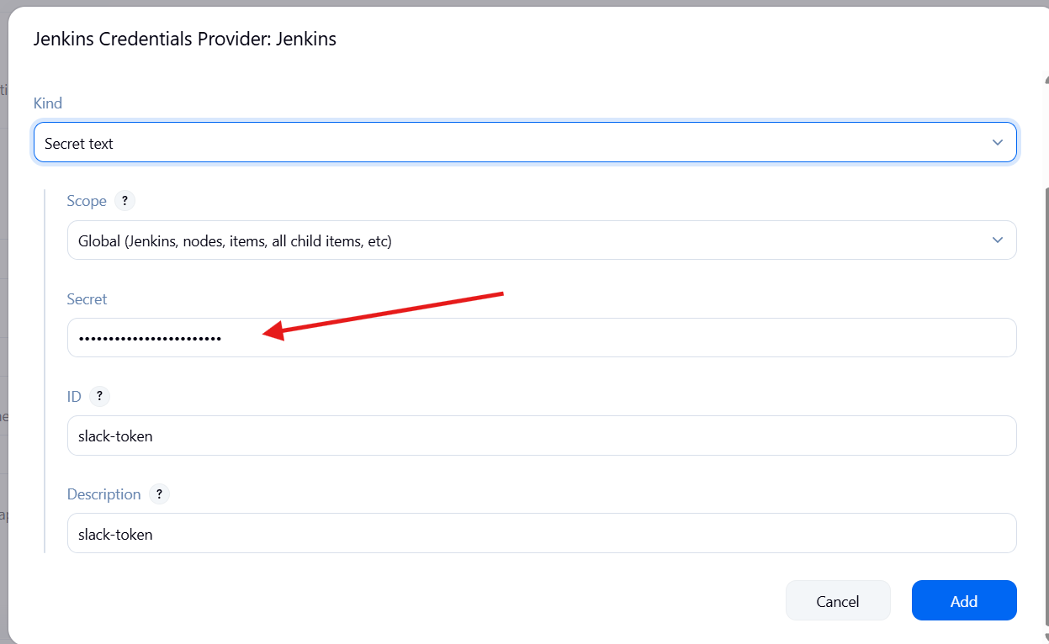
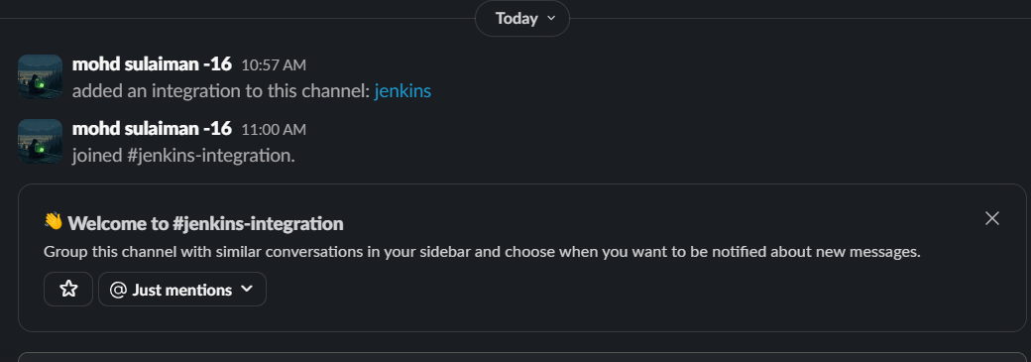
Now we need add sonar scanner
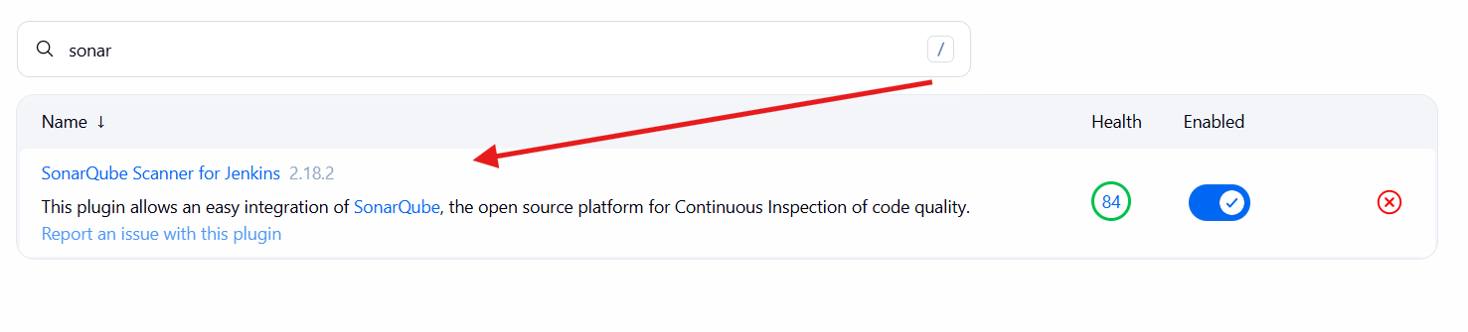
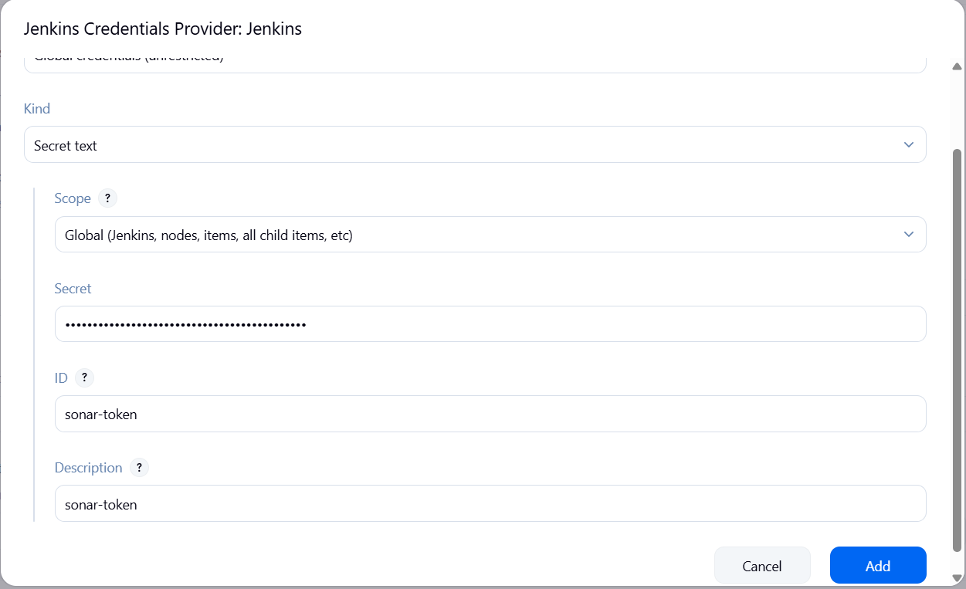
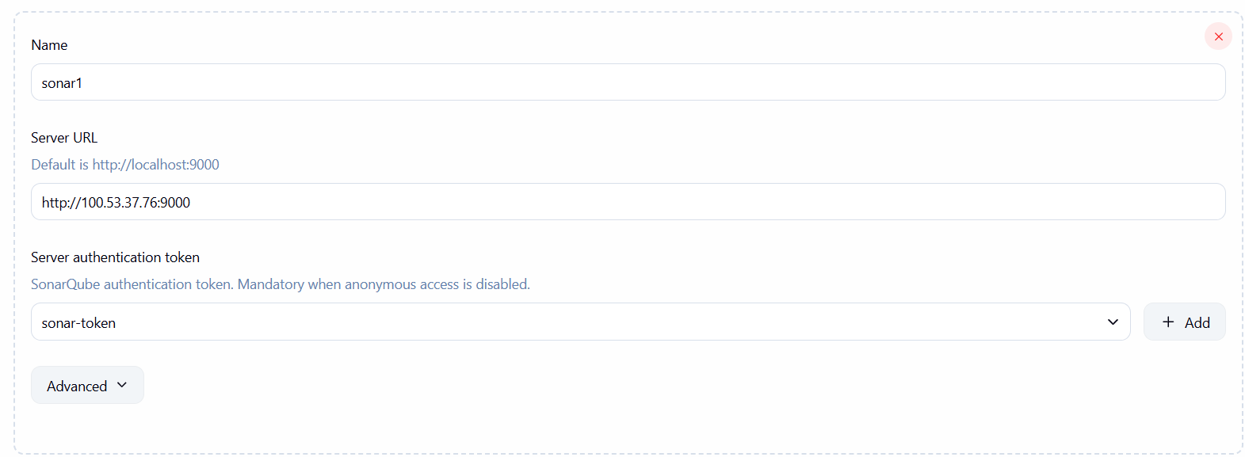
Make sure you have sonar scanner install on your Jenkins server
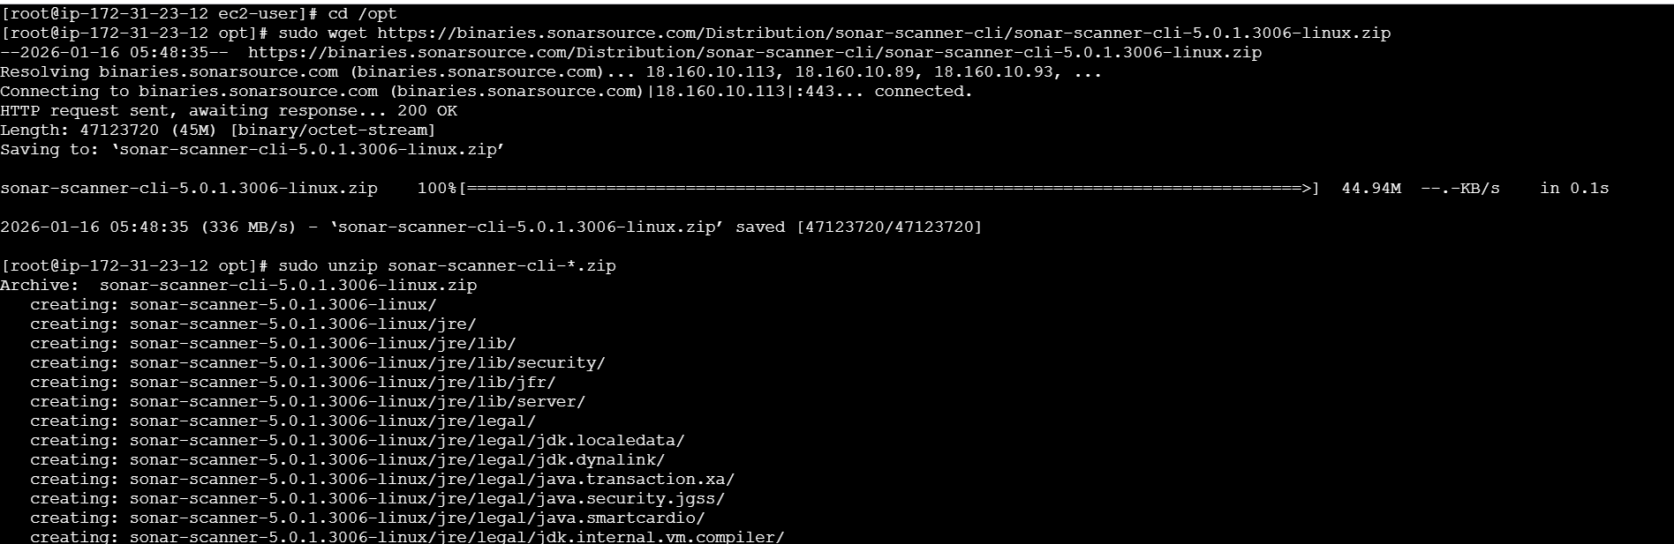
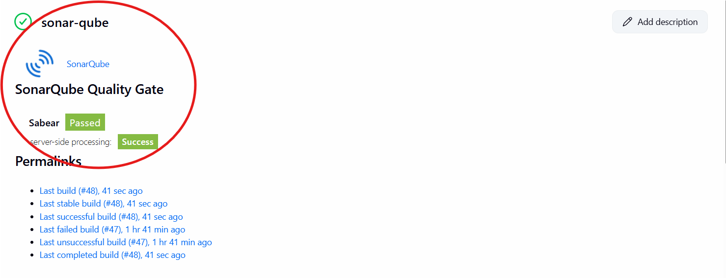
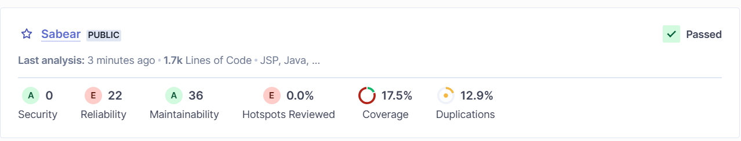

2. Create one jenkins job using the below code and create three stages.
stage1: Git clone to download the source code.
stage2: Sonarqube Integration to check the quality of code
stage3: Slack Integration to send the alerts to slack.
URL: https://github.com/betawins/hiring-app.git
First need create new item name and select free stype project press ok
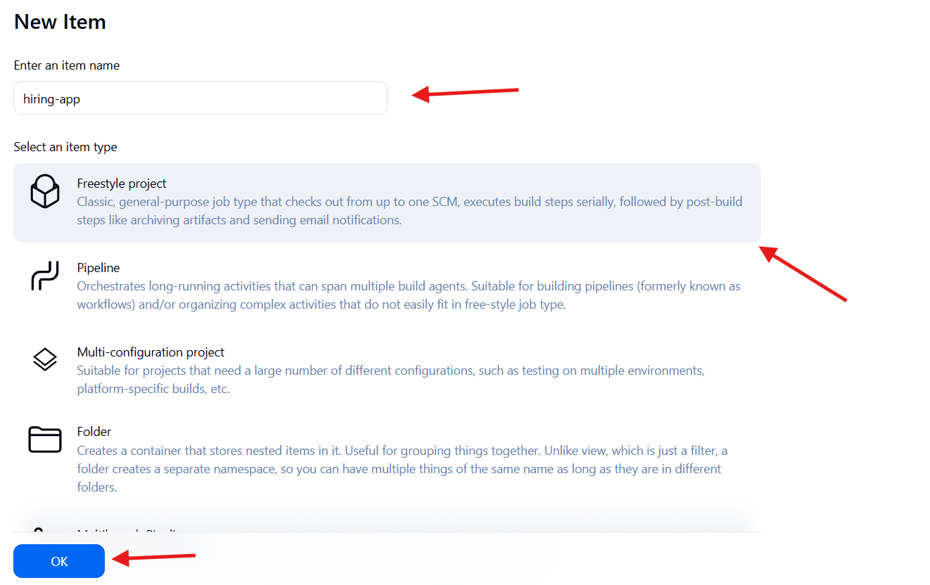
After go configuration select git url paste it git also select branch if it in branch master or main
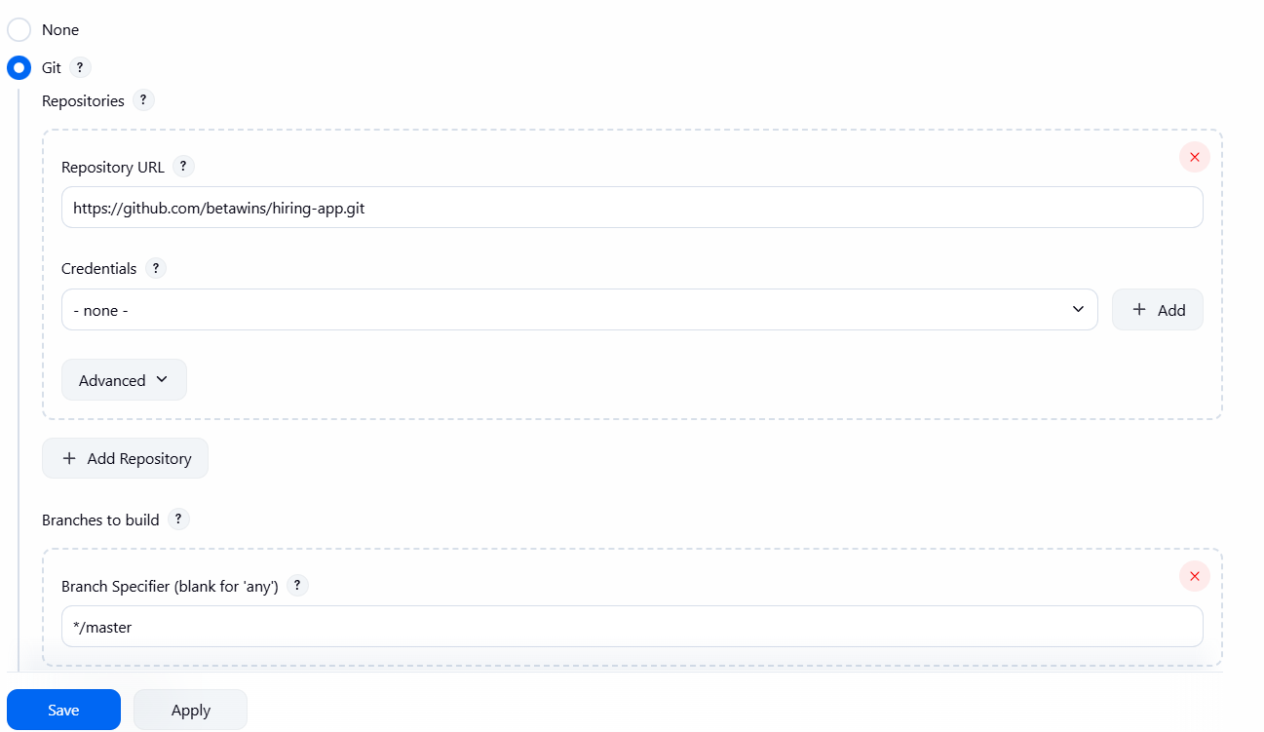
If in case don’t have code then goes sonar click on adminatraion in place of token write secret text then select global then create copy and that code paste it secrect also give it name
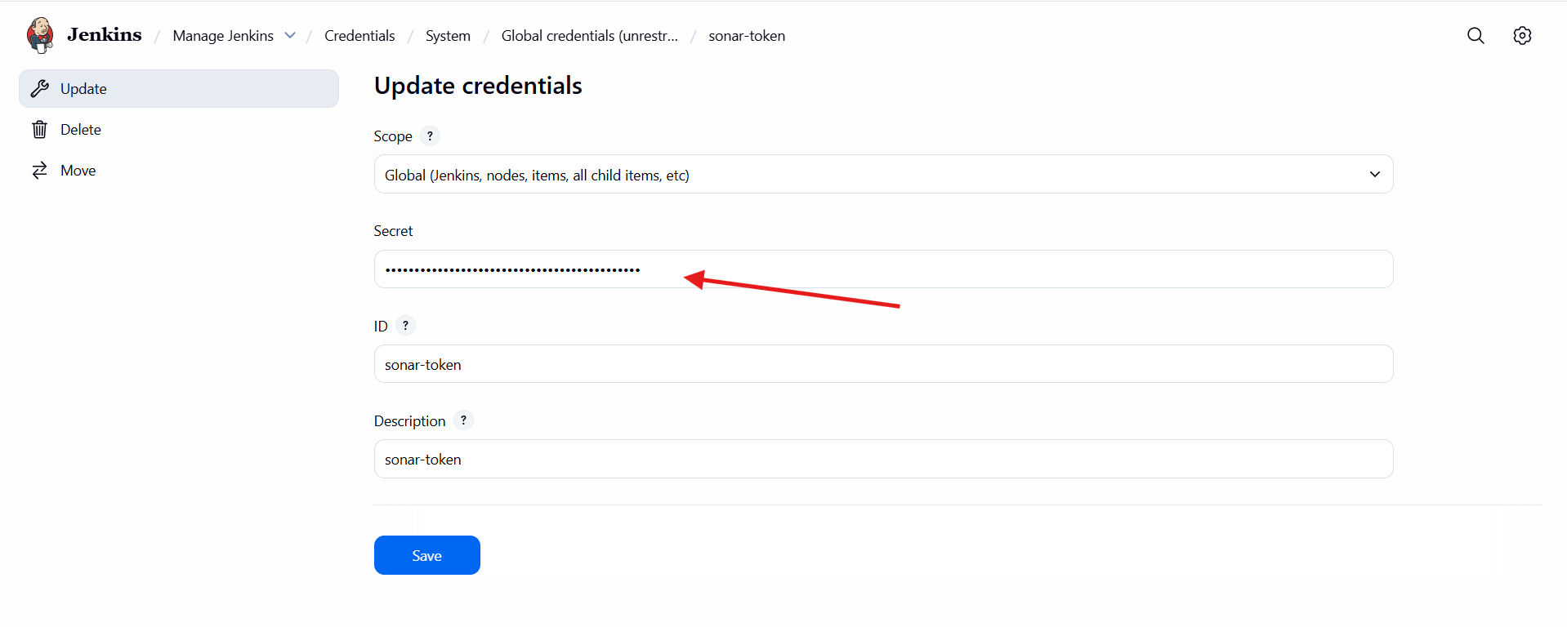
Then click on build now now it showing we successfully created
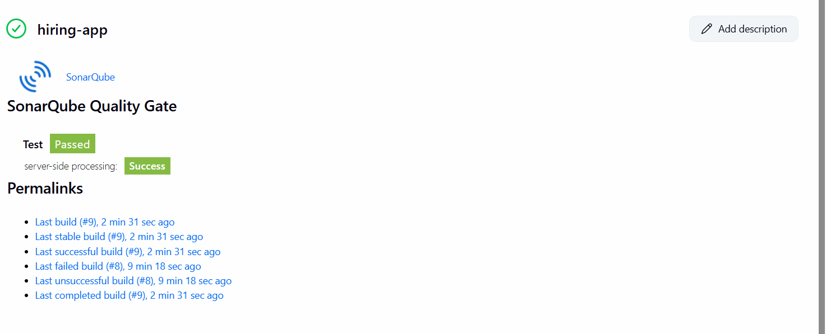
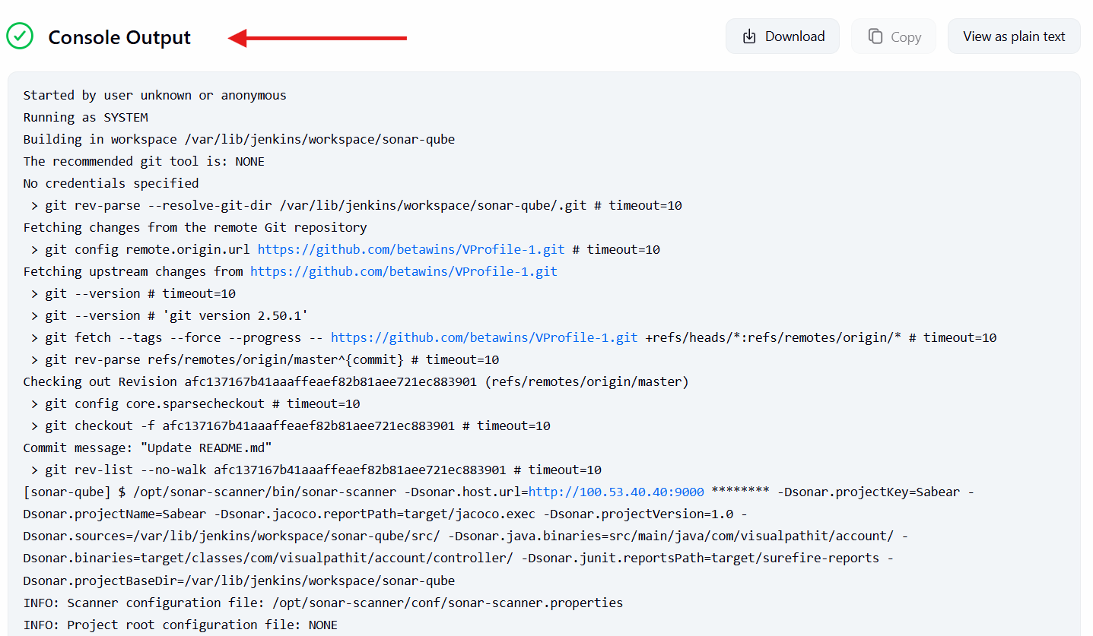
In sonar successfully showing hiring webapp showing

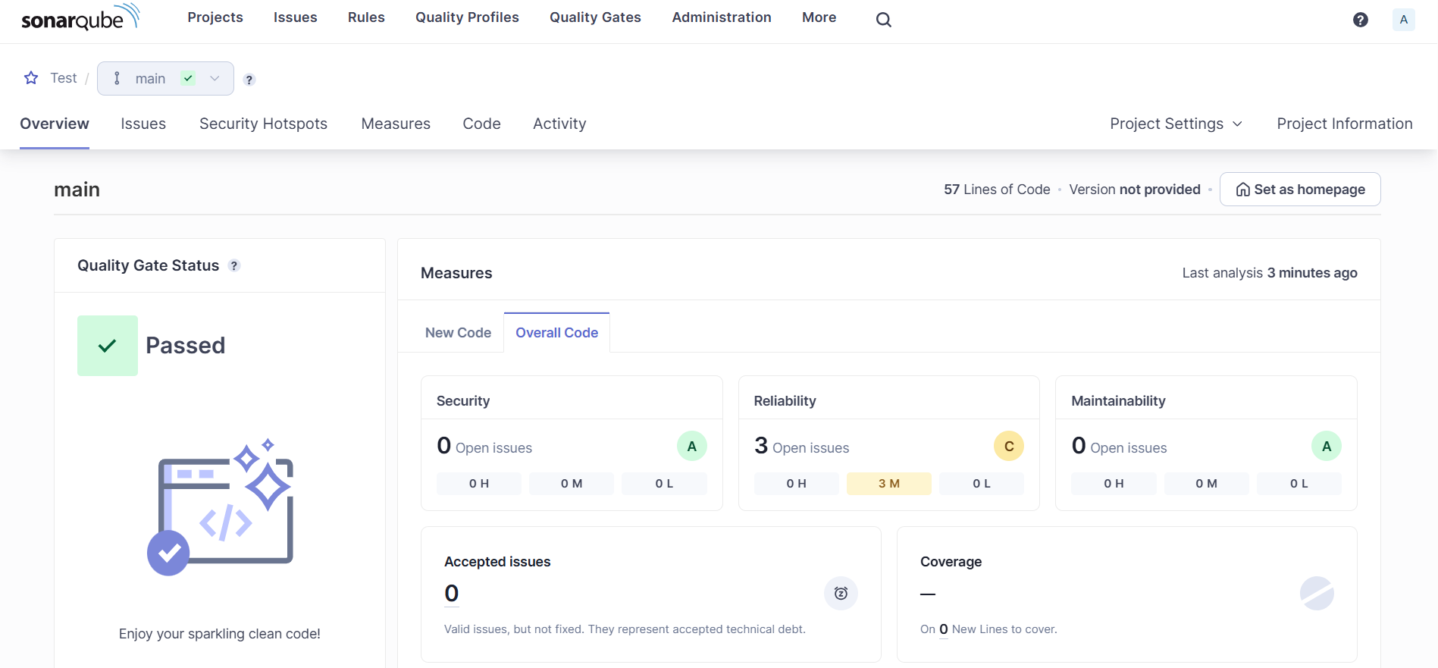
Console output
