- Deploy an application using a Deployment with 3 replicas and a rolling update strategy.

Step 1: Create Deployment YAML
Create a file:
vi rolling.yaml
Paste the following YAML:
apiVersion: apps/v1
kind: Deployment
metadata:
name: rolling-nginx
spec:
replicas: 3
strategy:
type: RollingUpdate
rollingUpdate:
maxUnavailable: 1
maxSurge: 1
selector:
matchLabels:
app: nginx-roll
template:
metadata:
labels:
app: nginx-roll
spec:
containers:
- name: nginx
image: nginx:1.25
ports:
- containerPort: 80
Save and exit.

Step 2: Apply the Deployment
- kubectl apply -f rolling.yaml
You should see:
deployment.apps/rolling-nginx created

Step 3: Verify the Pods
- kubectl get pods
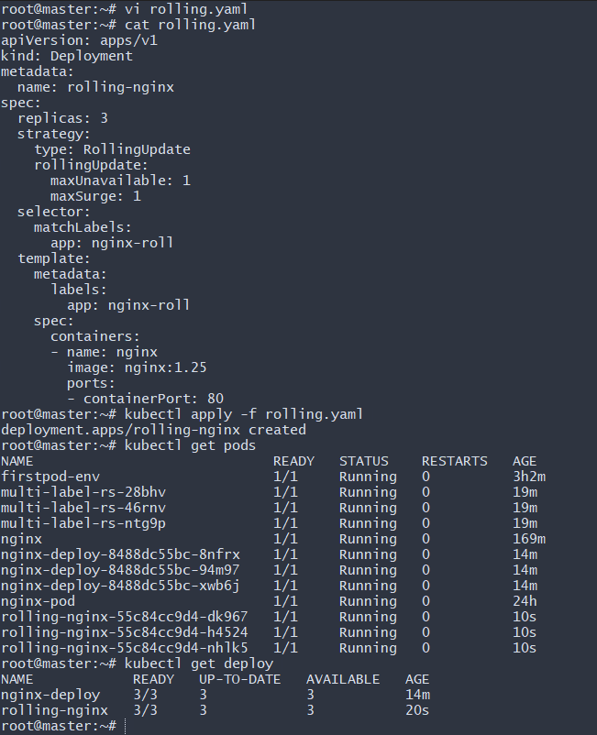
- Configure a Deployment with a Recreate strategy and observe the downtime.

Step 1: Create YAML File
vi recreate.yaml
Paste this:
apiVersion: apps/v1
kind: Deployment
metadata:
name: recreate-nginx
spec:
replicas: 3
strategy:
type: Recreate
selector:
matchLabels:
app: nginx-rec
template:
metadata:
labels:
app: nginx-rec
spec:
containers:
- name: nginx
image: nginx:1.25
ports:
- containerPort: 80
Save and exit.
Step 2: Apply the Deployment
- kubectl apply -f recreate.yaml
Output:
deployment.apps/recreate-nginx created

Step 3: Verify Deployment
- kubectl get deploy
- kubectl get pods
You should see 3 pods running:
recreate-nginx-xxxx 1/1 Running
recreate-nginx-yyyy 1/1 Running
recreate-nginx-zzzz 1/1 Running

Step 4: Update Image to Observe Recreate Behavior
Now update the image:
- kubectl set image deployment/recreate-nginx nginx=nginx:1.26
Step 5: Watch the Pods
- kubectl get pods -w
You will observe:
- All old pods go into Terminating
- Replica count becomes 0 temporarily
- Then new pods are created
- New pods move to Running
This causes downtime because:
- Old pods are deleted first
- New pods are created only after deletion
- No pods are available during that time
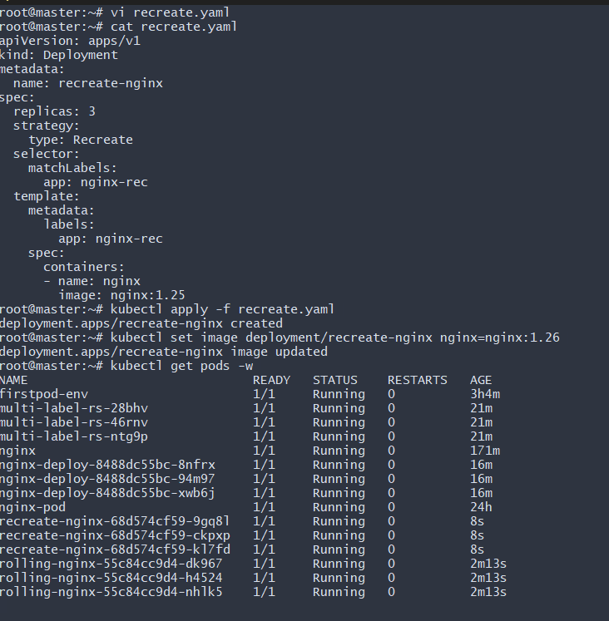
- Update an existing Deployment and perform a rollback to the previous version.

Step 1: Update the Deployment Image
Update nginx version:
- kubectl set image deployment/rolling-nginx nginx=nginx:1.26
Output:
deployment.apps/rolling-nginx image updated

Step 2: Check Rollout Status
- kubectl rollout status deployment/rolling-nginx
Output:
deployment "rolling-nginx" successfully rolled out
This confirms the new version is running.
Step 3: Check Rollout History
- kubectl rollout history deployment/rolling-nginx
Example output:
REVISION CHANGE-CAUSE
1 <none>
2 <none>
This shows:
- Revision 1 → Old version (nginx:1.25)
- Revision 2 → Updated version (nginx:1.26)
Step 4: Rollback to Previous Version
- kubectl rollout undo deployment/rolling-nginx
Output:
deployment.apps/rolling-nginx rolled back
This reverts to the previous revision automatically.
Step 5: Verify Rollback
- kubectl get deployment
or
- kubectl describe deployment rolling-nginx
You will see image reverted to:
nginx:1.25
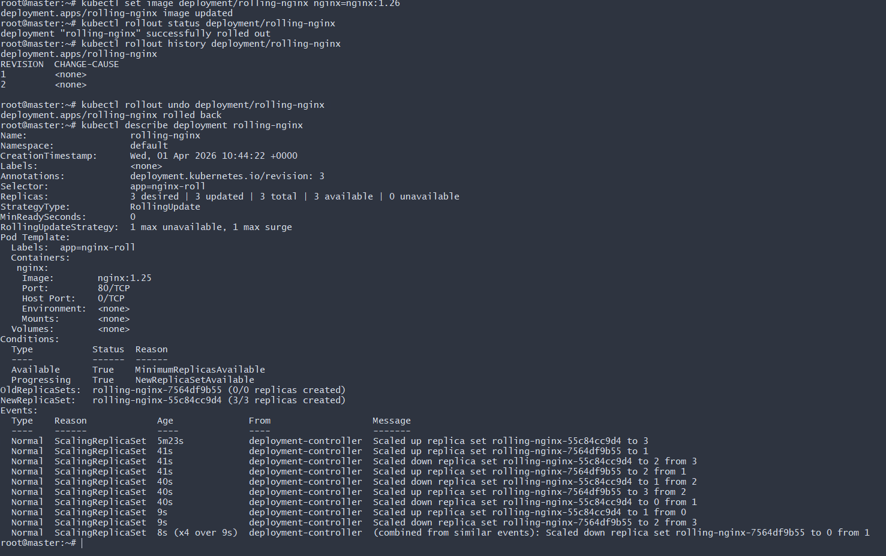
- Modify a Deployment to add resource requests and limits for CPU and memory.

Step 1: Edit or Create YAML File
vi resource-nginx.yaml
Paste this configuration:
apiVersion: apps/v1
kind: Deployment
metadata:
name: resource-nginx
spec:
replicas: 2
selector:
matchLabels:
app: nginx-res
template:
metadata:
labels:
app: nginx-res
spec:
containers:
- name: nginx
image: nginx
resources:
requests:
memory: "128Mi"
cpu: "200m"
limits:
memory: "256Mi"
cpu: "500m"
Save and exit.

Step 2: Apply the Deployment
- kubectl apply -f resource-nginx.yaml
Output:
deployment.apps/resource-nginx created

Step 3: Verify Deployment
- kubectl get deploy
- kubectl get pods
You should see 2 pods running.
Step 4: Verify Resource Configuration
Get pod name:
- kubectl get pods
Then describe the pod:
kubectl describe pod <pod-name>
You will see:
Limits:
cpu: 500m
memory: 256Mi
Requests:
cpu: 200m
memory: 128Mi
This confirms the resources are configured correctly.
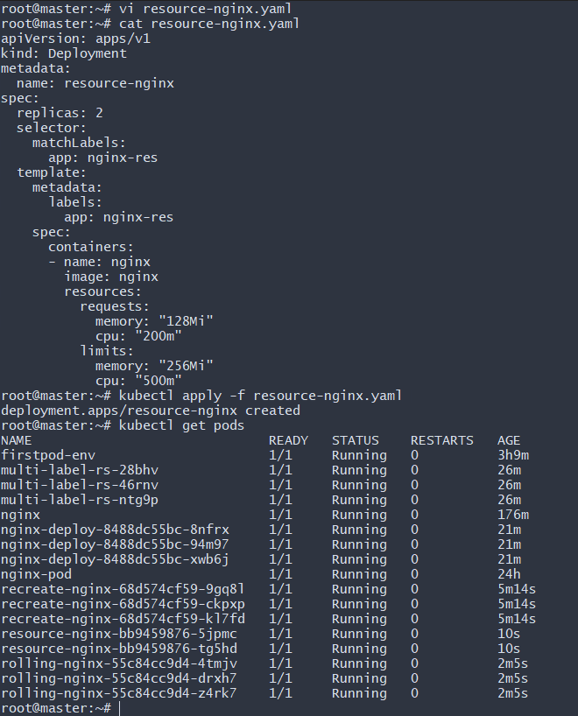
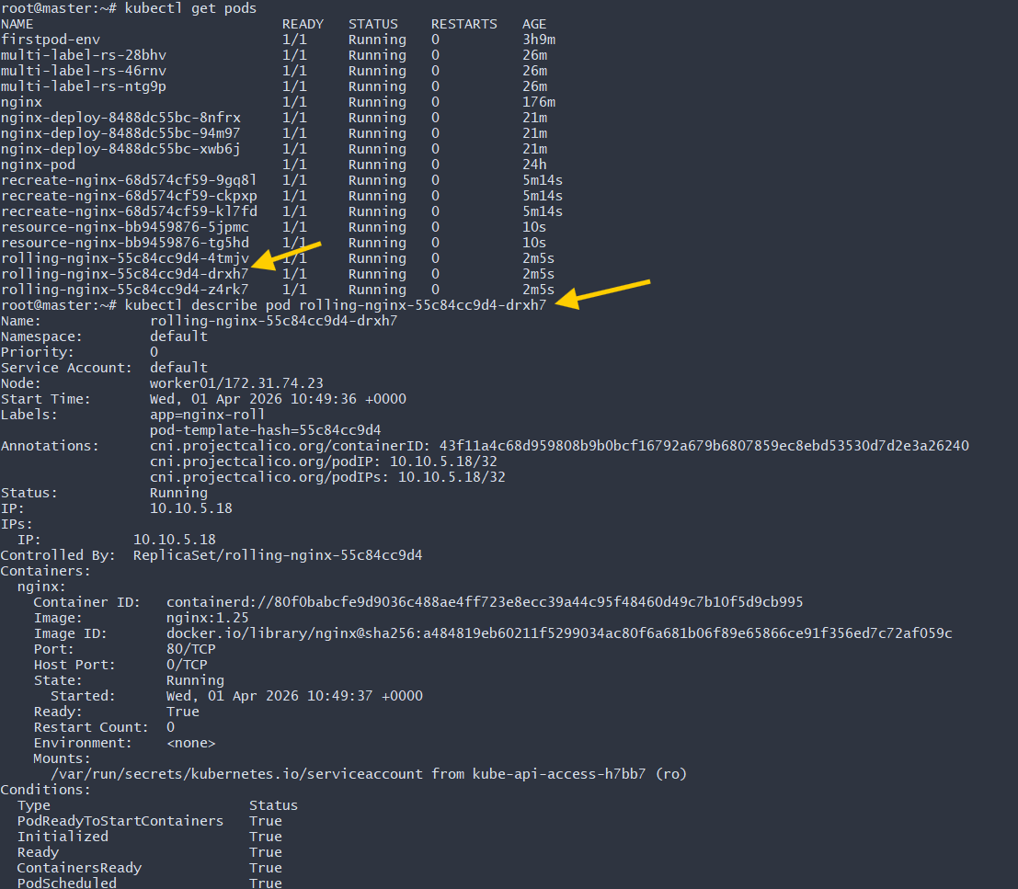
- Create a Deployment with MaxSurge and MaxUnavailable configurations.

Step 1: Create YAML File
vi surge-nginx.yaml
Paste this configuration:
apiVersion: apps/v1
kind: Deployment
metadata:
name: surge-nginx
spec:
replicas: 4
strategy:
type: RollingUpdate
rollingUpdate:
maxSurge: 1
maxUnavailable: 1
selector:
matchLabels:
app: nginx-surge
template:
metadata:
labels:
app: nginx-surge
spec:
containers:
- name: nginx
image: nginx
ports:
- containerPort: 80
Save and exit.

Step 2: Apply the Deployment
- kubectl apply -f surge-nginx.yaml
Output:
deployment.apps/surge-nginx created

Step 3: Verify Deployment
- kubectl get deploy
You should see:
NAME READY UP-TO-DATE AVAILABLE AGE
surge-nginx 4/4 4 4 10s
Step 4: Verify Pods
- kubectl get pods
You will see 4 running pods.
Step 5: Test Rolling Update Behavior
Update the image:
- kubectl set image deployment/surge-nginx nginx=nginx:1.26
Watch pods:
- kubectl get pods -w
What You Will Observe
Because:
replicas: 4
maxSurge: 1
maxUnavailable: 1
During update:
- Kubernetes can create 1 extra pod → Total = 5 temporarily
- Only 1 pod can be unavailable
- Pods are replaced one by one
- No downtime
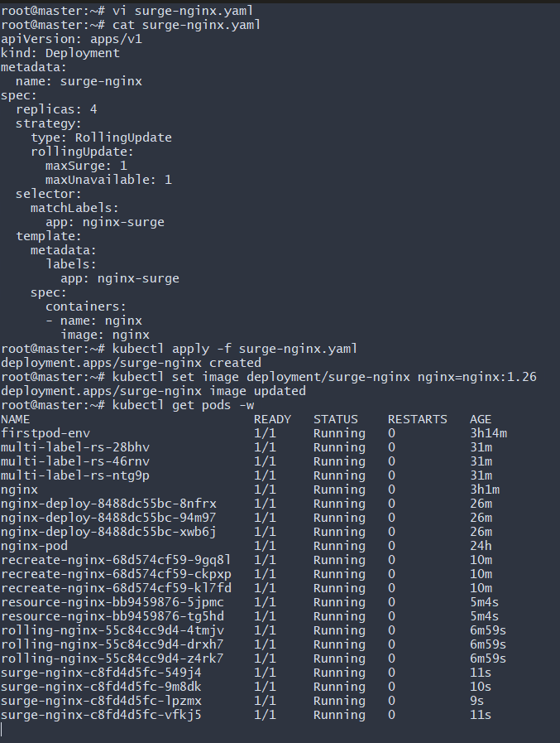
- Set up a Deployment with a custom revision history limit.

Step 1: Create YAML File
vi history-nginx.yaml
Paste this configuration:
apiVersion: apps/v1
kind: Deployment
metadata:
name: history-nginx
spec:
revisionHistoryLimit: 3
replicas: 2
selector:
matchLabels:
app: nginx-hist
template:
metadata:
labels:
app: nginx-hist
spec:
containers:
- name: nginx
image: nginx
ports:
- containerPort: 80
Save and exit.
Step 2: Apply the Deployment
- kubectl apply -f history-nginx.yaml
Verify:
- kubectl get deploy
Step 3: Check ReplicaSets
- kubectl get rs
You will see one ReplicaSet initially.
Step 4: Generate Multiple Revisions
Update image multiple times:
- kubectl set image deployment/history-nginx nginx=nginx:1.25
- kubectl set image deployment/history-nginx nginx=nginx:1.26
- kubectl set image deployment/history-nginx nginx=nginx:1.27
- kubectl set image deployment/history-nginx nginx=nginx:1.28
Each command creates a new revision.
Step 5: Check ReplicaSets Again
- kubectl get rs
You will notice:
- Only the latest 3 old ReplicaSets are retained
- Older ones are automatically deleted
Because:
revisionHistoryLimit: 3

Step 6: Check Rollout History
kubectl rollout history deployment/history-nginx
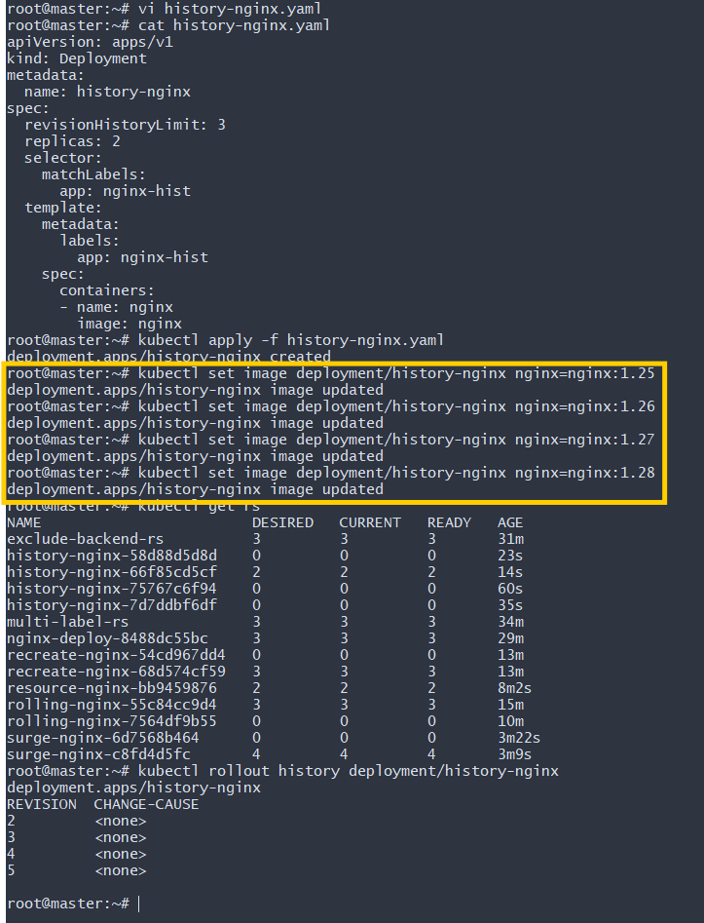
- Pause a Deployment during an update and then resume it.

Step 1: Pause the Deployment
- kubectl rollout pause deployment/rolling-nginx
Output:
deployment.apps/rolling-nginx paused
Now the Deployment will not perform rollout changes.
Step 2: Update the Image While Paused
- kubectl set image deployment/rolling-nginx nginx=nginx:1.27
Output:
deployment.apps/rolling-nginx image updated
Important:
Even though the image is updated, no new pods are created yet because the Deployment is paused.
Verify:
- kubectl get pods
Pods remain unchanged.

Step 3: Resume the Deployment
- kubectl rollout resume deployment/rolling-nginx
Output:
deployment.apps/rolling-nginx resumed
Now Kubernetes starts the rolling update.
Step 4: Verify Rollout
- kubectl rollout status deployment/rolling-nginx
You should see:
deployment "rolling-nginx" successfully rolled out
What Happens Internally?
Action | Behavior
Pause | Stops rollout process
Update image | Changes spec but does not create new ReplicaSet
Resume | Triggers rollout with updated configuration
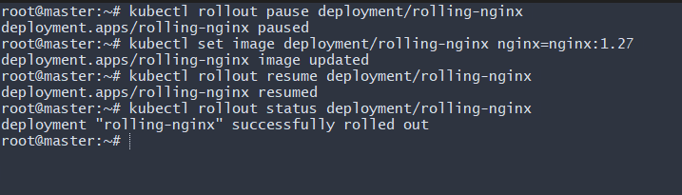
- Create a pod using resource requests for memory and CPU and observe how the scheduler assigns it to a node.

Step 1: Create Pod YAML
vi pod.yaml
Paste this:
apiVersion: v1
kind: Pod
metadata:
name: resource-pod
spec:
containers:
- name: nginx
image: nginx
resources:
requests:
memory: "256Mi"
cpu: "500m"
limits:
memory: "512Mi"
cpu: "1"
Save and exit.

Step 2: Create the Pod
- kubectl apply -f pod.yaml
Output:
pod/resource-pod created

Step 3: Observe Scheduling
Check pod with node details:
- kubectl get pods -o wide
You will see:
NAME READY STATUS IP NODE
resource-pod 1/1 Running 10.10.x.x worker02

Step 4: Verify Resource Allocation
Describe the pod:
- kubectl describe pod resource-pod
You will see:
Requests:
cpu: 500m
memory: 256Mi
Limits:
cpu: 1
memory: 512Mi
Node: worker02
