- Create a namespace dev-environment and apply a resource-based quota that restricts the number of pods to 3 and services to 2.

Step 1: Create Namespace
- kubectl create namespace dev-environment
Verify:
- kubectl get namespaces
You should see:
dev-environment Active
Step 2: Create ResourceQuota YAML File
Create a file:
- vi quota.yaml
Add the following YAML:
apiVersion: v1
kind: ResourceQuota
metadata:
name: dev-quota
namespace: dev-environment
spec:
hard:
pods: "3"
services: "2"
Save and exit.
Step 3: Apply the ResourceQuota
- kubectl apply -f quota.yaml
Expected output:
resourcequota/dev-quota created
Step 4: Verify the Quota
- kubectl get quota -n dev-environment
Detailed check:
- kubectl describe quota dev-quota -n dev-environment
You should see:
Resource Used Hard
pods 0 3
services 0 2
Step 5: Test the Quota (Optional – Like in Image)
Create 3 pods:
- kubectl run pod1 --image=nginx -n dev-environment
kubectl run pod2 --image=nginx -n dev-environment
kubectl run pod3 --image=nginx -n dev-environment
Try creating a 4th pod:
- kubectl run pod4 --image=nginx -n dev-environment
You will get:
Error from server (Forbidden): exceeded quota: dev-quota, requested: pods=1, used: pods=3, limited:
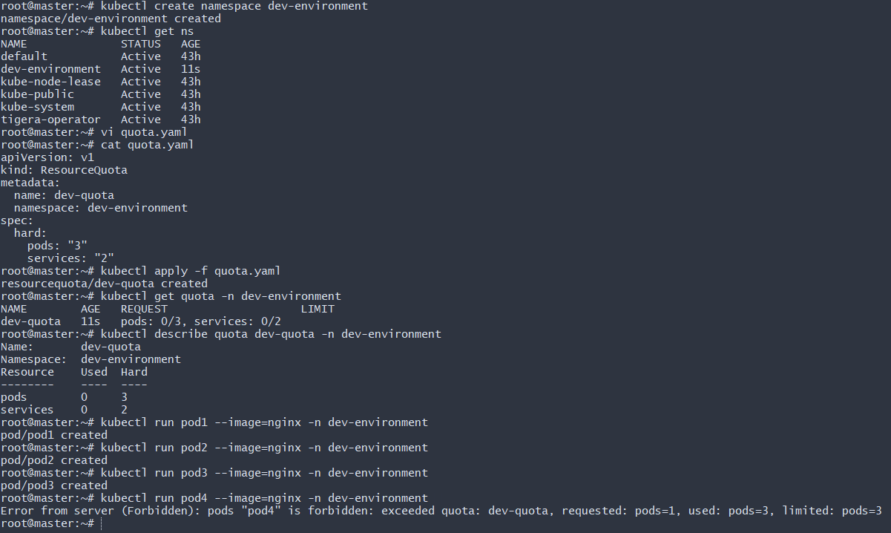
- Create a pod in the prod-environment namespace with 0.2 CPU and 200Mi memory requests, and 0.5 CPU and 500Mi memory limits.

Step 1: Create Namespace
- kubectl create namespace prod-environment
Verify:
- kubectl get ns
Step 2: Create Pod YAML File
Create file:
vi prod-pod.yaml
Add the following YAML:
apiVersion: v1
kind: Pod
metadata:
name: prod-pod
namespace: prod-environment
spec:
containers:
- name: nginx
image: nginx
resources:
requests:
cpu: "200m"
memory: "200Mi"
limits:
cpu: "500m"
memory: "500Mi"
Explanation
- 200m = 0.2 CPU
- 500m = 0.5 CPU
- 200Mi = 200 Megabytes memory
- 500Mi = 500 Megabytes memory
Step 3: Apply the Pod
- kubectl apply -f prod-pod.yaml
Expected Output:
pod/prod-pod created
Step 4: Verify Pod Resources
- kubectl describe pod prod-pod -n prod-environment
You should see:
Requests:
cpu: 200m
memory: 200Mi
Limits:
cpu: 500m
memory: 500Mi
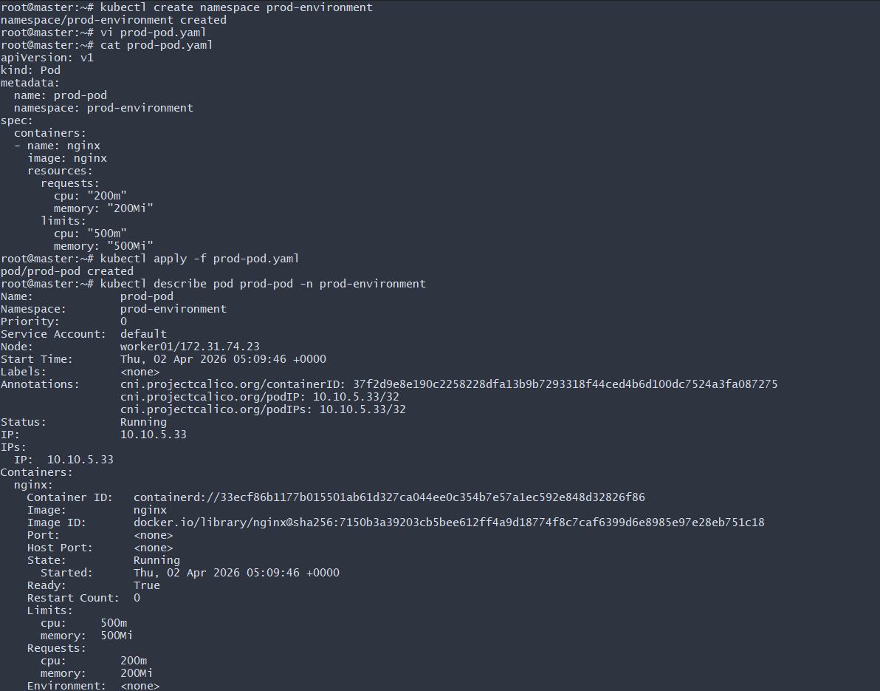
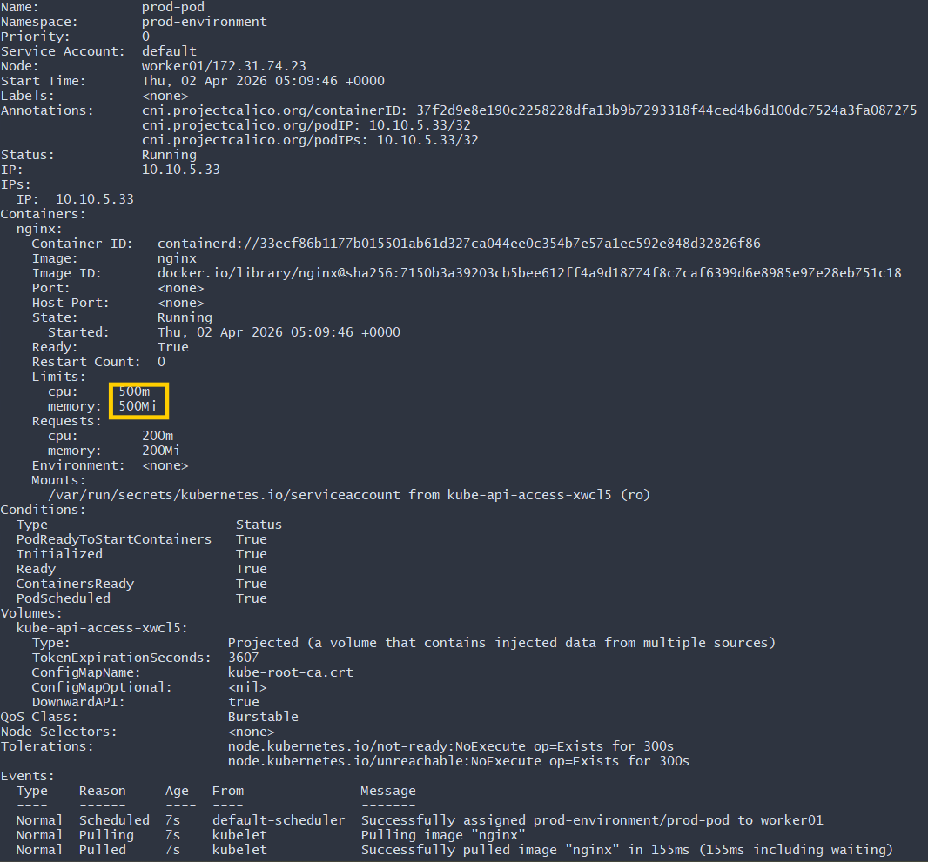
- In the staging-environment namespace, set a LimitRange that assigns default CPU and memory limits (300m CPU, 600Mi memory) and applies a minimum and maximum CPU.

Step 1: Create Namespace
- kubectl create namespace staging-environment
Verify:
- kubectl get ns
Step 2: Create LimitRange YAML File
Create file:
vi limitrange.yaml
Add the following YAML:
apiVersion: v1
kind: LimitRange
metadata:
name: staging-limits
namespace: staging-environment
spec:
limits:
- type: Container
default:
cpu: "300m"
memory: "600Mi"
defaultRequest:
cpu: "200m"
memory: "300Mi"
min:
cpu: "100m"
max:
cpu: "1000m"
What This Does
- Default Limit:
  - CPU: 300m
  - Memory: 600Mi
- Default Request:
  - CPU: 200m
  - Memory: 300Mi
- Minimum CPU allowed: 100m
- Maximum CPU allowed: 1000m (1 CPU)
If a pod is created without specifying resources, these defaults will be applied automatically.
Step 3: Apply the LimitRange
- kubectl apply -f limitrange.yaml
Expected output:
limitrange/staging-limits created
Step 4: Verify LimitRange
- kubectl describe limitrange -n staging-environment
You should see something like:
Type Resource Min Max Default Request Default Limit
Container cpu 100m 1 200m 300m
Container memory - - 300Mi 600Mi
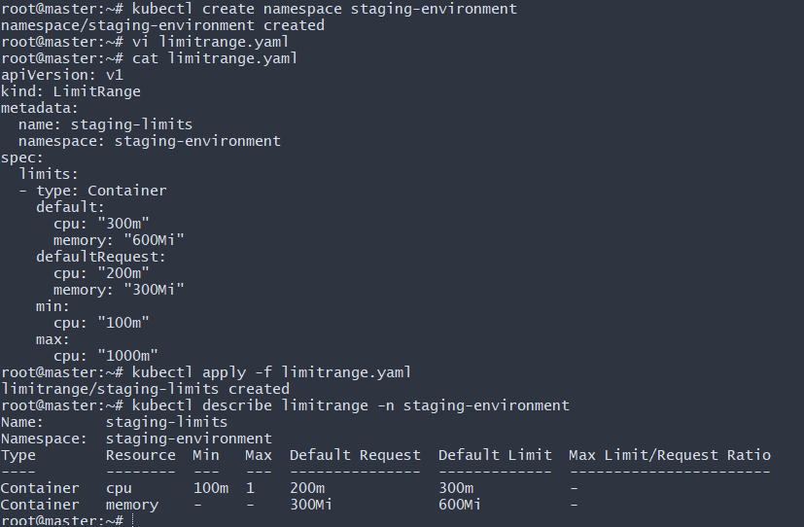
- Create a pod and a NodePort service in the default namespace, then create another pod in the test namespace and communicate between them using Service DNS.

PART 1 — Create Pod in Default Namespace
🔹 Step 1: Verify default namespace is empty
- kubectl get pods -n default
kubectl get svc -n default
No resources found in default namespace.
🔹 Step 2: Create nginx Pod YAML
vi nginx-pod.yaml
Add:
apiVersion: v1
kind: Pod
metadata:
name: nginx-pod
labels:
app: nginx
spec:
containers:
- name: nginx
image: nginx
ports:
- containerPort: 80
🔹 Step 3: Apply Pod
- kubectl apply -f nginx-pod.yaml
Verify:
- kubectl get pods -n default -o wide
You should see:
nginx-pod Running <IP> worker01
PART 2 — Create NodePort Service in Default Namespace
🔹 Step 4: Create Service YAML
vi nginx-service.yaml
Add:
apiVersion: v1
kind: Service
metadata:
name: nginx-service
spec:
type: NodePort
selector:
app: nginx
ports:
- port: 80
targetPort: 80
nodePort: 30007

🔹 Step 5: Apply Service
- kubectl apply -f nginx-service.yaml
Verify:
- kubectl get svc -n default
Output:
nginx-service NodePort 10.100.16.30 80:30007/TCP
🔹 Step 6: Verify Endpoints
- kubectl get endpoints nginx-service -n default
Output:
nginx-service 10.10.5.17:80
That confirms:
Service selector matches pod label
Service is routing traffic to pod
🔹 Step 7: Test from Browser (NodePort)
Open:
http://<NodePublicIP>:30007
Example from your image:
http://3.236.229.79:30007
You see:
Welcome to nginx!
NodePort working
PART 3 — Create test Namespace
🔹 Step 8: Create test namespace
- kubectl create namespace test
Verify:
- kubectl get ns
PART 4 — Create Test Pod in test Namespace
🔹 Step 9: Create BusyBox Pod
vi test-pod.yaml
Add:
apiVersion: v1
kind: Pod
metadata:
name: test-pod
namespace: test
spec:
containers:
- name: busybox
image: busybox
command: ["sleep", "3600"]
Apply:
- kubectl apply -f test-pod.yaml
Verify:
- kubectl get pods -n test
PART 5 — Communicate Using Service DNS

🔹 Step 10: Enter test pod
- kubectl exec -it test-pod -n test -- sh
🔹 Step 11: Try Service DNS (Failed in BusyBox)
wget -qO- http://nginx-service.default
or
wget -qO- http://nginx-service.default.svc.cluster.local
BusyBox returned:
bad address
This is BusyBox DNS limitation.
🔹 Step 12: Verify DNS Config
Inside pod:
- cat /etc/resolv.conf
saw:
search test.svc.cluster.local svc.cluster.local cluster.local
nameserver 10.96.0.10
CoreDNS working
DNS search domains correct
🔹 Step 13: Test Using ClusterIP (Worked)
Get service IP:
kubectl get svc nginx-service -n default
Example:
10.100.16.30
Inside test pod:
wget -qO- http://10.100.16.30
Output:
Welcome to nginx!
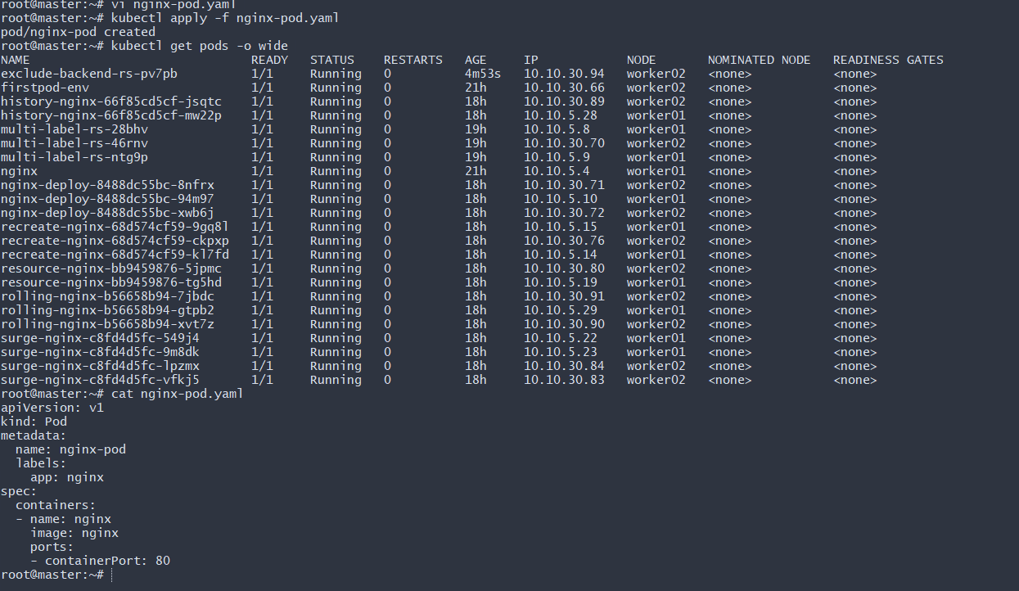

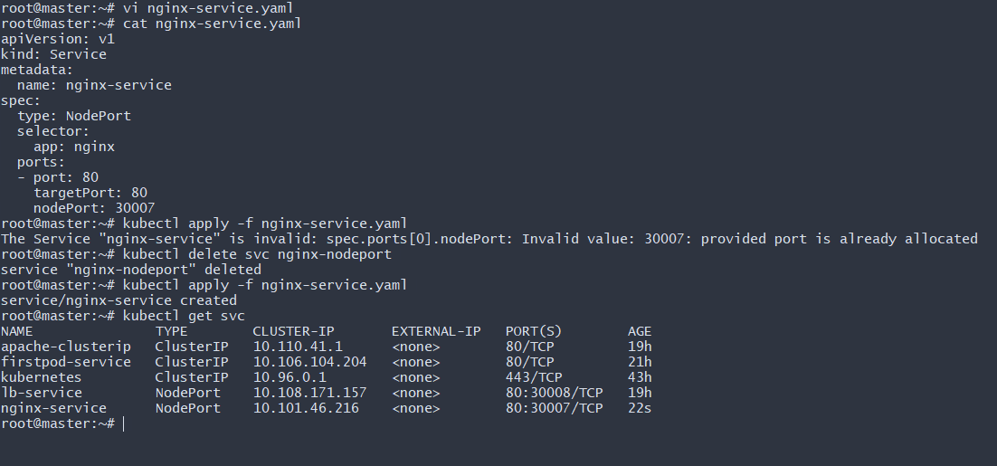
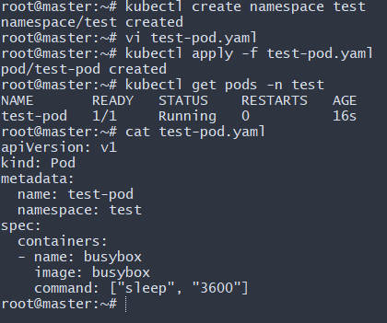
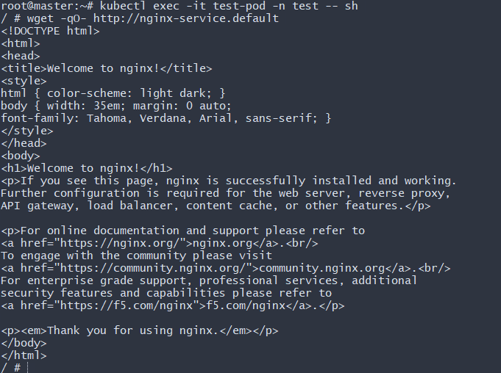
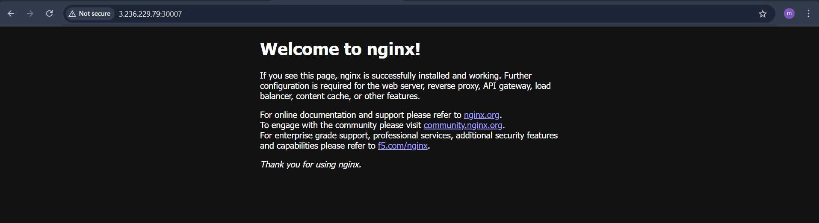
- Apply a LimitRange with a max limit/request ratio of 2 for memory in the performance-environment namespace, and test by creating a pod with mismatched resource requests and limits.

Step 1: Create Namespace
- kubectl create namespace performance-environment
Verify:
- kubectl get ns
Step 2: Create LimitRange with Max Limit/Request Ratio = 2 (Memory)
Create file:
vi performance-limitrange.yaml
Add the following YAML:
apiVersion: v1
kind: LimitRange
metadata:
name: performance-limits
namespace: performance-environment
spec:
limits:
- type: Container
maxLimitRequestRatio:
memory: "2"
What This Means
Memory limit cannot be more than 2 times the memory request.
Example:
- Request = 200Mi
- Max Limit allowed = 400Mi
Step 3: Apply the LimitRange
- kubectl apply -f performance-limitrange.yaml
Verify:
- kubectl describe limitrange performance-limits -n performance-environment
You should see:
Type Resource Max Limit/Request Ratio
Container memory 2

Step 4: Test with Incorrect Pod (Should Fail)
Create file:
vi bad-pod.yaml
Add:
apiVersion: v1
kind: Pod
metadata:
name: bad-pod
namespace: performance-environment
spec:
containers:
- name: nginx
image: nginx
resources:
requests:
memory: "200Mi"
limits:
memory: "800Mi"
Apply:
- kubectl apply -f bad-pod.yaml
Expected Error:
Error from server (Forbidden): pods "bad-pod" is forbidden:
memory max limit to request ratio per container is 2, but provided ratio is 4
Because:
800Mi / 200Mi = 4 (greater than allowed ratio 2)
Step 5: Create Correct Pod (Should Work)
Create file:
vi good-pod.yaml
Add:
apiVersion: v1
kind: Pod
metadata:
name: good-pod
namespace: performance-environment
spec:
containers:
- name: nginx
image: nginx
resources:
requests:
memory: "200Mi"
limits:
memory: "400Mi"
Apply:
- kubectl apply -f good-pod.yaml
Verify:
- kubectl get pods -n performance-environment
Expected:
good-pod Running
Final Summary
LimitRange enforces:
memory limit ≤ 2 × memory request
- 800Mi / 200Mi = 4 → Rejected
- 400Mi / 200Mi = 2 → Accepted
