KUBERNETS – TASK -06

- Create a ConfigMap from a directory containing multiple files and inject the variables into a pod as environment variables.

Step 1: Create directory with multiple files
- mkdir app-config
- echo "DB_HOST=localhost" > app-config/db.env
- echo "APP_MODE=production" > app-config/app.env

Step 2: Create ConfigMap from directory
- kubectl create configmap app-config --from-file=app-config/
Verify:
- kubectl get configmap app-config -o yaml
Step 3: Inject ConfigMap as Environment Variables in Pod
apiVersion: v1
kind: Pod
metadata:
name: configmap-env-pod
spec:
containers:
- name: nginx
image: nginx
envFrom:
- configMapRef:
name: app-config
Apply:
- kubectl apply -f pod.yaml
Check inside pod:
- kubectl exec -it configmap-env-pod – printenv
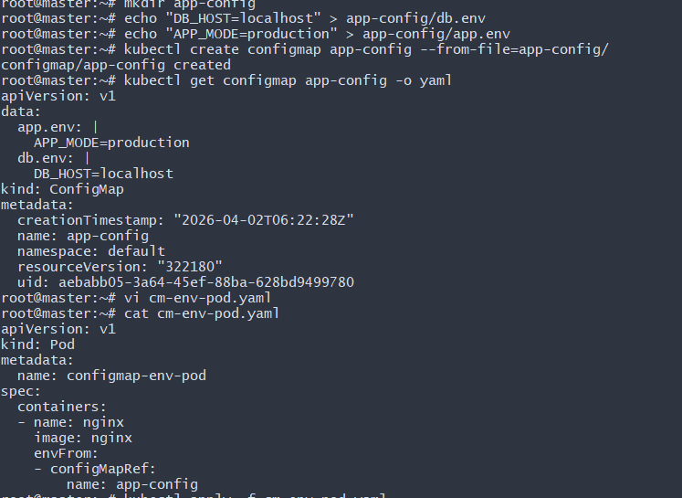
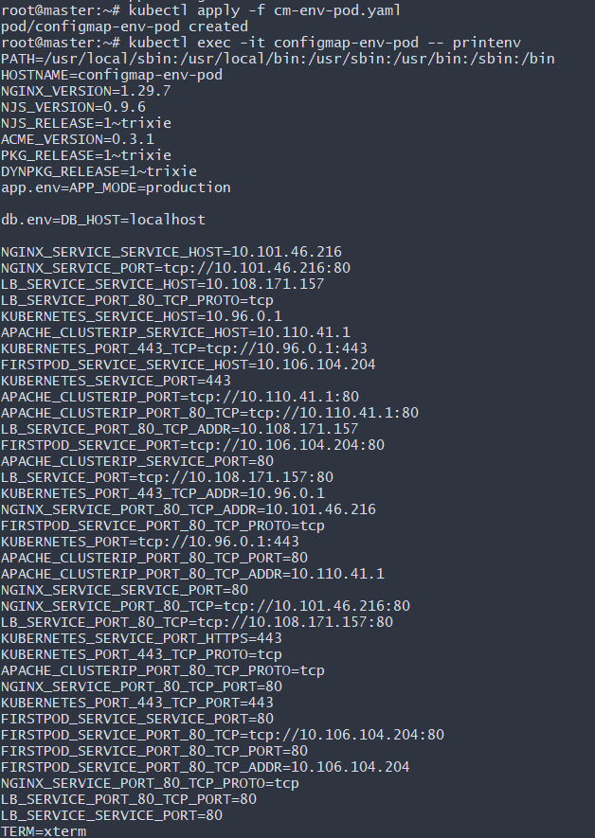
- Create a ConfigMap from a file and mount it as a volume inside a pod, ensuring the configuration data is available as files.

Step 1: Create configuration file
echo "server.port=8080" > app.properties
Step 2: Create ConfigMap from file
kubectl create configmap app-file-config --from-file=app.properties
Step 3: Mount ConfigMap as Volume in Pod
apiVersion: v1
kind: Pod
metadata:
name: configmap-volume-pod
spec:
containers:
- name: nginx
image: nginx
volumeMounts:
- name: config-volume
mountPath: /etc/config
volumes:
- name: config-volume
configMap:
name: app-file-config
Apply:
- kubectl apply -f pod.yaml
Verify:
- kubectl exec -it configmap-volume-pod -- ls /etc/config
kubectl exec -it configmap-volume-pod -- cat /etc/config/app.properties
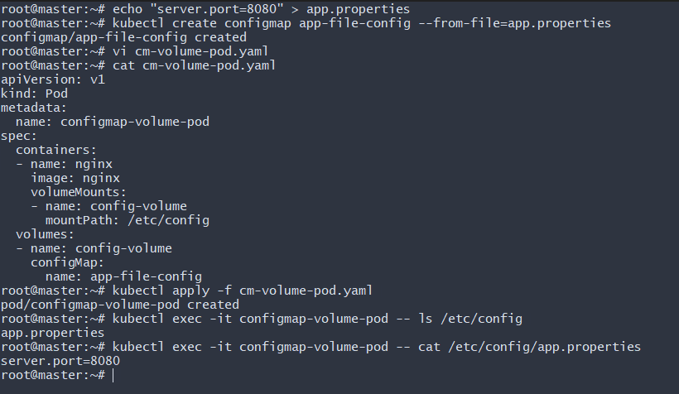
- Create a Secret with sensitive information (username and password) and inject it into a pod as environment variables.

Step 1: Create Secret
- kubectl create secret generic db-secret \
--from-literal=username=admin \
--from-literal=password=MyStrongPass123
Verify:
- kubectl get secret db-secret -o yaml

Step 2: Inject Secret into Pod as Environment Variables
apiVersion: v1
kind: Pod
metadata:
name: secret-env-pod
spec:
containers:
- name: nginx
image: nginx
env:
- name: DB_USER
valueFrom:
secretKeyRef:
name: db-secret
key: username
- name: DB_PASS
valueFrom:
secretKeyRef:
name: db-secret
key: password
Apply:
- kubectl apply -f pod.yaml
Verify:
- kubectl exec -it secret-env-pod -- printenv | grep DB
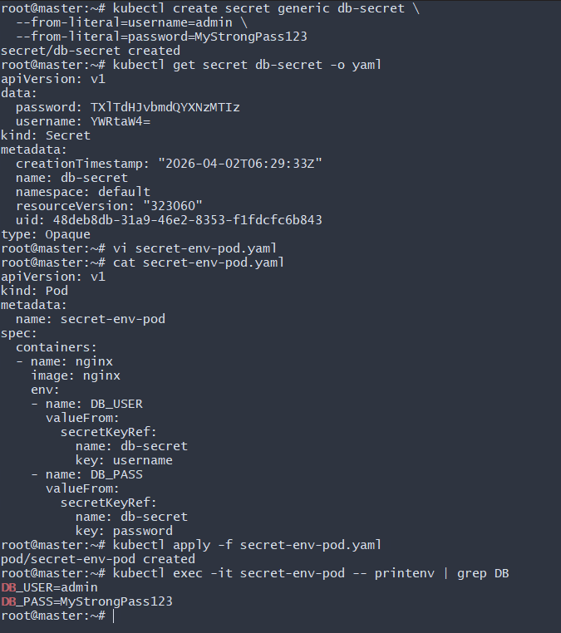
- Create a Secret using a YAML file, mount it as a volume in a pod, and verify the specific Secret values are available as files.

Step 1: Encode values in Base64
- echo -n 'admin' | base64
echo -n 'MyStrongPass123' | base64

Step 2: Secret YAML
apiVersion: v1
kind: Secret
metadata:
name: yaml-secret
type: Opaque
data:
username: YWRtaW4=
password: TXlTdHJvbmdQYXNzMTIz
Apply:
- kubectl apply -f secret.yaml
Step 3: Mount Secret as Volume
apiVersion: v1
kind: Pod
metadata:
name: secret-volume-pod
spec:
containers:
- name: nginx
image: nginx
volumeMounts:
- name: secret-volume
mountPath: /etc/secret
readOnly: true
volumes:
- name: secret-volume
secret:
secretName: yaml-secret
Apply and verify:
- kubectl exec -it secret-volume-pod -- ls /etc/secret
kubectl exec -it secret-volume-pod -- cat /etc/secret/username
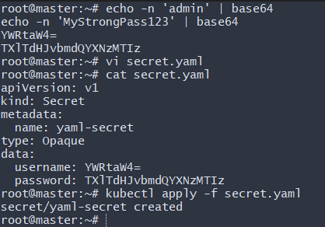
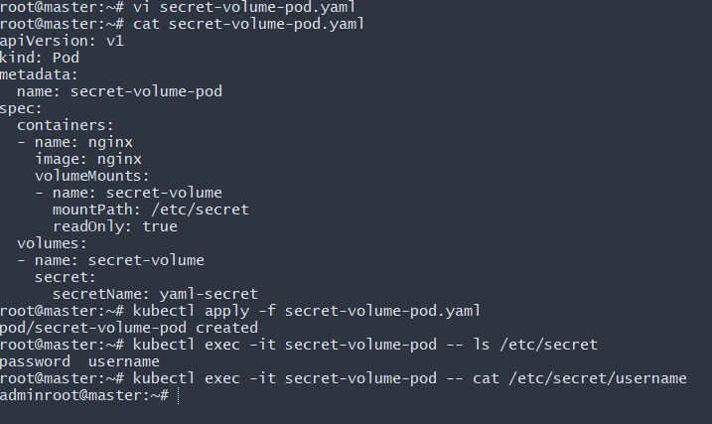
- Inject a ConfigMap as environment variables and a Secret as files into the same pod, ensuring both are accessible within the pod.

vi combined.yaml
apiVersion: v1
kind: Pod
metadata:
name: combined-pod
spec:
containers:
- name: nginx
image: nginx
envFrom:
- configMapRef:
name: app-config
volumeMounts:
- name: secret-volume
mountPath: /etc/secret
readOnly: true
volumes:
- name: secret-volume
secret:
secretName: yaml-secret
Apply:
- kubectl apply -f combined.yaml

Verify Both Are Accessible
Check environment variables:
- kubectl exec -it combined-pod -- printenv
Check secret files:
- kubectl exec -it combined-pod -- ls /etc/secret
