KUBERNETES - TASK -07

Task 1: Execute all yaml files shown in video.

— Taint worker01 and Run Pod Using Toleration (Equal)
Step 1: Add Taint to worker01
- kubectl taint nodes worker01 special=true:NoSchedule
Verify:
- kubectl describe node worker01 | grep Taints
You should see:
special=true:NoSchedule
Step 2: Create Pod with Equal Operator
VI pod-equal.yaml
apiVersion: v1
kind: Pod
metadata:
name: pod-equal
spec:
containers:
- name: nginx
image: nginx
tolerations:
- key: "special"
operator: "Equal"
value: "true"
effect: "NoSchedule"
Apply:
- kubectl apply -f pod-equal.yaml
Check:
- kubectl get pods -o wide
Pod should run on worker01
— Toleration Using Exists
📄 pod-exists.yaml
apiVersion: v1
kind: Pod
metadata:
name: pod-exists
spec:
containers:
- name: nginx
image: nginx
tolerations:
- key: "special"
operator: "Exists"
effect: "NoSchedule"
Apply:
- kubectl apply -f pod-exists.yaml
kubectl get pods -o wide
Will also run on worker01.
NoExecute Taint (Pod gets removed)
Step 1: Add NoExecute Taint
- kubectl taint nodes worker02 special=true:NoExecute
Step 2: Create Pod with tolerationSeconds
📄 pod-noexecute.yaml
apiVersion: v1
kind: Pod
metadata:
name: pod-noexecute
spec:
containers:
- name: nginx
image: nginx
tolerations:
- key: "special"
operator: "Exists"
effect: "NoExecute"
tolerationSeconds: 60
Apply:
- kubectl apply -f pod-noexecute.yaml
kubectl get pods -o wide
After 60 seconds → Pod will terminate automatically.
— Remove Taint (Untaint)
Remove NoSchedule:
- kubectl taint nodes worker01 special=true:NoSchedule-
Remove NoExecute:
- kubectl taint nodes worker02 special=true:NoExecute-
Node Selector
Step 1: Add Label to worker02
- kubectl label nodes worker02 env=prod
Verify:
- kubectl get nodes --show-labels
Step 2: Pod YAML with NodeSelector
pod-nodeselector.yaml
apiVersion: v1
kind: Pod
metadata:
name: pod-nodeselector
spec:
containers:
- name: nginx
image: nginx
nodeSelector:
env: prod
Apply:
kubectl apply -f pod-nodeselector.yaml
kubectl get pods -o wide
Pod will run only on worker02
Node Affinity (Hard Rule)
pod-affinity-required.yaml
apiVersion: v1
kind: Pod
metadata:
name: pod-affinity-required
spec:
containers:
- name: nginx
image: nginx
affinity:
nodeAffinity:
requiredDuringSchedulingIgnoredDuringExecution:
nodeSelectorTerms:
- matchExpressions:
- key: env
operator: In
values:
- prod
Apply:
- kubectl apply -f pod-affinity-required.yaml
Runs only on worker02
If label removed → pod becomes Pending
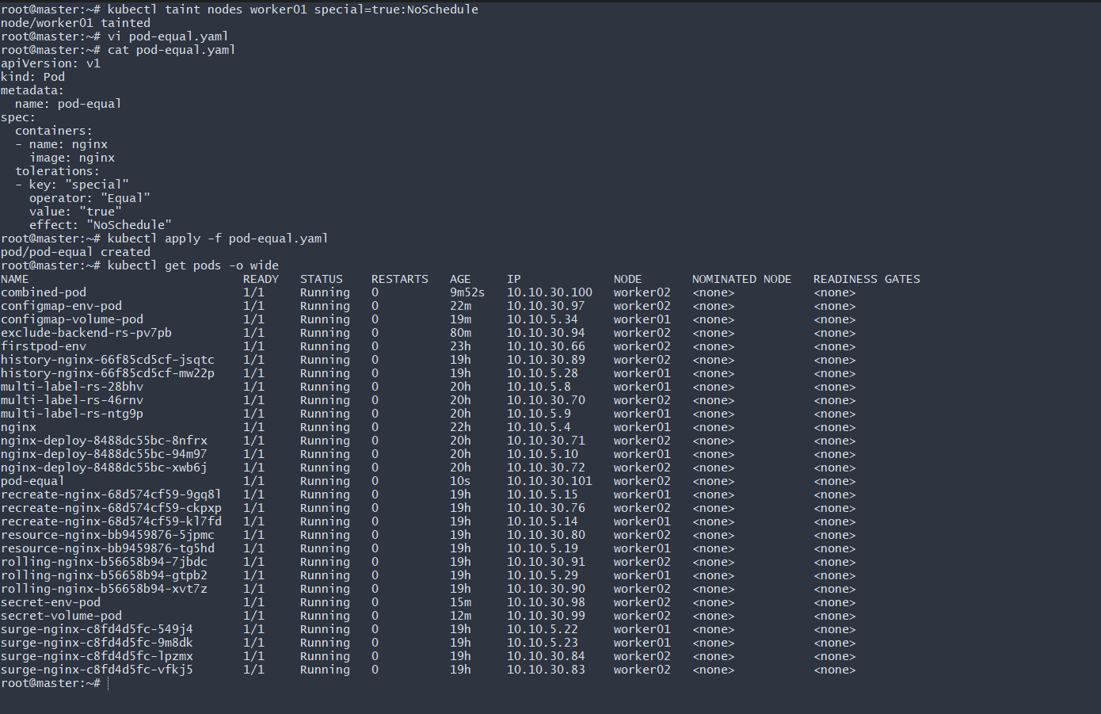
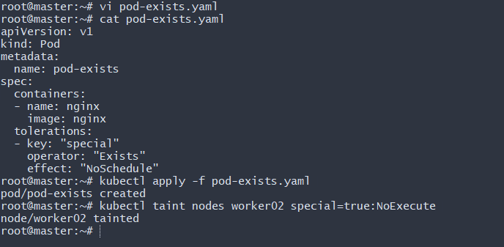
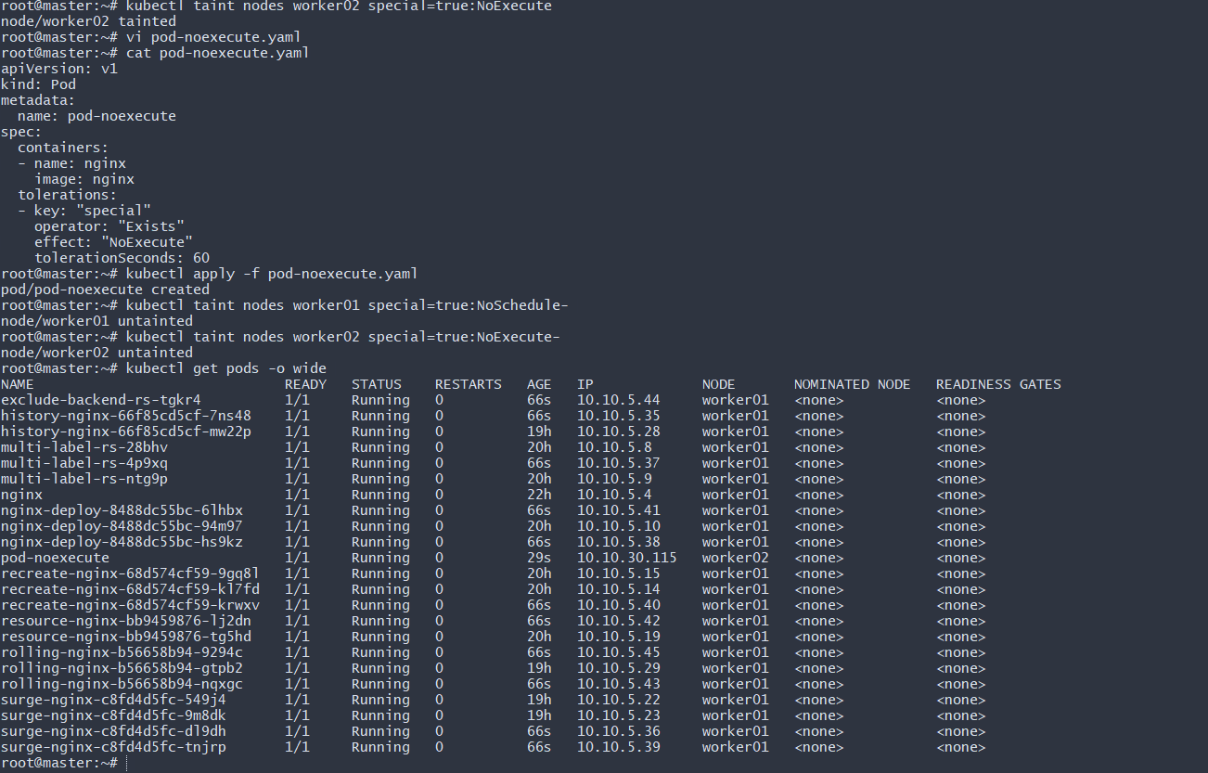

Task 2: Taint a Node and Schedule a Tolerant Pod Taint a node with special=true:NoSchedule. Create a pod with a toleration that matches the taint, allowing it to be scheduled on the tainted node.
Step 1: Check Available Nodes
First, verify your cluster nodes:
- kubectl get nodes
Step 2: Taint the Worker Node
Now taint worker01 with:
- kubectl taint nodes worker01 special=true:NoSchedule
Expected output:
node/worker01 tainted
This means:
- Key = special
- Value = true
- Effect = NoSchedule
- No pod will be scheduled on this node unless it has a matching toleration.
🔹 Step 3: Create a Normal Pod (Without Toleration)
Create a file:
vi test-pod.yaml
Paste:
apiVersion: v1
kind: Pod
metadata:
name: test-pod
spec:
containers:
- name: nginx
image: nginx
Apply it:
- kubectl apply -f test-pod.yaml
Check status:
- kubectl get pods -o wide
You will see:
test-pod 0/1 Pending
🔹 Step 4: Verify Why Pod is Pending
Describe the pod:
- kubectl describe pod test-pod
In the Events section, you’ll see something like:
0/3 nodes are available:
1 node had untolerated taint {special: true}
This confirms the taint is working.
Now Create a Tolerant Pod
🔹 Step 5: Create Pod with Toleration
Create:
vi tolerant-pod.yaml
Paste:
apiVersion: v1
kind: Pod
metadata:
name: tolerant-pod
spec:
tolerations:
- key: "special"
operator: "Equal"
value: "true"
effect: "NoSchedule"
containers:
- name: nginx
image: nginx
Step 6: Apply the Pod
- kubectl apply -f tolerant-pod.yaml
Step 7: Verify Pod Scheduling
- kubectl get pods -o wide
Now you should see:
tolerant-pod 1/1 Running worker01
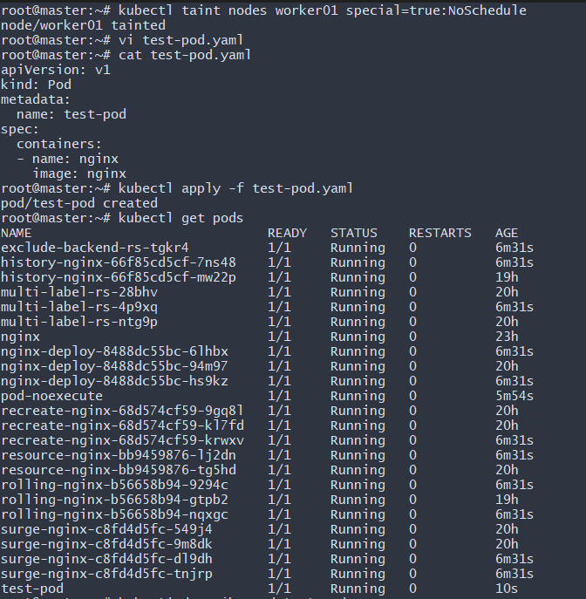
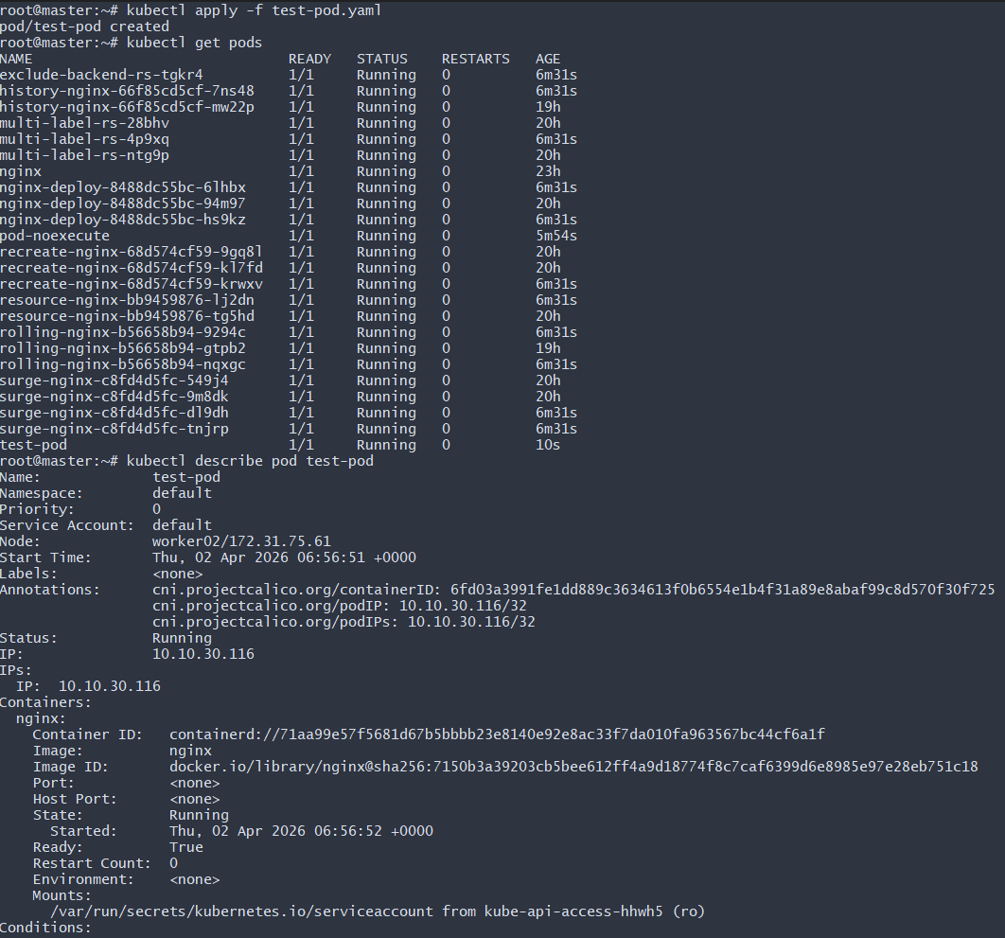
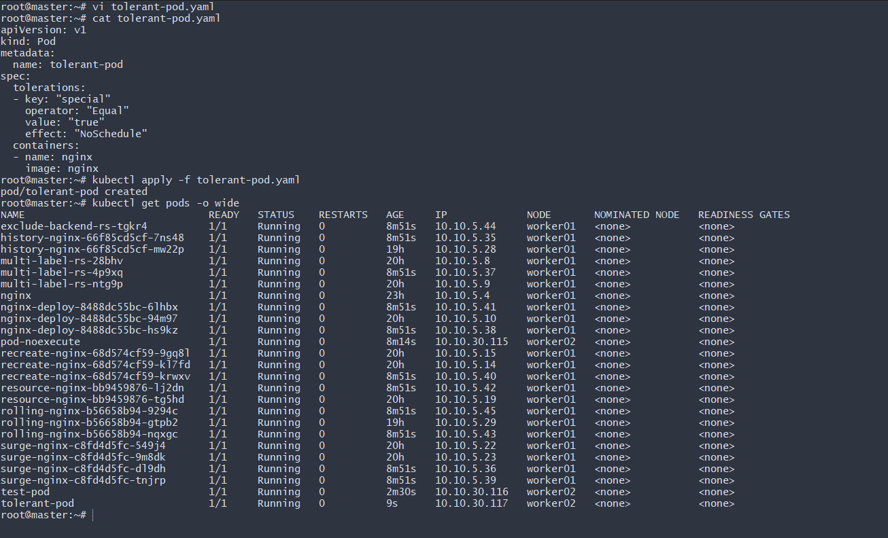
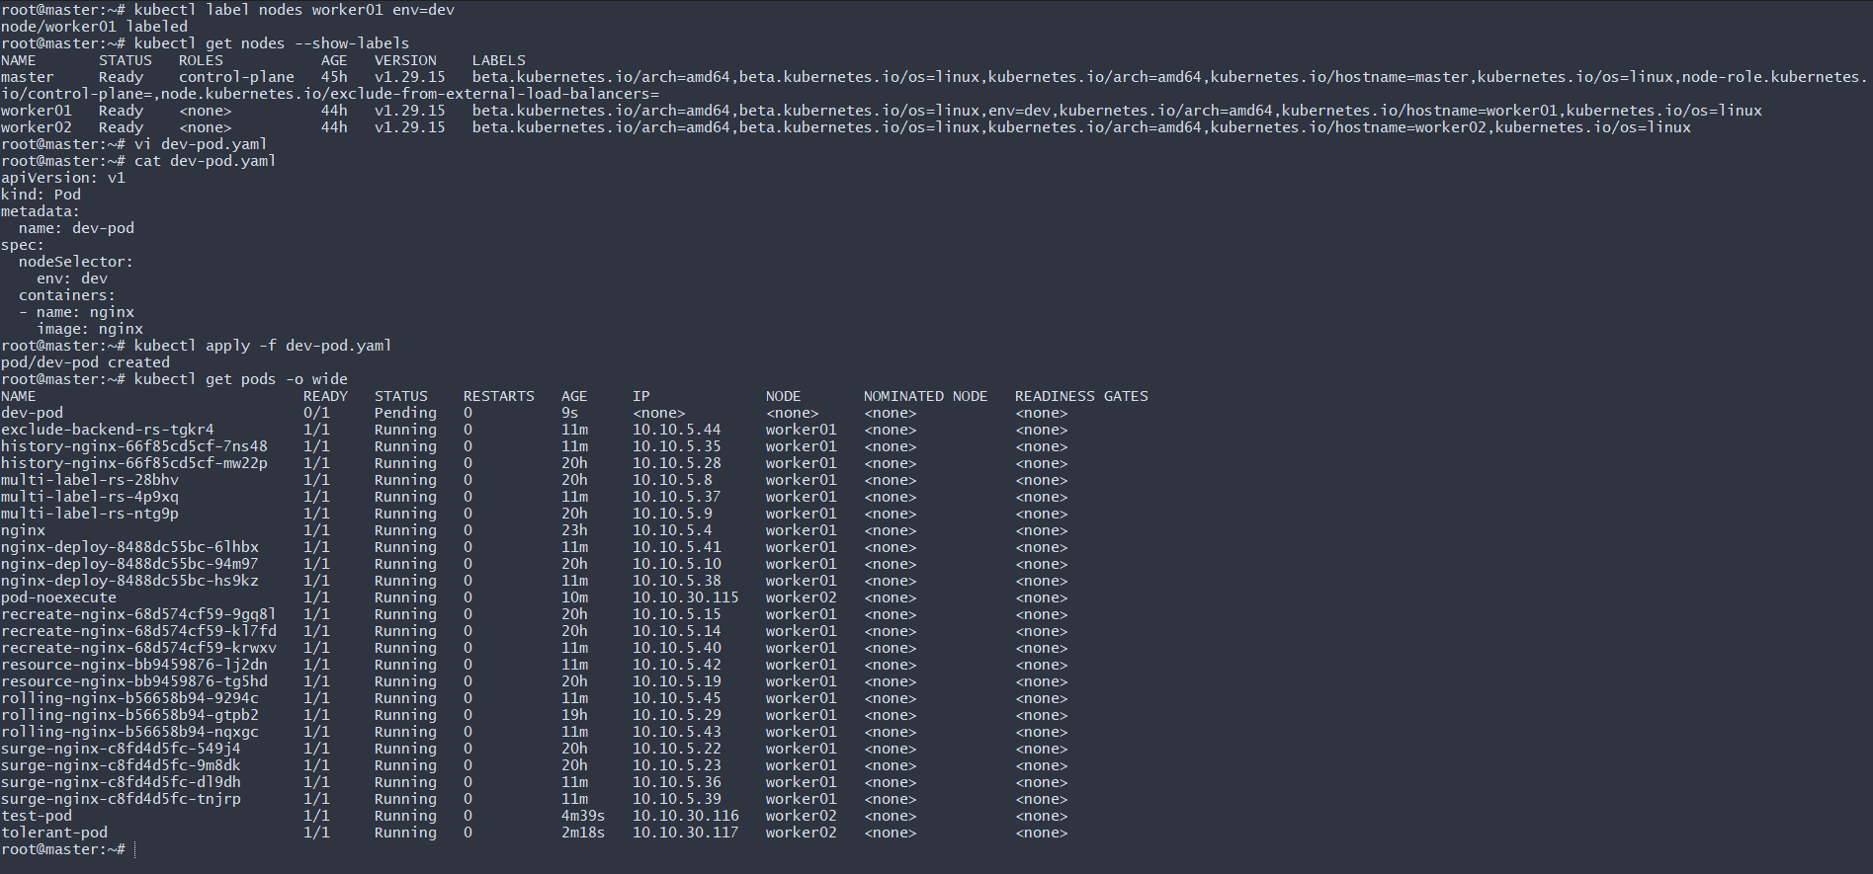
Task 4: Use Node Affinity with Soft Scheduling Label a node with env=test. Create a pod with PreferredDuringSchedulingIgnoredDuringExecution node affinity, preferring to schedule it on a node labeled env=test. Remove the label and verify the pod continues to run.

Step 1: Label a Node with env=test
Label worker02:
kubectl label nodes worker02 env=test
Expected output:
node/worker02 labeled
Verify:
kubectl get nodes --show-labels
You should see:
worker02 Ready ... env=test
Step 2: Create Pod with Soft Node Affinity
Create the YAML file:
vi soft-affinity-pod.yaml
Paste:
apiVersion: v1
kind: Pod
metadata:
name: soft-affinity-pod
spec:
affinity:
nodeAffinity:
preferredDuringSchedulingIgnoredDuringExecution:
- weight: 1
preference:
matchExpressions:
- key: env
operator: In
values:
- test
containers:
- name: nginx
image: nginx
🔹 Step 3: Apply the Pod
- kubectl apply -f soft-affinity-pod.yaml
Check status:
- kubectl get pods -o wide
You should see:
soft-affinity-pod 1/1 Running worker02
The pod prefers worker02 because it has env=test.
Step 4: Remove the Label
Now remove the label:
- kubectl label nodes worker02 env-
Expected output:
node/worker02 unlabeled
Verify:
- kubectl get nodes --show-labels
The env=test label should be gone.
Step 5: Verify Pod Still Running
Check again:
- kubectl get pods -o wide

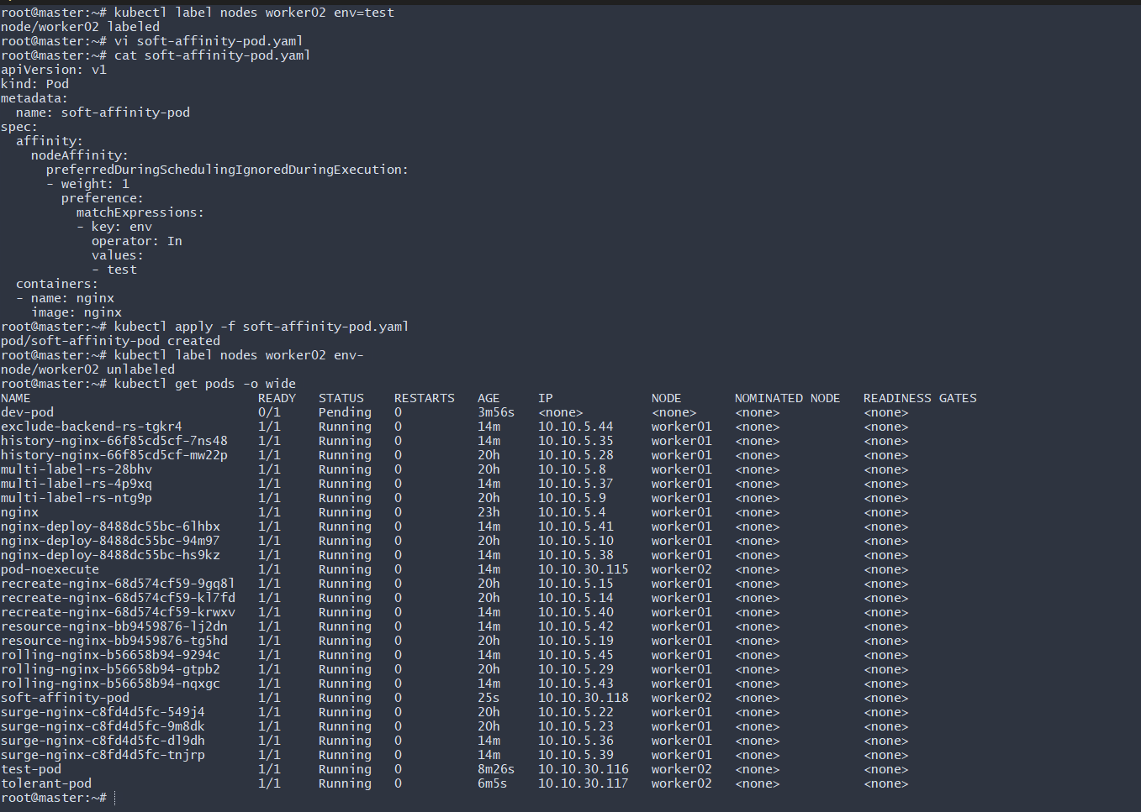
Task 5: Implement Node Affinity with Hard Scheduling Create a pod with RequiredDuringSchedulingIgnoredDuringExecution node affinity, ensuring it will only be scheduled on a node labeled env=prod. Verify the pod cannot be scheduled if no node has the env=prod label.

Step 1: Verify No Node Has env=prod
Check labels:
- kubectl get nodes --show-labels
Make sure no node shows:
env=prod
Step 2: Create Hard Affinity Pod YAML
Create file:
vi hard-affinity-pod.yaml
Paste:
apiVersion: v1
kind: Pod
metadata:
name: hard-affinity-pod
spec:
affinity:
nodeAffinity:
requiredDuringSchedulingIgnoredDuringExecution:
nodeSelectorTerms:
- matchExpressions:
- key: env
operator: In
values:
- prod
containers:
- name: nginx
image: nginx
Step 3: Apply the Pod
- kubectl apply -f hard-affinity-pod.yaml
Check status:
- kubectl get pods
You will see:
hard-affinity-pod 0/1 Pending
Pod is Pending because no node has env=prod.
🔹 Step 4: Verify Reason (Very Important)
kubectl describe pod hard-affinity-pod
In Events section, you’ll see something like:
0/3 nodes are available:
1 node didn't match Pod's node affinity/selector,
1 node had untolerated taint,
...
This confirms:
Hard affinity is enforced
Scheduler is strictly checking label
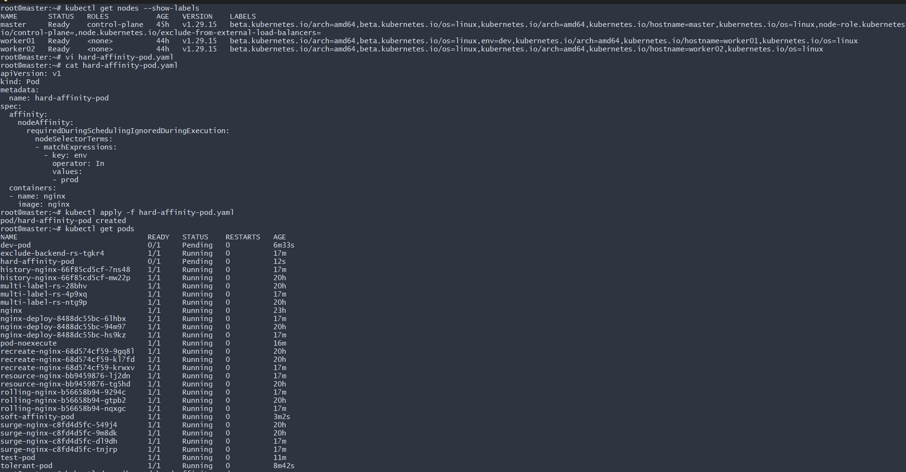
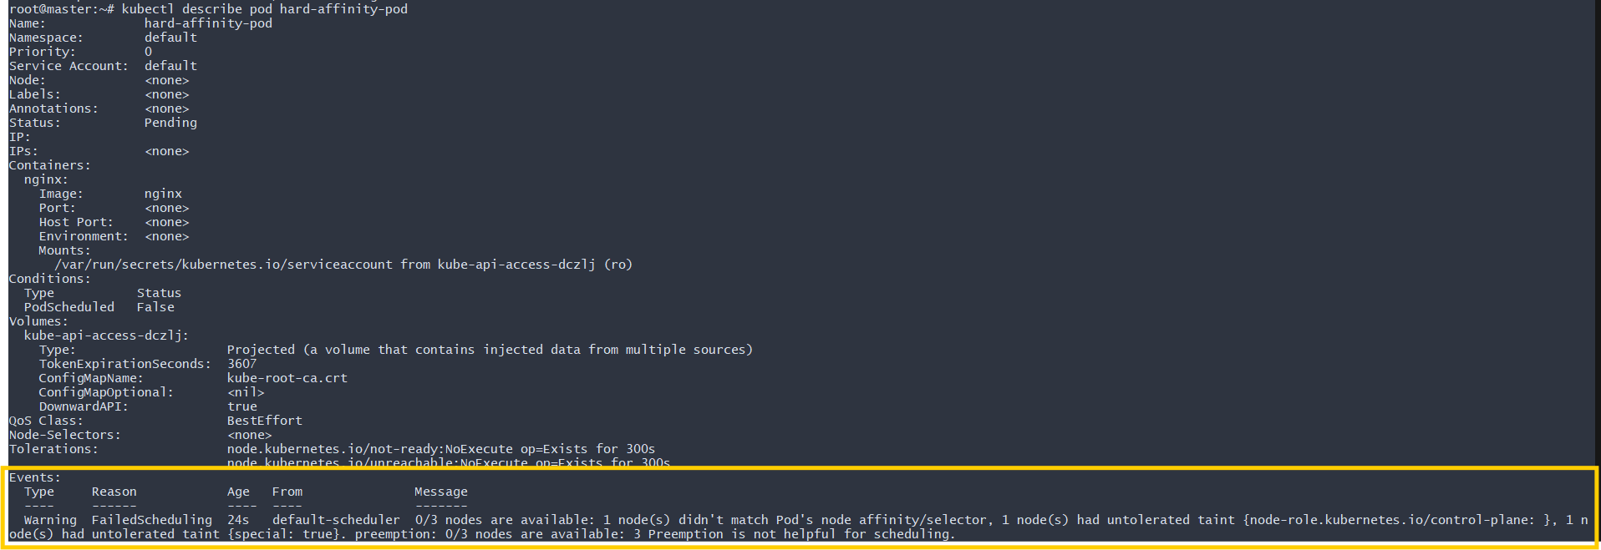
Task 6: Taint a Node and Use NoExecute with Toleration Seconds Taint a node with special=true:NoExecute. Create a pod with a tolerationSeconds field (e.g., 60 seconds) and observe it gets evicted after 60 seconds on the tainted node.

Step 1: Taint the Node with NoExecute
Taint worker01:
- kubectl taint nodes worker01 special=true:NoExecute
Expected output:
node/worker01 tainted
Verify taint:
- kubectl describe node worker01 | grep Taints
Output should show:
Taints: special=true:NoExecute

Step 2: Create Pod with tolerationSeconds
Create YAML file:
vi noexecute-pod.yaml
Paste:
apiVersion: v1
kind: Pod
metadata:
name: noexecute-pod
spec:
tolerations:
- key: "special"
operator: "Equal"
value: "true"
effect: "NoExecute"
tolerationSeconds: 60
containers:
- name: nginx
image: nginx

Step 3: Apply the Pod
- kubectl apply -f noexecute-pod.yaml
Check immediately:
kubectl get pods -o wide
You should see:
noexecute-pod 1/1 Running worker01
Pod runs because it tolerates the taint.

Step 4: Wait 60 Seconds
After ~60 seconds, check again:
kubectl get pods
Now you will see:
noexecute-pod 0/1 Terminating
Or it may disappear completely.
Step 5: Confirm Eviction
Describe pod (if still visible):
- kubectl describe pod noexecute-pod
You will see event message related to eviction due to taint.
