Title:
- Create and Test a Kubernetes Pod with an EmptyDir Volume
Create and Test a Kubernetes Pod with an EmptyDir Volume
Objective
To create a Kubernetes Pod using an emptyDir volume and verify that:
- Data is shared between containers in the same Pod
- Data is deleted when the Pod is removed
Step by Step Implementation:
Step 1 — Create Pod YAML
vi emptydir-pod.yaml
Paste:
apiVersion: v1
kind: Pod
metadata:
name: emptydir-pod
spec:
containers:
- name: writer
image: busybox
command: ["/bin/sh", "-c"]
args:
- while true; do
echo "Hello from writer container" >> /data/file.txt;
sleep 5;
done
volumeMounts:
- name: shared-volume
mountPath: /data
- name: reader
image: busybox
command: ["/bin/sh", "-c"]
args:
- while true; do
cat /data/file.txt;
sleep 5;
done
volumeMounts:
- name: shared-volume
mountPath: /data
volumes:
- name: shared-volume
emptyDir: {}
Save and exit:
Esc → :wq → Enter
Step 2 — Apply the Pod
kubectl apply -f emptydir-pod.yaml
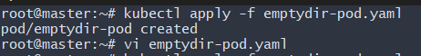
Validation Steps
Verify Pod is Running
kubectl get pods
Expected:
emptydir-pod 2/2 Running
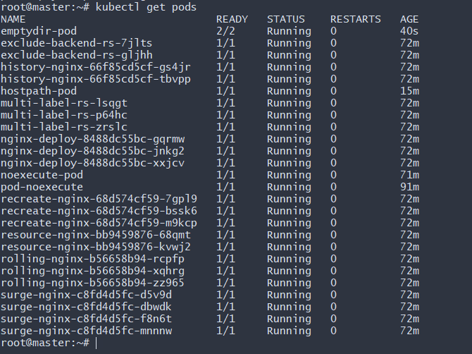
Check Logs of Reader Container
kubectl logs emptydir-pod -c reader
You should see:
Hello from writer container
Hello from writer container
This confirms both containers are sharing the same emptyDir volume
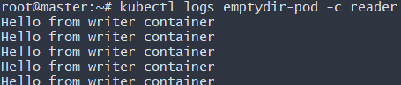
Test Data Deletion After Pod Removal
Delete the Pod:
kubectl delete pod emptydir-pod
Recreate the Pod:
kubectl apply -f emptydir-pod.yaml
Check logs again:
kubectl logs emptydir-pod -c reader
The old data will be gone, proving emptyDir is temporary storage
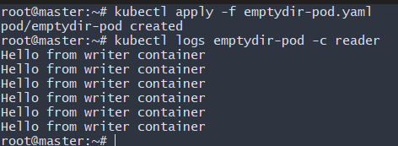
2. Configure a HostPath Volume in Kubernetes and Validate Data Persistence.
Step 1 — Create Pod with hostPath Volume
vi hostpath-pod.yaml
Paste:
apiVersion: v1
kind: Pod
metadata:
name: hostpath-pod
spec:
containers:
- name: writer
image: busybox
command: ["/bin/sh", "-c"]
args:
- echo "Persistent Data from HostPath" >> /data/hostfile.txt;
sleep 3600;
volumeMounts:
- name: host-volume
mountPath: /data
volumes:
- name: host-volume
hostPath:
path: /mnt/host-data
type: DirectoryOrCreate
Save and exit:
Esc → :wq → Enter

Step 2 — Apply the Pod
kubectl apply -f hostpath-pod.yaml
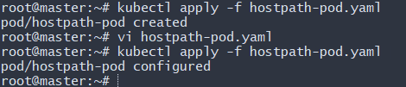
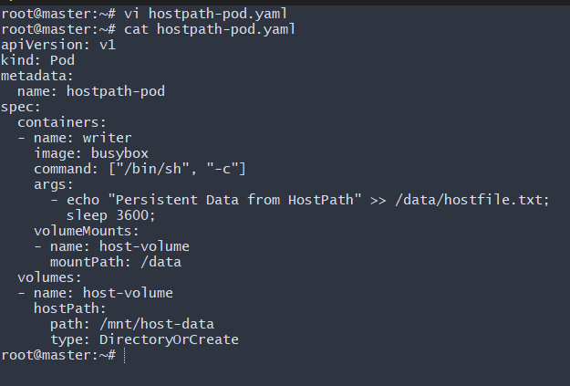
Validation Steps
Verify Pod Running
kubectl get pods
Expected:
hostpath-pod 1/1 Running
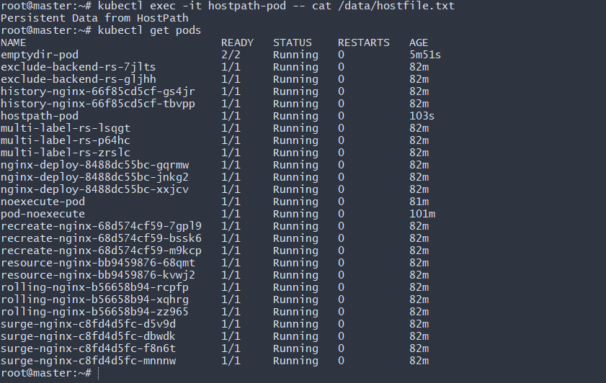
Verify File Inside Pod
kubectl exec -it hostpath-pod -- cat /data/hostfile.txt
Expected output:
Persistent Data from HostPath
Verify File on Node
Find the node where pod is running:
kubectl get pods -o wide
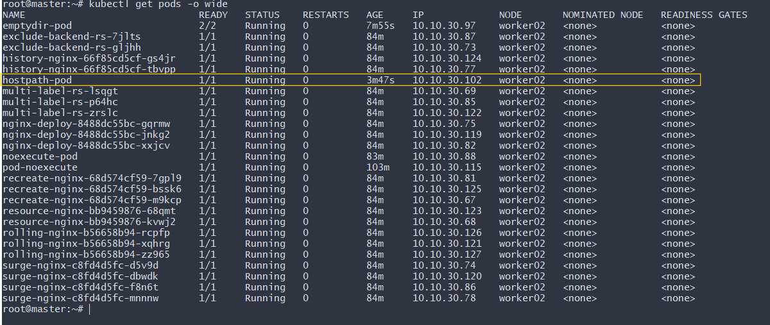
SSH into that node and run:
sudo cat /mnt/host-data/hostfile.txt
You should see the same content.
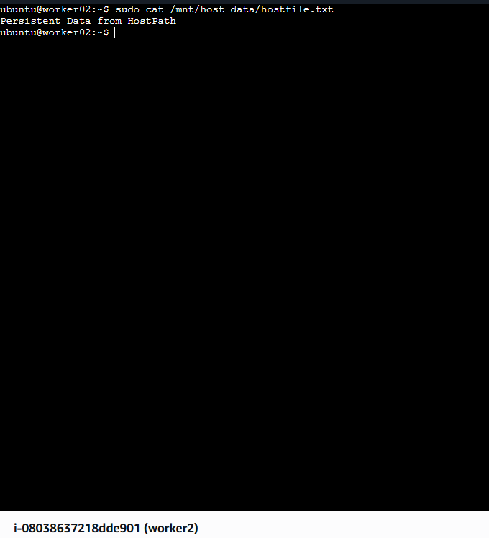
Delete and Recreate Pod
Delete the pod:
kubectl delete pod hostpath-pod
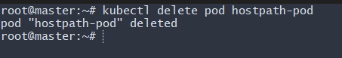
Recreate:
kubectl apply -f hostpath-pod.yaml
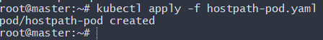
Check file again inside pod:
kubectl exec -it hostpath-pod -- cat /data/hostfile.txt
You will see the previous data still exists.
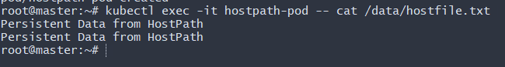

3. Deploy an Amazon EBS Volume Using Persistent Volume and Persistent Volume Claim (PVC)
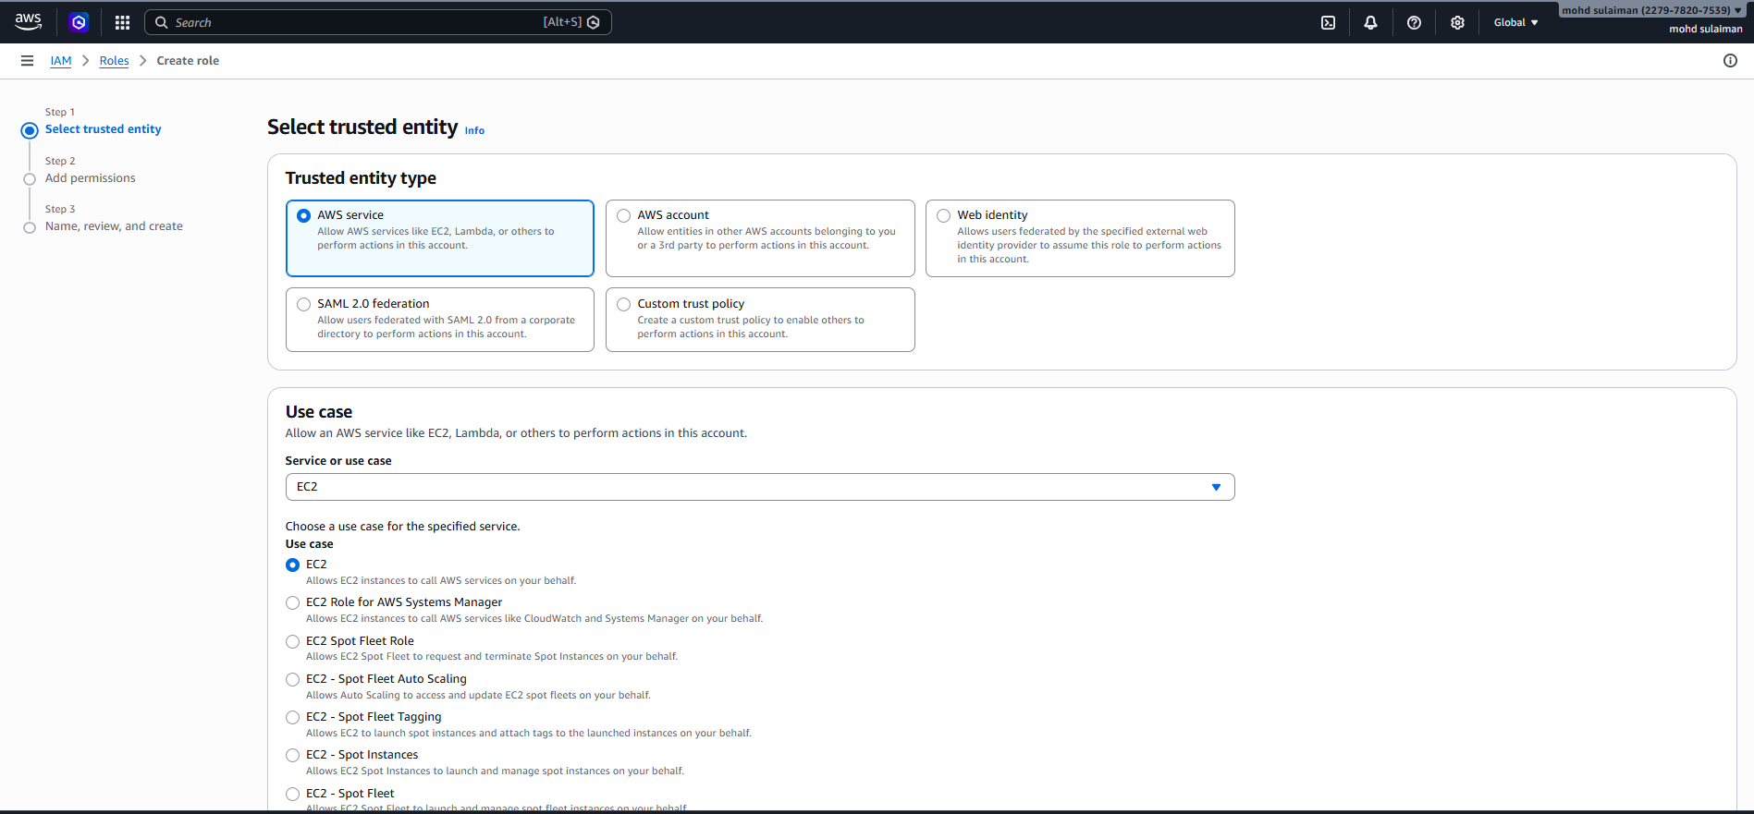
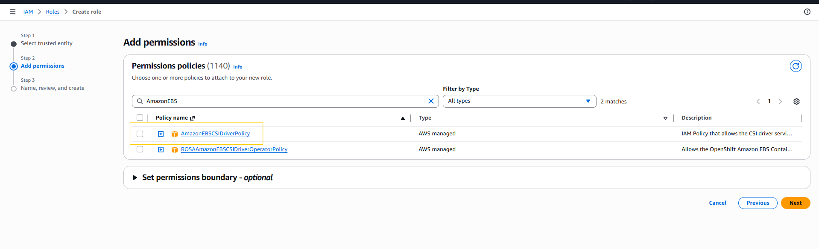
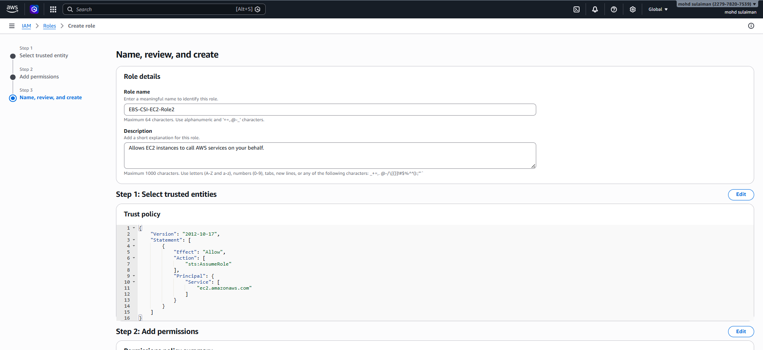
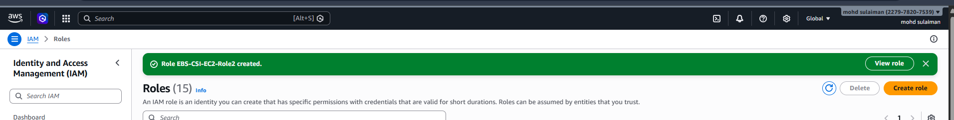
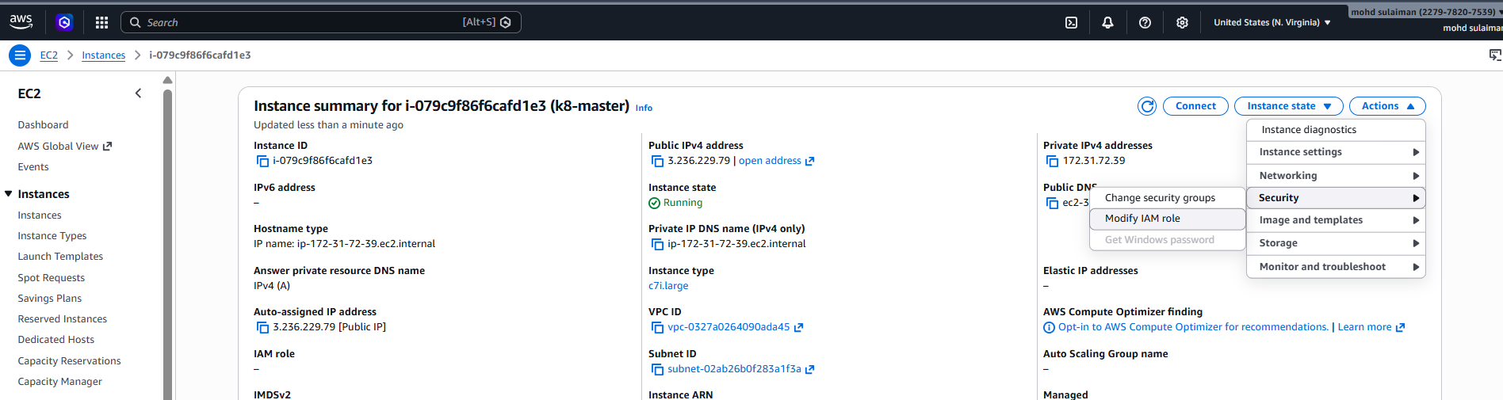
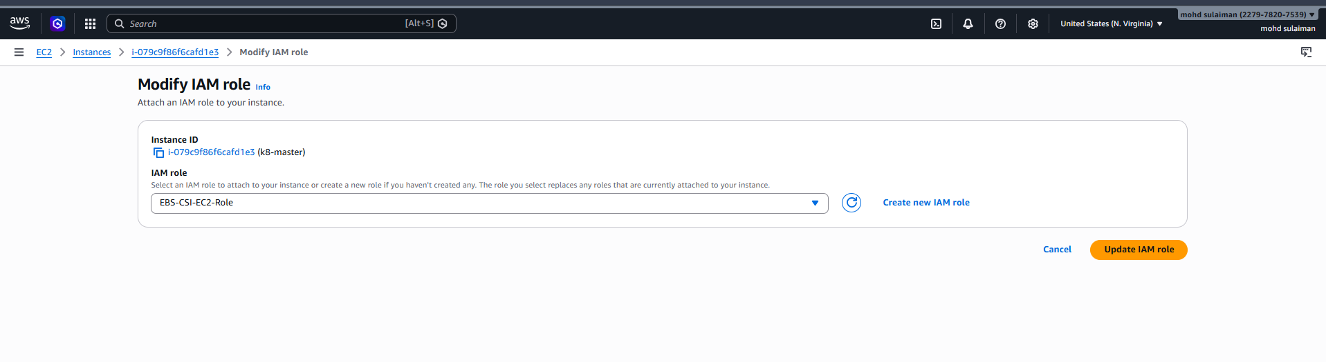
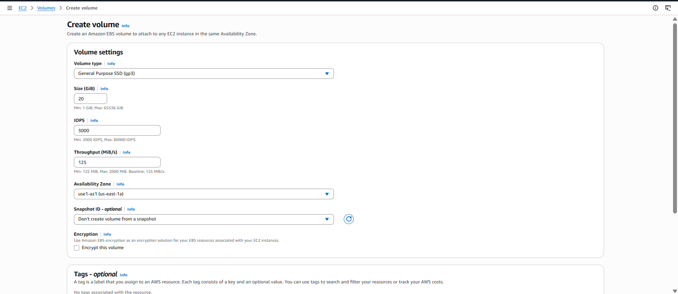
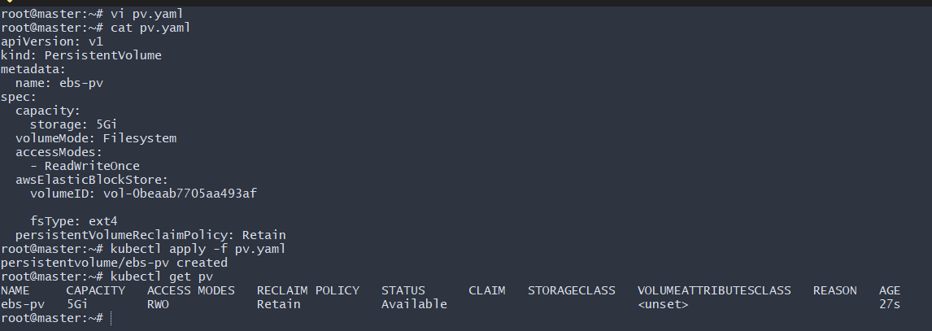
PersistentVolume (PV)
yaml
apiVersion: v1
kind: PersistentVolume
metadata:
name: ebs-pv
spec:
capacity:
storage: 20Gi
accessModes:
- ReadWriteOnce
awsElasticBlockStore:
volumeID: vol-0c08800682db64779
fsType: ext4
storageClassName: gp3
persistentVolumeReclaimPolicy: Retain
PersistentVolumeClaim (PVC)
yaml
apiVersion: v1
kind: PersistentVolumeClaim
metadata:
name: ebs-pvc
spec:
accessModes:
- ReadWriteOnce
resources:
requests:
storage: 20Gi
storageClassName: gp3
Apply Commands
bash
kubectl apply -f pv.yaml
kubectl apply -f pvc.yaml
Verify Binding
bash
kubectl get pv
kubectl get pvc
Expected result:
- PV status → Bound
- PVC status → Bound

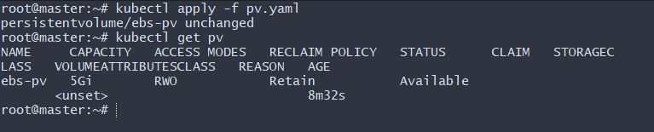
apiVersion: v1
kind: Pod
metadata:
name: ebs-pod
spec:
containers:
- name: app
image: nginx
volumeMounts:
- mountPath: /data
name: ebs-storage
volumes:
- name: ebs-storage
persistentVolumeClaim:
claimName: ebs-pvc
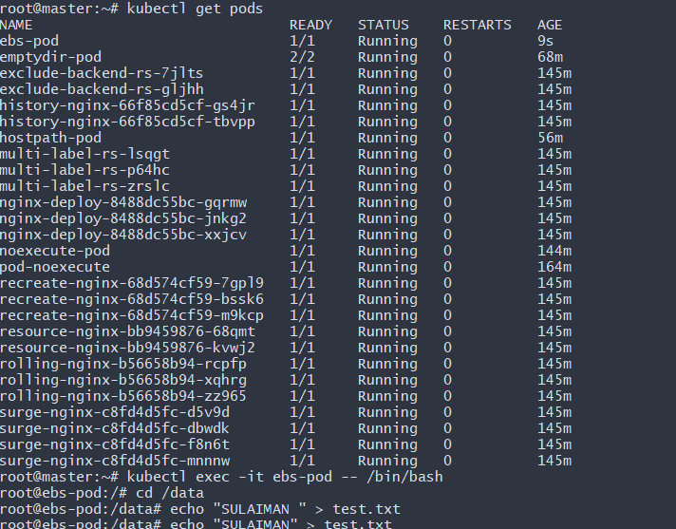
4. Set Up an Amazon EFS Volume and Attach it to Multiple Pods

Objective: Amazon EFS is perfect when you need:
- Shared storage across multiple pods
- Multi-node access
- ReadWriteMany (RWX)
- High availability
Unlike EBS (RWO), EFS supports multiple pods across multiple nodes at the same time.

Flow:
Pods → PVC → EFS CSI Driver → Amazon EFS → Shared storage

Step 1: Create Amazon EFS
Go to:
AWS Console → EFS → Create file system
Configure:
- VPC → Same VPC as your cluster
- Enable mount targets in all AZs used by worker nodes
- Security group → Allow NFS (2049) from worker node security group
After creation, note:
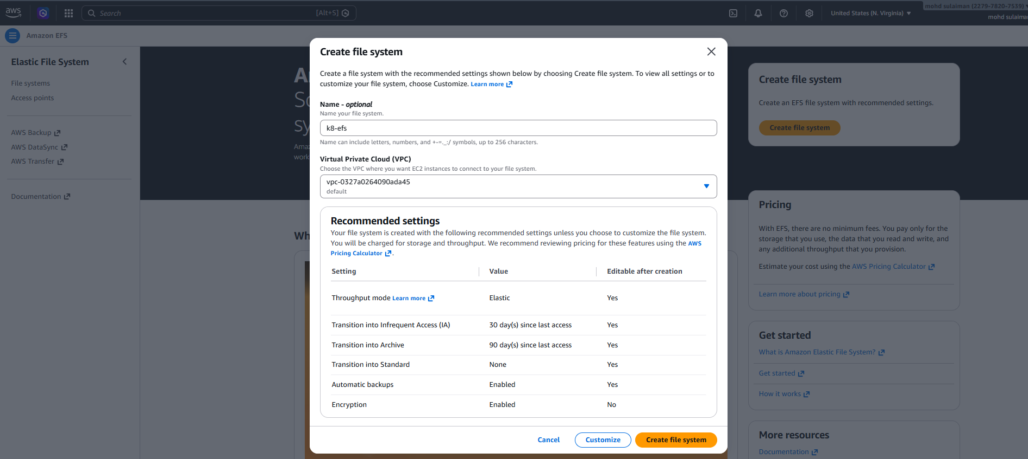
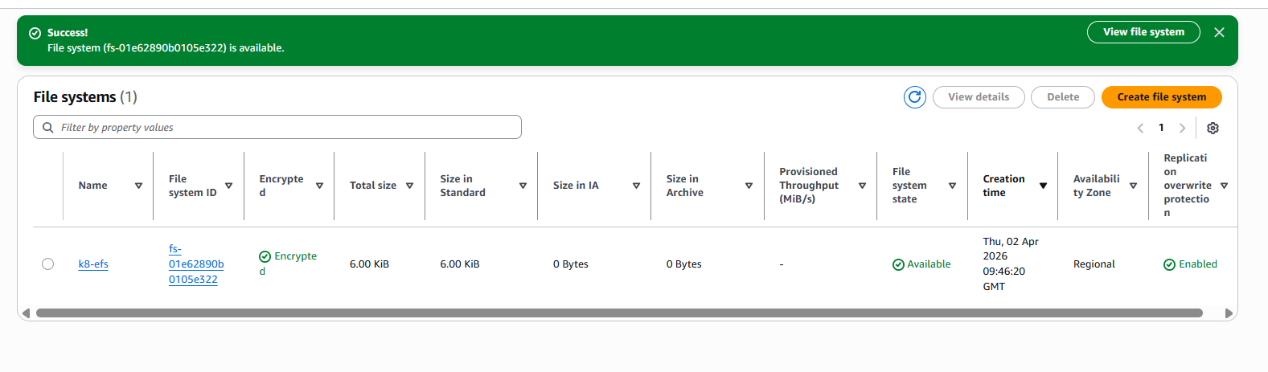
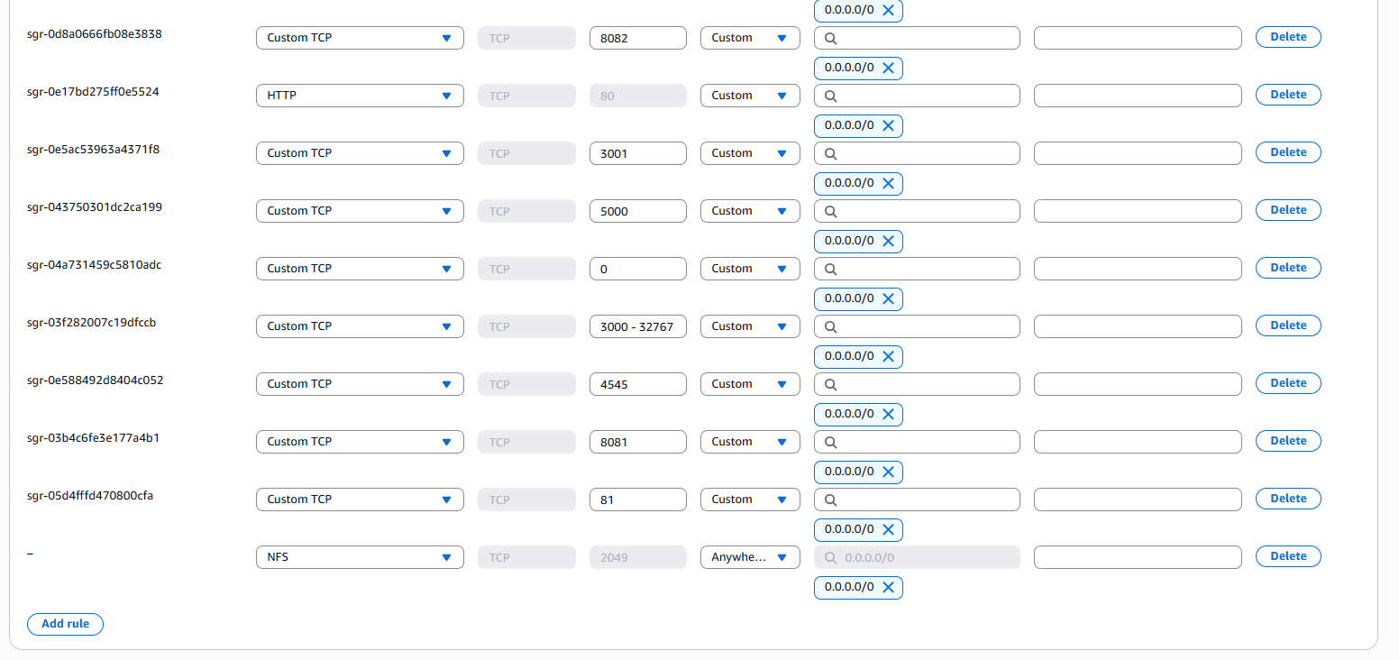
Step 2: Install AWS EFS CSI Driver
Since you are using kubeadm, install manually.
Install using kubectl:
kubectl apply -k "github.com/kubernetes-sigs/aws-efs-csi-driver/deploy/kubernetes/overlays/stable/?ref=master"
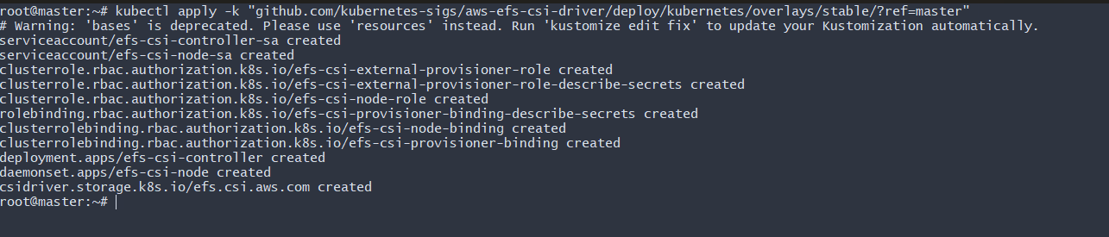
Verify:
kubectl get pods -n kube-system | grep efs
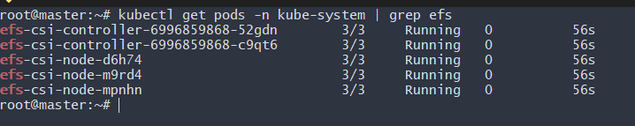
We should see:
efs-csi-controller running
efs-csi-node running
IAM Requirement
EFS CSI also requires IAM permissions.
Attach policy:
AmazonEFSCSIDriverPolicy
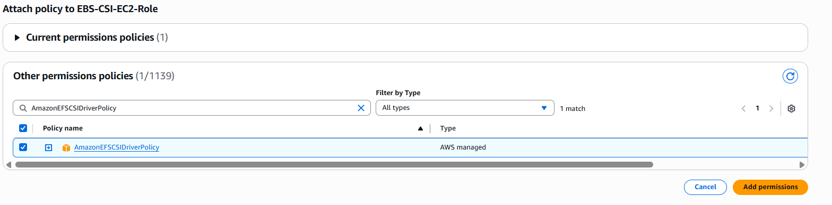
To worker nodes (same as you did for EBS).
Step 3 – Create StorageClass
Create vi efs-sc.yaml:

apiVersion: storage.k8s.io/v1
kind: StorageClass
metadata:
name: efs-sc
provisioner: efs.csi.aws.com
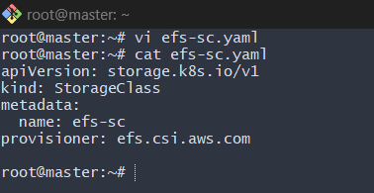
Apply:
kubectl apply -f efs-sc.yaml
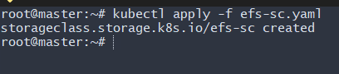
Step 4 – Create PVC
Create file: vi efs-pvc.yaml
apiVersion: v1
kind: PersistentVolumeClaim
metadata:
name: efs-pvc
spec:
accessModes:
- ReadWriteMany
storageClassName: efs-sc
resources:
requests:
storage: 5Gi
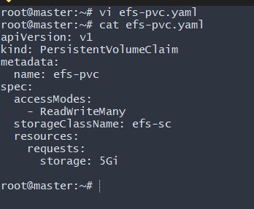
Apply:
kubectl apply -f efs-pvc.yaml
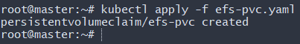
Step 5: Create PV (ReadWriteMany)
Create file: vi efs-pv.yaml
apiVersion: v1
kind: PersistentVolume
metadata:
name: efs-pv
spec:
capacity:
storage: 5Gi
volumeMode: Filesystem
accessModes:
- ReadWriteMany
storageClassName: efs-sc
persistentVolumeReclaimPolicy: Retain
csi:
driver: efs.csi.aws.com
volumeHandle: fs-01e62890b0105e322
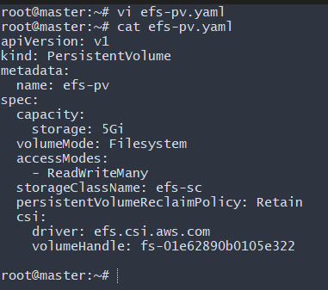
Apply:
kubectl apply -f efs-pv.yaml
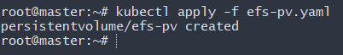
Check:
kubectl get pv
Status → Bound
Step 6 – Test Pod
Create vi efs-pod.yaml:

apiVersion: v1
kind: Pod
metadata:
name: efs-app
spec:
containers:
- name: app
image: nginx
volumeMounts:
- mountPath: "/data"
name: efs-storage
volumes:
- name: efs-storage
persistentVolumeClaim:
claimName: efs-pvc
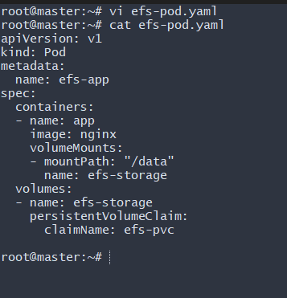
Verify:
kubectl apply -f efs-pod.yaml
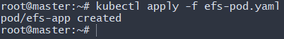
Step 7 – Verify Shared Storage
kubectl exec -it efs-app -- sh
echo "Hello EFS" > /data/test.txt
exit
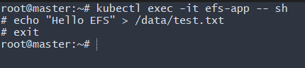
Kubectl get pods we can see the pod is running.
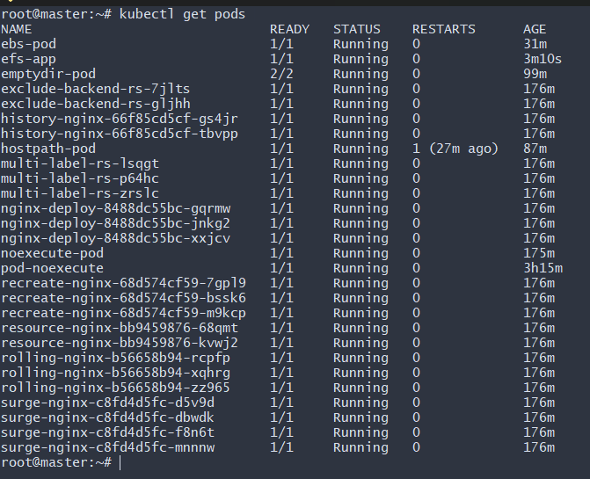
Now delete and recreate pod:

kubectl delete pod efs-app
kubectl apply -f efs-pod.yaml
kubectl exec -it efs-app -- cat /data/test.txt
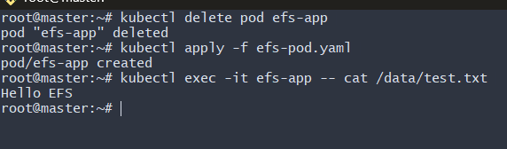
If file exists → EFS working.
In our case, file existed- Hello EFS
Implement and Test Liveness and Readiness Probes in a Kubernetes Pod
Objective: The requirement of this task is to Implement and Test Liveness and Readiness Probes in a Kubernetes Pod
We’ll:
1. Create a pod with both probes
2. Simulate readiness failure
3. Simulate liveness failure
4. Observe Kubernetes behavior
Step 1 – Create Test Pod
Create
Vi probe-pod.yaml
apiVersion: v1
kind: Pod
metadata:
name: probe-demo
spec:
containers:
- name: app
image: nginx
ports:
- containerPort: 80

readinessProbe:
httpGet:
path: /
port: 80
initialDelaySeconds: 5
periodSeconds: 5

livenessProbe:
httpGet:
path: /
port: 80
initialDelaySeconds: 10
periodSeconds: 5
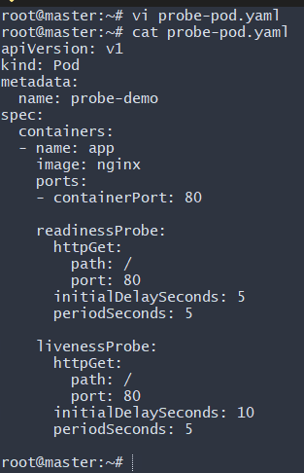
Apply it:
kubectl apply -f probe-pod.yaml
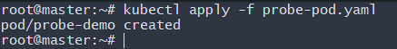
Check:
kubectl get pods -w
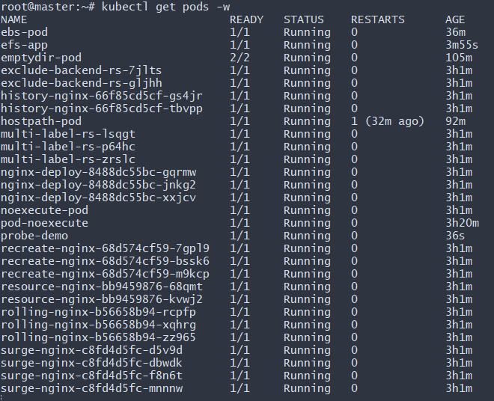
Step 2 – Test Readiness Probe
Now break readiness manually.
Enter pod:
kubectl exec -it probe-demo – sh
Inside container:
rm -rf /usr/share/nginx/html/index.html
exit
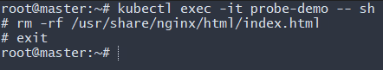
Now check:
kubectl describe pod probe-demo
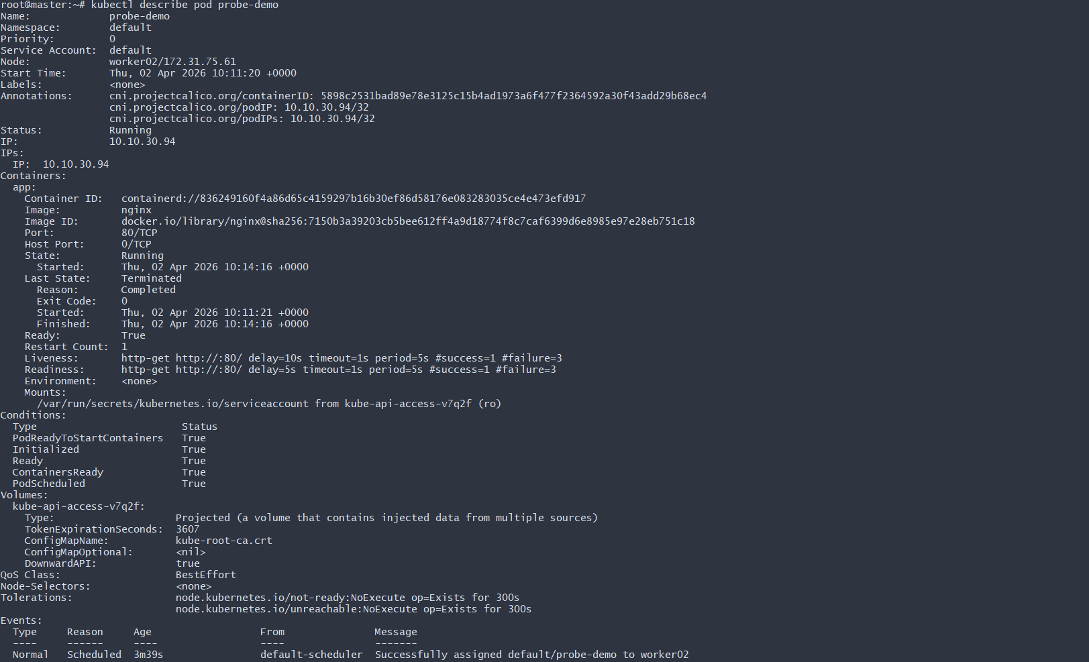
You should see readiness probe failing.
If this pod is behind a Service:
• It will be removed from endpoints
• But container will NOT restart

Step 3 – Test Liveness Probe
Modify YAML to simulate liveness failure after 30 seconds:

livenessProbe:
exec:
command:
- cat
- /tmp/healthy
initialDelaySeconds: 10
periodSeconds: 5
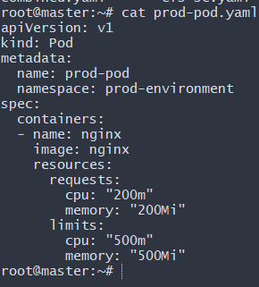
Now inside pod:
(Manual Creation – Quick Test)
kubectl exec -it probe-demo -- sh
touch /tmp/healthy
exit
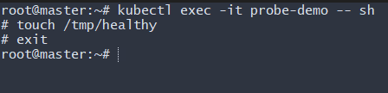
kubectl exec -it probe-demo -- sh
rm /tmp/healthy
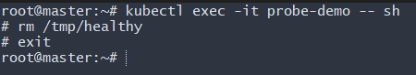
After few seconds:
kubectl get pods
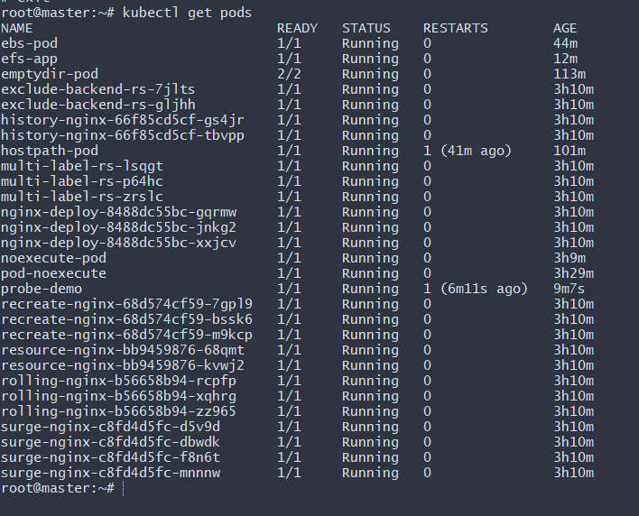
You will see:
RESTARTS: 1
Because liveness probe failed → Kubernetes restarted container

