Kubernetes 10

- Setup EKS Cluster using eksctl

Prerequisites
- AWS CLI configured (aws configure)
- kubectl installed
- eksctl installed
- IAM user with EKS permissions

  - Install kubectl on Windows
kubectl is the Kubernetes CLI tool.

Step 1: Download kubectl
Go to:
https://kubernetes.io/docs/tasks/tools/
Download the Windows version.
Or use PowerShell:
curl.exe -LO "https://dl.k8s.io/release/v1.29.0/bin/windows/amd64/kubectl.exe"

Step 2: Move to PATH
- Move kubectl.exe to:
C:\kubectl\
- Add this folder to Environment Variables → PATH

Step 3: Verify
kubectl version –client

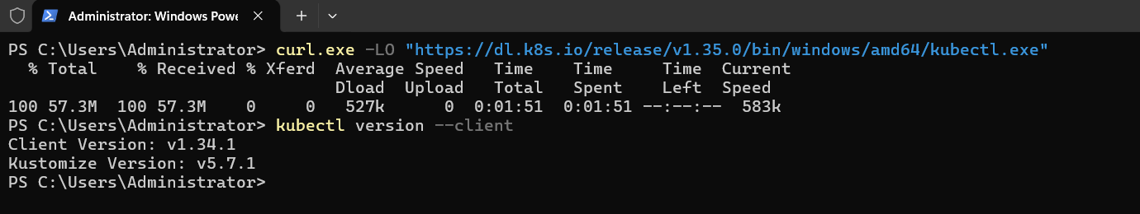
  - Install eksctl on Windows
eksctl is used to create EKS clusters easily.

Step 1: Install Chocolatey (Recommended)
Open PowerShell as Administrator and run:
Set-ExecutionPolicy Bypass -Scope Process -Force; `
[System.Net.ServicePointManager]::SecurityProtocol = `
[System.Net.ServicePointManager]::SecurityProtocol -bor 3072; `
iex ((New-Object System.Net.WebClient).DownloadString('https://community.chocolatey.org/install.ps1'))
Verify:
choco --version
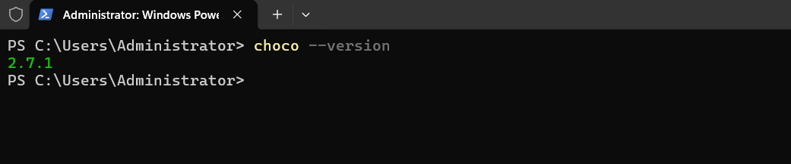
Step 2: Install eksctl
choco install eksctl -y

Step 3: Verify
eksctl version
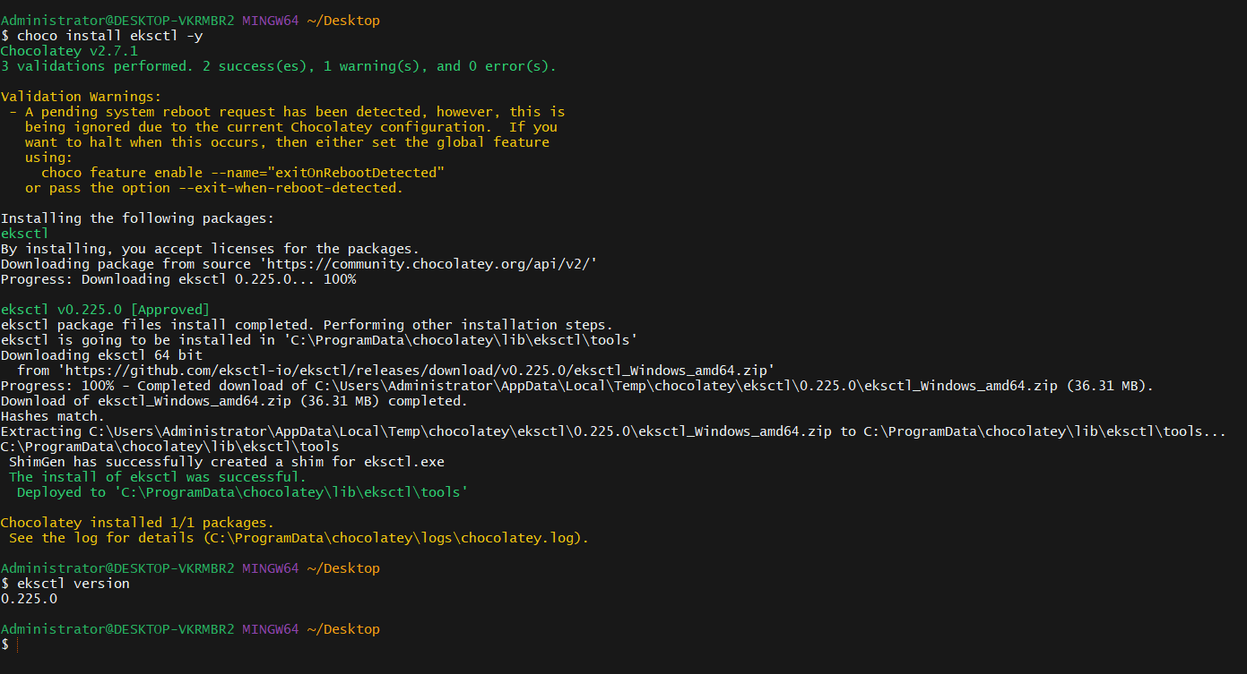
Step 1: Create EKS Cluster
eksctl create cluster \
--name my-eks-cluster \
--region us-east-1 \
--nodegroup-name ng-1 \
--node-type t3.medium \
--nodes 2 \
--nodes-min 2 \
--nodes-max 4 \
--managed
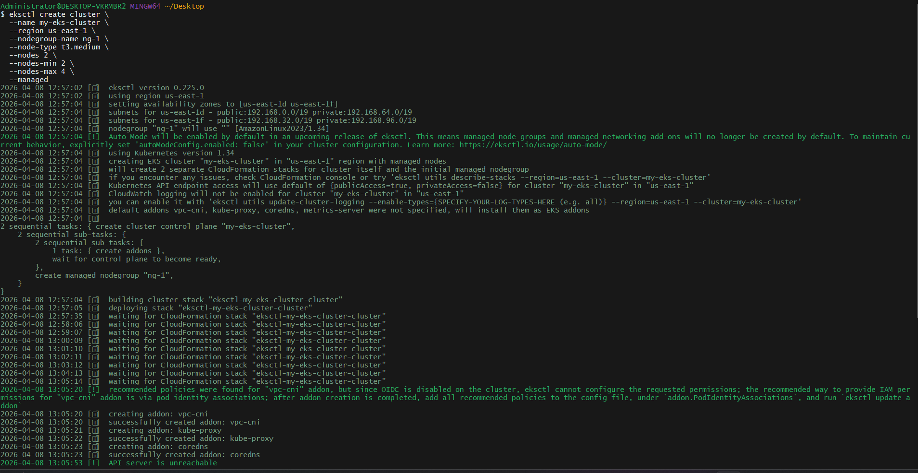
Explanation
- --managed → Creates managed node group
- --nodes-min/max → Enables autoscaling
- t3.medium → EC2 worker nodes
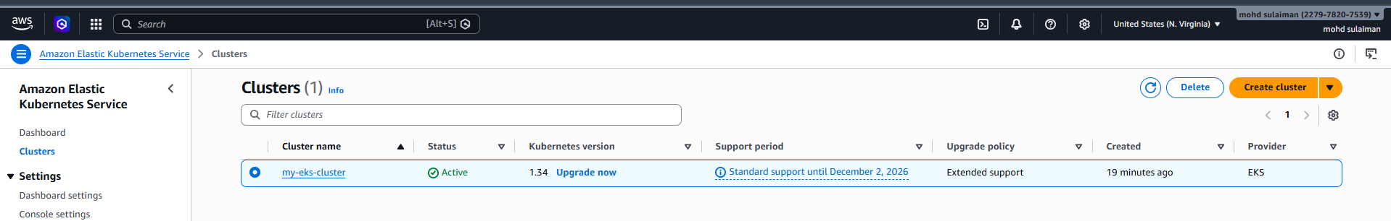
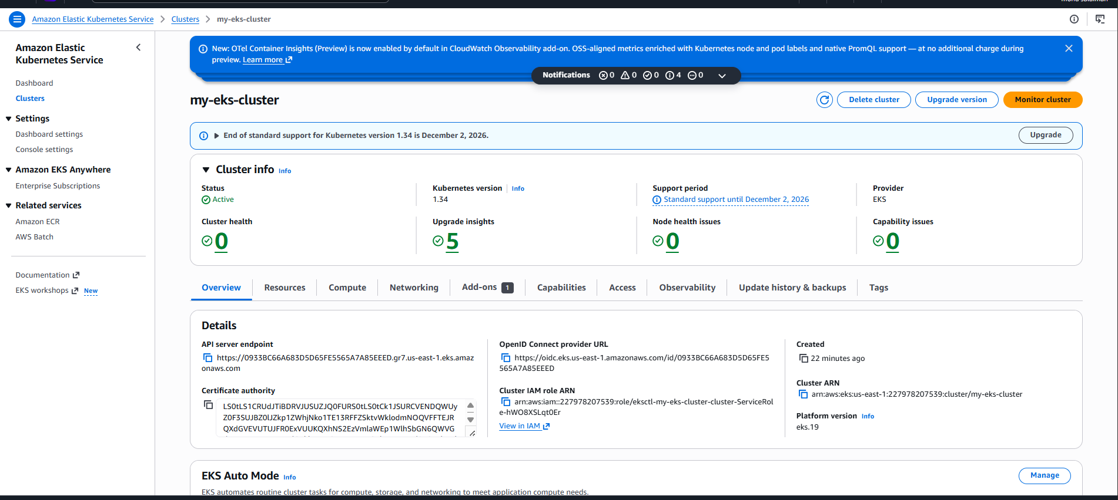
Step 2: Validate Cluster
kubectl get nodes
kubectl get pods -A
You should see:
- Nodes in Ready state
- Core system pods running in kube-system
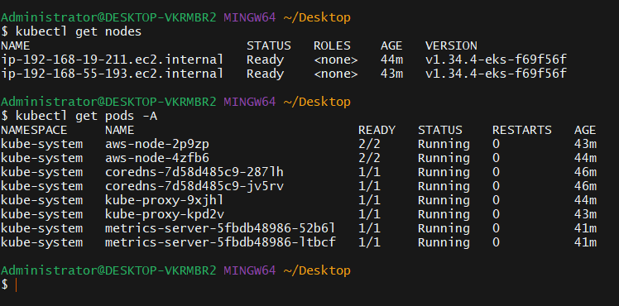
- Setup EKS Cluster using AWS Console
Step 1: Create Cluster
- Go to AWS Console → EKS → Create cluster
- Choose:
  - Name
  - Kubernetes version
  - IAM cluster role
- Configure networking (VPC, subnets)
- Create
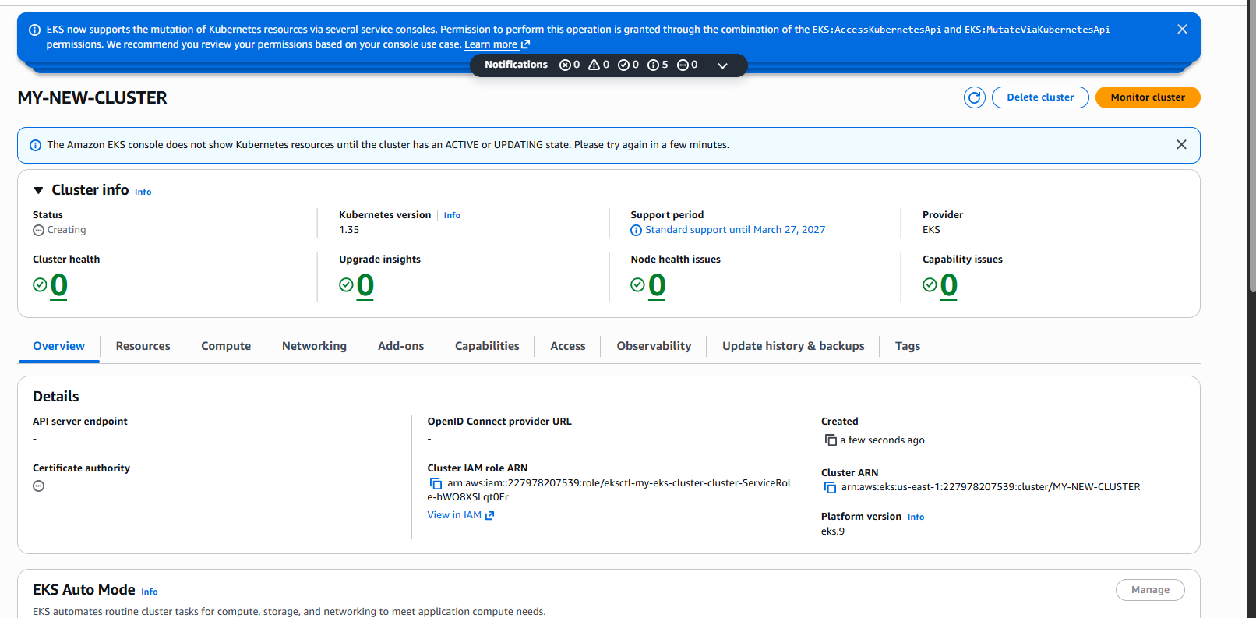
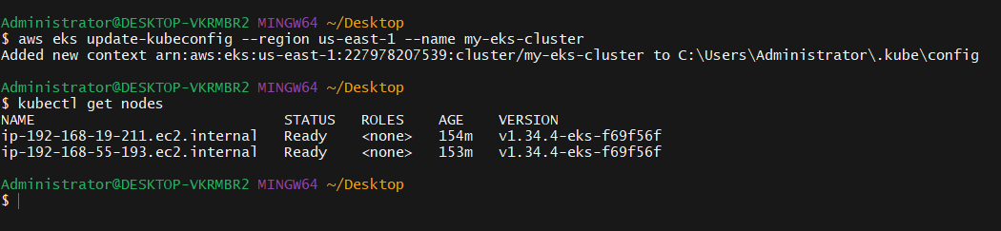
- Setup HPA (Horizontal Pod Autoscaler)
Step 1: Deploy Sample App
vi deployment.yaml
apiVersion: apps/v1
kind: Deployment
metadata:
name: nginx
spec:
replicas: 1
selector:
matchLabels:
app: nginx
template:
metadata:
labels:
app: nginx
spec:
containers:
- name: nginx
image: nginx
resources:
requests:
cpu: "100m"
limits:
cpu: "200m"
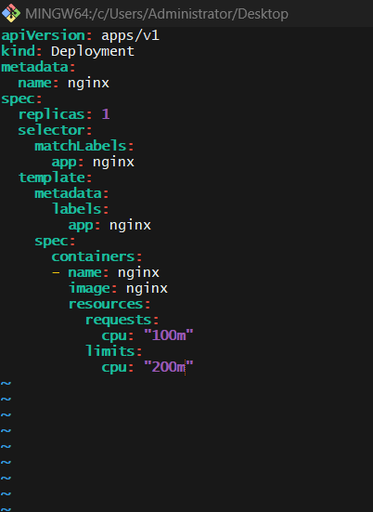
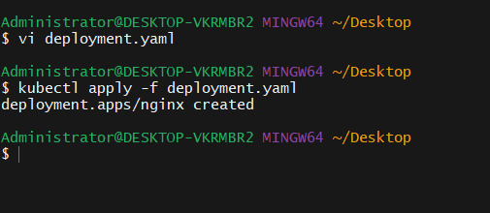
Step 2: Install Metrics Server
kubectl apply -f https://github.com/kubernetes-sigs/metrics-server/releases/latest/download/components.yaml
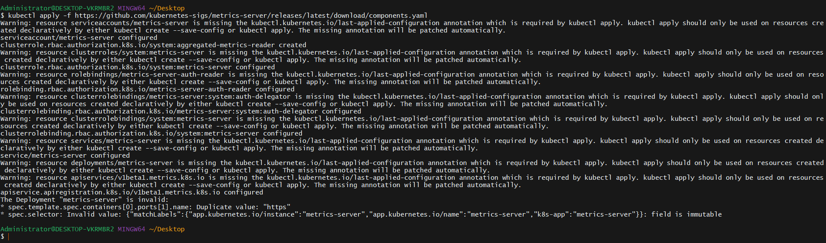
Step 3: Create HPA
kubectl autoscale deployment nginx --cpu-percent=50 --min=1 --max=5
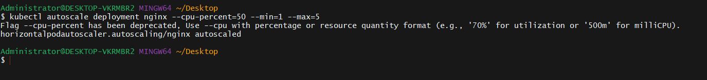
Validation
kubectl get hpa
kubectl top pods
Generate load → replicas should increase.

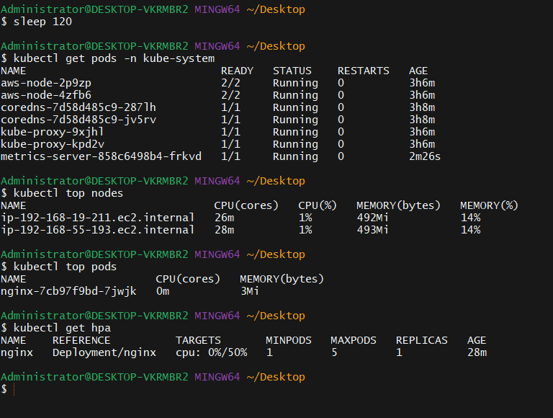
4. Setup Cluster Autoscaler

STEP 1 — Verify Node Group Scaling Range
Go to:
EC2 → Auto Scaling Groups
Select your node group ASG.
Check:
- Min capacity
- Desired capacity
- Max capacity
For example:
Min = 2
Desired = 2
Max = 4
If Max is not higher than Desired, increase it.
Autoscaler cannot scale beyond Max.
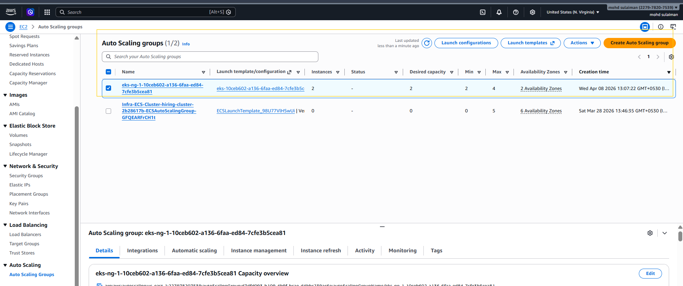
STEP 2 — Tag Auto Scaling Group (VERY IMPORTANT)
Still inside Auto Scaling Group → Tags → Add tags:
Add:
Key: k8s.io/cluster-autoscaler/my-eks-cluster
Value: owned
Add:
Key: k8s.io/cluster-autoscaler/enabled
Value: true
✔ Check “Apply to instances”
This step is mandatory.

