Terraform-01
Terraform is a tool for IAC
IAC Infrastructure as co Code.
- Terraform is a tool to create ec2’s, VPC’s, Databases etc. without any manual intervention.
- Terraform is developed by HashiCorp.
- Terraform uses HCL Language (HashiCorp Language)
Terraform official platform is – Terraform Registry
Install Terraform:
We shall install Terraform for now on Windows
- Install – Windows 386
- Extract and paste in C directory
- Open settings system variables env variables edit change the path to C terraform
- Open Gitbash and search for Terraform -V (so that, we will know, Terraform is available, from the Windows location).

How a Terraform configuration looks like?
<block> <resource_type> {
Option 1
Option 2
}

Navigate to Visual Studio create a folder in Desktop In VS code extension (search Hashi.Corp) and Install
.tf extension for the Terraform resource files
.tf is a plugin.

Let’s create a small Terraform configuration for testing:
Resource “local_file” “my_pet” {
Filename = “pets.txt”
Content = “I love pets!”
}

Resource – Block
Local – Provider
Type – type of resource
My_pet – name of Terraform
Filename and Content – attributes used for the resource

Terraform provider:
It is a complete package of API calls to communicate with our resource.
- Any provider- AWS, Azzure etc.
- Resource- “local_file”

Visual Studio-
Navigate to Terminal we have created the local path in C directory and Terraform is present.
- Terraform init this is initializing Terraform
- Terraform plan Before executing the script, to verify, we can use plan
- Terraform apply Executing the script
- Terraform destroy to remove the file created
- Terraform fmt to organize our syntax automatically.
Note:
- Idempotent when there is no change made, it will execute as idempotent.
How terraform will understand everything?
- Through terraform.tfstate
- State file will have complete Terraform.
Task- Install Terraform on your PC
Step by step Implementation:
Step 1: Navigate to browser and install Terraform from Registry
Now click on download if your using macbook then select macbook download for it at our case mostly used windwos so click on windwos download it
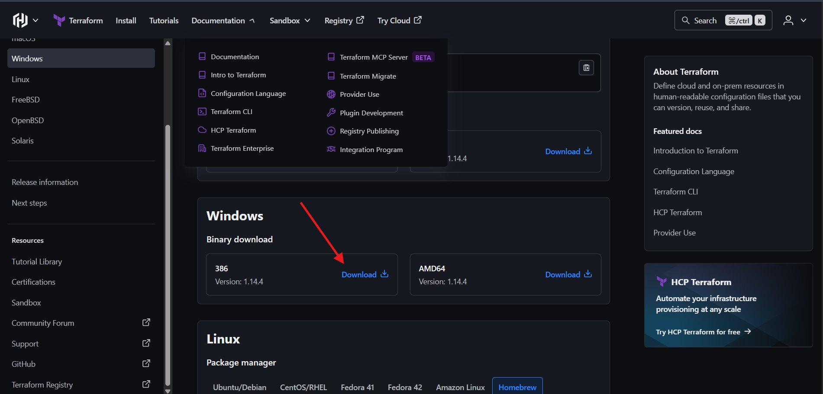
After click on download it go to your download path now see it download our terraform now it zip format we need extract it right click on it

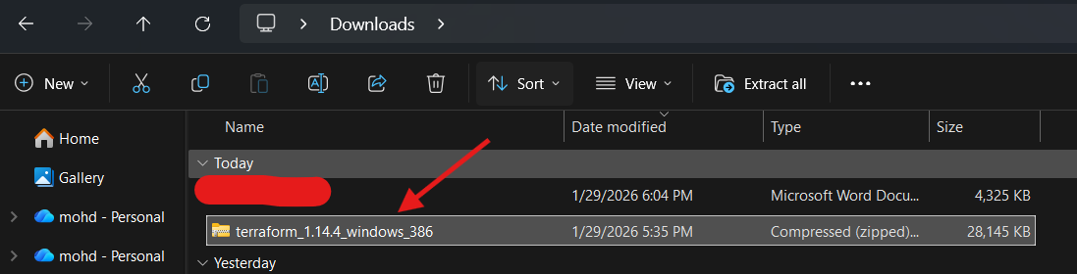
Right click on it select zip in my case using winrar or you any zip extracter after right click on select extract file
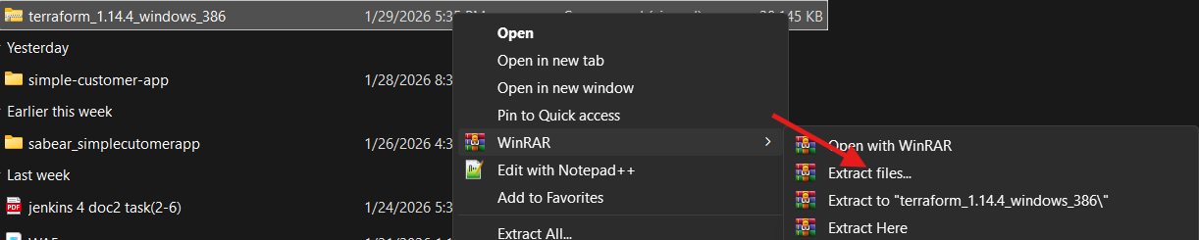
It will take some times then go path where have extract it now see two document and application

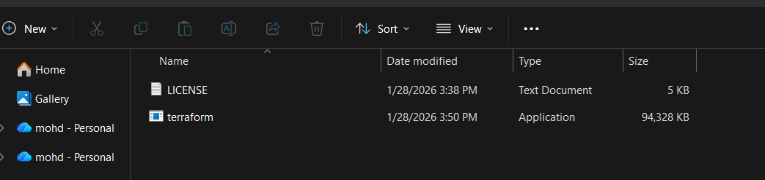
That’s now search on your task bar
That’s serach on it edit the system environment variable 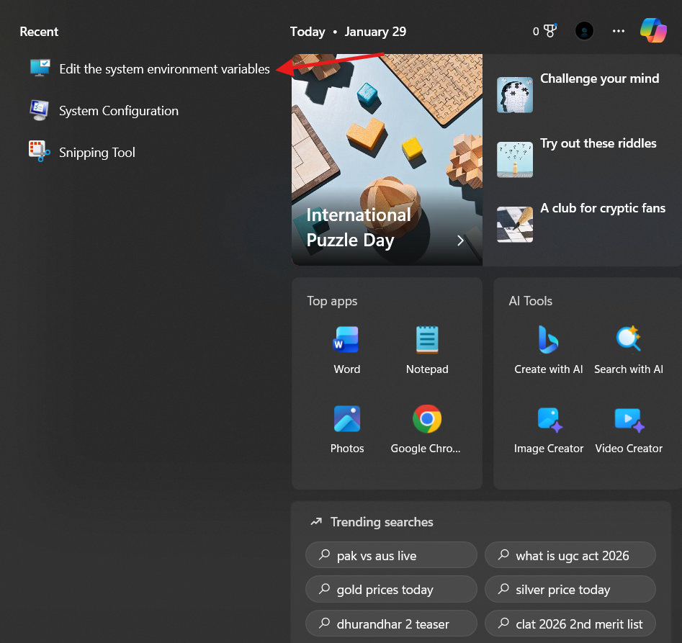
Set your path select your terraform path ok ok ok
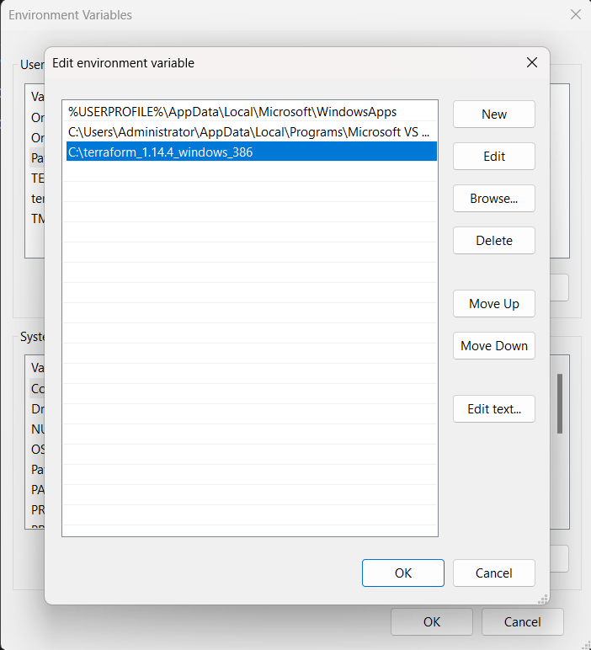
Now after that verfy it click on gitbash type terraform -v it show it version if show version successfully download terraform in it
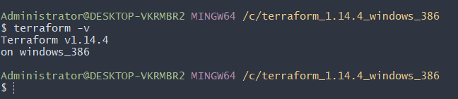
Now we have vscode we need extention serach hashi it show you hasicorp terraform install it
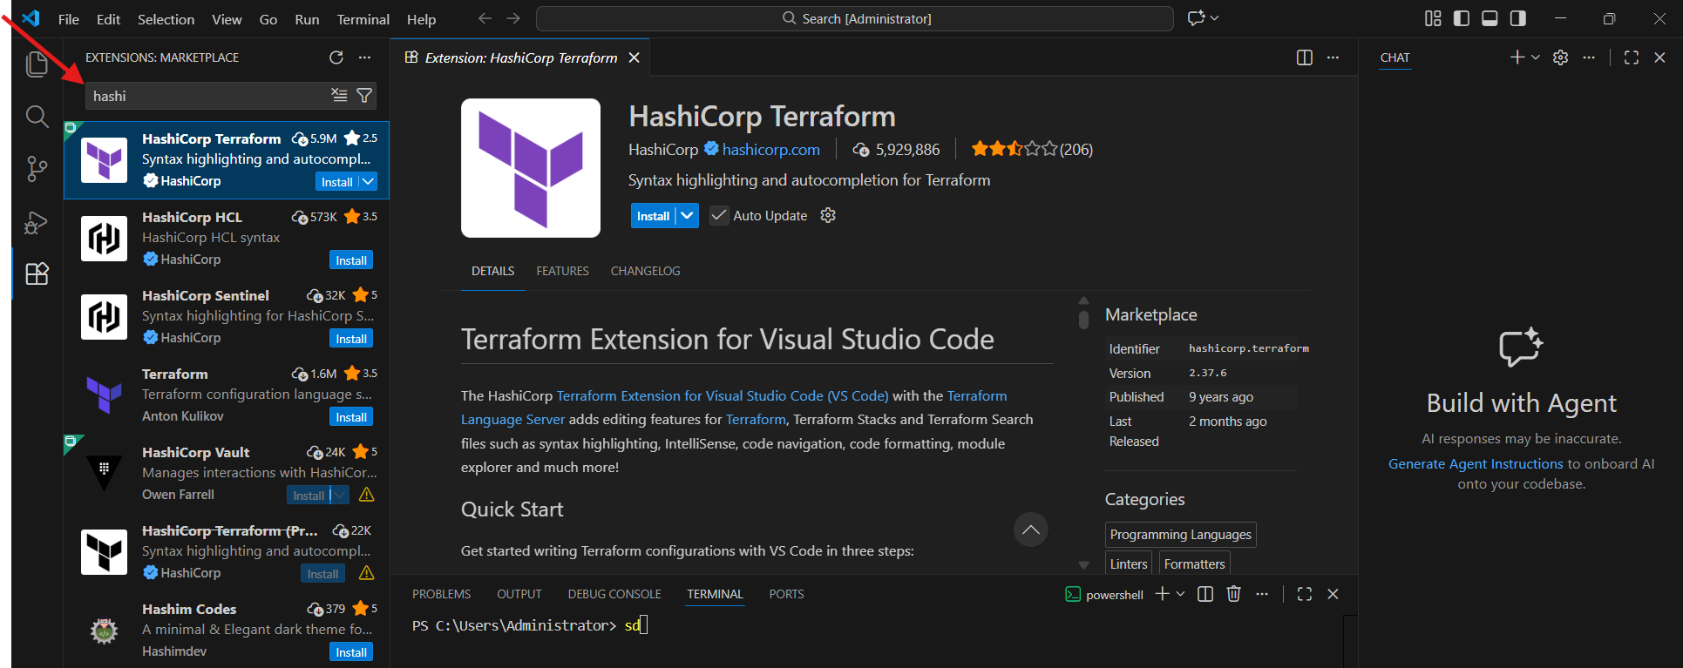
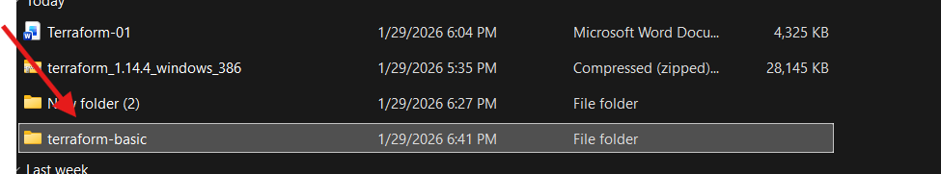
Now we need create one file name its like main.tf now we are In in terraform where excute our code

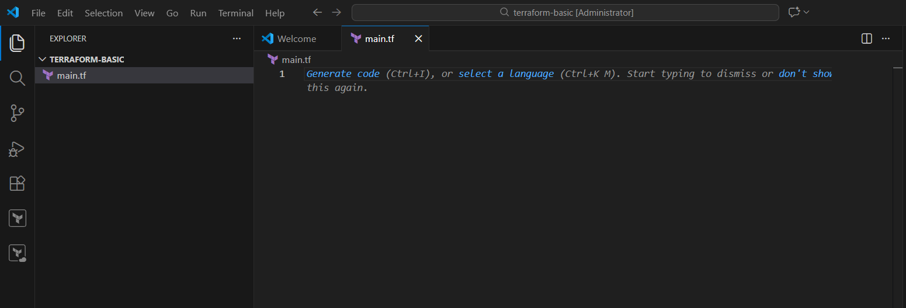
Now our file has been ready
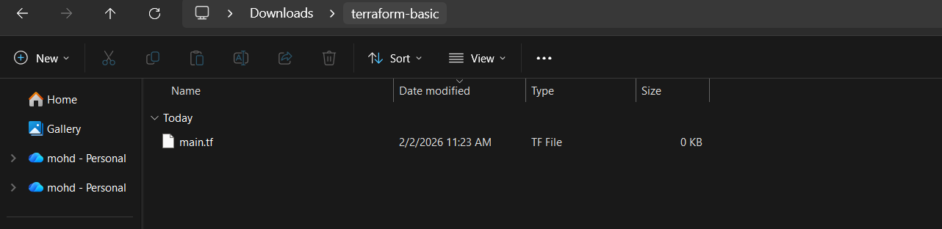
Now terraform configuration :-
Resource = Block name
Local = provider
File= resource type (What needs to be created)
My pet = it is a logical name to identify by terraform and can be named anything.
Example syntax
resource "local_file" "my_pet" {
filename = "pets.txt"
content = "I love pets!"
}
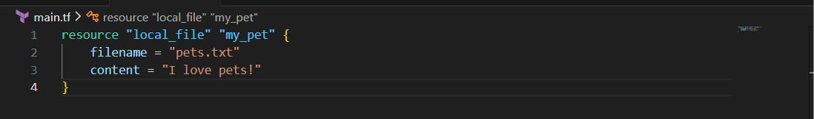
resource = a thing Terraform will create/manage
"local_file" = type of resource (a file on your local system)
"my_pet" = name of this resource (just an internal name)
A quick explaination to understand about syntax
1) filename = "pets.txt" The file name will be pets.txt
Terraform will create a file called pets.txt in this folder.
2) content= content "I love pets!" Inside the file, write this text
3) } = End of this resource block.
Now we need run our code just click on terminal to click on new terminal then It open terminal type in terminal
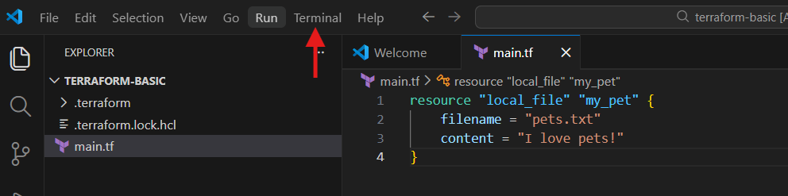
Now type terraform init to run your code
Init means initialization our code in it press enter
Now our code has successfully run
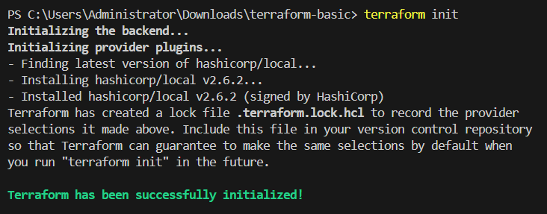
Now we have one more command terraform plan
terraform plan shows you what Terraform is going to do before it actually does it like a preview of changes create, update, delete without applying anything.
In simple word
It tells you what will happen if you run terraform apply
You notice when type terraform plan command it showing information what will happened plan content name , content use md5 it encryption names
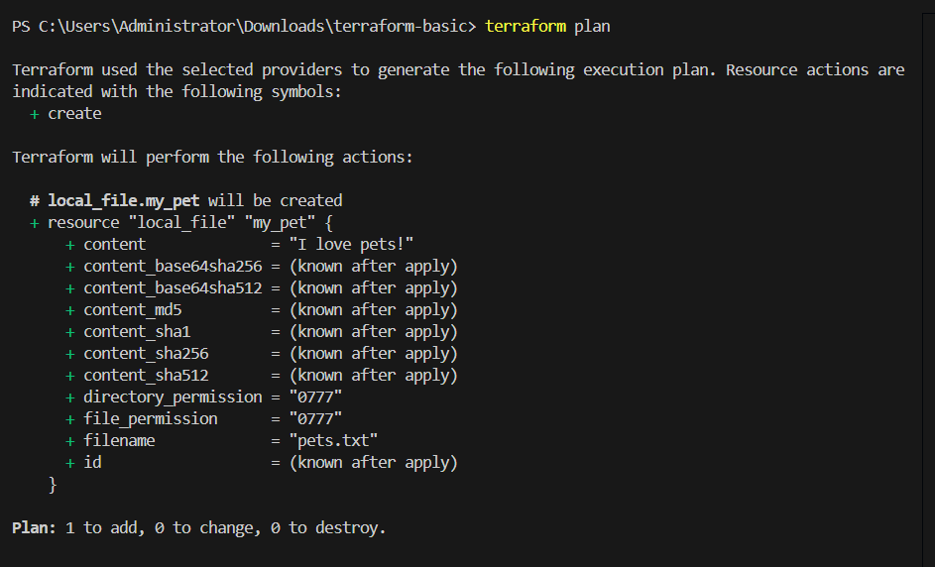
Now we have one more command called Terraform destroy
terraform destroy = deletes all the resources that Terraform created — it cleans everything up.
Before destroy we need create one file type command terraform apply
It ask just type yes
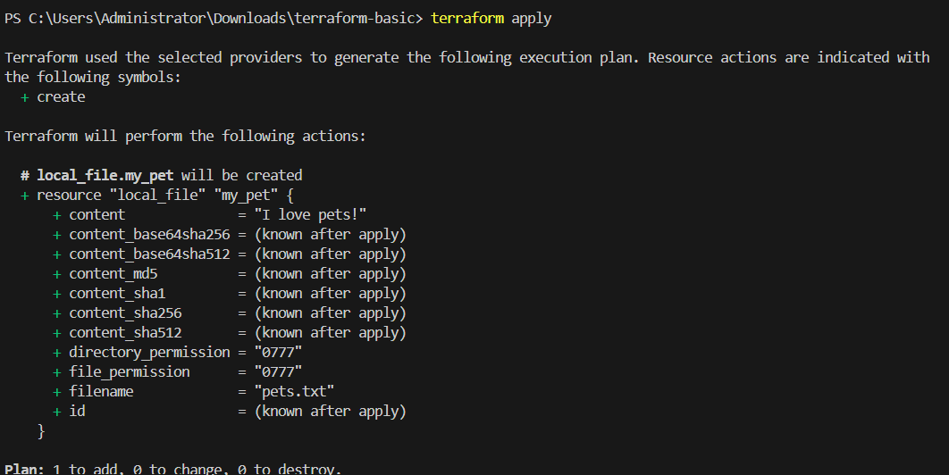
Now it autocally crate that file “ file name is pets.txt after destroying it deleted that’s it
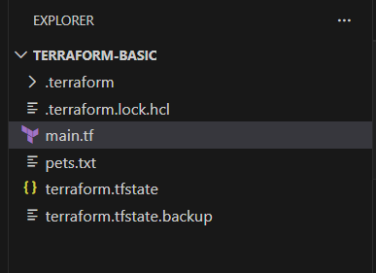
Now we have one more command Terraform fmt lets dive into it
Terraform fmt = terraform fmt automatically formats your Terraform code to a clean and standard style.
It makes your Terraform code neat and properly aligned.
Once the file is destroyed, then we need to come back from start just type this command
Terraform init terraform plan terraform apply terraform fmt
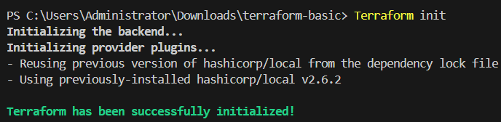
That’s it now type terraform apply
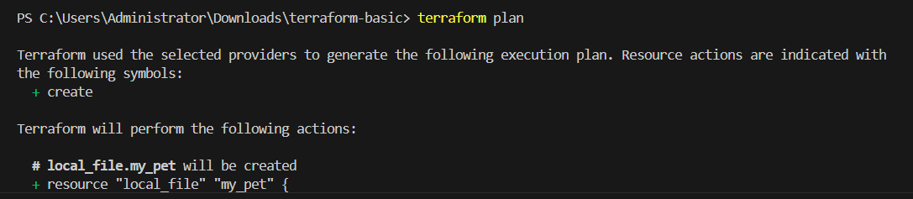
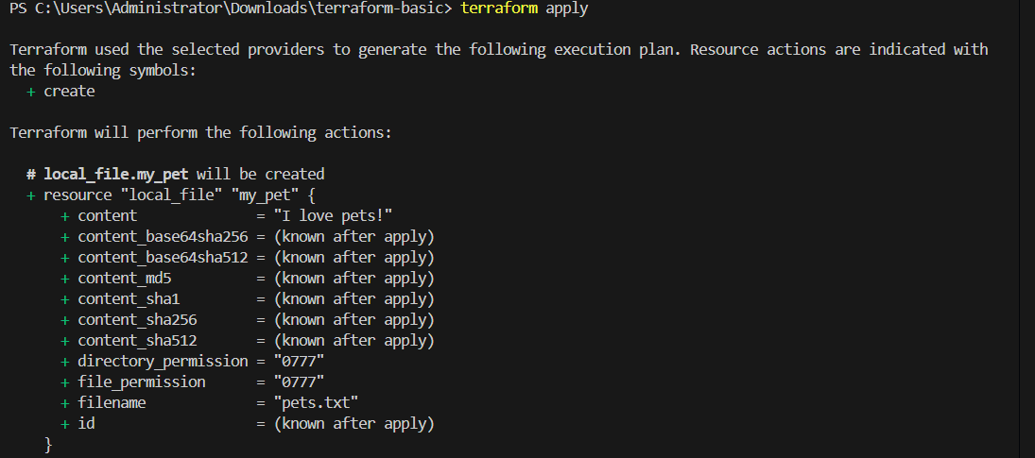
Command- terraform show
Will help us to view the details of the file.
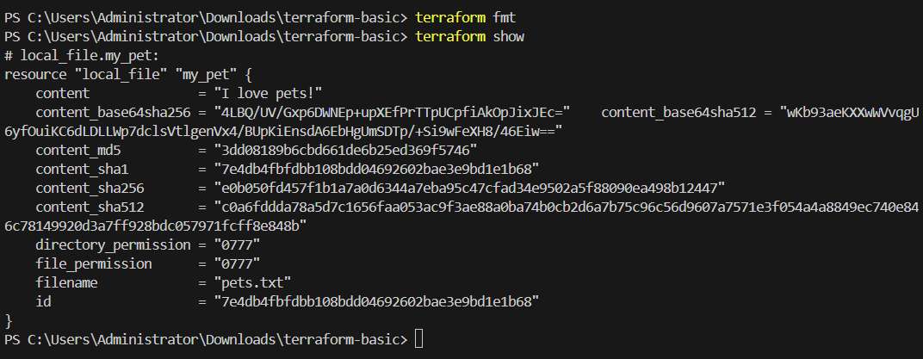
Terraform provider is a plugin that lets Terraform talk to a specific service (like AWS, Azure, GCP, Docker, etc.
Provider tells Terraform where and with what to create resources
Explain
terraform providers:- terraform provider are plugin that connect to our cloud machine like we think it like AWS , azure
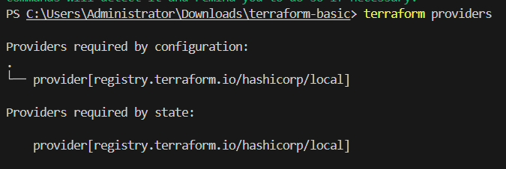
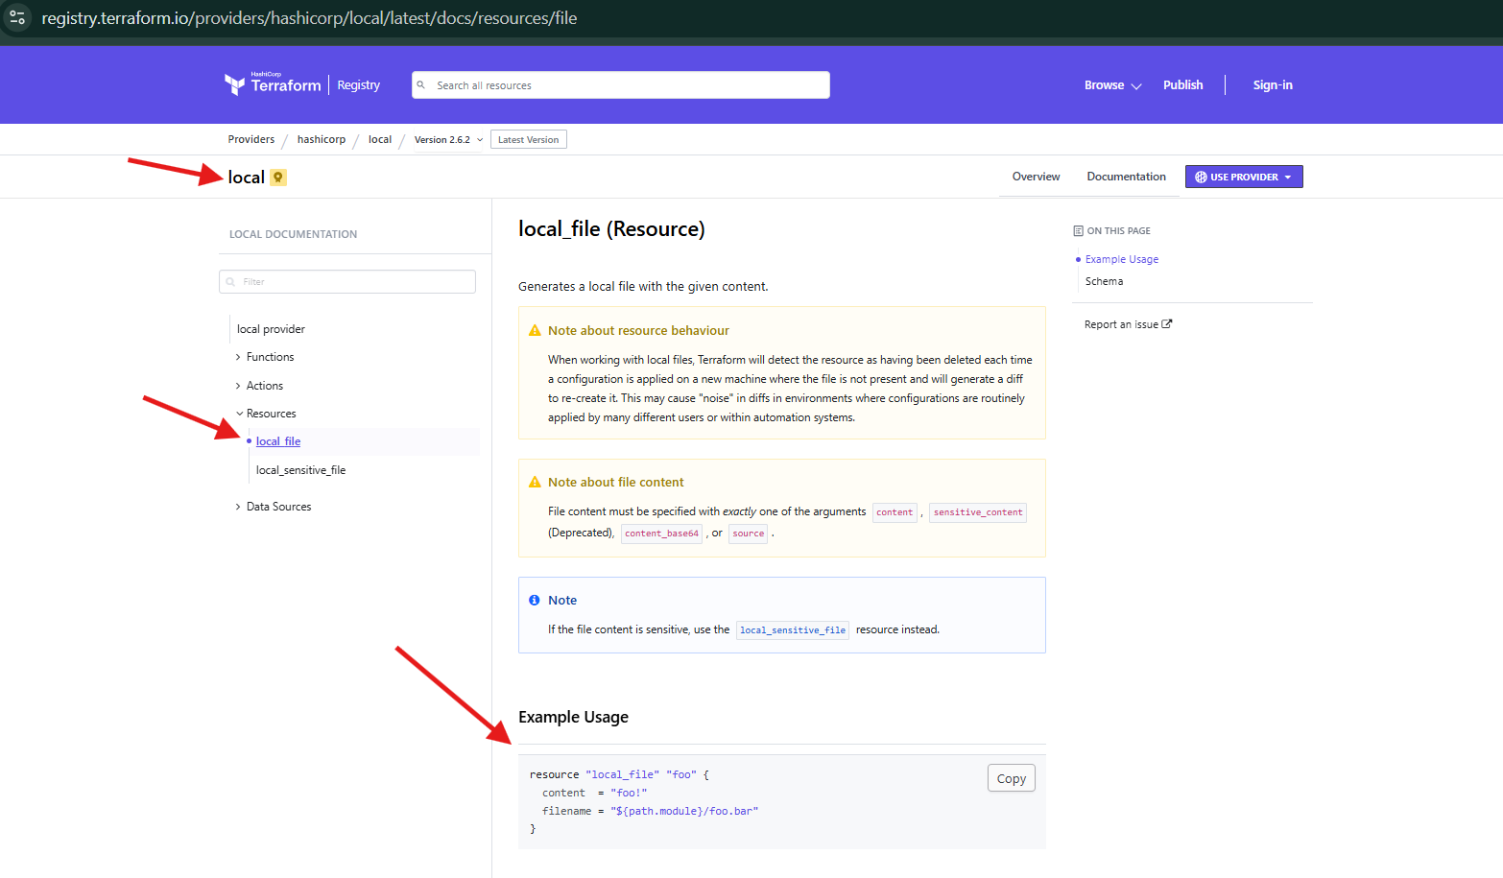
Now, lets make a change in our script and execute. Pets to animals that we need change here
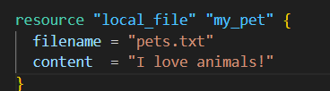
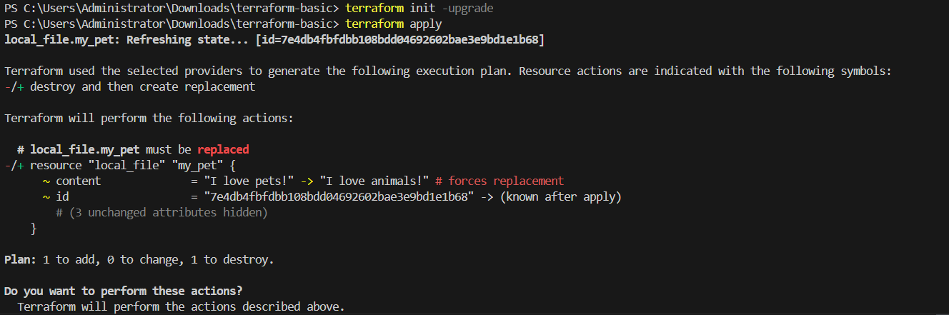
Task 3: Integrate a sample Terraform template in Jenkins.
Navigate to AWS ec2 and launch Jenkins server.
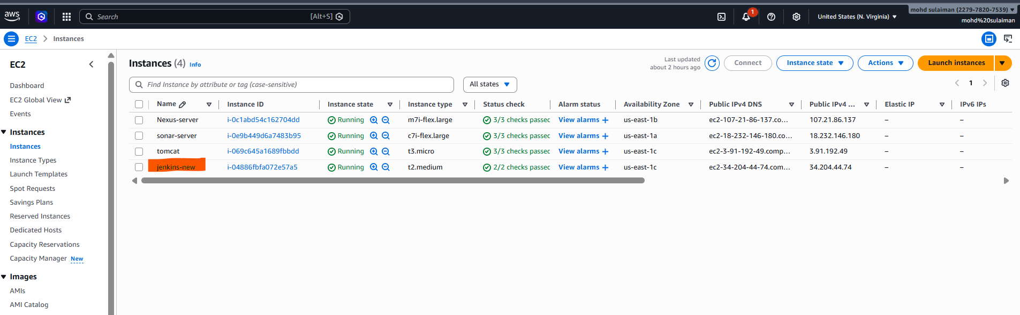
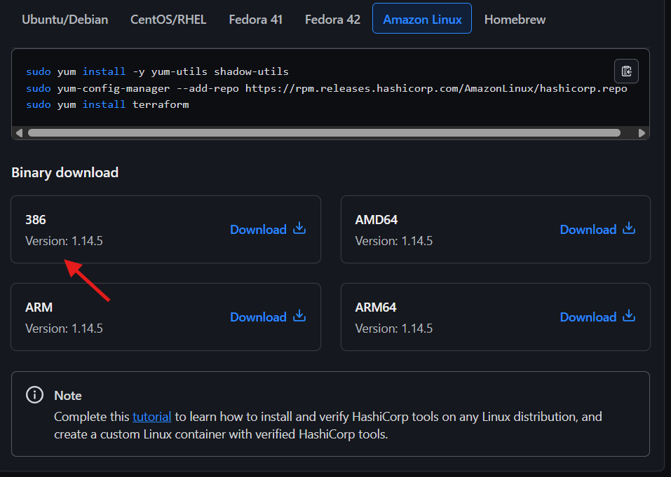
- Installed the packaged manager in Jenkins server.
sudo yum install -y yum-utils shadow-utils
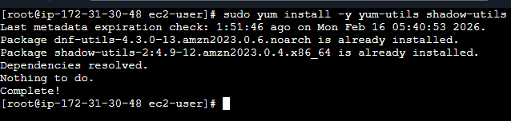
sudo yum-config-manager --add-repo https://rpm.releases.hashicorp.com/AmazonLinux/hashicorp.repo
sudo yum install terraform
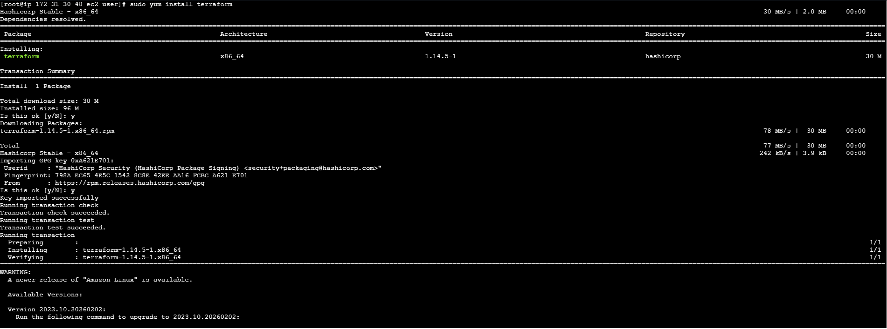
Now we need install terraform plugin
Step 3: Navigate to Jenkins GUI and install plugin Terraform
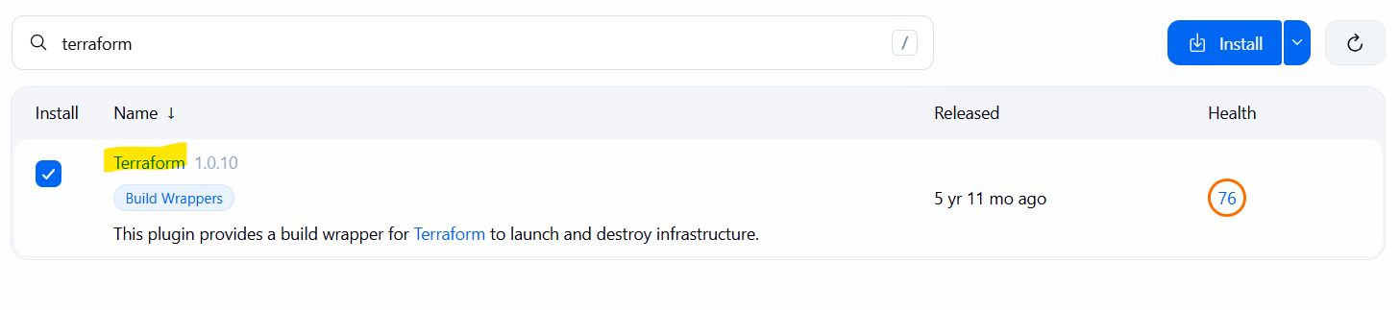
Now we have successfully install terraform on our Jenkins machine
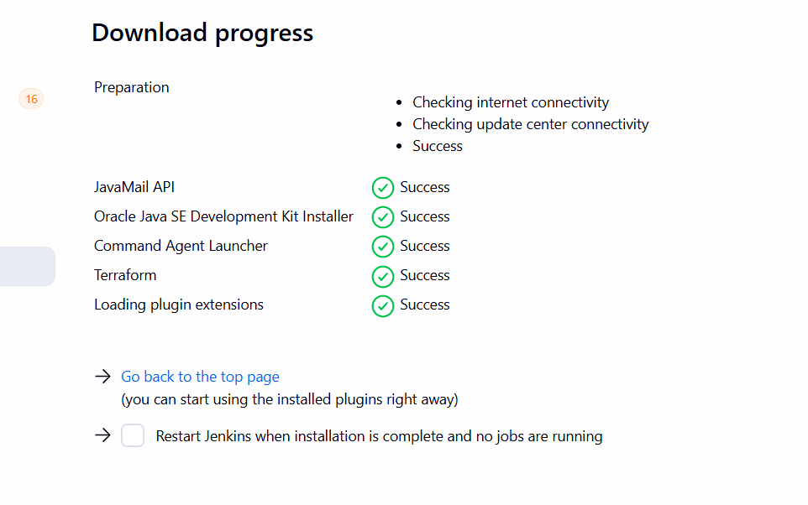
Navigate to Manage Jenkins and add Terraform under Tools
Version: Terraform 60204 darwin (amd64)
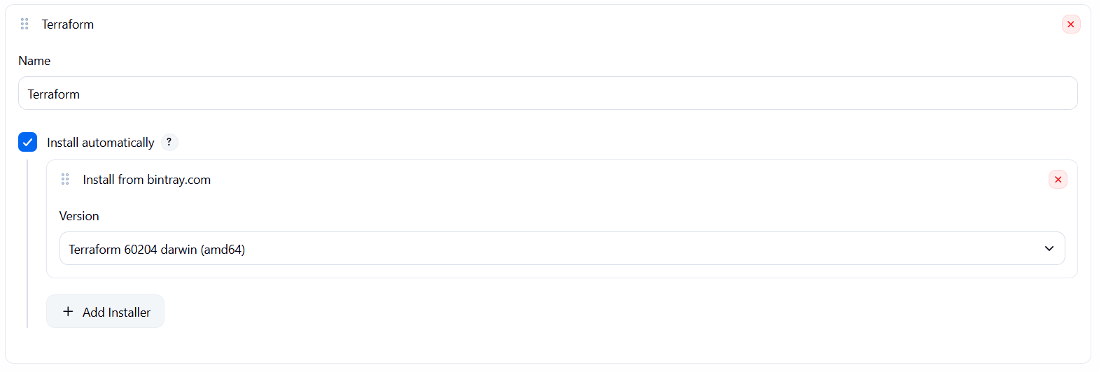
Navigate to GitHub and create a repo- Terraform
Mark Readme as required
Visibility- Public
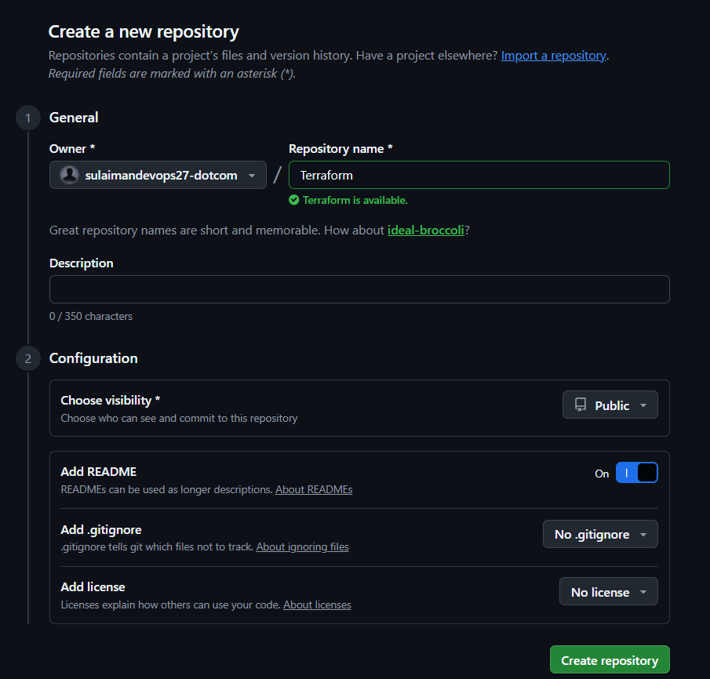
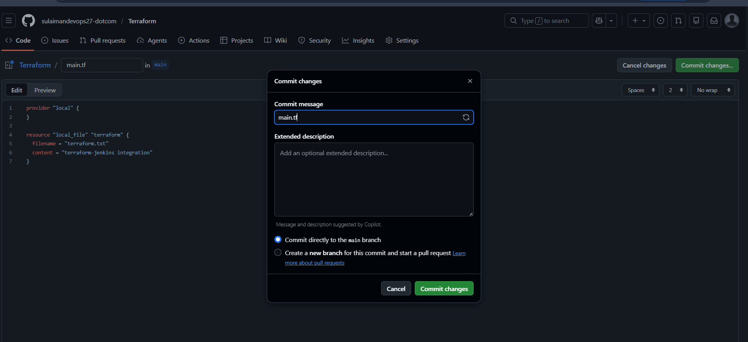
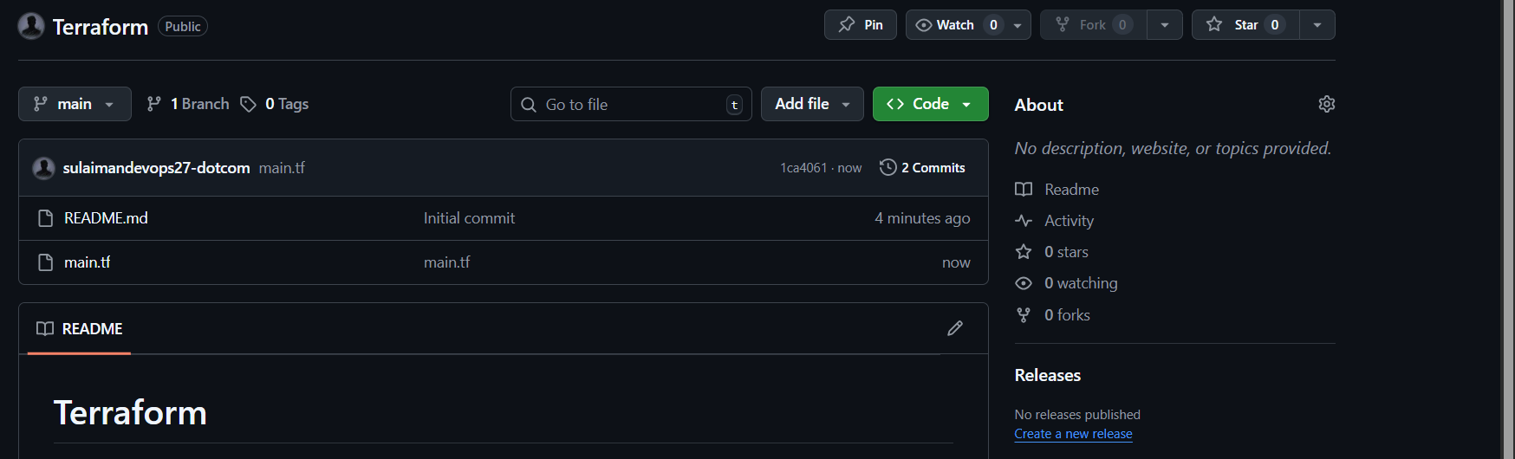
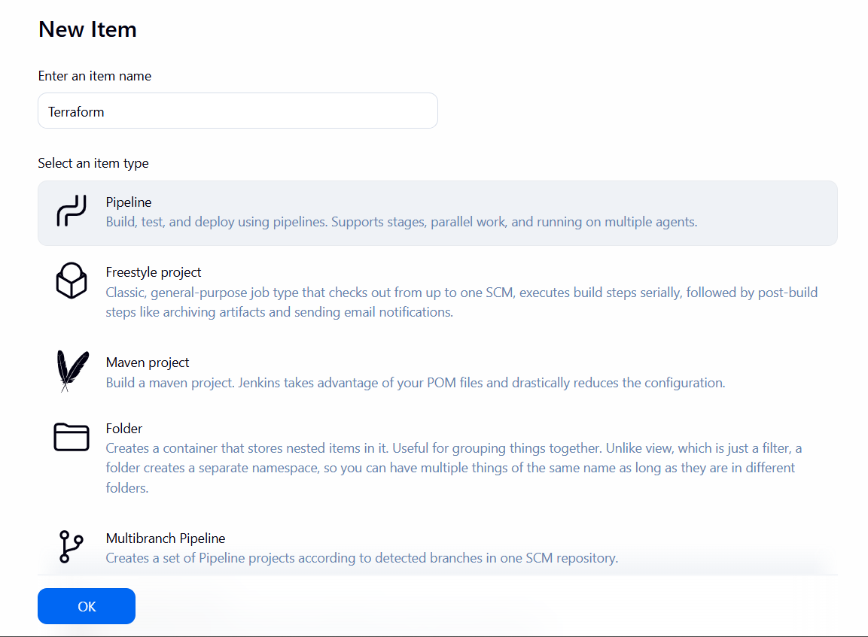
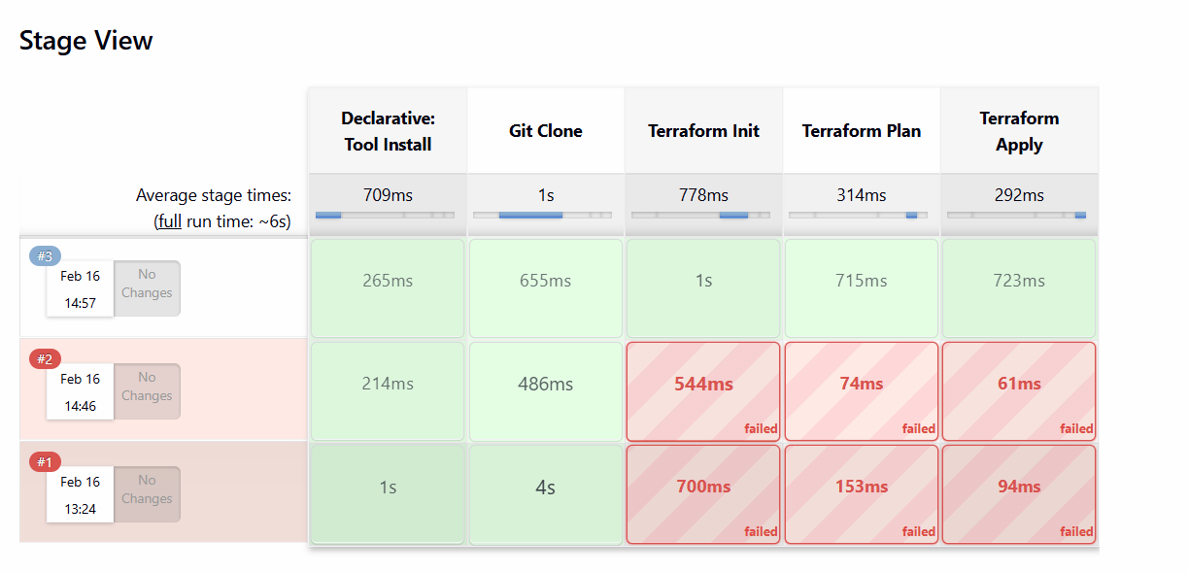
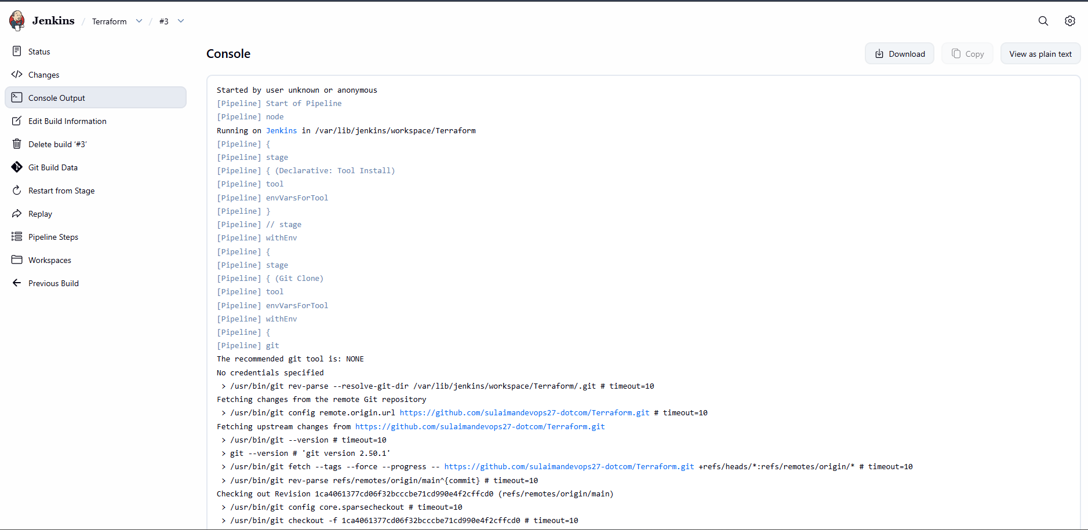
Pipeline script for Terraform:
pipeline {
agent any
tools {
terraform 'Terraform'
}
stages {
stage('Git Clone') {
steps {
git branch: 'main',
url: 'https://github.com/sulaimandevops27-dotcom/Terraform.git'
}
}
stage('Terraform Init') {
steps {
sh 'terraform init'
}
}
stage('Terraform Plan') {
steps {
sh 'terraform plan'
}
}
stage('Terraform Apply') {
steps {
sh 'terraform apply -auto-approve'
}
}
}
}

